Nervilia gammieana (Hook.f.) Pfitzer (Orchidaceae) - a new record for Kumaun Himalaya, India

Jeewan Singh Jalal¹ Lalit M. Tewari¹ and Y.P.S.Pangtey¹
¹Department of Botany, Kumaun University, Nainital, Uttarakhand

Abstract

Kumaun Himalayas are placed in the central sector of the Indian Himalayas and lies between 28° 44'- 30° 49' N Lat. and 78° 45’- 81° and 01' E long. The orchid flora of the Kumaun Himalayas is well studied and explored by the several workers in the past. (Duthie, 1906a & b; Gupta, 1968; Seidienfaden and Arora, 1982; Deva and Naithani, 1986; Pangtey et al., 1991). The present paper confirms the occurrence of Nervilia gammieana (Hook.f.) Pfitzer in the Kumaun Himalayas. In 2008, during the course of orchid explorations in Nainital district (as a part of the project sponsored by the Department of Science and Technology, Government of India), some orchids were collected from Nainital district. On critical examination of these specimens, they were identified as Nervilia gammieana (Hook.f.) Pfitzer. The present paper deals with the description and distribution of Nervilia gammieana (Hook.f.) Pfitzer from the Nainital region of Kumaun Himalayas.

Key words: Nervilia gammieana; Kumaun Himalaya; Nainital

1. Introduction
The genus Nervilia was established by Gaudichaud in 1829. The generic name is derived from the Latin word ‘nervus’ (veined), referring to the prominently veined leaves. About 80 species are distributed in the tropical Africa, Madagascar, tropical Asia, the Himalayas, S. China, Philippines, New Guinea, Australia and some in Polynesia. In India, the genus is represented by 14 species, of which 7 species are found in the Western Himalayas [Deva and Naithani 1986]. Members of the genus Nervilia are terrestrial herbs often growing in colonies and each plant produces a single heart-shaped leaf after flowering. The most interesting thing of this genus is that both the flower and the leaf can’t be seen at the same time. Leaf can be seen but only after the flowering occurs. The large single leaf is broadly cordate or orbicular, strongly plicate, glabrous or hairy along the radial veins. Flower scape appears one-leaved cormous herbs emitting corms located just below just below the substrate as well as producing two or three slender stolons, each producing at its extremity a new corm. The corm is subglobose, soft, of a few contracted, swollen internodes and the root system is very rudimentary. Leaf broadly cordate or orbicular, strongly plicate, glabrous or hairy along the radial veins. Flower scape is from the same corm as the leaf and appears before it does. Flowers are solitary, in pairs or in racemes, often pendulous and drooping. Sepals and petals are subequal, narrow, connivent or spreading. Lip is narrow and the lower part convolutes round the column. Lateral lobes are small and usually triangular and the apical lobe is flat, ovate or orbicular, either entire or fimbriate. Column is elongate; clavate is upwards and stigma is anticous. Two pollinia are present with large granules in two rows and often without caudicle or gland.

Kumaun Himalayas are located in the central sector of the Indian Himalayas and lies between 28°44'- 30° 49' N Lat. and 78° 45’- 81° and 01' E long. Broadly the area consists of three parallel mountain ranges (Fig. 1). The orchid flora of Kumaun Himalaya is well studied and explored by the several earlier workers (Duthie, 1906a & b; Gupta, 1968; Sedienfaden and Arora, 1982; Deva and Naithani, 1986; Pangtey et al., 1991). Recently, during the course of orchid explorations in Nainital districts, as a part of project sponsored by Department of Science and Technology, Government of India, some orchids were collected from Nainital district. On critical examination of these specimens, they were identified as Nervilia gammieana (Hook.f.) Pfitzer.
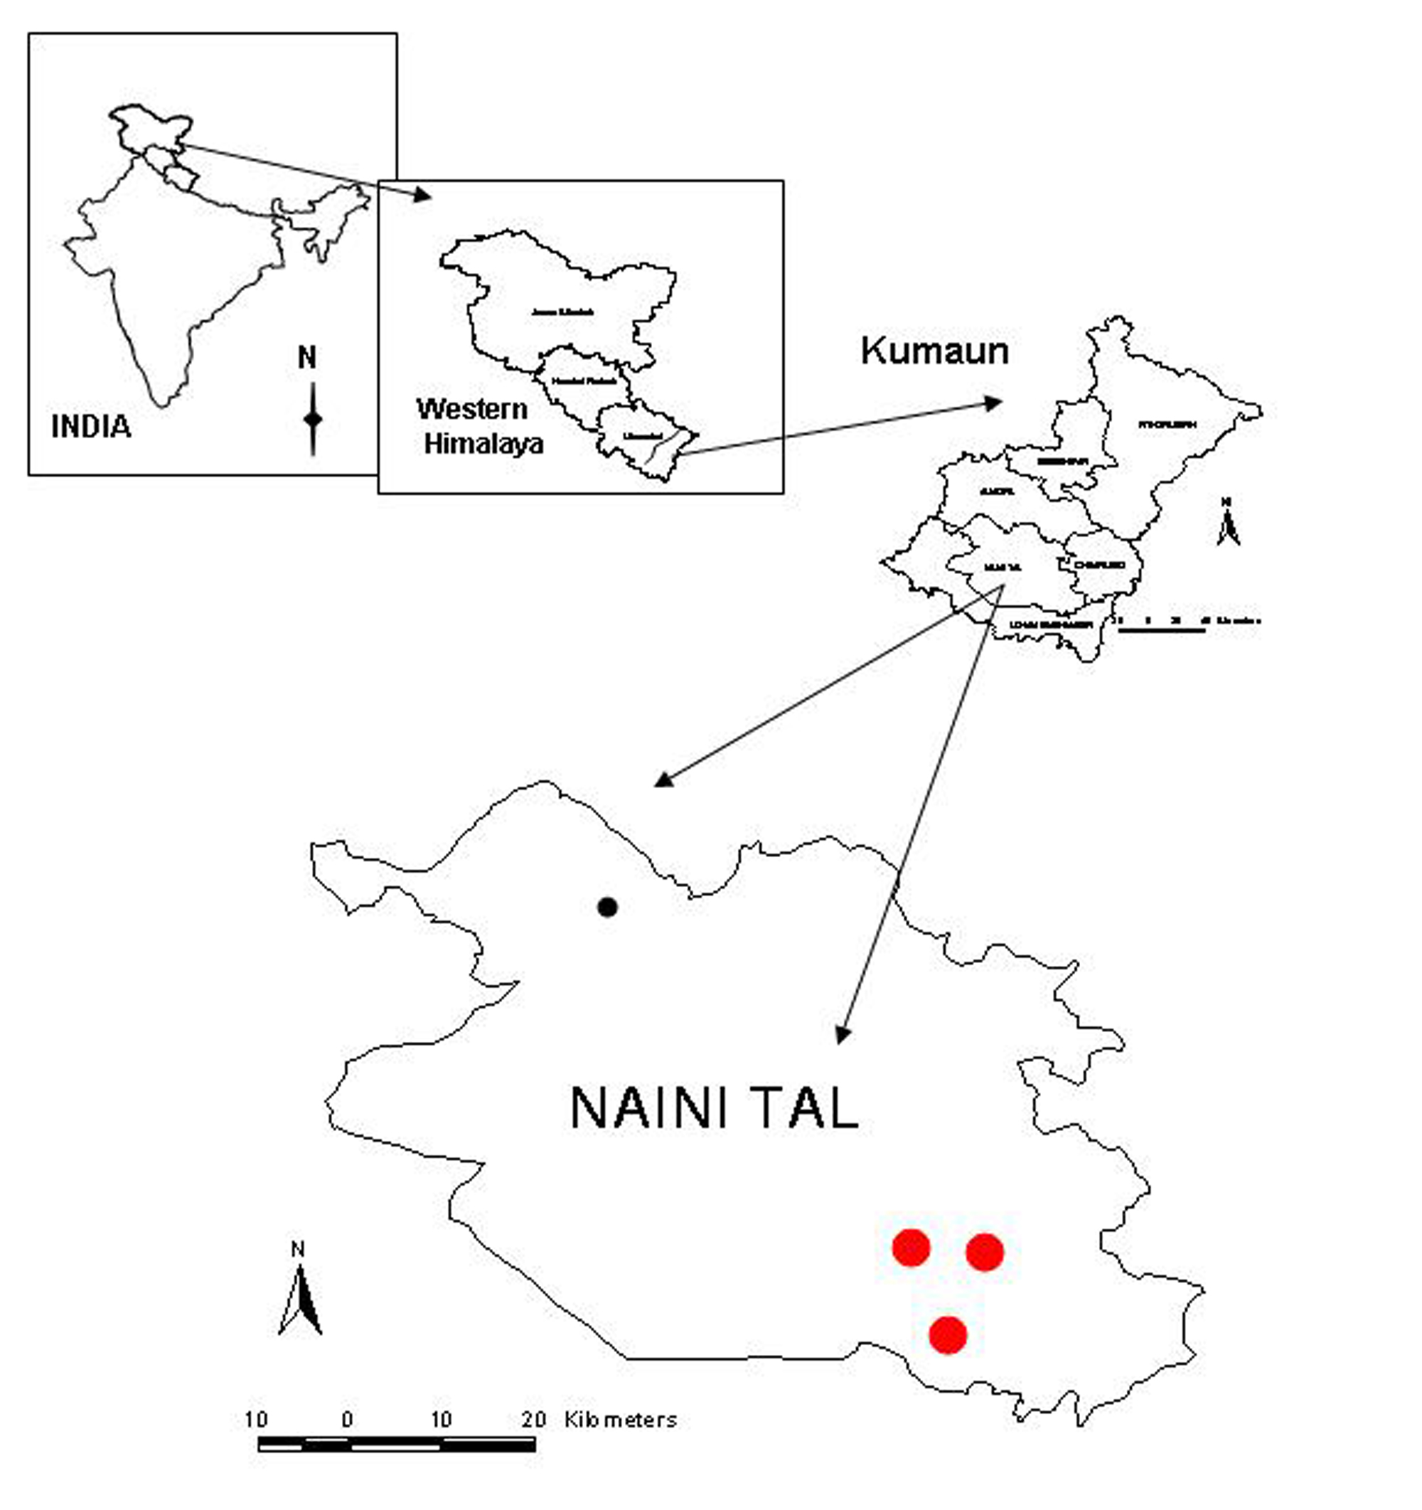
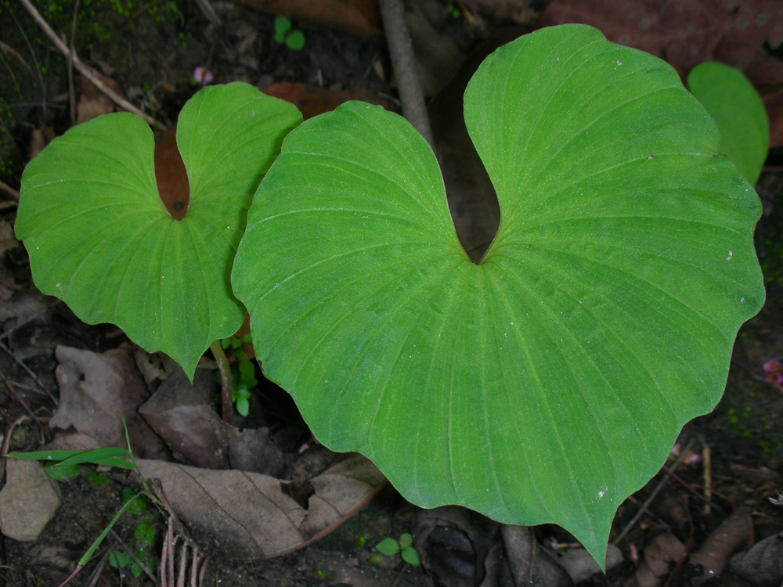
Fig 1. Map of Kumaun Himalaya and the district showing the current location (red circles) of Nervilia gammieana.

Fig. 2. Leaves of Nervilia gammieana
Nervilia gammieana (Hook.f.) Pfitzer, Nat. Pflanzenfam. 2. 6: 56, f. 44; 106, f. 105. 1889. Hook.f., Fl. Brit. Ind. 6:120. 1890; Seidenfaden & Arora, Nord.J.Bot. 2:22.1982; Deva and Naithani, Orchid Fl. North West Him. 81.t.82.1986.

Pogonia gammieana Hook. f. in Curtis Bot. Mag. 39. t. 669. 1883.

Nervilia aragoana sensu Stewart in Pak. J. Forest. 11 (1): 60. 1961 non Gaud.

2. Description
Terrestrial herb, 15-20cm tall; tuber globular warty, 3cm across. Stem stout, green; sheath 1-4, the lower streaked with red-brown. Leaf appears after flowering. Leaf solitary, with 10-18 cm long petiole, blade flabellate-orbicular to cordate, up to 12 cm in diam., veined fan-like, acuminate, margin wavy, glabrous, deeply cordate at base. Scape with 3 tubular, closely adpressed sheaths, 10-30 cm tall. Terminal inflorescence dense. Bracts linear-lanceolate, deflexed, exceeding ovary. Flowers 2.5 cm long, drooping, pink color. Sepals and petals subequal, pink, with darker and whitish lines, spathulately-lanceolate, ± connivent or slightly spreading, up to 20-25 mm long. Labellum greenish or yellowish-white, as long as sepals, slightly saccate at base, when spread out elliptic-obovate, lower half (hypochile) convolute, embracing the column, white, with 2 short triangular side-lobes and two central parallel ridges; anterior half (epichile) with crenulate margin, hairy above, with 3 central parallel ridges, greenish. Column 10-15 mm long, white with dark purplish apex. Ovary with 3 mm long stalk, both winged (Fig 2, 3, 4 & 5).
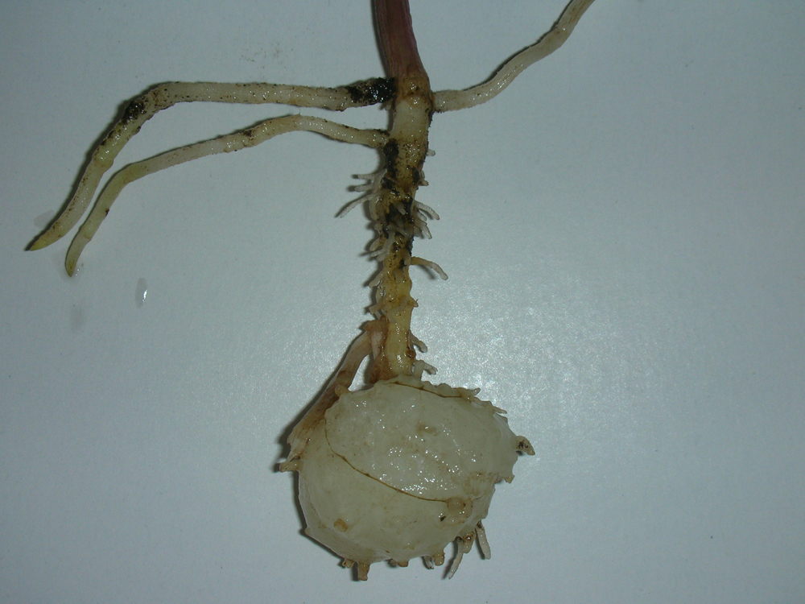
Flowering Season: May to June.
Fig. 3.Tubers of Nervilia gammieana

Fruiting: July.
Distribution in Uttarakhand: Dehradun- Mohand, Lachiwala, Near Kalupani, Near Mussoorie, Pauri- Outer hills, Nainital- Jeolikote, Kathgodam, and Patawandger.

Distribution in India: Jammu & Kashmir, Sikkim and Arunachal Pradesh.

Distribution in World: Pakistan and Nepal.
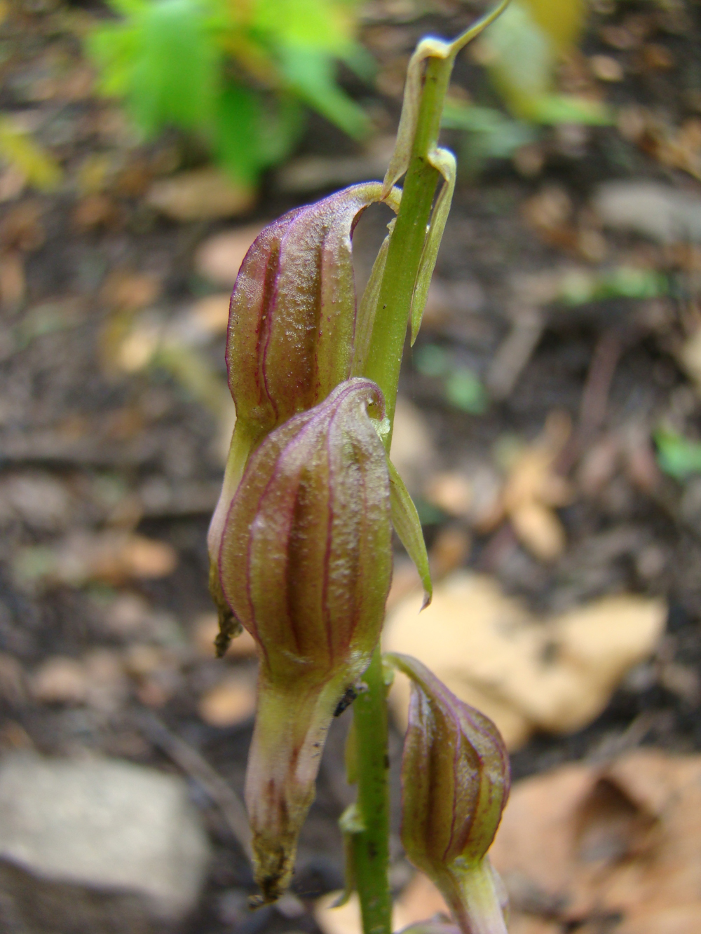
Fig. 5. Mature fruits of Nervilia gammieana

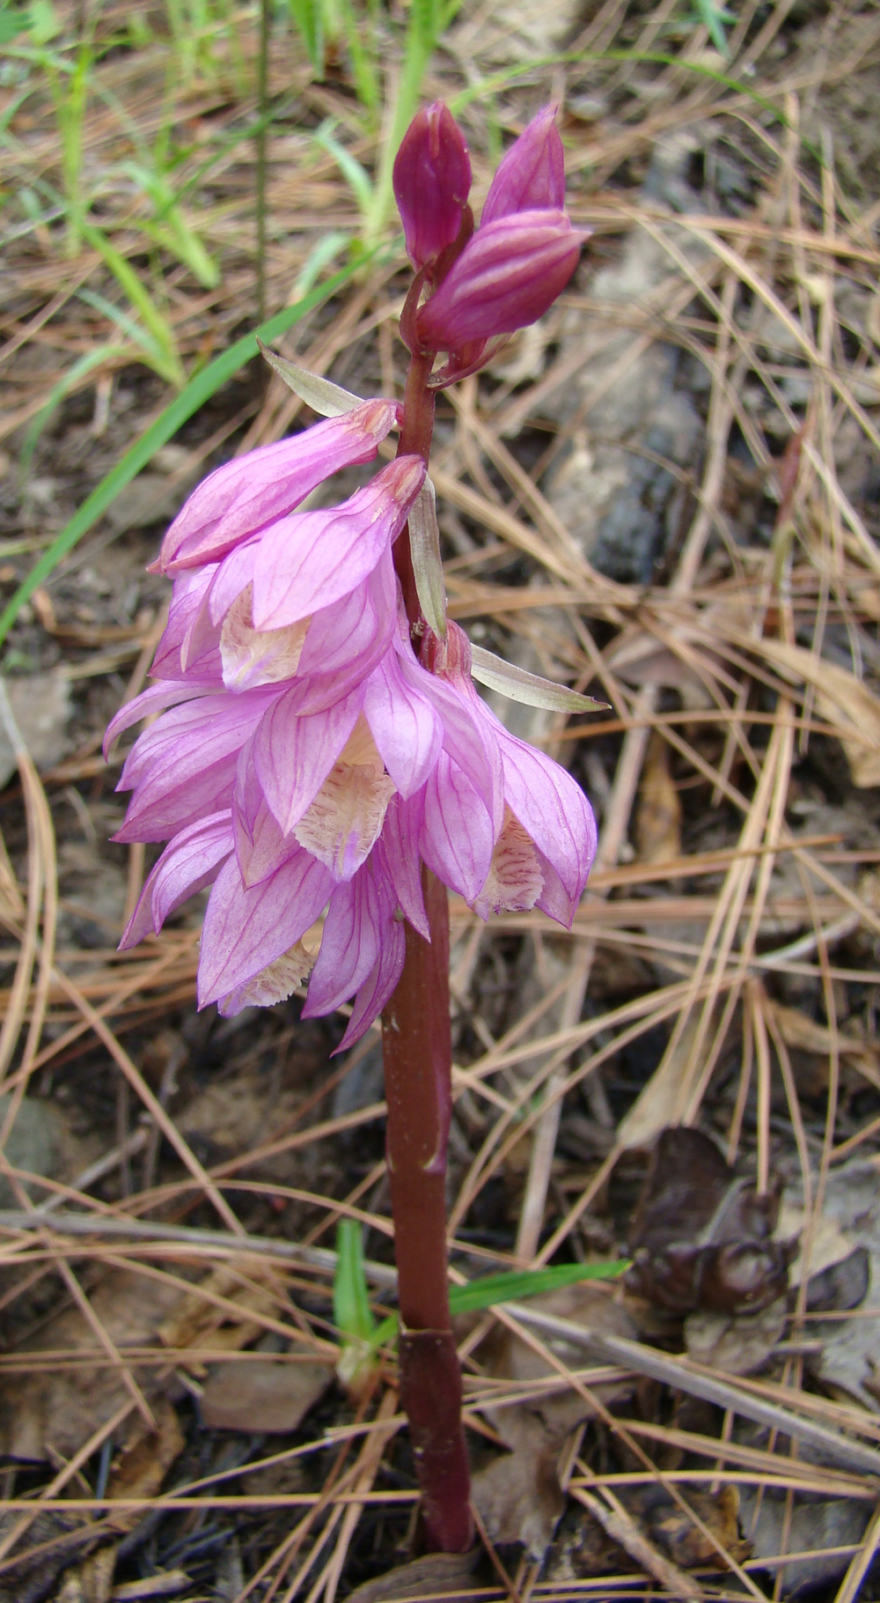
Fig. 4. Inflorescence of Nervilia gammieana
3. Ecology
We found Nervilia gammieana growing under Sal forest (Shorea robusta) at the altitude of 600-900m. This species enjoys the moist humus rich soil. In Nainital area this species has attained higher elevation of 1700m under the Quercus leucho-trichophora-Pinus roxburghii forest community. It is also found in the middle elevation range where generally chir pines hold the complete stand. This species flowers and reaches its extreme stage at the end of the summer season surprisingly at a time when most of the forest in Kumaun Himalayas is burning up in flames due to the forest fires. In most of the surveyed areas, we were not lucky enough to find any flowering scape of this species but as soon as the first monsoon shower touched the scorching earth, the leaf began to develop. It would be necessary to bring to notice that during our survey, the entire area was affected by forest fire. This means that probably most of the flowering scapes had been burnt down into ashes. But the interesting thing about the genus Nervilia is that they have an underground tuber system that bears new tubers every year and hence even without fruits or new seeds this species can survive. They have their strong capacity of vegetative reproduction. The leaf of Nervilia gammieana is generally veined, fan-like and with deep channels towards the base. The large surface of the leaf can collect a huge quantity of water and dewdrops. Later the leaf channels help to pass water, all the way up to the tubers giving the genus Nervilia a new life to look forward to.

Acknowledgements
Authors are grateful to the Department Science and Technology, Government of India for financial support to carry out this work.

References
Pangtey, Y.P.S., Samant, S.S., and G.S.Rawat (1991). Orchids of Kumaun Himalaya. Bishen Singh Mahendra Pal Singh. Dehradun.
Deva, S. and H. B. Naithani. (1986). The Orchid Flora of North West Himalaya. Print & Media Associate, New Delhi.
Hooker, J.D. (1888-1890). Orchidaceae in The Flora of British India. L. Reeve & Co. Ltd., Ashford, Kent, U.K.
Seidenfaden, G. and C.M. Arora. (1982). An enumeration of the orchids of the north-western Himalaya. Nordic Journal of Botany 2: 7-27.
Duthie, J. F. (1906a). The Orchids of the North-Western Himalaya. Ann. Royal Bot. Gard. Calc. 9 (2): 81-211.
Duthie, J. F. (1906b). Catalogue of the plants of Kumaun and adjacent portion of Garhwal and Tibet based on the collections made by Strachey and Winterbottom.
Gupta, R.K. (1968). Flora of Nainitalensis. New Delhi.

