FORENSIC
EVIDENCES
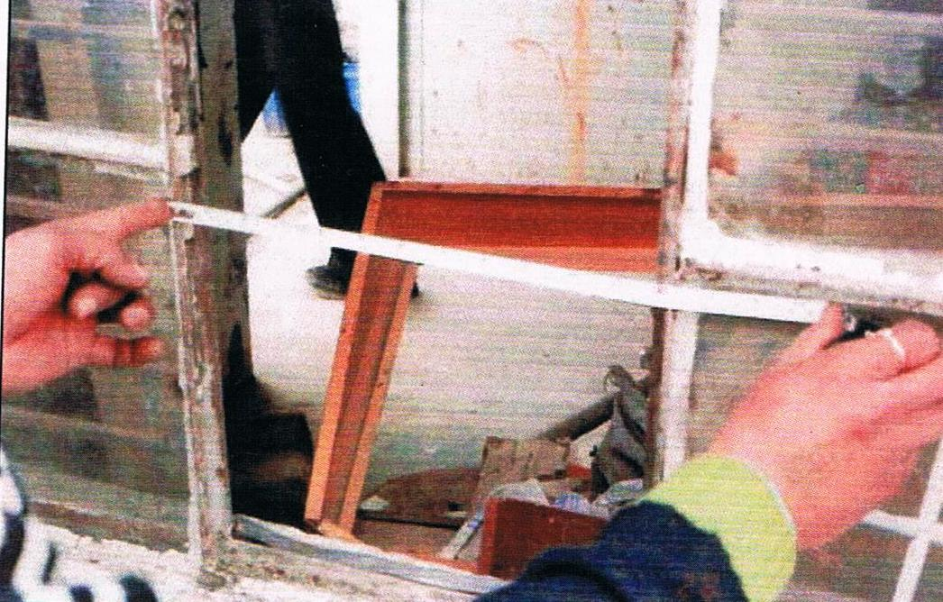
¹Dr. Anita Kadian
²Sh. Ajay Kumar
³Sh. Chander Shekhar

ISBN-1-59964-058-9

DETAILS ABOUT AUTHORS

¹Dr. Anita Kadian
(Assistant Director)
Biology Division,
Forensic Science Laboratory, Madhuban (H), Karnal
Phone no. +919991999018
Email-Kadiananita39@yahoo.com

²Sh. Ajay Kumar
(Research Scholar)
Wildlife and animal behavior laboratory,
Department of Zoology,
Kurukshetra University, Kurukshetra (Haryana)
Phone no. +918814874062
Email- ajayindorakuk@yahoo.com

³Sh. Chander Shekhar
(Senior Scientific Assistant)
Scene of crime,
Forensic Science Laboratory, Madhuban (H), Karnal
Phone no. +919996912626
Email-inchargemfsynr@gmail.com

PREFACE

The idea of writing this book for the purposes of investigating officers came from the fact that in the field at Scene of Crime when we met with the investigating officers then it has been observed that our investigating officers are lacking in scientific temperament and they do not give much importance to the scientific evidence present at the scene of crime, which in turn hampers the successful outcome to the criminal investigation. So when we have met them suggest them to fit the physical clues present at the spot and send them to FSL with a set of questions. Some of them when later on met told us that they do not have the idea that so much help can be got from the FSL through the analysis of physical evidences. So the comprehensive book was written in the simplest English which we think will certainly provide them basic knowledge of Forensic Science and inform about the potential of scientific evidences present at the scene of crime helping in solving the crime.

Through there are numbers of books written on the subject by the Indian and Foreign authors but this book was written in a concise and precise manner exclusively for the purpose of the investigating officers working in the various investigative agencies or laboratories.

ACKNOWLEDGEMENT
As writing is an arduous work but we were supported in this book by many people without their help it was very difficult to put this work in black and white. We are indebted to our parents, family members who provide us the moral support in the work. We express special thanks to all our colleagues and friends for their great help and support.
With immense gratitude, we thanks
Hon’ble Sh. Ranjeev Dalal, IPS, DGP, Haryana Police.
Sh. S.K. Sangwan, Director, FSL, Madhuban, Haryana for their important suggestions and moral support.
Science graduate constable Sushil Kumar, Pardeep Kumar 522/PKL and Parmod Kumar 2035/GGN posted in various mobile Forensic Science Units, Haryana and in the FSL helped us very much in preparing the material. It is because of their help that this book came into existence.
The view and opinion expressed in the book are those of the authors and do not necessarily represent those of the FSL, Madhuban or any other Government agency.
Though much care has been taken in choosing the topics, expressing the views and selecting the photographs, however any error or short coming due to any reasons are of course, ours.

CONTENTS
Chapter 1
Forensic Science
Chapter 2
Basic Principles/Laws of Forensic Science
Chapter 3
Crime and its cause
Chapter 4
Organization of the Forensic Science Laboratory
Chapter 5
Scene of crime
Chapter 6
Biological death
Chapter 7
DNA as Forensic tool
Chapter 8
Forensic Biology
Chapter 9
Asphyxia
Chapter 10
Physical evidences
Chapter 11
Physical Injuries and Lighting
Chapter 12
Forensic toxicology
Chapter 13
Forensic Ballistics
Chapter 14
NDPS evidences
Chapter 15
Cyber evidences
Chapter 16
Chemical evidences
Chapter 17
Some important cases
Chapter 18
Bibliography
● List of table
● List of figures
● List of photo
● Index
● Annexure

CHAPTER-1
FORENSIC SCIENCE
1.1 Forensic Science definition
Forensic science (often shortened to forensics) is the application of a broad spectrum of sciences to answer questions of interest to a legal system. This may be in relation to a crime or a civil action. The word forensic comes from the Latin forēnsis, meaning "of or before the forum." In Roman times, a criminal charge meant presenting the case before a group of public individuals in the forum. Both the person accused of the crime and the accuser would give speeches based on their sides of the story. The individual with the best argument and delivery would determine the outcome of the case. This origin is the source of the two modern usages of the word forensic – as a form of legal evidence and as a category of public presentation.
In modern use, the term "forensics" in the place of "forensic science" can be considered correct as the term "forensic" is effectively a synonym for "legal" or "related to courts". However the term is now so closely associated with the scientific field that many dictionaries include the meaning that equates the word "forensics" with "forensic science".
The word “Forensic” also means belonging to courts of justice or to public debate. Therefore, Forensic Science in broader sense can be defined as that of science which involve the applications of scientific methods/techniques for the purpose of justice. It is the scientific discipline which is related to the recognitions, identifications, individualizations and evaluations of the clues/physical evidences for the purpose of justice. Thus, Forensic Science encompasses all the branches of natural and physical sciences, borrows their techniques and methods of administrations of criminal justice.
However in recent years few of the disciplines evolved specially for Forensic Science like DNA typing, Brain mapping, Lie detection and Nacro analysis etc. In simplest form of Forensic Science borrows the techniques from the basic science and applies them in solving the crimes. Thus, Forensic Science is the application of Science to laws.
1.2 History of Forensic Science
The discipline of Forensic Science is as old as human civilization. Crime in one or other from has been present since the beginning of the human civilization. It is the methods and techniques of commission of crime which are going to change year by year. The oldest evidence show in that some what around 19th Centaury and natural science began to develop. The fictitious character Sherlock Holmes of Sir Arthur Conan Doyle in the novel. “A study in Scarlet” published in 1882 popularized the scientific method in solving the crime.
For centuries justice was based on oral testimony of the unwilling and hostile witnesses. In the 19th Centaury Forensic science started providing scientific assistance in solving crimes. The history of Forensic science is divided into two main age period.

1.2.1 Antiquity and the Middle Age
The ancient world lacked standardized Forensic practices, which aided criminals in escaping punishment. Criminal investigations and trials relied on forced confessions and witness testimony. However ancient sources contain several accounts of techniques that foreshadow the concepts of forensic science that is developed centuries later, such as the "Eureka" legend told of Archimedes (287–212 BC). The account about Archimedes tells of how he invented a method for determining the volume of an object with an irregular shape. According to Vitruvius, a votive crown for a temple had been made for King Hero II, who had supplied the pure gold to be used, and Archimedes was asked to determine whether some silver had been substituted by the dishonest goldsmith. Archimedes had to solve the problem without damaging the crown, so he could not melt it down into a regularly shaped body in order to calculate its density.
The first written account of using medicine and entomology to solve (separate) criminal cases is attributed to the book of Xi Yuan Lu (translated as "Washing Away of Wrongs"), written in Song Dynasty China by Song Ci (1186–1249) in 1248. In one of the accounts, the case of a person murdered with a sickle was solved by a death investigator who instructed everyone to bring his sickle to one location. (He realized it was a sickle by testing various blades on an animal carcass and comparing the wound.) Flies, attracted by the smell of blood, eventually gathered on a single sickle. In light of this, the murderer confessed. The book also offered advice on how to distinguish between a drowning (water in the lungs) and strangulation (broken neck cartilage), along with other evidence from examining corpses on determining if a death was caused by murder, suicide or an accident.
………………………………………………………………………………………………
………………………………………………………………………………………………

To order the full copy of the book, please contact with Marsland Press:
editor@sciencepub.net

Or contact with the authors

ISBN-1-59964-058-9

