Study of Weak Signal Detection Based on Second FFT and Chaotic Oscillator

Chongsheng Li
Research Institute of Diagnostics and Cybernetics, Xian Jiaotong University, Xian, Shaanxi 710049, China
cslee@mail.xjtu.edu.cn
Abstract: Due to the incapacity of conventional method, while detecting periodic signals buried in the noise and deciding accurate frequency, a novel method is presented. This method is an integration of second FFT, which is an additional DFT after PSD, and the chaotic oscillator. Second FFT can increase the detection ability of weak periodic signals and the chaotic oscillator can improve frequency precision. This method is simple, quick and convenient in hardware realization and instrument design. Furthermore, its effect is demonstrated by detecting a simulation signal and a communication signal. [Nature and Science. 2005;3(2):59-64].

Keywords: weak signal detection; second FFT; chaotic oscillator; intermittent chaotic motion

1 Introduction

Quickly detecting weak periodic signals is widely used in radar, communication, sonar, earthquake and industrial measurement. The capability of conventional detection method such as power spectral density (PSD) is limited when the signal is buried in the noise. According to the character of PSD analysis, the more the data in PSD, the more powerful the ability of detection [1]. But it isn't practical, especially when the detecting speed is strictly required as online or real-time measurement being needed. Second FFT (Fast Fourier Transform) can improve the detection ability of weak periodic signals, but the frequency resolution is so low that the frequency of the to-be-detected weak periodic signal can’t be decided accurately. The chaotic oscillator is proved to be effective in weak periodic signal detection for whose immunity to the noise and sensitivity to certain periodic signal, however, some blindness is showed when deciding the frequency. The method of integrating second FFT and chaotic oscillator is presented in this paper to learn from other’s strong points to offset one's weakness.

2 Principle of Second FFT

Jen-Yi Jong presented a method, CPLE (Coherent Phase Line Enhancer), to discover periodic signals buried in noises utilizing the phase-coherent character among signals. The method restrains the disadvantage of phase information abandoned in conventional PSD analysis [2,3]. In order to run the method in a DSP (Digital Signal Processors) with high speed, we modified the method with not overlapping as segmenting data into blocks, which increases the calculating speed. We name the above method without overlapping second FFT and SFFT in short.
Assuming x(n) is a discrete time series from a real signal after being sampled, segment x(n) into M blocks with N data in every block, namely:
x₁={x(1),x(2), …,x(N)}
…………………………………
x_{M}={x((M-1)×N+1), …,x(M×N)}
The DFT (Discrete Fourier Transform) for a discrete time series x_{i}, is defined as:
$X_{i}(k)=\sum_{n=0}^{N−1}{x_{i}(n)e^{−j\frac{2π}{N}\text{nk}}}$ (1)
Make the following definition as:
$X_{i}(k)=a_{i k}+j⋅b_{i k}$ (2)
where k=1,2, …,N, and i=1,2,…M.
From equation (2), we can construct a matrix Y with M×N form as shown in equation (3).
$Y=\begin{aligned}\left[a_{\text{11}}+j×b_{\text{11}}⋯a_{1N}+j×b_{1N} | \right]\left[ ⋯ ⋯ ⋯ | \right] \\ \end{aligned}$ (3)
namely: Y=(y₁,y₂…,y_{M})^{T} and y_{i}=X_{i}(k).

2.1 Conventional PSD
Conventional PSD calculates the mean value of the energy with respect to the frequency component according to equation (4), and then the value will be the estimation power of the corresponding frequency component. At last, power spectrum is obtained.
$P_{\text{CPSD}}(k)=\frac{1}{M}\sum_{i=1}^{M}{{\left|\frac{1}{N}X_{i}(k)\right|}^{2}}$ (4)

2.2 SFFT
Conventional PSD will end after getting the power spectrum from equation (4), but SFFT will further deal with matrix Y. For no overlapping in segmenting the data, some middle processes are passed over. For whom are interested to this, please refer [2] and [3]. Carry out DFT in every column of matrix Y. If M is not a power of 2, we should pad with zeros. When M is the power of 2, M_{new}=M. When M is not the power of 2, M_{new} is the closest power of 2 larger than M. And then a new matrix R is obtained via carrying out an additional DFT along the column of matrix Y as shown in equation (5).
$R=\begin{aligned}\left[a_{\text{11}}^{'}+{\text{jb}}_{\text{11}}^{'} ⋯ a_{1N}^{'}+{\text{jb}}_{1N}^{'} | \right]\left[ ⋯ ⋯ ⋯ | \right] \\ \end{aligned}$(5)
Get the max value of energy in each column and the corresponding index of w_{max} in matrix R, and calculate the power in a window according to equation (6) as the corresponding power with respect to the frequency component, where the rectangular window with length of 5 is used. The result P_{SFFT}(k) is defined as the SFFT spectra.
$P_{\text{SFFT}}(k)=\frac{1}{L_{h}}\sum_{w=w_{\text{max}}−W}^{w=w_{\text{max}}+W}{a×{\left|E_{k}(w)\right|}^{2}}$ (6)
where |E_{k}(w)|² is the energy with respect to w_{max}; L_{h} is the length of window; W is the half length of window used in the method; α is amplitude correction constant and α=M_{new}/M.
For example, the simulation signal X(t) is defined as :
$\begin{aligned}X(t)=A_{1}⋅\text{cos}(2{πf}_{1}t)+A_{2}⋅\text{cos}(2{πf}_{2}t) \\ +A_{3}⋅\text{cos}(2{πf}_{3}t)+5×N(t)\end{aligned}$ (7)
where t is time component; N(t) is a Gaussian white noise with mean of 0 and variance of 1.
The sampling frequency is 10240Hz, A₁=10V, f₁=200.1Hz, A₂=1V, f₂=300.5Hz, A₃=0.3V, f₃=500Hz. Take 32768(=1024×32) data without overlapping, namely N=1024 and M=32. As illustrated in Figure 1(a), the amplitudes associated with frequency components of 200Hz and 300Hz are very obvious while 500Hz is not obvious. As illustrated in Figure 1(b), the amplitude of 500Hz is obviously clearer than in Figure 1(a).
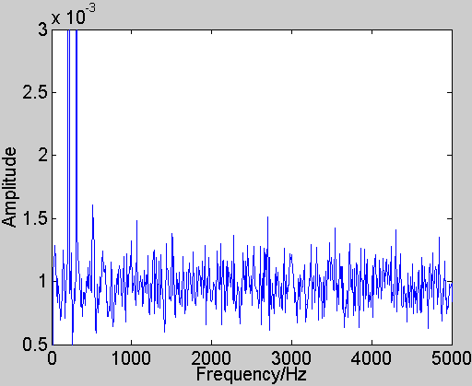  (a) The conventional PSD normalized spectrum. | 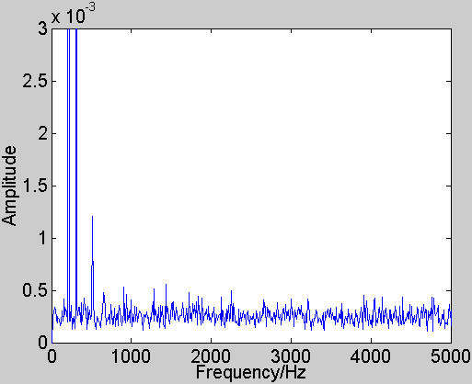  (b) The SFFT normalized spectrum.
Figure 1. The comparison between conventional PSD and SFFT spectrum of simulation signal.
Utilizing SFFT, we deal with the BPSK (Binary Phase-Shifted Key) signal widely used in radar and communication. The sampling frequency is 100 MHz. In practice, the accurate carrier frequency is unknown, but some imprecise information is known. Subtract the mean value and then square BPSK signal; we can get the standard sine signal theoretically. Error-code will occur for sampling and signal-to-noise ratio (SNR) will be deteriorated for square, so general methods are incapable to detect the signal. Take 32768 (=1024×32) data without overlapping, namely N=1024 and M=32. As illustrated in Figure 2(a), the trajectory changes gently in entire frequency range and there is not very obvious peak. However, a peak is very obvious with respect to frequency about 35MHz, as shown in Figure 2(b).

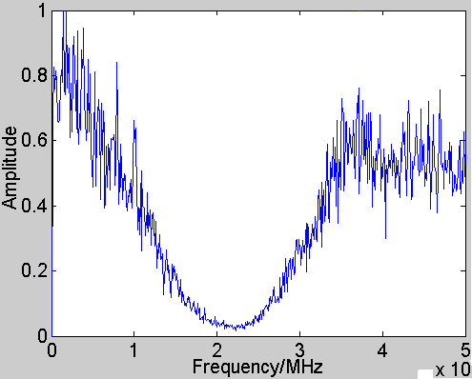  (a) The conventional PSD normalized spectrum. | 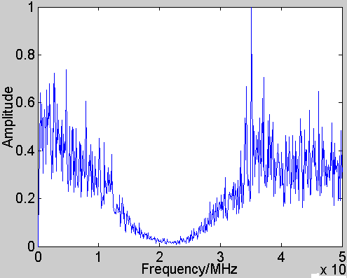  (b) The SFFT normalized spectrum.
Figure 2. The comparison between the conventional PSD and SFFT spectrum of BPSK signal.

After lots of tests, it is demonstrated that SFFT is more efficient than conventional PSD analysis on weak periodic signal detection in the same condition. Furthermore, performing a DFT on complex data is a well-known technique and the additional DFT will not increase the cost of hardware. However, the parameter N is limited to be small, for example, N=1024, due to the algorithm of DFT. So the frequency resolution, defined as F_{s}/N (F_{s} is the sampling frequency), is bigger and the frequency of weak periodic signal cannot be estimated accurately. As shown in Figure 1(b) and 2(b), we can only get the approximate frequencies of 200Hz, 300Hz, 500Hz and 35MHz.

3 Principle and Implement of Weak Periodic Signal Detection Using Chaotic Oscillator

Generally, for a nonlinear dynamic system, a small perturbation of system parameters may lead to the essential change of system state. Many methods utilizing the sensitivity to system parameters were put forward to detect weak periodic signal [4,5].

3.1 Principle
In this paper, the Holmes Duffing equation is chosen because it is one of the classic nonlinear systems and its characters have been studied extensively [6,7]. After introduction of the noise, the to-be-detected weak periodic signal and some transformations in time scale, the Holmes Duffing equation suit for any ω₀ is
$\begin{aligned}\left\{\overset{˙}{x}=ω_{0}y | \right.\left\{\overset{˙}{y}=ω_{0}(−\text{cy}+x−x^{3}+F_{0}⋅\text{cos}(ω_{0}t) | \right.\end{aligned}$(8)
where c is a damping constant; F₀∙cos(ω₀t) is a periodic driving force in oscillator; F₁∙cos(ω₁t+ψ) is the to-be-detected periodic signal. Here, (F₁cos(ω₁t+ψ)+N(t)) is named external perturbation.
If fix c, as F₀ varies gradually from zero to one threshold F_{a}, and then exceeds another threshold F_{b}, the oscillator state will vary from the small-scale periodic motion to the chaotic motion, and, at last, to the large-scale periodic motion in phase space. Discretize equation (8) and solve it using fourth-order Runge-Kutta algorithm. We chose iteration step h of 0.01s, total time of 50s, x₀=0 and y₀=0 convenient for investigating the state transformation of the Duffing oscillator as shown in Figure 3.

We can use the character of the phase plane trajectory of Duffing oscillator varying with F₀. Set ω₀ equal to the known frequency of the to-be-detected periodic signal and F₀ less than F_{b} slightly. The original state of oscillator is chaotic motion. When the periodic signal with the same frequency, namely ω₁=ω₀, is introduced, as long as F₀+F₁>F_{b}, even if F₁ is very small, the state transformation of the Duffing oscillator, from the chaotic motion to the large-scale periodic motion, will occur. By identifying the transformation, whether the periodic signal with frequency of ω₀ is present or not can be confirmed.
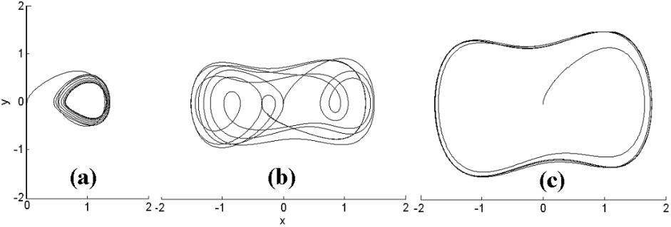
Figure 3. ω₀=1rad/s, c=0.5. (a) F₀=0.3 the small-scale periodic motion. (b) F₀=0.6 the chaotic motion. (c) F₀=0.9 the large-scale periodic motion.
The threshold of Duffing oscillator can be obtained by Melnikov arithmetic [6,8] combined with experiments. As h=0.01 and ω₀=1rad/s, F_{b}≈0.820. Set F₀=0.815, F₁=0, and then add Gaussian white noise with mean of 0, variance of 0.5 and mean of 0, variance of 1 respectively. The corresponding phase plane trajectories are shown in Figure 4(a) and 4(b). Set F₁=0.01, ω₁=1rad/s, and then add Gaussian white noise with mean of 0 and variance of 1. The corresponding phase plane trajectory is shown in Figure 4(c). The phase plane trajectory fluctuates for being affected by noise, but the state of oscillator doesn’t change. It is concluded that Duffing oscillator takes on some immunity to noise and strong sensitivity to some weak periodic signal.

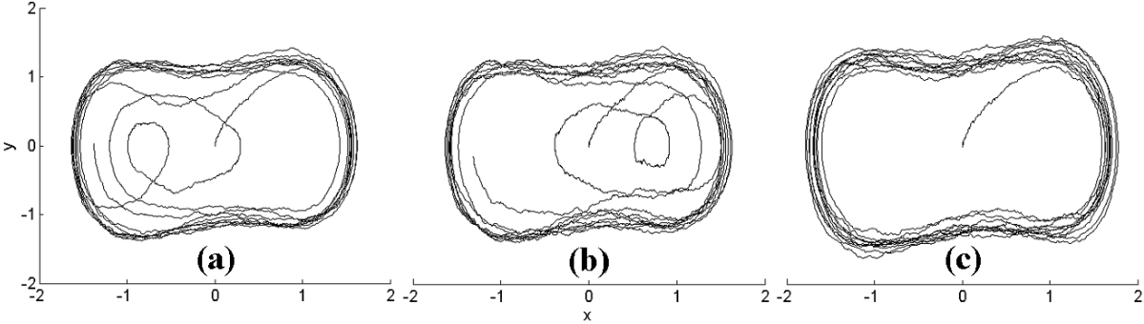
Figure 4. F₀=0.815, Duffing oscillator takes on some immunity to noise and strong sensitivity to some weak periodic signal. (a) σ²=0.5, F₁=0, (b) σ²=1, F₁=0 (c) σ²=1, F₁=0.01

3.2 Intermittent Chaotic Motion
The situation when |∆ω|=|ω₁-ω₀|=0, is analyzed above. Next, the situation with |∆ω|≠0 is analyzed.
$$\begin{aligned}F(t)=F_{0}⋅\text{cos}(ω_{0}t)+F_{1}⋅\text{cos}(ω_{1}t+ψ) \\ =F_{0}⋅\text{cos}(ω_{0}t)+F_{1}⋅\text{cos}((ω_{0}+Δω)t+ψ)\end{aligned}$$
$F(t)=F_{\text{CO}}(t)⋅θ(t)$ (9)
$F_{\text{CO}}(t)=\sqrt{F_{0}^{2}+F_{1}^{2}+2F_{0}F_{1}\text{cos}(Δωt+ψ)}$(10)
$θ(t)=\text{arctg}\frac{F_{1}\text{sin}(Δωt+ψ)}{F_{0}+F_{1}\text{cos}(Δωt+ψ)}$ (11)
From equation (10), the total force F_{CO}(t) will vary with ∆ω and become a time function. As F₀+F₁>F_{b}>F₀-F₁, F_{CO}(t) will be periodically more than or less than F_{b} with time. And then the periodic and chaotic motion of Duffing oscillator will happen alternately, namely intermittent chaotic motion. The period of alternate transform is just T₁=2π/∆ω. Assuming N(t)=0, ω₀=1rad/s, F₀=0.815, F₁=0.02, set |∆ω|=0.01, |∆ω|=0.03, |∆ω|=0.04 and |∆ω|=0.05 respectively, and the corresponding waveforms of oscillator's output in time domain are shown in Figure 5. When ∆ω is very small, as shown in Figure 5 (a) and (b), theoretically T₁ is about 628s or 209s and F_{CO}(t) varies more slowly than the state transformation, so the boundary between the chaotic and periodic motion is obvious and easy to be identified. However, when ∆ω is relatively big, as shown in Figure 5 (c) and (d), theoretically T₁ is about 157s or 126s and F_{CO}(t) varies relatively more quickly, so the boundary is not very obvious and hard to be identified. Therefore intermittent chaotic motion is limited by ∆ω. It's presented that |∆ω|≤0.03ω₀ is the range in which obvious intermittent chaotic motion happens [5].
Through the analysis and test above, we conclude that there is a serious limitation in weak periodic signal detection utilizing chaotic oscillator. The oscillator can only detect the periodic signal whose frequency is equal to inner periodic driving force or the frequency difference between them is in a small range. A parallel detecting array is presented to solve this problem in [5]. The detecting array is composed of 79 chaotic oscillators and the corresponding ω₀ is set from 1rad/s to 10rad/s with common ration of 1.03. When a signal is to be detected, transfer the frequency of signal into frequency range 1~10rad/s at first. And then introduce the signal to the detecting array. At last, the frequency of to-be-detected signal can be detected by identifying intermittent chaotic motion. However, when the frequency of to-be-detected signal is unknown, the scan of frequency is blindfold; any external perturbation will lead to false result and violent noise will weaken the detection ability. Furthermore, from Figure 5, hundreds, even thousands of seconds are needed to confirm the period of intermittent chaotic motion. It is slow and not suitable for quick detection. Furthermore, lots of elements are needed to construct 79 chaotic oscillators in hardware realization. The detection array needs great expense of hardware and its structure is complicated. The advantage of chaotic oscillator, easy to be realized with high speed in hardware, is missing.

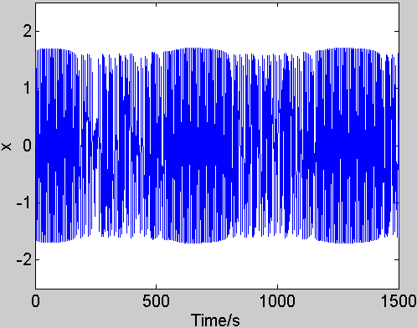  (a) | ∆ω|=0.01 | 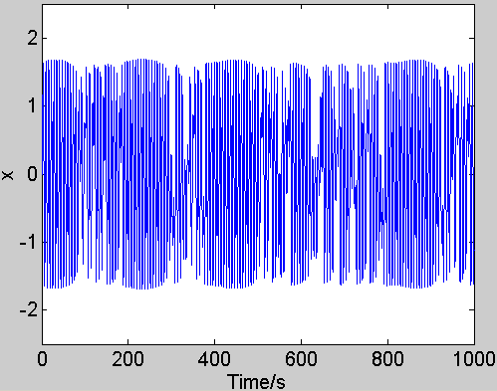  (b) |∆ω|=0.03
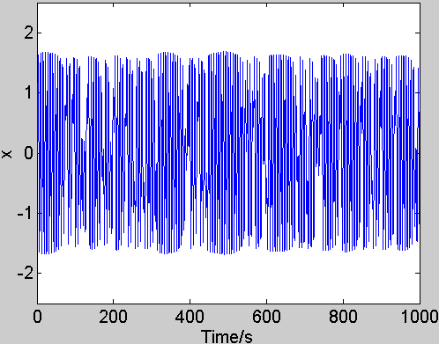  (c) |∆ω|=0.04 | 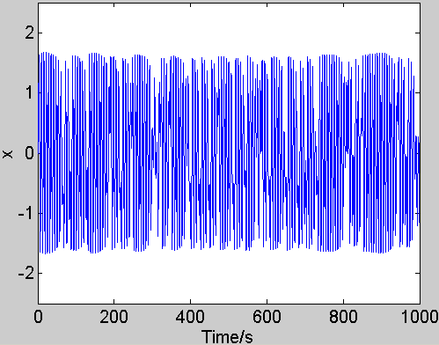  (d) |∆ω|=0.05
Figure 5. The plots of intermittent chaotic motion.

4 Integration of SFFT and Chaotic Oscillator

To overcome the low frequency resolution of SFFT and utilize the property of intermittent chaotic motion, we present a new method based-on the integration of SFFT and the chaotic oscillator to detect weak periodic signals. First we use SFFT to find out all relatively obvious peaks in SFFT spectrum and estimate all frequency components associated with those peaks, and then set ±5% range of every estimated frequency to be the estimated frequency band and scan the frequency using a small array of Duffing oscillator in the frequency band. By this means, the accurate frequency can be obtained using only 5 chaotic oscillators.

4.1 Calculating Steps
(1). According to the number of relatively outstanding peaks in SFFT spectrum, record the estimated frequency values corresponding to the peaks. Get f_{e}=(f_{e1}, f_{e2}, f_{e3}, …), or ω_{e}=2π/ f_{e}.
(2). According to the sampling frequency and f_{e1}, adjust the playing speed of signal and interpolating or exampling the signal, then get a new sampling frequency f_{SN} and the post-treatment signal.
(3). According to f_{SN}, iteration step h and the new estimated frequency f′_{e1} are obtained.
(4). Let the post-treatment signal pass a band-pass filter with a ±10%f′_{e1} band in order to eliminate the disturbance of other frequency components.
(5). Take Ω=(0.95,0.975,1,1.025,1.05) ω′_{e1} into equation (8) respectively to replace ω₀, and get five equations. Get threshold F_{b} according to f_{SN} and iteration step h, and then set F₀≤F_{b}.
(6). Replace (F₁cos(ω₁t+ψ)+N(t)) in above five equations respectively with post-treatment signal.
(7). By identifying the oscillator's output waveforms in time domain, the period of intermittent chaotic motion of every equation, and the four frequency difference, ∆f_{e1}, ∆f_{e2}, ∆f_{e4} and ∆f_{e5} are obtained. Take them into equation (12), and then the practical frequency f_{r1} of to-be-detected signal is obtained.
$\begin{aligned}f_{r1}=c_{\text{orf}}×((0\text{.}\text{95}f_{e1}^{'}+{Δf}_{e1})+(0\text{.}\text{975}f_{e1}^{'}+{Δf}_{e2}) \\ +(1\text{.}\text{025}f_{e1}^{'}+{Δf}_{e4})+(1\text{.}\text{05}f_{e1}^{'}+{Δf}_{e5}))/4\end{aligned}$(12)
where c_{orf} is the frequency correction constant and relative to the playing speed and sampling frequency.
(8). Take ω_{e2} or f_{e2} and repeat step 2 to step 7, till all estimated frequencies have been worked out.

4.2 Application
Assuming the structure of simulation signal described in equation (7) is unknown. From Figure 1(b), we can see three obvious peaks, so the simulation signal is at least composed of three periodic signals and the corresponding frequencies are f_{e1}=200Hz, f_{e2}=300Hz, f_{e3}=500Hz. According to the estimated frequency f_{e1} and the sampling frequency of 10240Hz, we chose the playing speed of 1000Hz, so the iteration step h is 0.001s and c_{orf} is 10.24. Accordingly, the frequency 200Hz is adjusted to 19.53Hz. 19.53Hz is set as the centre of the estimated frequency band, and then 18.55Hz, 19.04Hz, 20.02Hz and 20.51Hz are other four frequencies. Take the five frequencies into equation (8) respectively, and get five equations. As mentioned above in step 6, we get Figure 6. As shown in Figure 6, intermittent chaotic motion happened in four oscillators. According to the adjacent degree between the frequency of the to-be-detected signal and the inner periodic driving force, the periods of intermittent chaotic motion in the four oscillators are different slightly. After calculating, ∆f_{e1}≈0.990Hz, ∆f_{e2}≈0.501Hz, ∆f_{e4}≈−0.472Hz and ∆f_{e5}≈−1.010Hz. From equation (12), f_{r1}=200.08Hz. Also f_{r2}=300.52Hz and f_{r3}=500.01Hz. It can be seen that error between the practical frequency and the frequency calculated from this method is extraordinarily tiny.

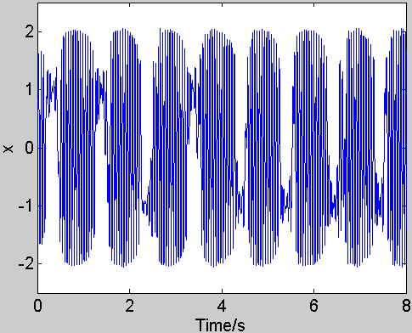  (a) ω₀=18.55Hz | 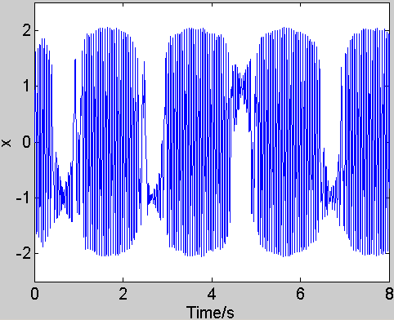  (b) ω₀=19.04Hz
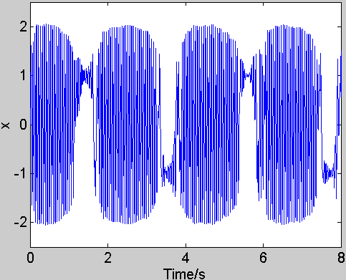  (d) ω₀=20.02Hz | 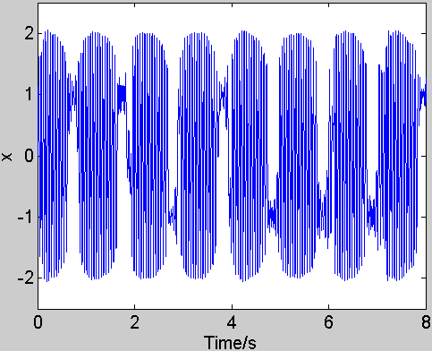  (e) ω₀=20.51 Hz
Figure 6. The time domain waveforms of the four intermittent chaotic motions when simulation signal is introduced to the four Duffing oscillators respectively.

From Figure 2(b), the BPSK signal in section 2 is a single-frequency signal and the frequency is estimated about 35MHz, namely f_{e}=35MHz. According to sampling frequency of 100MHz and f_{e}, after pre-treating the signal, the iteration step h=0.0005 and the centre estimated frequency is 175Hz, other four frequencies are 166.25Hz, 170.63Hz, 179.38Hz and 183.75Hz. As mentioned above, the result is shown in Figure 7. Intermittent chaotic motions are not obvious and the corresponding periods are fluctuating for noise, so we adopt averaging method to get the periods of intermittent chaotic motion. After calculating, ∆f_{e1}≈8.68Hz, ∆f_{e2}≈4.86Hz, ∆f_{e4}≈−5.42Hz and ∆f_{e5}≈−9.03Hz. From above, f_{r}=34.955MHz with c_{orf}=200000.

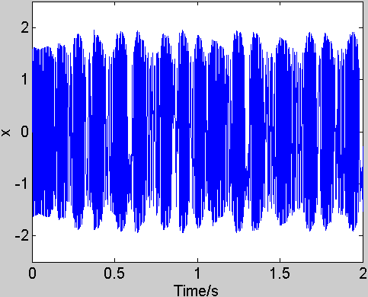  (a) ω₀=166.25Hz | 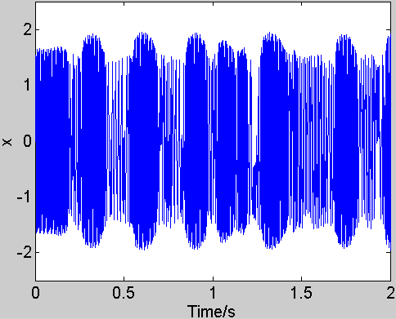  (b) ω₀=170.63Hz
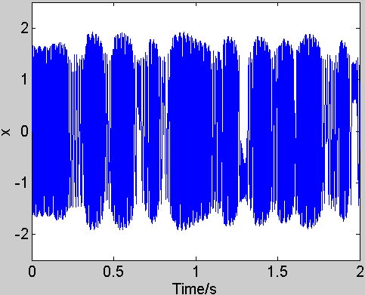  (c) ω₀=179.38Hz | 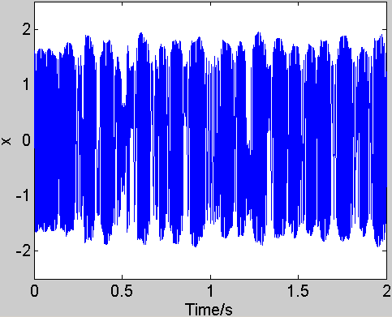  (d) ω₀=183.75Hz
Figure 7. The waveforms of the oscillator's output as BPSK signal introduced respectively.

The detection ability of weak periodic signals to be detected and frequency resolution are improved by means of SFFT and the chaotic oscillator. From figure 6 and figure 7, it is concluded that the larger the frequency of to-be-detected signal, the shorter the time required by calculation and the higher the detection speed. But this requires more powerful detection ability of chaotic oscillator. So we should choose the iteration step h and the threshold F_{b} according to the practical condition reasonably.

5 Conclusion

The method of integrating SFFT and chaotic oscillator presented in this paper is an integrated application of time domain and frequency domain method. SFFT is mostly used to estimate the frequency of the weak periodic signal approximately and the chaotic oscillator is used to decide the frequency accurately. Since a chaotic oscillator is composed of adder, integrator, gain element and sine signal generator, the detection system based on the chaotic oscillator is easy to be realized in circuits. This method improves not only the detection ability but also the frequency resolution of weak periodic signals, and the cost of detection system is not high and the method is easy in hardware realization and instrument design.

Correspondence to:
Chongsheng Li
Research Institute of Diagnostics and Cybernetics
School of Mechanical Engineering
Xian Jiaotong University
Xian, Shaanxi 710049, China
E-mail: cslee@mail.xjtu.edu.cn

References
- Alan V. Oppenheim, Alans S. Willsky, Iant T. Young, Signals and Systems, Prentice-Hall, Inc., Englewood Cliffs, New Jersey, 1983.
- Marshall Space Flight Center, Alabama, Acoustic-Emission-Analysis System for Diagnosis of Machinery, http://www.nasatech.com/Briefs/Aug00/MFS31468.html.
- Marshall Space Flight Center, Alabama, Coherent Phase Line Enhancer: a Method of Spectral Analysis, http://www.nasatech.com/Briefs/July01/MFS31426.html.
- Donald L. Birx. Chaotic Oscillators and Complex Mapping Feed Forward Networks (CMFFNS) For Signal Detection in Noisy Environments, IEEE International Joint Conference on Neural Network 1992;2:881~8.
- GuanyuWang, Dajun Chen, Jianya Lin, Xing Chen. The Application of Chaotic Oscillators to Weak Signal Detection, IEEE Transactions on Industrial Electronics 1999;46(2):440~4.
- John Guckenheimer, Philip Holmes. Nonlinear oscillations, Dynamical Systems, and Bifurcations of Vector Fields, Springer-Verlag, New York, 1983:82~91.
- Kapitaniak, Tomasz. Chaos for Engineers: Theory, Application, and Control, Springer-Verlag, Berlin Heidelberg 2000:69~85.
- Liu Zengrong, Perturbation Criteria For Chaos, Shanghai Scientific and Technology Education Publishing House, Shanghai, China, 1994:36~67.

