Application of Geographic Information Systems to produce descriptive maps for Poultry Farms in Egypt

Hassanein M. K., M. A. A. Abdrabbo, A. A. Farag, S.M. Abolmaaty and A. A. Khalil

Central Laboratory for Agricultural Climate (CLAC), Agricultural Research Center (ARC), Ministry of Agriculture and Land Reclamation, Egypt

Abstract: Geographic Information Systems (GIS) are ideal tool to use for making informed decision makers related to the expansion of poultry enterprises. The goal of this study is to develop and evaluate spatial analysis tools as a Decision Support System (DSS) implemented in a GIS environment for making informed decisions maker the expansion of poultry enterprises in Sharqia governorate, and all over Egypt. Sharqia governorate has thirteen geographic districts counties, all of them were involved, in this study survey aimed all poultry farms. Licensed and unlicensed farms, infected and non-infected farms by bird flu disease and evaluations Geographic Information Systems (GIS) tools in planning the potential expansion of poultry farms was applied. The result indicates that Al Husaineya county has the highest total number of poultry farms 960 and Al Ebrahemeyah county has the lowest total number of poultry farms 73. For licensed farms, Zaqaziq county has the highest total number of licensed farms 520 and Awlad Saqr county has the lowest total number of licensed farms 19 and for unlicensed farms, Al Husaineya county has the highest total number of unlicensed farms 860 and Al Ebrahemeyah county has the lowest total number of unlicensed farms 25. For infected farms by bird flu disease, Zaqaziq county has the highest total number of infected farms with bird flu disease181 and Al Ebrahemeyah county has only one infected farm with bird flu disease. The present paper is a step towards finding a common methodology to identify the vulnerable area of infectious disease using GIS.
[Hassanein M. K., M. A. A. Abdrabbo, A. A. Farag, S.M. Abolmaaty and A. A. Khalil. Application of Geographic Information Systems to produce descriptive maps for Poultry Farms in Egypt) Nature and Science 2012;10(3):43-48]. (ISSN: 1545-0740). http://www.sciencpub.net. 7

Key words: Poultry farms, GPS, Maps, Infected and non-infected, infected, Licensed and unlicensed and Bird flu.

1. Introduction
Geographical Information System (GIS) can be used as a tool for any discipline which handles data that can be connected with geographical locations, such as countries, regions, communities, or coordinates. The systems are developed rapidly during the past decade there is a number of different software which is more user-friendly than in the past. The need for using this system also in the field of veterinary medicine has been emerging during the last decade. A geographic information system (GIS) is a computer-based system with the ability to accept, store, manipulate, analyze, and display geographic information (Hay, 2000), including information on specific locations (spatial data), maps (geographic coverage), and attributes (descriptive data of the area) in the form of a relational database associated with the mapped features (Kitron, 1998).
In 1994 Sanson et al. described the systems and possible applications in the field of veterinary medicine. Still, the most used application of GIS is to produce descriptive maps. However, the potential of GIS is much larger. Reviews in the field of environment and human health (Briggs & Elliot 1995), and in the field of animal health (Sharma 1994) have been undertaken. GIS has been included in decision support systems for control of infectious diseases in animals (Laube et al, 1997). Information management will become an important factor in monitoring livestock movements and improving animal production practices. Animal production systems are inherently spatial. The physical and biological heterogeneity of animal agriculture creates spatial patterns that can be used to characterize the production systems. These patterns are dynamic and may be altered drastically by changes in various environmental factors such as livestock and land management practices; incidence of disease; and residential encroachment into agricultural land. Combining agricultural, animal health and environmental data in a GIS can provide insights that lead to enhanced animal health and productivity, environmental quality, and public health. The highly integrated business structure and intensity of production of the United States poultry industry present some unique challenges for disease surveillance, outbreak control, and emergency management, particularly in the Del-marva Peninsula where the density of poultry operations is high and the protection of environmentally sensitive ecosystems is of vital concern (Johnson et al, 2000). In an area with such a high density of poultry operations, the effects of an outbreak of infectious disease could be devastating unless control efforts are immediate and effective. Worldwide, GISs are becoming an increasingly integral component of disease management in animal agriculture (McGinn et al, 1996, and Nath et al, 2000). Despite increasing interest in these tools within the poultry industry, the current literature indicates that limited progress has been made toward the widespread development and application of GIS databases as tools for enhancing commercial poultry health and productivity. Sharqia governorate has the first largest poultry production area in Egypt (Agriculture statistics, 2009). This paper will attempt to present the technology and possibilities of GIS with regard to surveillance and monitoring of poultry farms, and will discuss some applications of GIS in the field of poultry farms in Sharqia governorate. The objective of this paper is to describe the processes used to develop a GIS database of the poultry farms on the Sharqia governorate.

2. Materials and Methods
The study survey data for poultry farms conducted during 2009 and a detailed database was developed for poultry farms operations in 13 county, in Sharqia governorate (Al Husaineya, Awlaad Saqr, Faqous, Kafr Saqr, Abu Kabeer, Hehya, Al Ebrahemeyah, Deyarb Najm, Abou Hammaad, Zaqaziq, Belbeis, Menya Al Qamh and Mashtol Elsok) (Fig 1).

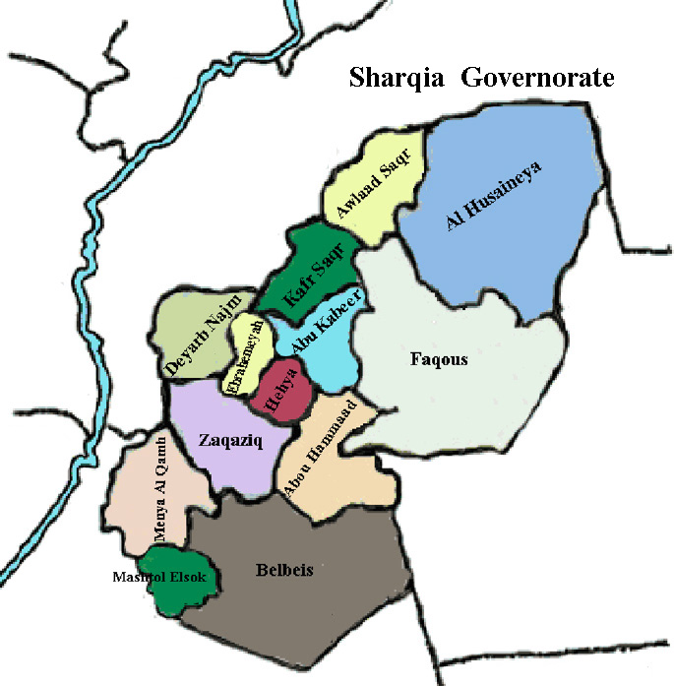

Figure 1: Distribution county map for Sharqia governorate.

The aim of this field survey was producing and a database connected to digital maps for the poultry farms in each county in Sharqia governorate. Licensed and unlicensed farms and infected and non-infected farms with bird flu disease were included in this study by conducting field visits to each farm to collect geographic and demographic information. The study consisted team of data collectors from the Sharqia governorate and the follow up team mapped operation from Central laboratory for Agriculture Climate, Agricultural Research Center. Questionnaires on farms contact information and demographics were completed by data collector farm owner/managers. The coordinate (longitude and latitude) of poultry farms location was recorded with global positioning system (GPS) unit. Data were collected and revised by follow up team and entered into GIS software. Arc GIS 9.1 software was used to build the Poultry database.

3. Results
  - Number of Poultry farms
Al Husaineya county has the highest number of poultry farms (960 farms) (Fig2) and Al Ebrahemeyah county has the lowest number of poultry farms (73 farms) (Fig3) in comparison with other counties. (Fig4) Show the total number of poultry farms in Sharqia governorate.

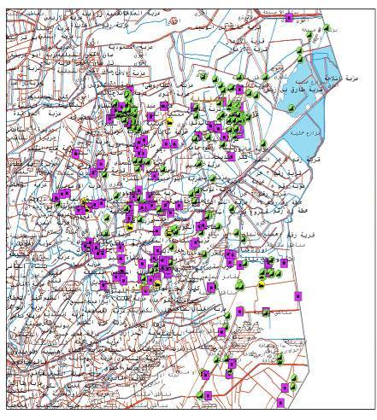
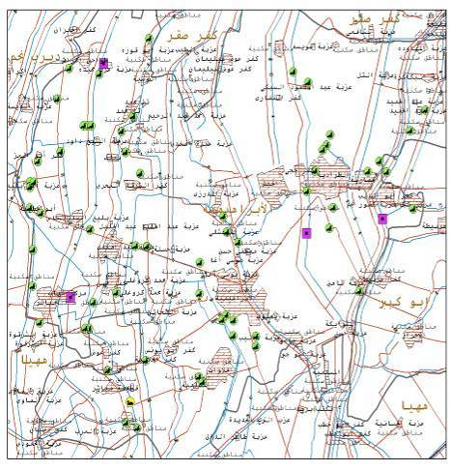

Closed farms
Poultry farms
Duck farms

Figure 3: Distribution of poultry farms in Al Ebrahemeyah
Figure 2: Distribution of poultry farms in Al Husaineya

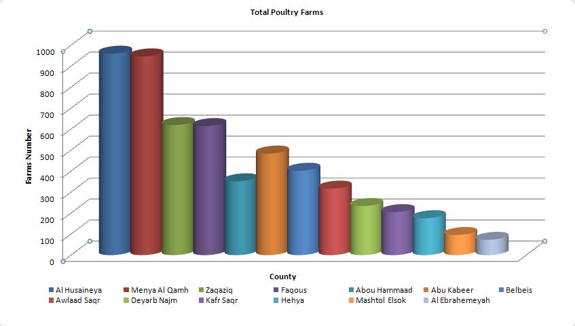

Figure 4: Total of poultry farms in Sharqia governorate

  - Number of licensed and unlicensed farms
Zaqaziq county has the highest number of licensed farms (520) from (620) farms (Fig5) and Al Ebrahemeyah county has the lowest number of licensed farms (1 farm) from (73) farms (Fig6) in comparison with other counties.
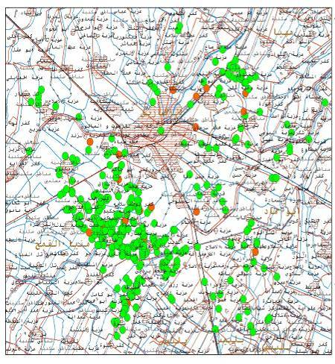
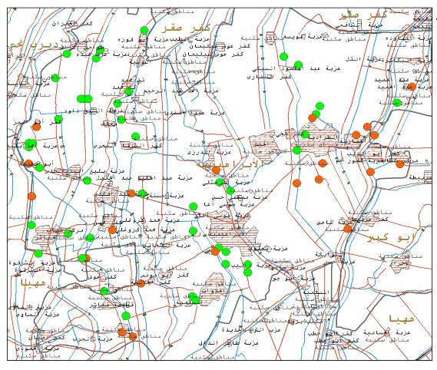
Al Husaineya county has the highest number of unlicensed farms (860 farms) from (960) (Fig7) and Mashtol Elsok county recorded the lowest number of unlicensed farms (40 farms) from (96) farms (Fig8) in comparison with other counties.

Unlicensed farms
Licensed farms
Figure 6: Distribution of licensed and unlicensed farms in Al Ebrahemeyah
Figure 5: Distribution of licensed and unlicensed farms in Zaqaziq

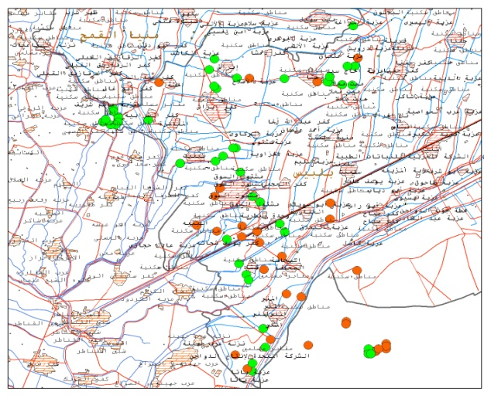
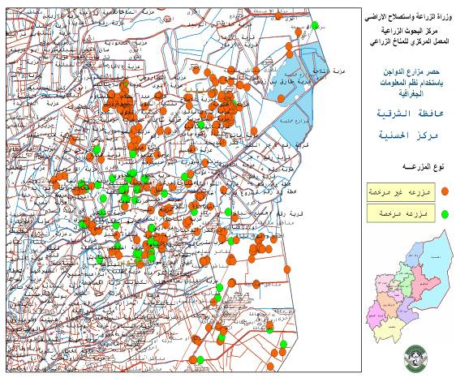

Unlicensed farms
Licensed farms

Figure 7: Distribution of licensed and unlicensed farms in Al Husaineya
Figure 8: Distribution of licensed and unlicensed farms in Mashtol Elsok

  - Number of infected and non-infected farms with bird flu disease
Zaqaziq county has the highest number of infected farms with bird flu disease (181 farms) (Fig9) and Al Ebrahemeyah county has the lowest number of infected farms with bird flu disease farms (1 farm) (Fig10) in comparison
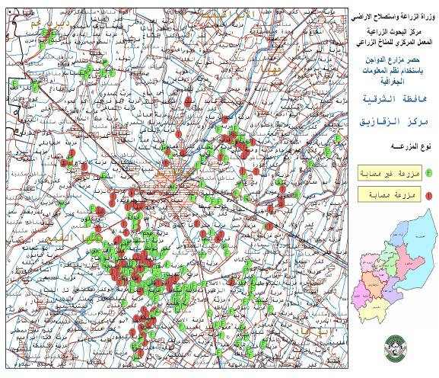
Non-infected farms
Infected farms

Figure 10: Distribution of infected and non-infected farms with bird flu disease in
Al Ebrahemeyah
Figure 9: Distribution of infected and non-infected farms with bird flu disease in Zaqaziq

  - Farms activity
Table (1) indicates the farms activity of each county. Highest number of broilers farms was in Menya Al Qamh county was 698 farms and the lowest number was 67 farms was in Al Ebrahemeyah and Mashtol Elsok counties in comparison with other counties. Faqous county has the highest number of ducks farms and the lowest number of ducks farms was in Awlaad Saqr county in comparison with other counties and there is no any ducks farms in Deyarb Najm county. Two goose farms were found in Abou Hammaad county, two ostriches farms in Belbeis county and two pigeons farms one of them in Zaqaziq county and another in Abu Kabeer county, were found. Turkeys farms were found only in Belbeis county (23 farms) and Menya Al Qamh county (2 farms). Some of farms were closed because infection with bird flu disease, the highest number of closed farms was in Al Husaineya county (412 farms) and the lowest number of closed farms was in Hehya county.

with other counties. Menya Al Qamh has the highest number of non-infected farms (686 farms) and Mashtol Elsok county has the lowest number of non-infected farms with bird flu disease (63 farms) in comparison with other counties.

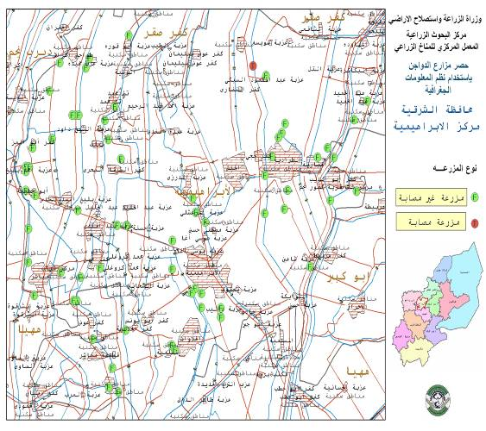

Total number of broilers farms in all counties were 3889 farms and of ducks farms were 232, two farms of (goose, ostriches and pigeons), and
25 farms of Turkeys farms. The total number of closed farms was 1329 farms.

4. Conclusions
Geographic Information Systems (GIS) is an effective tool to monitor and control the various infectious diseases. A number of papers discuss the applications of GIS in controlling, monitoring, and surveillance of infectious diseases. However, no research covers a wide number of contagious diseases with a common methodology with special treatment to a disease with respect to GIS application. The present paper is a step towards to find a common methodology to identify the vulnerable area of infectious disease using GIS. However, in some cases the method may not be very effective due to the need of high accurate data.

Table (1): Activity of poultry farms in the counties of Sharqia
Phased out  Farms | Turkeys Farms | Pigeons Farms | Ostriches Farms | Goose Farms | Ducks Farms | Broilers Farms | The county
4 | 0 | 0 | 0 | 0 | 2 | 67 | Al Ebrahemeyah
25 | 0 | 0 | 0 | 0 | 4 | 67 | Mashtol Elsok
106 | 0 | 1 | 0 | 0 | 5 | 508 | Zaqaziq
2 | 0 | 0 | 0 | 0 | 4 | 170 | Hehya
70 | 0 | 0 | 0 | 0 | 30 | 105 | Kafr Saqr
42 | 0 | 0 | 0 | 0 | 0 | 192 | Deyarb Najm
31 | 0 | 0 | 0 | 0 | 1 | 285 | Awlaad Saqr
16 | 0 | 0 | 0 | 2 | 2 | 332 | Abou Hammaad
412 | 0 | 0 | 0 | 0 | 19 | 529 | Al Husaineya
136 | 23 | 0 | 2 | 0 | 11 | 230 | Belbeis
73 | 0 | 1 | 0 | 0 | 6 | 404 | Abu Kabeer
174 | 0 | 0 | 0 | 0 | 139 | 302 | Faqous
238 | 2 | 0 | 0 | 0 | 9 | 698 | Menya Al Qamh
1329 | 25 | 2 | 2 | 2 | 232 | 3889 | Total

5. Reference
- Agriculture Statistics, 2009, Livestok, Fish and Honey bees Production, Ministry of agriculture Egypt, section (8).
- Briggs DJ and Elliott P: The use of geographical information systems in studies on environment and health. World Health Statistics quarterly 1995, 48(2): 85-94.
- Hay, S. I. An overview of remote sensing and geodesy for epidemiology and public Health Application. In: Remote sensing and GIS in epidemiology. S. I. Hay, S. E. Randolph, and D. J. Rogers, eds. Academic Press, Oxford, United Kingdom, pp. 2—27. 2000.
- Kitron, U. Landscape ecology and epidemiology of vector-borne diseases: tools for spatial analysis. J. Med. Entomol. 35:435-445. 1998.
- Johnson, Y. J., M. M. Colby, N. L. Tablante, N. Gedamu, B. Gebert, and L. Wilson. Development and use of geographic information systems (GIS) in the investigation of poultry diseases. In: Proc. 35th National. Meeting on Poultry Health and Processing, Ocean City, MD. pp. 21-27. 2000.
- McGinn, T. J., P. Cowen, and D. W. Wray. Geographic information systems for animal health management and disease control. J. Am. Vet. Med. Assoc. 209:1917-1921. 1996.
- Nath, S. S., J. P. Bolte, L. G. Ross, and J. Aguilar-Manjarrez. Applications of geographicalinformation systems (GIS) for spatial decision sup-port in aquaculture. Aquacult. Eng. 23:233—278. 2000.
- Sanson RL, Ster MW and Morris RS: Interspread-A spatial stochastic simulation model of epidemicfoot-and-mouth disease. The Kenyan Veterinarian 1994, 18(2): 493-495.
- Sharma P: Use of geographic information systems in animal health information programs. ACIAR Proceedings in 1994 51, 119-125.
- Laube P, Stärk KDC and Keller H: A GIS-based computer program for the region-wide eradication of Enzootic Pneumonia (EP). Proceedings of the 8th International symposium on veterinary epidemiology and economics in Paris in 1997, published in Epidemiologie et sante animale.1997: 31-32, 12.13.1-12.13.2.

