Production And Characterisation Of Keratinase By Fungi Isolated From Soil Samples At Gwagwalada, FCT – Abuja, Nigeria

Ugoh, Sylvanus Chukwudi and Ijigbade, Bamidele

Department of Biological Sciences, University of Abuja, P.M.B. 117, Abuja-Nigeria.
Email: sylvaugoh@hotmail.com

Abstract: Fifty soil samples were collected from refuse dumps, animal sheds, farm lands, drainage sites and barbers’ shops at Gwagwalada, FCT-Abuja and screened for the presence of keratinase- producing fungi by Hair Bait Technique using chicken feather as keratin bait. A total of 51 fungal isolates belonging to two genera and four species of keratinase- producing fungi were observed. Sixteen (31.37 %) of the isolates were from refuse dumps, animal sheds and barbers’ shops, both have 11 (21.57 %) isolates each, while farmlands and drainage sites have 10 (19.61 %) and 3 (5.88 %) isolates respectively. Aspergillus niger (van Teigh) 17 (33.33 %) was the most abundant species, followed by Penicillium chrysogenum (Thom) 13 (25.49 %), Aspergillus flavus (Link ex Fr.) 12 (23.53 %) and Penicillium marneffei (Hubert) 9 (17.65 %) being the least in abundance. The highest keratinase activities were recorded in Aspergillus niger (14.56±1.54 Keratinase unit (Ku)/ml), Penicillium marneffei (13.18±2.19 ku/ml), Penicillium chrysogenum (12.56±2.75 ku/ml) and Aspergillus flavus (11.93±1.80 ku/ml). The rate of prevalence and the quantity of enzymes produced are significantly different (P = 0.05). These non-dermatophytic keratinolytic fungi have potential use in biotechnological processes involving keratin hydrolysis. The results of this work revealed that keratinolytic activity is relatively widespread among common fungi and may have an important role in keratin degradation in the natural environment.
[Ugoh, Sylvanus Chukwudi and Ijigbade, Bamidele. Production And Characterisation Of Keratinase By Fungi Isolated From Soil Samples At Gwagwalada, FCT – Abuja, Nigeria. Nat Sci 2013;11(10):1-7]. (ISSN: 1545-0740). http://www.sciencepub.net/nature. 1

Keywords: Keratinase, fungi, soil, enzymes, keratinase unit

Introduction
Soil Enzymes are usually offered as “cocktails” of several activities rather than a single enzymatic activity (Agarwal et al. 2008; Sakthi et al., 2012). However, in many cases the enzyme activities can still act on the same composition, as the composition can have a complex chemical structure having various types of chemical bonds, requiring different enzyme activities for breakdown. Microbial soil Enzymes have become big business, with a wide range of industries using commercial enzymes, in addition to the feed industry. Today enzyme technology mostly depends on microbes like bacteria, fungi and actinomycetes. Fungi in particular have been regarded as treasure of useful enzymes. There is a great variation between various genera as to their ability to produce a specific enzyme the production of particular enzyme varies with the particular medium and pH (Akpan et al., 2009). In recent years the potential of using microorganisms as biotechnological sources of industrially relevant enzymes has stimulated interest in the exploration of extracellular enzymatic activity in several microorganisms (Pandey et al., 2000 ; Abu et al., 2005). Many fungi had been found to be good source of keratinase. Mukhopadhay et al. (1989) reported keratinase production by Streptomyces sp. He isolated an inducible extracellular homogenous enzyme, which shows 7.5 fold increases in its activity after DEAE cellulose column chromatography. The enzyme-activity was inhibited by reduced glutathione, PMSF and 2-Mercaptaethanol. Keratins are the widely distributed fibrous proteins of our environment found in epithelial cells of vertebrates and characterized by its high content of amino acids, especially cystine, arginine and serine. It is present in hair, feather, hooves, wool, horns, nail, stratum and cornium (Sharma and Prashar, 1997). A vast quantity of chicken are being utilized every day in the society that produces a large amount of feathers waste in poultry industries Keratin-consisting materials have always been plentiful in the nature but restricted in practical usages, mainly because of their insolubility and non-degradability by the ordinary proteolysis, the presence of the disulfide linkages, hydrophobic interactions, and hydrogen bonds, but however, are easily digested by alkali and keratinase enzymes, a group of proteinase enzymes that have high level of activity on insoluble environmental pollution, keratin (Onifade 1998; Fuchs, 1995). The keratineous materials in or on soil are attacked by these keratinophilic microbes, therefore biodegradation takes place.
Materials and Methods
Sterilization of Glassware
The sterilization of glass wares such as conical flasks, beaker and test tubes after washing with detergent was carried out in hot air oven at 160º C for 2 hours according to the procedure given by Harrigan and McCance (1976).
Sampling Site
Gwagwalada is one of the five municpal Councils of the Federal Capital Territory of Nigeria, together with Abaji, Kuje, Bwari, and Kwali; the FCT also includes the City of Abuja. Gwagwalada is also the name of the main town in the Local Government Area, which has an area of 1,043 km² and a population of 157,770 at the 2006 census (Awowole-Browne and Francis 2007). Gwagwalada is where the University of Abuja is located.
Samples collection
A total of fifty (50) soil samples were collected randomly with ten (10) samples each from five (5) different sites in Gwagwalada FCT-Abuja. Samples were collected from farm lands, animal sheds, refuse dumps, drainage sites and Barber’s shops (Sharma and Rajak 2003). At each location, 20 g of soil were collected from the superficial layer, at a depth of 10 cm. Soil samples were collected in the sterile polythene bags and brought to the laboratory of Microbiology Department, University of Abuja, for the isolation of keratinase producing fungi and analyzed on the day of collection (Adeniran and Abiose 2009; Amany et al., 2009; Ingle et al., 2012).
Collection and Sterilization of Chicken Feather
Chicken feather was purchased at the Gwagwalada market and taken to the laboratory of Microbiology Department, University of Abuja, for the isolation of keratinase producing fungi. Sterilization of the feather was done by soaking the feather for 24 hours in diethyl ether and later rinsed 5 times with distilled water and air dry (Sharma and Rajak 2003).
Preparation and sterilization of media
Sabraud’s Dextrose Agar was used in this study and prepared according to the manufacturer’s instructions thus, 65g of SDA was dissolved in 1000ml of sterile water and then sterilized (autoclaved) at 121ºC and pressure of 15Pa for 15 minutes (Beuchat, 1992). Saboraud’s Dexstrose agar was used for the isolation and maintainance of pure cultures of keratinolytic fungi (Sharma and Rajak 2003).
Isolation of keratinolytic fungi
Vanbreuseghem’s Hair bait technique as reported by Sharma and Rajak 2003 was used for the isolation of Keratinolytic fungi using chicken feather as keratin bait. Sterile Petri dishes was half filled with the soil samples. Short strand of about 2-3 cm long of sterilized chicken feather was spread over the surface of each soil sample and 5ml of sterile water was added to the soil to facilitate germination of fungal spores on the feather. The preparations were incubated at room temperature (20-25^{oC}) in the dark, for 4 weeks. The Plates were examined periodically for the development of mycelia.
Inoculation of Keratinolytic Fungi on Culture Media
The short strand of feather with fungus growth was remove with the aid of forceps and placed on the prepared Plate of Saboraud’s Dextrose agar supplemented with chloramphenicol (0.05mg/l) to inhibiting bacterial growth and incubated for 3-5 days (Kim 2003;Sharma and Rajak 2003; Soomro et al., 2007).
Preparation of Pure Cultures of Fungal Isolates
The young colonies of fungi were aseptically picked up and transferred to fresh sterile SDA Plates to obtain pure cultures. The pure cultures on SDA Plates were grown at 30ºC for 7 days and stored at 4ºC (Sharma and Rajak 2003). The isolate was sub-cultured for further studies.
Identification of keratinolytic fungal isolates
Isolates obtained were characterized and identified on the basis of their morphological assessment that is, macroscopic and microscopic features. Among the characteristics used were colonial characteristics such as size, surface appearance, texture and colour of the colonies (Sharma and Rajak 2003). In addition, microscopy revealed vegetative mycelium including presence or absence of cross-walls, diameter of hyphae, and types of asexual and sexual reproductive structures (Soomro et al., 2007). Slide culture method that minimized serious distortion of sporing structures was used. Appropriate references were then made using mycological identification keys and taxonomic description (Harrigan and McCance, 1976; Samson and Reenen-Hoekstra, 1988).
Viable spore count of Keratinolytic Fungal Isolates
The total viable spore number on a Sabdraud’s Dextrose Agar (SDA) slant was determined by colony count technique. The spores were suspended in 10ml of distilled water, using a sterile transfer needle and diluted serially up to 10¹⁰ cells/ml. One ml of spore suspension was poured onto sterile Petri-Plates, containing sterile SDA medium and spread uniformly. The inoculated Petri-Plates were incubated at 30⁰C for 48 hrs. A Plate that developed between 7 to 200 colonies was selected for counting. The spore density was calculated as the count multiplied by the dilution factor (Sakthi et al., 2012).
Determination of Keratinase potentiality by Feather Degradation
Feather degradation was assessed by measuring keratinase activity of isolated fungi according to Awasthi and Kushwaha, (2011). A basal medium which contained the following ingredients per litre of distilled water: Glucose – 2 gm, Peptone – 5 gm, Yeast – 5 gm, K₂HPO₄ – 1 gm, KH₂PO₄ – 3 gm, CaCl₂ – 1 gm, MgSO₄ – 1 gm and Feather - 200 mg per flask was prepared. The 250 ml Erlenmeyer flasks containing 50 ml of the basal medium and 200 mg of chicken feathers as a keratin substrate were autoclaved at 15 labs pressure for 10 minutes. The pH of the medium was adjusted to 6.0, 7.0, 8.0 and 9.0 respectively before sterilization. Spore suspension of the fungal isolates was prepared by adding 10 ml of sterilized water to 8 days old fungal isolates growing on Plates of potato dextrose agar. The final concentration of the spore suspension was adjusted to about 10⁶ mL⁻¹. The flasks were incubated at 30ºC and 40ºC respectively. All the experiments were carried out in triplicates.
Assay of Keratinase Enzyme
At the end of the growth period, the fungal mat and feather were separated from culture medium by filtering through whatman number 1filter paper. The culture filtrate from four test flasks was pooled, centrifuges at 4,000 rpm for 5 min and the supernatant was assayed for keratinase. keratinase was measured as per the method of Rammani and Gupta 2004. Keratnolytic products in the supernatant were determined by reading absorbance at 280 nm against basal medium using UV-Spectrophotometer (JENWAY 6305). An increase of 0.100 in the absorbance was considered as equivalent to 1 unit of KU (keratinase unit).
Statistical Analysis
Production and characterization of keratinase produced by fungi was analyzed, the mean difference was found through statistical procedure applying one way Analysis of Variance (ANOVA) from Ms Excel Statistics. Test applied was F-test statistic at p= 0.05.
RESULTS
Isolation rate of Keratinolytic Fungi
Isolation rate of keratinase-producing fungi from five soil samples at Gwagwalada include A. niger was higher in soil samples collected from the refuse arena and farm lands (Table 1).

Table 1: Isolation rate of keratinase producing fungi from soil sample at Gwagwalada FCT-Abuja
Keratinolytic and Isolation Rate, Number (%)
Amylolytic fungi F.L A.S B.S D.S R.D Total
(n=10) (n=10) (n=10) (n=10) (n=10) (n=50)
Aspergillus niger 4(40) 3(30) 2(20) 2(20) 6(60) 17(33.33)
Aspergillus flavus 3(30) 2(20) 4(40) 0(0) 3(30) 12(23.53)
Penicillium chrysogenum 1(10) 3(30) 3(30) 1(10) 5(50) 13(25.49)
Penicillium marneffei 2(20) 3(30) 2(20) 0(0) 2(20) 9(17.65)
Total 10(19.61) 11(21.57) 11(21.57) 3(5.88) 16(31.37) 51(100)
Keys: F.L=Farm land, A.S=Animal shed, B.S=Barber’s shop, D.S=Drainage Site, R.A=Refuse dumps and n=number of soil sample. Isolation Rate, Number (%)

Figure 1: Isolation rate of keratinase producing fungi from soil sample in Gwagwalada FCT-Abuja

Figure 2: Percentage of Isolation of keratinase producing fungi from soil sample in Gwagwalada FCT-Abuja

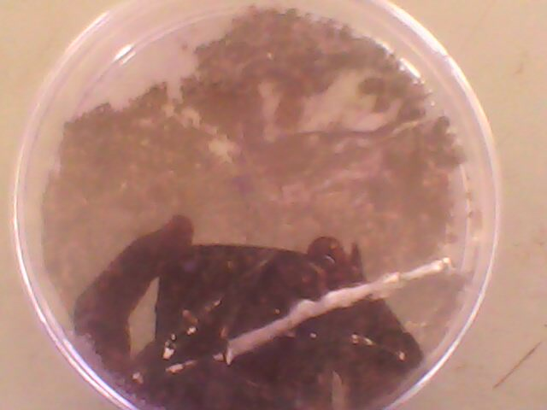
Plate 1: Growth of fungi on feather by ‘Hair Bait Technique’

IDENTIFICAION OF FUNGAL ISOLATES
The fungal strains were identified on the basis of colony morphology, cultural characters, slide culture, pigmentation and morphology of hyphae and their spores as Aspergillus niger, Aspergillus flavus, Penicillium chrysogenum and Penicillium marneffei (Plate 2, Plate 3 and Plate 4) as shown in Table 2.

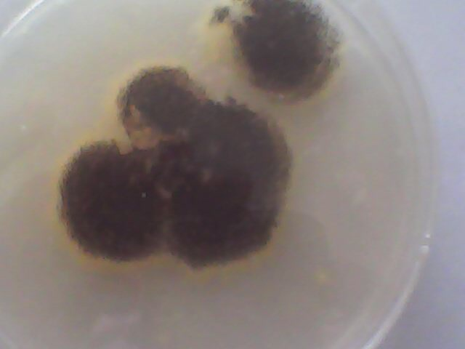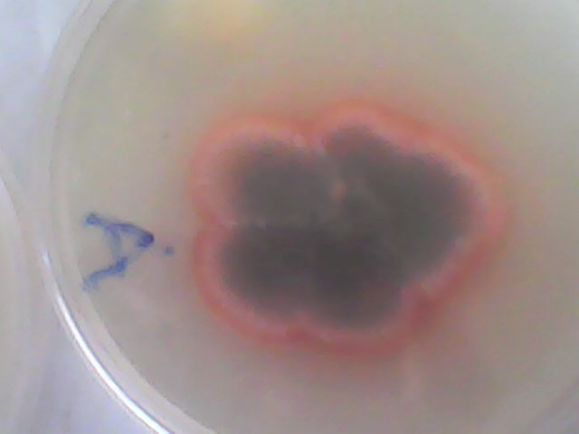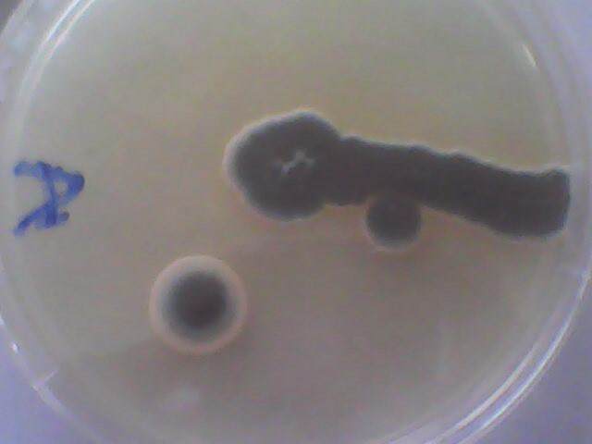
Pate2: Aspergillus niger Plate 3: Penicillium marneffei Plate 4: Penicillium chrysogenum

Keratinase fungal strains isolated was identified on the basis of colony morphology, cultural characters, slide culture, pigmentation, morphology of hyphae and their spores as Aspergillus flavus, Aspergillus niger, Penicillium marneffei and Penicillium chrysogenum respectively.

Characterization of Keratinolytic Fungi From Soil Sample in Gwagwalada FCT-Abuja
The keratinolytic activity of the crude enzyme of the fungal strains cultivated in basal medium as described in materials and methods. Keratinolytic activity of the culture filtrates (Crude enzyme) appeared after three days and reached its maximum after 7 days as shown in Table 2.

Table 2: Keratinase activities of some isolated fungi from soil sample in Gwagwalada FCT-Abuja.
Fungal species | Keratinase Activity  (KU/mL) | Optimum  PH | Optimum  temp(ºC) | Optimum  Time(days)
Aspergillus niger  Aspergillus flavus  Penicillium chrysogenum  Penicillium marneffei | 14.56±1.54  11.93±1.80  13.18±2.19  12.56±2.75 | 9  9  9  9 | 30  30  30  30 | 7  7  7  7

Figure 3: Keratinase activities of some isolated fungi from soil sample at Gwagwalada

DISCUSSIONS
The fungal strains having keratinolytic activity were isolated from soils from different sites at Gwagwalada. They include farmlands, refuse dumps, barber’s shops, drainage sites as well as animal sheds. The Hair Bait technique was used, using chicken feather as the keratin bait to screen the fungi for keratinolytic potential as shown in Plate 1. The keratinolytic fungal strains were identified on the basis of colony morphology, cultural characters, slide culture, pigmentation and morphology of hyphae and spores as Aspergillus niger, Aspergillus flavus, Penicillium chrysogenum and Penicillium marneffei (Plate 2, Plate 3 and Plate4 respectively) as shown in Table 2. It appears from this study that Aspergillus niger is the most prevalent keratinolytic fungus and also dominant species that was isolated from 17 soil samples (cover about 33.33%) of five different regions, followed by Penicillium chrysogenum (Thom) 13 (25.49 %), Aspergillus flavus (Link ex Fr.) 12 (23.53 %) and Penicillium marneffei (Hubert) 9 (17.65 %) being the least prevalent . Isolation rate of keratinolytic fungi including Aspergillus niger was higher in soil samples collected from the refuse arena and farm lands (Table 1 and Figure 1).
In order to determine the keratinolytic activity of the crude enzyme, the strains of fungi were cultivated in basal medium as described in materials and methods. Keratinolytic activity of the culture filtrates (Crude enzyme) appeared after three days and reached its maximum after 7 days and Aspergillus niger showed the highest keratinase activity (14.56±1.54Ku), followed by Penicillium chrysogenum (13.18±2.19), Penicillium marneffei (12.56±2.75) and the least was recorded for Aspergillus flavus (11.93±1.80) respectively as shown in Table 2 and Figure 2.
The production and characterization of keratinase enzyme by fungi that efficiently degrade feathers is interesting because these fungi play a significant role in the keratin degradation in natural setting. Among 4 filamentous fungi isolated from soil samples at Gwagwalada, 4 species belonging to two genera (Aspergillus and Penicillium) of ascomycetes were able to grow and produce keratinase in stationary cultures using poultry feather as the only substrate (Marcondes et al., 2008). The isolated fungi were able to grow normally, using chicken feathers as their sole source of carbon and nitrogen. The results showed that insoluble non-degradable chicken feathers were gradually decreased with the time, presumably due to keratin hydrolysis by keratinase of these fungi.
CONCLUSION
Research on keratinase has progressed very rapidly over the last five decades and potential industrial applications of the enzyme especially in solid waste management have been identified. Major impediments to exploit the commercial potential of amylase are the yield, stability and cost of amylase production. Although amylase production by microbes have been extensively studied by many researchers. Also, keratinolytic fungi are of great ecological interest not only in pathogenesis but also in keratin degradation. The degradative enzymes produced by Aspergillus spp and Penicillium spp. are capable of breaking down complex keratinous substrates in nature, and thus are responsible for the biodegradation of keratinized structure in polluted habitats. A thorough review of literature on microbial keratinolytic has shown that some of the fungi which were active in the characterization had been mentioned previously. But there is dearth of information about the ability of Penicillium marneffei to produce amylase and keratinase enzymes. However, the present study revealed that Penicillium marneffei is a good producer of keratinase enzymes.

REFERENCES
- Adeniran, A. H. and Abiose, S. H. (2009). Amylolytic potentiality of fungi isolated from some Nigerian agricultural wastes. African Journal of Biotechnology, 8 (4): 667-672.
- Abu, E.A., Ado, S.A. and James, J.D. (2005). Raw starch degrading amylase production by mixed culture of Aspergillus niger and Saccharomyces cerevisiae grown on sorghum pomace. African Journal of Biotechnology 4: 785 - 790.
- Akpan, I. Bankole, M.O. and Adesmovo, A.M (2009). Production of amylase by Aspergillus niger in a cheap solid medium using rice bran and agricultural material. Journal of Tropical Science. 39: 77-79.
- Agarwal, P.B., Nierstrasz, V.A. and Warmoeskerken, M.M.C.G. (2008). Role of mechanical action in low-temperature cotton scouring with Fusarium solani pisi cutinase and pectatelyase. Enzyme and Microbial Technology 42: 473–482.
- Amany, L. Kansoh, E.N., Hossiny and Eman K. Abd EL-Hameed. (2009). Keratinase Production From Feathers Wastes Using Some Local Streptomyces Isolates. Australian Journal of Basic and Applied Sciences,3(2): 561-571.
- Awasthi, P. and Kushwaha, R. K. S. (2011). Keratinase Activity of Some Hyphomycetous Fungi from Dropped Off Chicken Feathers. International Journal of Pharmaceutical and Biological. 2(6):1745-1750
- Awowole, B. and Francis (2007). "This is a waste!". Daily Sun The Sun Publishing Limited, Lagos. 10-23.
- Beuchat, L. R. (1992). Media for detecting and enumerating yeasts and moulds. International Journal of Food Microbiology. 17: 145-158.
- Fuchs, E. (1995). Keratins and the skin. Annual Review of Cell andDevelopmental Biology, 11: 123-153.
- Harrigan, W.F. and McCance, M.E. (1976). Laboratory Methods in Food and Dairy Microbiology. Academic Press. London. pp. 101-452.
- Ingle, S.S., Kalyankar, V.D., Karadkhele, G.M. and Baig, M.M.V. (2012). Biodegradation of Poultry feather by non dermatophytic filamentous Keratinolytic Fungi. Asian Journal of Biology and Biotechnology.1 (1)102 – 132.
- Kim and Jeong-Dong (2003).Keratinolytic Activity of Five Aspergillus Species Isolated from Poultry Farming Soil in Korea. Journal of Mycobiology 31(3): 157-161.
- Marcondes, N.R., Taira, C.L., Vandresen, D.C., Svidzinski, T.I.E., Kadowaki, M.K. and Peralta, R.M. (2008). New feather-degrading filamentous fungi. Microbial Ecology, 56, 13-17.
- Mukhopadhyay, N. K., Chattopadhyay, K. & Ranganathan, S. (1989). Quasicrystals and Incommensurate Structure in Condensed Matter, Singapore: World Scientist. pp. 212-221.
- Pandey, A., Soccol, C.R. and Mitchell, A. (2000). New developments in solid state fermentation, bioprocesses and applications. Process Biochemistry 35: 1153 – 1169.
- Onifade, A.A., Al-Sane, N.A., Al-Musallam, A.A. and Al-Zarban, S. (1998). Potentials for biotechnological applications of keratin degrading microorganisms and their enzymes for nutritional improvement of feathers and other keratins as livestock feed resources. Bioresource Technology, 66, 1-11.
- Ramnani, P. and Gupta, R. 2004. Optimization of medium composition for keratinase production on feather by Bacillus licheniformis using statistical methods involving response surface methodology. Biotechnology Applied Biochemistry. 40: 191-196.
- Sakthi, S.S., Kanchana, D., P Saranraj, P. and Usharani, G. (2012). Evaluation of Amylase Activity Of The Amylolytic Fungi Aspergillus Niger Using Cassava as Substrate. International Journal of Applied Microbiology Science 1: 24-34
- Samson, A.R. and Reenen-Hoekstra, E.S. (1988). Introduction to Food-Borne Fungi. Centraalbureau voor Schimmel cultures. Baarn. Third Edition. pp. 498.
- Sharma, J.L. and Prashar, R.K. (1997). A Dictionary of Biochemistry. CSB Publiher and Distributor, Dehli, Indian, p. 74
- Sharma, R. and Rajak, R.C. (2003). Keratinophilic Fungi: Nature Degrading Machines! Their Isolatin, Identification and Ecological Role. Resonance,13: 28-40.
- Soomro, I.H., Yasmeen, F.K., Miandad, Z. and Abdul H.S. (2007). Isolation of Keratinophilic Fungi from Soil in Khairpur City, Sindh, Pakistan. Bangladesh Journal of Microbiology. 24 (1): 79-80.

8/13/2013

