Histological and Ultrastructural studies On the Epididymis of Pigeon (Columba livia)

Abdel Aleem A. El- Saba and Mohamed I. Abdrabou

Department of Cytology and Histology; Faculty of Veterinary Medicine; Cairo University.
Abdo_1416@yahoo.com

Summary: The pigion's epididymis consisted of an extra testicular part of the rete testis, the proximal & distal efferent ductules, the connecting ductules & the epididymal duct. The extra testicular part of rete testis lined by squamous to cuboidal epithelium. The wall of the proximal efferent ductules was thrown into many longitudinal folds. Their epithelium formed of two main cell types, ciliated and non ciliated cells in addition to few basal cells. The ciliated cells appeared columnar with Long tuft of cilia projected from their luminal surfaces. Many cells showed large and small multi vesicular bodies, dense bodies associated with yellow Lipofuchsin pigment. The non ciliated cells were denser than the ciliated ones. They showed intracytoplasmic vacuoles, dens globules. Their apical cytoplasm might protrude into the ductular lumen to form bleb like projections with PAS +ve. The distal efferent ductule appeared smaller in diameter than the proximal ones. The epididymal duct had wide lumen. The lining cells consisted of non-ciliated columnar cells and basal cells. The columnar cells showed vacuolated cytoplasm.
[Abdel Aleem A. El- Saba and Mohamed I. Abdrabou. Histological and Ultrastructural studies On the Epididymis of Pigeon (Columba livia). Nat Sci 2013;11(10):53-63]. (ISSN: 1545-0740). http://www.sciencepub.com/neture. 10

Key words: pigeon, Columba livia, epididymis, rete testis, efferent ductules, epididymal duct.

1. Introduction
In all avian species studied to date, the epididymal ducts was not uniform along its length. It consisted of a different number of regions with different histological and Cytological structure. The epididymal region was suggested to perform many activities. A Secretory activity was recorded by (Tigari, 1972) in fowl. Phagocytosis of the broken down germ cells and degenerated spermatozoa have been also speculated by (Tingari & Lake, 1972 & Nakai et al., 1989) in fowl & (Aire 1979 & 1980) in different birds.
The majority of studies have been established on the epididymis of domestic fowl (Lake, 1957 & 1962; Tingari, 1971 & 1972; Tingari & Lake, 1972; Budras & Sauer, 1975; Aire, 1980 & 1982a & Nakai et al., 1989); Turkey (Hess et al., 1976; Hess & Thurslon, 1977; Balah et al., 1989); Japanes quail (Aire, 1979a, b & 1982a & Rikihisa & Lin, 1988); guinea Fowl (Aire et al., 1979 & Aire, 1982a); & Peking ducks (Aire, 1982a & b & Tetez (off, 1977) and pigeon (Stefanini et al.,1999).
However up till now little attention was directed to the epididymal region of pigeon. So the present study was directed to investigate the histological (Light & electron) structure of pigeon's epididymis.
2. Material and Methods:
The present work was conducted on 12 adult male apparently healthy pigeons. Samples from the the epididymal region of pigeon were taken and fixed in 10% buffered neutral formalin and Bouin's fluid for confirmation of the results. Fixed specimens were dehydrated, cleared and embedded in paraffin wax. Serial and step serial sections of 5-6 micrometers thick were obtained and stained with Harris Hematoxylin and Eosin, Weigert's elastic tissue stain, Gomori's reticulin method, Periodic acid Schiff (PAS) technique and Alcian blue pH 2.5 (Drury and Wallington, 1987). Crossmon's trichrome stain (Crossmon, 1937).
For transmission electron microscopy; small fragments from the epididymal region were fixed in
Karnovesky's solution overnight and submitted to routine of transmission electron microscope(Pearse, 1972). Semithen sections were stained with methylin blue were examined .Then ultrathin sections of 60-80nm were stained with uranyl acetate solution and lead citrate. The materials were examined and photographed in a Philips CEM-100 transimission electron microscope.
Results
The epididymal region of the pigeon macroscopically appeared as an elongated organ closely attached to the dorsomedial aspect of the testis and they were enclosed together within the tumica albuginea (Fig.1). Microscopically it consists of a mass of ducts and tubules. According to Stefanini et al., (1999) the ducts and tubules of pigion's epididymis could be differentiated into: An extra testicular part of the rete testis, the proximal, distal efferent ductules, the connecting ductules and the epididymal duct (Fig. 2). The reticular fibers formed the reticular lamina of the tubules basement membrane as well as the inter ductular framework (Fig. 3).
The extra testicular part of the rete testis:
This part appeared as an irregular thin walled channels located just outside the testicular capsule. It was lined by squamous to cuboidal epithelium (Fig. 4). As the rete tubules approached the proximal efferent ductules, their epithelium changes into high cuboidal, then to columnar type. The columnar epithelium continued with the higher columnar epithelium lining the proximal efferent ductules (Figs. 5, 6). These rete channels were supported by highly vascularized connective tissue containing lymphocytic aggregations. Some of these aggregations look the nodular form (Fig. 4). The lumina of the rete channels contained immature germ cells, macrophages, few spermatozoa and Some times parts of desquamated cells (Figs 5, 6,7). TEM of the rete tubules revealed overlapping low cuboidal lining cells joined apically with tight junctions. These cells contain irregular or oval nuclei, apical surface invagination could be observed in some cells. Phagosomes, residual bodies and cytoplasmic vacuoles were also detected. In addition, profiles of rER, and cytoplasmic dense bodies were seen (Figs. 6, 7).
The proximal efferent ductules:
The wall of the proximal efferent ductules was thrown into many longitudinal folds of variable height (Fig. 8). Their lumina were wide and contained few scattered spermatozoa and macrophage. The tubules epithelium showed two main cell types, ciliated and non ciliated cells. In addition, few basal cells with spherical or oval nuclei were observed between the bases of the main cell types (Figs. 3, 8).
The ciliated cells appeared columnar with ovoid to elongated lightly stained nuclei and acidophilic cytosplasm. Long tuft of cilia projected from their luminal surfaces. Many cells showed large and small multi vesicular bodies, dense bodies associated with yellow Lipofuchsin pigment (Figs. 8, 8a).
The ultra structure of these cells explained that the apical part showed cilia originated from clear basal bodies. Clear multi vesicular bodies, residual bodies, microvesicles, vacuoles, dense bodies, free ribosomes were observed in the ciliated cells (Figs. 9, 10).
The non ciliated cells were denser than the ciliated ones. They showed intracytoplasmic vacuoles, dens globules. Their apical cytoplasm might protrude into the ductular lumen to form bleb like projections. These projections contained acidophilic, PAS +ve bodies in other cells. Sometimes non ciliated cell appeared to be completely released into the tubular lumen (Figs. 3, 8, 8a, 11).
At the ultrastrucutral level, these cells contained ovoid lightly stained nuclei. Multivesicular bodies, cytoplasmic vacuoles were also observed. In addition the luminal surface of these cells showed numerous microvilli, tight junctions were observed between them and with the adjacent ciliated cells (Fig. 9).
The distal efferent ductles:
The distal efferent ductule appeared smaller in diameter than the proximal ones. They showed little or no epithelial folding. Aggregations of closely packed spermatozoa were evident in their lumina (Fig. 12). Under the light microscope their epithelium showed ciliated and non ciliated cells in addition to few basal cells (Figs. 12, 13). The cells were high columnar at the initial part of the tubules then becomes lower near the connecting tubules. The ciliated cells as in the proximal tubules were lightly stained than the non ciliated ones. The non ciliated cells also showed many intracytoplasmic dense bodies. Apical long bleb like projections and some of these cells were completely shed into the lumen (Figs.12a, 12b, 13). Apical acidophilic, PAS +ve bodies were observed (Figs. 12b & 14). Basal cytoplasmic vacuoles were detected specially in the ciliated cells. (Figs 13, 15). Irregular or lobulated nuclei were characteristic in the lining tubular cells (Fig. 15). The ultra structure of the ciliated cells explained supra-nuclear numerous mitochondria, arrays of rER. Free ribosomes, cytoplasmic vacuoles and microvesicles, however the basal cytoplasm showed many dense bodies and large vacuoles. The vacuoles were also observed between the lining cells (Figs. 16, 17).
The connecting tubules:
It begins narrow, then they anastmosed together near the epididymal duct and became progressively wider. The initial region of these tubules resembles that of distal efferent ductules while its terminal part was lined with shorter columnar ciliated and non ciliated cells (Fig. 18). Many dense bodies were found in the non ciliated dark cells. Apical PAS +ve granules were observed in most cells (Fig. 19). Blebs were also projected from the non ciliated cells (Fig. 18).
The ultrastructure revealed progressive decrease in microcovili length and number. The cilia disappeared toward the epididymal duct. The ciliated cells had lighter cytoplasm more irregular nuclei, less dense globules than in non-ciliated cells, the apical cytoplasm in both cell types contain mitochondria (Fig. 20).
Their cell membranes showed basal infolding with many hemidesmal junctions. Microvesicles and vacuoles were observed (Fig. 21). The cells showed large apical bleb-like projections with clear detached parts, cistermae of rER and free ribosomes were found in the supranuclear cytoplasm (Figs. 22, 23).
The epididymal duct:
It had wide lumen their wall supported with many layers of fibroblasts. The lumen of the duct was densely packed with spermatozoa. The lining cells consist of non-ciliated columnar cells and basal cells. The columnar cells showed spherical nuclei, vacuolated cytoplasm in some cells and acidophilic less vacuolated cytoplasm in either cell. The heads of many spermatozoa appear to be embedded in the apical cytoplasm of some lining cells (Fig. 24). The TEM revealed apical invaginations. Tight junction between the cells, the cells contain many dense globules, mitochondria, apical cytoplasmic vacuoles (Fig. 25).
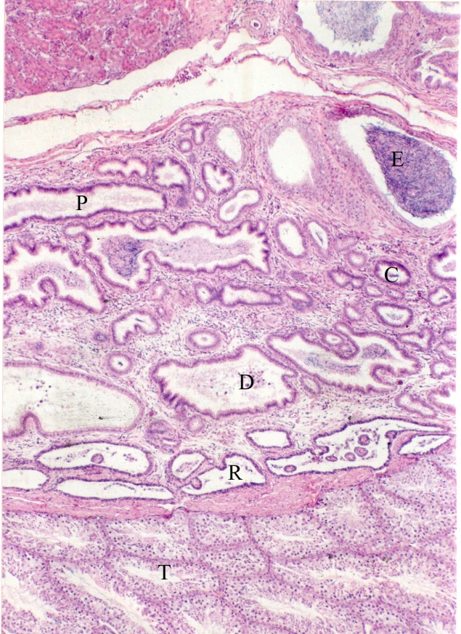

Fig. (1): Part of the testis (T) and epididymal region of the pigeonshowing the extratesticular rete (R), proximal efferent ductules (P), distal efferent ductules (D), connecting ductules (C) and the epididymal duct (E). (H&E stain X 65)
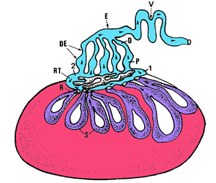
Fig. (2): Schematic drawing of the seminal pathway of pigeon Columba livia showing seminiferous tubules (S), tubuli recti (R), rete testis (RT), intratesticular segment of RT (1), extratesticular segment of RT (2), efferentductules (DE, roximal part 5 P, and distal part 5 D), epididymal duct (E), vas deferens (V), and seminal fluid course (arrowheads). (Mairaa et al., 1999).

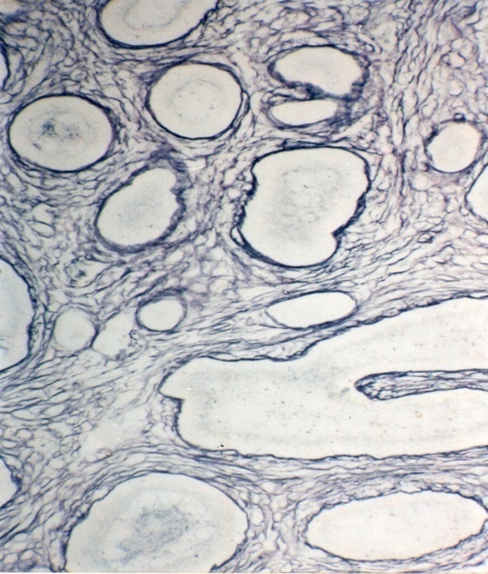

Fig. (3): Reticular fibers forming the reticular lamina of the basement membranes as well as net work between the epididymal ductules of the pigeon epididymis (Gomori's reticulin method X130)

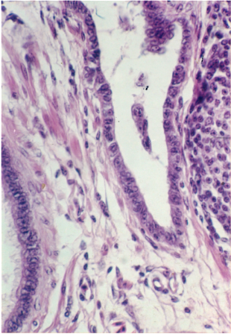

Fig. (4): Section of rete tubule of pigeon showing the cuboidal lining cells, notice the peritubular lymphoid aggregation & smooth muscle fibers in the interstitial tissue. (H&E X 320)

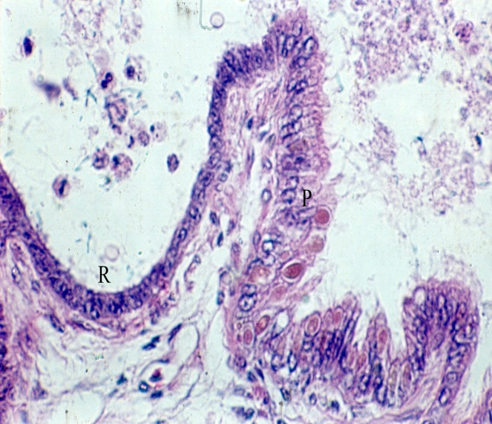
Fig. (5): section level showing the transition between the rete epithelium (r) & the proximal efferent ductules (P), Notice that the cuboidal rete epithelium increase in height to become high columnar epithelium at the proximal efferent ductile. ( H&E X 1024)

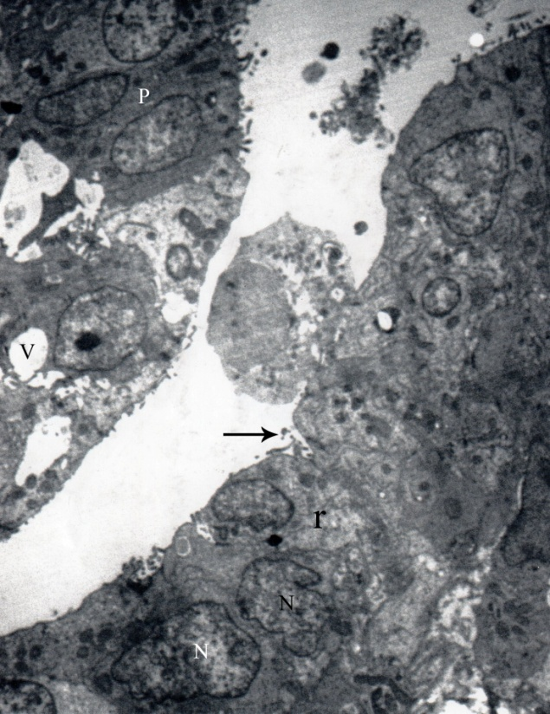
Fig. (6): TEM of the transitional region between the rete epith. (r) and the proximal efferent ductules epith. (P), Notice the overlapping low cuboidal epith. Of rete tubule changes into high cuboidal then columnar epith. Of the proximal efferent ductules. Some cells showing irregular nuclei (N), apical surface invaginations (arrow), intracellular Vacuoles (V), phagosomes, residual bodies could be observed, luminal macrophage was found (X5000)

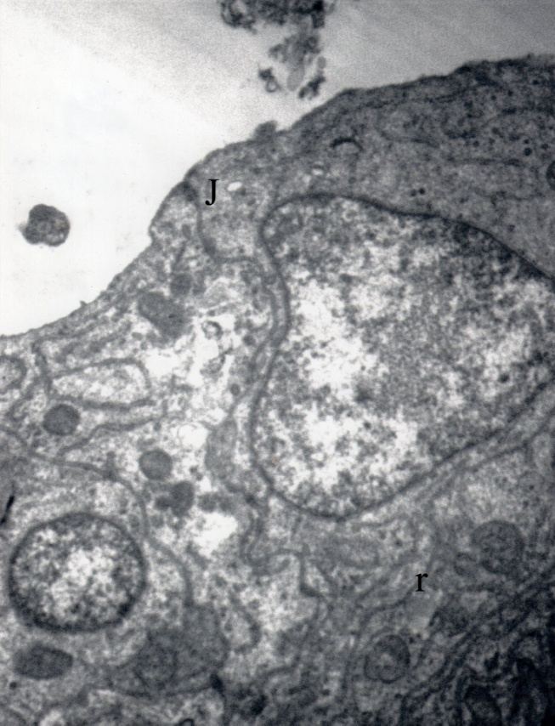
Fig. (7): Higher Magnification of the rete epith. Notice the overlapping cuboidal with oval nuclei, the apical tight junction between the cells (J), intercytoplasmic dens bodiofes & profiles rER (r) (X 10000)

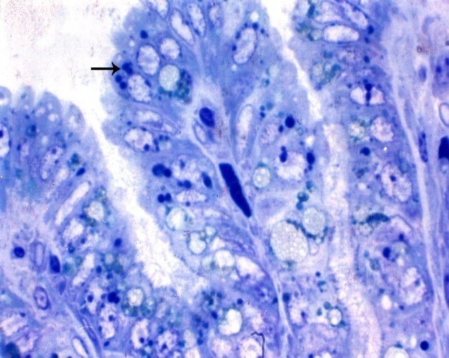
Fig. (8): Epithelium of proximal efferent ductile consisting of ciliated cells & nonciliated type I cells, Notice: the presence off vacuoles & dense globules in the nonciliated cells (arrow) which showed apical bleb like projection. Ciliated cells appear truncated lightly stained, Notice the presence of multivesicular bodies and yellowish lipofuchsin pigments in many cells. (T.B X 1024).

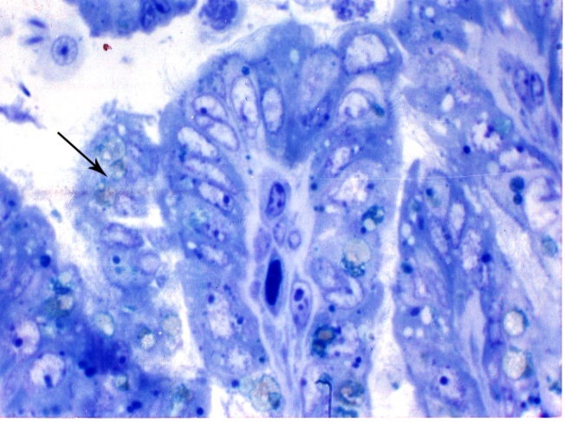
Fig. (8a): Epith. Of proximal efferent ductile showing ciliated & nonciliated cells. The nonciliated showing apical bleb like projectios & some of these cells were completely shed into the lumen (arrow), Luminal macrophage. (X 1024)
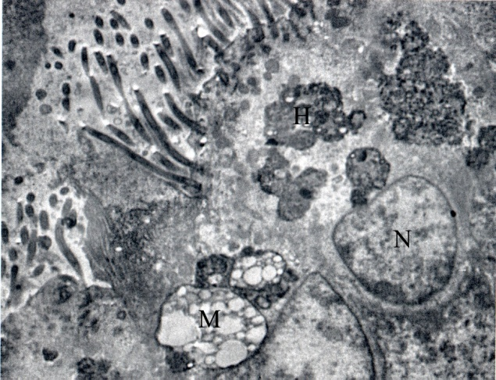
Fig. (9): TEM of proximal efferent ductile epith. Showing ciliated & nociliated lining cells with microvilli. The cells contains apical large heterogenous bodies, multivesicular bodies, ovoid nuclei, ciliated cell with free ribosomes basally. (X13000)
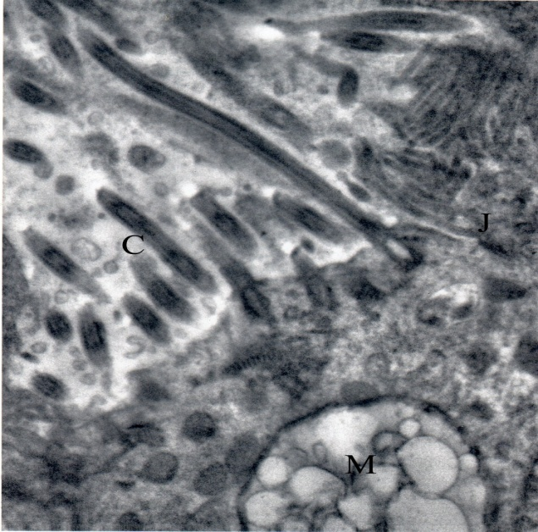
Fig. (10): Higher magnification of ciliated cells of the proximal efferent ductules, notice, large multivesicular body (B), Mitochondria (M), apical cilia (C), tight junction (J) & dense granules & vacuoles. (X15000)

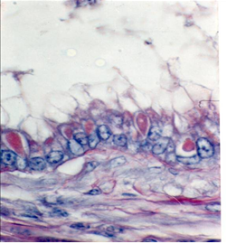

Fig. (11): Transverse section of proximal efferent ductule showing PAS +ve basal lamina & PAS +ve apical granules in the lining cells. (PAS X1024)

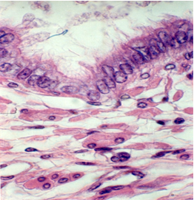

Fig. (12a): Distal efferent ductile showing apical bleb like projections of noncilated cells, notice the apical vacuolar & acidophilic bodies in many cells, supported by highly vascular stroma with may smooth muscle bundle. (H&E X 1024).

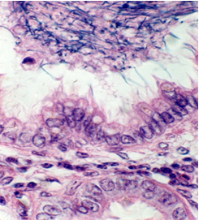
Fig. (12b): Distal efferent ductile showed apical acidophilic bodies & vacuoles. Notice the intraluminal aggregation of spermatozoa & luminal macrophage. (H&E X 1024)
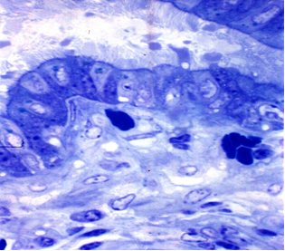
Fig. (13): Transverse section in distal efferent ductule, the epithelium was formed of dark nonciliated cells; showing apical projection & intercellular dark granules; and Light ciliated cells with basal vacuoles. (T.B. X1024)
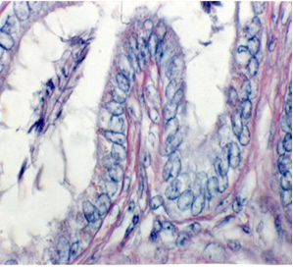
Fig. (14): Transverse section through distal efferent ductules showing PAS +ve granules and basal lamina. (PAS X1024)

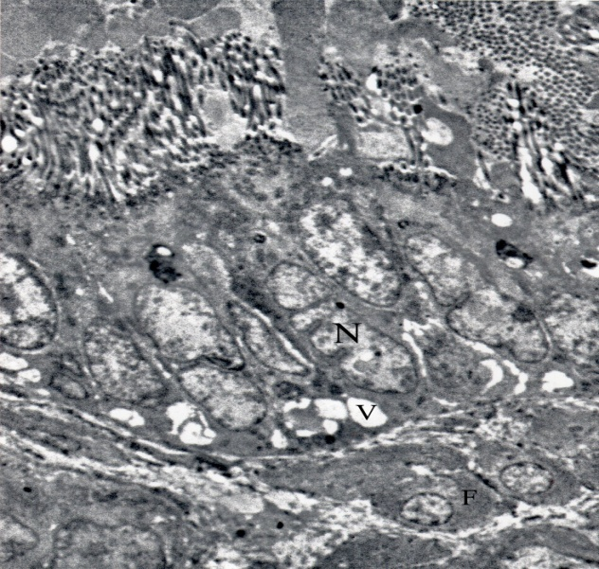

Fig. (15): TEM of the distal efferent ductulular epithelium showing tall columnar cells ciliated & nonciliated cells, Notice the highly irregular nuclei, basal vacuoles, apical mitochondria. Notice the peritubular fibroblasts & smooth muscle fibers. (x 6000)

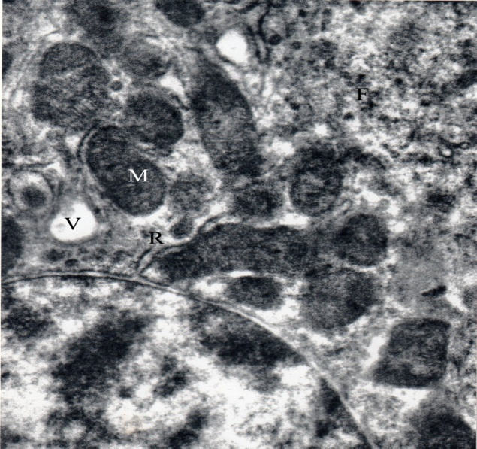

Fig. (16): Higher magnification of apical portion of distal efferent dutulular ciliated cell showing nucleus (N), many mitochondria (M), rER (R), Multiple vacuoles (V), free ribosomes (F). (X20000.)

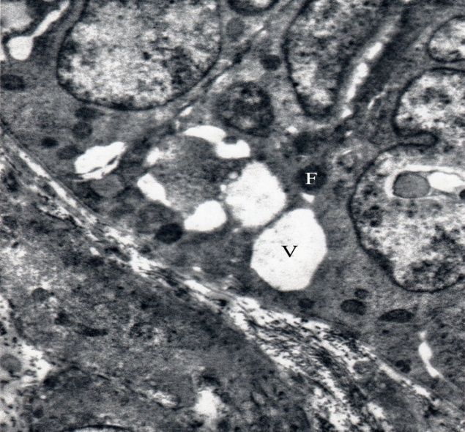
Fig. (17): Higher magnification of basal portion of distal efferent dutulular ciliated cell showing Multiple basal & intercellular vacuoles (V) & some dense bodies (F). (X20000)
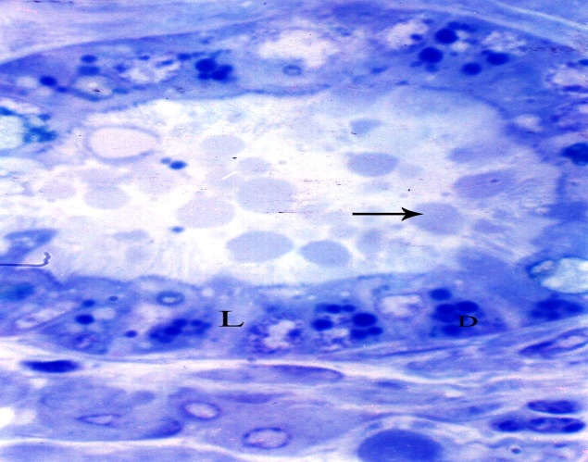
Fig. (18): Transverse section through the initial part of the connecting ductile, notice their regular outline, lined by light ciliated (L) & dark nonciliated cells(D), the dark nonciliated cells showing many dark granules & detached apical portion into their lumen (arrow). (T.B. X1024)
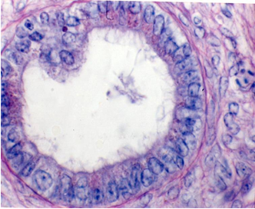
Fig. (19): Transverse section through the initial region of the connecting ductules showing their lining cells containing apical fine PAS +ve granules (PAS X 1024)

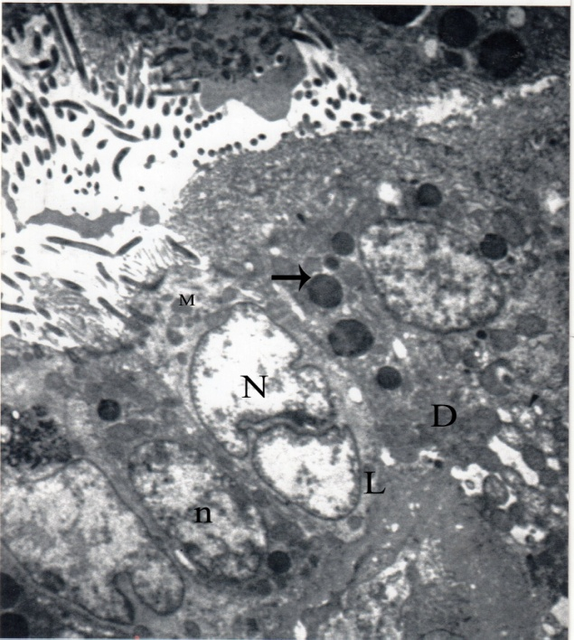

Fig. (20): TEM of the connecting ductules showing epithelial lining are dark nonciliated (D) & lighter ciliated cells (L), notice the highly irregular segmented nucleus (N) of ciliated cells & oval nuclei (n) in the nonciliated cells. Both types of cells contains multiple apical mitochondria (M), large electron dense granules (arrow), apical projection were seen in nonciliated cells. (X8000)Spermatozoa I the lumen some embedded at the apical surface of non ciliated cells

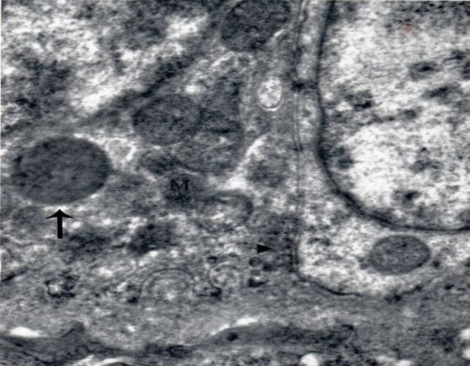

Fig. (21): TEM magnifying the basal part of the light & dark epithelial cells lining the connecting ductules. Notice the multiple electron dense granules (arrow) & mitochondria (M). Dark cells showing basal infolding with many hemidesmosomal junction (arrow head). (X 20000)

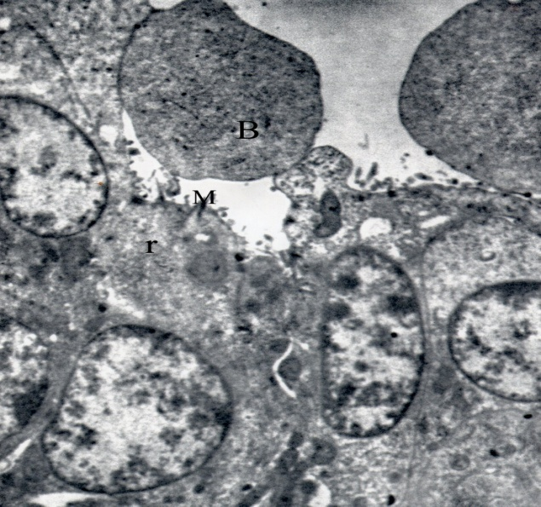
Fig. (22): TEM of the lining epith. Of terminal portion of connecting ductules showing absence of ciliated cells, the cells carry few microvilli (M), some cells showing apical bleb like projection (B), detached apical portion were seen in the tubular lumen, apical rER cistern (r) were present. (X 12000)
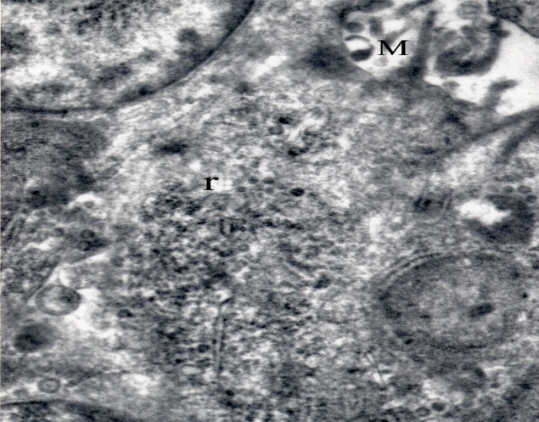
Fig. (23): Higher magnification of lining cell of connecting tubule, showing apical short microvilli (M) with microfilaments, multiple tubels pf rER (r), multiple microvesicles, dense bodies & dense granules. (X20000)
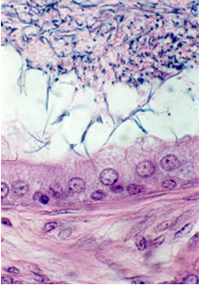
Fig. (24): section of the epididymal duct showing their lumen containing densely packed aggregation of spermatozoa (arrow), noncillated columnar cells with spherical nuclei, basal cells with more dark cytoplasm. (H&E 1024)

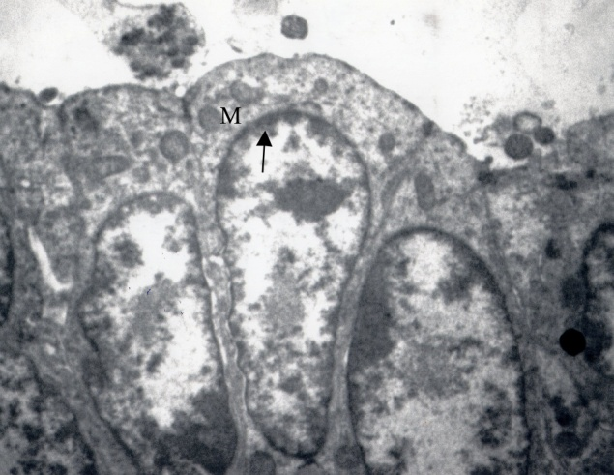
Fig. (25): TEM of the epididymal duct epithelium, all cells are columnar nonciliated with oval nuclei, contain many apical electron dense granules (arrow), mitochondria (M), dense bodies, apical tight junction, lighter intercellular space. (X 12000)

4.Discussion
The general structure of pigeon epididymal region was generally similar to that already described for domestic fowl (Lake, 1957; Tingari, 1971; Budras and Sauer, 1975); turkey (hess et al., 1976); japanese quail (aire, 1979a); guinea fowl (Aira et al., 1979); and duck (Aire, 1982b and Sallam et al., 2000).
Unlike the mammalian epididymis, it is not subdivided into head, body and tail since the efferent ductules arise throughout the entire length of the epididymis (Lake, 1981).
According to Aire (1982a), the extra testicular part of the rete testes of birds was termed the epididymal rete. The same author reported that the squamous rete epithelium changed into high cuboidal or columnar type before the typical epithelium of the proximal efferent ductules began, similar results were reported her in pigeon.
On the contrary Tingari (1971) and Budras and Sauer (1975) in fowl and Aire et al., (1979) in guinea fowl observed that this change was abrupt from squamous epithelium to the high columnar cells of the efferent ductules.
Most of studies dealt with the efferent ductules structure in different birds agreed with our results in that the efferent ductules consisted of two portions: the proximal and distal efferent ductules (Aire, 1979a, 1980 &1982a; Budras and Sauer, 1975; Aire et al., 1979;). On the other hand, Tingari (1971) did not describe such division in the fowl but he classified them as efferent ductules and narrow connecting ducts, respectively.
As described by Aire (1979b) in domestic fowl, japanese quail & guinea fowl, Aire (1980) in guinea fowl and Aire (1982b) in drake, that the proximal efferent ductules revealed wider lumina and greater epithelial folding than the distal segment. In addition, the lumina of the first segment had scattered spermatozoa and desquamated immature germ cells, whereas that of the second segment were filled with a mass of closely packed spermatozoa. Tingari (1971) explained that the increased luminal contents of spermatozoa exert mechanical pressure on the folded wall of the ductules and might be regarded as a factor controlling the height of the ductalar epithelium as well as the luminal diameter.
Our study showed that mainly ciliated and non-ciliated columnar cells, in addition to few basal cells, lined both segments of the pigeon’s efferent ductules. Similar results were recorded in fowl by Budras and Sauer (1975a), guinea fowl by Aire et al. (1979), Japanese quail by Aire (1979a), different birds by Lake (1981) and duck by Sallam et al. (2001).
Concerning the ciliated cells, Aire (1980) observed that such ciliated cells had a few short microvilli, vacuoles and flocculent content and small micropincytotic invaginations of the cell surface. So, our findings (presence of mulivesicular bodies, residual bodies, lipofuchsin pigment and the lysosome like dense bodies) strongly support the hypothesis of Aire (1980) in that the ciliated cells beside their principal role in the transport of the spermatozoa, they may also participate in the resorption of the seminal plasma and phagocytosis of the degenerated sperms. Cooper and Hamilton (1977) in rat assure that an extensive phagocytosis of spermatozoa occurs in the reproductive tract of intact males. The previous authors explained that the removal of these degenerated sperms before ejaculation cleared the lumen and permit the continual movement of the sperms along the tract.
The ultra structure of pigeon’s epididymis followed Aire et al., (1979) and Sallam et al., (2001) in their classification of the non-ciliated cells of the proximal efferent ductules as type I and that of the distal efferent ductules as non-ciliated cells type II. Whereas, Tingari (1972) and Hess & Thurston (1977) described only one cell type, non-ciliated type i cell, for the efferent ductules in the fowl and turkey respectively.
The same point was discussed in guinea fowl (Aire et al., 1979); domestic fowl (lake, 1981and Nakai et al., 1989) and duck (Aire 1982b) that both the non-ciliated cells type II& I are characterized by microvillus projections of their luminal surfaces. However, the two cells, contained cytoplasmic vacuoles, pinocytotic vesicles, dense bodies or globules, lysosomes, fragments of spertmatozoa and tubular structures, but they were fewer and not so prominent in type II as those in type I. Moreover, Aire (1980), working on domestic fowl, japanese quail and guinea fowl recorded that the most striking characteristic of the type II as compared to type I cell was the absence of vacuoles and globules in the former cell. On the other hand, the type II cells had much more distended rER, a well-developed Golgi apparatus, smooth vesicles and electron dense secretory granules than the type I cell (Lake, 1981).
The present findings support the speculation of Tingari and Lake (1972) and Nakai et al., (1989) in fowl and Aire (1979b and 1980) in different birds that the morphological features of the ciliated cells indicated their positive participation in phagocytosis and digestion of broken down germ cells and degenerated spermatozoa as well as, pinocytosis of most of the fluid entering the epididymal region from the testes. Aire (1980) added that the activity of type I cell in resorption is more than type II cell. Such resorption may offer an explanation for the great concentration of spermatozoa in the distal efferent ductules and connecting ductules (Tingr& Lake, 1981). El- rafey (1985) suggested that the testicular fluid could be an unsuitable vehicle for sperm maturation in the epididymis and must be resorped for concentration.
As it was observed in the duck by Aire (1982b) and Sallam et al., (2001), that the apical cytoplasm of the non-ciliated cells may protrude into the ductular lumen to form blebs. These blebs represented a sign of apocrine secretion (Tingari, 1971; Budras and Sauer, 1975; Hess et al. 1976; Hess and Thurston, 1977 and Bakest, 1980). However, they were regarded as fixation artifacts by Aire (1979a, 1980 7 1982b). The last author reported that these blebs contained cell organelles such as mitochondria, dense globules (probably lysosomes) and rER. Also a demarcation zone between the blebs and the rest of the cell did not occur, as would be the case in apocrine secretion (Kurosumi et al., 1961).
The intra luminal released secretory cells have been observed in pigeon’s efferent ductules were suggested to be mature holocrine secretory cells by Martan & Risley (1963) and Martan & Allen (1964) in mouse epididymis. The previous authors explained that these cells develop from the basal cells in a maturation cycle. They described the mature holocrine cells to be club-shaped with an expanded projecting apical part devoid of microvilli, central nuclei and a thin stalk attached to the basal lamina.
Martan & Risely (1963) added that mating shorten the cycle of holocrine cell maturation and the release of these cells from the epithelium. Martan & Allen (1964) assumed that the presence of holocrine cells in the epididymis establishes a secretory function of the organ these functions are likely related to the sperm maturation and maintenance in the epididymis. Moreover they reported increased holocrine secretory activities with age and relate this finding to the increasing androgen levels with age.
Secretory capabilities have been also attributed to the efferent ductules of the fowl (Tingari, 1972). Tingari (1973) and Budras and Sauer (1975) showed that hormone synthesis occurred in the epididymal region of the sexually mature cockerel, especially in the proximal efferent ductules. Aire (1980) suspected a limited secretory activity in the non-ciliated type II and I cells. Meanwhile, Lake (1981) recorded that the non-ciliated type ii cells had ultra-structural features of typical protein secreting cells. Morphological evidence of secretory activities was indicated in the efferent ductules of the pigeon by the presence of vacuoles, PAS positive granules in the supra-nuclear cytoplasm, as well as rER and secretory vesicles. The secretory products of the epithelial cells of the efferent ductules might be needed for sperm nutrition.
Previous reports confirmed the presence of macrophages in the lumen of the rete channels and in the intraepithelial linning of the efferent ductules (Tingari and Lake, 1972, Aire and Malmqvist, 1979b, Nakai et al, 1989 and Calvo et al, 1997). These authors concluded that the spermiophagy by luminal and tissue macrophages are among the factors concerned in the disposal of unejeculated or degenerated spermatozoa in the epididymal region. Meanwhile, abundant macrophages were seen in the rete channels of fowl and duck by Aire (1982) and Sallam et al. (2001). In this respect, Yeung et al., (1994) postulated that the basal cells of the human epididymis might transform into macrophages.
The present study revealed that the connective tissue supported the rete channeles contained lymphocytic aggregations; some of these aggregations took the nodular form. Aire, (1979b) in domestic fowel and Sallam et al., (2001) in duck assured that lymphoid nodules were scattered erratically in the periductal region epididymis. Moreover, intra epithelial lymphocytes were also reported in the epididymal region of different species (Aire & Malmquist, 1979a; Aire, 1980 and Calvo et al., 1997). The presence of solitary non-encapsulated lymphatic nodules in the connective tissue of virtually all organs in the domestic fowl and wild birds was regarded as normal (King and Mclelland, 1975). These authors believed that these lymphoid cells were of the day-to-day immunological responses of the bird to its environment. Balah et al., (1989) suggested that these lymphocytes might add a more protective condition for the sperms inside the epididymal region of turkey. On the other hand, lymphocytic aggregation has developed a number of different immunological strategies including cell mediated one in fowl (Sharma, 1997).
Arie et al., (1979) in guinea fowl, Lake (1981) in birds and Rikihsa and Lin (1988) in japanese quail, Sallam et al., (2001) in duck and our study revealed that the epididymal duct possessed essentially the same structure as that of the connecting ductules, although it was larger in diameter. Both ducts were lined by a non ciliated columnar epithelium consisted of light and dark cells with fewer basal cells. Their lumina contained densely packed spermatozoa. Aire et al., (1979) reported that the connecting ductules in guinea fowl were hardly distinguishable from the epididymal duct. Lake (1981) found that the connecting ductules were at first narrow, but as they approached the epididymal duct began to anastomose with each other and thus became progressively wider. They end by joining the single epididymal duct.

References
- Aire, T.A. (1979a): The epididymal region of the Japanese quail (Coturnix coturnix japonica). Acta Anat. (basel)., 103 (3): 305 – 312.
- Aire, T.A. (1979b): Micro-sterological study of the avian epididymal region. J. Anat., 129 (4): 707 -706.
- Aire, T.A. (1980): The ductuli efferentes of the epididymal region of birds. J. Anat., 130 (4): 707 – 723.
- Aire, T.A. (1982a): Surface morphology of the ducts of the epididymal region of the darke (Anas platyrhynchos) as revealed by scanning and transmission electron microscopy. J. Anat., 135 (3): 513- 520.
- Aire, T.A. and Malmqvist, M. (1979a): Intraepithelial lymphocytes in the excurrent ducts of the testis of domestic fowl (Gallus domesticus). Acta. Anat., 103: 142 – 149.
- Aire, T.A. and Malmqvist, M. (1979b): macrophage in the excurrent ducts of the testis of domestic fowl (Gallus domesticus). Anat. Histol. Embryol., 8: 172 – 176.
- Aire, T. A.; Ayeni, J.S. and Olowo-Okorun, M.O. (1979): The structure of the excurrent ducts of the testis of the guinea fowl (Numida meleagris). J. Anat., 129 (3): 633 – 643.
- Bakat, M.R. (1980): Luminal topography of the male chicken and turkey excurrent duct system. Scanning Electron Microscopy. 3: 419 – 425.
- Bakst, M.R. (1980): Luminal topography of the male chicken and turkey excurrent duct the male chicken and turkey excurrent duct. Scanning Electron Microscopy. 3 : 419- 425.
- Balah, A.M.; Salem, H.F.; AttiaA, M.; Eidaroos, H. and Bareedy, M.H. (1989): Histological and histochemical studies on the testis and epididymis of domestic turkey (Meleagris jallopava). The Egypt. Soc. Hist. and Cyto. 13th Sci. Conf.
- Budras, K.D. and Sauer, T. (1975): Morphology of the epididymis of the cock (Gallus domesticus) and its effect upon the steroid sex hormone synthesis. I Ontogenesis, morphology and distridution of the epidiymis. Anat. Embryol., 148: 175 – 196.
- Calvo, A.; Bustos-Obregon, E. and Pasror, L.M. (1997): Morphological and histochemical changes in the epididymis of hamsters (Mesocricetus auratus) subjected to short photoperiod. J. Anat., 191: 77-88.
- Cooper, T. G. and D. W. Hamilton: Phagocytosis of spermatozoa in the terminal region and gland of the vas deferens of the rat. Amer. J. Anat. 150: 247-268 (1977).
- Crossmon, G. (1937): A modification of mallory’s connective tissue stain with discussion of principle involved. Ibid., 69: 33 - 38.
- Drury, R. and Wallington E. (1980): Carleton's histological techniques. 5thEd. Oxford University Press.
- EL-Rafey, G.A. (1985): Micromorphology and histochemistry of the epididymis of sheep. M.V.Sc. Thesis. Fac. Vet. Med. Cairo University.
- kurosumi K.; Yamagish, M. and Sekine, M. (1961) Mitochondria! deformation and apocrine secretory mechanism in the rabbit submandibular organ as revealed by electron microscopy Z. 'Leff. Mik. Anat., 55 : 297-312.
- King, A.S. and Mclelland, J. (1975): The lymphatic system. In: Outlines of Avian Anatomy, pp. 103-105. London: Bailliere and Tindall.
- Hess, R.A., Thurston, R.J., 1977: Ultrastructure of epithelial cells in the epididymal region of the turkey (Meleagris gallopavo). J. Anat. 124, 765-778.
- Hess, R.A., Thurston, R.J., Biellier, H.V., 1976: Morphology of the epididymal region and ductus deferens of the turkee (Meleagris gallopavo). J. Anat. 122, 241-252.
- Lake, P.E. (1957): The male reproductive tract of the fowl. J. Anat., 91: 116-129.
- Lake, P.E., (1962): histochemical demonstration of phospho- monoesterase .secretion in the genital tract of domestic cock. J.Reprod. Fert., 3: 356-362.
- Martan, J. & Allen, J. M. (1964). Morphological andcytochemical properties of holocrine cells in the epididymis of the mouse. J. Histochem. Cytochem. 12, 628-639.
- Martan, J. & Risley, P. L. (1963). Holocrine secretory cells of the rat epididymis. Anat. Rec. 146, 173189.
- Nakai M.; Hashimoto, Y.; Kitagawa,H.; Kon, Y. and Kudo, N.(1989): Histological study on seminal plasma." absorption and spermiophagy in the epididymal region of domestic fowl. Poult. Sci., 68; 582-589.
- Pearse, A.G.E (1972): Histochemistry. Theoretical and a pplied. 2nd Ed. Churlchill, London.
- Rikihisa, Y. and Lin, Y.C. (1988): Ultrastructure of the testis and epididymis of japanese quail (Conturnix coturnix japonica) administered gossypol. Poult. Sci., 67: 961-972.
- Sallam, Th. F.; El-Gharbawy, S.M. and El-Bargeesy, G.A. (2001): The epididymal region of the balady ducks (Anas platyrhynchos):Light and Transmission electron microscopy. J.Egypt. Ger. Soc. Zool., Vol. 34 (c), Histology, Histochemistry & Genetics, 193- 211.
- Sharnl-k, J.M (1997) : The structure and function of the avian immune system Acta veter. Hung., 45 (3) : 229-386.
- Stefanini, M.A., Orsi, A.M., Gregorio, E. A., Viotto, M. S. and Baraldi-Artoni, S. M. (1999): Morphologic study of the efferent ductuled of the pigon (Columba livia). J. morph., 242: 247-255
- Tetzlaff. G.(1987):3-Beta- Hydroxysteroid-dehydrogenases of the testis and epididymis of the peking duck (Anas platyrhynchos L.). Acta. Histochem. 81 (1): 19-34.
- Tingari, M.D., 1971. On the structure of the epididymal region and ductus deferens of the domestic fowl (Gallus. domesticus). J. Anat. 109, 423-435.
- Tingari, M.D. (1972): The fine structure of the epithelial 1ining of the excurrent duct system of the testis of domestic fowl. Quart. J. Exp.physio., 57: 271- 293.
- Tingari,M.D.and Lake, P.E. (1972): Ultrastructural evidence for resorption of spermatozoa and testicular fluid in the excurrent ducts of the testis of the domestic fowl, Gallus domesticus J. Reprod. Fert. 31: 373-381.
- Yeung, C.H. Ash.-kN, D.; Sorg, C.; Oberpenning, F.; Schlrlze, H. and Nieslage, E. (1994) Basal cells of the human epididymis antigenic and ultrastructural similarities to tissue-fixed macrophages. Biol. Reprod., 50: 917 - 926.

8/12/2013

