Adhatoda aqueous Plant Extract as Environmentally Benign Corrosion Inhibitor for Carbon Steel in Sanitation Water in Polluted NaCl Solutions and its Biological effect on Bacteria

A.S.Fouda¹, A. Y. El-Khateeb², M. Ibrahim³ and M.Fakih³

¹Department of Chemistry, Faculty of Science, El-Mansoura University, El-Mansoura-35516, Egypt, Email: asfouda@mans.edu.eg, Fax: +2 050 2446254.
² Department of Agric. Chemistry, Faculty of Agriculture, Mansoura University, Mansoura, Egypt, Email: aymanco@mans.edu.eg
³Water and waste water company, Dakahlia, Egypt.

Abstract: The effect of aqueous plant extract on the corrosion inhibition of Adhatoda on carbon steel used in sanitation plants in 3.5% NaCl and 16 ppm Na₂S was studied using weight loss, potentiodynamic polarization, electrochemical impedance spectroscopy (EIS) and electrochemical frequency modulation (EFM) techniques. The results showed that Adhatoda extract is a good inhibitor for C-steel in 3.5% NaCl and 16 ppm Na₂S solution by forming an adsorbed film on the metal surface protecting the metal from the corrosive media. The adsorption of the extract on C-steel surface is physically and follows Temkin adsorption isotherm. The inhibition efficiency increases with the increase of the inhibitor concentration. Energy dispersive X-ray fluorescence microscopy observation of the metal surface proved the existence of the adsorbed film. The biological study of the inhibitor on Escherichia Coli activity shows that this extract increases its colonies in the bacterial agriculture.
[A.S.Fouda, A. Y. El-Khateeb, M. Ibrahim and M.Fakih. Adhatoda aqueous Plant Extract as Environmentally Benign Corrosion Inhibitor for Carbon Steel in Sanitation Water in Polluted NaCl Solutions and its Biological effect on Bacteria. Nat Sci 2015;13(2):71-82]. (ISSN: 1545-0740). http://www.sciencepub.net/nature. 11

Keywords: Corrosion, Adhatoda, Carbon steel, NaCl, Sanitation Plant, Escherichia Coli.

1. Introduction
Among the several methods of corrosion control and prevention, the use of corrosion inhibitors is very popular. Corrosion inhibitors are substances which when added in small concentrations to corrosive media decrease or prevent the reaction of the metal with the media. Chloride and sulfide in aqueous media are particularly aggressive and accelerate corrosion (Trabanelli, 1991). Among numerous inhibitors that have been tested and applied industrially as corrosion inhibitors, those that are non-toxic or low-toxic are now far more strategic than in the recent past. Most of the effective inhibitors are used to contain heteroatom such as O, N, and S and multiple bonds in their molecules through which they are adsorbed on the metal surface. It has been observed that adsorption depends mainly on certain physicochemical properties of the inhibitor group, such as functional groups, electron density at donor atom, π-orbital character, and electronic structure of the molecule. In the recent, the research in the field of green or eco-friendly corrosion inhibitors has been addressed toward the goal of using cheap, effective compounds at low or zero environmental impact. Plant extract is low-cost and environmental safe, that which is the main advantage of it. Many synthetic compounds give good anticorrosive activity, most of them are highly toxic to both human beings and the environment (Ostovari et al., 2012), and they are often expensive and non-biodegradable. The use of chemical inhibitors has been limited because of the environmental threat, recently, due to environmental regulations. The use of green inhibitor play an important role in the corrosion of the metals that it acts as an incredibly rich source of naturally synthesized chemical compounds that are biodegradable in nature and can be extracted by simple procedures with low cost (Abiola et al., 2009). Plant products are organic in nature, and some of the constituents including tannins, organic and amino acids, alkaloids, and pigments are known to exhibit inhibiting action. A molecule of an organic compound must have the ability to act as a corrosion inhibitor. Among these, the molecule may have a large structure, double bonds, an active center or group, etc. These features give the molecule ability to cover a large area of a metal surface with a firmly attached film (Muller, 2002). Several studies have been carried out on the inhibitor of corrosion of metals by plant extracts (Li et al., 2005), (El-Etre et al., 2005), (Bouyanzer et al., 2006), (El-Etre 2003), (Barannik et al., 2012), (Maheswari et al., 2010), (Loto et al., 2003), (El-Etre, 2012), (Subhashini et al., 2002), (Rajalakshmi et al., 2002), (Manohari and Rajalakshmi, 2001), (Prithiba et al., 2003).
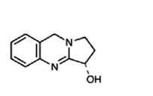
The aim of this work is to study: The effect of using adhatoda plant extract as a green inhibitor for the corrosion of carbon steel in sulfide polluted salt water using different techniques. The biological effect of adhatoda plant extract on the activity of Escherichia Coli.

2. Material and Methods
2.1. Material composition of the sample
The material used is carbon steel which provided from Talkha sanitation plant, Egypt. The chemical composition (weight %): 0.210% C, 0.004% Si, 0.360% Mn, 0.250% P and the remainder is iron.
2.2. Preparation of the inhibitor
The present investigation was carried out using the plant namely adhatoda. The used parts were the leaves of adhatoda tree. The sample were picked from the trees of Talkha sanitation plant and ground into a fine powder to give 500 g of powdered materials, a known quantity of the material was soxhlted using a bidistilled water. Finally the extract was lyophilized, weighed and preserved at 4ºC and kept for use when required.
2.2.1 Botanical aspect of adhatoda

Kingdom: | Plantae | Division: | Angiosperms
Class: | Eudicots | Order: | Lamiales
Family: | Acanthaceae | Genyss: | Justicia
Species: | J. adhatoda | Binomial name: | Adhatoda vasica
Synonyms: | Justicia adhatoda

2.2.1.1 Chemical structures of adhatoda (Roja et al., 2001)

Vasicine Vasicinone

2.2.1.2 Mass spectral analysis
The identity of vasicine was confirmed by co-chromatography with an authentic sample of the compound and also by mass spectra analysis. The extract compound was also identified by mass spectra. Mass spectra of the isolated extract compound revealed a molecular ion peak at 188 and M + 1 peak at 189 (Fig. 1A). The mass spectral fragmentation patterns, as well as the molecular weight observed, were in agreement with the values reported for authentic vasicine. Further, the mass spectral analysis of extract compound showed a molecular ion peak at 202 and an M + 1 peak at 203 (Fig. 1B). These values were in agreement with the spectral values reported for vasicinone (Fig. 1C). On the basis of TLC, HPLC results and mass spectral fragmentations the extract compound was identified as vasicinone. Vasicinone is an autoxidation product of vasicine. From the above investigations, it may be concluded that tissue cultures of A vasica possessed the biosynthetic potential to accumulate two important products, namely vasicine and vasicinone. Production of these compounds from the intact plant of A vasica is known but tissue culture studies dealing with the production of these compounds are rather limited (Roja et al., 2001).

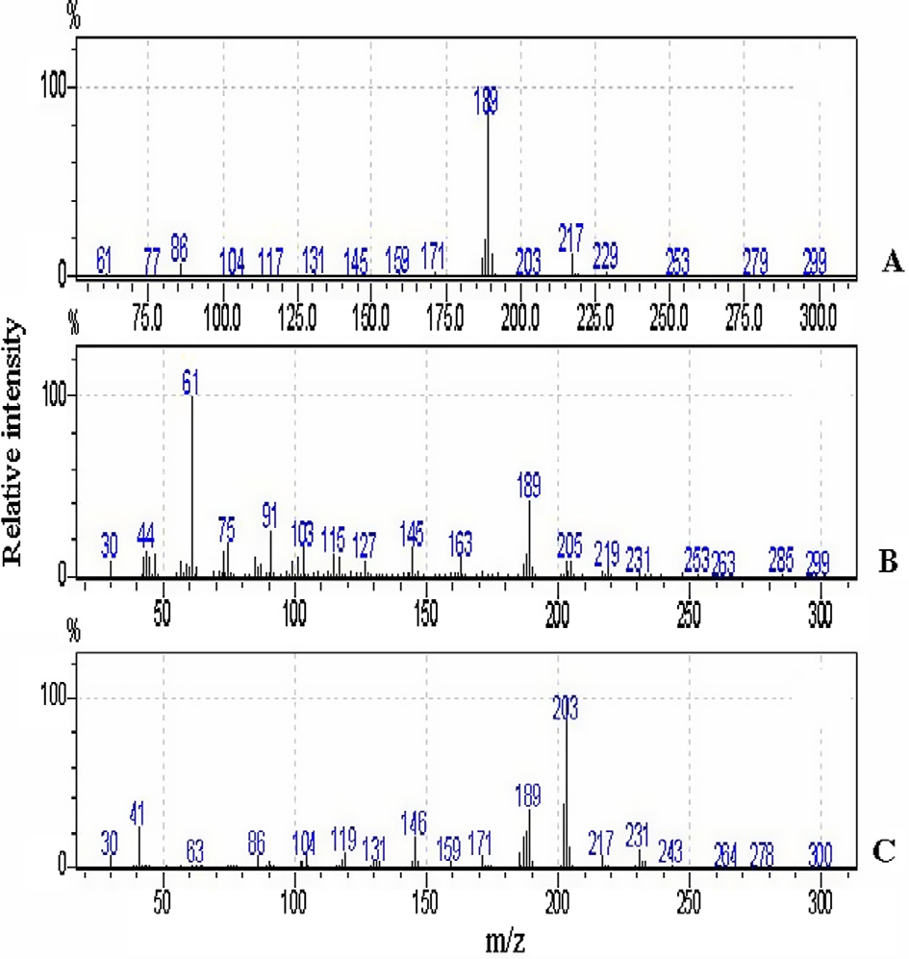
Figure 1. Mass spectral analysis (CI Mode – source temperature 200 -C, temperature programme from 30 to 350-C at the rate of 80 -C/min; mass range 30–300 amu; methane was used as reagent gas. (A) Standard vasicine (molecular weight 188, M + 1 peak at 189); (B) isolated vasicine (molecular weight 188, M + 1 peak at 189); (C) isolated vasicinone (molecular weight 202, M + 1 peak at 203).

2.3. Preparation of bacterial agriculture media
Suspend 50 g of the medium in 1 litter of distilled water and dissolve it by heating. Sterilize in autoclave at 121ºC for 15 min. Cool to 45-50ºC, mix well and dispense into plates. Allow the plates to solidify. The prepared medium should be at 8-15ºC. The color is violet-red.
2.4. Solutions
The aggressive solutions of 3.5 % NaCl and 16 ppm Na₂S was prepared by dissolving the required amount of salts in bi-distilled water. All chemicals were analytical-grade reagents. The experiments were carried out under non-stirred and naturally aerated conditions. The addition of the extract did not change the pH of the aggressive media.
2.5. Electrochemical procedure
For electrochemical measurements, the sheets were welded with Cu-wire for electrical connection and mounted into glass tubes of appropriate diameter using Araldite to offer an active surface of (1 cm²) geometric area to contact the test solution. Prior to each experiment, these sheets were first abraded with different grades of emery papers (800 to 1200 grades), washed with bi-distilled water, degreased with absolute ethanol and then dried. A conventional electrochemical cell of capacity 100 ml was used containing three compartments for working, platinum foil counter (1 cm²) and saturated calomel electrode (SCE) as reference electrode. The measurements were carried out in deaerated non-stirred 3.5% NaCl with 16 ppm Na₂S in the presence of various concentrations of the adhatoda extract, as environmentally-friendly corrosion inhibitor. For each run, a freshly prepared solution as well as a cleaned set of electrodes was used. Each run was carried out in deaerated stagnant solutions at the required temperature, using a water thermostat. The potentiodynamic polarization curves were carried out at a scan rate of 1 mV s⁻¹ starting from -1.7 V up to -0.1 V (SCE). Before polarization, the open circuit potential of the working electrode was measured as a function of time during 30 min, the time necessary to reach a quasi-stationary value for the open-circuit potential.
Impedance (EIS) measurements were carried out using AC signals of amplitude 5 mV peak to peak at the open-circuit potential in the frequency range 100 kHz and 0.2 Hz. All impedance measurements were recorded at open circuit potential (OCP) after immersion the electrode for 30 minutes in the test solution.
Electrochemical frequency modulation (EFM) was carried out using two frequencies 2 and 5 Hz. The base frequency was 0.1 Hz, so the waveform repeats after 1s. The Intermodulation spectra contain current responses assigned for harmonical and intermodulation current peaks. The larger peaks were used to calculate the corrosion current density (i_{corr}), the Tafel slopes (β_{c} and β_{a}) and the causality factors CF-2&CF-3 (Abdel-Rehim et al., 2006), (Bosch et al., 2001).
All electrochemical experiments were carried out using Potentiostat/Galvanostat/Zra analyzer (Gamry PCI300/4). A personal computer with DC 105 software for polarization, EIS 300 software for impedance, EFM140 software for electrochemical frequency modulation and Echem Analyst 5.21 was used for data ﬁtting and calculating.

3. Results
3.1. Weight loss measurements
The corrosion rate of carbon steel in 3.5% NaCl and 16 ppm Na₂S at various concentrations of adhatoda extract was determined after 3 hrs of immersion from 25Cº to 40Cº are presented in Table 1. Figs.2a to 2d give the weight loss-time curves in absence and presence of adhatoda extract at 25-40Cº. From the experimental data of the weight loss measurements, the % P and degree of surface coverage (Ɵ) were calculated from eq. (1):
% P = Ɵ x 100 = 100[1-W₂/W₁] (1)

where W₁ and W₂ are the weight losses in the absence and presence of extract, respectively.
From the data of Table 1 one can see, by increasing the concentration of the adhatoda extract the % P increases, and by raising the temperature the value of % P decreases (Bentiss et al., 2002). This behavior can be attributed to the increase of the surface coverage due to the physical adsorption of adhatoda extract on the metal surface. The results showed that the %P reached to 91.60 % at concentration 300 ppm adhatoda extract. This indicates that adhatoda extract acts as good corrosion inhibitor for C-steel in polluted salt solution.

Table 1- Effect of Adhatoda extract concentrations on weight loss and inhibition efficiency (% P) of C- steel in 3.5% NaCl + 16 ppm Na₂S at different temperatures.
Conc. ppm | 25ºC |  | 30ºC |  | 35ºC |  | 40ºC
 | Weight loss mg cm⁻² | % P | Weight loss mg cm⁻² | % P | Weight loss mg cm⁻² | % P | Weight loss mg cm⁻² | % P
Blank | 0.70710 | ------ | 0.73230 | ------- | 0.77020 | ------- | 0.833330 | -------
50 | 0.3571 | 49.5 | 0.4048 | 44.7 | 0.4762 | 38.2 | 0.5476 | 34.3
100 | 0.2834 | 59.9 | 0.3628 | 50.5 | 0.4422 | 42.6 | 0.4989 | 40.1
150 | 0.1840 | 74.0 | 0.2273 | 69.0 | 0.3281 | 69.1 | 0.3030 | 63.6
200 | 0.1136 | 83.9 | 0.1653 | 77.4 | 0.2162 | 71.8 | 0.2789 | 66.5
250 | 0.0930 | 86.8 | 0.1136 | 84.5 | 0.1446 | 81.2 | 0.1860 | 77.7
300 | 0.0593 | 91.6 | 0.0889 | 87.9 | 0.1087 | 85.9 | 0.1383 | 83.4

(a)
(b)
(c)
(d)
Figure 2a-2d Weight loss-time curves for the corrosion of carbon steel in sulfide polluted salt water in the absence and presence of Adhatoda extract at different temperatures.

3.1.1- Effect of Temperature
The effect of temperature on the corrosion parameters of carbon steel with the addition of various concentrations of adhatoda was studied using weight loss technique. Inspection of the Table 1 data, the corrosion rate of carbon steel increases with the increase of the temperature, the inhibition efficiency of adhatoda decreased as shown in Figure 3. This is due to the possibility of desorption of the adsorbed extract molecules on the metal surface with the increasing of temperature. This behavior shows that the addition of the extract is physically adsorbed on the metal surface. Arrhenius-type dependence is a relation between corrosion rate and temperature like in eq. (2):
k = A e ^{(- E* a/RT)} (2)
where k is the corrosion rate, E*_{a} is the apparent activation energy, R is the universal gas constant, T is the absolute temperature, and A is the frequency factor. Figure 4 is Arrhenius plot (log k against the reciprocal of temperature (1/T)) for carbon steel in 3.5% NaCl and 16 ppm Na₂S in the absence and presence of different concentrations of adhatoda extract. Straight lines of high correlation coefficients were obtained. The values of activation energy, E_{a}* were 8.54, 41.40 k`J mol⁻¹ for the blank and in the presence of adhatoda extract, respectively. The increase in the activation energy is directly proportional to adhatoda concentration, indicating that the energy barrier for the corrosion process is also increased (Popova et al., 2012).
An alternative formulation of Arrhenius equation is (Fouda et al., 2009):
k = RT/Nh exp (ΔS*/R) exp (−ΔH*/RT) (3)
Figure 3 The effect of inhibitor concentration and temperature on the inhibition efficiency of Adhatoda.

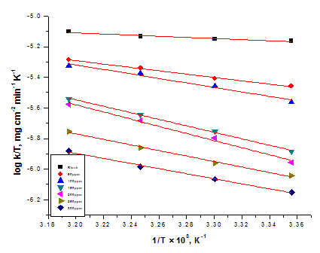
Figure 4 Arrhenius plots for the corrosion rate of carbon steel in sulfide polluted salt water in the absence and presence of Adhatoda extract at different temperatures.

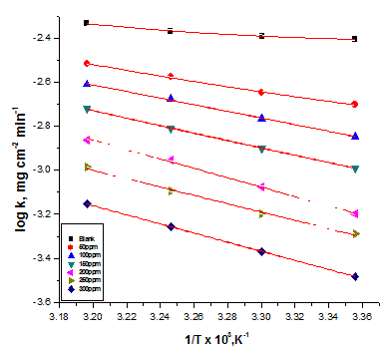
Figure 5 Log (k/T) versus 1/T for carbon steel in sulfide polluted salt water in the absence and presence of Adhatoda extract at different temperatures.

where h is the Planck’s constant and N is the Avogadro’s number. Figure 5 shows a plot of log k/T as a function of 1/T for carbon steel. Straight lines were obtained with a slope of −ΔH*/R and an intercept of ln R/Nh + ΔS*/R from which the values of ΔH* and ΔS* were calculated for the blank and adhatoda extract. The values of the activation enthalpy, ΔH* were 11.23 and 74.96 kJ mol⁻¹ and the values of the activation entropy, ΔS* were −218.48 − 242.15 J mol⁻¹K⁻¹ for the blank and adhatoda extract, respectively. It is known that values of ΔH* lower than 41.9 kJ mol⁻¹ indicative of physical adsorption (Umoren et al., 2012). Since, the absolute values of ΔH* obtained from this study was lower than 41.9 kJ mol⁻¹, this indication of physisorption. The increase in the activation enthalpy (ΔH*) in presence of the extract means that the addition of adhatoda extract to the corrosive media increases the height of the energy barrier of the corrosion reaction to the inhibitor depends on the concentration of the adhatoda extract. The adsorption of adhatoda molecules on the metal surface leads to a lower number of hydrogen atoms adsorbed on it; this will cause a decrease in hydrogen evolution rate rather than the rate of metal dissolution, because of the blocking of the surface of the metal by the inhibitor molecules.
3.1.2- Adsorption isotherms
The importance of the adsorption isotherm is to explain the mechanism of corrosion inhibitor of organo electrochemical reactions. The most frequently used isotherm include: Langmuir, Frumkin, Hill de Boer, Person, Temkin, Flory-Huggins, and recently formulated thermodynamic / kinetic model of El Awady et al (Kamis, 1990), (El-Rehim et al., 1999), (Cafferty, 2013). Adsorption of the organic molecules occurs as the interaction energy between the molecules and the metal surface, higher than between the H₂O molecule and the metal surface. The adsorption of the inhibitors can be described by two main types of interaction: physical adsorption and chemisorptions (Larabi et al., 2013), (Larabbi et al., 2004), (Benali and Ouazene, 2011), (Larabi. et al., 2007), (Larabi et al., 2005). These are influenced by the chemical structure of the inhibitor, the type of the electrolyte, and the charge and nature of the metal. The surface coverage Ɵ of the metal surface by the adsorbed inhibitor was calculated assuming no change in mechanism of the cathodic reaction.
The Ɵ values for different extract concentrations at different temperatures were tested by fitting to various isotherms. By far the best fit was obtained with the Temkin isotherm.
Temkin isotherm:

a Ɵ = ln K_{ads} C (5)
where a is heterogeneity factor, C is the concentration of the inhibitor and K_{ads} is the adsorption equilibrium constant, which is related to the standard free energy of adsorption (ΔGº_{ads}) by the equation:
K_{ads} = (1/ 55.5) exp (ΔGº_{ads} / RT) (6)
where 55.5 is the concentration of water in mol L⁻¹ at metal solution interface. The plot of surface coverage (Ɵ) as a function of logarithm of adhatoda concentration is shown in Figure 6. From the plot, straight lines were obtained for adhatoda extract indicating that the experimental data fit well into Temkin adsorption isotherm. The Temkin isotherm characterizes the chemisorptions of uncharged molecules on heterogeneous surface (Umoren et al., 2013). The regression values (R²) are about 0.99 as shown in Table 2.
The values of ΔG°_{ads} are about the same and it is independent of temperature Table 2 and, the adsorbates do not interact with one another, i.e. there is no effective interaction of the adsorbates on ΔG°_{ads}. The values of K_{ads} decrease with increasing temperature, suggesting that the inhibitor is physically adsorbed on the carbon steel surface. Generally, K_{ads} denotes the strength between adsorbate and adsorbent. The ΔGº_{ads} values were calculated from this plot were negative this mean spontaneous adsorption of the extract molecules on the surface of the carbon steel. The heat of adsorption (ΔHº_{ads}) can be calculated according to the Vant Hoff’s equation:
log K_{ads} = (−ΔHº_{ads}/2.303 RT) + constant (7)
In order to calculate heat of adsorption (ΔHº_{ads}), log K_{ads} was plotted against 1000/T Figure 6. A straight line was obtained. The absolute values of ΔHº_{ads} obtained in this study was lower than 100 kJ mol⁻¹, this indicative of physisorption, and this support the above mechanism of adsorption. The negative value of ΔHº_{ads} (−10.816 kJ mol⁻¹) in the presence of the extract reflects the exothermic nature of carbon steel dissolution process. It is clear that the activation enthalpies vary in the same manner as the activation energies, supporting the proposed inhibition mechanism. According to the basic equation:
ΔGº_{ads} = ΔHº_{ads} – TΔSº_{ads} (8)
The entropy of adsorption, ΔSº_{ads} was calculated. Large and negative values of entropies imply that the activated complex in the rate determining step represents an association rather than dissociation step, meaning that a decrease in disordering takes place on going from reactant to the activated complex.
In the present study the adhatoda component molecules are get adsorbed on the corroding site of metal surface, thus reduces the number of active sites involved in corrosion, which can be represented in the equation (9):
Fe (H₂O)₂ + inhibitor → Fe(inhibitor)₂ +2 H₂O (9)
The adsorption of the inhibitor on the metal surface leads to high degree of surface coverage and hence shows better inhibitive property.

Table 2- Adsorption parameters for carbon steel in the absence and presence of various concentrations of Adhatoda extract.
Temp.  K | Log K_{ads} | -Δ Gº_{ads}  kJ mol⁻¹ | - Δ Hº  kJ mol⁻¹ | - Δ Sº  J mol⁻¹K⁻¹
298 | 1.105 | 3.688 | 10.816 | 0.024
303 | 1.036 | 4.153 | 10.816 | 0.022
308 | 1.004 | 4.222 | 10.816 | 0.021
313 | 0.833 | 5.524 | 10.816 | 0.017
Figure 6- Temkin adsorption isotherm for Adhatoda extract at different temperature for the carbon steel in sulfide polluted salt water.
Figure 7- Log K_{ads} vs 1000/T for the corrosion of the carbon steel in presence of Adhatoda extract

3.2. Polarization measurements
Fig.8 show the potentiodynamic anodic and cathodic polarization carried out at 25ºC in 3.5% NaCl and 16 ppm Na₂S in absence and presence of different concentrations of the extract. From the result obtained from Table 3, the addition of the inhibitor decreases the metal dissolution at the anode and the hydrogen evolution reaction at the cathode. Table 3 shows the values the corrosion potential E_{corr}, corrosion current density i_{corr}, Tafel slopes (β_{a} and β_{c}), and the inhibition efficiency for the corrosion of carbon steel with different concentrations of the extract. The values of i_{corr} were estimated from Tafel extrapolation of cathodic and anodic curves to open circuit corrosion potential.
From this Table, it can be concluded that:
- The i_{corr} values decrease with the increase of the inhibitor concentration.
- The change in β_{a} from 507.6 – 219.8 mV dec⁻¹ with the increase in inhibitor concentration indicative to carbon steel kinetics dissolution.
- The change in β_{c} from 320.8 – 153.6 mV dec⁻¹ with the increase in inhibitor concentration indicating to the hydrogen evolution reaction (Benali et al., 2006).
- The inhibition efficiency of the inhibitor increases with the increase of the inhibitor concentration reaching to a maximum value 9.42 % at 300 ppm
- Adhatoda is a mixed inhibitor but predominant cathodic effect
The values of inhibition efficiency percentage P% and the degree of surface coverage Ɵ at each concentration was calculated using the equation (Ammar and Darwish, 2011), (Fouda et al., 2014)
% P = Ɵ × 100 = [1 – (i_{corr(inh)} / i_{corr})] × 100 (10)
where i_{corr} and i_{corr(inh)} are the corrosion current densities of uninhibited and inhibited solution, respectively. An inspection of the results obtained from Table 3 reveals that, by increasing the inhibitor concentration, the cathodic and anodic current densities decrease by decreasing the metal dissolution at the cathode and the hydrogen evolution at the anode which appears from the table that β_{a} > β_{c} with an effect on the anode larger than the cathode, this is due to presence of donor atoms of the oxygen, nitrogen, electron clouds of the benzene rings, and also the bulky group of the inhibitor making strike hindrance at the metal surface for the reach of the corrosive media to the metal surface.

Table 3 - The effect of concentration of Adhatoda extract on the electrochemical parameters calculated by using potentiodynamic technique for corrosion of carbon steel in sulfide polluted salt water at 25ºC.
Conc., ppm | -E_{corr}, mV vs SCE | i_{corr},  µA cm⁻² | -β_{c},  mV dec⁻¹ | β_{a},  mV dec⁻¹ | C.R  mmy⁻¹ | Ɵ | I%
blank | 1040 | 264 | 320.8 | 507.6 | 120 | ------ | -----
50 | 940 | 108 | 179.0 | 330.3 | 49.56 | 0.591 | 59.1
100 | 948 | 85 | 205.0 | 330.7 | 38.80 | 0.678 | 67.8
150 | 936 | 37 | 169.9 | 278.5 | 17.10 | 0.858 | 85.8
200 | 783 | 35 | 299.6 | 253.5 | 15.76 | 0.869 | 86.9
250 | 839 | 31 | 278.9 | 216.8 | 14.17 | 0.883 | 88.3
300 | 943 | 25 | 153.6 | 219.8 | 11.58 | 0.904 | 90.4

Figure 8 - Potentiodynamic polarization curves for the corrosion of carbon steel in sulfide polluted salt water in the absence and presence of different concentrations of Adhatoda extract at 25ºC.

3.3. Electrochemical Impedance Spectroscopy (EIS)
More information about the corrosion behavior of carbon steel, in 3.5% NaCl and 16 ppm Na₂S with and without adhatoda extract may be get using electrochemical impedance spectroscopy (EIS) measurements. The charge-transfer resistance (R_{ct}) values are calculated from the difference in impedance at lower and higher frequencies, as suggested by Tsuru et al (Tsuru et al., 1978). The double-layer capacitance (C_{dl}) and the frequency at which the imaginary component of the impedance is maximal (-Z_{max}) are found as represented in the following equation:
(11)
where f_{max} is maximum frequency at which the imaginary component of the impedance (Z_{im}) is maximum at R_{ct} is diameter of the loop. The inhibition efficiency got from the charge transfer resistance is calculated by:
%P = 100 × (1 – R_{ct} / R_{ct/inh}) (12)
R_{ct} and R_{ct/inh} are the charge-transfer resistance values without and with inhibitor, respectively.
The impedance parameters derived from these investigations are mentioned in Table 4. As we notice, Figure 9, the impedance diagrams consists of large capacitive loops. In fact, the presence of adhatoda extract enhances the values of R_{ct} in 3.5% NaCl and 16 ppm Na₂S solution reaching to 89.51% at 300 ppm extract concentration, indicating a charge transfer process mainly controlling the corrosion of carbon steel. Values of double layer capacitance (C_{dl}) are also brought down to the maximum extent in the presence of the extract. The decrease in C_{dl} is due to the adsorption of extract molecules on the metal surface leading to the formation of film from the corrosive media (Bentiss et al., 1999). The EIS data were simulated using equivalent electric circuits as shown in Figure 10 where R_{S} represents the solution or electrolyte resistance, C_{dl} the double layer capacitance, R_{ct} the charge transfer resistance.

Table 4 - Electrochemical kinetic parameters obtained by EIS technique for the corrosion of carbon steel using Adhatoda extract in sulfide polluted salt water at 25ºC.
Conc.,  ppm | R_{s}  Ω cm² | C_{dl}  µFcm⁻² | n | R_{ct}  Ω cm² | θ | %P
blank | 5.561 | 172.19 | 0.867 | 85.65 | ---- | ----
50 | 5.825 | 168.43 | 0.856 | 198.35 | 0.5682 | 56.82
100 | 5.640 | 146.13 | 0.821 | 255.06 | 0.6642 | 66.42
150 | 4.897 | 137.61 | 0.881 | 523.21 | 0.8363 | 83.63
200 | 5.602 | 119.54 | 0.872 | 620.20 | 0.8619 | 86.19
250 | 5.861 | 93.72 | 0.886 | 669.66 | 0.8721 | 87.21
300 | 5.762 | 31.72 | 0.882 | 816.49 | 0.8951 | 89.51

Figure 9. Nyquist plots recorded for the carbon steel in sulfide polluted salt water in the absence and presence of different concentrations of Adhatoda extract at 25ºC.

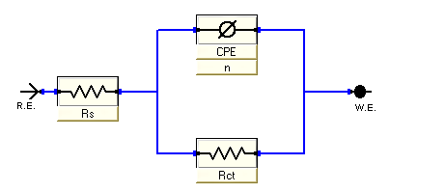
Figure 10. Electrical equivalent circuit used to fit impedance data.

3.3. Electrochemical Frequency Modulation (EFM)
Intermodulation spectra obtained from EFM measurements are presented in Figure (11a-b) as examples of carbon steel in 3.5% NaCl and 16 ppm Na₂S without and with 300 ppm concentration of adhatoda extract inhibitor at 25˚C. Each spectrum is a current response as a function of frequency.
The calculated corrosion kinetic parameters at different concentrations of the inhibitor in 3.5% NaCl and 16 ppm Na₂S containing different concentrations of extract at 25°C (i_{corr}, β_{a}, β_{c}, CF-2, CF-3 and % P) are given in Table 5. The corrosion current densities obtained from Table 5 are decreasing by increasing the concentration of the inhibitor and hence the inhibition efficiencies increase. The causality factors according to Table 5 are very close to theoretical (2.0 and 3.0) values which according to EFM theory should guarantee the validity of Tafel slope and corrosion current densities. Values of causality factors in Table 5 indicate that the measured data are of good quality (Ramachandran et al., 2008). The obtained results showed good agreement of inhibition efficiency obtained from the weight loss, potentiodynamic polarization, EIS and EFM methods.
According to Figure 12a an EDX spectroscopy for carbon steel surface gives the image of carbon steel surface. Figures 13a, 14a give the passive film formed on the carbon steel surface after immersion in the corrosive media in absence and presence of the inhibitor for about 5 days. In absence of the inhibitor (Fig. 13a) the results exhibited that thick porous layer of corrosion product (oxide film) cover all the electrode surface; the surface was strongly damaged, so the electrode surface cannot be seen. While Figure 14a present the image of the electrode surface in presence of 300 ppm adhatoda extract. The image show that, the surface is almost free from damages and it is smooth, which indicates a good protective film present on the carbon steel surface, and also confirms the highest inhibition efficiency of adhatoda extract.

Table 5 - Electrochemical Kinetic parameters obtained by EFM technique for carbon steel in 3.5%NaCl+16ppm Na₂S alone and with different concentrations of Adhatoda extract at 25±1º C.
%P | Ө | C.R,  mmy⁻¹ | CF-3 | CF-2 | β_{c},  mV dec⁻¹ | β_{a},  mV dec⁻¹ | i_{corr}.,  µA cm⁻² | Conc.  , ppm
------ | ------ | 309.9 | 2.891 | 1.933 | 1869 | 135 | 678.2 | blank
58.5 | 0.585 | 128.7 | 2.919 | 1.898 | 244 | 109 | 281.65 | 50
66.5 | 0.665 | 103.7 | 2.941 | 1.928 | 255 | 232 | 226.95 | 100
84.4 | 0.844 | 48.48 | 2.981 | 1.993 | 299 | 206 | 106.1 | 150
86.2 | 0.862 | 42.92 | 2.891 | 1.926 | 252 | 248 | 93.93 | 200
87.6 | 0.876 | 38.55 | 2.981 | 1.896 | 241 | 161 | 84.36 | 250
89.7 | 0.897 | 31.85 | 2.891 | 1.822 | 128 | 104 | 69.71 | 300

3.5. Surface Characterization

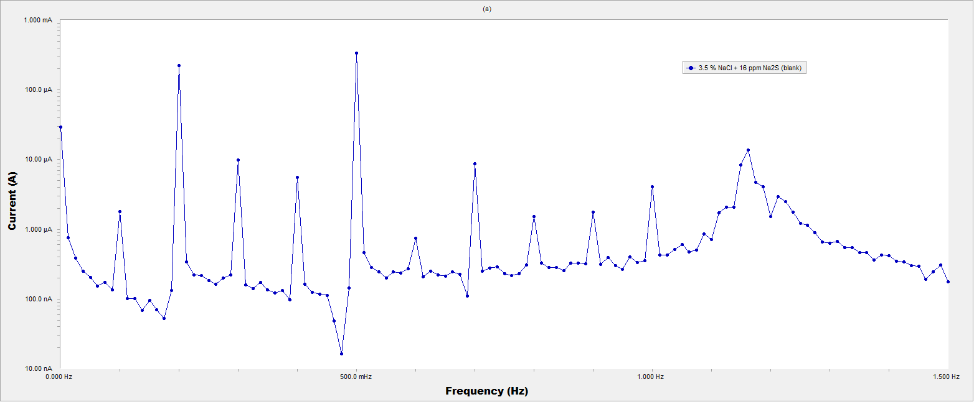
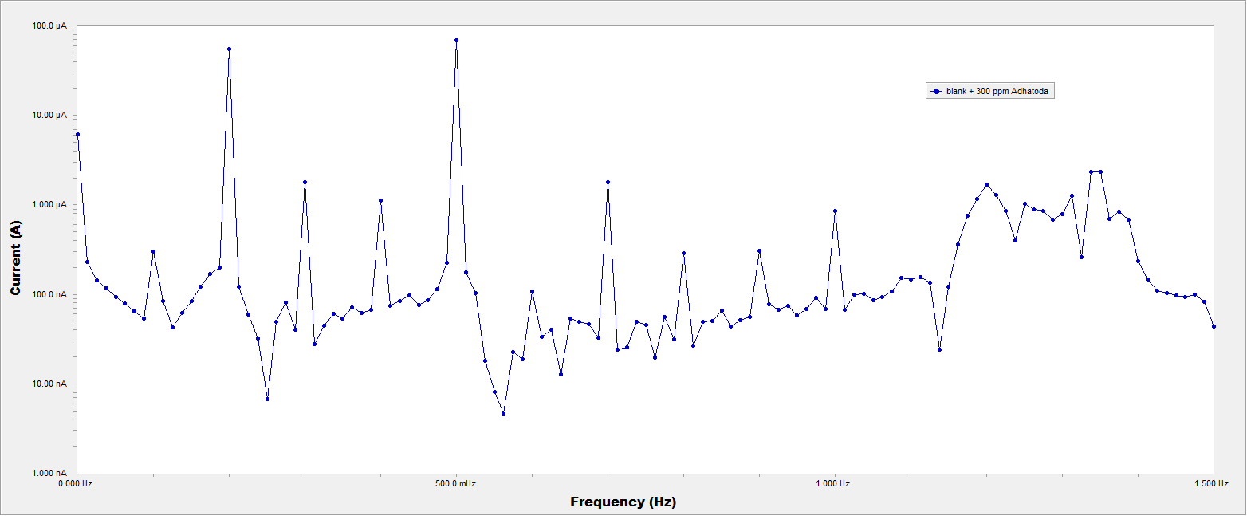
Figure (11a-b) Intermodulation spectrum for carbon steel in in sulfide polluted salt water in the absence and presence of 300 ppm concentrations of Adhatoda extract at 25ºC.

Figure 12b SEM spectroscopy for carbon steel surface. The characteristic peaks are related to the metals presented in the metal sample. In 3.5% NaCl and 16 ppm Na₂S only, Fig. 13b present the characteristic peaks which related to Fe, Mn, Cl, Na, S, and oxygen elements. This indicated to the corrosion product on the carbon steel surface being metal oxide. However, the data in Fig. 14b in presence of 300 ppm adhatoda extract shows addition peaks characteristic of N element, and the lower peaks height of Fe than those observed in the absence of inhibitor. This result proved that the adsorption of the inhibitor molecule on the metal surface leads to the decrease of metal oxide layer, and higher concentration of the inhibitor is necessary to delay the corrosion process.

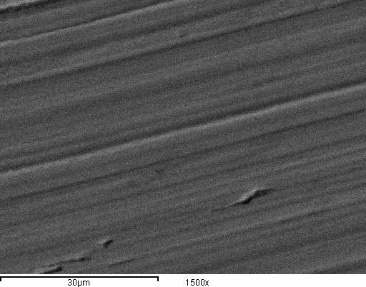(a)  Fig. 12a SEM of pure carbon steel surface. | 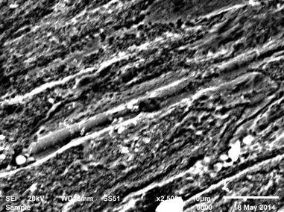(a)  Fig. 13a SEM of carbon steel surface after immersion in the corrosive media for 5days.
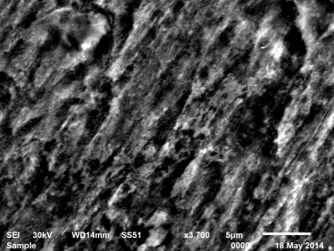(a)
Fig. 14a SEM of carbon steel surface after immersion in the corrosive media and 300ppm Adhatoda extract for 5 days.

(b)
Fig. 12b EDX of pure carbon steel surface.
(b)
Fig. 13b EDX of carbon steel surface after immersion in the corrosive media for 5days.
(b)
Fig. 14b EDX of carbon steel surface after immersion in the corrosive media and 300ppm Adhatoda extract for 5 days.

3.4. Biological Effect of Satirn on Escherichia Coli
From the bacterial agriculture of Escherichia Coli in absence and presence of Adhatoda extract inhibitor, we found a little activity and increasing in colonies of Escherichia Coli according to Table 6 and Figure 15. Adhatoda extract has oxygen, and nitrogen donor atom attached with the proteins and lipids on the bacterial tissues having activity for it by liberation of oxygen atom for respiration and nitrogen atom for nutrition. So this inhibitor has no toxicity on the bacterial activity, and can be applied safety on the sanitation plants without any problems in the treating operations.

Table 6 - Results obtained from the plate counter for bacterial agriculture
CFU (mean) | CFU (R2) | CFU (R1) | Samples
92 X 10⁴ | 95 X 10⁴ | 89 X 10⁴ | Control
93 X 10⁴ | 97 X 10⁴ | 88 X 10⁴ | Adhatoda

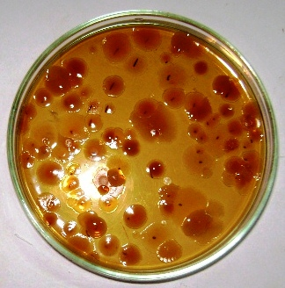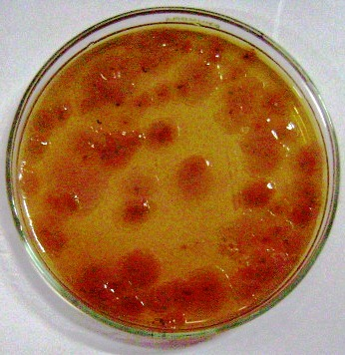

A B
A. Blank
B. The bacterial agriculture in presence of 300 ppm of Adhatoda
Figure 15. The bacterial agriculture in absence and presence of Adhatoda extract as inhibitor.

3.5. Mechanism of corrosion inhibition
The mechanism of inhibition of adhatoda extract depends on the adsorption of phytochemical composition of adhatoda extract on heterogeneous surface (Oguzie, 2007). The adsorption of the extract molecules on the metal surface is due to the donor – acceptor interaction between π electrons of donor atoms O, N, and aromatic rings of the vasicine and vasicinone structure of the inhibitor and the acceptor, i.e., vacant d orbital of carbon steel surface atoms (Lagrenee et al., 2002). The inhibitor molecules also can be adsorbed in the form of positively charged species on the metal surface which can interact electrostatically with negatively charged metal surface (due to the adsorption of Cl⁻ ions), leading to increase the surface coverage and consequently protect the metal surface from corrosion.

4. Conclusions
According to the obtained results, the following conclusions can be drawn:
Adhatoda extract acts mixed type inhibitor for the corrosion of carbon steel in sulfide polluted salt water. The inhibition is due to the adsorption of the inhibitor molecule on the metal surface by charge transfer or by the diffusion of the extract molecules. The adsorption of the extract molecules on the metal surface follows Temkin's adsorption isotherm. The inhibition efficiencies determined from different electrochemical techniques are in good agreement. Adhatoda extract was proved to be an effective ecofriendly and low cost inhibitor. This extract has no effect on the biological activity of Escherichia Coli, and can be applying safety on sanitation plants.

References
- G. Trabanelli, Inhibitors an old remedy for a new challenge, Corrosion 47 (1991) 410-419.
- Ostovari, S.M. Hoseinieh, M. Peikari, S.R. Shadizadeh, S.J. Hashemi, Corrosion inhibition of mild Steel in Seamum indicum 2M HCl/H₂SO₄ Interface, Corros.Sci. 51 (2012) 5805-5816.
- Abiola, J.O.E. Otaigbe, O.J. Kio, Corrosion Inhibition of Aluminium in Alkaline Medium using Vitex Negundo Leaves Extract, Corros. Sci. 51 (2009) 1879-1886.
- Muller, Zinc Corrosion in HCl in the presence of aqueous extract of Achillea Fragrantissima, Corros. Sci. 44 (2002) 1583-1591.
- Y. Li, P. Zhao, Q. Liang, B. Hou, Anise Extract as Green Corrosion Inhibitor for carbon Steel in hydrochloric Acid Solutions, Appl. Surf. Sci. 252 (2005) 1245-1253.
- A.Y. El-Etre, M. Abdallah, Z.E. El-Tantawy, Inhibition of mild Steel Corrosion in 1N HCl Medium by Acid Extract of Epherdra alata,Corros. Sci. 47 (2005) 385-395
- Bouyanzer, B. Hammouti, L. Majidi, Chemical Composition and Anticorrosive Activity of Warionia Saharea essential Oil Against the Corrosion of Mild Steel in 0.5M H₂SO₄, Mater. Lett. 60 (2006) 2840-2843.
- A.Y. El-Etre, Berberine as an Effective Corrosion Inhibitor for 7075 Aluminium Alloy in 3.5% NaCl Solution, Corros. Sci. 45 (2003) 2485-2495
- V.P. Barannik, I.N. Putilova, Uch. Zap. Mosk. Gosud, Inhibitive Action of Some Plant Extracts on the Alkaline Corrosion of Aluminium, Int. J. Electrochem. Sci., 7 (2012) 7823-7839.
- D. Maheswari, R. Rajalakshmi, S. Subhashini, M. Viswanathan S.Sivakamasundari, Inhibitory Action of Borassus Flabellifer Linn. (Palmyra Palm) shell Extract on Corrosion of Mild Steel in Acidic media, E-Journal of Chemistry, 7 (3) (2010) 1055-1065.
- C.A. Loto, A.I. Mohammed, R.O. Loto, Inhibition Effect of Extracts of Carica Papaya and Camellia Sinensis leaves on The Corrosion of Duplex (α β) Brass in 1M Nitric Acid, Corrosion Prevention Control 50 (3) (2003) 107-115.
- A.Y. El-Etre, Copper Corrosion Behavior in Phosphoric acid containing chloride and its inhibition by Artemisia Oil, Appl. Surf. Sci. 13 (2) (2012) 574-587.
- S. Subhashini, S. Sathyanarayana, C. Marikkannu, S. Sivakamasundari, Comined inhibition of Estrogen-Dependent Human Breast, ISAEST 7 (2002) 146-155.
- R. Rajalakshmi, S. Sathyanarayana, C. Marikkannu, S. Sivakamasundari, Study of the inhibitive Action of Bakery Waste for Corrosion of Mild Steel in Acid Medium, ISAEST VII (2002) 142-145
- G. Manohari, R. Rajalakshmi, Ninth Seminar Proceedings, Tamil Nadu State Council for Science and Technology, India 318 (2001).
- Prithiba, S. Sathiyanarayana, R. Rajalakshmi, S. Sivakamasundari, Proceedings of 11th NCCI, Baroda, India 3 (2003).
- G.Roja, B.H.Krant, Sant. K. Sandur, K.K. Pushpa. Food Chemistry 126 (2001) 1033-1038.
- Abdel-Rehim S.S., Khaled K.F., Abd-Elshafi N.S., Chemical and Electrochemical Investigations of L-Argininec as Corrosion Inhibitor for Steel in Hydrochloric Acid Solutions, Electrochemi. Acta, 51 (2006) 3269-3277.
- Bosch R. W., Hubrecht J., Bogaerts W. F., Syrett B.C., Enamin onitrile derivatives as corrosion inhibitors for Cu10Ni alloy in 0.5M HCl solutions, Electrochem.techniq for online corro. Monitor. Corros, 57 (2001) 60-70.
- Bentiss F, Traisnel M, Chaibi N, Mernari B, Vezin H, Lagrenee M 2,5-Bis (n-methoxyphenyl)-1,3,4-oxadizoles used as corrosion inhibitors in acidic media: correlation between inhibition efficiency and chemical structure. Corros. Sci. 44 (2002) 2271-2289.
- Popova, A.; Sokolova, E.; Raicheva, S.; Christov, M.; The inhibition effect of [3-(4-hydroxy-3-methoxy-phenyl)-1-(2-hydroxy-phenyl-propenone)] on the corrosion of the aluminium in alkaline medium, Corros. Sci. 4(5) (2012) 2213-2222.
- Fouda, A. S.; Al-Sarawy, A. A.; Ahmed, F.S.; El-Addasy H. M.,2-(2,6-dichloroanilino) phenyl acetic acid Drugs as Eco-Friendly Corrosion Inhibitors for Mild Steel in 1M HCl, Corros. Sci. 51(2009) 485-492.
- Umoren, S. A.; Eduok, U. M.; Solomon, M. M.; Udoh, A. P., Corrosion inhibition and adsorption behavior of Cocos nucifera L.coir dust for mild steel in 1M HCl: Synergistic effect of iodide ions, Arab. Jour. of Chemis. 1 (2) (2012) 2249-2272.
- Kamis E., the Effect of Temperature on the Acidic Dissolution of Steel in the Presence of Inhibitors Corrosion, 46 (1990) 476-484.
- El-Rehim S.S.A., Ibrahim M.A.M., Khaled K. F. 4-Aminoantipyrine as an inhibitor of mild steel corrosion in HCl solution, J. Appl. Electrochem., 29 (1999) 593-599.
- E. mc Cafferty, in : H. Leidheiser Jr. (Ed.) Corrosion control by coating, Synthesis of Magnetite-Containing Polyaniline-Polyacrylamide Nanocomposite haracterization and Corrosion Inhibition Behavior on Mild Steel in Acid Media, Sci. press, Princeton, 2 (4) (2013) 1148-1159.
- Larabi L., Benali O., Harek Y., Portug, Gravimetric and temperature effect studies of a novel imidazolium-based ionic Liquid as a corrosion inhibitor for carbon steelin molar hydrochloric acid, Electrochim. Acta, 5 (3) (2013) 294-304.
- Larabbi L., Harek Y., Traisnel M., Mansri A., Corrosion Inhibition of Mild Steel by 4-Allyl-5-Pyridin-4-yL-4H-1,2,4-triazole-3-thiol, J. Appl. Electrochem., 34 (2004) 833-839.
- Benali O., Ouazene M., Inhibition Effect of 3-bromo-2-phenylimidazol [1, 2-α] pyridine towards C38 Steel Corrosion in 0.5M H₂SO₄ Solution, Arab. J. Chem., 4 (2011) 443-448.
- Larabi L., Benali O., Harek Y., Application of Some Oligopolymers as Effective Corrosion Inhibitors for Mild Steel in 1M HCl: Gravimetric, Thermodynanic and electrochemical Analysis, Mater. Lett., 61 (2007) 3287-3291.
- Larabi L., Harek Y., Benali O., Ghalem S., Inhibition Effect of Thymelaea hirsute Extract towards Steel Corrosion in HCl Solution, Prog. Org. Coat., 54 (18) (2005) 256-262.
- Umoren, S. A.; U. M.; Solomon, M. M.; Udoh, Ethno Medicinal and Therapeutic Potential of SIDA ACUTA Burm. F, A. P. Arab. J. Chem., 4 (1) (2013) 88-92.
- Benali O., Larabi L., mekelleche S.M., Harek y., Inhibition of mild steel corrosion in 5% HCl solutionby 5-(2-hydroxyphenyl)-1,2,4-triazole-3-thione, J. Mater. Sci. 41 (2006) 7064-7073.
- Ammar, I. A.; Darwish, S., Thermodynamic and quantum chemistry study for dimethylol-5-methyl hydantoin and its derivatives as corrosion inhibitors for carbon steel N-80 in raw water (cooling water system), Corros. Sci., 2 (2) (2011) 128-147.
- A.S. Fouda; A. Nazeer; A. Y. Elkhateeb; M. Fakih, Cinnamon Plant Extract as Corrosion Inhibitor for Steel Used in Wastewater Treatment Plants and
- Its Biological Effect on Escherichia Coli, 58 (4) (2014) 359-365.
- T.Tsuru, S. Haruyama, B. Gijutsu, Corrosion Inhibition Performance of 3,5-Diamino-1,2,4-trizole forProtection of Copper in Nitric Acid Solution, J. Jpn. Soc. Corros. Eng. 27 (1978) 573-581.
- F. Bentiss, M. Lagrenee, M. Traisnel, j.C. Hornez. Inhibition of mild steel corrosion in hydrochloric acid solution by cloxacilin drug, Corros. Sci. 41 (1999) 789-803.
- S. Ramachandran, M. Tsai, M. Blanco, H. Chen, W. A. Tang, Langmuir, Molecular Simulation quantum chemical calculations and electrochemical studies for inhibition of mild steel by triazoles, 53 (2008) 3484-3492.
- E.E. Oguzie, Effect of Flowing Conditions on the Corrosion Inhibition of Carbon Steel by Extract of Buddleia Perfoliate, Corros. Sci. 49 (2007) 1527-1539.
- M. Lagrenee, B. Mernari, B. Bouanis, M. Traisnel and F. Bentiss, Improvement of Corrosion Resistance of Carbon Steel in Hydrochloric Acid Medium by 3,6-bis (3 Pyridyl) Pyridazine, Corros. Sci., 44 (2002) 573-588.

2/8/2015

