Spatial planning issues of intensive gravity and influence zone of the capital Ulaanbaatar city

Bazarkhand Ts¹, Munkhnaran S¹, Chinbat B¹ and Myagmartseren P¹

¹Department of Geography, School of Arts and Sciences, National University of Mongolia
munkhnaransugar@gmail.com

Abstract: The intensive gravity and influence zone of the capital city is a main space for Ulaanbaatar city decentralization and the core object to regional planning for the capital. The intensive gravity and influence zone of the capital city should be restructured for better planning and development of Ulaanbaatar region. Thereto micro zones of the intense gravity and influence zone are created through internal zoning and should be developed with precise development functions. To develop above-mentioned micro zones, major and sub centers and development policy are established based on a group settlement scheme. Development of micro zones in the intense gravity and influence zones are significant to produce urban construction, land management and city’s regional development plans for the reason that it is critical to define regional planning tendency without considering the number of population, employment, other socio-economic characteristics and spatial gravity of settlements and administrative units located in the intensive gravity zone of Ulaanbaatar city.
[Bazarkhand Ts, Munkhnaran S, Chinbat B and Myagmartseren P. Spatial planning issues of intensive gravity and influence zone of the capital Ulaanbaatar city. Nat Sci 2015;13(2):88-93]. (ISSN: 1545-0740). http://www.sciencepub.net/nature. 13

Keywords: intensive gravity and influence zone of capital city, micro zone, group settlement system

1. Introduction
Territory of capital city belongs to the Ulaanbaatar zone and the territory of Tuv aimag belongs to central region according to the regional planning principles of Mongolia, however they constitute an integrated area of territorial unit.
Ulaanbaatar city and other settlements play own roles in their territory as well as at the national level. Every 2 persons out of 5 permanently live or 40% of total population of the country resides in Ulaanbaatar city which occupies 0.3% of total territory of Mongolia. Therefore there is need to renew and define city’s intensive gravity and influence zone and create appropriate internal zones and thus optimal system of spatial organization would be developed.
Intensive gravity and influence zone of capital city was defined under the name of “Intensive gravity and influence zone of Ulaanbaatar zone” in master plan, developed in 2002. For the reason that the capital’s intensive gravity and influence zone should have integrated territorial and administrative character, it is appropriate to change the boundary of zone with Tuv aimag boundary which was formerly included capital city, Tuv aimag, 2 soums of Selenge aimag and 4 soums of Khentii aimag. Inclusion of capital city and Tuv aimag to the intensive gravity and influence zone of capital city is practical for optimal assumption of territorial spatial correlation, institutions' cooperation improvement and planning efficiency growth. The present development role of capital of the intensive gravity and influence zone and future tendency of some agricultural products were defined.
А. Geographical location, population and territory. Intensive gravity and influence zone occupies 74852.37 square km which comprises Tuv aimag, Bagakhangai and Baganuur districts territorially. Density of population is 1.5 persons per square km.
B. Agricultural development. Livestock husbandry - By the end of 2010, the number of livestock reached 2710.70 thousand which was increased by 21.75 percent or 753.45 thousand heads from year of 2009. The development plan for livestock husbandry should be closely linked to the development policy of every micro zone in intensive gravity and influence zone of capital. Supply with meat and dairy products to population of Ulaanbaatar city and other neighboring settlements are potential through the increased regional agricultural products.
Agricultural production - Development of agricultural sector is required to provide regional population with potatoes, vegetables, milk and dairy products from the local market in a maximum level (Table 1).
It is potential that 50% of the potatoes need and 100 % of vegetables demand can be provided locally in the level of intensive gravity and influence zone. Besides supplying with vegetables and potatoes, there is an urgent necessity to increase provision for the milk and dairy products also studying the feasibility to provide local market due to the fact that 40% of the total need of milk and dairy products are imported although we have only 2.8 million population with more than 40 million heads of livestock.

Table 1. Agricultural products demand of the Capital city's population
Name of products | Potatoes | Vegetables | Milk and dairy products
Annual standard per city person, kg | 45 | 25 | 200
Capital city’s demand, ton | 53670,6 | 29800 | 238500
Total amount of production of city zone, ton | 25394.6 | 12596 | 60048.4
Variance at regional level, ton | 28276 | 17204 | 178451.6
Note: Population demand for capital city in ton. Population of Tuv aimag and city is (1325200). Estimated unit to 0.9 is 1192680.

The following table is shown the perspectives of production of potatoes, vegetables, milk and dairy products until 2030 (Table 2).

Table 2. The perspectives of production of potatoes, vegetables, milk and dairy products until 2030
Cultivation field (ha) | 2010 | 2020 | 2030
Potatoes | 4000 | 5500 | 7000
Vegetables | 3000 | 4500 | 6000
Wheat | 65000 | 70000 | 75000
Forage plants | 4000 | 8000 | 12000
Berries | 4000 | 5000 | 6000
Total field of cultivation (ha) | 80000 | 93000 | 106000

C. Infrastructure development. Road network system in the intensive gravity and influence zone is the major transportation junction of the country connected with other aimag centers in the 7 directions passing through the territory of Tuv aimag, Baganuur and Bagakhangai districts. 60% of the national road as well as 6% of the local road are covered with asphalt. For power plant development, all soums and settlements were connected with central power plant system in intensive gravity and influence zone. Among the cities and settlements of the zone Zuunmond, Baganuur, Bagakhangai also Bayanchandmani, Batsumber, Ugtaal, Argalant and Zaamar centers have own central heating system.
D. Service and industrial development. It can be said that there is enough infrastructure sufficiency and working force and market resources which is the main resources to develop production and service sector in the zone. There is high possibility to distribute and collect the raw materials and goods which is produced in a national level besides the impact zone. Therefore, it is effective to improve and develop old service and production manufactures and diversify industrial centers by arranging the locations of manufactures which should be accommodate out of Ulaanbaatar city.

2. Material and Methods
In order to define intensity of gravitation of the centers and settlements to Ulaanbaatar city in influence zone the following parameters including distance, number of population of settlements’, reverse correlation of distance are used.
Distance correlation of settlements. Distance correlation of settlements is divided into two types of distances namely geometric and real distance. Geometric distance creates various gradients with parameters of time to reach to certain centers, number and frequency of communication and transportation expenses.
- Communication frequency is very high to settlements which are located in radius of 75 km with Ulaanbaatar city.
- Communication frequency is high to settlements which are located in radius of 75-100 км with Ulaanbaatar city.
- Communication frequency is average to settlements which are located in radius of 100-150 км with Ulaanbaatar city.
- Communication frequency is weak to settlements which are located in radius of 200 км with Ulaanbaatar city.
Reverse correlation of population, distance of centers and settlements. Relation gravity of the centers and settlements in intensive gravity and influence zone is calculated with deductive, inductive, quadrate and functional models (Bhatta.B, 2009) and relation gravity is defined by deductive and quadrate models depending on the accessibility of statistic data of capital city, Tuv aimag and other centers and settlements.
- Deductive model
- Inductive model
- Quadrate model
- Functional model
Gravity intensity of settlements
Settlement population
Settlement population
D- Distance of settlements
Any function in the settlement
a, b, f – Constant number
Deductive model was used to define general relation gravity of the settlements and quadrate model was clear to define more detailed gravity calculation of the centers and settlements. Because of lack of statistical and numerical data and scope and types of functional parameters of service and production, banking and finance, culture and education of remote districts the inductive and functional models were limited to check.

3. Results
3.1. Spatial gravity of settlements in intensive gravity and influence zone and system of community
As a result of distance correlation gradient, settlements in the intensive gravity and influence zone are classified into following sub zones:
- Sergelen, Zuunmod, Altanbulag, Bayanchandmani, Batsumber and Erdene soums are included in less than 75 km gradients from Ulaanbaatar city.
- Bornuur, Bayandelger, Arkhust, Bayan, Argalant and Bayantsogt soums are included in 75-100 км gradients from Ulaanbaatar city.

- Mungunmorit, Bayanjargalan, Bayantsagaan, Bayan-Unjuul, Undur- shireet, Lun, Bayankhangai, Ugtaal, Tseel, Jargalant and Sumber soums are included in 100-150 km gradients from Ulaanbaatar city.
- Buren, Erdenesant, Delgerkhaan, Zaamar soums are included in 200 km gradients from Ulaanbaatar city.
There are three gradients for relation gravity of Ulaanbaatar city, Tuv aimag and other settlements through the quadrate model calculation. It includes:
- Gravity intense is high - Zuunmod of Tuv aimag, Bayanchandmani, Batsumber, Altanbulag and one of the remote district of Ulaanbaatar is Baganuur
- Gravity intense is average - Jargalant, Bornuur, Erdene, Sergelen, Bagakhangai, Bayan, Argalant, Bayantsogt soums
- Gravity intense is weak - Sumber, Tseel, Ugtaal, Zaamar, Lun, Bayankhangai, Undurshireet, Erdenesant, Buren, Bayan-Unjuul, Bayantsagaan, Bayanjargalan, Arkhust, Mungunmorit, Bayandelger soums (Figure 1).

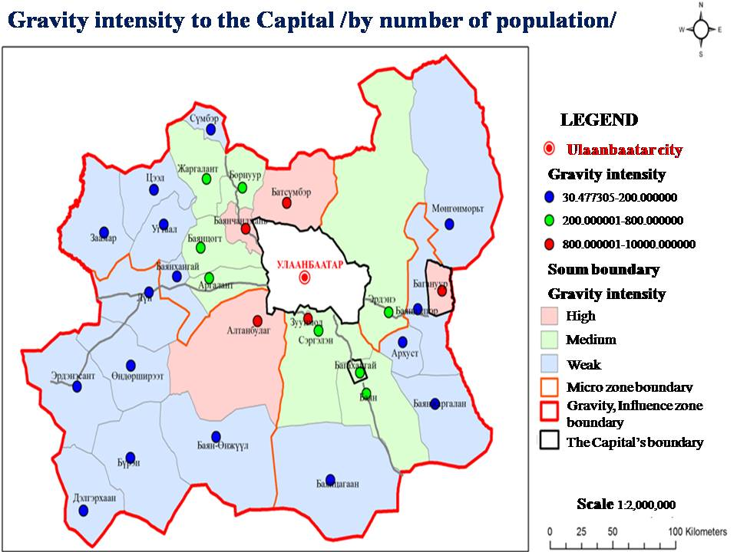
Figure 1. Gravity intensity to the Capital

Gravity to the axle of the settlements in intensive gravity and influence zone is assumed for passing through national and international road and railway along vertical axle and gravity of settlements from the central axle with 25 and 50 km as followed:
- Gravity to road axle
- Gravity to railway axle
Gravity to road axle. Road network system in intensive gravity and influence zone is a major transportation junction of the country connected with other aimag centers in the 7 directions passing through the territory of Tuv aimag, Baganuur and Bagakhangai districts. 60% of the national road as well as 6% of the local road are covered with asphalt. Roads were evaluated along the vertical and horizontal axles:
- Very high gravity intense gradient to road axle- Erdenesant, Lun, Undurshireet, Bayankhangai, Argalant, Bayanchandmani, Bornuur, Jargalant, Sumber, Zuunmod, Sergelen, Bagakhangai, Arkhust, Erdene, Bayandelger, Baganuur, Bayan and Altanbulag soums.
- High gravity intense gradient to the road axle- Zaamar, Ugtaal, Bayantsogt,
Batsumber, Bayanjargalan, Bayantsagaan soums. It can be concluded that most of centers and settlements are strongly pulled to the road axle intensively.
Gravity to railway axle. Railway which connects Asia and Europe passes through the capital’s intensive gravity and influence zone. Most part of the territory is bended to this railway axle.
- Soums with very high gravity intense to the railway axle are Batsumber, Bayandelger, Arkhust, Bayan, Bagakhangai, Sergelen and Zuunmod.
- Soums with high gravity intense to the railway axle are Bornuur, Bayanchandmani, Bayantsagaan, Bayanjargalan and Erdene soums.
- Pillar and sub centers were found out based on the result of research of intensive gravity and influence zone.
The group of settlements in intensive gravity and influence zone are Lun, Altanbulag, Argalant, Bayanchandmani, Baganuur and Bagakhangai and would be developed with group of settlement centers and total territory is divided into the micro zones (Figure 2).

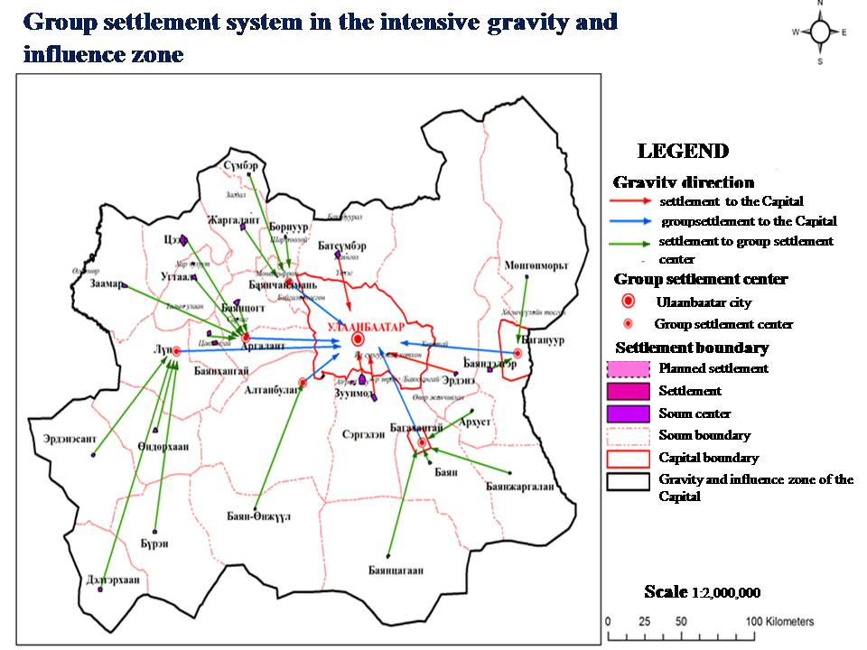
Figure 2. Group settlement system in the intensive gravity and influnece zone

3.2. Internal zoning of intensive gravity and influence zone
The following recommendations and changes have been made for the perspective development considering main role for the capital’s zonal development, spatial correlation of settlements and system of settlement group. There are four different development micro zones have been classified and defined looking at specialty of territory, present level of development and future perspectives (Figure 3).

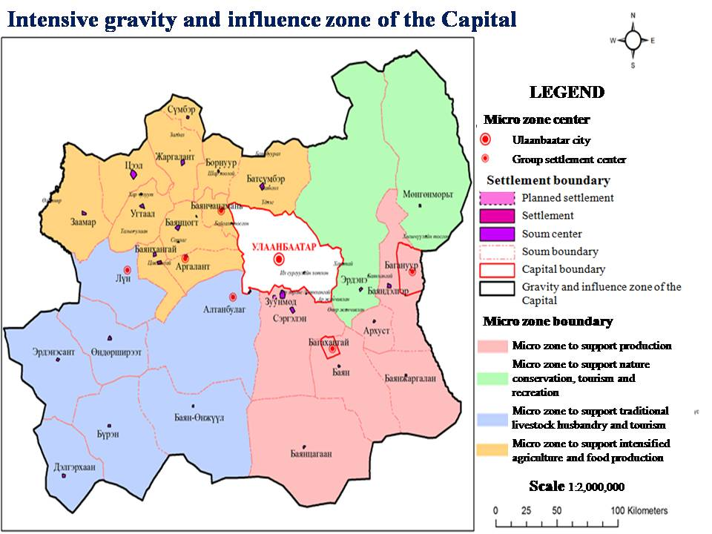
Figure3. Intensive gravity and influence zone of the Capital

A. Micro zone to support nature conservation, tourism and recreation and its development perspectives. This zone includes Erdene and Mungunmorit soums of Tuv aimag and ¼ of the Ccapital zone’s territory which occupies 14759.9 square km of area. 60% of total area of micro zone occupies strictly protected areas which require nature conservation, proper land use and planning policy. Nature conservation and proper use management is needed after defining international, national and local tourism zones based on tourism and recreational resources. Urbanization, mining and other production activities are prohibited in this area. The policy to keep the number of animals and cultivation field in an optimal size that can provide local necessity fully based on the agricultural development of the micro zone in an appropriate level.
B. Micro zone to support production and its future development perspectives. This zone includes Mungunmorit, Bayandelger, Erdene, Arkhust, Bayan, Bayantsagaan, and Bayanjargalan, Sergelen soums of Tuv aimag and Baganuur and Bagakhangai districts. Baganuur and Bagakhangai districts are planned to be pillar centers of the zone and following policy will be kept. To support meat production and intensified cattle farms increasing forage plants. Fuel and power plant, coal and chemistry production can be developed in Baganuur district and the same time should renew independent city status by supporting trade and service sector as well as social infrastructure development. For the first stage of development, meat and meat processing factories would be established in pillar center of Bagakhangai and further development of trade, business and social infrastructure should be supported and rearrange some offices and factories which are removed from city and support food and light industry and logistics based on the favorable geographical location and infrastructure development. In the future, number of population in the city will be increased as a result of production sector support in micro zone, therefore animal products and develop animal husbandry are required to be increased.
The micro zone land use policy should regulate land use of industrial centers and settlements and improve unified land fund utilization and decrease pasture degradation.
C. Micro zone to support traditional livestock husbandry and tourism and recreation and its future development perspectives. This micro zone includes Altanbulag, Buren, Bayan-Unjuul Undurshireet, Erdenesant, Lun and Delgerkhaan soums. Looking at the geographical location, infrastructure development and future perspectives Lun and Altanbulag soums are selected to become pillar centers of the zone. Simultaneously, increasing wheat production, flour and pastry production in pillar centers should have policy to establish and rearrange first steps of animal raw material processing factories which are planned to be removed from city center.
D. Micro zone to support intensified agriculture and food production and its future development perspectives. This zone includes Bayantsogt, Bayanchandmani, Batsumber, Bornuur, Jargalant, Argalant, Bayankhangai, Tseel, Zaamar and Sumber soums. According to the Tuv aimag’s unified land fund census, more than 60% of the cultivation field belongs to this zone and it is possible to improve the supply of food production and diversify cultivation agriculture in the zone.
Bayanchandmani and Argalant soums are planned to become pillar centers of this zone. It is worth to build storage for keeping vegetables and potatoes which is grown in Bulgan, Selenge and Tuv Aimags. Also there are recommendations to open wholesale center, vegetable processing factories as well as milk and dairy production have been made. Milk, potatoes, vegetables, eggs, and forage plants dominate among the supplying goods to Ulaanbaatar. In the future, policies to increase dairy production based on fodder plantation and intensify cultivation agriculture as well as an increase of cultivation field in the zone by cultivation types.

4. Discussion
In regard for renewing intensive gravity and influence zone, it is appropriate to change boundary of zone with Tuv aimag boundary which has been formerly capital city, Tuv aimag, 2 soums of Selenge aimag and 4 soums of Khentii aimag. Because the capital’s intensive gravity and influence zone must be provided unified character for administratively and territorially equally. This territorial spatial correlation shall be optimal including only capital city and Tuv aimag in the intensive gravity and influence zone. So there will be accumulated an efficient system of spatial organization of settlement, improve population food supply and increase the roles in the zone in the future.
In frame of spatial correlation of settlements to Ulaanbaatar city there are three types of gravity intensity gradients which are very high, average and weak gravity intense. The centers of the zone can be developed at Lun, Altanbulag, Argalant, Bayanchandmani as a group of settlement.
Four different micro zones have been classified based on gravity and influence correlation with Ulaanbaatar city, specialty of nature and territory, present level of development and future perspectives. The separate development policy shall be defined in order to reduce over concentration in Ulaanbaatar city by developing zonal centers which will be the main principle of local policy.

Corresponding Author:
Munkhnaran S
Department of Geography, NUM Building-7-201,
School of Arts and Sciences, National University of Mongolia
Ulaanbaatar 14191, Mongolia
E-mail: munkhnaransugar@gmail.com

References
- Bhatta. B “Modelling of urban growth boundary using geoinformatics”, 2009.
- Bilegsaikhan.M, Chinbat.B “Natural recreational geography”, 2009.
- Board of Land Administration, Construction, Geodesy and Cartography “Reports of unified land fund of the capital”, 2010.
- Capital city governor office, "Baganuur district general development planning", 2010.
- Capital city governor office, "Bagakhangai district general development planning", 2010.
- Capital city governor office, "Nalaikh district general development planning", 2010.
- Government decree No.133, “Take some measures to carry out livestock keeping in capital city territory”, 1st July, 2002.
- Institute of design and projects of capital city, “Capital city’s zonal development principle”, 2002
- Land service. LLC, "Land management planning of Tuv aimag", 2008.
- Narantsatsralt.J “Main issues of land management in new condition of socio economic situation”, 1998
- Purevtseren. G “Master plan of capital’s land management”, 2001.
- Tuv aimag governor office, “Development program of Tuv aimag”, 2008.
- Ulaanbaatar city zonal council-“Development perspectives of Ulaanbaatar city micro zone, satellite and border city, and villages”, 2010.

2/10/2015

