Manhole Odor Filter Pilot Project For the Sewerage Network in Sana'a, Yemen

Fadhl Ali Al-Nozaily¹, Abdulwahab Ismael Salah¹, Ibrahim Ahmed Al-Mahdi¹ and Hala S. Doma²

¹Sana'a Water and Sanitation Local Corporation, Yemen
²Department of Water Pollution Control, National Research Centre, Cairo, Egypt
drfadhl@yahoo.com

Abstract: A pilot project of manhole odor control unit was designed and implemented locally for the sewerage network of the last 5km from the side of WWTP at the Sana'a airport street, Sana'a, the capital city of Yemen. The project is implemented by Sana'a Water and Sanitation Local Corporation (SWSLC). The objective of this pilot project is to accommodate a cheap and sustainable technology to be implemented locally as innovation to eliminate the emitted bad odor in the form of hydrogen sulfide (H₂S) and ammonia (NH₃), as well as using a suitable protective coating for the concrete inside the manholes to prevent corrosion. The pilot project was conducted during two months of August and September 2008. The results showed that at the very high point inside the manholes, the H₂S and NH₃ concentrations were135 and 118mg/l, respectively; while at 20cm aside from the manhole surface, the concentration of H₂S and NH₃ became 105 and 30mg/l, respectively, while increasing slightly at the top of the ventilation column (at the height of 6m) the H₂S and NH₃ concentrations were measured 119 and 49mg/l, respectively. The installed unit was filled with activated carbon to adsorb the gases causing bad odors emitted from sewerage system. The averaged H₂S measurements after installation of the units were averaged 20mgH₂S/l, but unfortunately, at the same time, the galvanized steel container was corroded and need to be replaced. The pilot project demonstrated that the technology of activated carbon to adsorb odors is able to solve the problem locally in Sana'a Yemen, lowering concentrations of hydrogen sulfide gas with efficiency of around 85% and inexpensively in addition to low maintenance costs. Assuming that the activated carbon cartridge shall have a minimum H₂S capacity of 0.20g/CC, the activated carbon could be used for 4-5 years before replacement if the H₂S concentration reached 117mg/l. Further efforts are needed to develop the use of plastic material instead of the galvanized steel container to prolong life of the unit, and determine the extent of affect of ammonia on the activated carbon and the need to add the wet biological filter to remove ammonia beforehand.
[Fadhl Ali Al-Nozaily, Abdulwahab Ismael Salah, Ibrahim Ahmed Al-Mahdi and Hala S. Doma. Manhole Odor Filter Pilot Project For the Sewerage Network in Sana'a, Yemen. Nat Sci 2015;13(2):106-112]. (ISSN: 1545-0740). http://www.sciencepub.net/nature. 16

Keywords: Odors, hydrogen sulfide, ammonia, protective coating, manhole, corrosion.

1. Introduction:
Transport of wastewater in sewer networks causes potential problems associated with hydrogen sulfide in regards to odor nuisance, health risks and microbially induced corrosion (Yongsiris et al., 2005; Stuetz and Frechen, 2001; Koeand Yang, 2000). Developing countries such as the Republic of Yemen are facing difficulties to accommodate the technology required to solve this problem and thus need huge amounts of money to mitigate or eliminate such problem.
The sewerage network that was implemented in Sana'a, the capital city of Yemen began emitting bad odors in the form of H₂S and NH₃. People were complaining about such odor through a distance of 5km on the airport road. In addition, the concrete manholes were corroded (picture 1). There is much organic matter in the domestic water, which is the most common source of pollution. Analytical data showed that the dissolved oxygen concentrating in the waste water is very low, varying within 0.01-0.2mg/l, even nearly zero. The process of decomposition of organic matter in the wastewater storage and circulation systems (manholes, sewers) takes place mainly in anaerobic condition, giving the wastewater in the sewers its deep black color
(Boon A. G., 1995). The final products of this process are H₂S and NH₄; gases which give unpleasant odor, affecting greatly the air quality in the tenements, especially near the manholes and sewers (Truong et al., 2007; Metcalf & Eddy, 1991).
A lower pH produces more aqueous H₂S and increases the rate of H₂S transfer to the gas phase. Turbulent wastewater also facilitates the release of H₂S to the atmosphere(Sawyer et al., 1967). As H₂S is released into the sewer atmosphere, it combines with water on the crown of the pipe to form sulfuric acid (H₂SO₄), which corrodes the sewer infrastructure, thus it is necessary to stop H₂S production in the collection system (Churchill and Elmer, 1999). The activated carbon filter as an odor adsorbent proved to be the most dependable technology (Duan et al.,2006; Koe, and Yang,1999). Biological activated carbon (BAC) has been showing the ability to remove gaseous contaminants in biofiltration (Duan et al., 2007; Andrea, 2004). Bagreev et al. (2001) stated that the sewage sludge-derived materials were used as adsorbents of hydrogen sulfide from moist air. The adsorbent obtained by carbonization at 950°C has capacity twice of that of coconut shell-based activated carbon.
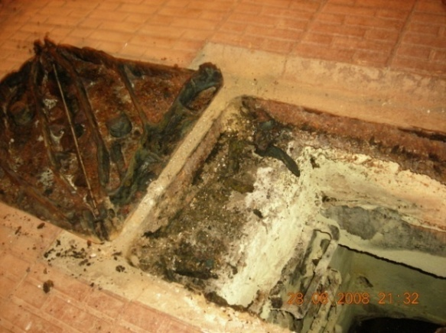

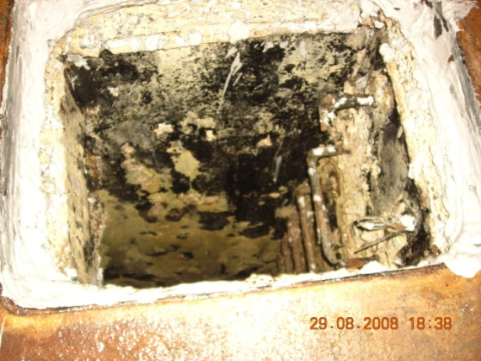
Picture (1) corroded MH sides and cover due to the emitted H₂S

Because of the complaints were raised by the guests coming from outside the country and passing airport street on the odors from the sewerage network, The SWSLC has taken the initiative announcing to request for solutions to eliminate the odors. Several firms reacted and submitted their offers for design, implementation and operation of the units to get rid of odors emitted from the sewerage network on the road to the airport.
Therefore, the main objective of this study is to eliminate bad odor from the sewerage network and to minimize the MH corrosion. This could be achieved by designing an innovative protective solution to the manhole using local and low cost technology with applying good absorbent material like activated carbon.

2. Materials and Methods:
This pilot project was conducted during two months August and September 2008, the installation of the units took one full week working from early morning (8am) to midnight (12pm). The methodology applied for the pilot project has started by getting down to the field and taking some measurements of H₂S and NH₃ from the manholes and the ventilation column chimney using Gas Alert Micoro5, BW TECHNOLOGIES 2008. The measurements of each spot took place at three points: manhole, aside of the manhole and at the ventilation columns. (Pictures 2&3). The material used for the manhole protective container was galvanized steel equipped with activated carbon as the adsorbent material. The container has been assembled in a workshop with mechanical assemblage and welding in Sana'a. It is shaped as part of a pyramid open from the upper side and closed from the base with rectangular holes of 10×30mm at the base. The upper base size was 42×58cm with lower base size of 30×20cm and a depth of container of 30cm. The adsorbent material of activated carbon and the nylon basket to hold the activated carbon grains were purchased from the local market. Before installing the units at site, the manhole (MH) sides and opening was cleaned and the highest iron step in the MH was removed in order to accommodate the container at the opening of the MH. The odor control unit was mounted as follows: The galvanized steel unit was installed above the manhole cover frame with screw nails; the welded pieces of the stainless steel container were painted by epoxy to prevent corrosion at the welding points; The bottom side of the MH-cover was shaved to avoid interference with the unit. Activated carbon as a bag of 20kg was decanted inside the nylon basket (with openings of less than the grains diameter to prevent passages of activated carbon grains). The unit was installed at the top of MH opening. All openings around the unit and manhole cover were closed with silicon to tighten the MH. The unit has been designed to bear vehicles load when passing above it.
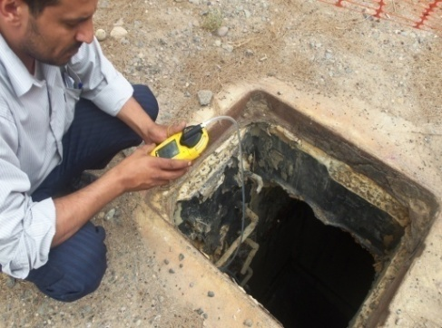
Picture (2) odor measurements at the MH.

Using activated carbon as adsorbent technology was selected to adsorb the gases causing odor emitted from the manhole. The unit was designed as manhole odor control unit by the authors in collaboration with technicians of the SWSLC (picture 4). The galvanized steel unit has been assembled in a workshop with mechanical assemblage and welding in Sana'a (picture 5, a, b, c &d) as follows:
Galvanized steel container shaped as part of a pyramid open upper side and closed base with rectangular holes of 10 × 30 mm with the sizes of upper base of 42 × 58 cm and lower base of 30 × 20 cm with a unit depth of 30 cm.

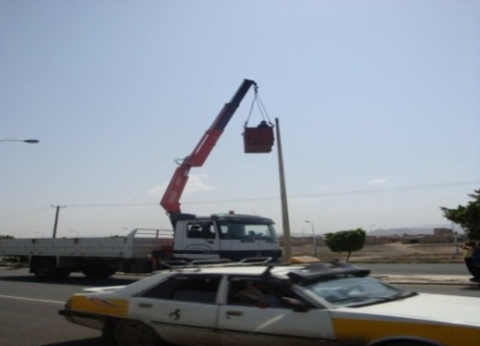
Picture (3) odor measurements at the ventilation column

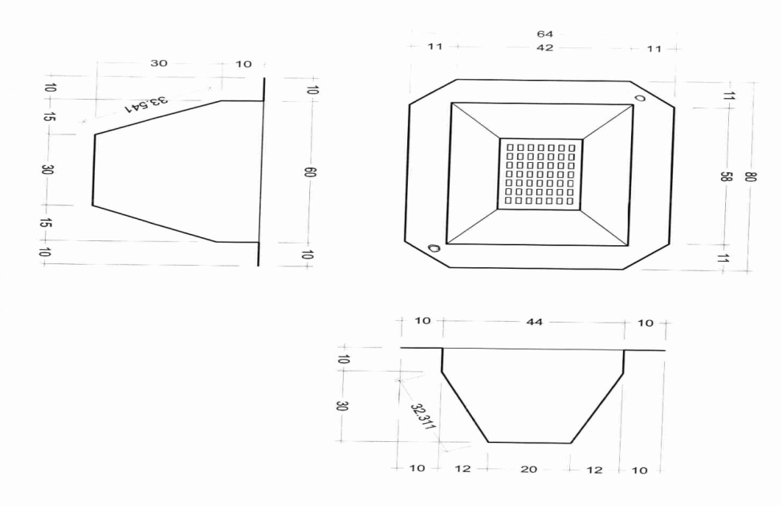
Picture (4) The Design of the galvanized steel unit.

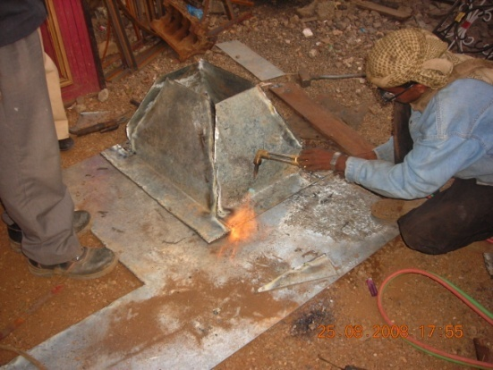
Picture (5a)
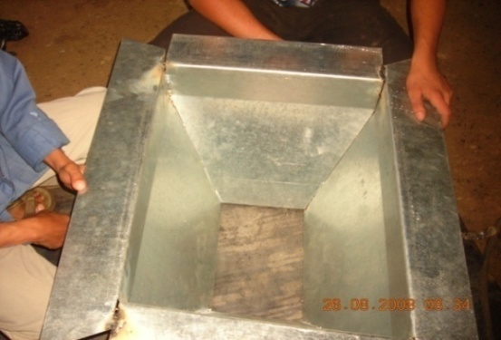
Picture (5b)
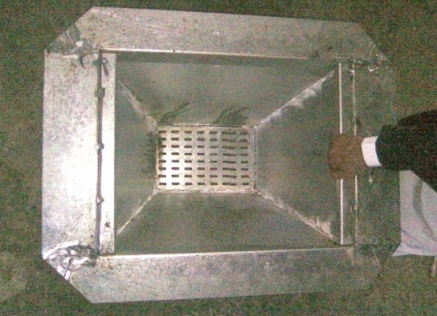
Picture (5c)

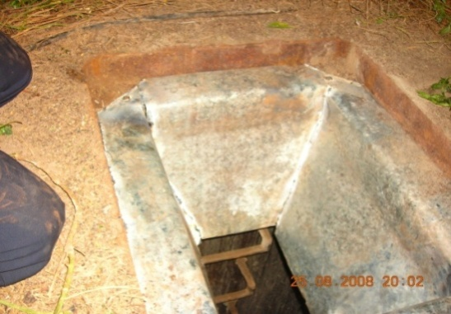
Picture (5d)
Pictures (5, a, b, c & d): The sequence of steps for processing, construction and installation of the protective cover of MH at a welding workshop

Other components (activated carbon, nylon basket) were purchased from the local market (picture 6,7).

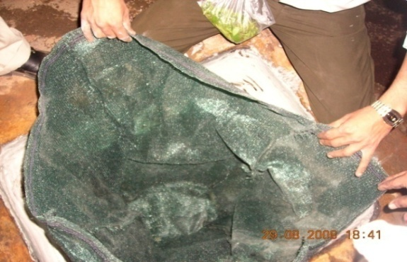
Picture (6) The nylon basket used for holding the activated carbon

The unit were carried to the site to be installed (Pictures 8, a, b, c, d, e, & f). Before installing the unit, the MH was cleaned and the highest step in the MH was removed to accommodate the container. The Unit was mounted as follows:
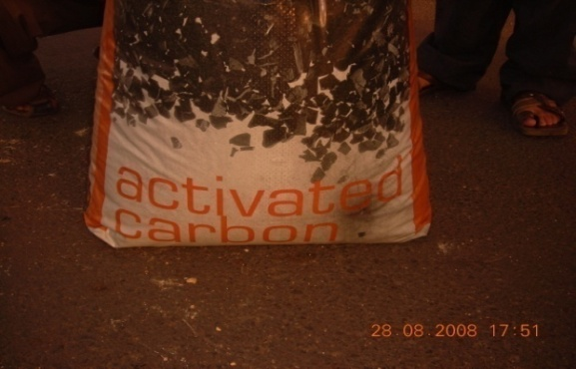
Picture (7) The Activated carbon used in the project

•The galvanized steel unit was installed above the manhole cover frame with screw nails, the pieces of the stainless steel container were welded and the welded points was painted by epoxy to prevent corrosion. The bottom of the MH cover was shaved to prevent interference with the Galvanized steel container.
• Perforated nylon basket with openings at a diameter of 5 mm was used so as to prevent passing the activated carbon grains out of the steel container.
• Activated carbon as a bag of 20 kg was placed inside the nylon basket.
• All openings around the unit were closed with silicon to tighten the MH and force odors to pass through the unit-containing activated carbon
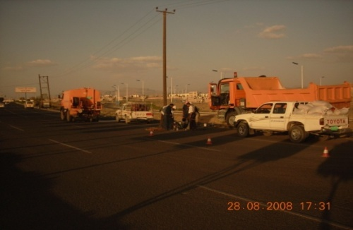
(Pic.8a)
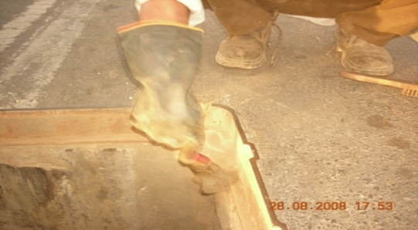
(Pic.8b)
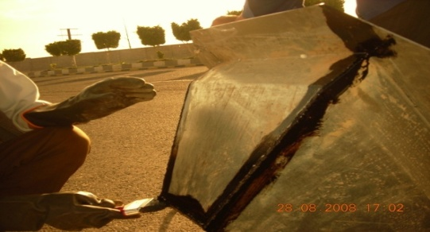
(Pic.8c)

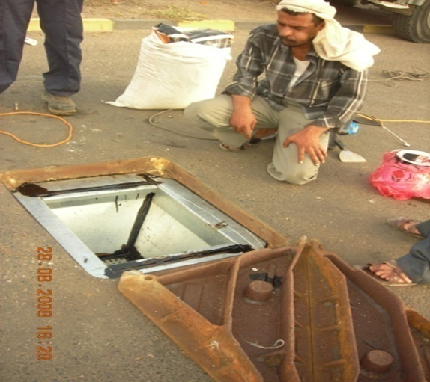
(Pic.8d)

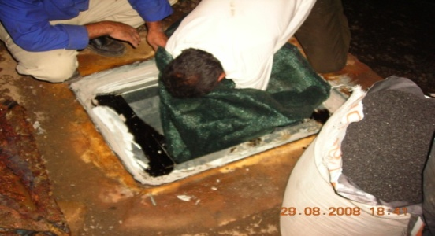
(Pic.8 e)

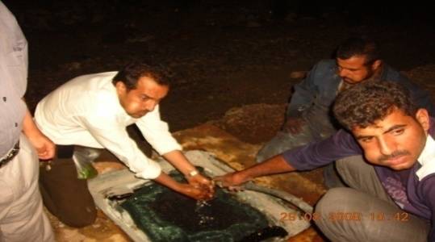
(Pic.8f)

Pictures (8,a,b,c,e & F) the sequential steps for installation of the unit in the field

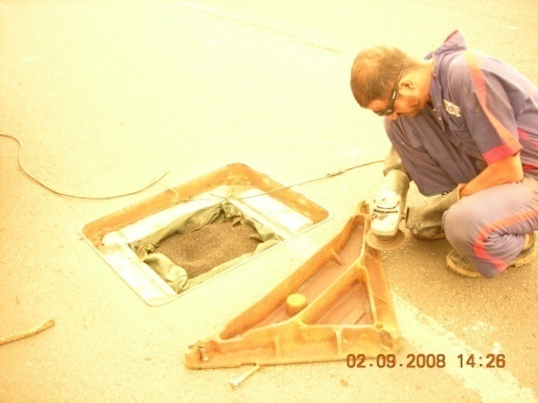
Picture (9) Adopting the manhole cover to the unit

The unit was designed to fit and to be installed on the manhole by bolts screws to prevent movement neither horizontally nor vertically. The unit and MH cover has been designed from galvanized steel to bear vehicle loads when passing above it (photo 9& 10). The size of unit was assembled, shaped as a part of pyramid to fit above the manhole cover at a sizes of 42×58cm for upper base and 30×20cm for lower base with a unit depth of 30cm in order to accommodate the 20 kilograms of activated carbon that has been purchased from the market in such packages. The activated carbon bought from the local market in the form of granules at diameters ranging between 6-10 mm, which usually used for drinking water treatment. When filled in the nylon basket it is washed to remove the fine dust. Unit was manufactured of galvanized steel thickness of 2.8mm which are normally used to manufacture water tanks in the local market in Yemen.

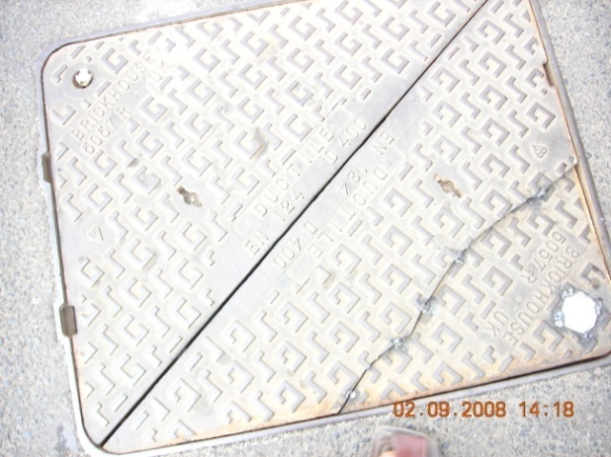
Picture (10) The cover of the MH after finishing the installation

For the purpose of operating the unit and control the odors, it was assumed that the activated carbon adsorbs odors of ammonia and hydrogen sulfide, and when the activated carbon is consumed (saturated), the activated carbon starts leaking gas through or the gas passes through the ventilation column through the MH. Therefore, operation can be monitored using the humans smell sense beside the MH and ventilation column (Brattoli M., 2011) as well as applying periodical measurements using a measuring devices, when the gas odors are high this indicates the it is required to change the activated carbon.

Results and Discussions:
The results of H₂S and NH₃ measurement showed that before installation of the odor control unit, at the higher point inside the manholes , the H₂S and the NH₃ concentration were135 and 118 mg /l, respectively, and it decreased when you are a side of the manhole by 20 cm to be 105 and 30 mg/l, H₂S and NH₃, respectively, while increasing slightly at the top of ventilation column (at the height of 6 meters) to be (119 and 49mg/l), H₂S and NH₃, respectively) (taking into account that the manhole was covered when taking the reading at the ventilation column).
The following table (1) shows the results of the measurements for hydrogen sulfide and ammonia in three sites before installation of the unit (inside and outside the MH as well as at the ventilation columns.

Table (1) field measurements of H₂S and NH₃
MH no. | Outside the MH |  | In the MH |  | At Ventilation columns
 | NH₃ mg/l | H₂S mg/l | NH₃ mg/l | H₂S mg/l | NH₃ mg/l | H₂S mg/l
1 | 30 | 105 | 30 | 118 | 5 | 23
2 | 25 | 85 | 4 | 6 | - | -
3 | 19 | 75 | 35 | 117 | - | -
4 | 18 | 52 | 35 | 117 | - | -
5 | 00 | 00 | 38 | 117 | 37 | 119
6 | 00 | 00 | 32 | 117
7 | 6 | 4 | 42 | 117 | 46 | 117
8 | 5 | 10 | 55 | 117 | - | -
9 | 2 | 6 | 44 | 117 | - | -
10 | 00 | 3 | 56 | 117 | 14 | 25
11 | 13 | 35 | 135 | 117 | - | -

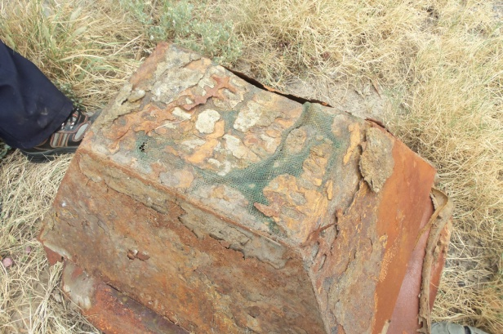
Pic.(11,a)

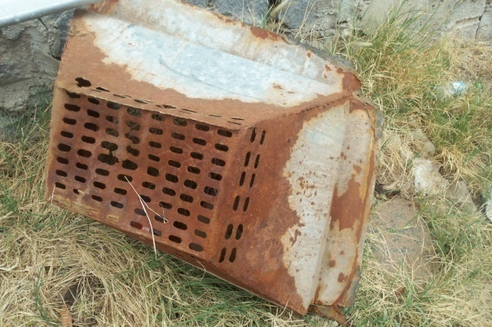
Pic.(11,b)
Photo (11a,b) corroded galvanized unit
The measurements after installation of the units was average 20mgH₂S/l, but the galvanized steel was corroded and need to be replaced or changed into other material (photo 11 a & b).
This pilot project demonstrated that the technology of activated carbon to adsorb odors is able to solve the problem locally in Yemen, lowering concentrations of hydrogen sulfide gas after a monitoring system of measurements was applied after three months from installation showed that the H₂S was decreased up to 20mg/l with an efficiently of around 85% and inexpensively in addition to maintenance costs that will not require to import parts required and the time required until the arrival and to install them.
Assuming the activated carbon cartridge shall have a minimum H₂S capacity of 0.20g/cc. In our case the volume of the carbon is 29700cc therefore, the carbon capacity is 5940g=5.94kg=app 12Ib of carbon which would have a life time of 4-5 years before replacement if the H₂S is assumed as 117 mg/l.

Conclusions and Recommendations
The authors recommend the application of this simple technology in developing countries, especially the Republic of Yemen as it will serve two essential functions as to get rid of odor and reduce corrosion of the manholes due to the escalation of hydrogen sulfide gas in the sewerage systems.
Further efforts are needed to do the following:
- Activate a simple monitoring program to determine the time required to change the unit.
- Develop the use of plastic material instead of the galvanized steel to prolong life of unit, taking into account the strength of the material used for the passage of vehicles.
- To raise the efficiency of maintenance there is a need to know the mechanism to identify the capacity of activated carbon for a combination of both gases (H₂S and NH₃) and determine the extent of affect of ammonia on the activated carbon and the need to add the wet biological filter to remove ammonia before and keep H₂S removal by activated carbon, as well as the possibility of re-activating carbon and how.

References:
- Andrea R. H. P. (2004) Biological Activated Carbon: The Relative Role of Metabolism and Co-metabolism in Extending Service Life and Improving Process Performance. Ph. D. Dissertation. The University of Texas at Austin.
- Bagreev A., Bashkova S., Locke D.C. and Bandosz T.J. (2001) "Sewage Sludge-Derived Materials as Efficient Adsorbents for Removal of Hydrogen Sulfide" Environ. Sci. Technol., 35 (7) pp. 1537-1543.
- Boon A. G. 1995 "Septicity in Sewers: Causes, consequences and containment" Water Science and Technology, 31,7, pp. 237-253.
- Brattoli M., GennaroG.i, Pinto V., Loiotile A. D., Lovascio S. and Penza M., 2011 "Odour Detection Methods: Olfactometry and Chemical Sensors " Sensors J. 11, 5290-5322.
- Duan H., Koe LCC., Yan R. and Chen X., (2006‏) "Biological treatment of H ₂ S using pellet activated carbon as a carrier of microorganisms in a biofilter‏" Water Research.
- Duan H., Yan R., Koe LCC. and Wang X. (2007) "Combined effect of adsorption and biodegradation of biological activated carbon on H ₂ S biotrickling filtration‏". Chemosphere J.
- Koe L.C.C. and Yang F.H. (2000) "Abioscrubber for hydrogen sulfide removal". Water Science and Technology 14(6)141-5.
- Koe, L.C.C. and Yang, F.H. (1999) Development of a Fixed-film Bioscrubber for Hydrogen Sulphide Removal, Proceedings of the Water Environment Federation 72nd Annual Conference and Exposition, New Orleans, LA. October.
- Metcalf & Eddy, Inc., (1991). Wastewater Engineering, Treatment, Disposal, Reuse, 3rd Edition, McGraw-Hill, Inc., NY.
- Churchill P.andElmer D.(1999), "Hydrogen Sulfide Odor Control In Wastewater Collection Systems , Newea J.vol.33, No.1.
- Sawyer, Clair N., and McCarty, Perry L., Chemistry For Sanitary Engineers (Second Edition), McGraw Hill Book Co., 1967.
- Stuetz R. and Frechen F. B. 2001, "Odours in Wastewater Treatment" IWA Publishing.
- Truong, Quang Hai; Nguyen, Cao Huan; Narumi, Kunihiro; Tran, Anh Tuan; Bui, Minh Tri" The Infrastructure And Environment In The Old Tenements In Hanoi". Annual Report of FY, The Core University Program between Japan Society for the Promotion of Science (JSPS) and Vietnamese Academy of Science and Technology (VAST) 2007, P.179.
- Yongsiri C., Vollertsen J. and Jacobsen T.H. 2005, "Influence of Wastewater constituents on Hydrogen Sulfide Emission in Sewer Networks". J. Envirn. Eng., 131(12), 1676-1683.

2/11/2015

