Evaluation of Anti-ulcer Activity of Laportea aestuans (Linn) Leaf Extract on Aspirin-induced ulcer in Male Albino Rats.

Okereke Stanley Chukwuma, Nosiri Chidi Ijeoma, and Chukwudoruo Chieme Sunday.

Department of Biochemistry, Abia State University Uturu, Nigeria.
Email: okerekecstan@gmail.com
Phone:23436769255

Abstract: The anti-ulcer activity of Laportea aestuans leaf extract was investigated using male albino rats. Aspirin was used to induce ulceration in the gastric mucosa, while Omeprazole was used as the reference antiulcer drug. Thirty two male albino rats were used for the study. Twelve rats were used for LD₅₀ assessment, while twenty rats were divided into four groups of 5 animals each. Groups II, III and IV received (400mg/kg, p.o) aspirin. Group I (positive control) received only distilled water and Tween 80 (Polysorbate 80). Group II, (negative control) received only aspirin. Group III was treated with (20mg/kg, p.o) omeprazole and group IV was given the leaf extract (500mg/kg, p.o). Acute toxicity test showed an oral LD₅₀ greater than 5000mg/kg. Gastric juice volume was lowest in group IV with value of 0.77±0.06ml/4h.The decrease was not significant (P<0.05). pH increased significantly (p˂0.05) in group IV compared to group II, with values of 5.40±0.10 and 3.98±0.40 respectively. Free and total acidity (Meq/L) values decreased significantly (p˂0.05) in group IV (103.67±7.09 and 130.00±7.94 respectively) compared to group II (208.00±6.08 free acidity and 193.67±16.17 total acidity). Pepsin activity (µmolTyr/ml) significantly decreased (p˂0.05) in group IV (106.30±3.90) compared to group II (374.42±3.87). Ulcer index decreased significantly (p˂0.05) in group IV compared to group II with values of 2.82±0.01 and 3.42±0.03 respectively. Percentage (%) inhibition increased significantly (p˂0.05) in group IV compared to group II, with values of 17.79% and 0.00 respectively. The chloroform leaf extract of laportea aestuans was able to protect the stomach against ulceration caused by aspirin. These observations could be attributed to the presence of bioactive compounds in the leaf of the plant.
[Okereke Stanley Chukwuma, Nosiri Chidi Ijeoma, and Chukwudoruo Chieme Sunday. Evaluation of Anti-ulcer Activity of Laportea aestuans (Linn) Leaf Extract on Aspirin-induced ulcer in Male Albino Rats. Nat Sci 2015;13(11):1-7]. (ISSN: 1545-0740). http://www.sciencepub.net/nature. 1

Keywords; Laportea aestuans, Aspirin, Omeprazole, pepsin activity, ulcer index.

Introduction
Gastric ulcer is an excoriated section in the lining of the stomach. This happens at the lower curvature of the stomach which is as a result of gastric secretion (Ojewole, 1996). However, peptic ulcer is hollow out areas in the mucosal wall of the stomach, in the oesophagus, duodenum and pylorus (Adreoli et al., 2008). Ulcer is formed when there is a distortion between the aggressive factors (pepsin and acid) and protective factors.bicarbonate and mucus in the stomach (Del- Vaille et al., 2003; Ojewole, 2004). Some other factors that may result to peptic ulcers include bad dietary habits, stress, Helicobacter pylori infection and excessive use of non-steroidal anti-inflammatory drugs (Peckenpaugh and Poleman, 1997) which is responsible for over 70% of peptic ulcer diseases (Hoogerwerf and Pasricha, 2001).
So many orthodox drugs such as Histamine H₂-receptor antagonists (e.g. cimetidine) antacids and more recently proton-pump inhibitors (e.g. omeprazole) have been found to be useful in the management of ulcer, but they trigger many adverse effects. However, there has been growing interest in alternative therapies mostly from plant sources because they have been found to exhibit less side effects, also they are readily available and affordable (Rates, 2001). Plants are known to be the richest sources of new drugs, and they have shown to be useful in the treatment of gastric ulcer with lesser side effects (Alkofahi and Atta, 1999; Schmeda-Hirschmann and Yesilada, 2005). One of such plants that have been found to be useful in folk medicine in the treatment of wounds and burns is Laportea aestuan.
Laportea aestuan is an annual little branched herb up to 1-3 cm tall, stem, fleshy wood at base; it is densely covered with stinging hairs up to 1mm long with soft glandular hairs, 1-2mm. It is called Ohuahihara in Igbo while in Yoruba; it is called Fiyafiya (Soladoye et al., 2013).
The plant has found its application in ethnomedicine in west Africa having being used in treating and managing chest problems, headache and in preventing menstrual bleeding (Essiet et al., 2011). The phytochemical screening of the plant showed that it is rich in Terpenes, Alkaloids, Saponins, Flavonoids, Polyphenolic compounds and sterols (Okereke et al., 2014). Also its antioxidant capacity has been reported by Okereke and Elekwa, (2014).
Therefore, there is need to investigate the gastro-protective potentials of Laportea aestuan leaf extract in experimentally induced gastric ulcer and contribute to knowledge in discovering cheaper and effective anti-ulcer remedies.

Materials and Methods
Animals
Thirty-two male albino rats weighing 160-220g were used for the study. They were procured from the animal house, Department of Physiology, College of Medicine, University of Nigeria, and Enugu Campus. The rats were kept in the animal house, Department of Biochemistry, Abia State University, Uturu. Under standard laboratory conditions for 14 days for acclimatization. They were fed with grower’s feed (Vital Feeds Nig. Plc.) and had free access to clean drinking water.

Plant Materials
Leaves of Laportea aestuan were harvested from the premises of Abia State University, Uturu and authenticated by a taxonomist at the herbarium section of the Department of Plant Science and Biotechnology, A voucher specimen was kept in the herbarium for future reference. The leaves were dried under shade and milled using an electric blender.

Preparation of Extract
One thousand grams (1000g) powdered leaves of Laportea aestuan was soaked in 3 litres of chloroform for 24 hours and strained with muslin cloth then was filtered using Whatman no. 1 filter paper. The filtrate was allowed to dry in open air and a greenish extract was formed. Twenty grams (20g) of the extract was dissolved in 10ml of 3% Tween 80 and made up to 100ml with distilled water.

Acute Toxicity Test
12 male albino rats were used for determination of LD₅₀ as described by Lorke (1983).

Ulcer Induction
Twenty male albino rats were divided into four groups (1-4) of five rats each. The rats were starved for 48 hours prior to the commencement of the experiment but had free access to clean water. Rats in group 1 were given 5ml/kg of distilled water mixed with 0.03ml of 3% Tween 80 which is the positive control. Rats in group 3 were given 20mg/kg of omeprazole and rats in group 4 were given 500mg/kg of the extract. All administration was via oral route (P.O) using a gavage tube. Thirty minutes after administration, 400mg/kg of aspirin was given orally to all the rats in group 2, 3 and 4 except group 1 which is the positive control group. The animals were anaesthetized with chloroform and sacrificed after 4 hours in accordance with the principle of laboratory care; their stomachs were removed, cut open through the greater curvature and then washed in normal saline. Their stomachs were spread and pinned flat on plywood using thumb tacks. With the aid of a magnifying glass, their stomachs were observed using Main and Whittle (1975) method as described below:
Normal stomach = 0
Red coloration = 0.5
Spot ulcer = 1
Hemorrhagic streaks = 1.5
Ulcer > 3mm < 5mm = 2
Ulcer > 5mm = 3
The total score divided by a factor of 10 was designed as ulcer index for their stomach which is
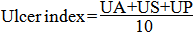
Where:
UA = Average number of ulcers per animal
US = Ulcer severity score
UP = % of animals with ulcers
The percentage ulcer inhibition was calculated using the formula by Suzuki et al., 1976 as follows:
Percent ulcer inhibition =
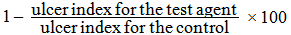

Gastric Juice Collection
After sacrificing the animals, the stomach was excised carefully by keeping the esophagus closed and was opened along the greater curvature which enhanced the collection of the gastric juice.

Volume of Gastric Juice Estimation
This was carried out by the method described by Deshphande et al.,(2003).

Estimation of pH of the Gastric Juice
The pH of the gastric juice was determined by using a pH meter. The pH meter was first switched on and allowed to warm up for five minutes.
The electrode of the pH meter was standardized with a universal pH meter. After the standardization, the electrode was introduced into the gastric juice and the pH was read and recorded accordingly.

Pepsin Activity Determination
This was determined by the method described by Debnath et al., (1974) and Lowry (1951).

Free Acidity and Total Acidity Determination
This was determined by the method described by Kulkarni, (1999).
Statistical Analysis
Data were represented as mean $±$ standard deviation (SD). A one-way analysis of variance (ANOVA) for a completely randomized block design and Turkey’s multiple comparison tests using Minitab (Version 14.0). Values were considered significant when P<0.05.

Results
The result shows the effect of Laportea aestuans leaf extract on ulcerogenic indices of aspirin induced ulcer, The result obtained showed no significant decrease in the gastric juice volume, however there was a significant decrease P<0.05 in pH level when comparing groups 2 to other groups. The result also showed a significant decrease P<0.05 in free acidity and total acidity level in group 3 and group 4 when compared to group 1 and 2 respectively. The result obtained further showed a significant increase P<0.05 in pepsin activity with group 1, 3 and 4. There was a significant decrease P<0.05 in ulcer index when group 2 was compared with group 3 and group 4. However the result obtained showed no significant decrease P<0.05 in the percentage inhibition level but a marginal reduction was observed when group 3 was compared with group 4 as shown in table 1.
Result of the acute toxicity study showed an oral LD₅₀ greater than 5000mg/kg. Also, looking at the images of the stomach, figure one shows the stomach of the positive control rats having no erosion and lacerations whereas figure two shows the stomach of the negative control rats showing erosions and lacerations which is an indication of ulcer.
Figure three shows the stomach of the reference drug (Omeprazole) used in the experiment, it was observed that the reference drug was able to prevent ulceration caused by aspirin as well as the leaf extract of the plant did as shown in figure four after treatment.

Discussion
The antiulcer activity of chloroform leaf extract of Laportea aestuan against aspirin-induced ulceration was evaluated and acute toxicity study was carried out which showed an oral LD₅₀ greater than 5000mg/kg which signifies that the extract is safe. Aspirin is known to be a weak organic acid that reversibly inactivates cycloxygenase (COX-1) required for the synthesis of prostaglandins, thereby blocking the gastric cytoprotective action of prostaglandins (Harvey et al., 2009). According to Wang et al., (2007), Aspirin may also cause inhibition of gastric mucous secretion and mucosal blood flow.
Omeprazole is a known proton pump inhibitor which forms a covalent disulphide bond with H⁺/K⁺ ATPase (proton pump); and inactivates the enzyme irreversibly by inhibiting the final common pathway for acid secretion (McQuid, 2009). Chloroform leaf extract of Laportea aestuan showed gastro-protective activity against ulcer induced aspirin. This perhaps may be associated with the phytochemical compound present in the leaves of the plant as investigated by Okereke et al., (2014).
A reduction in the volume of the gastric juice was observed in the groups treated with Omeprazole and the leaf extract when compared to Aspirin treated group.
There was also a reduction in the pH level in the group that received only Aspirin but the extract at 500mg/Kg was able to increase the pH level when administered thereby reducing the acidity level of the mucosal cells. Omeprazole was able to act as much as the leaf extract in increasing the pH.
Aspirin increases gastric juice secretion and decrease pH as well as increase Pepsin activity as shown in group 2 table 1.This causes an imbalance which encourages ulceration. But the extract was able to reduce the Pepsin activity as much as the reference drug (Omeprazole) did; this is in collaboration with the report of Wang et al., (2007).
Free acidity and total acidity were significantly decreased (P < 0.05) by the leaf extract of Laportea aestuan at 500mg/Kg. This may be as a result of the bio active compounds found in the leaf extract.
Ulcer index was reduced in both 500mg/Kg of the leaf extract and in 20mg/Kg of Omeprazole significantly (P < 0.05) when compared to the group that received only Aspirin.
From the results, the leaf extract of Laportea aestuan showed similar potency as Omeprazole. The protective effect of the extract may be due to the high content of flavonoids, saponins and terpenes. These are phytochemicals that have demonstrated high anti-oxidant properties (Salah et al., 1995).
The elevation in pH and decrease in Pepsin activity and volume of gastric juice evaluated in the rats that received the leaf-extract contain some bioactive compounds that may be responsible for the observed anti-ulcer activity.

Table 1: Effect of Laportea aestuans leaf extract on ulcerogenic indices of aspirin- induced ulcer
Group | Treatment (mg/kg) | Vol. of Gastric Juice (mL/4h) | pH | Free Acidity  (MEq/L) | Total  Acidity  (MEq/L) | Pepsin Activity µmol Tyr/ml | Ulcer Index | Percent  Inhibition
1  Positive Control | 5mg/kg  distilled  water +  0.03ml  Tween 80 | 1.03±0.15ª | 5.21±0.10ª | 117.00±5.20ª | 134.00±4.36ª | 260.90±4.20ª | 0.00ª | --
2  Negative  Control | 400mg/kg  Asprin | 1.54±0.12ª | 3.98±0.40^{b} | 208.00±6.08^{b} | 193.67±16.17^{b} | 374.42±3.87^{b} | 3.42±0.03ª | 0.00ª
3  Reference  Drug  Control | 20mg/kg Omeprazole  400mg/kg Asprin after 30 minutes | 0.91±0.44ª | 5.40±0.10ª | 156.00±4.00^{c} | 159.00±9.54^{c} | 106.30±3.90ª | 2.80±0.01^{b} | 18.84^{b}
4  Test Leaf Extract | 500mg/kg Leaf Abstract  400mg/kg Asprin after 30 minutes | 0.77±0.06ª | 5.40±0.10ª | 103.67±7.09^{c} | 130.00±7.94^{c} | 129.90±2.20ª | 2.82±0.01^{b} | 17.97^{b}
The results represented are Mean±SD of triplicate determinations at (P<0.05).
Mean with the same superscript, in the same column are not significantly different.

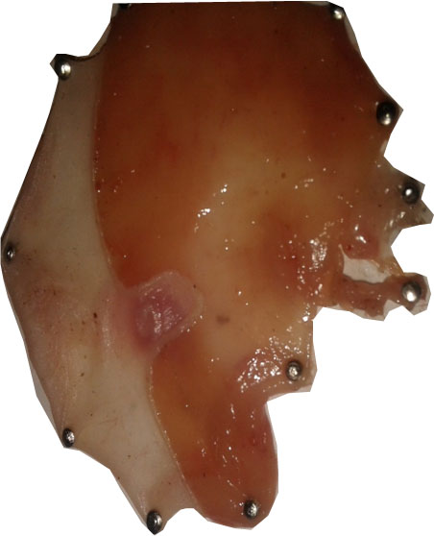
Plate 1: Stomach of positive control rat showing no erosion and laceration.
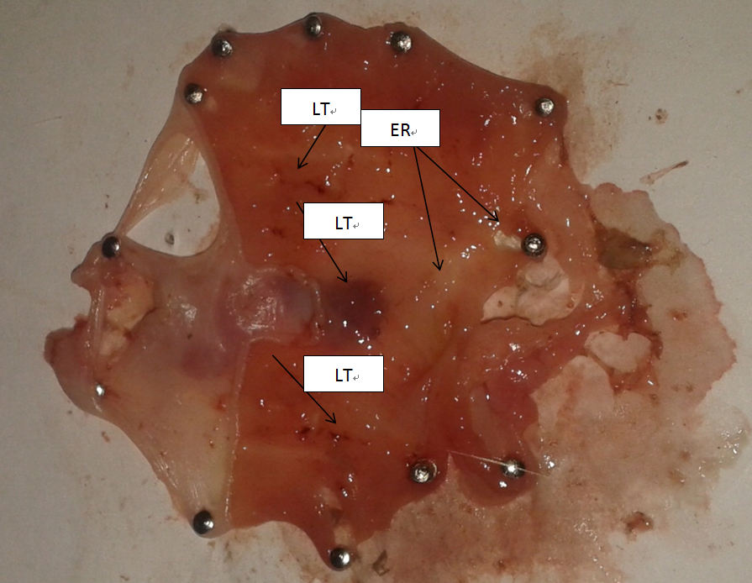
Plate 2: Stomach of negative control rat showing erosions and lacerations
LT= Laceration, ER= Erosion

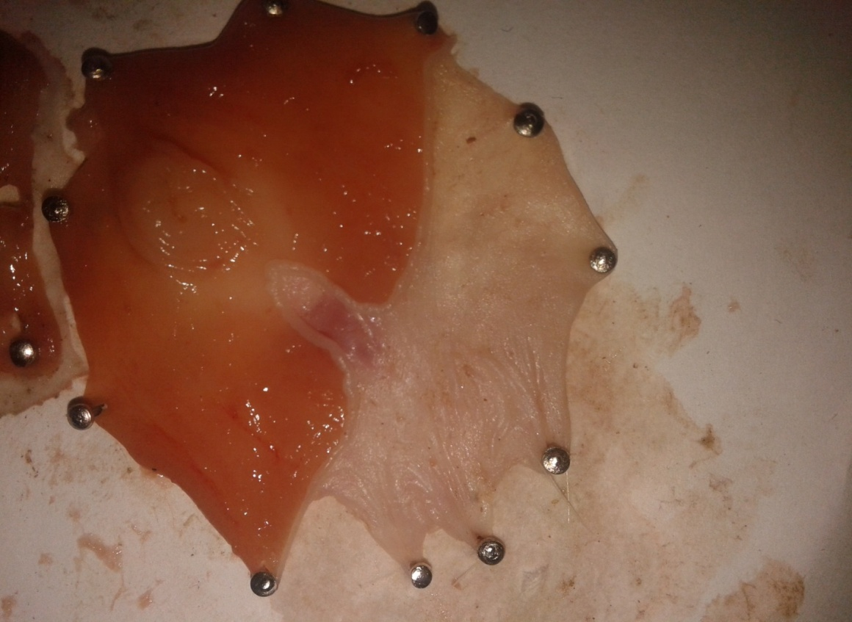
Plate 3: Stomach of reference drug control rat after treatment

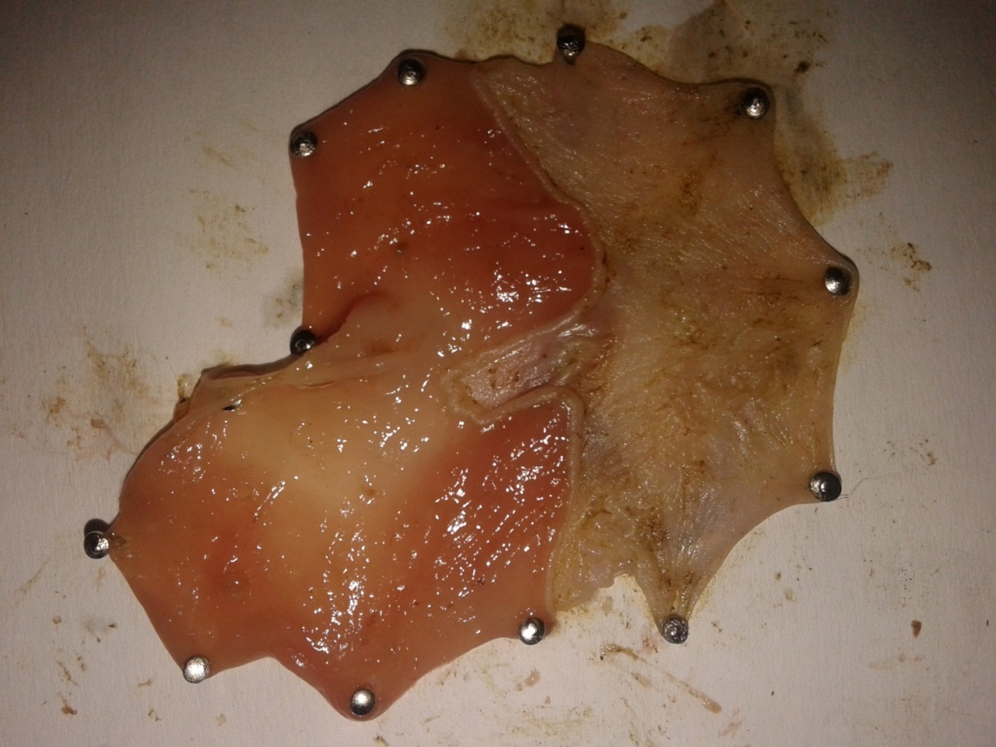
Plate 4: Stomach of the test group rat after treatment

Conclusion
The leaf extract of Laportea aestuan demonstrated considerable anti-ulcer activity compared to that of Omeprazole in aspirin-induced ulceration in albino rats. This effect may be as a result of the bioactive compounds like terpenes and Flavonoids present in the leaf extract of the plant.

Corresponding author:
Dr. Okereke S.C.
Department of Biochemistry,
Abia State University, Uturu P.M.B 2000, Nigeria.
Email: okerekestanc@gmail.com
Phone:23436769255.

References
- Alkofahi A. and Atta A., H. Pharmacological screening of the anti-ulcerogenic effects of some jordanian medicinal plants in rats. J. Ethnopharm. 1999; 67(3): 341-345.
- Andreoli T., chan P.,D., Cowell J.,C., Gilbert D.M., Green G., and Johnson M. Management of patients with Gastric and Duodenal disorders in Brunner and Suddarths Textbook of medical nursing. 11th eds, Elsevier, Philadelphia. USA 2008;Pp 1203-1279.
- De valle J., Cheg W., and Scherman J. Acid Peptic Disorder in Textbook of gastroenterology, 4th eds, Philadelphia, Lippincott, Willam and Wilkins. 2003; Pp 1321-1376.
- Debnath P.,k., Gode K.,D, Govinda D., and Sanyal A.,K. Effects of propanol or gastric secretion in albino rats. Br.J. Pharmacol. 1974;51: 213-216.
- Deshpande S.,S., Shan G.,B, and Parmar N.,S. Anti-ulcer activity of Tephrosia purpurea in rats. Ind. J. Pharmacol. 2003; 35(3): 168-172.
- Essiet U., A., Edet N.I., and Bala D., N. Phytochemical and physiochemical analysis of leaves of laportea aestuan (linn) and laporea ovalifolia (schumach) (male and female). Asian J. Pl.Scl.Res.2011;1:35-42.
- Harvey R.A., Champe P.C., Finkel R., Cubedu L.X., and Chark M.,A. Anti-inflammatory drugs and autocoids, lippincotts illustrated reviews, pharmacology 4th eds. Lippincott Williams and wilkins. 2009; Pp 500-518.
- Hoogerwerf W.A., and Pasricha P.J. Agents used for control of gastric acidity and treatment of peptic ulcers and a gastroesphageal reflex disease. Pharmacological basis of Therapeutics 10th eds.2001; Pp 1005-1019.
- Kulkarni S.K (1999). Experiments on intact preparations (in-vivo studies). Handbook of experimental pharmacology 3rd eds, Delhi: Vallable prakashan. 1999;148.
- Lorke D. New approach to practical acute toxicity. Arch. Toxicol. 1983; 54: 275-287.
- Lowry O.H., Rosebrough N.,L., Farr A., L and Randell R.J. Protein measurement with folin phenol reagent. J.Bio.chem.1951; 193: 265-275.
- Main G., and Whittle N.,B. Investigation of vasodilator and anti-secretor role of prostaglandins in the rat mucosa by use of NSAIDs. Br. Pharm.1975; 53: 217-224.
- McQuid R.,K. Drugs used in the treatment of gastrointestinal diseases in basic and clinical pharmacology 11th eds. McGraw-Hill companies New York USA. 2009; Pp 1068-1098.
- Ojewole E.,B. Peptic ulcer disease in therapeutic basis of clinical pharmacy in the tropics. 2nd eds, Optimal publishers Enugu, Nigeria. 1996; Pp 401- 437.
- Ojewole E.,B. Peptic ulcer disease in Therapeutic basis of clinical pharmacy in the tropics. 3rd eds SNAAP press, Enugu, Nigerian 2004; Pp 541-564.
- Okereke S.C., and Elekwa I.Studies on the invitro antioxidant activity of Laportea aestuan (linn) leaf extract. J. Environ. Sci. Toxicol. Food. Tech. 2014; 8: 33-41.
- Okereke S.C., Elekwa 1. and Chukwudoruo C.S. Preliminary phytochemical screening and gas chromatographic FID evaluation of Laportea aestuan leaf extracts. Int. J. Biochem. Res.2014; 2(3) :37-43.
- Peckenpaugh N.,J and Polemon C., M. Nukricao: Essecia Dietoteraphia, Editora Roca Sao Pawo, Brazil 7th eds.1997; Pp 22-28.
- Rates S.,M.,K. Plants as source of drugs, Toxicon, 2001;39(5): 603-613.
- Salah N., Miller N.I., Payange G., Bolwell G.P., Rice E., and Evans C. Polyphenol Flavonoids as scavenge of aqueous phase radicals as chain breaking antioxidant. Arch. Biochem.Biophysiol. 1995; 92(6): 667-669.
- Schmeda-Hirschman G., and Yesilada E. Traditional medicine and gastroprotective crude drugs, J. Ethnopharm.2005; 100(1-2): 61-66.
- Soladoye M.O., Itokun T., Chukwuma E.C., Ariwaodo J.O., Ibhanesebor G.A., Agbo – Adediran D.A., and Owolabi S.M. Our plants, Our heritage: Ann.Bio.Res.2013;4:27-34.
- Suzuki Y., Hamagani M., Iko M., and Yamani T. Anti-ulcer effects of cetraxate on various experimented gastric ulcers in rats. Jap. J. pharm. 1976;26:471-474.
- Wang G.Z., Huang G.p., Zhou G., Yin G.L., Guo C.J., and Xie C.G. Aspirin can elicit the occurrence of gastric ulcer induced with acetic acid in rats. Cell physio. Biochem.2007; 20(1-4): 205-212.

10/2/2015

