Review forms of karst in the arid and semi- arid zones (Ramhormoz)

Farangis Nazari Bayatiyani

Graduated student of Geomorphology Imam memory Unit, Ray City, Tehran.
Dr. Gulamhossein Eskani Kazazi
Assistant Professor of Azad University. Imam Memory Unit, Ray City

Abstract: More than ten percent of the earth’s surface has been occupied by carbonate stones that most of them has been formed of limestone and dolomite And also karst phenomenon mainly form of dissolution of the carbonate stones and also that way is considered as the biggest underground water resources of earth. Our country as well as has vast expanse karsti arenas , from Zagros mountains to parts of Alborz, hot pile and else include the very big percentage of the country soil, so the recognition of karsti arenas and their characteristics of usage view that related to many human activities has great importance. According to the importance of this issue, this research in the same way study the forms of karst In the arid and semi – arid in the range of Rahmormoz and for the first time study the forms of existing karsti in this range and the way of their formation, evolution and transformation.
[Farangis Nazari Bayatiyani. Review forms of karst in the arid and semi- arid zones (Ramhormoz). Nat Sci 2015;13(11):17-24]. (ISSN: 1545-0740). http://www.sciencepub.net/nature. 3

Key words: Ramhormoz, Geomorphology, karst, arid and semi- arid zones.

Introduction
Today, karst and karsti phenomena have been so much attention with regard to scientific progress. Especially due to the presence of rich water resources in it, this is a German words in principal that has been formed of Slavic and Italian words of Cross and Karssow and then it become change to karst In Serbian and Hrvatlanguages. (Askani, 2004, page 7). The importance of the karsti forms and especially its role as a rich source of water is renewable. Therefore understanding and identify karstiResources is very important. According to that Ramhormoz region is situated in the arid and semi- arid areas of the country and regard to existence of karst in different heights and especially humid weather can ask: if the weather is playing a role in the emergence of karst Or not ? if the height is playing a role in the emergence of karst? Whether the kind of formation is an important factor in emergence of karstornot? What is the role of water in this relation? What is the main mechanism in emergence, forming and change and evolution of karstif the prevailing phenomenon in studying area is the forms of karst or the other words if the forms of karstAre the dominant perspective in studying region? Whether the geological building, tectonic, petrology and especially climate have role in creating karsti forms in the studying region? Theses are the questions that we are trying to find their answers and in way to achieving to answers of these questions formed some hypothesis like these: karstiForms is the predominant form morphology of the studying region.
The form of geology, tectonic and petrology and climate of region have role in forming of karst forms. Due to the increase of population and also climate need to new source of water it is very important. According to karst is note of considered as major sources of underground water, there fore recognition of such region light up the importance of these reviews and researches. It is important to be mentioned that water of karst. Has higher value than alluvium water resources and it should be the focus of attention. With regard this matter that the studying region is allocated in Khouzestan province and it has semi – desert weather and according to climate change the recognition of such resources has abundant importance. The overall object of this research is identifying karst forms and how of their change and their evolution in semi- arid areas that with this can do plantings in the sustainable development in the karsti areas, especially in the Ramhormoz region that is an agricultural and livestock region and in recent years it stops toward industrialization. Some of sub goals' in this research can introduce identification of scientific position of geomorphology in environmental planning.
The situation of Ramhormoz
Ramhormoz region is one of piedmont areas in wrinkled Zagros piedmonts that carbonate sediments have a relative numerous in it and karsti phenomena in it observe abundance. Ramhormoz is located in the east of Ahvaz on the way of Ahvaz to Behbahan and Shiraz and according to existence Gachsaran of Shiraz machinery cement and plaster factories have been opened in this region. One another of features of this region is firing lad in southwest of Ramhormoz and in vicinity of the road of Ahvaz- Ramhormoz that eruption of earths gas keeps part of the land constantly alight. This region is located in latitude of 17 and 31 degrees of north and longitude of 35 and 49 digress of east in 83.5 kilometres in east of Ahvaz and medium height is equal 16 meters of the level of free waters is extended in a flat plain in hillsides of wrinkled Zagros mountains and this is extended from north toward northeast.

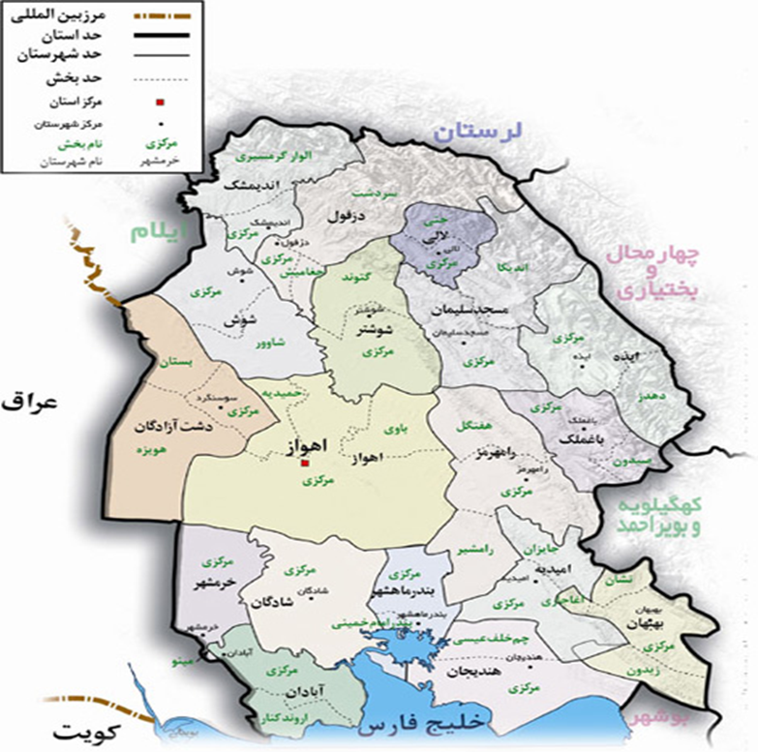
The situation of Ramhormoz in khouzestanprovince (source:khouzestan governorate)

The climate of Ramhormoz area
It can be said that the weather of each region is a result of balance between data and results In other words the balance between the humidity and heat and the effect of these two agents on each other. In this study has been use of statistic of synoptic station in Ramhormoz during the period of 1990 to 2010 for 20 years. According to this statistic the highest rains are related to Azar and Day and the lowest of the m are related to Khordad to Shahrivar. According to the latitude of studying region that in most of times in year is influenced of high pressure site near to torrid daily temperature changes aren’t so but seasonal changes and annual temperature especially seasonal changes are significant. Based on this matter, the months of Tir and Mordad are hottest months of year and the month of Day is the coldest month of year and also due to the statistics achieved of the average of annual humidity in studying region has been 37.6 percent and the maximum amount of relative humidity in month of Day is equal 69.5 percent and least of it is equal 16.8 percent that have been observed in the month of Khordad.
Materials and methods
This research is practical regarding to method, descriptive – analytical and methodology and analysis in it is performing based on reasoning and determination. In order to achieve to target of research used of tool like taking note , use of tables and camera, computer networks for collecting data and information.
Findings and discussion
Definition of karst
The phenomenon of dissolution of the lime in the water and formation karsti forms is called karstification so that: continuous sediments that are formed by dissolution show the features of karsti and they can be divided in three main groups of carbonate, sulphate and chloride.
Review of karsti forms in Ramhormoz region
Dissolution forms have very importance in various reasons form the perspective of underground water to else. Moreover it is evidence that the result of karstification process is creation of morphology or special morphology of earth that apart karstiregions of each other.
Also it should be known that the stages of forming of karst in Asmara limestone and bangestan limestone and else have vast outcrop in the presence of water especially after rain has provided suitable conditions for create development of karst In a wide range so the dissolution forms as dissolution pits observe abundant. It should be noted that the impassable of area along with the distance from the town and especially gender of recorder likely caused to some of these forms such as caves become hide. Generally karst forms can be divided in three groups: liner forms, surface forms and pixel forms.
Liner forms
Karren(lapiehe)
karren is a word with Germany root that it is equal with a French term of lapiehe. This term has vast application in describing dissolution forms in small scale and surface like grooves and etc in carbonate outcrop. It can be said that the manifest karsti Phenomenon in studying region are the karren than in the rain or flowing of water ( in chemical activity of water) on limestone components take place dissolution action f of course dissolution take place in parts of limestone and the result of this action is complications on stones that are karren . It should be mentioned that karren has various types that is caused of effect in various factor like liner karrens, annular karren and etc.
Some of effective factor in the creation different types of karren can be:litology, kind of stone cover (barestone, soil, snow, etc.), sloop of ground, amount and distribution of rain.
Ghobadi in page 54 writes that karrens observe in limestone in 2 to 4 meters deep and one meter weight and the depth some of them became 5 meters.

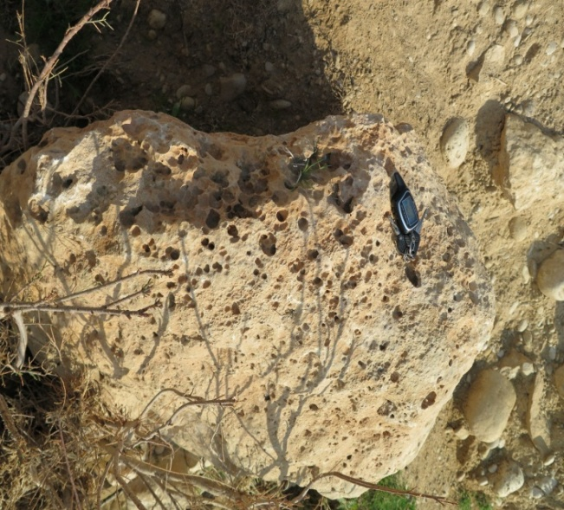
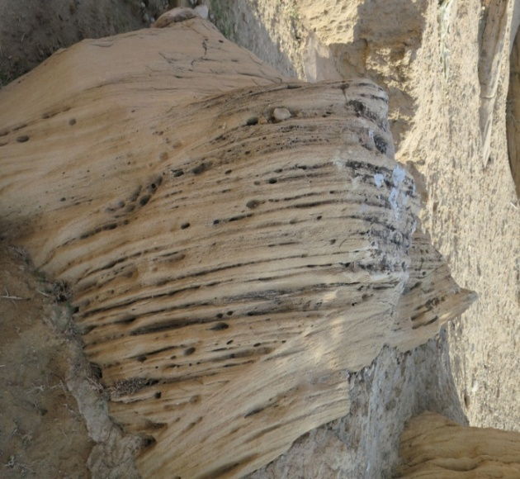

Karsti grooves
In karstic regions, some of grooves are observed that they are known for sharp top corners that in long grooves of carbonate stone are create and it is evidence and a sign of initial phases of karstification and latter it caused to develop and create karrens.

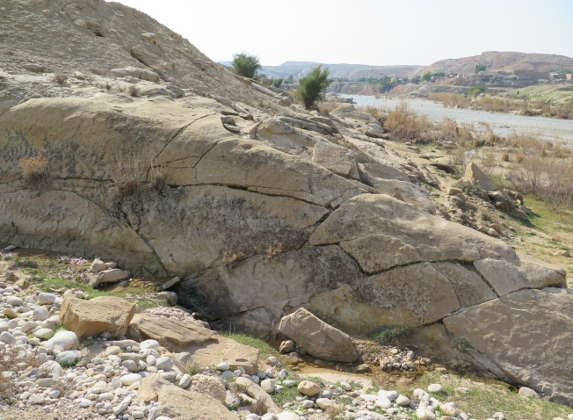

Karsti valleys
One of the main perspective in studying region are various and difficult cuts in Asmarilimestone formation. This valleys are the same valley or in other words are Yale valleys that they have been observed ( Askari , 2004, page 180). It can be said that in this valleys currently instead karstification process observe degradation process and loss of the effects of dissolution related to the cycles of damper climate in past. This photo shows the performance of water in current climate situation.

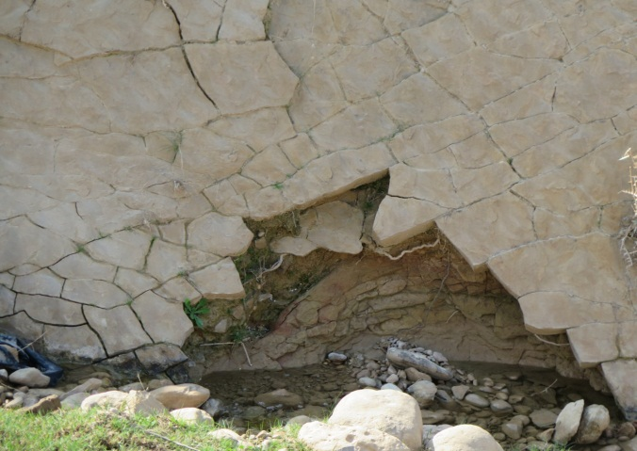

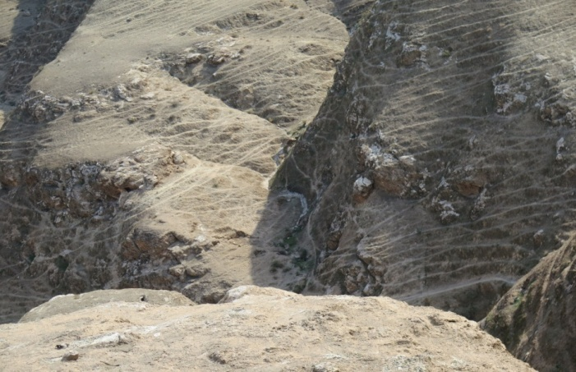

Surface forms
doline
The term of doline means pits or cycle or ellipse in Serbian - Hrvat language. ( Askari 2004, page 181). The size of these pits maybe be various from a few meters to several meters. There are various samples of it in nature. For example:
If the depth of available pit be less than diameter pit,according to the slope the wall of pit and the amount of its slope, doline like tub, plate and or boiler observe. (Mahmud , 1993 , page 83). It can be said that existence this phenomena in karsti Regions show development of karst in formation mechanism can said that the phenomenon of dissolution and then purring of ceiling or the walls of the dissolution parts caused to forming doline from kind dissolution. It is necessary to note that sinkholes is the another name for this phenomenon. It should also be noted that like between two or more nearby do line. Form another complication named Ovella. Instudying region do line and ovellaobserve on the top of mountains and in high heights that impassable of mountain and especially the gender of recorder is double difficult. In this way, not only the forms but also other forms include axis basins become hidden.

Aven
Vascularkarstipit has vertical walls and it is almost cylindrical that mainly observes in the Yale valleys or become destroyed by blow of water or water flow.

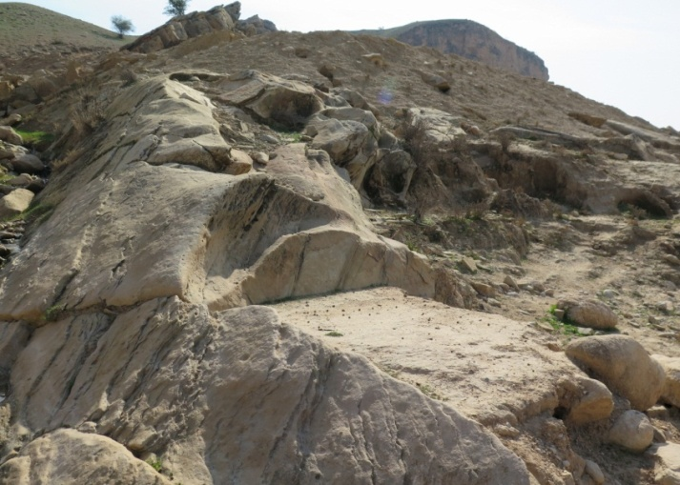

Pixel complication
Jama
Jama is the vertical channel or almost vertical on the surface of land in open karsti areas. (Askani, 2004, page 177). In studying region, the hills well like were being formed in a long fractures and seam and gaps and stractification lime stones and conductor pits of underground water. The diameter of these pits is variable.

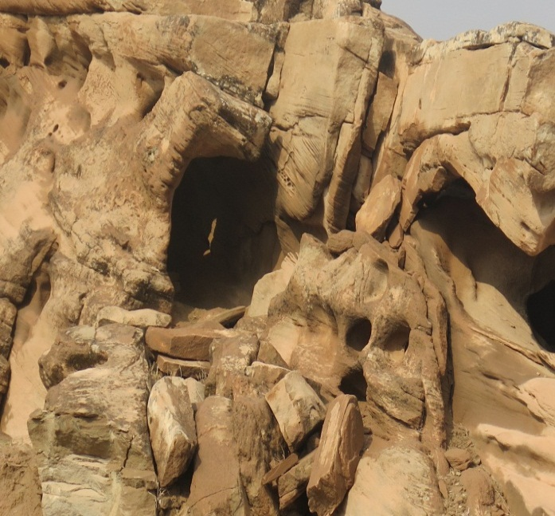

Karsti spans
In studying region, there are various spans that mainly they are the origin of under ground water; also it can be observed enormous springs with permanent flows. It can be said that karsti springs in the studying area, go back to the water that has been received from heights with karsti complications to the surface of land and sometimes they are the main source to supply the agriculture water, drinking water in the villages that are located in adjacent them or in their route.

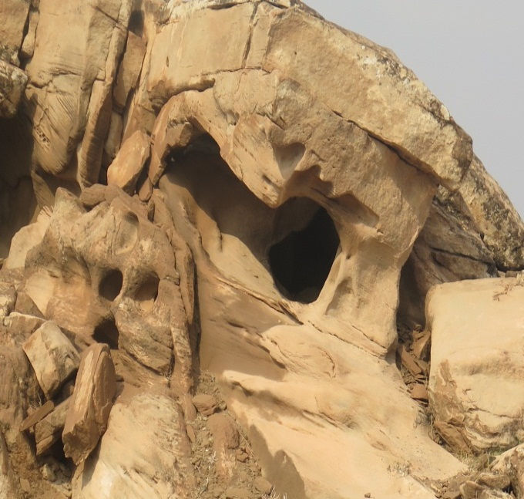

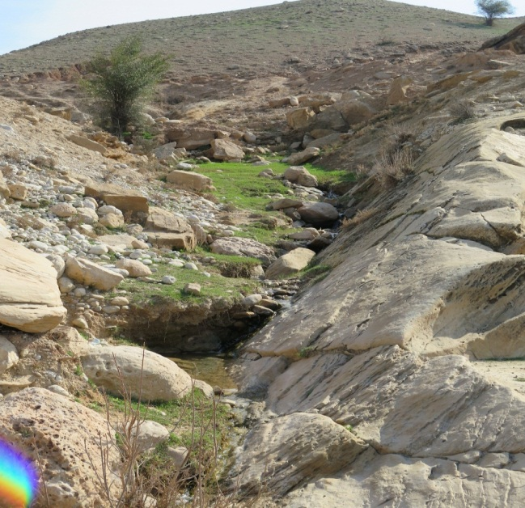

Caves and underground passages
Cave is one underground passage that it usually has been formed from one almost horizontal channel. This phenomenon maybe is known as representative of climax the dissolution process in level of underground water. Therefore maybe can said that cave is a karsti and underground phenomenon. In studying region, caves are one another of various karsti Form in the region.
Maybe can said that the system of seam and rifts and fractures in limestone formation aren’t effect less in creating them and the dissolution phenomenon has been expanded and developed by this same seam and gaps.

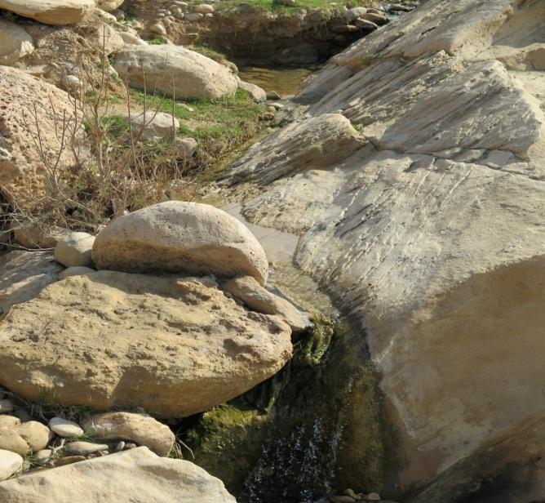

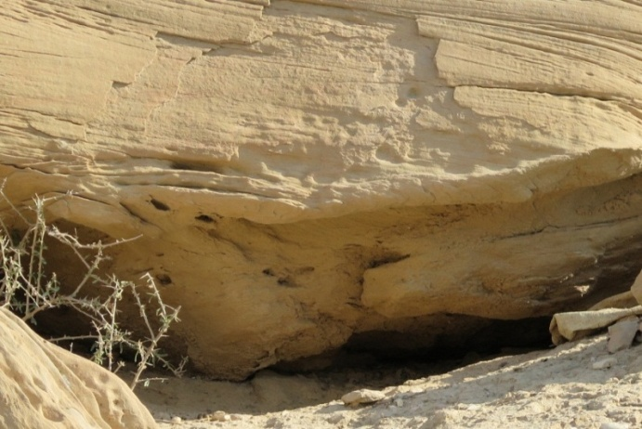

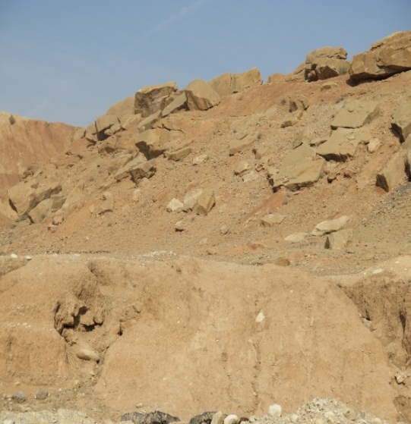

Other forms of existing morphology in studying region
The falling of stone, slide and creep
Certain forms in most parts of country and especially in semi- arid areas are the phenomenon of falling stones and slide. Also creeping is another form that can be observes in studying region both of these phenomenons are shown in this picture.

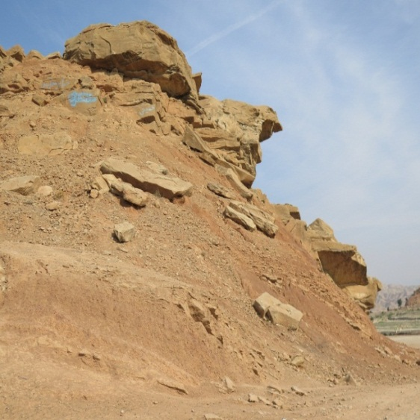

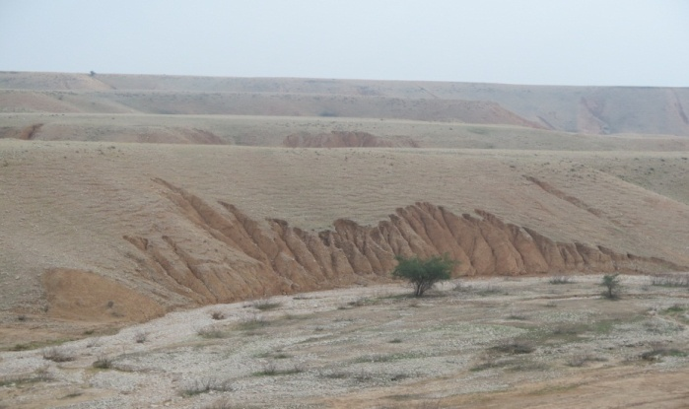

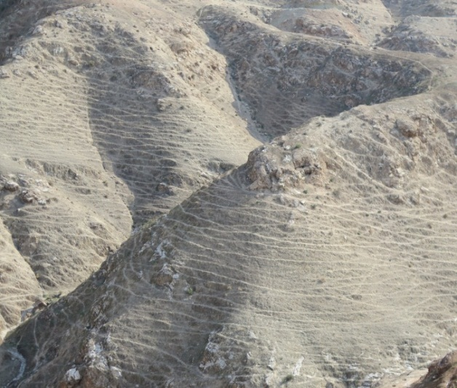

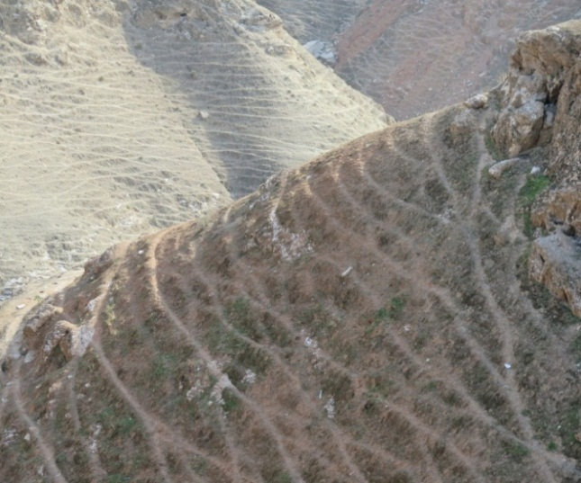

Slide and Badland or Hezardareh
Existing of permeability Asmari limestone and importability causes'pabedehgorei formations under these suitableness the circumstances in the presence of humidity and suitable slop for this phenomenon in the studying region. Another beautiful form of morphology in the studying region is the Badland Phenomenon or HezardarehBoth of phenomenon are shown in this picture.

Solifeksion
This phenomenon in studying region especially foot livestock kind are abundance

Terrace or alluvial terrace
In the vicinity of the rivers or studying region sometimes observe two or more alluvial terrace that impel on damper climate in the studying region.

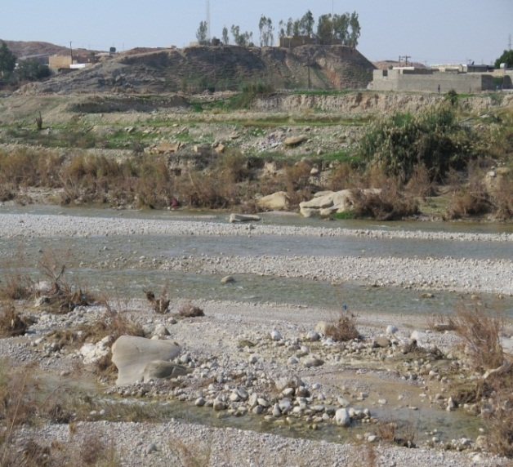

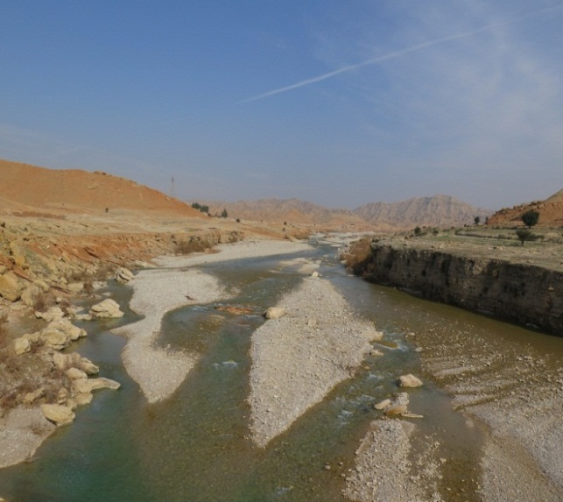

Cliff
Some of available forms in the studying region are cliffs that some of them are building or attrition.

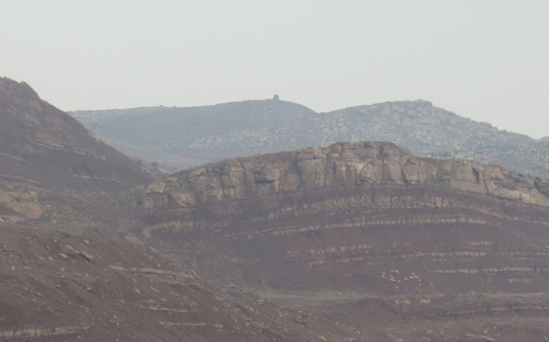

Physical- mechanic weathering
Temperature change caused to create phenomenon of contraction and expansion and consequently bursting of stones, while severe rainfall in arid regions causes to corrosion calcium carbonate and this matter helps to the phenomenon of karstification.
According to hypothesis of research that in it geology building and petrology, tectonic and climate in forming and evolution of karstin studying region are effective can present matters as follow:
It can be said that according to severe interference of geology forces on the one hand and Asmari lime stone resistance in front of it of other hand cause to form systems of seam and breakage and fraction in different directions in Zagros Mountains. In addition, according to climate suitable features in part of region as well as another part of country, form suitable conditions for the development of karst.
It is necessary to note that with regard the current climate situation in (semi- desert) region, currently there aren’t favourable conditions for forming and evolution of karst especially we are usually facing with destruction and erosion of karst Forms in this region.
It can be said that the forms of karstavailable in region are sedimentology related to past of geology and the age that the weather was damper than today.

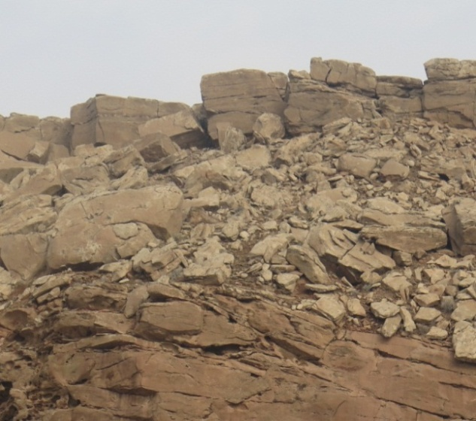

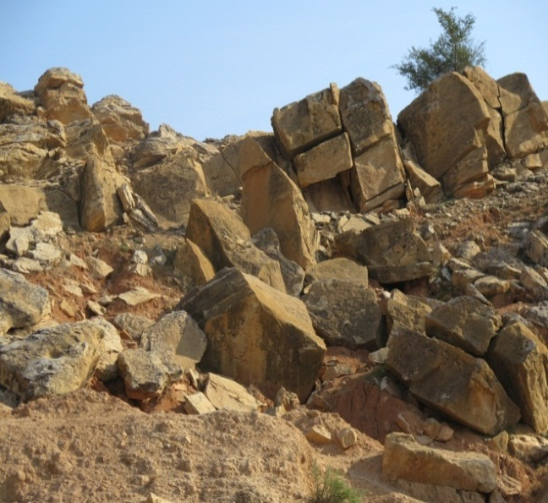

In related with the role of petrology the existence of components soluble of lime stone and plaster in this region is representative the role of stone and kind of it in forming this forms, therefore the hypothesis of research that emphasize on the technotic and petrology and damper climate of past can confirm.

Conclusion
We said that from application point of view studying karst as a geomorphic Phenomenon has great importance. With regard to that karstcan form rich sources of underground water and according to need human to new sources of water, recognition this arena in country has double importance and this need is very enormous.
In this research in geographical mission try to discover and identify phenomenon and relations between its various components and the attributes and characteristics
Karsti arenas have been considered. In addition it was trying to find casual relationship between effective different factors in forming and evolution of karst as well as the movement of Arabic plate And the resistance of touranplate Form one side, the role of Asmari limestone and its resistance that lead to create the system of seam and fraction and else and on the other hand the humidity and temperature also become blusters with frequency and presence of dissolution phenomenon and finally it led to formation karst forms. Therefore based on it can predict the process of transition of the forms. According it can say that:
Existing various spas and their scattering in studying region is representative the evolution of undergroundkarst forms in some of parts in studying region.
Existence alluvial terrace in studying region and in the vicinity with the great river of Rahmormoz and Aalla River is representative past damper climate conditions and the same issue caused to phenomenons like sliding and solicitation in region and in the mountain ranges.
Existence sinkholes in along with existing faults in the studying region that refer to it in geology section can help to predict evolution process of forms.
Therefore and according to what has been said can note that existingkarsti forms in studying region (Rahmormoz) mainly have been paleokarstand it is related to past climate periods that were damper of present time and in current situation maybe can observe the effects of karst evolution on top of heights higher than a few thousand meters in studying region although the destruction of karst forms dominate several in downhill and lower heights and frequency of temperature and erosion of running water has the biggest role in the destruction.
In the end it is necessary to note that without a systematic attitude to the features of karsti arenas that need to cooperation various experts cant achieve to a systematic studying in the fields of the studying about karstiphenomenons and the above fields such as: alluvial terraces,karsti spans, caves ,paleokelima of region and etc are the fields that various researchers can and should in these fields investigate until all unknown corners of karst In these regions become clarify.
The first thanks and praise is special of God that his little servant makes as a drop in the boundless sea of thought to I observe the vast it from pure thoughts gracious teachers. In the shade of his championship the current research carry out so i think it is necessary that i thanks from the courthouses that if don’t exist their helping hand, this research never don’t carry out.
In the first i prefer my total gratitude to my cherished professor Excellency Dr. Eskani that charged the troubles of guidance of this research.
I sincerely thank from my senior professor Dr. Sistani pour that he sustained the trouble of assistance of this research.
I prefer my last gratitude to my father and mother and sisters and brothers and also my dear son that their presence in living space has been the instance of generosity truthful. I hope that this smallest gratitude thanks from some their troubles.

Reference
- Governor of Khuzestan, 2014.
- Eskani kazazi, gh. 2004. Relationship between Structural system with Karst¬Shdgy (Anticline Khavyz PA),sarzamin journal, NO. 3,science and research Branch.
- Eskani kazazi, gh. 2004, Zagros karst geomorphology Chyn¬Khvrdh, Science and Research Branch of Tehran thesis.
- Meteorological Organization Country, Statistical data.
- Ghobadi, M. 2009. Karst Geological Engineering, second edition, Bu-Ali Sina University Press.

10/11/2015

