Calibration and verification of SALTMED model for simulation of soil salinity distribution under condition using of saline irrigation water and maize cultivation

Negar Khalvandi¹, Amir Soltani Mohammadi² and Saeed Borooman Nasab³

¹⁻ M.Sc. Student, Irrigation and Drainage Department, Faculty of Water Sciences Engineering, Shahid Chamran University, Ahvaz, Iran. E-mail Address: negar_khalvandi@yahoo.com
²⁻Assistant professor, Irrigation and Drainage Department, Faculty of Water Sciences Engineering, Shahid Chamran University, Ahvaz, Iran. E-mail Address: a.soltani@scu.ac.ir
³⁻ Professor, Irrigation and Drainage Department, Faculty of Water Sciences Engineering, Shahid Chamran University, Ahvaz, Iran. E-mail Address: boroomand@scu.ac.ir

Abstract: Salt movement under the conditions of use of saline irrigation water is highly regarded. Using models such as SALTMED can be simulation salinity distribution. In this study, calibration and verification of SALTMED model was done by using data from experimental maize field. For this purpose, field experiment consists of five levels of salinity irrigation water (S₀: Control treatment, S₁, S₂, S₃ and S₄) with three replications was performed in Research Field of Water Sciences Engineering Faculty at Shahid Chamran University of Ahvaz, Iran. The experiment was arranged according to a randomized complete block design with split plot layout. During the cultivation, six times soil samples were collected from the depths of 0-30, 30-60, 60-90 and 90-120 cm for all treatments to determine soil salinity. 70% of soil salinity data measured from control treatment used for calibration and 30% remaining data used for verification of model. Calibration and verification results show that the model can simulate soil salinity with high accuracy, also Coefficient of determination (R²) and the NRMSE for model calibration obtained 0.76 and 3.13, respectively. The coefficient of determination (R²) and NRMSE for the model verification was obtained 0.96 and 9.14, respectively. The calibrated model used to simulation of soil salinity of S₁ to S₄ treatments. The coefficient of determination and NRMSE for S₁, S₂, S₃ and S₄ treatments, calculated 0.90, 0.86, 0.87 and 0.89 and 19.38, 19.24, 18.07 and 16.51, respectively. Overall, the results showed that the model is useful for simulation of soil salinity under using of saline irrigation water and with increasing the salinity of irrigation water difference between measured and simulated decreased.
[Negar Khalvandi, Amir Soltani Mohammadi and Saeed Borooman Nasab. Calibration and verification of SALTMED model for simulation of soil salinity distribution under condition using of saline irrigation water and maize cultivation. Nat Sci 2015;13(11):36-40]. (ISSN: 1545-0740). http://www.sciencepub.net/nature. 5

Keywords: Soil Salinity, calibration, verification, SALTMED model.

Introduction
Using simulation models it will be possible to perform several complicated calculations concerning the flow of water, salt and heat in the soil and also designing irrigation and drainage systems in a short period of time, while the effect of each parameter can be easily examined. Recently, SALTMED model has been developed for the purpose of integrated water management in farmlands (Ragab, 2002). Different irrigation systems and strategies and different water, plants and soil qualities can be taken into consideration by means of this model. A number of reports related to calibration and verification of SALTMED model and also application of this model under various conditions are put forward. Ragab (2005) has calibrated the model based on plant performance. Calibration and verification results showed that the model is able to prediction soil moisture and salinity under different circumstances. Ali et al. (2015), Akbari Fazli et al. (2013), Rameshvaran et al. (2013), Hedayatizadeh (2011) and Razaghi et al. (2011) calibrated SALTMED model and claimed that the model predicted the moisture and salinity of the soil with high accuracy.
Review of research carried out with SALTMED model showed that the effect of irrigation water salinity on efficiency of model is not study, therefore this research carried out with the aim of calibration and verification of model and evaluating the effect of irrigation water salinity on efficiency of the model for simulation of moisture and salinity distribution in soil profile under corn cultivation in Ahvaz.

Materials and Methods
A) SALTMED Model
SALTMED model is presented by Ragab (2002). This version of model that released on 2009 is able to perform the following key processes: Evaporation and transpiration, plants water uptake, water and salt transport under different irrigation systems and strategies, fertigation, drainage, presence of shallow groundwater, nitrogen cycle and the relationship between crop yield and water use. In this study used of 3.03.19 version of SALTMED model which is released in 2013. The main difference compared with the 2009 version, is the new option for the calculation of water uptake throughout the crop season. The new version of the model allows the user to assign a different water stress tolerance level for each crop growth stage, instead of only a single tolerance level value for the whole growth period (Silva et al., 2012). The model is free download from the Web site at: http:// www.swup-med.dk/SALTMED.aspx.
B) Field Data
The data used for this study were obtained from a field test carried out in a research farm located in Water Sciences Engineering Faculty, Shahid Chamran University of Ahvaz ( 48◦40’ longitude, 31◦18’ latitude and 20m above sea level) during the 2013-2014. The mean (mean value for a 50 Years period, 1951 to 2010) annual rainfall in the area is 209.2 mm. The mean of maximum monthly temperature is in July (54◦C) and the mean of minimum monthly temperature is in January (1◦C).
Soil characteristics of the experimental site is shown in Table (1). The experiments were arranged according to a randomized complete block design layout with four replications and five irrigation water salinity. The five Salinity treatments were S0 (non-saline water control treatment, 2dS.m⁻¹), S₁ (3.5dS.m⁻¹), S₂ (4.5dS.m⁻¹), S₃ (5.5dS.m⁻¹) and S₄ (6.5dS.m⁻¹).
Irrigation schedule was carried out by measuring soil moisture content. Irrigation was performed when 50 % of the available soil water was depleted.
Irrigation was conducted manually by connecting a hose to a water hydrant, with a flow meter to record the amount of water applied. Grains of maize (Zea mays L.) cv. Single Cross Mobin (SC616) was sown on February 24, 2014 on 75 cm apart furrows and harvested on around June 15, 2014. The seedling density was around 70000 plants ha⁻¹.
S1, S2, S3 and S4 treatments were formulated using S0 water as the base, to which different amounts of NaCl, CaCl₂, and MgCl₂ were added. S1 to S4 treatment waters were constituently mixed with proportions of the three added salts to maintain an SAR value equal to SAR value of S0. Ca to Mg ratio of S1, S2, S3 and S4 waters were kept close to the Ca to Mg ratio of S0 water (Henggeler, 2004). Chemical characteristics of the irrigation waters are shown in Table 2. Irrigation scheduling is shown in Table 3.

Table 1. Soil Physical and chemical analysis
θ_{VFc}  (%) | θV_{PWP}  (%) | Available  potassium (mg.kg⁻¹) | Phosphorus  (mg.kg⁻¹) | Organic carbon  nitrogen  (%) | Bulk density  (g.cm⁻³) | Texture | Particle size (%) |  |  | Soil Depth  (cm)
 |  |  |  |  |  |  | Clay | Silt | Sand
32 | 15 | 110 | 10.0 | 0.12 | 1.40 | Silt- Loam | 22.6 | 52.1 | 25.3 | 0-30
32 | 15 | 124 | 10.5 | 0.08 | 1.55 | Silt- Loam | 23.5 | 51.5 | 25.0 | 30-60
32 | 15 | 108 | 10.1 | 0.08 | 1.60 | Silt- Loam | 23.2 | 51.7 | 25.1 | 60-90
32 | 15 | 108 | 10.1 | 0.08 | 1.75 | Silt- Loam | 23.9 | 52 | 24.1 | 90-120

Table 2. Chemical characteristics of the irrigation waters
Treatments | So₄⁻  (meq.L⁻¹) | Cl⁻  (meq.L⁻¹) | Hco₂⁻  (meq.L⁻¹) | K⁺  (meq.L⁻¹) | Na⁺  (meq.L⁻¹) | Mg²⁺  (meq.L⁻¹) | Ca²⁺  (meq.L⁻¹) | pH | EC  (dS.m⁻¹)
S₀ | 9.85 | 13.55 | 3.43 | 0.09 | 13.42 | 3.94 | 8.11 | 7.40 | 2
S₁ | 8.84 | 34.11 | 3.06 | 0.10 | 20.13 | 7.33 | 15.79 | 7.40 | 3.5
S₂ | 9.56 | 39.1 | 3.37 | 0.14 | 22.8 | 9.85 | 17.91 | 7.30 | 4.5
S₃ | 10.15 | 39.8 | 3.52 | 0.11 | 24.1 | 10.13 | 20.16 | 7.50 | 5.5
S₄ | 13.3 | 48.1 | 3.63 | 0.12 | 27.9 | 12.30 | 25.13 | 7.40 | 6.5

Table 3. Irrigation scheduling
S₄ (mm) | S₃ (mm) | S₂ (mm) | S₁ (mm) | S₀ (mm) | Date
31 | 57 | 56 | 66 | 44 | 2/24/2014
31 | 57 | 56 | 66 | 44 | 3/03/2014
31 | 57 | 56 | 66 | 44 | 3/10/2014
31 | 57 | 56 | 66 | 44 | 3/15/2014
31 | 57 | 56 | 66 | 44 | 3/20/2014
31 | 57 | 56 | 66 | 44 | 3/25/2014
31 | 57 | 56 | 66 | 44 | 4/01/2014
37 | 49 | 50 | 48 | 50 | 4/09/2014
46 | 52 | 56 | 46 | 65 | 4/17/2014
66 | 78 | 74 | 68 | 79 | 4/24/2014
78 | 58 | 82 | 83 | 97 | 5/01/2014
65 | 79 | 72 | 61 | 74 | 5/11/2014
102 | 96 | 96 | 85 | 100 | 5/19/2014
79 | 93 | 95 | 69 | 78 | 5/27/2014
75 | 91 | 75 | 79 | 100 | 6/04/2014

Soil sampling was done six times from all treatments. Measurements were taken every 20 cm down to a depth of 120 cm. Dates of samplings are shown in Table 4.

Table 4. Date of sampling
No | Date
1 | 2/23/2014
2 | 4/08/2014
3 | 4/23/2014
4 | 5/10/2014
5 | 5/26/2014
6 | 6/03/2014

C) The calibration process
The data and information used in the calibration process were:
- Daily meteorological data from Ahvaz weather station.
- the irrigation data, measured in the field.
- Crop parameters including Maximum plant height, rooting depth, length of each growing stage, planting and harvesting date that measured. Kc, kcb and FC used from SALTMED data base. Also, Leaf Area Index (LAI) values were measured several times from each treatment and used in calibration process.
Soil parameters including total porosity, saturated hydraulic conductivity, bubbling pressure and pore size distribution were estimated from RETC software. Initial soil moisture and initial salinity measured in the field.
In order to calibrate the model, 70% of control treatment measured soil salinity is used to simulate the distribution of root zone soil salinity. For this purpose, data collected on the dates 04/08/2014, 04/23/2014, 05/26/2014, 06/03/2014 were used and model calibration is carried out as follows:
1. Running the model for control treatment and determining the simulated soil salinity
2. Comparing between simulated and measured soil salinities of aforementioned dates.
3. Making gradually changes to the amounts of saturated hydraulic conductivity, residual water content and bubbling, lambda pressure, reference diffusion coefficient until the simulated soil salinity and measured was equal or very close to other.
D) SALTMED model verification
Model verification is done using 30 percent of remaining control treatment data (dates 02/23/2014, 05/10/2014). For this purpose, soil salinity is simulated using the calibrated model and then it is compared to the measured values of abovementioned dates.
E) Model examination parameters
To ensure the reliability of the model, three statistical indicators, namely, Normalized Root mean Square Error (NRMSE), Coefficient of Determination and Coefficient of Residual Mass (CRM) were used:

$CRM=\frac{\sum_{i=1}^{n}{O_{i}}-\sum_{i=1}^{n}{P_{i}}}{\sum_{i=1}^{n}{O_{i}}}$ (1)

$R^{2}=\frac{{\left[\sum_{i=1}^{n}{\left(O_{i}-\overline{O}\right)\left(P_{i}-\overline{P}\right)}\right]}^{2}}{\sum_{i=1}^{n}{{\left(O_{i}-\overline{O}\right)}^{2}} \sum_{i=1}^{n}{{\left(P_{i}-\overline{P}\right)}^{2}}}$ (2)

$NRMSE={\left[\frac{\sum_{i-1}^{n}{{(P_{i}-O_{i})}^{2}}}{n}\right]}^{\frac{1}{2}}×\frac{100}{\overline{O}}$ (3)

which $P_{i}$ is the predicted values, $O_{i}$ is the measured values, n is the number of predicted or measured values and $\overline{O}$ is the average of measured values. CRM is a measure of tendency of the model to overestimate (negative value for CRM) or underestimate (positive value for CRM) the measurements.
The coefficient of determination (R²) is determined by a regression analysis between measured and predicted values. The R² value ranges from 0 to 1. R² = 1 indicates a perfect correlation between observed and simulated values.
The Normalized Root Mean Square Error (NRMSE) often expressed as a percentage, where lower values indicate less residual variance.

Results and discussion:
A) Model calibration for soil salinity
Obtained results by calibration of SALTMED model (Figure 1) showed that the model approximately simulates soil salinity values to measured values. Coefficient of determination, NRMSE and CRM values were 0.76, 3.13 and -0.2 respectively which shows that the model is able to simulate soil salinity with acceptable accuracy. In this regard, during SALTMED model calibration, Akbari Fazli et al. (2013) achieved the same results and reported data coefficient of determination (R²) as 0.92. Furthermore, Han et al. (2014) reported correlation coefficient as 0.87.
NRMSE value for soil salinity was 3.13 which is perfect. CRM value was -0.2 which shows that the model overestimate soil salinity.

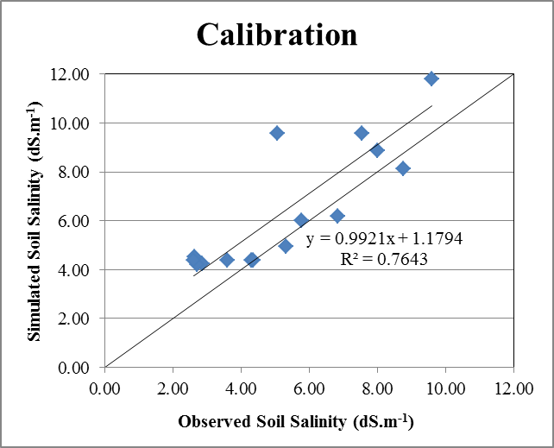
Figure 1. Relation between simulated and observed soil salinity simulated with SALTMED during calibration.

B) SALTMED model verification
Figure (2) shows an acceptable correlation between simulated values and observed values and coefficient of determination is 0.96. Akbari Fazli et al. (2013) also achieved the same results and reported the coefficient of determination as 0.92.
NRMSE value for soil salinity was 9.14 which is acceptable. CRM was -0.07 which shows that the model overestimate soil salinity values.

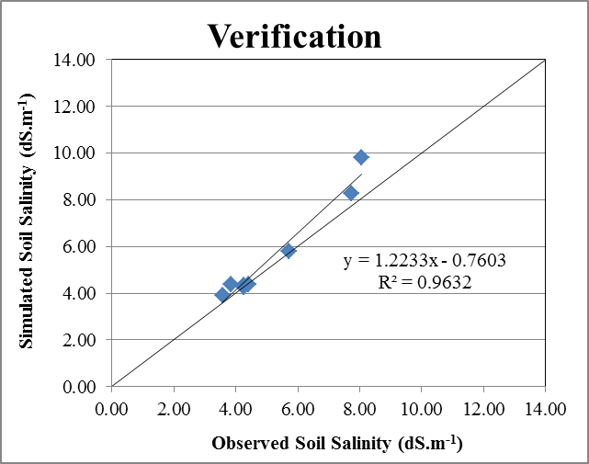
Figure 2. Relation between simulated and observed soil salinity simulated with SALTMED during verification.

C) Simulation of soil salinity for other treatments
Using calibrated and verified model, root zone soil salinity of S₁ to S₄ treatments were simulated (Figure 3).
Figure 3 shows the correlation between the observed and simulated soil salinity values. For all treatments, there was a good agreement between simulated and observed values and the coefficient of determination (R²) for S₁, S₂, S₃ and S₄ were 0.9, 0.86, 0.87 and 0.89 respectively.
NRMSE values for S₁, S₂, S₃ and S₄ treatments were 19.38, 19.24, 18.07 and 16.51 respectively which is acceptable for all treatments. CRM values for S₁, S₂, S₃ and S₄ treatments were –0.11, –0.08, 0.01 and 0.03 respectively which shows that the model slightly overestimated soil salinity in S₁ and S₂ and slightly underestimated in S₃ and S₄ treatments. Considering these results, by increasing irrigation water salinity, the difference between predicted values and measured values decreased. Also, by increasing irrigation water salinity, NSRMSE value decreases. This results show that by increasing irrigation water salinity, model accuracy will increase. Therefore, it can be concluded that the model works efficiently when using saline water. Ragab et al. (2005) using information from Egypt and Syria farms stated that the model is able to predict soil salinity; moreover, in a similar study Razaqi et al. (2011) stated that the model has great ability in predicting soil salinity. Rameshvaran et al. (2013) achieved the same results.

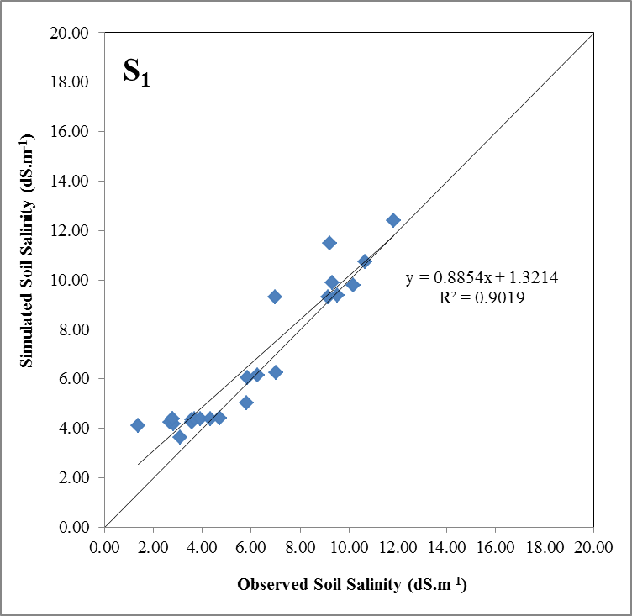

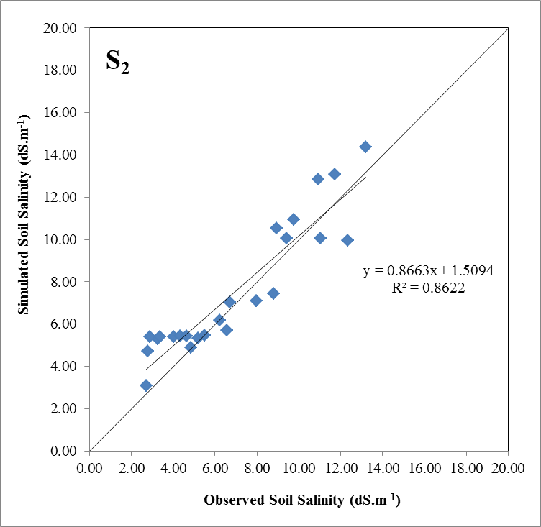

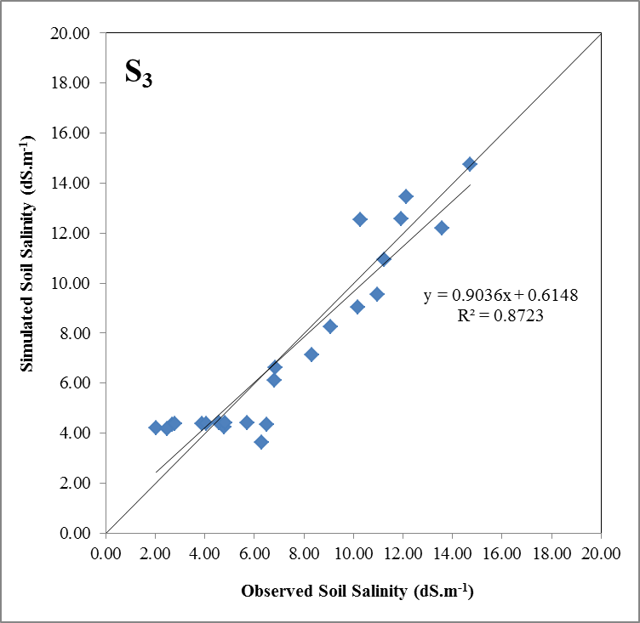

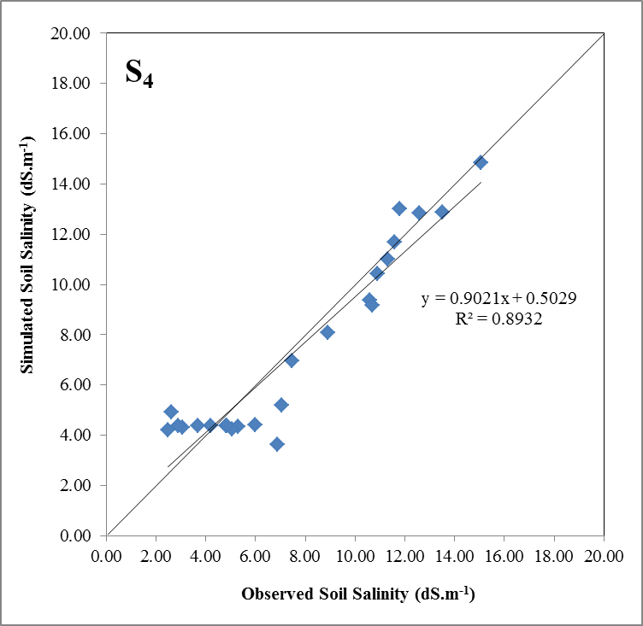
Figure 3. Correlation between observed and simulated soil salinity for treatments S₁, S₂, S₃ and S₄

Conclusion
In this study, 2013 released version of SALTMED model was calibrated and verified under corn cultivation condition using saline irrigation water. The SALTMED model proved to be an efficient tool for the simulation of root zone soil salinity under condition of using saline water. Also by increasing irrigation water salinity, the difference between simulated and measured values of soil salinity decreased. Thus, application of this model for simulation of soil salinity distribution under the condition of using saline irrigation water is suggested.

References
- Akbari Fazli R,Gholami A, Andarzian B, Ghoosheh M, Darvishpasand Z. Investigating the effect of applying drainaged-water on Wheat yield using SALTMED model. Novel Applied Sciences 2013; 2(S3):1003-1011.
- Aly A A, Al-Omran A M, Khasha A A. Water management for cucumber: Greenhouse experiment in Saudi Arabia and modeling study using SALTMED model. Soil and Water Conservation 2015; 70(11):1-11.
- Han M, El-Noemni A S, Pepars S K. Validation of SALTMED model under different conditions of drought and N fertilizer for Snap Bean. ATINER's Conference Paper Series WAT 2014; 3-15.
- Hedayati zadeh M. Simulation of solute distribution in soil profiles under maize cultivation using software SALTMED. M.Sc. Thesis. Water Science Engineering Faculty. Shahid Chamran University of Ahvaz. Iran. 2013.
- Henggeler J C. The conjuctive use of saline irrigation water on deficit irrigation. Ph.D. Dissertation, Texas University. 2004.
- Ragab R. A holistic generic integrated approach for irrigation, crop and field management: The SALTMED model. Environmental Modelling and Software 2002; 17: 345-361.
- Ragab R. Advances in integrated management of fresh and saline water for sustainable crop production: Modelling and practical solutions. Intl. Agricultural Water Management (Special Issue) 2005; 78(1-2): 1-164.
- Ragab R, Malash N, Abdel Gawad G, Arslan A, Ghaibeh A. A holistic generic integrated approach for irrigation, crop and field management 1. The SALTMED model and its calibration using field data from Egypt and Syria. Agricultural Water Management 2005; 78: 67-88.
- Rameshwarana P, Tepeb T, Yazarc A, Ragab R. Model application using greenhouse experiment data from Turkey. International Conference on: Sustainable Water Use for Securing Food Production in the Mediterranean Region under Changing Climate, 10–15 March. Agadir. Morocco. 2013; 144-149.
- Razzaghi F, Plauborg F, Ahmadi S H, Jacobsen S E, Andersen M N, Ragab R. Simulation of quinoa (chenopodium quinoa willd). Response to soil salinity using the Saltmed model. ICID 21st International Congress on Irrigation and Drainage, 15-23 October, Tehran, Iran. 2011.
- Silva L L, Ragab R, Duarte I, Lourenc E, Simoes O N, Chaves M M. Calibration and validation of SALTMED model under dry and wet year conditions using chickpea field data from Southern Portugal. Irrigaton Science 2013 ; 31:651–659.

10/18/2015

