A Comparative Study on the Healing Potential of Induced Labial Ulcerative Defects Treated with Nanosilver and Chlorhexidine.

Aziza EL-SanousiSaad, Dalia Elbaz andMaha Bashir

Oral Biology Department, Faculty of Oral and Dental Medicine, Cairo University
Aza_dent@yahoo.com

Abstract: Nanosilver NS is a potent antibacterial and powerful anti-inflammatory effects which improve wound healing. Aim of the study: To evaluate the effect of nanosilver on healing of induced labial mucous membrane ulcer and compare this to the conventionally used chlorohexidine solution on the rat animal model. Materials and methods: Forty five adult male rats were used and exposed to induced ulcers in the labial mucosa. The rats were divided into three groups control group (received no treatment), and two experimental groups. Group I: ulcers were irrigated with nanosilver solution twice daily. Group II: ulcers were irrigated with chlorohexidine twice daily. Histological, histochemical examination (using Proliferating Cell Nuclear Antigen PCNA, and Interlukien-6 IL-6) and statistical analysis were performed for all groups. Results: It was found that nanosilver promotes healing of oral ulcers better than the conventionally used chlorhexidine. Conclusion: This study showed that nanosilver has superior healing properties on oral ulcer mainly by decreasing the amount of inflammatory cells in underlying connective, and enhancing cell proliferation compared to the conventionally used chlorohexidine.
[Aziza EL-SanousiSaad, Dalia Elbaz and Maha Bashir. A Comparative Study on the Healing Potential of Induced Labial Ulcerative Defects Treated with Nanosilver and Chlorhexidine. Nat Sci 2015;13(11):59-73]. (ISSN: 1545-0740). http://www.sciencepub.net/nature. 9

Keywords:Nanosilver, chlorohexidine, ulcer, healing.

1. Introduction
In recent years nanotechnology has been emerging as a rapidly growing field with numerous applications in science and technology for the purpose of manufacturing new materials.It is defined as the utilization of structures with at least one dimension of nanometer size for the construction of materials, devices or systems with improved properties due to their nano-size (Russell, 2002). Nanotechnology has been attending much attention since 1980s and has been adapted into many engineering fields such as electronics and mechanics, with significant progress in the biomedical field (Panyam and Labhasetwar, 2003).
Nanomedicine is defined as the application of nanotechnology to achieve breakthrough in healthcare. It improved physical, chemical and biological properties of materials at the nanometer scale (Sahoo et al., 2007 and Narducci, 2007).
Nanosilver is a useful prophylactic and therapeutic agent for the prevention of wound colonization by organisms that impede healing (Lam et al., 1998). The main rationale for using nanosilver on open wounds is prevention and treatment of infection and increasing rate of the healing process (Salas, 2005).
An ulcer is a breakdown in the continuity of the skin or mucous membrane, disintegration and necrosis of epithelial tissue. Ulcers usually are accompanied by pain and discomfort often when eating, drinking or talking (Scully and Felix, 2005). Chlorhexidinegluconatehas been used for many years as an antiseptic and disinfectant. It is also used to promote gingival healing following periodontal surgery and to manage oral ulceration. (Zadik et al., 2011).
Reviewing the literature, few studies dealt with the effect of nanosilver on wound healing. Hence the present investigation was designed to compare between the healing potential of nanosilver and the wildly used disinfectant or antiseptic chlorhexidine in induced labial ulcerative defects both histologically and immunohistochemically.

2. Materials and Methods
All procedures of this experimental study were performed in accordance with guidelines of laboratory care and use of experimental animals. The present study was carried out at the experimental animal house, Faculty of Medicine, Cairo University. The experimental part was conducted on 45 albino rats. Rats were anesthetized by intramuscular injection of ketamine (50 mg/kg) and incisions measuring 3mm in length was made. Topical application of Nicorandil paste (20 mg) was used three successive days to induce labial ulceration. The rats were divided into three equal groups. The first one acted as a control group and the other two acted as experimental ones.
- Group Control C: The animals didn’t receive any treatment.
- Group Nanosilver NS: The induced ulcer was irrigated for 30 seconds with nanosilver solution twice per day for fourteen days successively.
- Group Chlorohxidine (CH): The induced ulcer was irrigated with the chlorhexidine solution for 30 seconds twice per day also for fourteen days.
The animals were sacrificed at three successive period, 3,7 and 14 days after ulcer induction.
Specimens of lip labial mucosa containing induced ulcers were excised and fixed in 10% neutral formalin. After routine laboratory processing, specimens were embedded in paraffin. The obtained sections were studied both histologically and immunohistochemically by subjecting them to haematoxyline & eosin histological stain, PCNA and IL-6 immunohistochemial stains respectively.
All sections were examined under light microscope.
Histomorphometric and Statistical analysis
For evaluation of the positive epithelial cells count, the immunoreactivity was measured by an image analysis system (Leica DM LB2 with QWIN plus image analyzer computer system, Germany). This analysis was carried out in the Faculty of Oral and Dental Medicine, Cairo University.
The data obtained from the histomorphometric analysis was statistically calculated and computed to compare the change in the count of positive cells for PCNA and IL-6 between the studied groups. Results were considered significant when probability P value (P) is 0.05 and highly significant when P.

3. Results
Histological examination
1. Three days:
(i) Control Group subgroup I (IC):
Histological examination of the labial mucosa sections of the rats showed ulcer formation in the epithelium. Exposed connective tissue revealed large aggregation of inflammatory cells. Dilated and engorged blood vessels were also observed (Figure 1).
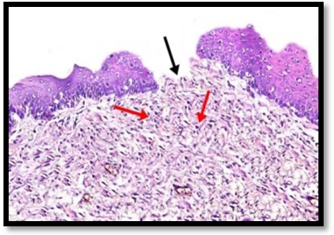
Fig.(1) Photomicrograph of rat labial mucosa of the control group subgroup I(I C) showing ulcer formation in the epithelium. (black arrow) with many inflammatory cells infiltration in the connective tissue (red arrows) (H & E× 200).

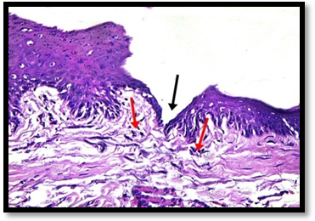
Figs.(2) Photomicrograph of rat labial mucosa of nanosilver group subgroupgp I(I NS) showing proliferation and migration of the basal cells over the ulcer area (black arrow) and some inflammatory cells in the connective tissue (red arrows), (H&E× 200).

ii) Nanosilver Group subgroup I (I NS):
Specimens of this group showed evidence of starting proliferation and migration of the epithelial basal cells over the ulcerated area. Some inflammatory cells were noticed. Dilated blood vessels in the lesion area were also observed (Fig 2).
(iii) Chlrohexidine group subgroup I (I CH):
Histological examination of sections of this group showed discontinuity of the epithelium at the lesion area. The connective tissue showed noticeable presence of inflammatory cells, dilated blood vessels,and randomly arranged collagen fibers (Fig 7).
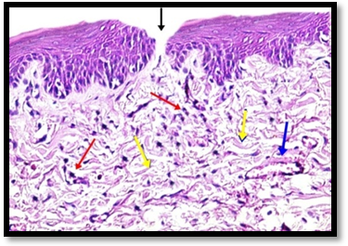
Fig.(3) Photomicrograph of rat labial mucosa of CH group subgroup I(I CH) showing discontinuity of the epithelium at the ulcer area(black arrow), Inflammatory cells(red arrow) randomly arranged collagen fibers (yellow arrows), anddilated blood vessels(blue arrow) (H&E ×200).

2. Seven days:
(i) Control Group subgroupII (II C):
Specimens of the lower lips of this subgroup showed ulcerated area in the epithelium. Under the margin of the ulcer, the inflammatory cells seemed to be less than those observed in subgroup I (C) group. Some dilated blood vessels were also seen (Fig 8).

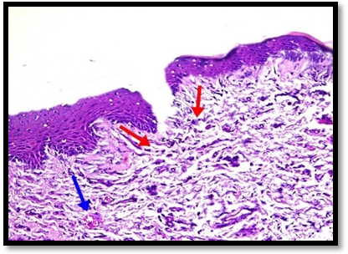
Fig. (8) photomicrograph of rat labial mucosa of the control group subgroup II (IIC) showing some inflammatory cells (red arrows) and dilated blood vessels (blue arrow), (H&E 200).

(ii) Nanosilver group subgroup II (II NS):
Histological examination of sections of this group revealed fusion of the cut edges of the wound area. The inflammatory cells in the connective tissue appeared to be less than those of the control group of the same period. Collagen fibrils were observed under the fusion area (Fig 9).

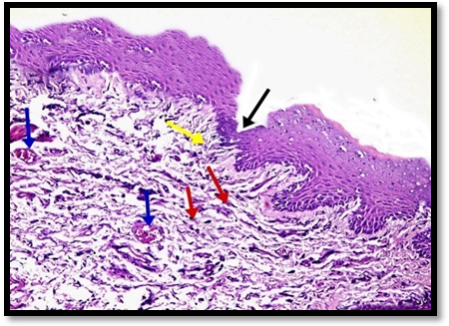
Fig (9): Photomicrograph of rat labial mucosa of NS group subgroup II (II NS) showing fusion of the cut edges of the wound area (black arrow), few inflammatory cells (red arrow), dilated blood vessels (blue arrows), and Collagen fibrils (yellow arrow) (H&E×200).

(iii) Chlorhexidine group subgroup II(II CH):
Sections of this subgroup showed that the epithelium started to heal by the proliferation of the basal cell at the edge of the ulcer to form very thin continuous layer of epithelium. At the base of the lesion, inflammatory cell infiltration was observed, (Fig 10).

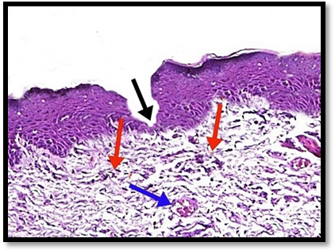
Fig.(10): Photomicrograph of rat labial mucosa of CH group subgroupII (II CH)showing proliferation of the basal cell at the edge of the ulcer (black arrow), some inflammatory cells (red arrows)and dilated blood vessels (blue arrows) (H&E×200).

3.Fourteen days:
(i)Control group subgroup III (IIIC):
Specimens of the lower lip in this group showed signs of healing by regrowth of epithelium, as the edges started to meet and re-epithelialze, by migration of the basal cells at the margin of the ulcer. Some inflammatory cells were noticed in the connective tissue under the ulcer. The collagen fibers were thicker and dilated blood vessels were also observed (Fig 11).

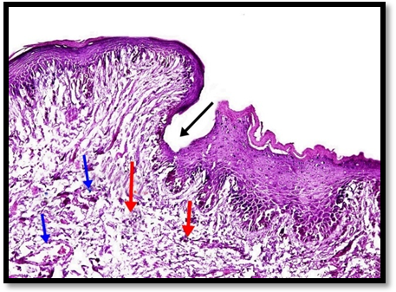
Fig. (11): Photomicrograph of rat labial mucosa of the control group subgroup III (IIIC) Showing beginning of regrowth of epithelial cells over the ulcer surface (black arrow), some inflammatory cells (red arrows) and dilated blood vessels(blue arrows) (H&E× 200).

(ii) Nanosilver group subgroup III (III NS):
Apparently, the epithelium was completely healed. The healed area showed moderately thick, irregularly fused epithelium covered with thin keratin layers. Scattered inflammatory cells were noticed in the connective tissue which almost looked normal (Fig 12).
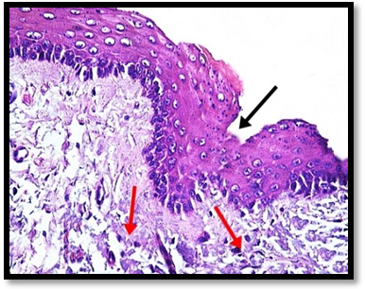
Fig (12): Photomicrograph of rat labial mucosa of NS group subgroup III (III NS) Showing the healed area with moderately thick, irregularly fused epithelium (black arrow) and Scattered inflammatory cells (red arrows) (H & E ×200).

(iii) Chlorhxidine group subgroup III (III CH):
Specimens of this group showed migration and fusion of proliferated basal cells at the edges of ulcer forming an irregular continuous layer of the epithelium with short epithelial ridges. Few inflammatory cells with some dilated blood vessels were observed in the connective tissue (Fig 13).

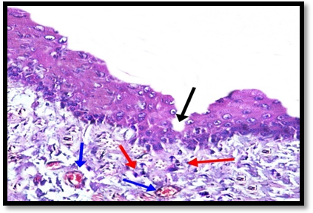
Fig.(13): Photomicrograph of rat labial mucosa of CH group subgroup III (III CH) showing fusion of proliferated basal cells at the edges of the lesion (black arrow), few inflammatory cells (red arrows)and dilated blood vessels (blue arrows) (H & E×200)

Immunohistochemical examination
1.PCNA immunostaining
The staining results were categorized based upon cellular distribution and intensity of the reaction product. Positive staining of PCNA was observed in all tissues examined with different degree of staining and cell number.
1. Three days group I: (C, NS & CH)
Weak immunostaining was noticed in few epithelial basal cells of the labial mucosa of the control group subgroup I(I C) (Fig10). On the other hand, in (NS) group subgp I strong PCNA immunoreactivity, in large number of epithelial cells was observed (Fig 11). While, in (CH) group subgp I, some basal cells of the epithelium demonstrated mild immunostaining (Fig 14).

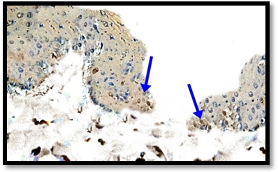
Fig.(14): Photomicrograph (C)group subgp I (IC) showing weak PCNA immunostaining in the basal cells of epithelium (blue arrows) (PCNA. Orig. Mag 400).

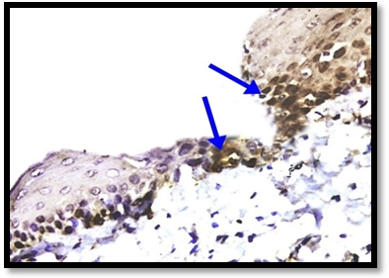
Fig (15): Photomicrograph of (NS) group subgp I (I NS) showing strong PCNA immunereactivity in large number of epithelial cells(blue arrows), (PCNA. Orig. Mag 400).

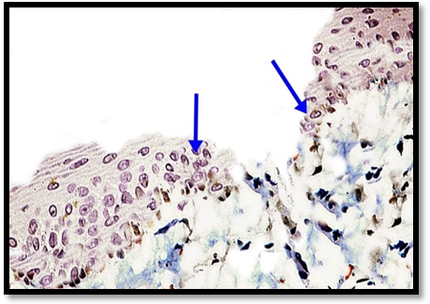
Fig.(16): Photomicrograph of (CH) group subgroup I (I CH) showing mild PCNA immunostaining in some basal cells of the epithelium (blue arrows) (PCNA. Orig. Mag 400).

2. Seven days subgroup II:(C, NS & CH)
In subgroup II of the control group (II C), the PCNA immune expression was mild in few basal cells of the epithelium (Fig 13), while, moderate to strong immunostaining in many epithelial cells was noticed in nanosilver group subgp II (Fig 14). In chlorhexidine group subgp II (II CH), moderate immunoreactivity was observed in some epithelial cells (Fig 17).

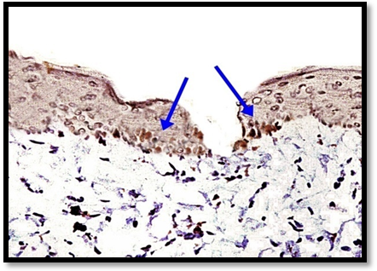
Fig. (17): Photomicrograph of the control group subgp II (II C) showing mild to moderate PCNA immune expression in the basal cells of the epithelium (blue arrows) (PCNA. Orig. Mag 400).

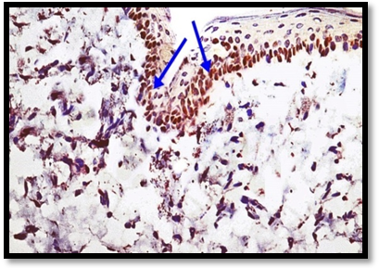
Fig.(18): Photomicrograph of (NS) group subgp II (II NS) showing moderate to strong PCNA immunostaining in many basal epithelial cells (blue arrows) (PCNA. Orig. Mag 400).

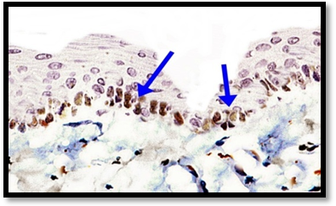
Fig. (19): Photomicrograph of (CH) group subgp II (II CH) showing moderate PCNA immunoreactivity in some epithelial cells (blue arrows) (PCNA. Orig. Mag 400).

3.Fourteen days subgroup III:(C, NS& CH)
Moderate immunoreactivity of PCNA in many basal cells was observed in subgroup III of the (C) group (Fig 19). Scattered epithelial cells showed mild immunoreaction in subgroup III of the nanosilver group (IIINS) (Fig 20). In subgroup III of the (CH) group, mild to moderate immunexpression in few parabasal and basal epithelial cells were observed (Fig 21).
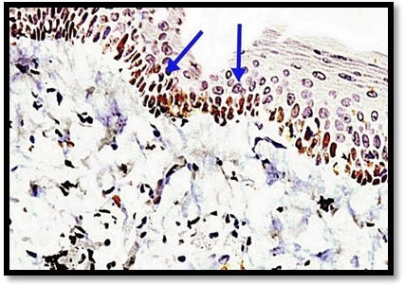
Fig. (19): Photomicrograph of (C) group subgpIII (III C) showing moderate PCNA immunoreactivity in many basal cells of epithelium (blue arrows) (PCNA. Orig. Mag 400).
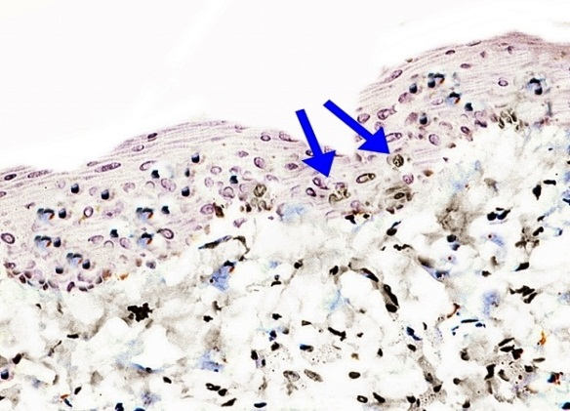
Fig (20): Photomicrograph of (NS) group subgp III (III NS) showing mild PCNA immunereactions in few epithelial cells (blue arrows) (PCNA. Orig. Mag 400).

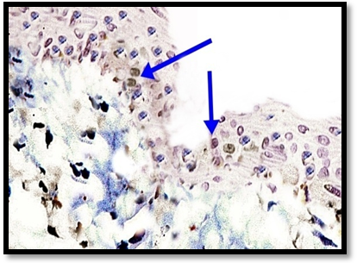
Fig. (21) Photomicrograph of (CH) group subgp III (III CH) showing mild to moderate PCNA immunexpression in few parabasal and basal epithelial cells (blue arrows) (PCNA. Orig. Mag 400).

2. IL-6
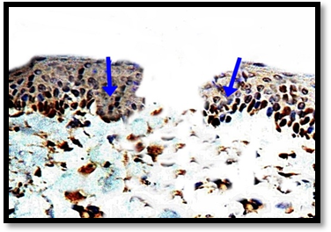
Fig. (22) Photomicrograph of (C) group subgroup I(IC) showing strong IL-6 immunostaining in many basal and parabasal cells of epithelium (blue arrows) (IL-6. Orig. Mag 400).

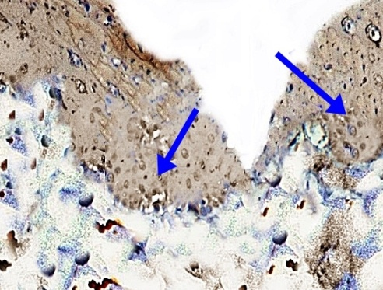
Fig. (23) Photomicrograph of (NS) group subgroup I (I NS) showing moderate IL-6 immunostaining in some basal and parabasal cells of epithelium (blue arrows) (IL-6.Orig. Mag 400).

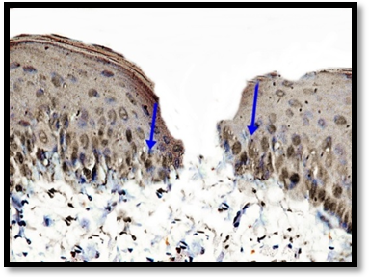
Fig. (24): Photomicrograph of (CH)group subgroup I(I CH) showing moderate to strong IL-6 immunostaining in many epithelial cells (blue arrows) (IL-6.Orig.Mag 400).

1. Three days subgroup I(C, NS and CH):
Strong interlukin-6 expression was detected in many basal and parabasal cells in (C) group subgroup I (fig 22).while, in (NS) group subgroup I, moderate immuoexpression was noticed in some epithelial cells (fig 23). Specimens of the (CH) group subgroup I demonstrated moderate to strong immunoexpression in many epithelial cells (fig 24).

2. Seven days subgroup II(C, NS and CH):
The IL-6 expression was moderate on subgroup II of the control (C) group in many basal and parabasal epithelial cells (fig 22), while, mild IL-6 staining in few basal cells in (NS) group subgroup II was observed (fig 23). Moreover, moderate immunostaining of IL-6 in some epithelial cells was demonstrated in (CH)group subgroup II (fig 24).

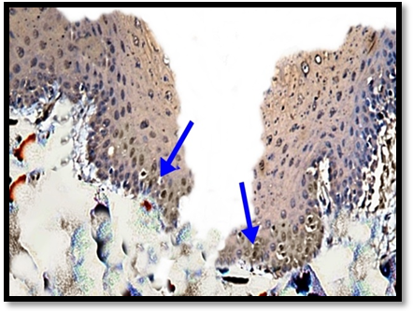
Fig. (25): Photomicrograph of (C) group subgroup II (IIC) showing moderate IL-6 immunostaining in basal and parabasal cells of epithelium (blue arrows) (IL-6. Orig. Mag 400)

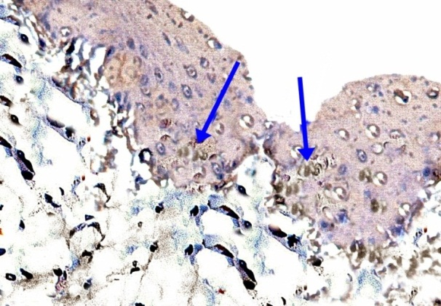
Fig. (26): Photomicrograph of (NS) group subgroup II (II NS) showing mild IL-6 immunostaining in few basal cells of epithelium (blue arrows) (IL-6. Orig. Mag 400)

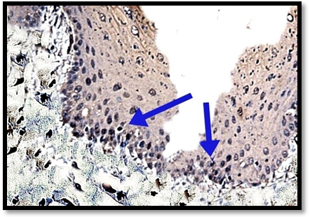
Fig. (27): Photomicrograph of (CH)group subgroup II(II CH) showing moderate IL-6 immunostaining in some epithelial cells (blue arrows) (IL-6. Orig. Mag 400)

3. Fourteen days subgroup III(C, NS and CH):
The expression of IL-6 in some basal cells was mild to moderate in subgroup III of the (C) group (Fig 25). On other hand, the epithelial cells of the (NS) group subgroup III demonstrated weak IL-6 expression in scattered epithelial cells (Fig 26). Mild immunostaining in few basal cells was observed in the (CH) group subgroup III (Fig 27).
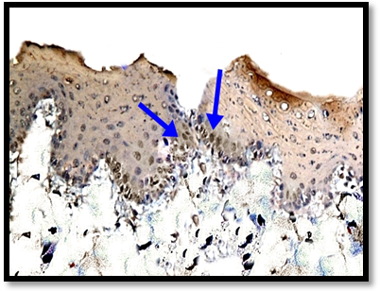
Fig. (28): Photomicrograph of (C) group subgroup III (III C) showing mild to moderate IL-6 immunostaining in some basal and parabasal cells of epithelium (blue arrows) (IL-6. Orig. Mag 400)

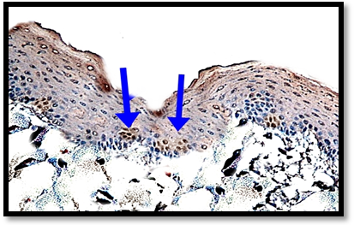
Fig. (29) Photomicrograph of (NS)group subgroup III (IIINS)showing weak IL-6 immunostaining in few basal epithelial cells (blue arrows), (IL-6.Orig.Mag 400)

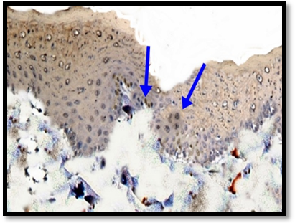
Fig. (30) Photomicrograph of (CH) group subgroup III (III CH) showing mild IL-6 immunostaining in few basal and parabasal cells of epithelium (blue arrows) (IL-6. Orig. Mag 400)

Statistical results:
1. PCNA: (Proliferating Nuclear Cell Antigen)
-The image analysis of PCNA stained labial mucosa sections demonstrated noticeable difference in epithelial cell count between control, nanosilver and chlorohexidine groups 3 days after ulcer induction.
-The nanosilvergroup recorded the highest cell count mean as compared to the other groups followed by chlrohexidine group, then control group. Analysis of variance (ANOVA) test revealed that the difference between control and experimental groups throughout the experiment was statistically significant (p=0.05) as demonstrated in Table (1) & Graph(1).
Graph (1): Representing difference in epithelial cell count stained with PCNA between C, NS and CH at 3 days.

- The image analysis of PCNA stained labial mucosa sections demonstrated marked difference in epithelial cell count between the three studied groups 7 days after ulcer induction.
-The nanosilver group recorded the highest cell number mean as compared to the other groups, followed by chlrohexidine group, then control one. Analysis of variance (ANOVA) test revealed that the difference between control and experimental groups throughout the experiment was statistically significant (p=0.006) as demonstrated in Table (2) & Graph(2).
Table (1): Represents difference in epithelial cell count stained with PCNA between C, NS and CH at 3 days after ulcer induction
3 Days | Control | Nanosilver | Chlrohexidine | P value
Mean | 2.092 | 9.632 | 4.166 | *0.058203
±SD | 0.692 | 0.555 | 0.684
Max | 3 | 10.407 | 5.01
Min | 1.322 | 9.134 | 3.336
*statistically significant

Table (2): Represents difference in epithelial cell count stained with PCNA between C, NS and CH at 7 days after ulcer induction.
7 Days | Control | Nanosilver | Chlrohexidine | P value
Mean | 3.212 | 6.105 | 4.302 | *0.006248
±SD | 0.473 | 2.091 | 0.61
Max | 3.856 | 8.955 | 5.587
Min | 2.733 | 3.998 | 4.121
*statistically significant

Graph (2): Representing difference in epithelial cell count stained with PCNA between C, NS and CH at 7 days.

- The image analysis of PCNA stained labial mucosa sections demonstrated marked difference in epithelial cell count between the three studied groups 14 days after ulcer induction.
-The control group recorded the highest epithelial cell count mean as compared to the other groups, followed by chlrohexidine group, then nanosilver one. Analysis of variance (ANOVA) test revealed that the difference between control and experimental groups throughout the experiment was statistically significant (p=0.003) as demonstrated in Table (3) & Graph(3).

Table (3): Represents difference in epithelial cell count stained with PCNA between C, NS and CH at 14 days after ulcer induction
14Days | Control | Nanosilver | Chlrohexidie | P value
Mean | 5.565 | 1.819 | 4.71 | *0.003822
±SD | 1.075 | 0.417 | 0.598
Max | 6.583 | 2.142 | 4.971
Min | 4.079 | 1.23 | 3.52
*statistically significant

Graph (3): Representing difference in epithelial cell count stained

2. IL-6: (A pro-inflammatory and anti-inflammatory cytokine)
- The image analysis of IL-6 stained labial mucosa sections demonstrated marked difference in epithelial cells count between control, nanosilver and chlorohexidine groups 3 days after lesion induction.
-The nanosilver group recorded the lowest epithelial cell count mean as compared to the other groups, followed by the chlrohexidine group, then the control one. Analysis of variance (ANOVA) test revealed that the difference between control and experimental groups throughout the experiment was statistically significant (p=0.005) as demonstrated in Table (4) & Graph(4).

Table (4): Represents difference in epithelial cell count stained with IL-6 between C, NS and CH at 3 days after ulcer induction
3 Days | Control | Nanosilver | Chlrohexidine | P value
Mean | 8.16 | 4.333 | 6.155 | *0.0055
±SD | 0.94 | 0.384 | 0.688
Max | 4.738 | 9.404 | 6.928
Min | 7.131 | 3.817 | 5.258
*statistically significant

Graph (4): Representing difference in epithelial cell count stained with IL-6 between C, NS and CH at3 days.

- The image analysis of IL-6 stained labial mucosa sections demonstrated marked difference in epithelial cells count between control, nanosilver and chlorohexidine groups 7 days after lesion induction.
-The nanosilver group recorded the lowest epithelial cell count mean as compared to the other groups, followed by the chlrohexidine group, then the control one. Analysis of variance (ANOVA) test revealed that the difference between control and experimental groups throughout the experiment was statistically significant (p=0.0014) as demonstrated in Table (5) & Graph(5)

Table (5): Represents difference in epithelial cell count stained with IL-6 between C, NS and CH at 7 days after ulcer induction.
7 Days | Control | Nanosilver | Chlrohexidie | P value
Mean | 7.652 | 2.181 | 4.753 | *0.001
±SD | 1.876 | 0.317 | 0.377
Max | 10.246 | 2.527 | 5.262
Min | 5.878 | 1.761 | 4.362
*statistically significant
Graph (5): Representing difference in epithelial cell count stained with IL-6 between C, NS and CH at 7 days.

-The image analysis of IL-6 of labial mucosa sections demonstrated difference in epithelial cell count between the three studied groups, 14 days after ulcer induction.
- The nanosilver group recorded the lowest cell count mean as compared to the other groups, followed by chlrohexidine group, then control group. Analysis of variance (ANOVA) test revealed that the difference between control and experimental groups throughout the experiment was statistically significant (p=0.004) as demonstrated in Table (6) & Graph(6).

Graph (6): Representing difference in epithelial cell count stained with IL-6 between C, NS and CH at 14 days

Table (6): Represents difference in epithelial cell count stained with IL-6 between C, NS and CH at 14 days after ulcer induction
14 Days | Control | Nanosilver | Chlrohexidine | P value
Mean | 4.71 | 1.444 | 2.914 | *0.004126
±SD | 0.39 | 0.158 | 0.369
Max | 5.142 | 1.664 | 3.436
Min | 4.197 | 1.305 | 2.639
*statistically significant

4. Discussion
Wound healing is a multistep process that passes through several important events including inflammation, proliferation, and remodeling to replace the missing cellular structures and tissue layers (Li et al., 2007).
Infections may delay and deteriorate wound healing through different mechanisms, such as persistent production of inflammatory mediators, metabolic wastes, and toxins. Moreover, bacteria could compete with host cells for nutrients and oxygen necessary for wound healing (Warriner, 2005).
The main rationale for using nanosilver on open wounds is prevention and treatment of infection and increasing rate of the healing process (Salas, 2005).
The present study was performed to assess the possible beneficial effect of nanosilver in induced labial ulcerative defects as compared to chlorhexidine.
Histological examination of the specimen of the control group at the 3rd day after induction of the ulcer revealed many inflammatory cells infiltration in the sub epithelial connective tissues, and the collagen fibers appeared thinner, and more loosely arranged. These results were in agreement with the work of Saetta et al., 1992 who showed at 3–5 days of bronchial ulcer induced by high-dose brachytherapy (a procedure used to place radioactive material inside the body), marked inflammatory changes in the control group, such as an increased number of inflammatory cells in the connective tissue, extensive epithelial desquamation and loss of celery appearance of bronchial epithelium.
In the current research, the ulcers irrigated with nanosilver solution for 3 days, histological examination, after 3 days, showed that the healing response was enhanced by rapid proliferation and migration of the epithelial basal cells over the ulcerated area and decreased the number of inflammatory cells in the connective tissue beneath the ulcer. These findings were in agreement with Sibbald et al., 2007 who reported that after 3 days of ulcer induction and treatment with silver, the nanocrystalline silver lessened the number of inflammatory cells, which in turn reduced wound inflammation and enhanced the healing process in chronic venous leg ulcer patients.
Moreover, the histological examination of sections of chlorhexidine groups at the third day of ulcer induction, showed discontinuity of the epithelium at the lesion area and some inflammatory cells with dilated blood vessels in the connective tissue. The collagen fibers appeared thin and were arranged in a wrinkled manner. These results were in accordance with Rezanur et al., 1998 who reported that after 3 days of ulcer irrigation with chlorhexidine, irregular margins of the ulcers, heavy inﬁltration of inﬂammatory cells and oedema were noticed.
At the 7th day, in control group, the wound decreased in size, and was covered by a thin layer of the epithelium, the intense inflammation was decreased and some newly formed blood vessels were seen. These findings were in agreement with Ali, 2012 who reported a marked decrease in inflammatory cell infiltration with sporadic chronic inflammatory cells, incompletely epithelized wound surface and a slight increase in the number of blood vessels 7th days after ulcer induction in the rat labial mucosa.
Specimen of the nanosilver groups at 7th day showed union of the edges of the ulcer area. The inflammatory cells infiltration in the underlying connective tissue were less than those of the other groups with newly formed collagen bundles and dilated blood vessels under the healing area were also seen. These results agreed with Han et al., 2006 who demonstrated that the use of nanosilver on infected burn wound in female mice,did not have any adverse effect on healing, on the contrary it decreased the wound healing time and enhanced re-epithelization, new tissue formation, angiogenesis and proliferation.
Microscopically, H&E specimens at 7th day of CH group (II CH) showed irregular margins of the ulcer as the epithelial cells started to migrate towards the center of the wound, decrease the inflammatory cells infiltration in connective tissue with formation of new blood vessels. These results were in agreement with Victor, 2005 who showed mild inflammation of the corneal epithelial layers, migration and proliferation of epithelial cells after application of chlorhexidinegluconate 0.2% four times a day for 7 days. He added that the cationic portion of CH interacted with the anions on the bacterial-cell wall with subsequent damage and death to the bacteria.
On the fourteenth day, healing of the epithelium started to occur in control group by proliferation and migration of basal cells at the margin of the ulcer forming a delicate continuous layer of epithelium. Also, new blood vessels, some inflammatory cells and fine collagen fibers were observed. These findings were in accordance with Noakchat, 2002 who reported decrease in size of the burn wounds in rats of the control group, little number of macrophages and neutrophils in the connective tissue, and an increase in the wound contraction and epithelization at 10-14 days after wounding.
In the present study, histological examination of fourteenth day post induction, showed that the healing response was enhanced by decreasing the number of inflammatory cells in the connective tissue and complete union of soft tissue incisions in the mucous membrane of the lip, with newly formed blood vessels occurring in the second week postoperatively. These results were concomitant with Liu, 2013 whoreported in the excisional wound of rat model treated with silver nanoparticles (AgNPs), that AgNPs was able to trigger differentiation of epidermal progenitors into keratinocytes, enhance proliferation and migration of keratinocytes, promote keratinocytes to produce vascular endothelial growth factor (VEGF) which stimulated the angiogenesis, and enhance the differentiation of fibroblasts into myofibroblasts for wound contraction.
The accelerated healing recorded in the nanosilver group of the present study, could be related to the extremely large surface area of nanosilver crystals, that led to increase the contact with bacteria and inhibit their replication. This explanation is in agreement with that of Lanl et al., 2010 who reported that the highly great surface area of nanosilver increased the contact with large number of bacteria in inflamed wound, leading to adverse effects on the cell metabolism and the transport of substrate through the microbial cell membrane, which inhibited multiplication and growth of those bacteria.
The use of chlorhexidinedigluconate solution two times for 30 seconds fourteen days in the current study, revealed marked decrease in the inflammatory cells, migration and proliferation of basal cells at the edges of the lesion and complete re-epithelialization of epithelium. These findings coincided with Victor, 2005 results, after 14-days of chlorhexidinegluconate 0.2% application for treating keratomycosis of eye in rabbits. Adequate healing of the corneal epithelial defect with complete re-epithelialization, absence of severe inflammation and no structural alteration in the deeper layers of the cornea were found. The author reported that prolonged treatment with chlorhexidinegluconate was effective as antimicrobial agent with no toxic effects on the cornea.
It had been proved from the histological results of the current studynanosilver and chorohexidine influenced ulcer treatment. That was further confirmed through the immunohistochemichal labeling for PCNA and interleukin -6.

The immunohistochemical results of the ongoing research have revealed the greatest PCNA expression in nasosilver group than that in chlorhexidine and control groups. The higher PCNA expression in the NS group indicated the presence of great number of proliferative cells, incorporated in epithelium during regeneration.
Little number of proliferating epithelial cells were found and showed weak PCNA immunostaining in the control group after three days (I C). These results could be correlated with those of Pohle et al., 1997, who found in the tissues of acetic acid induced gastric ulcer in rats of the control group, few positively stained epithelial and mesenchymal cells. On the third and fifth day as compared to the experimental group that was treated by acid-stable mutein of basic fibroblast growth factor (bFGF).
Epithelial cells surrounding the ulcer area in the NS group (I NS) exhibited strong immunoreaction for PCNA on 3rd day, (Indicating the presence of proliferative cells which started to appear after irrigating the lesion with NS). This finding coincided with the results of Xuelai 2010, who demonstrated that with PCNA staining proliferation of promoted epithelial cells was greatly increased in skin wound of rat model treated with nanosilver in comparison to silver sulphadiazine and control groups at 3days after wounding.
Moreover, the epithelial cells in the chlorhexidinegroup (CH) after three days of lesion irrigation (I CH), demonstrated mild PCNA immunostaining in some basal cells. These results agreed with Celenligil-Nazliel, 2002, who demonstrated mild immunoreactivity of PCNA in gingival epithelial cellsafter treatment of the periodontal pocket in vitro model with CH 3-5 days postoperatively, as compared to saline control group.
After seven days of the lesion, specimens of the control group (II C) demonstrated mild immunoreactions of PCNA in few basal cells. This result correlated with Becker, 2004, who revealed mild PCNA immunostaining in few epithelial and connective tissue cells at the gastric ulcer margin induced with a cryoprobe (blunt chilled instrument used to freeze tissues in cryosurgery) in control group of male rats after seven days of ulcer induction.
On the seventh day, the labial mucosa sections of nanosilver group revealed moderate immunostaining of PCNA in many epithelial cells. The higher proliferative expression of PCNA in NS group could be attributed to that the NS enhanced the proliferation of the epithelial cells. These findings agreed with Tam, 2010, who found moderate PCNA expression in cells of epidermal layer of the wound in rat model, in the silver nanoparticles (AgNPs) group during the healing phase at 7th day. The author suggested that silver nanoparticles could trigger the maturation of the proliferating keratinocytes and fibroblast cells as compared to silver sulphadiazine (SSD) cream group.
Some epithelial basal cells showed moderate PCNA immunoreactivity after seven days of lesion irrigation by chlorhexidine. These results were in accordance with Huth et al., 2006 findingswho found moderate PCNA expression in gingival epithelial cells of the wounded area in male patients after seven day of gingivectomy in CH group as compared to PCNA expression in ozone treated group.
Specimens of the control group subgroup III (after 14 days) revealed moderate PCNA immunoreactivity in many epithelial cells.These results agreed with Zayed, 2009 who studied the immunohistochemical effect of Nigella Sativa (NS) extract on chemotherapy induced oral mucositis in albino rats. In this study, the author demonstrated that the proliferating cells were still found in the control group at 14th day, with the moderate immunoexpression of PCNA in some epithelial basal cells and lamina propria cells.
Moreover, the density of PCNA expression and the number of positive cells in the labial mucosa decreased on the 14th day in nanosilver group NS where the healing was completed. These findings coincided with Liu, 2013, who found significant proliferation of the cells in the dorsal excisional wound of rat started from the 3rd day in NS group, and demonstrated the proliferative effect of NS dressing which was sustained after 10 days from wounding, where the immunereaction of PCNA was weak and the wound healed after this period.
At fourteen days, CH group showed mild to moderate PCNA immunostaining in few parabasal and basal epithelial cells. These findings were in agreement with Victor, 2005 results, who studied the effect of chlorhexidinegluconate on keratinomycosis of the eyes in rabbits, and demonstrated mild immunoreactivity of PCNA in epithelial cells of the cornea after 14 days of the lesion irrigation.
The inflammatory response is an important part of wound healing and involves the ordered migration of neutrophils and macrophages. Within wounds, these cells secrete various inflammatory mediators that modulate the healing process. A cytokine is a small protein released by cells and has a specific effect on the cell interactions, which triggers inflammation and respond to infections. There are pro-inflammatory cytokines and anti-inflammatory cytokines, both of them are involved in almost every disease. (Dinarello, 2000).
IL-6 is a pro-inflammatory cytokine produced by a variety of cell types, including fibroblasts, macrophages, endothelial cells, and keratinocytes in response to induction by variety of stimuli such as (infectious agent, endotoxin, wounding), (Balsetal, 1998). keratinocytes can synthesize and release signiﬁcant amounts of cytokines (IL-6) that are capable of modulating the inﬂammatory and immune responses (Grone, 2002). Moreover, IL-6 isn’t expressed by normal human keratinocytes except in various inflammatory disorders. The epithelial cells are the major source of the IL-6 that produced in response to bacterial infection and bacterial adherence (Spencer et al, 1992).
Cytokines have been classified as, lymphokines (cytokines made by lymphocytes), monokines (cytokines made by monocytes), chemokines (cytokines with hemotactic activities), and interleukins (cytokines made by one leukocyte to act on other leukocytes) (Christensen and Thomsen, 2009).
In the present study, the control group after three days (I C) revealed strong expression of IL-6 in many basal and parabasal epithelial cells. These results were consistent with Yumi et al., 2006 findings who reported in control samples of superficial dermatophytosis (common skin infection in humans) collected after 24-36 h of infection induction, a significant increase of pro-inflammatory cytokines (IL-6), due to skin infection.
On the other hand, the expression of IL-6 in some basal cell was moderate in NS group subgroup I (I NS), this could be related to the little number of inflammatory cells in the connective tissue of this group. This result was in agreement with Wright et al., 2002 results, who found moderate IL-6 immunoexpression in silver nanoparticles treated group in murine infected burns at three days after wounding. They demonstrated the decreasing in inflammatory cells infiltration lead to increase the rate of healing and decrease the scarring of the wound. Also, this finding was in accordance with Tian et al., 2007 who demonstrated that treatment with nanocrystalline silver in pig infected wound model, increased the apoptosis of inﬂammatory cells and decreased the IL-6 expression in wound area three days after wounding.
In CH group subgroup I (I CH), strong Il-6 expression in many basal and parabasal cells was observed. This result was in agreement with Wilson, 2008, who found high infiltration of inflammatory cells with elevated IL-6 expression in epithelial cells of gingiva that irrigated with 0.02% CH solution in patients after 3and 5 days of perioondtits treatment.
At 7th day, C group subgroup II (II C) demonstrated moderate IL-6 expression in some basal cells since the number of inflammatory cells decreased as compared to control group subgroup I(3 days). This finding coincides with Jeong, 2000 results, who studied the effects of aucubin (an iridoid glycoside commonly found in plants and function as defensive compounds used in traditional Chinese and folk medicine) on the healing of oral wounds in mice, and reported moderate IL-6 expression in epithelial and connective tissue cells in the control group on day 7.
Mild expression of IL-6 in few basal cells was detected in NS group subgroup II(II NS) in the ongoing study. This result was in accordance with Yin et al., 1999, who revealed that there was less inflammatory cells infiltration in the nanosilver treated group at 7 days after thermal injury and the expression of IL-6 was weak due to the higher IL-10 production. This could be explained by the study of Sato et al., 1999, who concluded that IL-10 was a major regulator in suppressing the inflammatory cells activation, it inhibited their capacity to release IL-6, and led to a consequent inflammation reduction. This could be due to increase expression of IL-10, produced by keratinocytes and inflammatory cells involved in the healing process. IL-10 was able to inhibit the synthesis of inflammatory cytokine (IL-6). It also inhibited the leukocyte migration toward the site of inflammation throughout the healing process.
In CH group subgroup II(II CH), some basal cells revealed mild expression of IL-6 since the inflammatory cells were still found but lesser than those which were seen in the control group of the same period. This finding was in agreement with Erdinc, 2010 who found that the CH ability to reduce the inflammatory cells infiltration on gingival tissue of patients who used postoperative CH (0.2%) rinse, was due to its bactericidal action, that inhibited the growth of microorganisms, and reduced inflammatory cells infiltration, and finally led to reduce IL-6 production.
In the current study, some basal cells of the control group subgroup III(III C) demonstrated mild IL-6 expression. Such result could be related to the presence of few inflammatory cells in the epithelium at the healed area at 14 days. This finding coincided with Radema et al., 1991 who found mild immunostaining of IL-6 in some epithelial cells of colon at fourteen days after acetic acid-induced colitis. This finding was due to lessen inflammatory cells infiltration and consequent reduction of IL-6 production.. The author concluded that detection of IL-6 expression was parallel to the presence of inflammatory cells infiltration within the epidermis of the wounds.
In the current work the expression of IL-6 was very weak in NS group subgroup III (III NS). These results could be attributed to the ability of nanosilver to decrease inflammatory cells infiltration which led to reduction of IL-6 production and the healing time of the wound (Lok et al., 2007). This observation was in agreement with Hauck et al., 2008 who found that the weak expression of IL-6 in the wound areas treated with silver nanoparticles of peyronie’s disease (chronic inflammation in connective tissue caused by trauma or surgical injury to skin of penis) in rat model after 2 wks of wounding. Similarly, Lee 2010 demonstrated the effect of silver nanoparticles in reepithelialization and increased the rate of wound closure during wound healing. This was achieved, through the promotion of proliferation and migration of keratinocytes, deceased secretion of IL-6, and apoptosis of inflammatory cells.
CH group subgroup III (III CH) showed mild IL-6 expression in some basal epithelial cells. This finding was in accordance with the investigation of Hideki 2010, who found mild expression of IL-6 in peritoneal epithelial cells of induced peritoneal inflammation by peritoneal dialysis in chlorhexidinegluconate treated group of rat model as compared to control group. Moreover, CH was able to destruct bacterial cellular wall, enhance of cell proliferation and reduced the inflammatory cells after 14 days of lesion irrigation with it.
The histological and immunohistochmichal data gathered from the present study after 3,7 and 14 days of ulcer induction, revealed difference in the rate of epithelization and the healing process between the three groups (C,NS,CH). However, the NS group showed significant enhancement of ulcer healing and accelerated healing time. Based upon the current results, it could be concluded that silver nanoparticles by means of their unique chemical and physical properties could be used as a useful treatment for oral ulceration in clinical practice.

Conclusion
The study showed that the nanosilver treated induced ulcer has a more accelerated pattern of wound healing by decrease the amount of inflammatory cells in underlying connective tissue, and enhancing the proliferation of the basal epithelial cells as compared to both control and chlorohexidine.

Acknowledgment
The author is thankful to Dr. Dalia Elbaz Ass professor of oral biology, Faculty of Oral and Dental medicine, Cairo University and Dr. Maha Bashir Professor of oral biology, Faculty of Oral and Dental medicine, Cairo University, for their kind help and support.

Reference
- Ali M. (2012): Propolis versus D`aktarin in mucosal wound healing. Life Science Journal. 9:624-636.
- Bals, R., Wang M., Zasloff and Wilson M. (1998): The peptide antibiotic LL-37/hCAP-18, IL-6 are expressed in epithelia of the human lung where hcap-18 has broad antimicrobial dermal contraction, epidermalactivity at the airway surface. Proc. Natl. Acad. Sci. 95:9541–9546.
- Becker S. (2004): Growth hormone enhances gastric ulcer healing in rats. Journal of Medical Science Monitor.10:255-258.
- Celenligil-Nazliel H., Ayhan A., Uzun H., and Ruacan S. (2002): The effect of age on proliferating cell nuclear antigen expression in oral gingival epithelium of healthy and inflamed human gingiva. Journal of Periodontol 71:1567–1574.
- Christensen J., and Thomsen A. (2009): Co-ordinating innate and adaptive immunity to viral infection: mobility is the key. J of Pathology, Microbiology & Immunology APMIS 117:338-355.
- Dinarello C. (2000): Proinflammatory cytokines. Journal of Allergy Clin. Immunol. 103:11-24.
- Elder D., Dowson S., and Wiernikowski T. (1994): A comparison of sterile saline and bacteriostatic chlorohexidine solution. American Journal of Pediatric and Oncology 13:137-140.
- Erdinc D. (2010): Impact of chlorhexidine mouth rinse use on postextraction infection via nitric oxide pathway. Journal of the European Histamine Research Society.59: 437-441.
- Grone A. (2002): Keratinocytes and cytokines. Journal of Vet Immunol. Immunopathol. 88: 1–12.
- Han M., Lin X., Tang J., and Su J. (2006): Effect of silver nanoparticle dressing on second degree burn wound. Journal of Vector Borne Dis 44: 50–62.
- Hideki Y. (2010): Inflammation and increased peritoneal permeability leading to peritoneal fibrosis. International journal of Society of Nephrology. 81: 160–169.
- Huth C., Jakob M., Saugel B., Cappello C., and Paschos E. (2006): Eﬀect of ozone on oral cells compared with established antimicrobials. Eur Journal of Oral Sci.114: 435–440.
- Jeong M. (2000): Effects of aucubin on the healing of oral wounds. Int Journal of Experi and clin pathophysiology and dent resech 21:1037-1041.
- Lam K., Buret G, and Olson M. (1998): Wound management in an era of increasing bacterial antibiotic resistance and a role for topical silver treatment. Journal of Am. Inf. control.26:572-577.
- Lanl K., Chan S., and Liew T. (2010): In vitro cytotoxicity testing of a nanocrystalline silver dressing (Acticoat) on cultured keratinocytes. Br Journal of Biomed Sci.61:125-127.
- Lee Y., Lui C., Chen Y., Che M., and Tam K. (2010): Silver nanoparticles and skin wound healing. Journal of Invest Dermatol. 60:791 –798.
- Li H., Fu L., Ouyang Y., Cai C., Wang J., and Sun Z. (2007): Adult bone-marrow-derived mesenchymal stem cells contribute to wound healing of skin appendages. Journal of Dermatol Sci 14:325–335.
- Liu X. (2013): The role of silver nanoparticles on skin wound healing, tissue remodeling and their potential cytotoxicity. Journal of Nanosci. Nanotechnol. 9: 4521-42.
- Lok N., Yu Y., Sun H., Tam K., Chiu F., and CheM. (2007): Silver nanoparticles: Partial oxidation and antibacterial activities. Journal of BiolInorg Chem. 12:527-534.
- Narducci, D. (2007): The effective of nanotechnologies on different diseases. Journal of Pharm Tech Research. 13:131-137.
- Noakchat H. (2002): Preparation and evaluation of medical nanosilver dressing. Journal of Wound care. 37:315-322.
- Paddock N. (2002): Clinical assessment of silver –coated antimicrobial dressing on MMPs and cytokine levels in non –healing wounds. Journal of Wound healing society. 14:191-196.
- Panyam J., and Labhasetwar V.(2003): Biodegradable nanoparticles for drug and gene delivery to cells and tissue. Journal of Drug Target. 55:329-347.
- Pohle T., Drees M., and Gillessen A., and et al. (1997): Simultaneous restitution of matrix and cells in gastric ulcer—use of a combined in-situ hybridization and immunohistochemistry technique. Journal of Histochem Cell Biol 28: 601- 610.
- Radema S., Hommes W., Fockens P., and Stronkhorst A. (1991): Cytokine Induction in Experimental and Ulcerative Colitis. Int Journal for GI surgeon. 9:177–187.
- Rezanur R., Gordon J., Rabiul H., and et al. (1998): Randomized trial of 0.2% chlorhexidinegluconate and 2.5% natamycin for fungal keratitis in Bangladesh. Br Journal of Opthalmol. 82: 919-925.
- Russell E. (2002): Nanotechnology and Shrinking world of textiles. Journal of Textile Research 10:7-9.
- Saetta M., Stefano A., and Maestrelli P. (1992): Activated T-lymphocytes and macrophages in bronchial mucosa of subjects with chronic bronchitis. Am journal of Rev Repir Dis. 47:301–306.
- Sahoo K., Parveen S., and Panda J. (2007): The present and future of nanotechnology in human health care. Nanomedicine: Nanotechnology, Biology and Medicine. Journal of Pharm Tech Research.3: 20-31.
- Salas C. (2005): Topical chemotherapy for treatment of the burns. Journal of Wound Care. 28:67-70.
- Sato Y., Ohshima T., and Kondo T. (1999): Regulatory role of endogenous IL-10 in cutaneous inflammatory response of murine wound healing. Biochem Biophys Res Comm 26:194–199.
- Scully C., and Felix D. (2005): Mouth ulcers of more serious connotation. Journal of Br. Dent. 19:339-343.
- Sibbald R., Coutts P., Fierheller M., and Rothman A. (2007): A study of nanocrystalline silver dressings in chronic venous leg ulcers. Journal of Adv Skin Wound Care. 20: 549-48.
- Spencer H. Majlis S., and Catharina S. (1992): Interleukin-6 Response of Epithelial Cell Lines to Bacterial Stimulation In Vitro. Journal of American Society for Microbiology 60:1295-1301.
- Tam k. (2010): Silver nanoparticles mediate differential responses in keratinocytes and fibroblasts during skin wound healing. Journal of Chem Med Chem2:129 -136.
- TianJ., Wong K., Ho C., Lok C., and Chew et al. (2007): Topical delivery of silver nanoparticles promotes on beryllium disease. Journal of Chem Med Chem, 2:129-136.
- Victor V. (2005): Toxicity of 0.2% chlorhexidinegluconate on the cornea and adjacent structures. Philippine Journal of Ophthalmology. 30: 119–123.
- Warriner R., and Burrell R. (2005): Infection and the chronic wound: a focus on silver. Journal of of Advanced Skin Wound Care. 18:2–12.
- Wilson F. (2008): Effect of ultrasonic debridement using a chlorhexidine irrigation on circulating levels of lipopolysaccharides and interleukin-6. Journal of clinical periodontology. 34:415-419.
- Wright, J., Buret, A., and Olson E. (2002): Early healing events in a murine model of contaminated wounds: effects of nanocristallinesilver on matrix metalloproteinases, cell apoptosis and healing. Journal of Wound Repair Regeneration.10: 141-151.
- XuelaiL. (2010): Silver nanoparticles mediate differential responses keratinocytes and fibroblasts during skin wound healing. Journal of Chemistry Drug Disc. 3:468-475.
- Yin Q., Langford R., and Burrell E. (1999): Comparative evaluation of the antimicrobial activity of Acticoat antimicrobial barrier dressing. Journal of Burn Care Rehab.20: 195-200.
- Yumi S., Yoshio I., and Masataro H. (2006): Cytokine secretion profiles of human keratinocytes during Trichophytontonsurans and Arthrodermabenhamiae infections.Journal of MedMicrobiol. 55:1175-1185.
- Zayed M. (2009): Immunohistochemical Study of the Effect of Nigella Sativa L Extract on Chemotherapy Induced Oral Mucositis in Albino Rats. Cairo Dental Journal.25: 159-166.
- Zadik Y., Yitschaky O., Neuman T., and Nitzan W. (2011): On the self-resolution nature of the buccal bifurcation cyst. Journal of Oral Maxillofacial groups.

10/25/2015

