Development of Albino Rat Knee Joint Cavitation and the Effect of Ciprofloxacin and the Possible Protective Role of Vitamin E

Saadia Ahmed Shalaby, Essam Mohamed Eid, Naglaa Ali Saber Sarg, Osama Foaad Ahmed and Hanan Ibrahim Hussein.

Anatomy & Embryology Department, Faculty of Medicine, Benha University
tantawy_d@yahoo.com

Abstract: Introduction: The knee joint cavity started to developed in the intrauterine life from mesenchymal progenitor at the interzone. Ciprofloxacin is one of fluorinated derivatives of quinolone, which has a broad spectrum bactericidal activity. Ciprofloxacin induces damage of the epiphyseal growth plate during early post-natal developmental phase resulting in irreversible bone damage and growth inhibition. Aim of this work: is to study the prenatal and postnatal development of the knee joint cavity in albino rat and detect the effect of ciprofloxacin on the articular cartilage of knee joint and epiphyseal growth plate cartilage of femur and tibia and evaluate the possible protective role of vitamin E and detect the possible reversible effects of ciprofloxacin after drug stoppage. Material and methods: eighteen pregnant rats were divided in to two groups: (Ι) Developmental groups: pregnant rats sacrificed at 16th, 18th, 20th days of gestation. (П) Experimental groups: A-Control group and B-Ciprofloxacin treated group: divided into four subgroups. a- Ciprofloxacin Treated pups subgroup: received 20 mg/kg/day ciprofloxacin for 14 days. b- Ciprofloxacin Treated rats subgroup: Rats aged 5weeks received 20 mg/kg/day ciprofloxacin for 14 days. c- Ciprofloxacin plus vitamin E subgroup: Rats aged 5 weeks received 20 mg/kg/day ciprofloxacin in addition to 100 mg/kg/ day vitamin E for 14 days. d- Ciprofloxacin withdrawal subgroup: Rats aged 5 weeks received 20 mg/kg/day ciprofloxacin for 14 days then left to live for 30 days after Ciprofloxacin stoppage then rats were sacrificed. Results: The knee joint cavity started to appear at 16 day intrauterine life in the interzone and completed at 20 day intrauterine life, Ciprofloxacin cause erosion and cavitations of the articular cartilage and the epiphyseal growth plate of the femur and tibia by light microscopy and chondrocyts degeneration by electron microscopy,and after giving vitamin E with Ciprofloxacin, the articular cartilage of the femoral condyle affected only small cavitations of deep zone with little sign of degenerations by electron microscopy. After stopping of Ciprofloxacin for 30 days we found persistence its effect on growing articular cartilage and epiphyseal growth plate. Conclusion: The knee joint cavity started to appear at the interzoe at 16 day I.U.L. and completed at 20 day I.U.L. Ciprofloxacin causes toxic effect on the growing cartilage. The vitamin E partially minimizes the toxic effect of Ciprofloxacin. The toxic effects of Ciprofloxacin are irreversible after stoppage of this drug.
[Saadia Ahmed, Shalaby, Essam Mohamed Eid, Naglaa Ali Saber Sarg, Osama Foaad Ahmed and Hanan Ibrahim Hussein. Development of Albino Rat Knee Joint Cavitation and the Effect of Ciprofloxacin and the Possible Protective Role of Vitamin E. Nat Sci 2015;13(11):78-86]. (ISSN: 1545-0740). http://www.sciencepub.net/nature. 11

Keywords: development, knee joint, articular cartilage, epiphyseal cartilage plate, ciprofloxacin, vitamin E.

1. Introduction
Several studies have been attempted to evaluate the development of knee joint, and revealed that the joint developed at the interzone [1]. Some author’s accepted that the developmental mechanism of the synovial joint cavity was concerned that a partial cavity emerged somewhere within the interzone and became enlarged by mechanical stimulation due to movement [2]. Others accepted that the developmental mechanism of the synovial joint cavity was due to cell disappearance in the interzone, including cell degeneration and cell death[3]. Ciprofloxacin is one of fluorinated derivatives of quinolone, which has a broad spectrum bactericidal activity. Fluoroquinolones continue to be prescribed as a drug of choice for treatment of some life threatening diseases in pediatrics[4]. Ciprofloxacin induces damage of the epiphyseal growth plate during early post-natal developmental phase resulting in irreversible bone damage and growth inhibition and showed a statistically significant decrease in their thickness as well as the number of articular cartilage chondrocytes [5]. Single high oral dose and multiple lowdoses of ciprofloxacin were chondrotoxic in juvenilerats inducing scars and erosions of the joint surface.

2. Materials and Methods
Materials:
In the present study, thirty sex adult albino rats from Veterinary Medical Collage of Benha University were used (18 adult females &18 adult males) and growing pups were born in our laboratory in Benha Faculty of Medicine. Eighteen female albino rats were matted with males overnight and were examined in the next morning for the presence of sperms in vaginal smear. The day in which the sperms were detected is counted as day zero of gestation. Pregnant rats were housed individually in clean cages of well aireated environment, given a normal daily diet and maintained 12/12 hour light/dark cycle.
Drugs: Ciprofloxacin will be obtained in the form of the commercially packed tablets “Ciprofloxacin”. European Egyptian Pharm. Ind. Company Alexandria Egypt. Each tablet contains 250 mg ciprofloxacin Hcl. The recommended dose of ciprofloxacin in rat was 20 mg/kg/day. One tablet will be suspended in 100ml 2% freshly prepared starch suspension. So, 1 ml was contained 2,5 mg of ciprofloxacin. Vitamin E is available commercially as E–vitoncapsules (Kahira Pharm. and Chem. Ind. Company). Each capsule contains 100 mg α-tocopherolacetate. The recommended dose of vitamin E is 100mg/kg/day. The content of one capsule was dissolved in 30ml corn oil.
Methods:
Eighteen pregnant rats were divided in to two groups.
(Ι) Developmental groups: consisted of nine pregnant rats which were subdivided into: three pregnant rats for each subgroup which were sacrificed at 16th, 18th, 20th days of gestation.
(П) Experimental groups consisted of nine pregnant rats which were remained until birth then forty pups resulted were divided in to 2 groups. Each group twenty rats. A- Control group: subdivided in to 3 small subgroups: 1-The lactating mothers of one small subgroup aged one day after birth received 0.5ml of 2% freshly prepared starch suspension once daily for 14 consecutive days using gastric tube. 2-Other small subgroup aged 5weeks after birth received 0.5ml of 2% freshly prepared starch suspension once daily for 14 consecutive days using gastric tube then the rats were sacrificed 3- Other small subgroup aged 5 weeks after birth received 1.8 ml corn oil for 14 consecutive days using gastric tube then the rats were sacrificed. B-Ciprofloxacin treated group: divided into four subgroups. a- Ciprofloxacin Treated pups subgroup: received 20 mg/kg/day ciprofloxacin for 14 days. b- Ciprofloxacin Treated rats subgroup: Rats aged 5weeks received 20 mg/kg/day ciprofloxacin for 14 days. c- Ciprofloxacin plus vitamin E subgroup: Rats aged 5 weeks received 20 mg/kg/day ciprofloxacin in addition to 100 mg/kg/ day vitamin E for 14 days. d- Ciprofloxacin withdrawal subgroup: Rats aged 5 weeks received 20 mg/kg/day ciprofloxacin for 14 days then left to live for 30 days after Ciprofloxacin stoppage then rats were sacrificed.
Specimen and tissue preparation:
The knee region dissected, extracted and soft tissues removed. Then the specimens fixed in 10 % neutral buffered formaldehyde at room temperature for1 week. Decalcification was performed in neutral EDTA (ethylene-diaminetetra-acetic acid) solution with several changes of the solution for 4 weeks. Then specimens processed for electron microscopy and light microscopic examinations. It stained with the following: a-Hematoxylin and Eosin (H&E) stain: For demonstration of the general histological structure [6].

3. Results:
(Ι) Developmental groups: divided in to:
(1) Fetal rats aged 16 days intra uterine life: By light microscopy, the knee joint cavity begin to appear simultaneously between the femoral condyle and the tibial condyle. By electron microscopy, the chondroblasts in the intermediate zone have well defined heterochromatic eccentric nucleus with dense nuclear membrane and nucleolus. Fig (1)
(2) Fetal rats aged 18 days intra uterine life: By light microscopy, the knee joint cavity is still incomplete with area of fusion. By electron microscopy, parallel group of fusiform chondroblasts inside the matrix. These cells has central nucleus, its cytoplasm contain a large cavity at both side of the cells. Fig (2)
(3) Fetal rats aged 20 days intra uterine life: By light microscopy, complete formation of knee joint cavity between femoral condyle, tibial condyle and patella. By electron microscopy, chondroblasts fusiform in shape with large oval heterochromatic nucleus, the supranuclear cytoplasm form thin layer around the nucleus and contains rough endoplasmic reticulum. Fig (3)
(П) Experimental groups: (A) Control group: (1) Rats aged 2 weeks after birth received starch: by light microscopy, the growing tibial articular cartilages consists of smooth surface, the superficial zone, the intermediate zone then the deep zone and blood sinusoids deep to the articular cartilage. The tibial epiphyseal growth plate consists of reserve zone, the proliferative zone, the hypertrophic zone, and the mineralized zone.By electron microscopy, the chondrocytes are elongated and arranged parallel to each other between matrix, with eccentric nucleus, and supranuclear cytoplasm contains condensed rough endoplasmic reteculum. Fig (4, 5, 6) (2) Rats aged 5 weeks after birth received starch: by light microscopy, the growing tibial articular cartilages consists of smooth surface, the superficial zone, the intermediate zone then the deep zone and blood sinusoids deep to the articular cartilage. The tibial epiphyseal growth plate consists of reserve zone, the proliferative zone, the hypertrophic zone, and the mineralized zone. By electron microscopy, the chondrocytes are active for production of matrix so its cytoplasm has many granules, lipid droplet, lysosome and rough endoplasmic reticulum. With elongated nucleus, the cell membrane surrounded by capsular matrix, and the territorial matrix outside the capsular matrix. Fig (7)
(3) Rats aged 5weeks after birth received corn oil: the same as in Rats aged 5weeks after birth received starch.
(B) Ciprofloxacin Treated group:
(1) Pups aged 2weeks after birth Treated by ciprofloxacin subgroup by light microscopy, the surface of the articular cartilage of the femoral condyle affected by erosion of the superficial zone while the intermediate zone, and hypertrophied zone were intact. The cavitations affect the epiphyseal growth plate of the femur. by electron microscopy, the chondrocyte degenerated with dark pechnotic nucleus, the cytoplasm contains deferent size of cavitations and the cell membrane partialy ruptured. Fig (8, 9,10)
(2) Rats aged 5weeks after birth Treated by ciprofloxacin subgroup
By light microscopy, many cavitations in the articular cartilage of the femoral condyle, affects all layers, the superficial zone, the intermediate zone and hypertrophied zone. By electron microscopy, the chondrocytes were degenerated and shrunked with dark pechnotic nucleus, the cell membrane has multiple cytoplasmic processes. Fig (11, 12,13)
(3) Rats aged 5weeks after birth treated by ciprofloxacin plus vitamin E subgroup
By light microscopy, the articular cartilage of the femoral condyle affected by small cavitations of deep zone with intact, superficial zone, and intermediate zone. The femoral epiphyseal growth plate has a well defined proliferative zone, hypertrophic zone, but with low cellularity of the reserve zone. By electron microscopy, the chondrocyte has a elongated dark nucleus. The cytoplasm contains vacuolated mitochondria, groups of granules, lysosomes, and rough endoplasmic reticulum. Fig (14, 15, 16)
(4) Rats aged 5weeks after birth after withdrawal of ciprofloxacin
By light microscopy, the surface of the articular cartilage of the femoral condyle has irregular surface, collagen fibers arranged parallel to the eroded surface with cavitations of the deep zone, with intact of superficial zone and intermediate zone. The cavitations affect the epiphyseal growth plate of the femur either in the hypertrophic zone but proliferative zone and reserve zone were intact. By electron microscopy, the chondrocytes were degenerated with dark vacuolated nucleus, the cytoplasm contained deferent size of cavitations and granules.the cell membrane had multiple cytoplasmic processes. Fig (17, 18, 19).

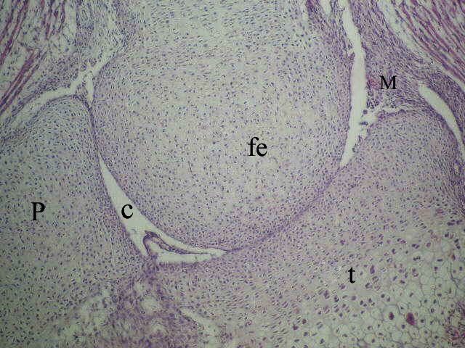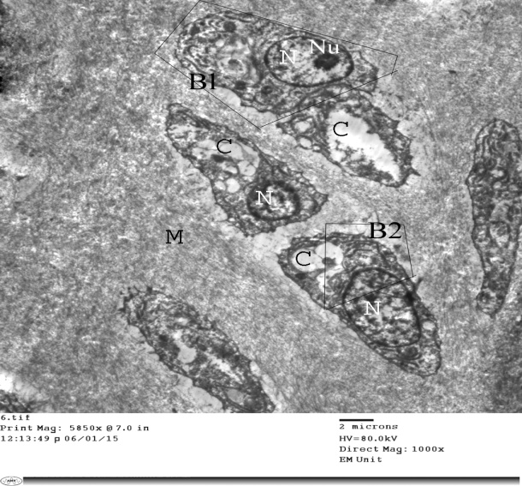
A B
Fig: 1 - A a photomicrograph of a sagittal section of rat knee joint aged 16 day I.U.L showing the Cavity(C) begin to appear simultaneously between the femoral condyle (fe) and thetibial condyle (t) patella (P), note meniscus (M). (H & E X40), B An electron micrograph of the rat knee joint aged 16 days IUL showing chondroblasts (B1, B2) in the intermediate zone. These cells has well defined eccentric nucleus (N) with nucleolus (Nu), its cytoplasm contain a large cavity (C). Note matrix (M). (E. M.X 1000).

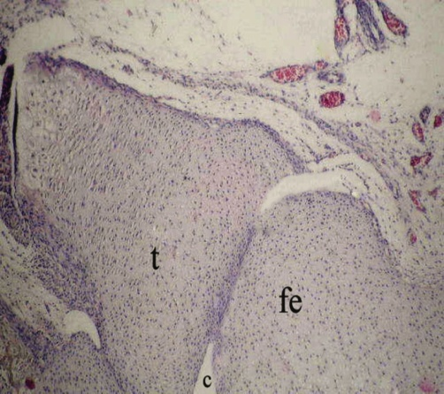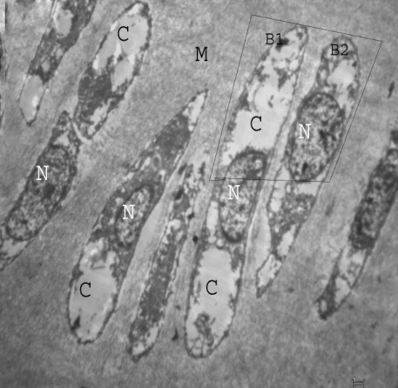
A B
Fig. (2): A photomicrograph of a sagittal section of a rat knee joint aged 18 days I.U.L showing chondrofication of the epiphyses of femoralcondyle (fe) and tibialcondyle (t) the joint Cavity (C) is still in complete with area of fusion (H & E X40), B An electron micrograph of the rat knee joint aged 18 days IUL showing: parallel group of fusiform chondroblasts (B1, B2) inside the matrix (M). These cells has central nucleus (N), its cytoplasm contain a large cavity (C) at both side of the cells. (E. M. X 2000).

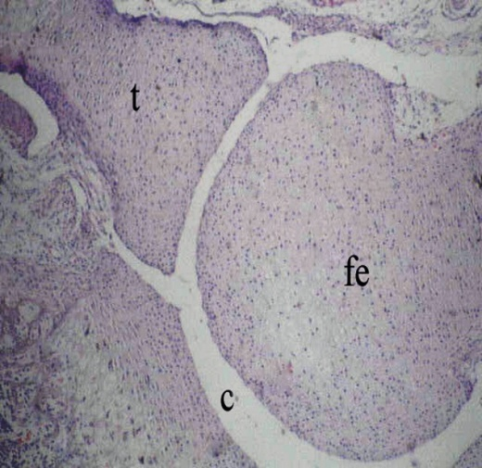
Fig. (3): A aphotomicrograph of a sagittal section of a rat knee joint aged 20 days I.U.L showing: complete formation of knee joint cavity(C) between femoral condyle (fe) and tibial condyle (t) and patella (p), B An electron micrograph of the rat knee joint aged 20 days IUL showing: chondroblasts (B) arranged parallel to each other inside the matrix (M). These cells are fusiform in shape with central nucleus (N), and RER in cytoplasm (arrow).

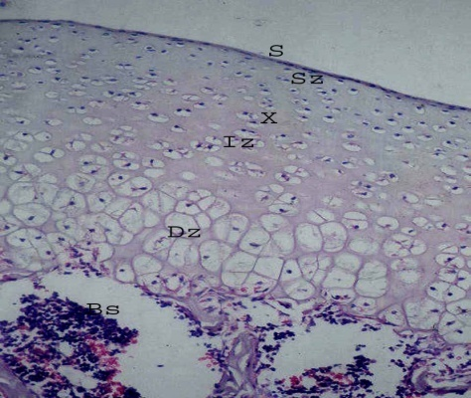
A
Fig. (4): (A) A photomicrograph of a sagittal section of a rat knee joint aged 2 weeks after birth received starch showing: the growing tibial articular cartilages of the knee joint is formed of a superficial smooth surface (S) followed by three distinct zones of chondrocytes; the superficial zone (SZ) is formed of tangentially flattened chondrocytes, the intermediate zone (IZ) has radially arranged chondrocytes and the deep zone (DZ) is formed of hypertrophied chondrocytes. These three zones of cells had a characteristic regular arrangement inside articular matrix (X) blood sinusoid (Bs). (H & E X 200)
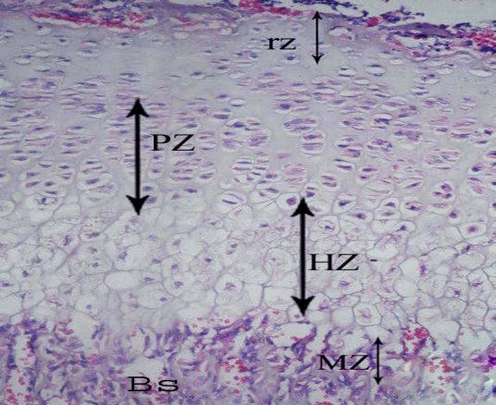
B
Fig. (5): (B) a photomicrograph of a sagittal sectionof a rat knee joint aged 2 weeks after birth received starch showing: the tibialepiphyseal growth plate cartilages has four distinct zones which are the reserve zone (rz) that is formed of chondroblasts arranged singly or in small clusters inside a basophilic matrix. The proliferative zone (PZ) is formed of columns of chondrocytes. The hypertrophic zone (HZ) is formed of large hypertrophied and vacuolated chondrocytes. The mineralized zone (MZ) is also seen adjacent to the metaphysis. (H & E X200)

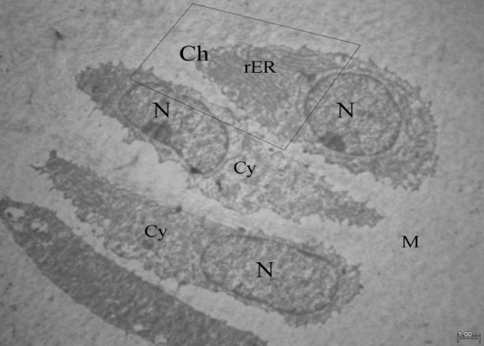
Fig. (6): An electron micrograph of the rat knee joint aged 2weeks after birth received starch showing: elongated chondrocytes (Ch) arranged parallel to each other in the matrix (M) with eccentric nucleus (N), and rough endoplasmic reticulum (rER). Note cytoplasm (Cy). (E. M. X 3000)

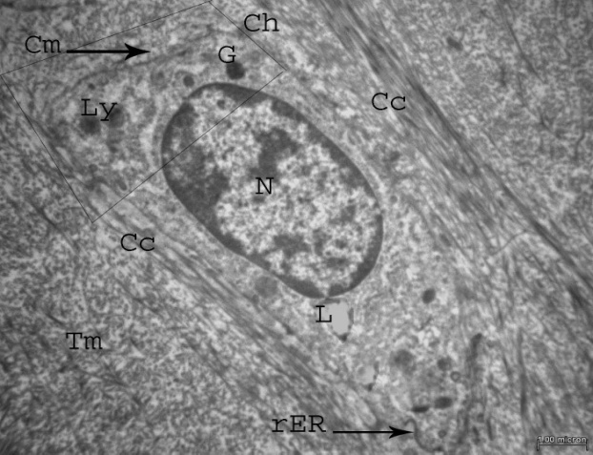
Fig. (7): An electron micrograph of the rat knee joint aged 5 weeks after birth received starch showing: active chondrocytes (Ch) with central heterochromatic nucleus (N), cytoplasm contains many granules (G), lipid droplet (L), lysosome (Ly) and rough endoplasmic reticulum (rER). Note cell membrane (Cm) and cell surrounded by capsular matrix (Cc) and outer territorial matrix (Tm). (E.M.X 6000)

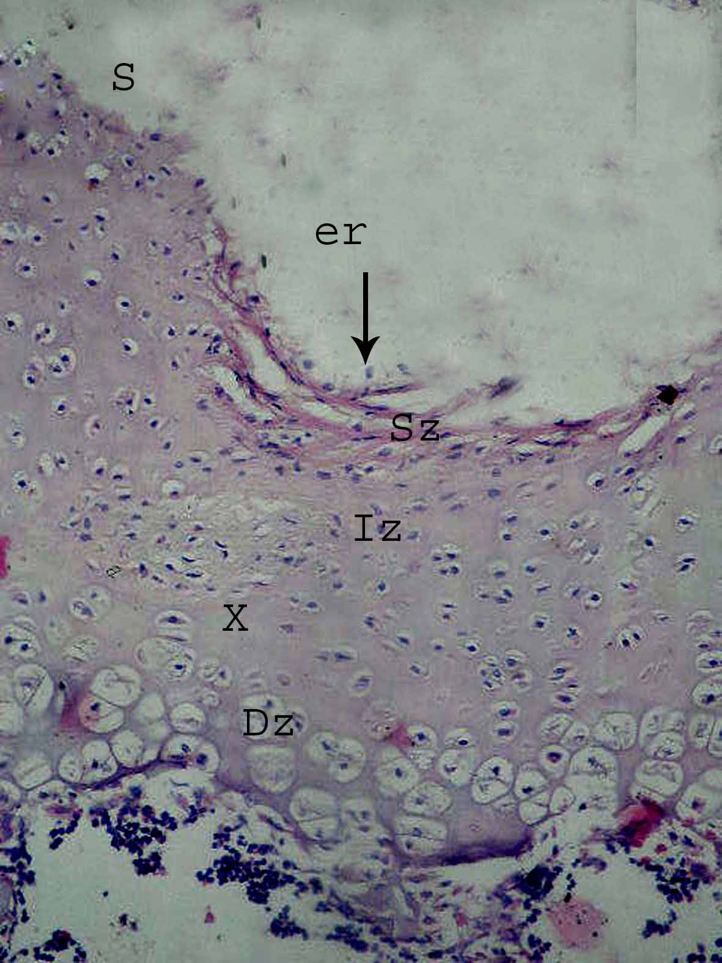
Fig. (8): A photomicrograph of a sagital section of a rat knee joint aged 2 weaks after birth treated by ciprofloxacin showing: area of erosion (er)of the surface of the articular cartilage of the femoral condyle, this erosion affects only the superficial zone (SZ), while the intermediate zone (IZ) and hypertrophied zone (DZ) are intact.(H & E X200)

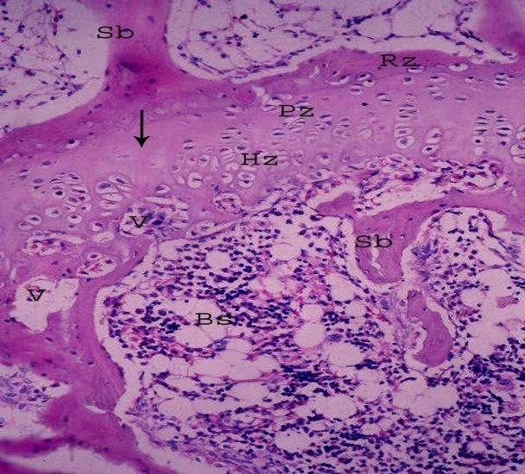
Fig. (9): A photomicrograph of a sagital section of a rat knee joint aged 2 weaks after birth treated by ciprofloxacin showing: cavitations (V) affects the epiphyseal growth plate of the femur in the, hypertrophic zone (HZ), but, proliferative zone (PZ), reserve zone (RZ) are intact with low cellularety (arrow). Note the lacunas of blood sinusoids (Bs). (H & E X200)

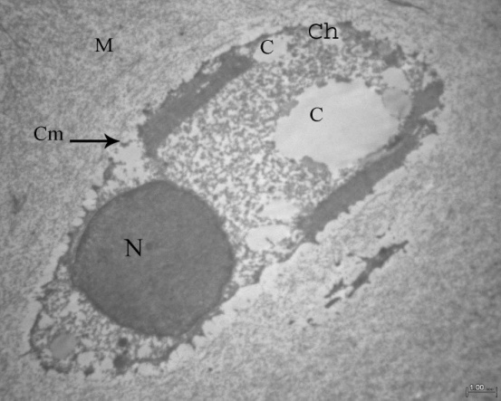
Fig. (10): An electron micrograph of the rat knee joint aged 2 weeks after birth showing: degenerated chondrocyte (Ch) with dark pechnotic nucleus (N), the cytoplasm contains deferent sizes of cavitations (C). Note partial rupture (arrow) of cell membrane (Cm) and matrix (M). (E.M.X 4000)

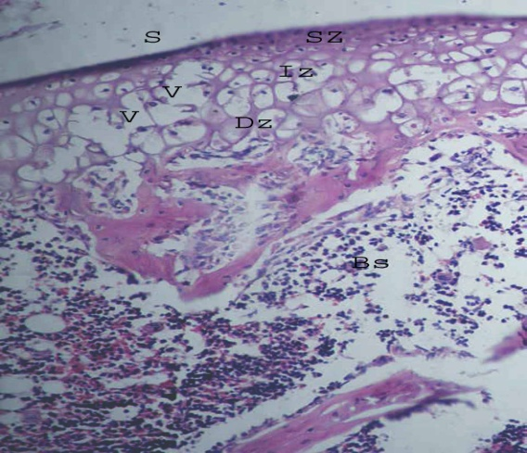
Fig. (11): Aphotomicrograph of a sagital section of a rat knee joint aged 5 weeks after birth showing: many cavitations (v) in the articular cartilage of the femoral condyle, affects all layers, the superficial zone (SZ), the intermediate zone (IZ) and hypertrophied zone (DZ) blood sinusoids (Bs) (H & E X200)

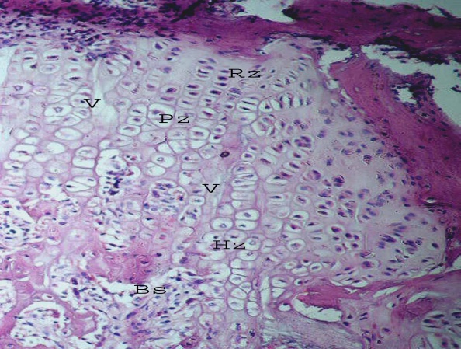
Fig. (12): A photomicrograph of a sagital section of a rat knee joint aged 5 weaks after birth treated by ciprofloxacin showing: cavitations (V) affects the epiphyseal growth plate of the femur in the reserve zone (RZ),and proliferative zone (PZ), but the hypertrophic zone (HZ) is intact.Note the lacunas of blood sinusoids (Bs). (H & E X200)

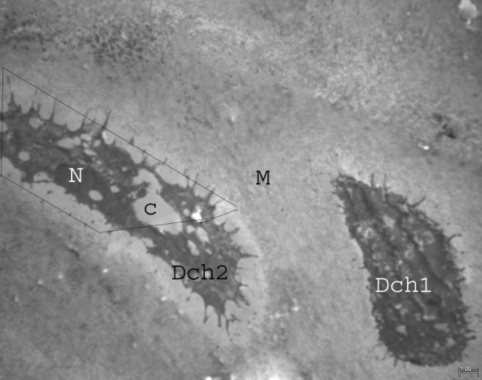
Fig. (13): An electron micrograph of the rat knee joint aged 5 weeks after birth showing: degenerated shrunked chondrocyte (Dch1) with ill defined nucleus, the other cell (Dch2) contains dark pechnotic nucleus (N), and its cytoplasm contains deferent size of cavitations (C). Note matrix (M). (E.M.X 3000)

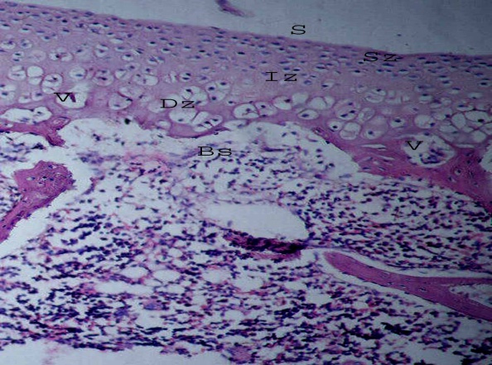
Fig. (14): A photomicrograph of a sagital section of a rat knee joint aged 5 weeks after birth of Treated by Ciprofloxacin and vitamin E showing: femoral articular cartilage with intact, superficial zone (SZ), intermediate zone (IZ), with small cavitations (V) of deep zone (DZ) Note the lacuna of blood sinusoids (Bs). (H & E X200)

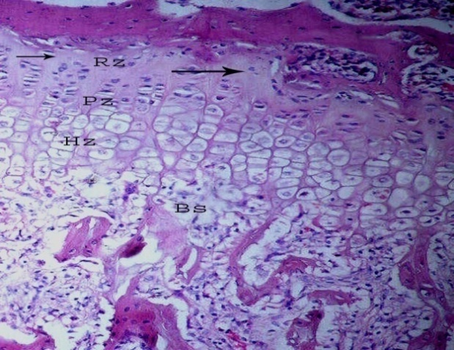
Fig. (15): A photomicrograph of a sagital section of a rat knee joint aged 5 weeks after birth of Treated by Ciprofloxacin and vitamin E showing: femoral epiphyseal growth plate with low cellularity (arrow) ofreserve zone (RZ), with well defined proliferative zone (PZ), hypertrophic zone (HZ). Note blood sinusoids (Bs) (H & E X200)

Fig. (16): An electron micrograph of the rat knee joint aged 5 weeks after birth of ciprofloxacin and vitamin E treated group showing chondrocyte with elongated nucleus (N), the cytoplasm contain vacuolated mitochondria (Mi), groups of granules (G), lysosomes (Ly), rough endoplasmic reticulum (rER), Note the matrix (M). (E.M.X 3000)

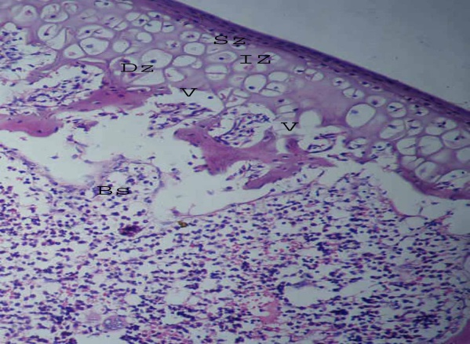
Fig. (17): A photomicrograph of a sagital section of a rat knee joint aged 5 weeks after birth after withdrawal Ciprofloxacin showing: cavitations (V) of the deep zone (DZ), with intact of superficial zone (SZ), intermediate zone (IZ). Note blood sinusoids (Bs). (H & E X200)

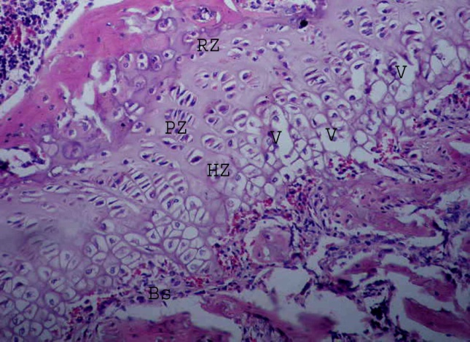
Fig. (18): A photomicrograph of a sagital section of a rat knee joint aged 5 weeks after birth after withdrawal Ciprofloxacin showing: cavitations (V) of the hypertrophic zone (HZ), with intact reserve zone (RZ), proliferative zone (PZ). Note blood sinusoids (Bs). (H & E X200)

Fig. (19): An electron micrograph of the rat knee joint aged 5 weeks after birth of ciprofloxacin withdrawal group showing: chondrocytes (Ch1, Ch2) with signs of degeneration in the form of dark vacuolated nucleus (N) and vacuolated cytoplasm (C), Note the matrix (M), granules (G). (E.M.X 1000)

4. Discussion
In This study the developmental group showed that the development of knee joint cavity was started at the interzone which consists of 3 layers. This results are agreed with Moskalewski et al. (2013) who added that the outer layers were found to differentiate into chondrocytes early in embryogenesis and become incorporated into the epiphyses, and the intermediate zone were instead found to remain located in the joint proper and become articular cartilage. In This study, the knee joint cavity started to appear at 16 day intrauterine life and at 18 day intrauterine life the cavity was still incomplete with area of fusion and at 20 day intrauterine life complete formation of knee joint cavity between femoral condyle, tibial condyle and patella. This agreed with Masaaki and Mssahiko (2000) but they found that complete formation of knee joint cavity was at 19 day intrauterine life. In this study the developmental group showed that at16 day and 18 day intrauterine life the chondroblasts were fusiform in shape with its cytoplasm contains cavitations and ill developed organelles. This result also was found by Masaaki and Mssahiko (2000) and they added that there were no other findings indicating cell death, such as shrinkage, blebbing, appearance of apoptotic bodies, phagocytosis, or increase in the number in ribosomes. In this study at the 2nd and 4th weeks we detected that the chondrocytes cytoplasm contained condensed rough endoplasmic reteculum, mitochondria, granules and lipid droplets. This result as a result of (Byun et al, 2010) who said that the active Chondrocytes in matrix production had areas of cytoplasmic basophilia, which are indicative of protein synthesis, and clear areas, which indicate their large Golgi apparatus. In the present study at the fifth week we found that the chondrocytes surrounded by capsular matrix, and the territorial matrix outside the capsular matrix. This result agreed with David (1979) and William and Patrick, (2008) who added that the territorial matrix rich in sulfated glycosaminoglycans and few collagen fibers and the inter territorial matrix between chondrocytes were older synthetically and contained more collagen fibers. In this study, the experimental ciprofloxacin treated group at 2 weeks showed erosion δ depression on the surface of the articular cartilage, the surface was covered by a layer of collagen fibers and cavitations affected the epiphyseal growth plate. By electron microscopy, some chondrocytes were degenerated. This proved by Channa et al. (2008) who reported that when Ciprofloxacin was administered to newly born rat-litters intraperitonealy Ciprofloxacin induced growth plate retardation by inhibiting mitosis in the proliferative zone and Ciprofloxacin also affected the mean length of humerus and femur leading to reduction in Limb length of rat pups, In the present study the cavitations affected all layers of the articular cartilage of the femur and tibia in rats aged 2 δ 5 weeks after birth. This result is agreed with Elias and Nelson (2012) who observed decrease in the width of epiphyseal growth plate cartilage of the femur as compared to the control. In this study the vitamin E minimize the side effect of ciprofloxacin as in light microscopy: The articular cartilage affected only the deep zone with low cellularity of the reserve zone of the epiphyseal growth plate and little degenerative changes in chondrocyts by electron microscopy. This agreed by Elias and Nelson (2012) who added that Ciprofloxacin induced cartilage lesions was reversed in animals treated with vitamin E or magnesium or both. In the present study the ciprofloxacin withdrawal did not reverse the cytotoxic effect of ciprofloxacin on the articular cartilage. This result is as a result of Amal (2010) who stated that significant diminution of the articular cartilage thickness and chondrocyte number indicating irreversibility of the lesion.

References
- Masaaki M. Ito and Masahiko, Y. Kida (2000): Morphological and biochemical re-evaluation of the process of cavitation in the rat knee joint: cellular and cell strata alterations in the interzone J. Anatomy. 197, p 659- 679.
- Li, Q.; Peng, S.; Sheng, Z. and Wang, Y. (2010):Ofloxacin induces oxidative damage to joint chondrocytes of juvenile rabbits: Excessive production of reactive oxygen species, lipid peroxidation and DNA damage. Eur.J.Pharmacol.;626(2-3):146- 153.
- Gary, A. T. and Kevin, T.P. (2012): 14th Ed text book structure and function of the body P,135.
- Sendzik, J.; Lode, H. and Stahlmann, R. (2009): Quinolone- induced arthropathy: An update focusing on new mechanistic and clinical data. Int. J. Antimicrob.Agents;33(3):194-200.
- Amal Mohamed Halawa,(2010): Effect of Ciprofloxacin on the Articular Cartilage and Epiphyseal Growth Plate Cartilage in the Growing Albino Rats and the Possible Protective Role of Vitamin E (α–Tocopherol): A Histological and Morphometric Study Department of Anatomy, Faculty of Medicine, Tanta University Egypt. J. Histol. Vol. 33, No. 3, 569 – 582.
- Drury, R.A.B and Wallington E.A., (1980):Carletion's histological technique, 5th ed. Oxford University press. Oxford New York. Toronto: P 136-147.
- Moskalewski, S. A.; Hyc, E.; Jankowska-Steifer, A. and Osiecka-Iwan, (2013): Formation of synovial joints and articular cartilage Department of Histology and Embryology, Warsaw Medical University, Warsaw, Poland vol 72, no 3 pp 181_187.
- David H. Cormack (1979): Ham's histology text book 9th Ed, 269.
- Michael, H. Ross and Wojciech Pawlina (2011): histology a text and atlas with correlated cell and molecular biology 6th Ed. 198- 217.
- Byun, I.S.; Sarkar, S.K.; Anirban; Jyoti, M.; Min, Y. K.; Seo, H.S. and Lee, B.T. (2010): Initial biocompatibility and enhanced osteoblast response of Si doping in a porous BCP bone graft substitute. J Mater Sci Mater Med (6):1937-1947.
- William K. Ovalle; Patrick C. Nahirney (2008): Netter's essential histology text book, page 134.
- Channa, H.M.; Ashfaq, M.; Bangash, R.; Abbasi, A. and Qureshi, M.A. (2008): Preventive role of zinc chloride against toxicity of ciprofloxacin on the growing cartilage of Wistar albino rat litter. J.AyubMed.Coll.Abbottabad;20(4):77-81.
- Elias, Adikwu and Nelson, Brambaifa (2012): ciprofloxacin induced chondrotoxicity and tendinopathy department of Pharmacology, Faculty of Basic Medical Sciences, College of Health Sciences, University of Port Harcourt, Rivers State Choba, Nigeria American Journal of Pharmacology and Toxicology, 7 (3), 94-100.

10/28/2015

