Shot-hole borer (Scolytus nitidus Schedl) (Coleoptera: Curculionidae: Scolytinae): a new host-Himalayan birch (Betula utilis) - Short Communication

Abdul Lateef Khanday¹* and Abdul A. Buhroo

¹Postgraduate Department of Zoology, University of Kashmir, Hazratbal, Srinagar-190006 (India)
*Corresponding author: lateefkhanday@gmail.com

Abstract: Fruit trees are considered to be the primary host trees of the shot-hole borer bark beetle Scolytus nitidus (Schedl, 1957). This paper documents the first recorded successful development of S. nitidus on Betula utilis D. Don. Five densely infested birch trees were found in a forest close to the village of Dawar (Gurez valley). S. nitidus is a polyphagous species that attacks different fruit tree species but was not previously reported to develop on Himalayan birch. The infestation of Himalayan birch recorded in the present study was most likely promoted by a large population of S. nitidus in the studied region combined with a local lack of primary host trees as a consequence of bark beetle outbreak.
[Khanday AL, Buhroo AA. Shot-hole borer (Scolytus nitidus Schedl) (Coleoptera: Curculionidae: Scolytinae): a new host - Himalayan birch (Betula utilis) - Short Communication. Nat Sci 2015;13(11):87-89]. (ISSN: 1545-0740). http://www.sciencepub.net/nature. 12

Keywords: Himalayan birch; fruit trees; Scolytus nitidus; scolytinae

Bark beetles are distributed worldwide occupying a wide range of niches on woody and herbaceous plants. The species of genus Scolytus are among the main insect pests which have created a perennial problem in the management of fruit trees of Kashmir valley. There is only a relatively short period of the life cycle in which the adult is free and in which distribution of the species occurs and new breeding sites are sought out. The remainder of the life cycle is spent in a small area below the bark. A maternal gallery is constructed in the phloem and eggs are laid along its sides. The larvae make galleries through the phloem and, when mature, pupate in the bark or sapwood. Finally the adults emerge through holes cut in the bark.
Considering the importance and current interest in the development of pest management systems the scolytids are among the main insect pests. Scolytus nitidus is a polyphagous insect pest which has caused considerable losses to fruit trees in the fruit growing areas of the valley since 1961 (Malik, 1966) and its population has increased enormously during the past decade due to favourable environmental conditions, mainly, drought, thus expands its host range to new tree species (e.g. Betula utilis). S. nitidus is distributed in the Himachal Pradesh, Kashmir & Uttar Pradesh of India and Xizang (Tibet) of China on host trees - Juglans regia, Prunus armeniaca, Pyrus malus & Cotoneaster microphylla (Wood & Bright, 1992).
Buhroo & Lakatos (2007) investigated biological characters of S. nitidus and reported that this common shot-hole borer overwinters in larval stage on apple trees in Kashmir. After emergence the adults fly to suitable trees and undergo maturation feeding for 4-6 days. The copulation takes place at the entrance hole. The maternal gallery is one armed longitudinal, in average 4.6 cm long. The female lays 52 eggs on an average. The eggs hatch in 5 to 7 days. The larvae have 5 instars and complete their development in 38 to 50 days constructing larval galleries 5-8 cm in length. The larvae pupate for 6-18 days and finally the adults emerge to attack new suitable trees. The adults live for 45-60 days and the total life-span of this species ranges from 97 to 124 days. The above authors also observe that this species has two complete and a 3rd partial generations per year in Kashmir but the developmental durations and generations of S. nitidus do not coincide with its related species worked out by other researchers (Beaver, 1967; Khanday & Buhroo, 2015; Zeiri et al., 2011).The above differences in the life history of scolytine species around the world could be due to environmental factors as well as the variation of biochemical composition of host trees.
On the 19th of August 2015, we found approximately 48 dead individuals of S. nitidus in five felled Himalayan birch trees (B. utilis) close to the village of Dawar (GPS location 34.6333⁰ N, 74.8333⁰ E and Elevation 8,460 ft). The stems of all five trees were densely colonized, with an average of 102.0 (± SD 8.84) exit holes of S. nitidus (Figs. 1 & 2-A). The average stem length of all five trees measures 56 cm (± 11.93 SD). Several dead S. nitidus individuals were found to be trapped in the bark while boring entrance holes (Fig. 2-B). Although some attack holes were observed on the bark (stem) of a live tree but no live beetle individuals were found (Fig. 3). Fig. 4 shows the gallery pattern of S. nitidus. This observation indicates that the trees were still alive and relatively vigorous when the beetles arrived. The present paper provides the first evidence of the successful development of S. nitidus on B. utilis.
Currently, Himalayan birch is a popular forestry species, growing at elevations up to 4,500 m (14,800 ft). It forms tree line vegetation all along the Nepal Himalayas and extensive stands of this species can be found on northern shady slopes and ravine (TISC, 2002). It is the only broadleaved angiosperm tree species in the Himalayas which dominates an extensive area at subalpine altitudes (Zobel & Singh, 1997). Betula spp. show a high freezing tolerance (Sakai & Larcher, 1987) which enables them to form a tree line in the Himalayas as well as in the Scandinavian region (Cairns & Moen, 2004). It frequently grows among scattered conifers, with an undergrowth of shrubs that typically includes evergreen Rhododendron. The tree depends on moisture from snow melt, rather than from the monsoon rains. They often have very bent growth due to the pressure of the deep winter snow in the Himalaya. High elevation ecosystems of Himalayan region are the most vulnerable geographic regions of the world and are important regions for detecting the patterns of climatic change on regional scale.
The Scolytus species are included among the many Scolytines that occur in economically important forest trees of the Himalayan region that could harbor new biodiversity, if explored further.

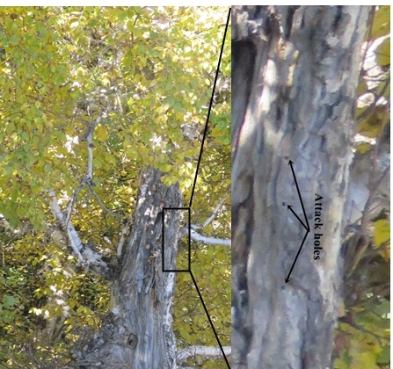
Fig. 3. Attack holes of S. nitidus

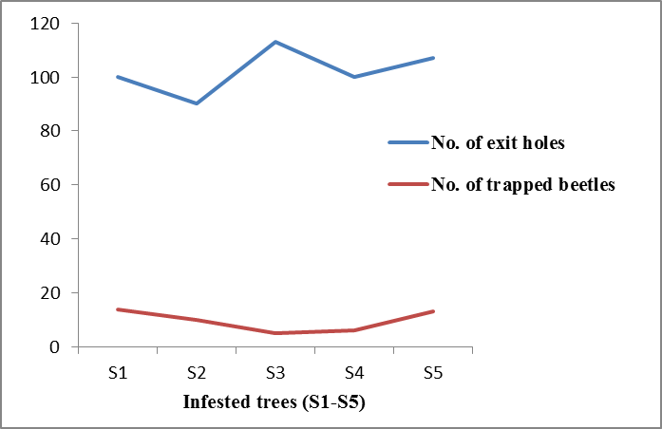
Fig. 1. Exit holes counted/beetles collected from five infested trees of B. utilis

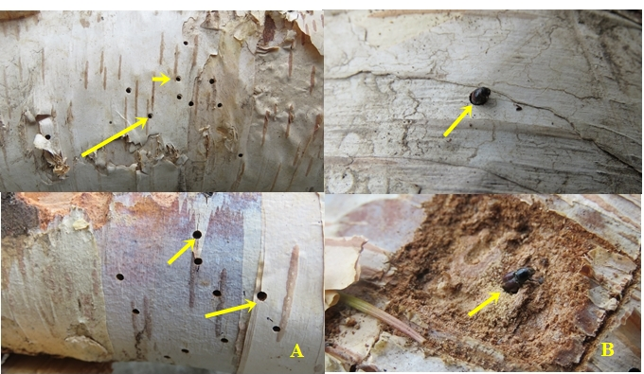
Fig. 2. A - Exit holes of S. nitidus
B - Trapped dead individuals of S. nitidus

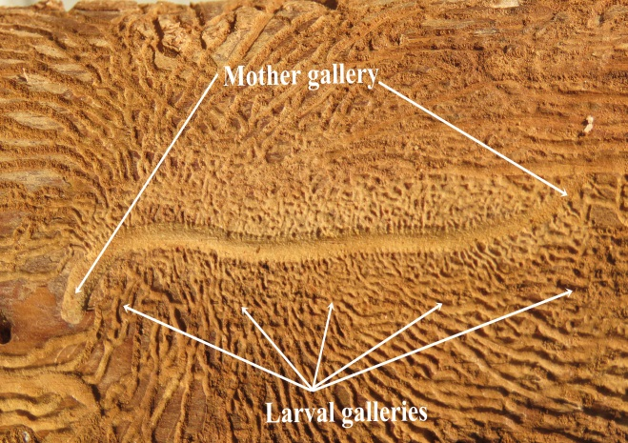
Fig. 4. Gallery pattern of S. nitidus

Acknowledgements:
We gratefully acknowledge Mr. S. Rather and Mr. A. Maqbool for field assistance. We also thank Dr. O.A. Chat for GPS support, and many M.Sc. Zoology students especially Mr. S.A. Bhat for help in identifying research sites.

Corresponding Author:
Abdul Lateef Khanday
Entomology Research Division
P.G. Department of Zoology
University of Kashmir Srinagar -190006 (India)
E-mail: lateefkhanday@gmail.com

References
1. Beaver, R. A. (1967). Notes on the biology of the bark beetle attacking elm in Wytham wood, Berks. Entomologist’s Monthly Magazine, 102, 156-162.
2. Buhroo, A. A., & Lakatos, F. (2007). On the biology of the bark beetle, Scolytus nitidus Schedl (Coleoptera: Scolytidae) attacking apple orchards. Acta Silvatica et Lignaria Hungarica, 3, 65-75.
3. Buhroo, A. A., & Ramamurthy, V. V. (2008). Seasonal history and activity of the bark beetle, Scolytus nitidus Schedl (Coleoptera: Scolytidae) on apple trees in Kashmir. Indian Journal of Entomology, 70, 385-388.
4. Cairns, D. M., & Moen, J. (2004). Herbivory influences tree line. Journal of Ecology, 92, 99 -131.
5. Khanday, A. L., & Buhroo A. A. (2015). Life history and biology of the elm bark beetle Scolytus kashmirensis Schedl (Coleoptera: Curculionidae: Scolytinae) infesting Ulmus villosa in Kashmir. Open Journal of Forestry, 5, 443-453.
6. Malik, R. A. (1966). Improved technique to control shot-hole borers and bark beetles. Plant Protection Bulletin, 18, 29-30.
7. Sakai, A., & Larcher, W. (1987). Forst survival of plants: Response and Adaptation to freezing stress, Ecological studies, 62.
8. Schedl, K. E. (1957). Indian bark and timber beetles 1. Indian Forest Records Entomology, 9, 165-169.
9. TISC (Tree Improvement and Silviculture Component). (2002). Forest and vegetation types in Nepal TISC Document: Department of Forest.
10. Wood, S. L., & Bright, D. E. (1992). A catalog of Scolytidae and Platypodidae (Coleoptera), Part 2: Taxonomic Index, Volumes A and B. Great Basin Naturalist Memoirs, 13: 354.
11. Zeiri, A., Braham, M., & Braham, M. (2011). Laboratory Studies of the Almond Bark Beetle Scolytus amygdali Geurin-Meneville, (Coleoptera: Curculionidae: Scolytinae) collected in the Center Region of Tunisia. International Journal of Entomology, 2, 23-30.
12. Zobel, D. B., & Singh, S. P. (1997). Himalayan forests and ecological generalizations. Bioscience, 47, 735-756.

11/1/2015

