Flood risk mapping in urban areas (case study: Hamadan)

Sepehri M ¹, Ildoromi A ¹, Farokhzadeh B ¹, Nori H ¹, Atapourfard A ², Artimani M ².

¹Department of watershed management, Faculty of natural resource, Malayer University, Malayer, Iran.
²Department of watershed management, natural resource center, Hamadan, Iran
Sepehri_mehdi@ymail.com or n.sepehri@basu.ac.ir

Abstract: Flood risk mapping (FRM) can be considered as the most serious threat, mainly in areas and countries where hardly any other natural risks occur. In relation to the field of valuation and insurance, flood risk represents a significant factor entering the new valuation procedures as well as binding regulations for real property valuation. Recently, the cities of Hamadan, Iran, have been affected by several storm flood events, causing hundreds of people to be evacuated from their homes. Heavy intensity rainfall, new housing developments covering previously permeable grounds, and old drainage systems are the main causes for this situation. This paper presents a simple approach of urban flood hazard assessment in a region where primary data are scarce. The objectives of this study are to joint assessment of hazard, exposure and social vulnerability provides valuable information for the evaluation of FRM strategies. In this paper, we present an approach for determining spatial flood risk index map based on population vulnerabilities and terrain morphological characteristics using a geographic information system.
[Sepehri M, Ildoromi A, Farokhzadeh B, Nori H, Atapourfard A, Artimani M. Flood risk mapping in urban areas (case study: Hamadan. Nat Sci 2015;13(11):114-121]. (ISSN: 1545-0740). http://www.sciencepub.net/nature. 16. doi:10.7537/marsnsj131115.16.

Keywords: Flood risk, Flood hazard, Vulnerability, Hamadan

1. Introduction
Despite the progress of engineering works for flood disaster reduction over the past two decades, flooding continues to be a major challenge (Yamada et al., 2010). The incidences of floods have been on the rise, which are responsible for more than half of all disaster-related fatalities and for a third of the economic losses of all natural catastrophes (White, 2000 as cited by Bradford et al., 2012). Fast-growing cities with increasing populations have many problems with runoff water management during storms. In fact, urbanization has aggravated flooding due to some reasons such as restricting the flood-water flow, covering large parts of the ground with houses, roads and pavements, obstructing channels, and building drains to ensure that water will flow into rivers faster than it would under natural conditions (Harris and Rantz, 1964; Konrad and Booth, 2002; Konrad and Booth, 2005). The more people crowd into cities, the more these effects will be intensified. Consequently, even fairly moderate storms produce high peak flows in the discharge channels because there are more hard surfaces and drains (Fernandez and Lutz, 2010). The risk of flooding is defined as a function of both the probability of occurrence of a flood (flood hazard) and its impact (Vulnerability), ((HIRA 2011). In urban areas, this impression may be very high since the areas affected are densely populated and contain vital infrastructure. The ongoing developments in the flood-prone areas have worsened this risk. Nowadays, the flood risk management approaches, which have focused on non-structural measures such as rainwater harvesting, improved land use planning, relocation, flood proofing, flood forecasting and warning and insurance, are being mainly advocated (Bradford et al., 2012). Over the past centuries until the present time, the city of Hamadan has experienced numerous floods. The preliminary analysis conducted on the historical area, located in the north-west of the city called Hegmataneh, shows that the effect of the damage caused by the floods of the last century has led to the destruction of the Hegmataneh area (Ildoromi, 2010). Hamadan’s population is nearly 563466, concentrated in an area of 70 km2. From the social and geographical point of view, Hamadan is one of the most vulnerable cities in Iran as the 2nd most populated city in western Iran. The city is located at the foot of Alvand mountain. Because of the special location of the city, five large rivers cross Hamedan including: 1. Abbas Abad, 2. Khidr, 3. Deven, 4. Murad Beg, and 5. Phagire. Multi-criteria decision analysis (MCDA) provides the methodology and techniques required for analyzing complex decision problems, which often encompass incommensurable data or criteria. The use of GIS and MCDA has proven successful in natural hazards analysis (Rashed and Weeks, 2003; Gamper et al., 2006) and other geo-environmental studies (Dai et al., 2001; Kolat et al., 2006), but this kind of model must involve a procedure to analyze the uncertainty associated with spatial outputs. The purpose of this study is to propose an urban flood risk model using MCDA techniques with GIS support and evaluate it by means of the uncertainty and sensitivity analysis.

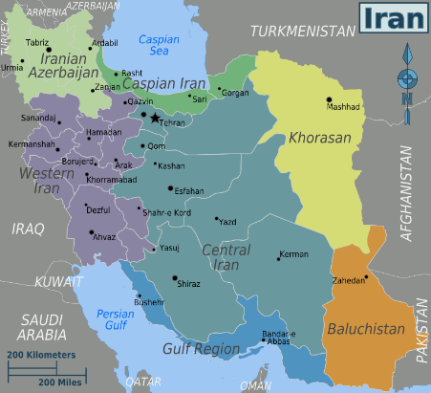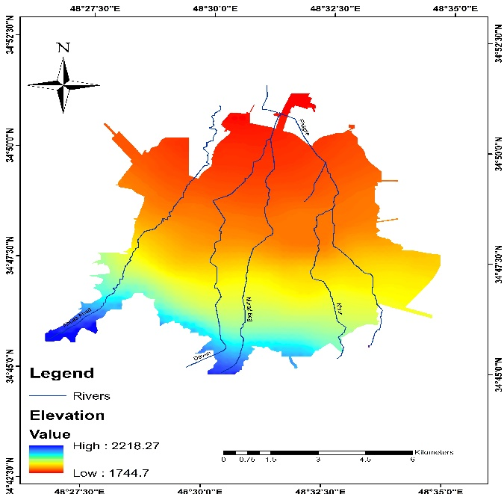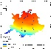

Figure (1). Location of the study area.

2. Data and method
A flood hazard depends on the flood magnitude; i.e., the flood depth, velocity, and duration. In urban areas, more researchers have recently paid attention to the hydrostatic characteristics of flood or the flood depth (Kelman and Spence, 2004). In this research, a combination of catchment characteristics, including terrain slope, drainage network, elevation data, distance to the discharge channel, cover type, and also people’s vulnerability is taken into account to evaluate the flood risk. The flood hazard component is calculated based on this assumption that flood inundation normally occurs at the areas with low terrain slope, near the drainage system, with low elevation, and with land use that has the lowest cure number. On the other hand, vulnerability is defined according to the conditions, determined by physical, social, economic, and environmental factors, which increase the susceptibility of a community to the impacts of hazards (Tingsanchali, 2012). In developing countries, natural hazards are mostly relevant to human losses rather than financial losses. For this reason, the present study has mainly focused on and addressed human losses.
Geographical Information Systems (GIS) are powerful tools, since they manage large amount of data involved in multiple criteria decision analysis (Fernandez and Lutz., 2010). Multicriteria decision analysis (MCDA) provides methodology and techniques for analyzing complex decision problems, which often involve incommensurable data or criteria (Fernandez and Lutz., 2010). Basically, AHP is a multi-objective, multicriteria decisionmaking approach that employs a pair-wise comparison procedure to arrive at a scale of preferences among a set of alternatives. The AHP uses a fundamental scale of absolute numbers to express individual preferences or judgements. This scale consists of nine points, chosen because psychologists conclude that, nine objects are the most that an individual can simultaneously compare and consistently rank. Pairwise judgements are made based on the best information available, and the decision maker's knowledge and experience. The AHP also provides mathematical measures for the purpose to mathematically determine the inconsistency of judgments. According to the properties of reciprocal matrices, the consistency ratio (CR) can be calculated. In a reciprocal matrix, the largest eigenvalue (ymax) is always greater than or equal to the number of rows or columns (n). If a pairwise comparison does not contain any inconsistency, ymax will be equal to n. The more consistent the comparisons are, the closer the value of the computed ymax will be to n. A consistency index (CI) that measures the inconsistencies of pairwise comparisons can be written as follows:
CI = (Ymax-n)n-1
And the coherence measure of the pairwise comparisons can be calculated in the form of the consistency ratio (CR):
CR=100(CI*ACI)
where the ACI is the average CI of the randomly generated comparisons. A consistency ratio of the order of 0.10 or less is a reasonable level of consistency (Saaty, 1980). A consistency ratio, above 0.1, requires revising the judgments in the matrix, because of the inconsistent treatment for ranking of a particular factor. The consistency ratios for all of the pairwise comparisons, used to obtain the urban flood hazard map, were calculated and found to be consistent (CI < 0.1) (Fernandez and Lutz, 2010). The use of GIS and MCDA has proven successful in natural hazards analysis (Rashed and Weeks, 2003; Gamper et al., 2006) and other geo-environmental studies (Dai et al., 2001; Kolat et al., 2006)

3. Analysis and results
  - Flood Hazard Estimation:
The flood hazard maps often generate using topographic and land use data (Fernandez and Lutz., 2010; Kazakis et al.,2015; Armenakis and Nirupama.,2014). In this study, we used 10m grid
cell size Digital Elavation Model (DEM) and river network. Flood hazard was evaluated using Distance to the discharge, Slope, Elevation, drainge density and land use data. The relevance variables and their classification were described as follows.
    - Distance to the discharge channels:
According to the records and the previous studies carried out by the local and administrative authorities, the areas most affected during floods are those near these channels, as a consequence of overflows. In this study, the following distance intervals have been used: 1. from the river up to 386 meters, 2. between 386 and 878 m, 3. between 878 and 1622 m, and 4. from 1622 m to the top.
    - Elevation data:
The study area is located between 1745 and 2218 meters. This parameter has a key role in the control of the overflow direction movement and in the depth of the water table (Stieglitz et al., 1997).
    - Slope data:
Slope is an important factor in identifying the zones that have shown high susceptibility to flooding over the years due to the low slope gradient. In fact, it should be mentioned that the slope of the land in the watershed is a major factor in determining the water velocity (Fernandez and Lutz, 2010). Thus, on very flat surfaces, where ponding areas occur, a considerable amount of the surface runoff may be retained in the temporary storage (USDA, 1986). It should be mentioned that the general direction of water in this study is due north.
    - Flow accumulation:
Flow accumulation is the most important parameter in defining flood hazard. The accumulated flow sums the water flowing down-slope into the cells of the output raster. The high values of the accumulated flow indicate the areas of concentrated flow and consequently, the higher flood hazard (Kazakis et al., 2015).
    - Land use:
Impervious cover (buildings, roads, and parking lots) reduces the infiltration capacity, and the runoff from paved areas can substantially add to the total runoff. In general, urbanization can lead to a decrease in the lag time, an increase in the peak discharge, and an increase in the total discharge for a particular flood (Murck et al., 1996). The cure numbers that define the permeability characteristics of the basins refer to land uses. According to the above explanation, in the present study, the cure numbers are re-classified as follows: 1. 61-66, 2. 66-75, 3. 75-83, 4. 83-89, and 5. 89-95.
    - Development of weights
In the analyses, the related weights were assigned to the layers, and the respective ranks were given to the classes of each layer. These values were determined according to the importance level of the layers and the classes in the case study of the floods of the area. The assigned weights and ranks for the layers and classes of the study area are based on the local characteristics of each layer, the previous available studies, the local and administrative data, and the authors’ judgment, which are unveiled in Table 1. The most important layer, according to the weights, was defined based on the distance to the discharge channels; in fact, the historical review of flood events and the other available studies have revealed that the areas near the channels are highly affected as a consequence of their overflow (Fernandez and Lutz, 2010). The elevation and slope layers were assigned with the same weight value, based on their importance in the accumulation and discharge of water (Fernandez and Lutz, 2010). The flow accumulation layer is the next important layer, and the land use layer is the final one since in the study area, nearly 85 percent of the local areas are located in the connected areas and therefore, this parameter (land use) has a low impact on the flood hazard mapping. An impervious area is considered connected, if the runoff from it directly flows into the drainage system. It is also considered unconnected, if the runoff from it occurs as the concentrated shallow flow that runs over a pervious area and then, into the drainage system (USDA, 1986). The weight of the rainwater harvesting layer in this study is considered equal to the weight of the slope and elevation layers; but for the weights of the classes in this layer, if a class has a decreasing impact on the flood hazard, its weight will be considered reverse, and contrariwise. In addition, for the ranking of classes, the ranks decrease in the order that are more favorable for a flooding process. The total scores are, then, calculated by applying a simple weighted sum. Accordingly, each pixel of the output map (Hi) is calculated by using the following summation:
Hi = j Wj * Xij
Where, xij=rank value of each class with respect to the j layer and wj= normalized weight of the j layer.
The consistency ratios for all of the pair-wise comparisons used to obtain the urban flood hazard map were calculated and found to be consistent (C<0.1).
  - Vulnerability Estimation:
This parameter shows the spatial distribution of vulnerable socio-economic and environmental conditions. The vulnerability assessment is employed to determine how likely these elements may be harmed by flooding (Schanze, 2006; Messner and Meyer, 2005). Specifically, the vulnerability of different elements depends upon how exposed they are to the hazard and how susceptible they are to the hydraulic characteristics of a flood. The extent of their susceptibility is also dependent on the flood preparedness, the capability to cope with the event, and the ability to recover from it. In developing countries, in order to evaluate the vulnerabilities, health issues are more critical than the economic concerns. For this reason, in the present study, health issues have received more attention. The relevance variables and their classification were described as follows.
    - Residential areas
This parameter has the highest share in other urban land uses, and alongside the economic vulnerability that is the common denominator of all land uses, it is the most sensitive parameter to human vulnerability. It should be stated that a proper urban planning, due to the close relationship between the vulnerability and the density of the urban land, can have a decisive role in reducing the human and financial risks. This parameter can be divided into following three categories: 1. High density, 2. Moderate density, and 3. Low density.
    - Office and commercial areas
Normally, office and commercial areas in a city can take up to approximately 5% of the city’s land use. In this parameter, unlike the residential areas, the presence of people is not permanent. Thus, it has a lower vulnerability than the residential areas.
    - School districts
The time for the presence of humans in the school districts is fairly the same as in the office and commercial areas, but the population density is apparently higher. For this reason, this parameter has been located between the residential and the office and commercial areas.
    - Special facilities
These are the facilities, responsible for providing services, in times of crisis. Hence, their vulnerability can cause the worst crises and as a result, they should be meticulously identified and evaluated.
    - Industry and workshops:
Industry and workshops, because of their key role in the cycle of the economy of a city or a region, expose a high degree of economic vulnerability.

Table (1): Assigned weight and rank values for the layer/classes of the study area.
weight | classes | weight |  | layer
0.528  0.268  0.134  0.068  0.0669 | 0-386  386-878  878-1622  1622-3404  Consistency Rate | 0.397 | Distance to the discharge channels
0.038  0.07  0.115  0.273  0.502  0.0157 | 0- 18.42  73.70-18.42  202.68-73.70  420.11-202.68  9423.427-420.11  Consistency Rate | 0.2279 | accumulation flow
0.431  0.262  0.161  0.096  0.047  0.0229 | 2-0  5-2  8-5  12-8  20-12  Consistency Rate | 0.1154 | slope
0.431  0.262  0.161  0.096  0.047  0.0229 | 1780-1745  1808-1780  1868-1808  1930-1868  2218-1930  Consistency Rate | 0.1154 | elevation
0.038  0.07  0.115  0.273  0.502  0.0157 | 66-61  75-66  83-75  89-83  95-89  Consistency Rate | 0.0276 | cover

Slope layer Elevation layer
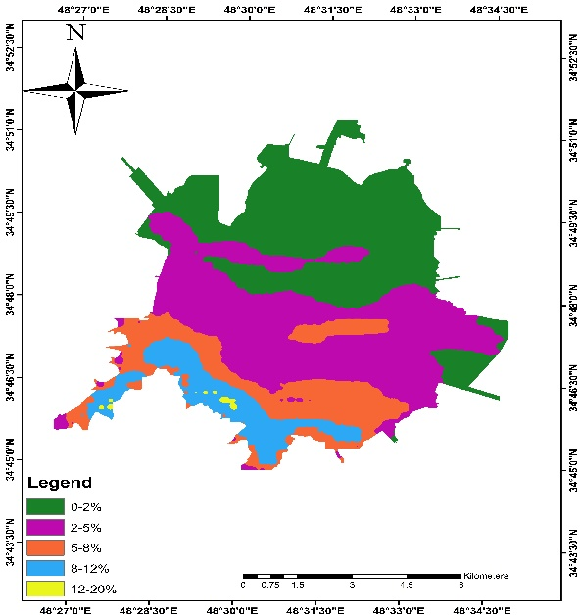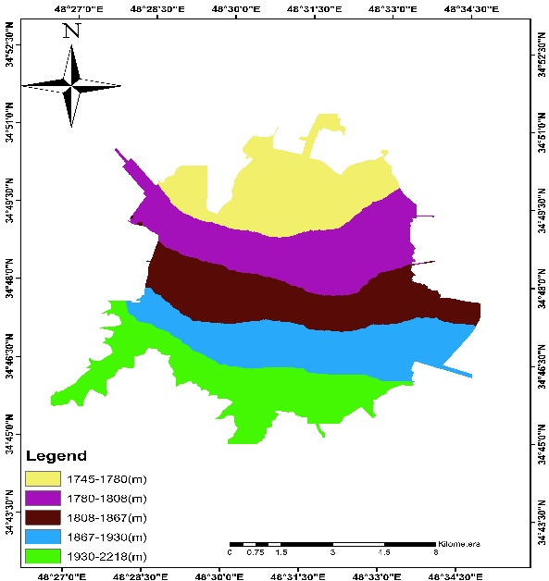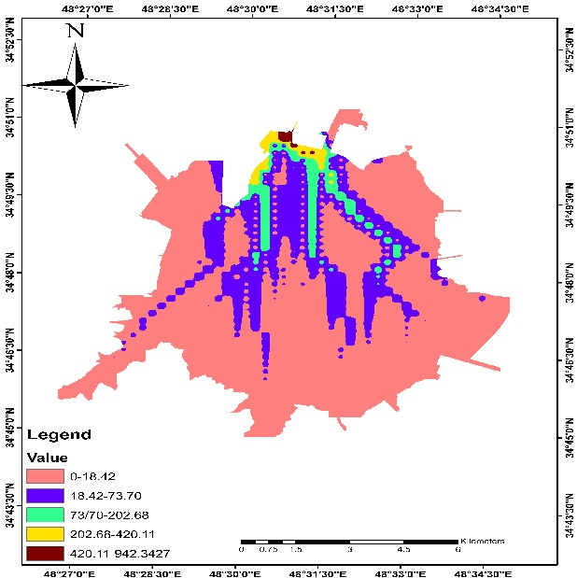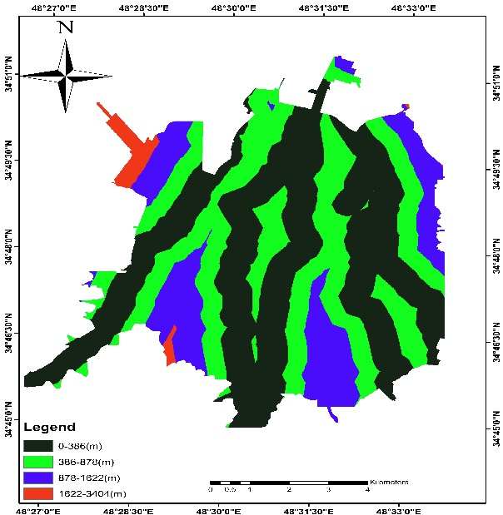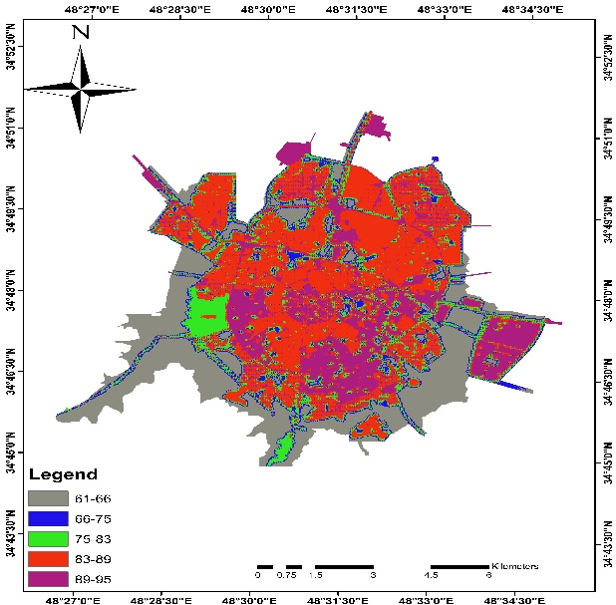
Cover layer

Flow accumulation layer Distance to the discharge channels layer
Figure (2): The variables incorporated within the model as the GIS layers and their classification

    - Streets and roads:
This type of urban land uses is only examined economically, but has a key role in assisting various regions.
    - Parks, gardens and green land
These land uses have a double effect on vulnerability and also a double impact on the vulnerability mapping in a region. In this paper, they are only reviewed in terms of losses that can be incurred.
    - Other land uses
The land uses, such as sport centers and hotels, even though might be highly vulnerable like the above land uses, but since the percentage of this category of applications is less than the above mentioned applications, it has the lowest vulnerability.
    - Development of weights
In the analyses, the weights were assigned to the layers and the ranks to the classes of each layer according to their importance in the case study of the area floods. The assigned weights and ranks for the layers/classes of the study area based on the health and economic characteristics of each layer, the previous studies, the local and administrative data, and the authors’ judgment are given in Table 2. The category of the residential areas was selected as the most important layer according to the weights, because the presence of humans in this layer is permanent. The other layers based on the presence of humans and the economic characteristics were located in the next positions. It should be stated that the development of weights and the consistency check are performed similar to flood hazard mapping.

Table (2) - The assigned weights and ranks for the layers/classes of the study area
weight | classes | weight | layer
0.6648  0.2449  0.0902  0.013 | High density  Medium density  Low density  Consistency Rate | 0.32023 | Residential areas
0.226437 | School districts | 0.226437 | School districts
0.0833  0.1666 | density upper 50%  density lower 50% | 0.165977 | Administrative, commercial
0.113441 | Other land uses | 0.133441 | Other land uses
0.078009  0.048472  0.029307  0.018128 | Special facilities  Industry and workshops  Streets and roads:  Parks, gardens and green land | 0.078009  0.048472  0.029307  0.018128 | Special facilities  Industry and workshops  Streets and roads:  Parks, gardens and green land  Consistency Rate

- Flood risk:

The combination of the hazard and vulnerability maps can enable the identification and ranking of the probable endangered areas. The final flood risk map was generated by the integration of the two spatial layers, hazards and vulnerability, respectively.
Flood risk = Flood hazard * Flood vulnerability

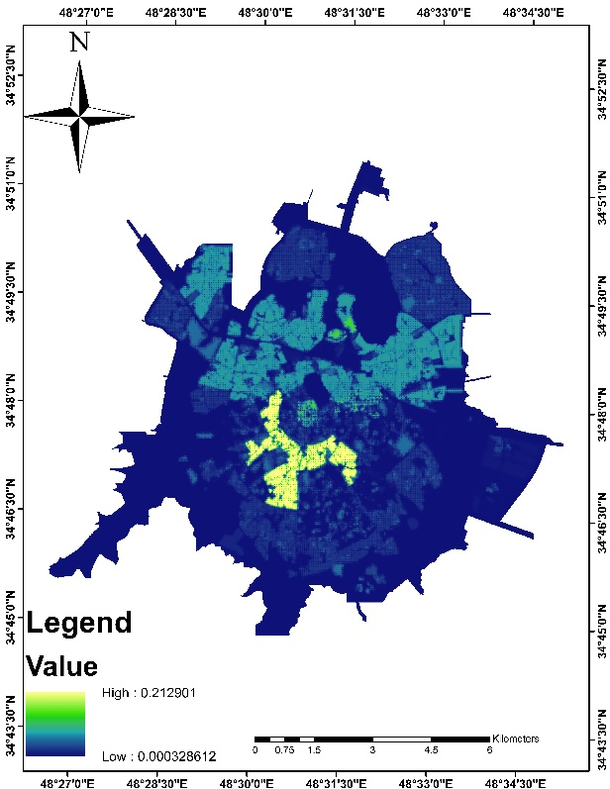
Figure (3). Estimated vulnerability for the study area.

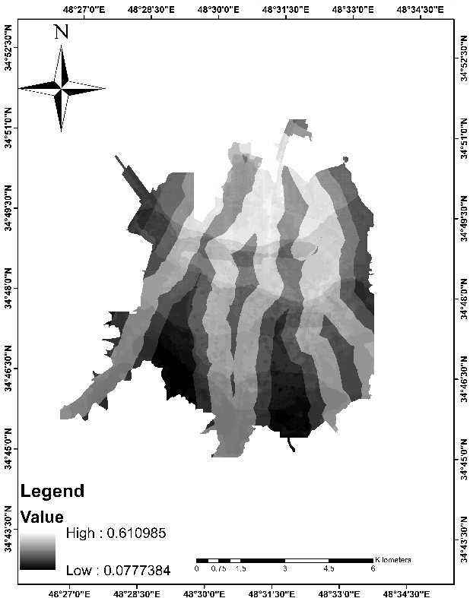
Figure (4). Estimated hazard for the study area.

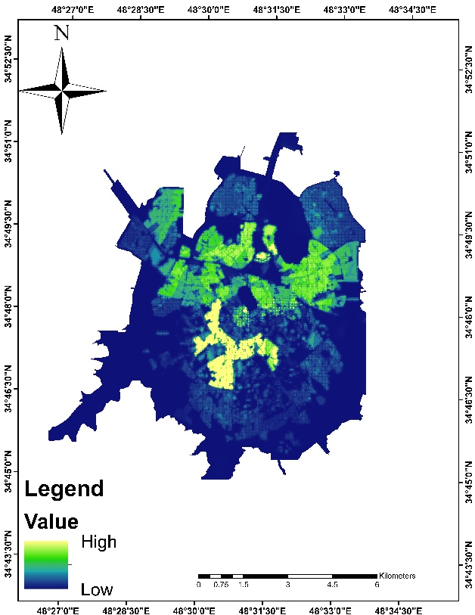
Figure (5). Estimated flood risk for the study area.

- Conclusion
One of the best implementation for reducing the impacts of flood is flood risk mapping. In this study, a preliminary assessment of flood risk has been carried out. The ArcGIS geographic information system was used for the spatial modeling and visualization of the results. The proposed method uses analytical tools to prioritize spatial flood risk areas. It is worth noting that highly vulnerable areas that are located in north areas and are exposed to higher risk of flooding. Effective mitigation and preparedness strategies are required to reduce future flood risk in the communities.

Corresponding Author:
Mr. Mehdi sepehri
Department of Natural reource, Malayer University
Malaer, Iran
E-mail: sepehri_mehdi@ymail.com

References
- Armenakis, C., Nirupama, N., 2014. Flood risk mapping for the city of Toronto. Procedia Economics and Finance 18 ( 2014 ) 320 – 326
- Bradford, R.A., O’Sullivan, J.J., van der Craats, I.M., Krywkow, J., Rotko, P., Aaltonen, J., Bonaiuto, M., De Dominicis, S., Waylen, K., Schelfaut, K., 2012. Risk perception – issues for flood management in Europe. Nat. Hazards Earth Syst. Sci. 12 (7) 2299–2309.
- Dai, F.C., Lee, C.F., Zhang, X.H., 2001. GIS-based geo-environmental evaluation for urban land-use planning: a case study. Engineering Geology 61, 257–271.
- Fernández, D.S., Lutz, M.A., 2010. Urban flood hazard zoning in Tucumán Province, Argentina, using GIS and multicriteria decision analysis. Engineering Geology 111 (2010) 90–98.
- Gamper, C., Thöni, M., Weck-Hannemann, H., 2006. A conceptual approach to the use of cost benefit and multi criteria analysis in natural hazard management. Natural Hazards and Earth System Sciences 6 (2), 293–302.
- Harris, E., Rantz, S., 1964. Effects of urban growth on streamflow regimes of Permanente Creek, Santa Clara County, California. USGS WSP 1591B (1964).
- HIRA 2011. Provincial Hazard Identification and Risk Assessment, Emergency Management Ontario, Govt. of Ontario, Canada, p. 212.
- Iidoromi, A., 2010. Examine the evolution of the northern slopes of the mountain front Hamedan. Journal of Geography and Planning (Tabriz university)17, 16-33.
- Kelman, I., Spence, R., 2004. An overview of flood actions on buildings. Engineering Geology 73 (2004) 297–309.
- Kazakis, N., Kougias, I., Patsialis, T., 2015. Assessment of flood hazard areas at a regional scale using an index-based approach and Analytical Hierarchy Process: Application in Rhodope–Evros region, Greece. Science of the Total Environment 538 (2015) 555–563
- Kolat, C., Doyuran, V., Ayday, C., Lütfi Süzen, M., 2006. Preparation of a geotechnical microzonation model using Geographical Information Systems based on multicriteria decision analysis. Engineering Geology 87, 241–255.
- Konrad, C.P., Booth, D.B., 2002. Hydrologic trends associated with urban development in western Washington streams, United States Geological Survey Water-Resources Investigations Report 02-4040. Tacoma, Washington.
- Konrad, C.P., Booth, D.B., 2005. Hydrologic changes in urban streams and their ecological significance. American Fisheries Society Symposium 47, 157–177.
- Messner, F., Meyer, V., 2005. Flood damage, vulnerability and risk perception— challenges for flood damage research. In: UFZ Discussion Papers 13/2005.
- Murck, B., Skinner, B., Porter, S., 1996. Environmental Geology. Wiley and Sons Inc. 535 pp. Rashed, T., Weeks, J., 2003. Assessing social vulnerability to earthquake hazards through spatial multicriteria analysis of urban areas. International Journal of Geographic Information Science 17 (6), 549–576.
- Rashed, T., Weeks, J., 2003. Assessing social vulnerability to earthquake hazards through spatial multicriteria analysis of urban areas. International Journal of Geographic Information Science 17 (6), 549–576.
- Schanze, J., 2006. Flood risk management—A basic framework. In: Schanze, J. (Ed.), Flood Risk Management: Hazards, Vulnerability and Mitigation Measures. , pp. 1–20.
- Stieglitz, M., Rind, D., Famiglietti, J., Rosenzweig, C., 1997. An efficient approach to modeling the topographic control of surface hydrology for regional and global climate modeling. Journal of Climate 10 (1), 118–137.
- USDA, 1986. Urban hydrology for small watersheds. Technical Release 210-VI-TR-55. 160 pp.
- White, W.R., 2000. Water inRivers: Flooding. A Contribution to the Worldwater Vision. IAHR, UK.
- Yamada, F., Kakimoto, R., Yamamoto, M., Fujimi, T., Tanaka, N., 2010. Implementation of community flood risk communication in Kumamoto, Japan. J. Adv. Transp. 45 (2) 117–128.

11/10/2015

