Possibility of Improving Growth, Yield and Bunch Quality of Melissa Grapevines Through The Application Of Some Summer Pruning Practices

Abd El-Wadoud, M. Z.

Viticulture Dept., Hort. Res. Instit., Agric. Res. Center, Giza, Egypt
Mohap.mohamed.zakarya@gmail.com

Abstract: This investigation was conducted for two successive seasons (2013 & 2014) in a private vineyard located at El-Khatatba, Menoufiya governorate on mature Melissa grapevines to study possibility of using some summer pruning practices to improve vegetative growth, yield and bunch quality. The vines were 8-year-old, grown in a sandy loam soil, spaced at 1.75 X 2.5 meters apart, irrigated by the drip irrigation system, cane-pruned and trellised by the "T" shape system. The vines were pruned during the third week of January for the two seasons of the study so as to leave bud load equal 84 buds (6 canes X 14 buds/cane). Eight summer pruning treatments were carried out before the beginning of bloom for pinching treatments and veraison stage for defoliation treatment as follows; pinching and maintaining laterals, pinching and topping laterals, pinching and removing laterals, defoliation, pinching and maintaining laterals + defoliation, pinching and topping laterals + defoliation as well as pinching and removing laterals + defoliation, in addition to control. The results revealed the possibility of using some summer pruning practices to improve vegetative growth, yield and bunch quality. Pinching and maintaining laterals + defoliation treatment achieved the best yield and its components as well as the best physical properties of bunches, improved the physical characteristics of berries, ensured the best vegetative growth parameters and increased total chlorophyll of leaves and total carbohydrates of canes in comparison with the control for Melissa grapevines.
[Abd El-Wadoud, M. Z. Possibility of Improving Growth, Yield and Bunch Quality of Melissa Grapevines Through The Application Of Some Summer Pruning Practices. Nat Sci 2015;13(12):28-34]. (ISSN: 1545-0740). http://www.sciencepub.net/nature. 4. doi:10.7537/marsnsj131215.04.

Key words: Melissa, summer pruning, canes.

1. Introduction
Melissa grape (known as a princess), this variety is a mid-to late-mid season, white seedless table grape developed and released by the USDA‘s Agricultural Research Service in 1999 as a result of a cross of complex hybrids between ‘Crimson Seedless’ with ‘B40-208’ grapevines. The quality of the clusters and berries is not rather good; since this cultivar is characterized by the production of loose bunches and medium berries which is negatively reflected on bunch quality (Vial et al., 2005).
Summer pruning is considered as an important horticultural practice already carried out in most of vineyards. It gains its importance from the fact that it is a complementary process for the preceding winter pruning and a preparatory practice for the subsequent one. Many workers reviewed the effect of summer pruning on growth and fruiting of various grape cvs. They emphasized the necessity of summer pruning for enhancing growth and production of grapes (Reynolds, 1989; Wolf et al., 1990; Abd El-Wahab et al., 1997 and Alia et al., 2001).
Shoot pinching has a definite place as a principal element of summer pruning practices, it is mainly done to regulate the growth, and provide better ventilation and light interception into the vine canopy; since this technique has been found to increase carbohydrate content of the shoots which was reflected on bud fertility, yield and its components and fruit quality of various grape cultivars; Abd El-Wahab, et al., (1997), Ibrahim et al., (2001), Lorenzo et al., (2001) and Omar (2004).
Defoliation or leaf removal is of utmost importance that clusters should be exposed to sunlight during ripening for obtaining the best colouration of berries (Dokoozlian et al., 1995). Some reports mentioned that partial defoliation of plants enhanced the efflux of assimilates from the remaining leaves [Streeter et al., 1980 and Koblet et al., (1996)]. Defoliation or removal of 2-3 leaves from the base of the cluster has been used commercially to allow more light to enter the cluster area that was reflected on enhancing coloration (Abd El-Ghany et al., 2005).
The target of this study was achieving the possibility of improving vegetative growth, yield and bunch quality through the application of some summer pruning practices on Mellisa grapevines.

2. Materials and Methods
This investigation was conducted for two successive seasons (2013 & 2014) in a private vineyard located at El-Khatatba, Menoufiya governorate on mature Melissa grapevines to study possibility of using some summer pruning practices to improve vegetative growth, yield and bunch quality. The vines were 8-year-old, grown in a sandy loam soil, spaced at 1.75 X 2.5 meters apart, irrigated by the drip irrigation system, cane-pruned and trellised by the "T" shape system. The vines were pruned during the third week of January for the two seasons of the study so as to leave bud load equal 84 buds (6 canes X 14 buds/cane). One hundred twenty eight uniform vines were chosen on the basis their growth depending on weight of prunings and trunk diameter of the vine as indirect estimates for vine vigour. Each four vines acted as a replicate and each four replicates were treated by one of the following treatments.
Eight treatments were applied as follows:
- Control (untreated vines).
- Pinching the main shoots (by cutting off 2-3 cm. of the shoot tip) before the beginning of bloom and maintaining laterals
- Pinching the main shoots before the beginning of bloom and topping laterals to 4-5 leaves
- Pinching the main shoots before the beginning of bloom and removing laterals
- Defoliation (by removal of leaves beneath the bunches at veraison stage)
- Pinching and maintaining laterals + defoliation
- Pinching and topping laterals + defoliation
- Pinching and removing laterals + defoliation

The following parameters were measured to evaluate the tested treatments:-
Representative random samples of nine bunches/vine were harvested at maturity when TSS reached about 16-17% according to Tourky et al., (1995). The following characteristics were determined:
I. Yield and physical characteristics of bunches:
Yield/vine (kg) was determined as number of bunches/vine X average bunch weight (g). Average bunch weight (g) and average bunch dimensions (length and width) (cm) were determined.
II. Physical properties of berries:
Average berry weight (g), average berry size (cm³) and average berry dimensions (length and diameter) (cm) were determined.
III. Chemical properties of berries:
Total soluble solids (T.S.S.) percentage in berry juice was determined by hand refractometer and total titratable acidity expressed as tartaric acid (%) was determined according to (A.O.A.C. 1985). Hence, TSS /acid ratio was calculated.
IV. Some characteristics of vegetative growth:
At growth cessation, the following morphological and chemical determinations were carried out on three fruitful shoots / the considered vine:
a- Average leaf area (cm²) of the apical 5th and 6th leaves using a CI-203- Laser Area-meter made by CID, Inc., Vancouver, USA.
b- Coefficient of wood ripening: this was calculated by dividing length of the ripened part of the shoot by the total length of the shoot according to Bouard (1966).
c- Weight of prunings (Kg) at dormancy period (winter pruning).
V- Leaf content of total chlorophyll and cane content of total carbohydrates:
- Leaf content of total chlorophyll (SPAD)
Samples of leaves were taken at full bloom and its were measured by using nondestructive Minolta chlorophyll meter SPAD 502 of the apical 5th and the 6th leaves (Wood et al., 1992).
- Cane content of total carbohydrates (%)
Samples of canes were taken at winter pruning (during the third week of January) and its were measured according to (Smith et al., 1956).

Statistical analysis:
The complete randomized block design was adopted for this experiment. The statistical analysis of the present data was carried out according to Snedecor and Cochran (1980). Averages were compared using the new L.S.D. values at 5% level.

3. Results and Discussion
3.1. Yield and bunch physical characteristics:
Results presented in (Table, 1) show that the yield and its components of Melissa grapevines were greatly affected by all summer pruning treatments as compared with control in both seasons. The highest value of yield was obtained from pinching and maintaining laterals + defoliation treatment. The beneficial effect of summer pruning treatments on the yield could be ascribed mainly to the increase in bunch weight in the first season and the increase of number of bunches /vine beside the increase in bunch weight in the second season.
The positive influence of pinching treatments on increasing number of bunches/vine can be explained through the following facts: the actively growing shoot tips compete with the developing inflorescences for the nutrient assimilates. During bloom time, the leaves in the mid and upper shoot section export carbohydrates to the shoot tip. After pinching, the direction of translocation is reversed instead of moving up to the shoot tip, assimilates are diverted downwards and made available to the developing inflorescences (Hunter and Visser, 1988). Therefore, number of bunches increase with the increase in coefficient of bud fertility and high accumulation content of the reserved materials especially carbohydrates in the shoots besides the temporary cessation of the growth of the main shoots which aids in the redistribution of assimilates (Ahmed, 1985). In addition, the favourable effect of laterals is manifested promotion the development of embryonic shoot growth and the increase of cluster number inside the winter bud (Winkler, 1965).
As regards bunch dimensions, it is clear that all summer pruning treatments had significantly increased bunch length and width as compared with control. Pinching and maintaining laterals + defoliation treatment gave the best results in both seasons.

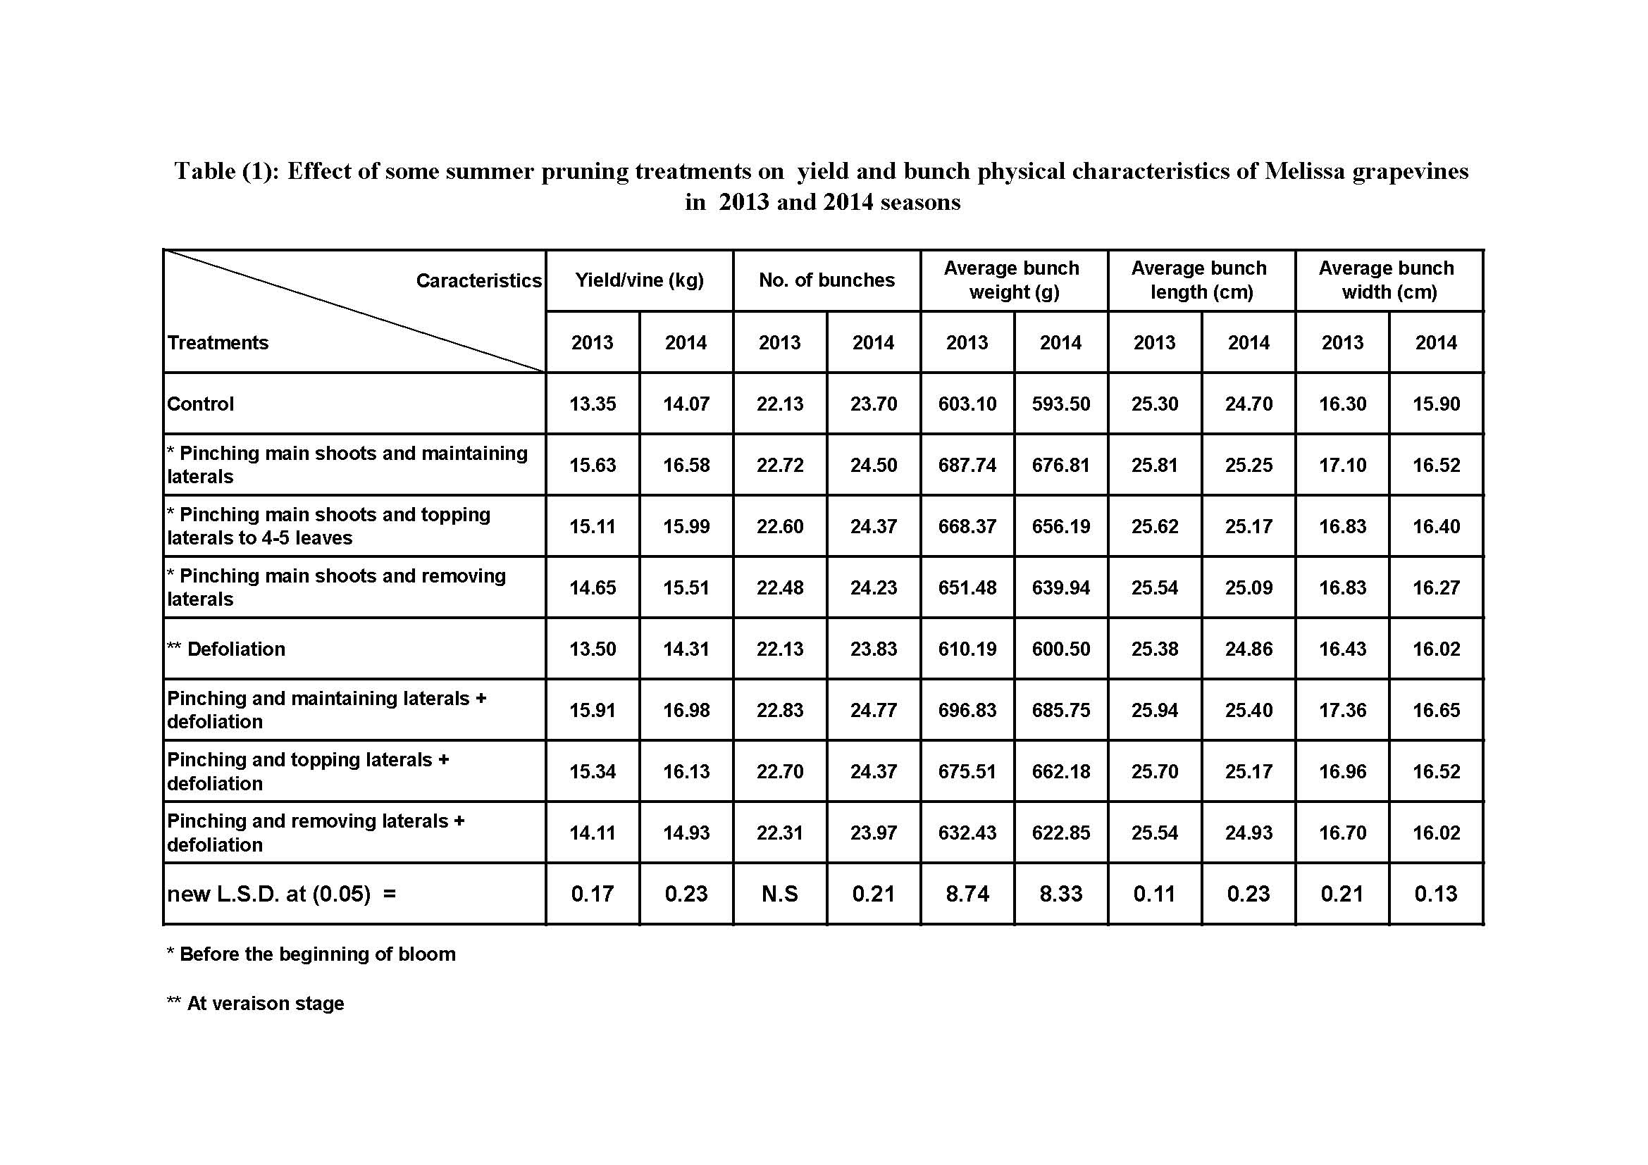

These obtained results in this respect are in line with those of Abd El-Wahab, et al., (1997) and Ibrahim et al., (2001) who mentioned that pinching the main shoots and maintaining laterals resulted in the highest average weight of bunches and yield.

3.2. Physical properties of berries:
As shown in (Table 2), it is obvious that all berry physical components i.e. berry weight, size, length and diameter were significantly affected by all summer pruning treatments as compared to the control. The highest values of those parameters were detected in case of vines treated with pinching and maintaining laterals + defoliation treatment in both seasons.
The increase in berry weight and dimensions observed in summer pruning treatments can be interpreted in view of the fact that these treatments lead to the increase in photosynthetic activity of leaves. As a consequence of that, immigration of assimilates from leaves towards berries is enhanced (Winkler, 1965). With respect to defoliation, late leaf removal (at veraison stage) is related to the activation of photosynthesis inside the canopy of the vine through increasing light penetration and temperature, which induces an increase in sugars in the berries raising its osmotic pressure and attraction force of water, thus improving physical berry properties (Omar, 2005) .
The obtained results referring to the positive effect of summer pruning treatments on the physical characteristics of berries are in agreement with those reported by Abd El-Wahab et al., (1997) and Ibrahim et al., (2001) who showed that pinching the main shoots and maintaining laterals resulted in the highest average berry weight, berry size and berry dimensions.

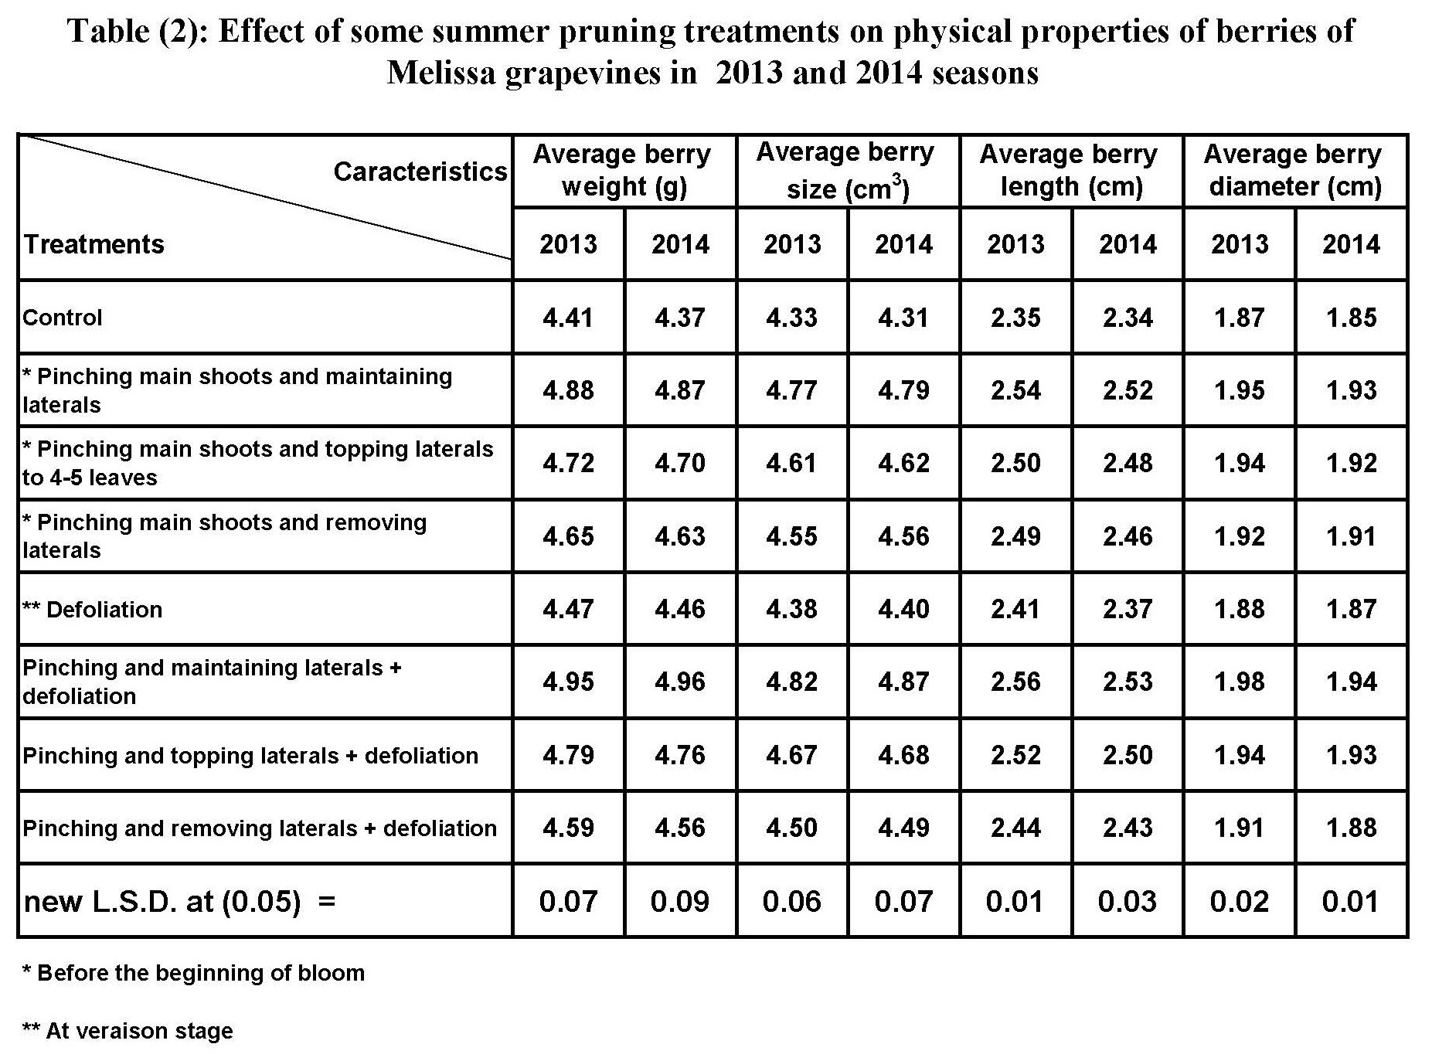

3.3. Chemical properties of berries:
Data presented in (Table 3) show that summer pruning treatments had significantly improved all berry chemical characteristics, including total soluble solids, titratable acidity and TSS/acid ratio in berry juice as compared to the control. Pinching and maintaining laterals + defoliation treatment gave the highest values of TSS percentage and TSS/acid ratio and the lowest values of acidity in berry juice in both seasons.
The positive effect of summer pruning treatments on berry chemical properties i.e. TSS%, acidity% and TSS/acid ratio of the berry juice in the grape juice could be attributed to that removing shoot tips promotes lateral shoot growth at the nodes closer to the excised tip. Lateral shoots developed during the period of active shoot growth become net exporters of carbohydrates. They provide an additional photo-assimilating surface to support their own growth and export the surplus to the main shoot, contributing to fruit ripening. The most efficient leaves during ripening are located at the top of the canopy and those arising from lateral shoots (Wolf et al., 1986 and Candolfi-Vasconcelos and Koblet, 1994). Closely related to this topic is the work of Ali et al., (2006) who found that these findings can be interpreted as summer pruning might increase the intensity of photosynthesis in the leaves situated in the section of clusters. This, by its turn, enhanced the immigration of assimilates from leaves towards clusters during the process of ripening. With respect to defoliation, Shading has been identified as a major factor in reducing grapevine fruit quality (Smart, 1985). On the other hand, summer pruning helps in ameliorating fruit quality by more exposure to sunlight and generally exhibiting higher concentrations of sugars and lower acidity in grape juice compared to those ripened in dense canopy shade (Kliewer et al., 1988). Recently, (Omar, 2005) reported that leaf removal allows the light to penetrate the canopy of the vine resulting in an increase in the photosynthetic activity of the leaves inside the canopy and permits air circulation raising temperature inside the canopy, consequently, ripening is promoted through the positive influence on grape composition i.e. increasing TSS and decreasing acidity.
These obtained results in this respect are in line with those of Wang (1989), Abd El-Wahab, et al., (1997) and Ibrahim et al., (2001) who ensured that pinching the main shoots and maintaining laterals resulted in the highest percentages of TSS and TSS/acid ratio and the lowest acidity of berry juice.

3.4. Some characteristics of vegetative growth
As shown in (Table 4), it is obvious that some vegetative growth characteristics i.e. average leaf area, coefficient of wood ripening and weight of prunings were significantly affected by all summer pruning treatments as compared to the control. The highest values of those parameters were detected in case of vines treated with pinching and maintaining laterals + defoliation treatment in both seasons.
The positive influence of the conducted treatments was previously supported by Abd El-Wahab et al., (1997), Ibrahim et al., (2001) Lorenzo et al., (2001) who stated that head suckering and pinching the main shoots and maintaining laterals resulted in the highest values of vegetative growth parameters. With respect to defoliation, late leaf removal (at veraison stage) increased the formation of laterals and production of photosynthetically and physiologically efficient leaf area which increased root density (Hunter and Le Roux, 1992) resulting in an appreciable increase in nutrient absorption and translocation of more carbohydrates to vegetative growth (Hunter and Visser, 1990).

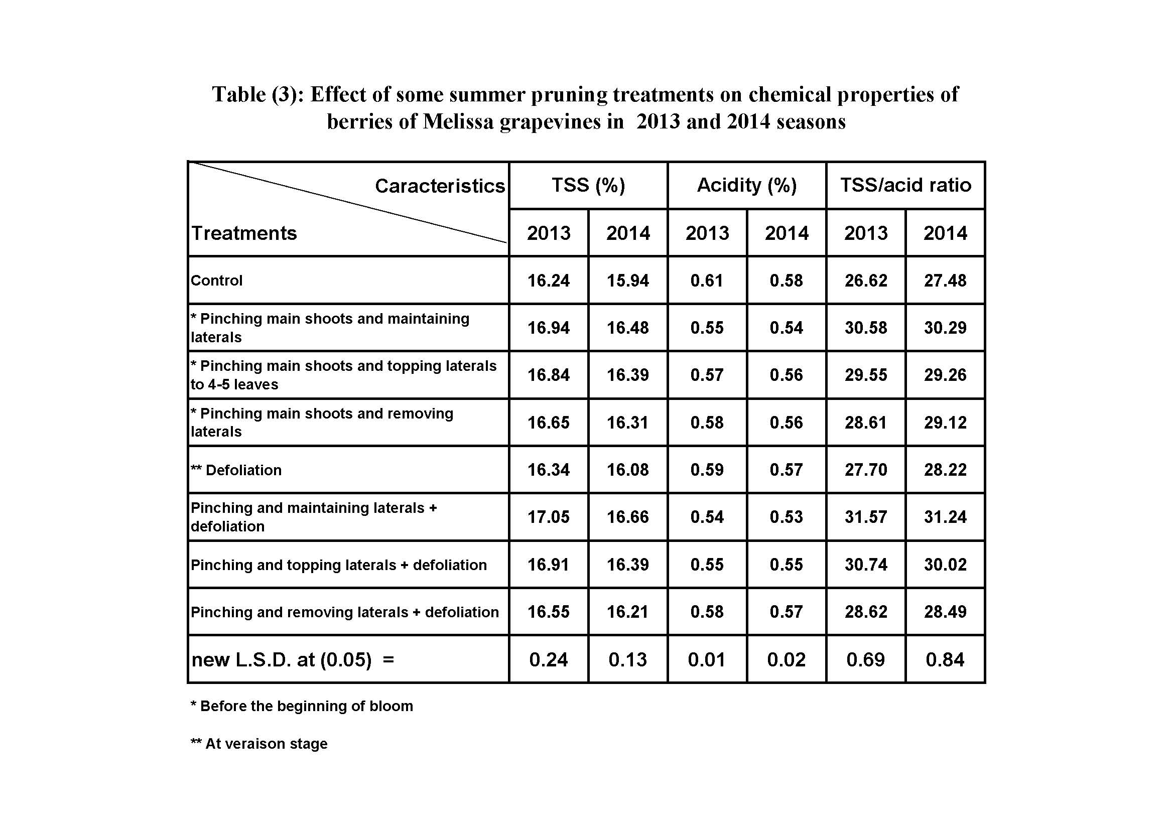

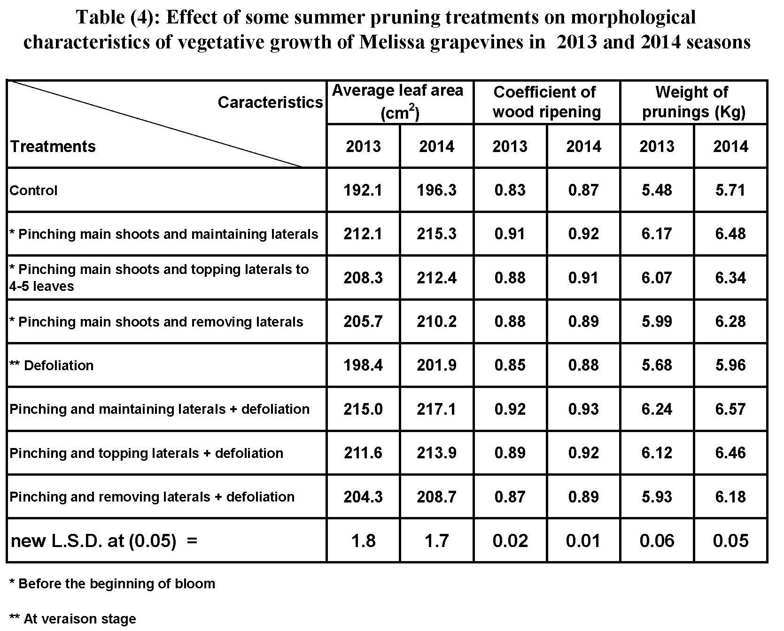

3.5. Leaf content of total chlorophyll and cane content of total carbohydrates
Results presented in (Table, 5) show that summer pruning treatments had significantly increased leaf content of total chlorophyll and cane content of total carbohydrates as compared to the control. Pinching and maintaining laterals + defoliation treatment gave the highest values of total chlorophyll and cane content of total carbohydrates in both seasons.
The relative increase in total carbohydrate content of canes observed in summer pruning treatments may be attributed to the high rate of shoot growth and wood ripening, since there existed a highly positive correlation between carbohydrate accumulation in the canes and the degree of wood ripening, in addition to the increase in the intensity of photosynthesis in leaves as well as the great accumulation of organic and mineral nutrients in favor of the rest tissues of the vines (Winkler, 1965). In addition, summer pruning increases solar radiation received by the leaves in the interior canopy, which by its turn increases photosynthetic activity of the leaves and consequently carbohydrate accumulation (Kliewer, 1981). Shoot tipping improves the movement of photosynthetic towards the main shoot via removing the part of shoot tip, which consumes photosynthetic, also laterals which grow on the main shoot become exporter of photosynthetic to the main shoot (Abd El-Ghany et al., 2005).
These results are in accordance with those obtained by Abd El-Wahab et al., (1997) who found that pinching the main shoots and maintaining laterals resulted in the highest percentages of total carbohydrates in the second season.

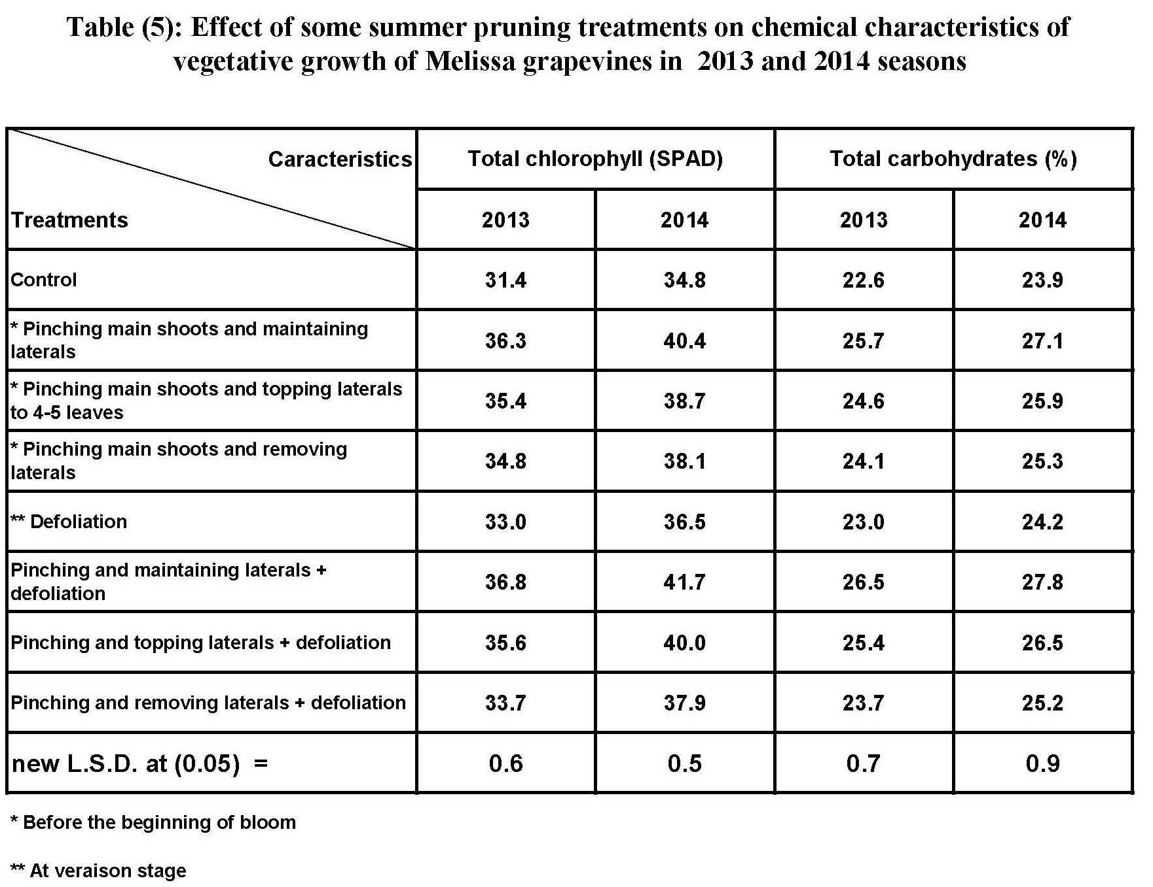

Conclusion
From the foregoing results, it can be said that there is a possibility of using some summer pruning practices to improve vegetative growth, yield and bunch quality. Pinching and maintaining laterals + defoliation treatment achieved the best yield and its components as well as the best physical properties of bunches, improved the physical characteristics of berries, ensured the best vegetative growth parameters and increased total chlorophyll of leaves and total carbohydrates of canes in comparison with the control for Melissa grapevines.
References
- Abd El-Ghany, A.A.; Omran, Yasser A.M.M. and Abd El-Galil, H.A. (2005): Effect of summer pruning on Thompson Seedless grapevines productivity. Assiut J. of Agric. Sci., 36(5): (167-180).
- Abd El-Wahab, W.A, Mohamed. S.M. and El-Gendy, R.S. (1997): Effect of summer pruning on bud behaviour and bunch characteristics of Thompson Seedless grapevines. Bull. Fac. Agric. Univ. Cairo, 48: 351-378.
- Ahmed, F.F. (1985): Effect of alar as growth retardant and pinching on vegetative growth and the yield of Roomy red grapevines. Ph.D. Thesis. Fac. Agric., Minia, Univ.
- Ali, M.A.K.; El-Gendy, R.S.S. and El-Morsi (2006): A study on the possibility of improving coloration of Crimson Seedless grapes under desert conditions via the application of some treatments. B- Summer pruning and girdling. Bull. Fac. Agric., Cairo Univ., 57: 723-744.
- Alia H.I., Mervet A.A. and Abd EL-Hady M.A. (2001): Response of Red Roomy grapevines to summer pruning. J. Agric. Sci. Mansoura Univ., 26(9):5641-5649.
- Association of Official Agricultural Chemists (A.O.A.C.) (1985): Official Methods of Analysis A.O.A.C., Benjumin Franklin Station, Washington, D. C. N. S. A. pp 440-510.
- Bouard, J. (1966): Recherches physiologiques sur la vigne et en particulier pour I'aoutment des sarrments. Thesis Sc. Nat Bordeaux-France. Pp.34.
- Candolfi-Vasconcelos, M.C. and Koblet, W. (1994): Influence of defoliation, rootstock, training system and leaf position on gas exchange of Point Noir grapevines. Am. J. Enol. Vitic.45: 173-180.
- Dokoozlian, N.; D. Luvisi; M. Moriyama and P. Schradr (1995): Cultural practices improve colour, size of "Crimson Seedless". California Agriculture, 49 (2): 36-40.
- Hunter, J.J. and Le Roux, D.J. (1992): The effect of partial defoliation on development and distribution of roots of Vitis vinifera L cv. Cabernet sauvignon grafted onto rootstock 99 Richter. Am. J. Enol. Vitic.43: 71.
- Hunter, J.J. and Visser, J.H. (1988): The effect of partial defoliation, leaf position and developmental stage of the vine on the photosynthetic activity of Vitis vinifera L. cv. Cabernet Sauvignon, Afr. J. Enol. Vitic., vol. 10, pp. 67–73.
- Hunter, J.J. and Visser, J. H. (1990): The effect of partial defoliation on quality characteristics of Vitis vinifera L cv. Cabernet sauvignon grapes. II- Reproductive growth. S. Afr. J. Enol. Vitic. 11 (1): 26-32.
- Ibrahim, A. H. , Abd El-Karem M. A. and Abd EI-Hady M. A. (2001): Response of Red Roomy grapevines to summer pruning. J. Agric. Sci. Mansoura Univ., 26 (9): 5641-5649.
- Kliewer, W.M. (1981): Grapevine physiology: How does a grapevine make sugar? Leaflet 21231. Division of Agricultural Sciences. Univ. Calif.
- Kliewer, W.M.; J.J. Marois and A.M. Bledsoe (1988): Relative effectiveness of leaf removal, shoot positioning and trellising for improving wine grape composition. In proceedings of the second International Symposium for Cool Climatic Viticulture and Oenology 11-15 January. Auckland, New Zealand.
- Koblet, W.; Carmo Candolfi-Vasconcelos, M., and Keller, M., (1996): Effects of Training System, Canopy Management Practices, Crop Load and Rootstock on Grapevine Photosynthesis, Acta Hortic. (ISHS), vol. 427, pp. 133–140.
- Lorenzo, R. di, Ferrante, S. and Barbagallo, M. G. (2001): Modification of source/sink ratios in Nero d'Avola (Vitis vinifera L.) grapevines in a warm-dry environment. Advan. in Hort. Sci., , 15 (1/4):31-38.
- Omar, A. H. (2004): Summer pruning and foliar application with Fe, Zn and Mn for Thompson Seedless grapevines. J. Agric. Sci. Mansoura Univ., 29(12): 7177-7189.
- Omar, A. H. (2005): Partial leaf removal and its influence on microclimate and characteristics of Superior Seedless grapevines. J. Agric. Sci. Mansoura Univ., 30(7): 4073-4083.
- Reynolds, A.G. (1989): Impact of pruning strategy, cluster thinning and shoot removal on growth, yield and fruit composition of low De Chaunac vines. Canadian J. plant Sci., 69(1): 260-275.
- Smart, R.E. (1985): Principles of grapevine canopy management microclimate manipulation with implications for yield and quality. A review. Am. J. Enol Vitic., 36: 230-239.
- Smith, F. Gilles, M. A. Hamilton, J. K. and Gedess, P. A. (1956): Colorimetric methods for determination of sugar and related substan. Anal. Chem. 28: 350.
- Snedecor, G. W. and Cochran. W.G. (1980): Statistical Methods. 7th ed, The Iowa State Univ. . Press . Ames. , Iowa , U.S.A. , pp. 593.
- Streeter, J.C., Mederski, H.J., and Ahmad, R.A., (1980): Coupling between Photosynthesis and Nitrogen Fixation, World Soybean Res., 2nd Conf., Proc. Builder, Col. L., pp. 129–137.
- Tourky, M.N., El-Shahat, S.S. and Rizk, M. H. (1995): Effect of Dormex on fruit set, quality and storage life of Thompson seedless grapes (Banati grapes) J. Agric. Sci., Mansoura Univ., 20(12): 5139-5151.
- Vial, P.M.; Crisosto, C.H. and Crisosto, G.M. (2005): Early harvest delays berry skin browning of ‘Princess’ table grapes. California Agricultural. 59(2):103-108.
- Wang. W.Y. (1989): Studies on forcing of Golden Muscat grapevine (Vitis vinifera x Vitis labrusca) II. Study of the improvement of fruiting potential and autumn-winter fruit quality. Jour. of Agric Res. of China 38 (1) : 42-52 C.F. (Hort. Abst. 60:5055).
- Winkler, A. (1965): General Viticulture. Univ. Calif. Press, Barkely and Loss Angeles.
- Wolf, T. K.; Pool, R.M. and Mattik, L.R. (1986): Responses of young chardonnay grapevines Vitis vinifera to shoot tipping, ethephon, and basal leaf removal. Amer. J. Enol. Vitic. 37:263-268.
- Wolf, T.K.; Zoechlein, B.W.; Cook, M.K. and Coreingham, C.K. (1990): Shoot topping and ethephon effects on White Riesling grapes. Amer. J. Enol. Vitic. 41(4): 330-341.
- Wood, C.W., Reeves, D.W. and Himelrick, D.G. (1992): Relationships between chlorophyll meter readings and leaf chlorophyll concentration. N status and crop yield. A review: Proc. Agro. Soc. N.Z. 23: 1-9.

12/1/2015

