Usage of some sunscreens to protect the Thompson Seedless and Crimson Seedless grapevines growing in hot climates from sunburn

Bedrech S. A. and S. Gh. Farag

Viticulture Department, Horticultural Research Institute, Agricultural Research Center, Giza, Egypt.

Abstract: In this study the effect of some plant sunscreens, Aluminum Silicate (Kaolin, Al₂O₇Si₂), Calcium Carbonate (Purshade, CaCO₃) and Potassium Silicate (Agsil, K₂SiO₃) each at 3% and 5 % was investigated on the control of sunburn effects, berry temperature and yield quality of Thompson Seedless and Crimson Seedless grapevines grown under the Egyptian hot conditions during 2013 and 2014 seasons. The vines received two sprays,twoweeks after fruit setting and at 30 days later. Results showed that on days of maximum temperature of 40°C to 45°C, Kaolin (Al₂O₇Si₂) berries was about 12°C cooler, Purshade (CaCO₃) berries was 9°C cooler and Agsil (K₂SiO₃) berries was 7°C cooler by increasing the concentration to 5% compared with the control in both cultivars. Kaolin treatment followed by Purshade treatment at 5% were the most effective techniques for controlling sunburn of both cultivars with Agsil treatment being less effective at the same concentration. However, spraying in all treatments effectively reduced sunburned berries %, total acidity and improved yield quality, cluster weight, total soluble solids of both cultivars. On the other hand, Agsil treatment was significantly the best in increasing the anthocyanin for Crimson Seedless comparing with other treatments. We conclude that under the high temperature and high radiation levels experienced in Egyptian hot climate, the technologies which reduce solar radiation and berry temperature were the most effective in reducing the sunburn.
[Bedrech S. A. and S. Gh. Farag. Usage of some sunscreens to protect the Thompson Seedless and Crimson Seedless grapevines growing in hot climates from sunburn. Nat Sci 2015;13(12):35-41]. (ISSN: 1545-0740). http://www.sciencepub.net/nature. 5. doi:10.7537/marsnsj131215.05.

Key words: Thompson Seedless grapevine, Crimson Seedless grapevine, sunburn, solar radiation, berry temperature, sunscreens.

- Introduction:
Under the Egyptian climate conditions, which characterized with higher temperature during summer periods, growing grapevine cv. Crimson Seedless and Thompson Seedless in sandy soil undergo several problems among them are sunburn as well as uneven coloration of clusters for Crimson Seedless. These problems cause negative effects on yield and berry quality. Therefore, by studying the reasons beyond these problems solar radiation was reported to be the cause for sunburn in various crops (Lipton, 1977). Solar radiation results in excessive light and heat on leaves and clusters, this led to an increase in the berry surface temperature to as high as 10- 15°C higher than the air temperature (Parchomchuk and Meheriuk, 1996). The inadequacy of resistance Mechanisms and high susceptibility of clusters to sunburn would suggest the need for external intervention to suppress sunburn in berries of regions with very high temperature. In this case using compounds to control sunburn is useful by coating the berries by a thin film that is reflective to radiation, especially UV wavelengths reaching the surfaces of leaves and clusters, thereby lowering their temperatures (Glenn et al., 2002). Application of kaolin-particle film Aluminum Silicate (Al₂O₇Si₂) to the leaf or fruit surface has been shown to reduce heat stress without restricting gas exchange (Glenn et al., 2001). The leaf intercepts photosynthetically active radiation through the particle film, while the film reflects ultraviolet and infrared radiation from the leaf or fruit surface (Glenn and Puterka, 2005). Calcium Carbonate (Purshade, CaCO₃) plant protectant is a flow able suspension concentrate that is mixed with water and then sprayed directly on plant surfaces. Once dry, Purshade forms an even film of millions of microscopic “prisms” or mirrors that reflect harmful ultraviolet radiation (UV) and infrared radiation (IR) while not blocking leaf stomata, therefore not impeding photosynthesis. The reflective properties of Purshade protect fruit from direct sunburn damage and help prevent heat stress in the entire crop canopy. Agsil (K₂SiO₃) mitigates nutrient imbalances and toxicity in plants, moreover, it reduces sunburn and heat stress by thickening the cell walls which reduces moisture loss.

2. Materials and Methods:
This study was carried out during the seasons 2013 and 2014in a vineyard located at Cairo-Alexandria Desert Road. 10 years-old Thompson Seedless and Crimson Seedless grapevines grown in a sandy soil by Y- shape training system were used in this investigation. The vineyard is spaced 2 x 3 m. The vines were pruned during the first week of January for the Thompson Seedless leaving 6 canes x 12 buds for each cane with a total vine load of 72 buds and 5 canes x 12 buds for each cane with a total vine load of 60 buds for Crimson Seedless. Vines were irrigated through drip irrigation system. One hundred twenty six uniform vines were chosen for this study (7 treatments x 3 replicates x 3 vines / replicate), sixty three vines for each cultivar. All the vines received common horticultural practices and the treatments were sprayed in two dates, the first date was two weeks after fruit setting and the second was at 30 days later for both cultivars as follow:
- Kaolin(Al₂O₇Si₂)3 %.
- Kaolin (Al₂O₇Si₂) 5 %.
- Purshade(CaCO₃) 3%.
- Purshade(CaCO₃) 5 %.
- Agsil(K₂SiO₃) 3%.
- Agsil(K₂SiO₃)5%.
- Control.
A randomized complete block design in a split plot arrangement was used in this experiment.

The following parameters were measured to evaluate the effect of the different treatments:

1- Climatic data:

Data of microclimatic factors was recorded weekly in both cultivars for each treatment and compared with those of the untreated treatments to identify the effect of each compound in ameliorating the cluster microclimate as follow:
- Light intensity.
- Canopy temperature.
- Berry temperature.

They were measured using “Scheduler Plant Stress Monitor”, Standard Oil Engineered Materials Co., Ohio, USA. All the above-mentioned measurements were used by the microprocessor of the apparatus to calculate the average of canopy microclimate in order to find the relationship between the microclimate and the effect of different compound which were used in this investigation.
2- Morphological measurements and chemical characteristics of berries were carried out on 5 shoots / vine:
- Leaf area:
Samples of leaves were randomly collected from the fruiting shoots, the apical 5th and 7th leaves from those opposite to the basal clusters on the shoots, for each treatment for leaf area determination, (using leaf area meter, Model CI 203, U.S.A.).
Representative random samples of 15 clusters / treatment (5 clusters from each replicate) were collected when clusters reached their full color and total soluble solids reached about 18-20% for Crimson Seedless and from 15-17% for Thompson Seedless, according to Badr and Ramming (1994).
The following determinations were carried out:
- Refractometric total soluble solids (TSS %) and titratable acidity as gram of tartaric acid per 100 ml of juice (A.O.A.C., 1985).
- TSS / acid ratio.
- Total anthocyanin in berry skin of Crimson Seedless using spectrocolourimeter at 250 µm according to Yilidz and Dikmen (1990).
3-Yield:
- Yield per vine (kg).
- Average cluster weight (g).
- Average number of berries / cluster.
- Average number of Sunburned berries % cluster.
4- Statistical analysis:
Means representing the effect of the tested treatments were compared by the New L.S.D. method at 0.05 according to Snedecor and Cochran (1980).
5- The economic study:

The economic evaluation of spraying different sunscreens to control the sunburn was done for the average of the two seasons for the various items, regarding the cost per feddan for each.

3. Results and Discussion:
1- Microclimatic data around and/or beneath the vine canopy:
- Sunlight intensity:
The data presented in table (1) and fig. (1) showed the light intensity at the vines canopy as affected by various treatments in both cultivar Thompson Seedless and Crimson Seedless grapevines. There are significant differences among treatments. However, in arid production regions with high solar radiation and evaporative demand, water stress may render the vine more susceptible to solar injury and inhibit fruit ripening. Application of kaolin-particle film to the leaf or fruit surface has been shown to reduce heat stress without restricting gas exchange (Glenn et al., 2001).
- Canopy temperature:
Data in table (1) and fig. (2) showed the measured air temperature around the canopy for the two growing seasons in both cultivars. It is significantly different by 3-8°C higher than the berry temperature. The lowest berry temperature was recorded in the Kaolin (Al₂O₇Si₂) 5%treatment followed by Purshade (CaCO₃) 5%, Agsil (K₂SiO₃) 3% and the control. Kaolin is a mineral chemically inert that sprayed on crops to form a white powdery film that reduces canopy temperature and therefore reduces water and heat stress and sunburn damage (Glenn and Puterka, 2005). However, vines with kaolin-particle film had the coolest leaf and canopy temperature (Cooley et al., 2010)
- Berry temperature:
Table (1) and fig. (3) showed that clusters of the treatments exposed to more sunlight in the Agsil (K₂SiO₃), has a higher berry temperature more than the less exposed ones as in Purshade (CaCO₃), followed by the Kaolin (Al₂O₇Si₂) treatment. Also Tomasi et al. (2003) report a temperature difference of 8° C or more in grape berries from the same bunch, both directly exposed to sunlight or not.

Table (1) Effect of different sunscreen treatments on microclimatic data of Thompson Seedless and Crimson Seedless grapevines in two successive seasons (2013-2014).
Thompson Seedless
First season 2013 |  |  |  |  |  |  |  |  | Second season 2014
Treatments | Kaolin |  | Purshade |  | Agsil |  | Control | New LSD at 5% | kaolin |  | Purshade |  | Agsil |  | Control | New LSD at 5%
 | 3% | 5% | 3% | 5% | 3% | 5% |  |  | 3% | 5% | 3% | 5% | 3% | 5%
Light intensity | 55.4 | 48.2 | 57.3 | 51.8 | 64.0 | 60.2 | 68.0 | 1.5 | 54.3 | 46.2 | 55.5 | 50.8 | 62.7 | 60.1 | 67.6 | 1.1
Canopy temperature | 34.6 | 33.2 | 35.1 | 33.8 | 36.3 | 35.9 | 36.7 | N.S. | 34.0 | 33.1 | 34.9 | 33.6 | 35.8 | 35.4 | 36.1 | N.S.
Berry temperature | 25.1 | 21.5 | 26.6 | 23.8 | 30.4 | 29.6 | 36.5 | 0.8 | 24.6 | 21.3 | 26.4 | 23.5 | 29.8 | 28.6 | 36.0 | 0.6
Crimson Seedless
First season 2013 |  |  |  |  |  |  |  |  | Second season 2014
Treatments | Kaolin |  | Purshade |  | Agsil |  | Control | New LSD at 5% | kaolin |  | Purshade |  | Agsil |  | Control | New LSD at 5%
 | 3% | 5% | 3% | 5% | 3% | 5% |  |  | 3% | 5% | 3% | 5% | 3% | 5%
Light intensity | 67.6 | 58.6 | 70.2 | 62.4 | 77.0 | 73.1 | 79.5 | 1.3 | 64.3 | 55.7 | 67.8 | 60.0 | 74.1 | 71.2 | 77.6 | 1.2
Canopy temperature | 43.5 | 42.7 | 43.8 | 43.0 | 44.9 | 44.1 | 45.3 | N.S. | 42.9 | 42.6 | 43.2 | 42.6 | 43.9 | 43.3 | 44.2 | N.S.
Berry temperature | 33.5 | 31.2 | 34.6 | 32.2 | 38.1 | 38.2 | 44.5 | 0.5 | 32.4 | 30.6 | 34.2 | 31.4 | 37.4 | 36.0 | 43.9 | 0.7

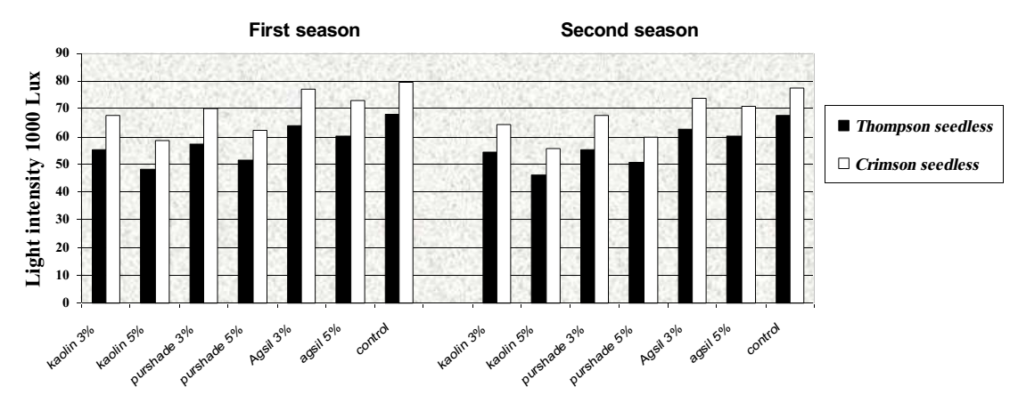

Fig (1) Average light intensity as affected by all treatments for Thompson Seedless and Crimson Seedless in the two growing seasons (2013 and 2014).

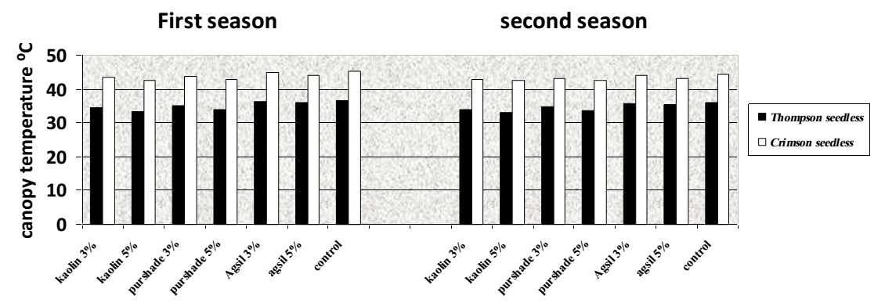

Fig (2) Average canopy temperature (⁰C) as affected by all treatments for Thompson Seedless and Crimson Seedless in the two growing seasons (2013 and 2014).

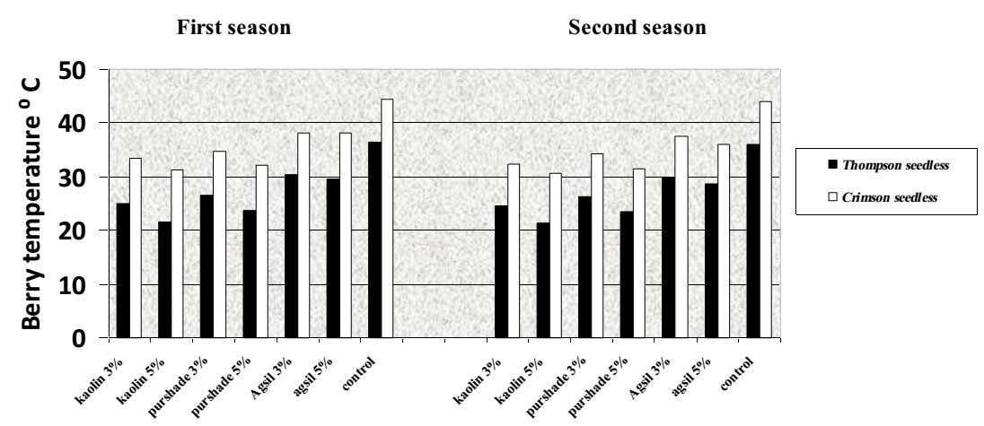

Fig (3) Average berry temperature (⁰C) as affected by all treatments for Thompson Seedless and Crimson Seedless in the two growing seasons (2013 and 2014).

2- Morphological measurements:
  - Leaf area:
Leaf area development and canopy structure are important characteristics affecting yield and fruit quality of grapevines. Table (2) shows the effect of different treatments on the average leaf area in both cultivars. It is obvious from the recorded data that there are significant differences among treatments. The highest values were obtained from the treatment sprayed by Kaolin (Al₂O₇Si₂) 5% followed by Kaolin (Al₂O₇Si₂) 3% and Purshade (CaCO₃) where there are no significant differences between them. These results are in harmony with those of Nakano and Uehara, (1996) who found that, a reflective Kaolin spray was found to decrease leaf temperature by increasing leaf reflectance and to reduce transpiration rate more than photosynthesis in many plant species grown at high solar radiation levels. Moreover, application of kaolin-particle film to the leaf or fruit surface has been shown to reduce heat stress without restricting gas exchange (Glenn et al., 2001), which in turn increase the leaf surface area, according to Kosé (2014) who found that larger leaf areas of growing vines were obtained under shaded conditions .
3- Chemical characteristics of berries:
1-Total soluble solids (TSS %), titratable acidity and TSS / acid ratio:
There are significant differences among treatments in TSS%, titratable acidity and TSS / acid ratio as shown in table (2). Potassium Silicatein both concentrations significantly was accompanied with improving quality of the berries in terms of increasing TSS%, and total sugars and reducing total acidity % in relative to the other treatments and the control(Al- Wasfy, 2014).
Grapes berries exposed to high temperature and radiation levels as in the Agsil (Potassium Silicate) 3%,the least coated clusters, (table 3)presented higher levels of soluble solids and lower titratable acidity (Bergqvist et al., 2001; Tomasi et al., 2003). Increasing fruit exposure to light penetration has been linked to enhanced accumulation of soluble solids (Reynolds et al., 1986; Smart, 1987; Morrison and Noble, 1990).
2-Total anthocyanin in berry skin:
It is clear from the obtained data in table (2) that the maximum anthocyanin content was gained by the Potassium Silicate in both concentrations, which significantly affected the accumulation of anthocyanin in Crimson Seedless berry skin in both seasons. However, clusters of the treatments exposed to more sunlight (fig.1) gave the highest values of total anthocyanin. Similarly, Jackson and Lombard (1993) found that a shaded microclimate reduces color and reduces sugar levels which are usually interpreted as delayed maturity.
4-Yield:
- Average cluster weight (g) and Yield per vine (kg):
At harvest time, all clusters on the vines in each treatment were counted and the total cluster fresh weight per vine recorded. Samples of these clusters were then taken to the laboratory and assessed for numbers of berry and sunburned berries in each cluster.
It is evident from the data in table (3) that foliar application of Aluminum Silicate (Kaolin, Al₂O₇Si₂) 5%, and Calcium Carbonate (Purshade, CaCO₃) 5% as a protectant compound significantly was responsible for improving yield and cluster weight comparing with the Potassium Silicate (Agsil, K₂SiO₃) 3 and 5% and the control treatments.

Table (2) Effect of different sunscreen treatments on morphological and chemical characteristics of Thompson Seedless and Crimson Seedless grapevines in two successive seasons (2013-2014).
Thompson Seedless
First season 2013 |  |  |  |  |  |  |  |  | Second season 2014
Treatments | Kaolin |  | Purshade |  | Agsil |  | Control | New LSD at 5% | kaolin |  | Purshade |  | Agsil |  | Control | New LSD at 5%
 | 3% | 5% | 3% | 5% | 3% | 5% |  |  | 3% | 5% | 3% | 5% | 3% | 5%
Leaf area  cm² | 199.5 | 235.9 | 183.3 | 213.8 | 170.1 | 178.6 | 162.0 | 4.9 | 200.5 | 234.3 | 184.1 | 210.8 | 169.1 | 171.4 | 160.6 | 4.2
TSS % | 18.7 | 18.1 | 17.7 | 17.1 | 19.6 | 19.2 | 16.2 | 0.3 | 18.5 | 18.0 | 17.4 | 16.6 | 19.7 | 19.1 | 16.0 | 0.4
Acidity % | 0.61 | 0.63 | 0.65 | 0.68 | 0.55 | 0.55 | 0.71 | 0.04 | 0.57 | 0.60 | 0.64 | 0.66 | 0.53 | 0.55 | 0.75 | 0.05
TSS/acid ratio | 30.6 | 28.7 | 27.2 | 25.1 | 35.6 | 32.0 | 22.8 | 2.5 | 32.4 | 30.0 | 26.7 | 25.2 | 37.1 | 34.7 | 21.3 | 1.9
Crimson Seedless
First season 2013 |  |  |  |  |  |  |  |  | Second season 2014
Treatments | Kaolin |  | Purshade |  | Agsil |  | Control | New LSD at 5% | kaolin |  | Purshade |  | Agsil |  | Control | New LSD at 5%
 | 3% | 5% | 3% | 5% | 3% | 5% |  |  | 3% | 5% | 3% | 5% | 3% | 5%
Leaf area  cm² | 118.3 | 131.4 | 115.8 | 124.7 | 102.5 | 104.6 | 100.4 | 5.3 | 131.5 | 140.1 | 127.4 | 126.3 | 10.8 | 114.6 | 104.2 | 4.7
TSS % | 19.2 | 19.0 | 18.5 | 18.3 | 21.3 | 20.9 | 17.4 | 0.6 | 21.1 | 20.9 | 19.2 | 19.3 | 22.0 | 21.7 | 17.4 | 0.7
Acidity % | 0.50 | 0.52 | 0.58 | 0.58 | 0.44 | 0.46 | 0.62 | 0.02 | 0.54 | 0.54 | 0.60 | 0.62 | 0.42 | 0.46 | 0.69 | 0.04
TSS/acid ratio | 38.4 | 36.5 | 31.8 | 31.5 | 48.4 | 45.4 | 28.1 | 1.3 | 39.0 | 38.7 | 32.0 | 31.1 | 52.3 | 47.1 | 25.2 | 1.6
Anthocyanin  mg/100g | 25.9 | 24.0 | 22.7 | 21.1 | 30.8 | 27.2 | 18.4 | 0.7 | 25.6 | 23.1 | 22.4 | 21.7 | 31.5 | 28.0 | 17.3 | 0.4

- Number of berries in each cluster, number of sunburned berries and Severity of infection %:
Table (3) demonstrated that in particular, damage of the untreated clusters amounted to 35% of berries whereas in protected clusters only about 10% of berries were sunburned. These results varies among treatments, foliar application of Aluminum Silicate (Kaolin, Al₂O₇Si₂) 5% recorded the lowest number of sunburned berries in both cultivars. These results are similar to those of Moutinho-Pereira et al. (2014) which found that delays in leaf senescence of grapevines sprayed with Kaolin inhibited scorching of clusters and, consequently, lead to a higher yield per plant, particularly emphasized in years of lower production. It is obvious that the number of sunburned berries in Thompson Seedless was lower than those of Crimson Seedless grapevines in both seasons and this Variation in sunburn between the two cultivars could relate to differences in temperatures prior to harvest which on average were 40⁰C in Crimson compared with about 30⁰C in Thompson. Grapevines growing under severe summer stress experienced significant decline in yield due to stomatal and mesophyll limitations to photosynthesis (Moutinho-Pereira et al., 2004). The reduction of foliage temperature by using sunscreens compounds may improve net photosynthesis through reducing daytime stomatal closure and daytime respiration (Glenn et al., 2001).
5- The economic study:
Table (4) shows the economic justification of the recommended treatment (spraying with Kaolin, Al₂O₇Si₂ 5%) compared with the other treatments. It can be shown from the data presented in tables (2 and 3) that it gave the maximum net profit in both seasons. From the obtained results, it can be concluded that spraying grapes treated with Kaolin, (Al₂O₇Si₂) 5% gave the highest yield and improved the physical and chemical characteristics of berries.
Moreover, the cost of production/feddan over control for this treatment is economically justified in view of the higher price of the yield obtained from this treatment and the lower price of this material compared with Purshade, (CaCO₃) 5%.

Table (3) Effect of different sunscreen treatments on yield characteristics of Thompson Seedless and Crimson Seedless grapevines in two successive seasons (2013-2014).
Thompson Seedless
First season 2013 |  |  |  |  |  |  |  |  | Second season 2014
Treatments | Kaolin |  | Purshade |  | Agsil |  | control | New LSD at 5% | Kaolin |  | Purshade |  | Agsil |  | control | New LSD at 5%
 | 3% | 5% | 3% | 5% | 3% | 5% |  |  | 3% | 5% | 3% | 5% | 3% | 5%
Average yield/vine (Kg) | 14.0 | 16.8 | 12.6 | 14.6 | 11.2 | 11.7 | 09.1 | 1.1 | 13.5 | 16.5 | 12.3 | 15.0 | 11.5 | 11.6 | 10.1 | 1.3
Cluster weight (g) | 397.4 | 413.2 | 387.5 | 401.9 | 334.9 | 350.8 | 120.3 | 8.3 | 395.1 | 410.7 | 385.8 | 400.3 | 340.0 | 355.7 | 221.5 | 10.6
No. of berries  in each cluster | 169.8 | 185.6 | 161.5 | 173.4 | 149.1 | 156.3 | 120.3 | 9.6 | 160.0 | 185.1 | 165.3 | 174.9 | 148.7 | 145.3 | 115.2 | 11.5
No. of sunburned berries | 21.0 | 10.9 | 27.4 | 15.4 | 39.1 | 31.2 | 44.2 | 2.8 | 18.4 | 9.2 | 25.2 | 12.4 | 36.7 | 28.8 | 41.0 | 1.7
Severity of infection % | 12.3 | 5.8 | 16.9 | 8.9 | 26.2 | 19.9 | 36.7 | 1.6 | 11.5 | 5.0 | 15.3 | 7.1 | 24.7 | 18.7 | 35.6 | 2.1
Crimson Seedless
First season 2013 |  |  |  |  |  |  |  |  | Second season 2014
Treatments | Kaolin |  | Purshade |  | Agsil |  | control | New LSD at 5% | Kaolin |  | Purshade |  | Agsil |  | control | New LSD at 5%
 | 3% | 5% | 3% | 5% | 3% | 5% |  |  | 3% | 5% | 3% | 5% | 3% | 5%
Average yield/vine (Kg) | 10.4 | 12.6 | 10.0 | 11.5 | 9.6 | 9.8 | 8.2 | 1.2 | 10.9 | 13.2 | 10.3 | 12.2 | 9.8 | 9.9 | 8.5 | 1.1
Cluster weight (g) | 294.3 | 394.3 | 276.4 | 330.5 | 244.2 | 235.7 | 200.3 | 14.2 | 301.6 | 396.8 | 296.3 | 349.5 | 248.3 | 259.6 | 199.5 | 15.7
No. of berries  in each cluster | 167.5 | 184.4 | 151.7 | 166.8 | 135.6 | 139.3 | 118.9 | 12.5 | 163.7 | 182.8 | 155.1 | 172.5 | 130.0 | 137.4 | 118.3 | 10.9
No. of sunburned berries | 29.6 | 18.8 | 35.1 | 22.3 | 40.1 | 36.7 | 45.3 | 1.5 | 26.5 | 17.7 | 32.2 | 21.3 | 36.2 | 33.5 | 44.8 | 1.4
Severity of infection % | 17.7 | 10.2 | 23.2 | 13.4 | 29.6 | 26.4 | 38.1 | 1.9 | 16.2 | 9.7 | 20.8 | 12.4 | 27.9 | 24.4 | 37.9 | 1.7

Table (4) The economic study of the cost per feddan for each treatment of Thompson Seedless and Crimson Seedless grapevines in both seasons (2013-2014).
Treatments | Amount in ml/tree | Amount in liters/feddan | Cost of liter/L.E | Cost of feddan/L.E | Cost for two seasons /L.E
Kaolin (Al₂O₇Si₂) 3 %. | 7.5 | 5.25 | 10 | 52.2 | 104.4
Kaolin (Al₂O₇Si₂) 5 %. | 12.5 | 8.75 | 10 | 87.5 | 175
Purshade(CaCO₃) 3%. | 7.5 | 5.25 | 90 | 472.5 | 945
Purshade(CaCO₃) 5 %. | 12.5 | 8.75 | 90 | 787.5 | 1575
Agsil(K₂SiO₃) 3%. | 7.5 | 5.25 | 15 | 78.75 | 157.5
Agsil(K₂SiO₃) 5%. | 12.5 | 8.75 | 15 | 131.25 | 262.5
Control | - | - | - | - | -

Conclusion
In conclusion, the results of this study carried out with grapevines of two varieties Thompson Seedless and Crimson Seedless grapevines and under similar field-grown conditions, emphasized the beneficial role of some sunscreens as a short-term measure for growing grapevines under high temperature and irradiance levels conditions. It can be concluded that spraying grapes treated with Kaolin, (Al₂O₇Si₂)5% gave the highest yield and improved the physical and chemical characteristics of berries.

References
- A.O.A.C. (1985). Association of Official Agricultural Chemists. Official Methods of Analysis. 9th ed., Benjamin. Franklin Station, Washington, D.C., P.O. Box. 450, 832 pp.
- Al- Wasfy, (2014). The Synergistic Effects of Using Silicon with Some Vitamins on Growth and Fruiting of Flame Seedless Grapevines. Stem Cell 2014;5(1).
- Badr, S.A.; and D.W. Ramming (1994). The development and response of Crimson Seedless cultivar to cultural practices. International Symposium on Table Grape Production, 219- 222.
- Bergqvist, J.; N. Dokoozlian, and N. Ebisuda (2001). Sunlight exposure and temperature effects on berry growth and composition of Cabernet Sauvignon and Grenache in the Central San Joaquin Valley of California. Am. J. Enol. Vitic. 52:1-7.
- Cooley, N.; R. Walker ; and P. Clingeleffer (2010). Impact of Kaolin Particle Film and Water Deficit on Wine Grape Water Use Efficiency and Plant Water Relations. Hort Science vol. 45 no. 8, 1178-1187.
- Glenn, D.M. and G.J. Puterka (2005). Particle films: A new technology for agriculture. HortRev.31:1–44.
- Glenn, D.M.; E. Prado; A. Erez; J. McFerson, and G.J. Puterka (2002). A reflective processed-kaolin particle film affects fruit temperature, radiation reflection and solar injury in apple. J. Am. Soc. Hort. Sci., 127: 188-193.
- Glenn, D.M.; G.J. Puterka; S.R. Drake; T.R. Unruh; L.A. Knight; P. Baherle; E. Prado and T.A. Baugher (2001). Particle film application influences apple leaf physiology, fruit yield and fruit quality. J. Am. Soc. Hort. Sci., 126: 175-181.
- Jackson, D.I. and P. B. Lombard (1993). Environmental and management practices affecting grape composition and wine quality - a review. Am. J. Enol. Vitic. 44(4):409-430.
- Kosé, B. (2014). Effect of Light Intensity and Temperature on Growth and Quality Parameters of Grafted Vines. Not Bot Horti Agrobo, 2014, 42(2):507-515.
- Lipton, W. J. (1977).Ultraviolet radiation as a factor in solar injury and vein tract browning of cantaloupes. J. Am. Soc. Hort. Sci., 102(1), 32-6.
- Morrison, J. C. and A.C. Noble (1990). The effects of leaf and cluster shading on the composition of Cabernet Sauvignon grapes and on fruit and wine sensory properties. Am. J. Enol. Vitic. 41:193-200.
- Moutinho-Pereira J. M.; C. M. Correia; B. M. Gonçalves; E. A. Bacelar, and J. M. Torres-Pereira (2004). Leaf gas exchange and water relations of grapevines grown in three different conditions. Photosynthetica, 42, 81-86.
- Moutinho-Pereira, J.M.; Dinis, LIa-Tânia; Fraga, H.; Pinheiro, Rafael; Ferreira, Helena F; Costa, Jorge; Gonçalves, Igor; Oliveira, Ana A; Pinto, Glória; Santos, J. A; Malheiro, Aureliano; Correia, Carlos M. (2014). "Physiological and yield responses of grapevines to kaolin under summer stress", Trabalho apresentado em Xth International Terroir Congress, Vol. 2, 202-206, 6-11 julho, In Proceedings of Xth International Terroir Congress, Tokaj.
- Nakano, A. and Y. Uehara (1996).The effect of kaolin clay on cuticle transpiration in tomato.Acta Hort. 440: 233–238.
- Parchomchuk, P., and M. Meheriuk (1996). Orchard cooling with pulsed overtree irrigation to prevent solar injury and improve fruit quality of ‘Jonagold’ apples. Hortscience 31: 802-804.
- Reynolds, A. G.; R. M. Pool, and L.R. Mattick, (1986). Effect of shot density and crop control on growth, yield, fruit composition and wine quality of ‘Seyvalblanc’ grapes. J. Amer. Soc. Hort. Sci. 111:55-63.
- Smart, R. E. (1987). Influence of light on the composition and quality of grapes. Acta Hort. 206: 37-45.
- Snedecor, G. W., and Cochran, W. G. (1980). Statistical Methods, Seventh Edition, Ames: Iowa State University Press.
- Tomasi, D.; A. Pitacco; G. Pascarella, (2003). Bunch and berry temperature and anthocyanin synthesis and profile in Cabernet sauvignon. Riv. Vitic. Enol.4: 3-15
- Yilidz, F. and D. Dikem (1990). The extraction of anthocyanin from black grape skin. Doga Degisi, Vol. 14, No 1, 57-66 pp.

12/5/2015

