Seasonal Variation In Physico-Chemical Characteristics Of Cross River Estuary, South Eastern Nigeria.

George, Ubong Uwem¹, Atakpa, Edidiong Okokon²

¹Department of Zoology and Environmental Biology, University of Calabar, Cross River State, Nigeria.
²Department of Zoology, University of Uyo, Akwa Ibom State, Nigeria.
talk2georgeubong@gmail.com.

Abstract: The quality of water from Cross River Estuary was investigated using standard methods with the view of assessing the level of pollution and the effect of anthropogenic activities in the system. Seasonal variations of some physical and chemical characteristics of Cross River Estuary were carried out between January 2014 and December, 2014. A total of nine (9) different parameters were investigated. Variations in these physico-chemical parameters were observed both in the dry and rainy seasons. The results revealed that some parameters Temperature, pH, Dissolved Oxygen, Salinity, Total Dissolved Solids, Conductivity and Total hydrocarbon concentrations in the Cross river Estuary were within the levels recommended by World Health Organization for potable water. However, the Cross river Estuary, contains other physico-chemical parameters such as Turbidity and Transparency that were above the levels recommended by World Health Organization for potable water which render it unsafe to be consumed raw. Adequate treatment before consumption is strongly recommended in order to avoid waterborne related diseases.
[George, U. U., Atakpa, E. O. Seasonal Variation in Physico-Chemical Characteristics of Cross River Estuary, South Eastern Nigeria. Nat Sci 2015;13(12):86-93]. (ISSN: 1545-0740). http://www.sciencepub.net/nature. 12. doi:10.7537/marsnsj131215.12.

Keywords: Water quality, Cross River Estuary, Seasonal variation, Physico-chemical characteristics, Nigeria.

1. Introduction
The aquatic ecosystems are the final sink to every human activity on land. The impacts of anthropogenic activities on the aquatic ecosystem are devastating. All pollutants, atmospheric and land-based invariably enter water bodies, by direct discharge, precipitations and run-offs. Water bodies, thus become sink as well as carriers of pollutants. Water pollution has wide ecological impact, as it is an important raw material in photosynthesis and hydrological processes. Water pollution impart to it undesirable properties like odours, turbidity and retardation of photosynthesis, deoxygenation and eutrophication.
The quality of water may be described according to their physical and chemical characteristics. For effective maintenance of water quality through appropriate control measures, continuous monitoring a large number of these parameters is essential. However, it is very difficult and laborious task for regular monitoring of all the parameters even if adequate manpower and laboratory facilities are available. Water quality deals with the physical, chemical and biological characteristics in relation to all other hydrological properties. Any characteristics of water that affects the survival, reproduction, growth and production of aquatic species, influences the productivity of aquatic ecosystem.

Freshwater bodies are important source of water for human activities; they serve as drinking water, water for agricultural use, domestic use (including cooking, washing etc.), transportation, electricity generation, recreation and sometimes, the disposal of waste materials. Freshwater bodies contain diverse habitats within and around which support myriads of both plants and animals lives. Variations in water quality parameters due to pollution affect resident species leading to alteration in biotic community structure with the most vulnerable dying off leaving behind tolerant species.
Continuous monitoring and evaluation of the pollution state of our environment must be ensured to provide data which will serve as check and balance to multinational oil operators and other users of aquatic ecosystem. Secondly such data is useful in the proper planning, management and protection of the mangrove ecosystem which is the breeding ground for fry’s and fingerlings from total destruction by oil pollutants. This paper therefore provides information to complement the existing data in the management of the Cross River Estuary.

2. Material and Methods
2.1 Study Area
The Cross River Estuary is a tropical brackish ecosystem located between 4⁰30’5.15’N of the equator, and between 8⁰00’8.40’E of the Greenwich meridian. It is a part of South-eastern Nigeria rainforest characterised by shallow depth (4-10m) and 5.5km width, and extensive intertidal mud with salinity fluctuating between fresh and brackish water depending on the tidal phase and season (Akpan, 1994). The climate is marked by alternating dry and wet seasons- a long wet season between April and November and a relatively short dry season from December to March (Akpan, 1994). The mean annual air temperature is 28⁰c and the mean precipitation is 500mm, surface water temperature varies between 22⁰c and 30⁰c (Etim, 1991).

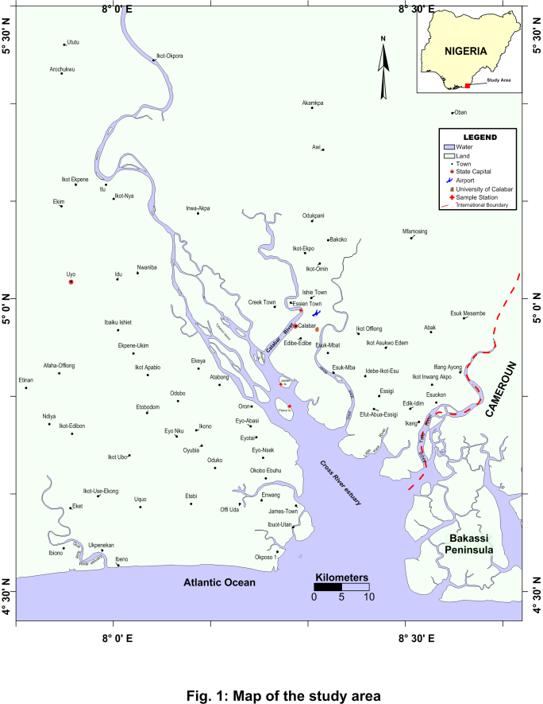

2.2 Sampling locations
The experimental site were selected in such a way that the represent areas with high, medium and low human activities respectively. Three sampling locations were identified. The sampling locations were: location 1(Calcemco), location 2 (James Island) and location 3 (Parrot Island) respectively (Fig. 1). Human activities here include wood logging, trading, artisanal fisheries and farming.
2.3 Collection of water samples / Analysis
Water Samples were collected from January 2014 to December 2014 in monthly interval. Surface water samples were collected from three different Stations. Water samples were collected in a one (1) litre capacity of plastic rubber for physico-chemical analysis. All the sampling bottles were thoroughly washed and sun dried after which the sampling bottles were labeled with dates and collection stations before use for collection of water samples. Collected water samples were stored in a cool box containing ice blocks and transported to the laboratory. Physico-chemical parameters, such as temperature, pH, turbidity, dissolved oxygen, conductivity, transparency as well as total dissolved solids were measured in situ during sampling using test kits.
Water samples for Total Hydrocarbon and salinity was collected using sample bottles and transported to Ministry of Science and Technology laboratory, Uyo. In the laboratory THC and salinity was determine based on the principles and procedures outlined in standard methods for the examination of physico-chemical parameters in water (APHA, 1998).
2.4 Data Analysis
The parameters were tabulated against sample points to enable the examination of the water quality under various stations with the aim of comparing the values with International standards. Furthermore, this study employed description statistics, such as column graphs to represent the spatial variation and seasonal variation of the water quality graphically. Analysis using T-test powered by (SPSS, Version 20.0) was used to test for seasonal variations between the means of the physico-chemical parameters.

3. Results
The results of the physical and chemical parameters of water are presented in Table 1-3, while Table 4 shows the range values of the physico-chemical parameters of the surface water compared with WHO Standards and Fig. 2 - 4 shows the mean variation of the physico-chemical parameters in the different stations during the study period.
Temperature is an important water quality parameter and is relatively easy to measure. Water bodies will show changes in temperature seasonally. The mean temperature of the study ranged between 27.8 - 29.24⁰C in all the three stations. The lowest mean value of 27.8⁰C±1.81 was recorded at station 1 (Calcemco) during wet season while the highest mean temperature value of 29.24⁰C±1.25 was recorded at location 2 during dry season (James Island).
The pH values of the water were observed to have variations at each sampling locations. The pH value recorded ranged from slightly acidic to slightly alkaline. In all water samples, the lowest mean pH value recorded was 6.7 at station 1 during wet season while the highest mean pH value was 7.52 recorded at station 3 during wet season (Parrot Island).
Mean dissolved oxygen value ranged from 3.9 - 4.2 mg/L. The highest mean value of dissolved oxygen was recorded at station 3 (Parrot Island) during dry season while the lowest mean value was recorded at station 2 and 3 (James Island and Parrot Island) during rainy season respectively. Salinity values were observed to vary in the different month during the study period.
The highest mean salinity value was recorded at station 3 (Parrot Island) during dry season while the lowest mean value was recorded at station 1 (Calcemco) during rainy season.
Turbidity is a measure of the degree to which the water loses its transparency due to the presence of suspended particulates. Turbidity is considered as a good measure of the quality of water. Mean turbidity value range from 13 – 385 NTU. The highest and lowest mean turbidity value was recorded at station 3 (Parrot Island) during dry season.
Transparency is the measure of the degree of water clarity. Mean transparency value in the three stations during the study period were within the range of 22 – 70. The highest mean transparency value was recorded at station 3 (Parrot Island) during dry season while the lowest mean transparency value was recorded at station 3 (Parrot Island) during rainy season.
Conductivity in natural waters is the normalized measure of the water ability to conduct electric current. The values for conductivity ranged from 0.06 – 1.18 mS/cm. The highest value was recorded at Parrot Island during dry season while the lowest value was recorded at station 1 - 3 during rainy season.
Total Dissolved Solids (TDS) is a measure of the combined content of all inorganic and organic substances contained in a liquid; molecular ionized or micro granular suspended form. The mean value of TDS was 0.01 – 3.83 mg/L with highest value recorded at station 2 (James Island) during rainy season and lowest at station 2(James Island) during dry season.
Mean value of total hydrocarbon (THC) during the study was observed to range between 0.2 – 8.82 mg/L. The mean highest and lowest value was recorded at station 1 (Calcemco) during rainy season.

Table 1: Monthly And Seasonal Variations In Physico-Chemical Parameters Of Cross River Estuary.
STATION 1: CALCEMCO
DRY SEASON |  |  |  |  |  | RAINY SEASON
Parameters | Nov | Dec | Jan | Feb | Mar | Mean ±SD | Apr | May | Jun | July | Aug | Sept | Oct | Mean ±SD
Tempt. (ºC) | 26.60 | 27.10 | 27.20 | 29.10 | 30.00 | 28±1.47 | 29.80 | 29.90 | 29.30 | 27.30 | 26.00 | 26.40 | 25.90 | 27.8±1.81
pH | 7.40 | 6.68 | 6.50 | 7.12 | 6.81 | 6.9±0.36 | 6.56 | 6.70 | 6.80 | 6.80 | 6.65 | 6.50 | 6.85 | 6.7±0.13
DO (mg/l) | 3.9 | 4.5 | 4.21 | 4.50 | 3.2 | 4.1±0.54 | 4.3 | 5.4 | 4.1 | 4.5 | 4. 6 | 4.9 | 4.6 | 4.63±0.42
Sal. (%₀₀) | 0.053 | 0.060 | 0.056 | 0.058 | 3.900 | 0.825±1.72 | 3.800 | 3.000 | 0.400 | 0.050 | 0.040 | 0.022 | 0.028 | 1.048±1.63
Turbidity | 51.0 | 48.0 | 49.0 | 52.0 | 140.0 | 68±40.28 | 136.0 | 29.0 | 40.0 | 29.0 | 19.0 | 40.0 | 33.0 | 46.6±40.09
Transparency | 54.0 | 31.0 | 34.0 | 36.0 | 26.5 | 36.3±10.52 | 26.2 | 25.0 | 35.8 | 30.0 | 36.0 | 36.0 | 40.0 | 32.71±5.68
Conductivity | 1.08 | 1.12 | 1.06 | 0.10 | 0.08 | 0.69±0.55 | 0.08 | 0.10 | 0.06 | 0.12 | 0.07 | 0.10 | 0.08 | 0.09±0.02
TDS | 0.014 | 0.012 | 0.010 | 0.007 | 0.015 | 0.012±0.00 | 4.08 | 4.09 | 3.50 | 4.20 | 3.80 | 4.02 | 2.80 | 3.78±0.49
THC | 1.08 | 2.00 | 1.50 | 1.20 | 1.24 | 1.40±0.37 | 1.20 | 0.60 | 0.20 | 0.44 | 0.80 | 0.20 | 8.82 | 1.75±3.14

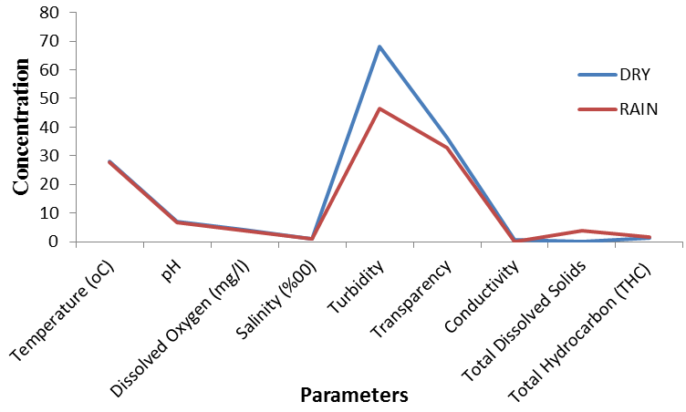
Fig 2: Mean Seasonal Variation in Physico-chemical parameter in Cross River Estuary at station 1 (Calcemco) during the study.

Table 2: Monthly And Seasonal Variations In Physico-Chemical Parameters Of Cross River Estuary.
STATION 2: JAMES ISLAND
DRY SEASON |  |  |  |  |  | RAINY SEASON
Parameters | Nov | Dec | Jan | Feb | Mar | Mean ±SD | Apr | May | Jun | July | Aug | Sept | Oct | Mean ±SD
Tempt. (ºC) | 27.80 | 28.20 | 29.8 | 29.5 | 30.90 | 29.24±1.25 | 30.70 | 30.80 | 30.00 | 26.20 | 26.50 | 26.95 | 25.90 | 28.15±2.24
pH | 6.8 | 6.9 | 6.8 | 7.12 | 7.15 | 7.0±0.17 | 7.09 | 6.90 | 6.90 | 6.90 | 6.85 | 6.50 | 6.51 | 6.8±0.22
DO (mg/l) | 3.7 | 4.3 | 4.21 | 3.8 | 4. 6 | 4.12±0.37 | 5.3 | 5.2 | 4.0 | 4.5 | 4.6 | 4.8 | 4.6 | 4.71±0.44
Sal. (%₀₀) | 0.170 | 1.360 | 0.052 | 0.054 | 8.200 | 1.967±3.53 | 7.900 | 5.600 | 1.430 | 0.076 | 0.040 | 0.074 | 0.074 | 2.170±3.24
Turbidity | 37.0 | 52.0 | 52.0 | 54.0 | 125.0 | 64±34.78 | 61.0 | 46.0 | 124.0 | 56.0 | 39.0 | 49.0 | 18.0 | 56.14±32.99
Transparency | 45.0 | 36.0 | 31.0 | 32..0 | 30.0 | 34.8±6.14 | 30.0 | 31.0 | 30.0 | 38.0 | 26.0 | 34.0 | 45.0 | 33.43±6.32
Conductivity | 1.02 | 1.12 | 0.08 | 1.08 | 1.06 | 0.87±0.44 | 0.06 | 0.08 | 0.06 | 0.08 | 0.12 | 0.06 | 0.08 | 0.08±0.03
TDS | 0.012 | 0.014 | 0.008 | 2.30 | 2.40 | 0.95±1.28 | 4.08 | 3.80 | 4.02 | 3.60 | 3.80 | 4.02 | 3.50 | 3.83±0.22
THC | 0.82 | 1.60 | 1.07 | 1.06 | 1.10 | 1.13±0.29 | 1.10 | 0.40 | 0.08 | 0.06 | 0.10 | 0.20 | 0.66 | 0.37±0.39

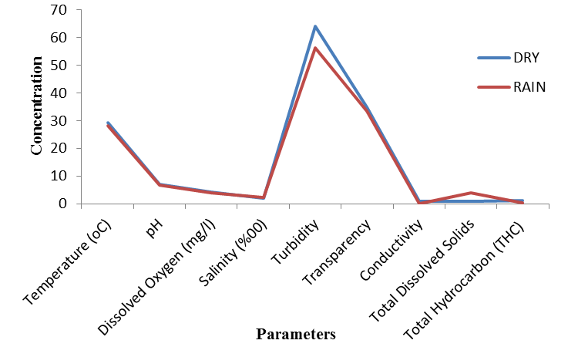
Fig 3: Mean Seasonal Variation in Physico-chemical parameter in Cross River Estuary at station 2 (James Island) during the study.

Table 3: Monthly And Seasonal Variations In Physico-Chemical Parameters Of Cross River Estuary.
STATION 3: PARROT ISLAND
DRY SEASON |  |  |  |  |  | RAINY SEASON
Parameters | Nov | Dec | Jan | Feb | Mar | Mean ±SD | Apr | May | Jun | July | Aug | Sept | Oct | Mean ±SD
Tempt. (ºC) | 27.80 | 28.10 | 29.5 | 29.2 | 30.70 | 29.06±1.16 | 30.50 | 30.60 | 30.15 | 27.80 | 26.80 | 26.10 | 25.70 | 28.2±2.15
pH | 7.48 | 7.05 | 6.80 | 7.12 | 7.51 | 7.2±0.30 | 7.43 | 7.20 | 6.90 | 6.50 | 6.56 | 6.80 | 7.52 | 7.0±0.41
DO (mg/l) | 4.1 | 3.4 | 4.1 | 3.6 | 4.3 | 3.9±0.38 | 4.1 | 4.5 | 4.21 | 4.01 | 4.3 | 4.1 | 3.9 | 4.16±0.2
Sal. (%₀₀) | 0.360 | 1.670 | 1.360 | 1.670 | 10.700 | 3.152±4.25 | 10.600 | 8.600 | 2.360 | 0.466 | 0.100 | 0.830 | 0.206 | 3.309±4.40
Turbidity | 13.0 | 41.0 | 45.0 | 31.0 | 385.0 | 103±158.13 | 327.0 | 25.0 | 14.0 | 31.0 | 25.0 | 144.0 | 38.0 | 86.3±115.04
Transparency | 72.0 | 23.0 | 29.5 | 35.0 | 29.5 | 37.8±19.59 | 29.5 | 35.0 | 26.9 | 23.0 | 22.0 | 50.0 | 70.0 | 36.6±17.51
Conductivity | 1.08 | 1.18 | 0.12 | 1.06 | 1.02 | 0.89±0.44 | 0.08 | 0.06 | 0.08 | 1.06 | 0.12 | 0.08 | 0.06 | 0.22±0.37
TDS | 0.009 | 0.007 | 0.012 | 0.014 | 0.009 | 0.01±0.00 | 3.8 | 4.02 | 3.60 | 4.02 | 3.50 | 2.60 | 4.02 | 3.65±0.51
THC | 0.46 | 1.20 | 1.08 | 0.98 | 0.40 | 0.82±0.37 | 0.43 | 0.20 | 0.08 | 0.08 | 0.04 | 005 | 0.29 | 0.17±0.15

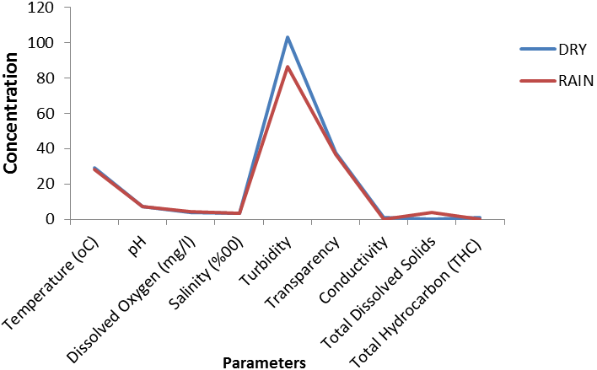
Fig 4: Mean Seasonal Variation in Physico-chemical parameter in Cross River Estuary at station 3 (Parrot Island) during the study.

Table 4: Mean range Values of Physico-Chemical Parameters of Cross River Estuary with WHO Standards
Parameters | Range Values | WHO
Tempt ⁰C | 27.8 - 29.24⁰C | 24 - 30^{O}C
Ph | 6.9 - 7.52 | 6.5 – 8.0
DO (mg/l) | 3.9 - 4.2 | 5.0 mg/l
Salinity (%₀) | 0.825 - 3.309 | NI
Turbidity | 46.6 – 103 | 1- 5.0 NTU
Transparency | 22 – 70 | NI
Conductivity (mS/ cm³) | 0.06 – 1.18 | 250 mS/cm³
Total Dissolved solids (mg/l) | 0.01 – 3.83 | 0 - 500 mg/l
Total Hydrocarbon (mg/l) | 0.2 – 8.82 | NI
NI = Not indicated, WHO = World Health Organization

4.0 Discussion
The values of temperatures were observed to vary during the study period. In both seasons, the least temperature was recorded at station 1. Statistical analysis showed no significant difference (P>0.05) in all the three stations between the dry and wet seasons values. The temperature values showed slight variations with seasons. This observation was found to be consistent with the trends reported in previous studies within the Niger Delta (Chindah et. al., 1999). The values of temperature obtained in the study were within permissible limit of WHO (Table 4). This range is normal in the tropics (Akpan, 1999) and is attributed to the weather condition of the study area- which is characterized by hot dry season and cold wet season (Moses, 1987; Akpan, 1999; Michael et. al., (2015).
The mean pH values between both seasons showed no significant difference (P>0.05) in all the stations. Water pH which is an indicator of acidic or alkalinity condition of water status was within WHO permissible limit of 6.5-8.5. The mean pH value was slightly acidic to slightly alkaline throughout the period of study; this could be attributed to the dilution of saline mangrove water by fresh water inflow. High pH recorded during the study could be due to the removal of CO₂ by photosynthetic organism. The pH was found to have slight variations between stations and seasons. Elevated pH was found in the dry season than in the wet season. The results obtained for pH are similar to the results obtained by Adefemi et al. (2007) in water samples from Ureje, Egbe, Ero and Itapaj dams, all in Ekiti State. High or low pH values in a river have been reported to affect aquatic life and the toxicity of other pollutant in one form or the other (Morrison et al., 2001).
Mean dissolved oxygen values were higher in the wet season than in the dry season due to the increased current flow that enables the diffusion and mixing of atmospheric oxygen into the water. This finding is consistent with those reported in previous studies for Zambezi River (Hall et al., 1977), Qua Iboe River (Akpan, 1993) who observed that tropical African aquatic systems generally have low DO in the dry season than the wet season. King and Ekeh (1990) in their work on Nworie Stream, Nigeria, attributed the dry season decline in dissolved oxygen concentration to stream stagnation and increased input of organic load into the water (mainly as leaf litter), whose decomposition result in anoxia situation. On the other hand, the high levels of dissolved oxygen observed in the wet season in all the stations in Cross River Estuary is consistent with the work of Chindah and Braide (2004) in Bonny River, in the Niger Delta who observed that DO concentrations values were significantly higher in wet season than that of dry season. Similar result was reported by Izonfuo and Bariweni (2001), while working in Epie Creek, in the Niger Delta, observed that the values of DO in the wet season were higher than the values obtained in the dry season. Seasonal fluctuation in DO was attributed to the effect of temperature on the solubility of oxygen in water. At high temperature, the solubility of oxygen decreases while at lower temperature, it increases (Plimmer, 1978). In the present study DO values were observed to be within the permissible limit of 4-5mg/1 which is essential for fish and aquatic life. This implies that the Cross River Estuary has the capacity to sustain aquatic life. Although, the result of the present study agrees favorably with those of the author under reference but there was no significant difference in the values of DO in any of the season and in all the three stations.
Conductivity in any aquatic system is strongly influenced by the concentration of dissolved constituents. The remarkable increase in conductivity in the dry season is possibly due to high evapo-transpiration process which resulted in the concentration of the ions in the water (Allan, 2001; Wetzel, 2001). The dry season values of electrical conductivity were generally higher than the wet season values and statistical analysis showed significant difference (P<0.05) between them in all the three stations. This intra-seasonal variability indicates a strong influence of hydro meteorological factors on conductivity levels in the river. Similar influence has been reported by Adebisi (1981) in Ogun River, Nigeria. This seasonality regime is consistent with those of other tropical rivers (Welcomme, 1985; Wright, 1982; King and Ekeh, 1990; Akpan and Ufodike, 2005). The levels of conductivity measured at Cross River Estuary is within WHO permissible limits but consistent with values obtained in most waters of the Niger Delta by Nwadiaro, (1989), Ogamba (2003), Agbozu and Emperor (2004), Agbozu and Izidor (2004).
TDS was higher in downstream site because of salt intrusion from the sea and with a significant difference between the seasons. The high wet season mean values in TDS was attributed to high precipitation which resulted in influx of allochthonous materials into the river through surface run-off. This result is consistent with the report of (Akpan, 2004) when working on water bodies in Uyo, where he observed an increase in dissolved load with a corresponding increase in precipitation. Fatoki et. al., (2001) also noted an increase in total dissolved solids in Umtata River (South Africa) from contributions from runoff from the settlements during the summer rains. Comparatively, higher values were considerably observed for all the stations in the wet than dry season. However, the mean difference between the dry and wet seasons values of TDS was statistically significant (P<0.05) in all the three stations during the study.
The mean wet season values for salinity were higher than that of dry season which can be attributed to high precipitation which resulted in influx of allochthonous materials into the river through surface run-off from both domestic and industrial source. There was no significant difference (P>0.05) between the mean levels of salinity in both seasons in all the three stations. The present study does not agree with the work of Ekpenyong, 2005 which reported high values in dry season than wet season which he attributed to water evaporation in the dry season as well as the intrusion of salty water from the estuary as a result of no rainfall discharge during the season in his studies in Qua Iboe River.
The mean transparency in the dry season was higher than that of the wet season with no significant difference in both seasons in all the three stations. The decreasing mean transparency values during the wet season may be attributed to increased tributary input of suspended materials and increased surface run-off from the drainage basin. It could also probably be attributed to increased plankton abundance downstream. From this study, transparency decreased markedly in the wet season (April – October). This could be due to the heavy load of organic matter carried into the river by surface run-off and also by silt generated by the disturbance of the river bottom (sediment) by the greater turbulence of flood water which comes after heavy rains. This trend was also observed by (Ekpo et al., 2003) for Calabar River; Adebisi (1981), for Ogun River; Akpan (2004) for some tropical freshwater bodies in Uyo; Akpan (1995) for a pond in Uyo; Michael et. al., (2015) for fresh water segment of the Lower Cross River System, all in Nigeria.
The highest mean value of total hydrocarbon (THC) obtained at station 1 during wet season in the month of October (8.82mg/l) indicates pollution traceable to oil and gas, and the lower mean value obtained in other station and month during the study may be due to seasonal effects as well as surface runoffs and flooding (Fatoki et al., 2001). The results show significant (P<0.05) difference in both station 2 and station 3 in both season but no significant (P>0.05) difference was observed in station 1 in both season.
Higher values of turbidity were measured during the dry season and lower values of turbidity were obtained for wet season respectively. There was significant (P<0.05) difference in values obtained during the study in both season for turbidity. The turbidity values obtained for all the locations were higher than WHO standards of 5NTU (WHO, 2004). Excessive turbidity in water can cause problem for water purification processes such as flocculation and filtration which may increase treatment cost. High turbid waters are associated with microbial contamination (DWAF, 1998). Again, turbidity inhibits photosynthetic activities, since turbidity precludes deep penetration of light in water. Ultimately, the water receiving body is disqualified as source of water for domestic use in the community.

Conclusion
The results of the physico-chemical parameters used to access the water quality of Cross River Estuary in Nigeria revealed that it is moderately safe for use for human consumption, irrigation purpose and other domestic activities. Temperature, pH, Dissolved Oxygen, Salinity, Total Dissolved Solids, Conductivity and Total hydrocarbon concentrations in the Cross river Estuary, Nigeria were within the levels recommended by World Health Organization for potable water. However, the Cross river Estuary, contains other physico-chemical parameters such as Turbidity and Transparency that were above the levels recommended by World Health Organization for potable water which render it unsafe to be consumed raw. The water obtain from this source can be made completely potable by scientific treatment that is filtration, chlorination and boiling.

Reference
- Agbozu I.E. and Emperor J. (2004): Effect of waste Dump on Water Quality of Central Sombreiro River in the Niger Delta, Nigeria. Journal of Agricultural and Environmental Engineering Technology. Vol. 1, No. 1 pp 48-54.
- Agbozu I.E. and Izidor U.A. (2004) Assessment of water quality in Niger Delta: A Case study of Ogba/Egbema/Ndoni Local Government Area Rivers State. Journal of Agricultural and Environmental Engineering Technology Vol. 1, No. 1. pp 42-47.
- Adebisi, A. A. (1981). The physico-chemical hydrology of a tropical seasonal River-Upper Ogun River. Hydrobiology, 79. 157-165.
- Akpan, A.W. (2004): The water quality of some tropical fresh water bodies in Uyo (Nigeria) receiving municipal effluents, slaughterhouse washings and agricultural land drainage. The environmentalist, 24. 49-50.
- Akpan, A. W. and Ufodike, E. B. C. (2005): The Geo-morphological features of a tropical coastal River draining forested catchments and influence of fluvial processes on ecosystem structure. Journal of Aquatic Sciences 20(2): 89-95.
- Akpan, A. W. (1993). The effect of hydrological regime on the temperature and salinity profiles of a tropical coastal river (Nigeria). Acta Hydrobiol. 35(4): 275- 284.
- Akpan, E. R. (1994). Seasonal Variation in Phytoplankton biomass in relation to physico-chemical factors in the Cross River Estuary of South Eastern Nigeria. . Ph.D Thesis, University of Calabar.
- Akpan, A. W. (1995) Limnology and Net Plankton periodicity of a tropical freshwater pond in Uyo (Nig.); Tropical Freshwater Biology 4, 65-81.
- Akpan E. R. Spatio-seasonal trends of physicochemical characteristics of Cross River Estuary, Nigeria. Progress in Biometeorology, 1999:13:127-131.
- Allan, J. D. (2001). Stream Ecology. Structure and function of running waters. School of Natural Resources and Environment, University of Michigan, USA. Kluwer Acadamic Publishers.
- APHA (1998). American Public Health Association, American Water Works Association and Water Pollution Control Federation. Standard methods for the examination of water and waste waters. 20th Edn America: Public Health Association, New York.
- Chindah, A.C., Hart, A.I. and Uzoma, A. (1999). Prepiphton associated with submerged macrophyte (Crinium nations) in the Upper reaches of the New Calabar River, Niger Delta.
- Chindah A. C., Braide A. S. and Sibeudu O. C., (2004). Distribution of Hydrocarbons and Heavy metals in sediment and a crustacean (shrimps-Penaceous notialis) from the bonny/new Calabar river estuary, Niger Delta. Ajeam-Ragae, 9, 1-14.
- DWAF (1998). Quality of domestic water supplied. Assessment of guide (2nd Edition). Vol. I. Department of water affairs and forest department of health, and water research commission.
- Ekpeyong, E. O. Some physico-chemical parameters of water sediments and soils of Qua Iboe coastal area. International Journal on Science and Technology, 2005:2 (4): 48 -162.
- Ekpo, H. E., Ekpe, U. J. and Akpan E. R. Establishment of water quality classification scheme: A case study of Calabar River Estuary, Nigeria: Global Journal of Environmental Science, 2003:2 (1): 67 – 71.
- Etim, L. (1991). Growth, biochemical composition and reproduction cycle in Egeria radiate (Lamark, 1804) (Lamellibiancheia Tellinaceae; Dmacidea) from the Cross River Nigeria. Ph.D Thesis, University of Calabar.
- Fatoki, O. S., Muyima, N. Y. O., Lujiza, N. (2001) Situation analysis of water quality in the Umtata River catchment. Water SA 27:467-473.
- Hall, A., I. M.C. Valente, B. Davies, (1977). The Zambezi River in Mozambique: The Physico-chemical Status of the middle and Lower Zambezi Prior to the closure of the Cubora Bassa Dam. Freshwater. Biol. 7, 187-206.
- Izonfuo, L. W.A. and Bariweni, A. P (2001): The Effect of Urban Runoff Water and Human Activities on some physico-chemical parameters of the Epie Creek in the Niger Delta.J. Appl. Scs Envtal Mgt., 5(1) 47-55.
- King, R.P. and S Ekeh, I.B. (1990): Status and seasonality in the physico-chemical hydrology of a Nigerian headwater stream. Acta Hyrobiol. 32 (314): 313 – 378.
- Michael M. A., George, U. U., Ekpo, E. A. (2015). Studies on the Physico-chemical Parameters of the fresh water segment of the Lower Cross River System, South Eastern Nigeria. New York Science Journal, 8 (7):60-65
- Morrison, G., Fatoki, O.S., Persson, L. and Ekberg, A. 2001. Assessment of the impact of point source pollution from the Keiskammahoek Sewage Treatment Plant on the Keiskamma River–pH, electrical conductivity, oxygen demanding substance (COD) and nutrients. Water SA. 27(4): 475-480.
- Moses, B. S. (1987). The influence of flood regime on fish catch and communities of the Cross River flood plain ecosystem, Nigeria. Environment Bio Fish, 18: 51-61.
- Nwadiaro, C.S. (1989): Ichthyofauna of Lake Oguta a shallow Lake in Southern Nigeria. Arch. Hydrobiology, 115 (3): 413-425.
- Ogamba, E.N. (1998). A baseline study of the fisheries of Elechi creek. M.Sc. thesis R/S UST Port Harcourt Nig. P. 32-33.
- Plimmer, R. J. (1978): Degradation Methodology chemical and physical effects in: Proceedings of the workshop on Microbial Deynadation of pollutants in Marine Environments. Pensacola Beach. Florida. 423-431.
- Welcomme, R. L., (1985): River Fisheries. FAO Fish. Tech. Pap, 262, 330p.
- Wetzal, R. G. Limnology of lake and river eco-system, 3rd edition. Academic Press, New York, 2001; 1006Pp.
- WHO (2004). World Health Organization Guideline for Drinking Water Quality. 3rd Edition Vol.1Recommendation, Geneva, 515.
- Wright, R. (1982). Seasonal variations in water quality of a West African river (R. Jong in Sierra Leone) Rev. Hydrobiol. Trop. 15: 193 –199.

12/12/2015

