Study of the effectiveness of locally manufactured alarms in treating children with monosymptomatic nocturnal enuresis

Abd El-Hamid El-Hamshary¹, Ghada El-Mashad², Mohamed Bayoumy¹

¹Pediatric Department, Faculty of Medicine, Benha University, Benha, Egypt
² Pediatric Department, Faculty of Medicine, Menoufia University, Menoufi, Egypt
amirayosri2010@gmail.com, hemauncut33@gmail.com

Abstract: Objectives: This study aims at determining the effectiveness of locally manufactured alarms in treating children with monosymptomatic nocturnal enuresis. Background: monosymptomatic nocturnal enuresis represents a major problem affecting about 20% of children aged 5 years causing multiple troubles to both the child and his family. Methods: A cross sectional study conducted prospectively upon 100 child who wet their beds minimally 3 times/week, (65% males and 35% females) whose age ranges (7-13 years). They were prospectively collected from Menouf general hospital and Benha university hospital during the period from June 2014 to May 2015 and followed up for 3 months and for 6month after treatment by bedwetting alarm. Results: success was achieved in 68% of the sample (dry nights for 14 successive nights) while the other 32% of the sample failed to attain initial success. On 3months follow up of responded group 85% of them succeeded to maintain response and on following them up for 6months 88% of them continued to have response. Conclusion: Usage of bed wetting alarm in treatment of patients with monosymptomatic nocturnal enuresis is effective.
[Abd El-Hamid El-Hamshary, Ghada El-Mashad, and Mohamed Bayoumy. Study of the effectiveness of locally manufactured alarms in treating children with monosymptomatic nocturnal enuresis. Nat Sci 2015;13(12):161-167]. (ISSN: 1545-0740). http://www.sciencepub.net/nature. 21. doi:10.7537/marsnsj131215.21.

Keywords: Nocturnal enuresis, Monosymptomatic, Alarm.

1. Introduction:
Enuresis is defined as the repeated voiding of urine in to clothes or bed at least twice a week for at least 3 consecutive months in a child who is at least 5 year of age. The behavior is not due exclusively to the direct physiologic effect to fasubstance (e.g., diuretics) or general medical condition (e.g. diabetes, spin bifida, a seizure disorder). Diurnal enuresis defines wetting while awake and nocturnal enuresis refers to voiding during sleep. Primary enuresis occurs in children who have never been consistently dry through the night, whereas secondary enuresis refers to the resumption of wetting after at least 6months of dryness. Monosymp to maticenuresis has no associated day time symptoms (urgency, frequency, daytime enuresis), and non monosymptomatic enuresis often has at least on subtle day time symptom. Monosymptomatic enuresis is rarely associated with significant organic under lying abnormalities [1].
The prevalence rate of this disorder is 20% among children aged 5 and, subsequently, 15% of children recover every year. However, approximately 0.5% of children carry over the disorder in to their adulthood with noracial differences, It is more common in males (3:1). In some cases, the symptom relapses after 6months have elapsed (secondary yenuresis) [2].
The prevalence of enures is at age 5 years is 7% for males and 3%f or females. At age 10 years, it is 3% for males and 2% for females, and at age 18 years, it is 1% formales and extremely rare in females [3].
Despite the high prevalence of enuresis, the professional training of doctors in the evaluation and management of this condition is of ten minimal and / or in consistent. Therefore, patient care is neither optimal no refficient, which can have aprofoundimpacton affected children and their families. Once comprehensive history taking and evaluation has eliminated day time symptoms or co morbidities, monosymptomatic enuresis can be managed efficaciously in the majority of patients. Non-monosymptomatic enuresisis of ten a more complex condition; the sepatients may benefit from referral to specialty care centers [4].
A single explanation for nocturnalenuresis has been elusive. The condition is multifactorial. Numerous etiological factors have been investigated and various theories have been proposed. Recent studies indicate that N. Eisbest regarded as a group of conditions with different etiologies. Agenetic component is likely in many affected children[5].
The cause of enuresis is considered to be a mismatch between nocturnal dieresis and no cturnal bladder capacity, no cturnal polyuriaduetoa lack of circadian change in antidiuretichormones, and a developmental delay in the voiding mechanisms. Therefore, patient scan be classified as the type associated with a large amount of urine at night (polyuria type), the type that is associated with a functionally small bladder capacity (bladder type), the type associated with both the aforementioned (mixed type), or the type that does not fall under any of these (normal type) [6].

2. Patients and methods:
The study was conducted prospectively upon 100 child who wet their beds minimally 3 times/week, (65% males and 35% females) whose age ranges (7-13 years). They were prospectively collected from Menouf general hospital and Banha university hospital during the period from June 2014 to May 2015 and followed up for 3month and for 6month after treatment by bedwetting alarm.
Inclusion criteria:
(a) Egyptians residents in delta governorates.
(b) All above 7 years old of both genders.
(c) patients with monosymptomatic nocturnal enuresis who wet their beds minimally 2 times/week.
(d) Co-operative, interested and concerned mothers oriented about alarm usage.
(e) Parents’ consent to be involved in the study.
Exclusion criteria:-
(a) Below 7 years old.
(b) Ignorant non co-operative mothers.
(c) Patients used the alarm before.
(d) Patients having other urinary or neurologic disorders.
Parents’ consent:-
Was taken from the parents to be enrolled in this study.
Administrative consent:-
Was taken from the head of pediatric department of the selected hospitals for permission for data collection from corresponding pediatric outpatient clinics.
All children were subjected to the following:-
- Thorough history taking regarding:-
Enuresis (duration and severity), presence of lower urinary tract symptoms (frequency of day time urination), other co-morbid illness (dm, sleep apnea), bowel movement(constipation regarding consistency and frequency of stool or encopresis), psychological history (punishment, abuse, family troubles and parents child relationship), school achievement and absence, family history of enuresis (family size, delivery of younger child and social assessment) and previous treatment of nocturnal enuresis and its results.
- Physical examination including:-
General appearance, vital signs, back and spine examination, abdominal examination, neurological examination and external genital examination.
- Investigations (as indicated) including:-
Urine analysis, blood sugar, urine culture and sensitivity test, pelvi abdominal U/S, urological assessment, IQ assessment and CT spine.
According to their initial response (14 consecutive dry nights within 16 weeks of alarm treatment) they were divided into 2 groups:-
Group A: Those patients who responded initially
Group B: Those patients who failed to attain initial response.
Then group A was further divided into:-
A1:-Part of group A that continued to attain response after 3 months of initial response.
A2: Part of group A who relapsed after 3 months of initial response. Then according to response after 6 month of in initial therapy group A1 further divided into:-
A1a:-Part of group A1 who continued to attain response after 6 months of initial response.
A1b:-Part of group A1 who relapsed after 6 months of initial response.

3. Results:
The mean age of patients of the studied group was 9.35±1.75 (figure: 1) 65% of them were male while the other 35% were female (figure: 2).
According to initial response the patients were divided into group A (responder){68%} and group B (non-responders){32%}(figure: 3).
Regarding comparison between group A and group B according to socio-demographic data there was positive significant relationship regarding the age (table: 1).
Regarding comparison between group A and group B according to possible risk factors there was positive significant relationship regarding behavioral treatment while there was negative significant relationship regarding family troubles, punishment and constipation (table: 2).
According to patients response 3 months after initial response they were divided into group A1(responder){85%} and group A2 (non-responders){15%}(figure: 4).
On comparing between group A1 and group A2 according to socio-demographic data there was positive significant relationship regarding the age (table: 3).
On comparing between group A1 and group A2 according to possible risk factors there was positive significant relationship regarding behavioral treatment while there was negative significant relationship regarding punishment (table: 4).
According to patients response 6 months after initial response they were divided into group A1a(responder){88%} and group A1b (non-responders){12%}(figure: 5).
Comparing between group A1a and A1b regarding sociodemogrphic data and possible risk factors revealed no significant relationship (tables: 5,6).

Table (1): comparison between group A and group B according to socio demographic data:-
`Initial results | Group A |  | Group B |  | test | P value
Age mean ±SD (Range) | 10.1±1.5(7-13) |  | 7.75±1.05(7-12) |  | t=8.0 | 0.001**
 | N | % | N | %
Sex  Male | 44 | 64.7% | 21 | 65.6% | X²=0.008 | 0.928
Female | 24 | 35.3% | 11 | 34.4%
Family history  Positive | 19 | 27.9% | 8 | 25% | X²=0.096 | 0.757
Negative | 49 | 72.1% | 24 | 75%
Father education n & %  High | 29 | 42.6% | 9 | 28.1% | FET=2.05 | 0.347
Average | 34 | 50% | 20 | 62.5%
Ignorant | 5 | 7.4% | 3 | 9.4%
Mother education n & %  High | 8 | 11.8% | 2 | 6.2% | FET=0.661 | 0.788
Average | 47 | 69.1% | 24 | 75%
Ignorant | 13 | 19.1% | 6 | 18.8%
Residence n & %  Urban | 26 | 38.2% | 11 | 34.4% | X²=0.139 | 0.709
Rural | 42 | 61.8% | 21 | 65.6%

Table (2): comparison between group A and group B according to possible risk factors:-
Initial results | Group A |  | Group B |  | test | P value
Constipation  Positive | N | % | N | % | FET=5.06 | 0.025*
 | 16 | 23.5% | 1 | 3.1%
Negative | 52 | 76.5% | 31 | 96.9%
Family troubles  Positive | 20 | 29.4% | 21 | 65.6% | X²=11.8 | 0.001**
Negative | 48 | 70.6% | 11 | 34.4%
Psychological problems  Positive | 27 | 39.7% | 7 | 21.9% | X²=3.08 | 0.079
Negative | 41 | 60.3% | 25 | 78.1%
Punishment  Positive | 14 | 20.6% | 15 | 46.9% | X²=7.3 | 0.007**
Negative | 54 | 79.4% | 17 | 53.1%
Behavioral ttt  Positive | 54 | 79.4% | 7 | 21.9% | X²=30.28 | 0.001**
Negative | 14 | 20.6% | 25 | 78.1%

Table (3): comparison between group A2 and group A1 according to socio demographic data:-
 | GroupA2 |  | Group A1 |  | test | P value
Age mean ±SD (Range) | 8.9±1.1(8-11) |  | 10.31±1.47(7-13) |  | 2.9 | 0.005**
 | N | % | N | %
Sex  Male | 4 | 40% | 40 | 69% | 1.99 | 0.158
Female | 6 | 60% | 18 | 31%
Family history  Positive | 3 | 30% | 16 | 27.6% | 0.0 | 1.0
Negative | 7 | 70% | 42 | 72.4%
Father education n & %  High | 7 | 70% | 22 | 27.9% | 3.07 | 0.181
Average | 3 | 30% | 31 | 53.4%
Ignorant | 0 | 0% | 5 | 8.5%
Mother education n & %  High | 1 | 10% | 7 | 12.1% | 2.77 | 0.259
Average | 9 | 90% | 38 | 65.5%
Ignorant | 0 | 0% | 13 | 22.4%
Residence n & %  Urban | 4 | 40% | 22 | 37.9% | 0.0 | 1.0
Rural | 6 | 60% | 36 | 62.1%

Table (4): comparison between group A2 and group A1 according to possible risk factors:-
 | Group A2 |  | Group A1 |  | test | P value
Constipation  Positive | N | % | N | % | 0.014 | 0.906
 | 3 | 30% | 13 | 22.4%
Negative | 7 | 70% | 45 | 77.6%
Family troubles  Positive | 4 | 40% | 16 | 27.6% | 0.176 | 0.765
Negative | 6 | 60% | 42 | 72.4%
Psychological problems  Positive | 3 | 30% | 19 | 32.8% | 0.0 | 1.0
Negative | 7 | 70% | 39 | 67.2%
Punishment  Positive | 5 | 50% | 9 | 15.5% | 6.2 | 0.013
Negative | 5 | 50% | 49 | 84.5%
Behavioral ttt  Positive | 4 | 40% | 50 | 86.2% | 8.49 | 0.004**
Negative | 6 | 60% | 8 | 13.8%

Table (5): comparison between group A1a and group A1b according to socio demographic data:-
 | GroupA1a |  | Group A1b |  | test | P value
Age mean ±SD (Range) | Age mean ±SD (Range) |  | 9.71±0.49 (9-10) |  | 10.39±1.54 (7-13) | 1.15
 | N | % | N | %
Sex  Male | 6 | 85.7% | 34 | 66.7% | 0.343 | 0.558
Female | 1 | 14.3% | 17 | 33.3%
Family history  Positive | 3 | 42.9% | 13 | 25.5% | 0.263 | 0.608
Negative | 4 | 57.1% | 38 | 74.5%
Father education n & %  High | 4 | 57.1% | 18 | 35.3% | 2.48 | 0.301
Average | 2 | 28.6% | 29 | 56.9%
Ignorant | 1 | 14.3% | 4 | 7.8%
Mother education n & %  High | 2 | 28.6% | 5 | 9.8% | 2.88 | 0.207
Average | 3 | 42.9% | 35 | 68.6%
Ignorant | 2 | 28.6% | 11 | 21.6%
Residence n & %  Urban | 4 | 57.1% | 18 | 35.3% | 0.493 | 0.483
Rural | 3 | 42.9% | 33 | 64.7%

Table (6): comparison between group A1a and group A1b according to possible risk factors:-
 | Group A1a |  | Group A1b |  | test | P value
Constipation  Positive | N | % | N | % | 0.004 | 0.95
 | 1 | 14.3% | 12 | 23.5%
Negative | 6 | 85.7% | 39 | 76.5%
Family troubles  Positive | 1 | 14.3% | 15 | 29.4% | 0.151 | 0.697
Negative | 6 | 85.7% | 36 | 70.6%
Psychological problems  Positive | 1 | 14.3% | 18 | 35.3% | 0.464 | 0.496
Negative | 6 | 85.7% | 33 | 64.7%
Punishment  Positive | 1 | 14.3% | 8 | 15.7% | 0.0 | 1.0
Negative | 6 | 85.7% | 43 | 84.3%
Behavioral ttt  Positive | 6 | 85.7% | 44 | 86.3% | 0.0 | 1.0
Negative | 1 | 14.3% | 7 | 13.7%

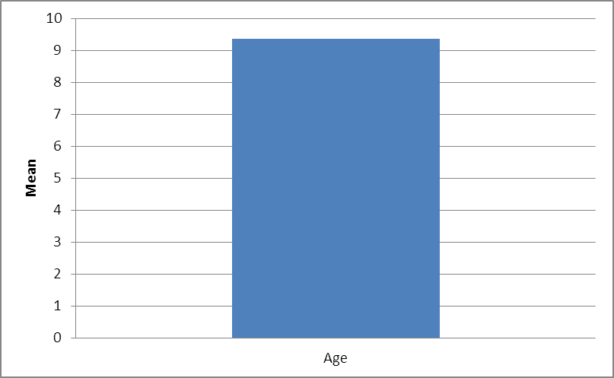
Figure (1): mean age of patients.

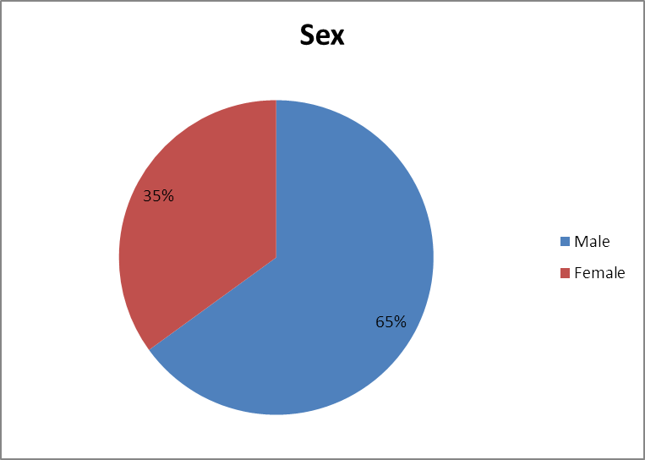
Figure (2): Sex distribution of patients.

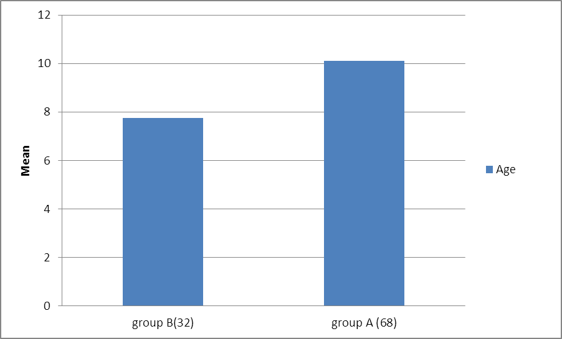
Figure (3): initial response of patients.

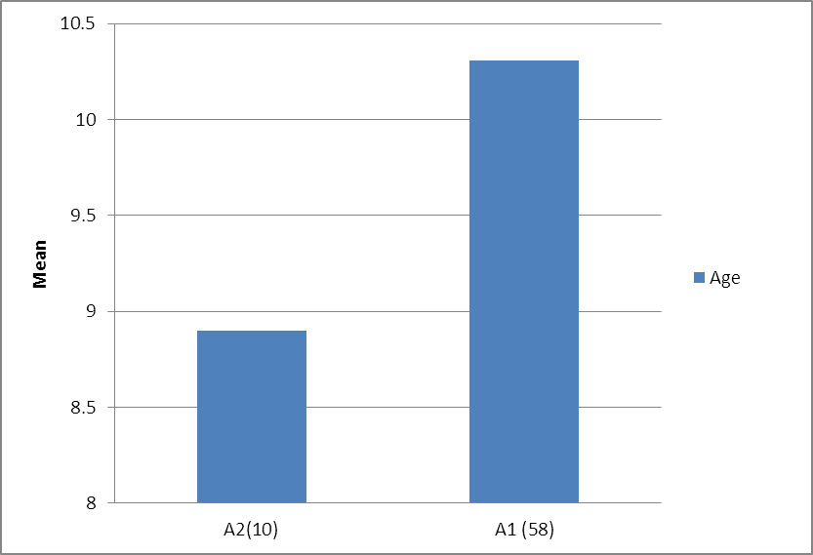
Figure (4): Patients response 3 month later.

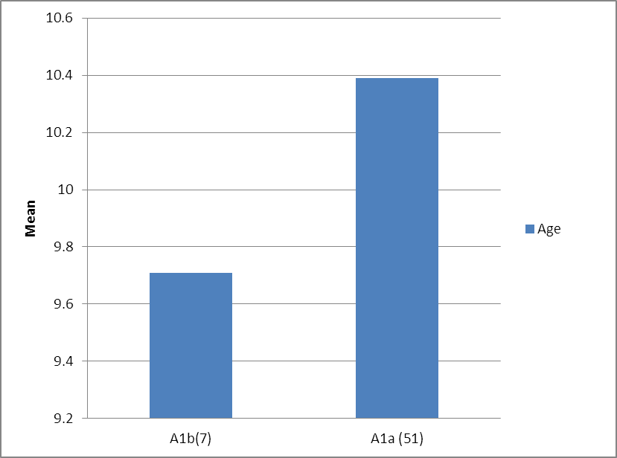
Figure (5): Patients response 6 month later.

4. Discussion
According to our study success was achieved in 68% of the sample (group A) (dry nights for 14 successive nights) while the other 32% of the sample (group B) failed to attain initial success. On 3month follow up of group A we found that 85% of them succeeded to maintain response (group A1) and on following them up for 6 month 88% of them continued to have response (group A1a).
In comparison to our study [7] a Cochrane review of 65 randomized trials that involved 3257 children concluded that alarm therapy is beneficial. Two thirds of children were dry with alarm therapy.
Almost half of those for whom alarm therapy was successful remained dry after therapy was stopped. Successfully treated children usually begin to have a response in the first month with regular dryness typically requiring a total of 3 to 6 months of continuous therapy before it can be discontinued [7].
Matching with our results another trial [8] reported on the outcome and follow up of children with monosymptomatic nocturnal enuresis utilizing alarms. This prospective study included 505 children with monosymptomatic nocturnal enuresis with outcome assessed at 6 months. At a median of 10 weeks, 79% had achieved initial dryness of those achieving initial dryness, 73% remained dry at 6 months. The authors concluded that monosymptomatic nocturnal enuresis can be successfully managed through the use of bed wetting alarm and without the use of pharmacological interventions [8].
In agreement with our trial [9] a trial that was done upon 84 Brazilian children from a university psychology clinic. All patients received full spectrum home training which consisted in the use of alarm therapy during the night and the treatment was considered to be successful if the child remained dry for 14 consecutive nights during the treatment period. Success was achieved in 71% of the sample[9].
In contrary to our trial [10]a study was done upon 40 child who had monosymptomatic nocturnal enuresis. They used an enuretic alarm for 12 weeks initially with success criterion was defined as 14 consecutive nights and relapse criterion was defined as more than one wet night/week. 67% of the studied group showed initial response.
After their follow up for 6 months only 33% remained dry while the other 67% were relapsed[10].
On comparing between the two main groups (A & B) regarding socio demographic data (Table 3) there was significant relationship regarding the age{more increase in patient age is associated with better response} (P value > 0.001) and that might be because the more increase in patient age is associated with better awareness of the disease and better desire to cure while there was no significant relationship regarding other factors (sex, family history, parents education and residence) however some studies reported that the age and sex of the child has not been shown to affect the treatment outcome[11]. Jensen found a minor influence in success for girls related more to their higher initial rate of frequency of wetting compared with boys [12].
Comparison between the two main groups (A & B) regarding possible risk factors (Table 4) revealed that there was significant positive relationship between behavioral treatment and the treatment outcome (P value>0.05). Combining enuresis alarms with other behavioral modalities (retention control training, dry bed training, over learning and rewards & penalties) enhances treatment outcome[7].
There was also significant negative relationship between treatment outcome and punishment, constipation, and family troubles (P value>0.05). Factors that predict good response to enuresis alarm include a cooperative family and no co existing family troubles (Hjalmas et al,. 2004). Treatment of constipation may also reduce enuresis, although this approach has not been studied in randomized trials. In uncontrolled study, successful treatment of constipation resulted in resolution of enuresis in 63% of 41 patients[13].
On following up group A for 3months 85% remained dry (58/68) {group A1} while the other 15% relapsed(10/68){group A2}(figure4). [14]. randomized control trial on 45 patients with monosymptomatic nocturnal enuresis showed relapse of 16.6% of the studied group after 3months of follow up. Another British study[15] randomized control trial on 71 enuretic children revealed that relapse rate after using alarms 19% of the studied group after 3 months of follow up.
Comparing between group A₁ & A₂ regarding socio demographic data (Table 5) revealed significant relationship regarding the age (P value > 0.001) while there was no significant relationship regarding other factors (sex, family history, parents education and residence).
On comparing between group A1&A2 regarding possible risk factors (table 6) there was no significant differences.
On following up group A1 for another 3months 88% remained dry (51/58) {group A1a} while the other 12% relapsed (7/58) {group A1b}(figure5). However [8] showed higher rate of relapse on following the patients for 6 months (27%).
Comparison between group A1a and group A1b regarding socio demographic data & possible risk factors showed no significant differences (Table 7, 8).

Conclusion
Usage of bed wetting alarm in treatment of patients with monosymptomatic nocturnal enuresis is effective. However patients response is also affected by other possible risk factors (age, behavioral treatment, presence of constipation, punishment and family troubles) while other risk factors were found to have minimal effects as sex, family history, family education and residence.

References
- Emily R. Katz, and David R. DeMaso (2011): Enuresis (Bed-Wetting). In NELSON TEXTBOOK OF PEDIATRICS, 19th. Edition, Chapter 21.3 ISBN: 978-1-4377-0755- by Saunders, an imprint of Elsevier Inc.
- Nevéus T. (2011): Nocturnal enuresis-theoretic background and practical guidelines. Pediatr. Nephrol. 26: 1207–14.
- Neil W. Boris And Richard Dalton. (2009): Nocturnal enuresis, NELSON, part III, Psychologic disorders. 20.3.
- Johan Vande Walle, Soren Rittig, Stuart Bauer, et al., (2012):- Practical consensus guidelines for the management of enuresis. European Journal of Pediatrics.201210.1007/s00431-012-1687-7.
- Robson JT. (2012): Nocturnal enuresis. Medical Collage of Georgia.
- Kazunari Kaneko (2012): Treatment for nocturnal enuresis: The current state in Japan Issue Pediatrics International Pediatrics International, Volume 54, Issue 1, pages 8–13, February 2012.
- Glazener CMA., Evans JE, Petro RE. (2005): Alarm intervention for nocturnal enuresis in children. Cochrane database systematic Review. 18 (2): D002911.
- Cutting M., Inoue K., Kato M., Usai A., Kurihara M., Usui I. (2007): Nocturnal enuresis and overactive bladder in children. An epidemiological study. Inter National J of Urol.
- Rodrigo F. Pereira, Edwiges F. M. Silvares, Paula F. Braga. (2010): Pediatric urology Vol. 36) 332-338, May - June, 2010 doi: 10.1590/S1677-55382010000300010.
- Ozgur BC, Ozgur S, Dogan V, Orun U A (2009): Singapore Med J, 50(9): 879-880.
- Vood an Kampenm BG, Feys H, Baert L, De Raeymaeker I, De Weerdt W. (2002): High initial efficacy of full-spectrum therapy for nocutural enuresis in children and adolescents. BJU Int. 2002; 90: 84–7.
- Jensen IN, Kristensen G. (1999): Alarm treatment analyses of response and relapse. Scand. J. Urol. Nephrol.; 202 (Suppl.): 73–5.
- Nurko S., Youssef N.N., Sabri M., et al. (2008): PEG3350 in the treatment of childhood constipation: a multicentre, double-blinded, placebo-controlled trial. J. pediatric, 153:254-261.
- Yamamoto LG, Inaba AS, Okamoto JK, Patrinos ME, Yamashiroya VK, (2010): editors. Case based pediatrics for medical students and residents [monograph on the Internet]. Honolulu: Department of Pediatrics, University of Hawaii John A Burns School of Medicine; c2004. Enuresis [cited 2010 May 28]; p. 5-28.
- Bradbury MG, Meadow SR. (1995): Combined treatment with enuresis alarm and desmopressin for nocturnal enuresis. Acta Paediatr 1995;84:1014-8.

12/25/2015

