Physico-chemical characteristics of Untreated and Treated Effluent of Shivam Automobile limited At Haridwar: A comparative study

Sushil Bhadula, Rohit Choudhry and B. D. Joshi

Department of Zoology & Environmental Sciences, Gurukula Kangri University, Haridwar- 249404, Uttarakhand (India). sushil86.ntl@gmail.com.

Abstract: The present study is carried out the physico-chemical parameters of Shivam automobile in Haridwar city. The selected physico-chemical parameters viz. temperature, pH, total solids, total dissolved solids, total suspended solids, biochemical oxygen demand, chemical oxygen demand analyzed during the study period. The relative difference, temperature was 41.12% higher, pH was14.44% higher, total solids was 66.77% higher, total dissolved solids were 50.70% higher total suspended solids were 374.43% higher, biochemical oxygen demand was 1125.80% higher and chemical oxygen demand was 451.83 % higher in the untreated effluent in comparison to treated effluent. BOD showed maximum (1125.80%) relative difference and the pH (14.44%) showed minimum relative difference among all parameters.
[Sushil Bhadula, Rohit Choudhry and B. D. Joshi. Physico-chemical characteristics of Untreated and Treated Effluent of Shivam Automobile limited At Haridwar: A comparative study. N Y Sci J 2012;5(12):179-182]. (ISSN: 1554-0200). http://www.sciencepub.net/newyork. 30

Key words: Automobile Effluent, treated, untreated.

- Introduction
The automobile industry in India is the ninth largest in the world with an annual production of over 2.3 million units in 2008. In 2009, India emerged as Asia's fourth largest exporter of automobiles, behind Japan, South Korea and Thailand. Automobile workshops are an important component of the service sector industry. The most significant environmental impact associated with the existing workshops is the seepage of used engine oil and washed. Oil released into the environment is a well recognized problem in today's world. Oil spills affects many species of plants and animals in the environment, as well as humans beings (Moorthi et. al. 2008). In most of the developing cities sewage and effluent pollution, is one of the major problems, which creates lot of health issue as well as environmental pollution. In developing countries, many people are still facing the scarcity of clean water, beside other basic sanitations. Sewage disposal affects people's immediate environments and leads to water-related disease such as diarrhoea that kills 3-4 million children each year, beside other water-related diseases, which could kill 135 million people by 2020 has been reported by Gleick (2002). Fast industrialization resulting in discharging of untreated waste water, coupled with massive abstraction of water for irrigation, industrial and domestic use, are main cause of water quality degradation. About 12,222 million liter of domestic and 2500mld of industrial waste water is generated per day in the entire Ganga basin (Trivedi, 2010). Effluent and run-off from vehicle washing and cleaning activities can damage the environment and pollute rivers, streams, burns and groundwater. Dirt, brake dust, traffic film residue and oil that is washed off are all pollutants SEPA (Scottish Environment Protection Agency, 2007). A variety of activities related to development, industrializations, urbanization, quality deterioration contribute towards increasing within Haridwar. The impacts of effluent are not only hazardous to human health but also to whole ecosystem of water bodies in which the effluent discharge. Polluted water is unsuitable for drinking, recreation, agriculture it diminishes the aesthetic quality of water bodies. The industrial pollutants degrade ecosystem many folds, pollute the water bodies, damage aquatic ecosystem damage the soil fertility which ultimately leads in to the different disease in human as well as in other organisms.

- Materials and methods
In the present study effluent samples were taken from untreated and treated effluent of Shivam automobile during the year of 2010.

Study Area: Shivam Automobile is located in State Infrastructure & Industrial Development Corporation of Uttarakhand Limited. (SIDCUL), Haridwar and 15 km away from Haridwar railway station.
Physico-chemical Parameters:
- Temperature
- pH
- Total Solids (TS)
- Total Dissolved Solids (TDS)
- Total Suspended Solids (TSS)
- Bio-chemical Oxygen Demand (BOD)
- Chemical Oxygen Demand (COD)
The physico-chemical parameters were analyzed with the help of APHA (1995) and Trivedi and Goel (1986).

- Results and Discussion
In the present study significant difference was found in the water quality of untreated and treated effluent of the Shivam Automobile. The comparative annual mean value and range value of physico-chemical parameters of untreated and treated effluent of the Shivam automobile are described below and also summarized in Table-1.
During the present study the mean value for individual observation for temperature of untreated effluent was between 30⁰C to 36⁰C in the month of June and August respectively, the lowest and highest value recorded and the mean value for temperature of treated effluent was between 21⁰C to 26⁰C in the month of June and March, respectively the lowest and highest value was recorded. Tripathy et. al. (2008) studied the physico-chemical parameters of distillery effluent and pointed out similar type of result pointed out that the temperature was higher in the untreated effluent in comparison to untreated effluent. During the present study the mean value for individual observation for pH of untreated effluent was between 8 to 8.75 in the month of February and July respectively, the lowest and highest value recorded and the lowest mean value for pH of treated effluent noted 7.10 in the month of February, March, September and highest value for pH noted 8.07 in the month of May. In the present investigation the mean value for individual observation for TS of untreated effluent was between 1725mg/l to 1778mg/l in the month of April and September respectively, the lowest and highest value recorded and the mean value for TS of treated effluent was between 1017mg/l to 1065mg/l in the month of April and August, respectively the lowest and highest value was recorded. Bhadula and Joshi (2012) studied the sewage and pointed out that the total solids were higher in the sewage zone in comparison to dilution zone. During the present study the lowest mean value for individual observation for TDS of untreated effluent was noted 1490mg/l and highest mean value was recorded as 1530mg/l in the month of May, August and September and the mean value for TDS of treated effluent was between 960mg/l to 1100mg/l in the month of January and June, respectively the lowest and highest value was noted. Similar type of results as reported by Joshi and Bisht (1993) who also pointed out that various physico-chemical component of sewer effluent of Jwalapur were degraded in comparison to confluence and dilution zone. In the present investigation the mean value for individual observation for TSS of untreated effluent was between 235.00mg/l to 260.00mg/l in the month of July and January respectively, the lowest and highest value recorded and the mean value for TSS of treated effluent was between 45.00mg/l to 58.00mg/l in the month of March and January, respectively the lowest and highest value was recorded.

Table-1: Physico-chemical characteristics of untreated effluent of Shivam automobile during 2010.
Untreated Effluent
 | January | February | March | April | May | June | July | August | September | October | November | December | Mean Value
Temperature | 34.00 | 33.00 | 35.00 | 33.00 | 31.00 | 30.00 | 34.00 | 36.00 | 35.0 | 33.44 | 32.76 | 33.50 | 33.39
pH | 8.30 | 8.00 | 8.12 | 8.20 | 8.50 | 8.40 | 8.75 | 8.60 | 8.25 | 8.34 | 8.30 | 8.15 | 8.32
TS | 1770.00 | 1778 | 1752 | 1725 | 1780 | 1759 | 1735 | 1775 | 1788 | 1761 | 1775 | 1772 | 1764.16
TDS | 1510.00 | 1520.00 | 1512.00 | 1490.00 | 1530.00 | 1510.00 | 1500.00 | 1530.00 | 1530.00 | 1514.00 | 1520.00 | 1515.00 | 1515.08
TSS | 260.00 | 258.00 | 240.00 | 235.00 | 250.00 | 249.00 | 235.00 | 245.00 | 258.00 | 247.00 | 255.00 | 257.00 | 249.08
BOD | 220.0 | 330.00 | 258.00 | 250.00 | 243.00 | 236.00 | 320.00 | 220.00 | 310.00 | 265.00 | 285.00 | 255.00 | 266.00
COD | 506.00 | 480.00 | 500.00 | 512.00 | 520.00 | 500.00 | 480.00 | 515.00 | 530.00 | 504.00 | 510.00 | 524.00 | 506.75
Treated Effluent
Temperature | 25.00 | 22.00 | 26.00 | 23.00 | 22.00 | 21.00 | 24.00 | 24.00 | 25.0 | 23.44 | 24.00 | 24.50 | 23.66
pH | 7.20 | 7.10 | 7.10 | 7.30 | 8.07 | 7.35 | 7.08 | 7.30 | 7.10 | 7.28 | 7.25 | 7.19 | 7.2766
TS | 1018 | 1034 | 1056 | 1017 | 1063 | 1155 | 1061 | 1065 | 1060 | 1058 | 1064 | 1043 | 1057.83
TDS | 960.00 | 980.00 | 1011.00 | 970.00 | 1010.00 | 1100.00 | 1010.00 | 1015.00 | 1005.00 | 1006.00 | 1010.00 | 987.00 | 1005.33
TSS | 58.00 | 54.00 | 45.00 | 47.00 | 53.00 | 55.00 | 51.00 | 50.00 | 55.00 | 52.00 | 54.00 | 56.00 | 52.50
BOD | 22.50 | 22.80 | 20.40 | 25.20 | 23.40 | 20.50 | 21. 05 | 20.00 | 21.00 | 22.00 | 20.00 | 21.00 | 21.70
COD | 92.00 | 90.00 | 91.00 | 95.00 | 90.00 | 90.00 | 89.00 | 93.00 | 96.00 | 92.00 | 93.00 | 91.00 | 91.83

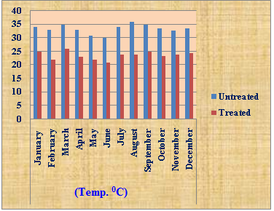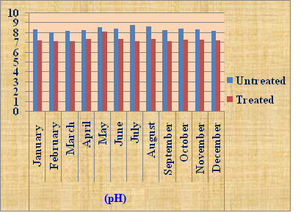
B
A
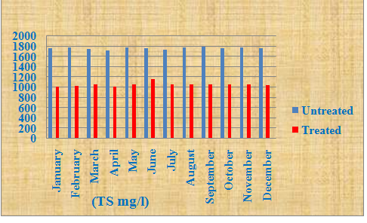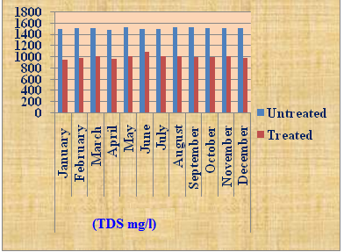
D
C
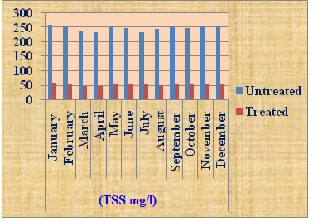
E
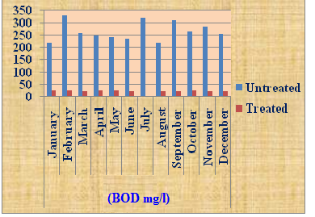
F
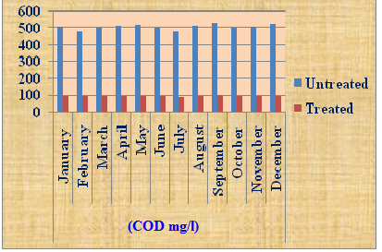
G
Fig.1- Graphs A to G showing physico-chemical parameters variation in the untreated and treated effluent of Shivam Automobile (A, B, C, D, E, F, G).

Biological oxygen demand is an important parameter, which is widely used to determine the pollution load of sewage, effluent water. In the present investigation the mean value for individual observation for BOD of untreated effluent was between 220.00mg/l to 330.00mg/l in the month of January and February respectively, the lowest and highest value recorded and the mean value for BOD of treated effluent was between 20.00mg/l to 25.00.00mg/l in the month of November and April, respectively the lowest and highest value was recorded. In the present investigation the lowest mean value for individual observation for COD of untreated effluent was between 480mg/l in the month of February and July and highest value 530mg/l in the month of September and the mean value for BOD of treated effluent was between 89.00mg/l to 96.00.00mg/l in the month of July and September, respectively the lowest and highest value was recorded. Tripathi et.al (2008) studied the physicochemical parameters of effluents and pointed out that level of BOD and COD in the effluent. Kumar et. al. (2010) also studied the industrial effluents and impacts on a water body and find out that the effluent certainly degrading the water quality of river

Acknowledgments
The authors are grateful to the Indian Academy of Environmental Sciences, Haridwar for laboratory facilities as well as financial support during the study.

Corresponding author
Sushil Bhadula
Research scholar
Department of Zoology and Environmental Sciences
Gurukula Kangri University,
Haridwar-2494 04
sushil86.ntl@gmai.com
Mob: +91-9027571658

References
- Trivedi, R.C. water quality of Ganga river- an overview. Aquatic Ecosystem Health & Management, 2010. 13 (4): 347-351.
- Tripathi, S., Pandey, G.C., Singh, C.S. and Srivastava, S.K. Physico-chemical analysis of effluents of Narang distillery, Nawabganj, Gonda. J. Env. Bio. Sci. 2008. 22(1): 25-29.
- Gleick, P. H. Dirty Water: Estimated Deaths from Water-Related Diseases 2000-2020Pacific Institute for Studies in Development, Environment, and Security www.pacinst.org. 2002. page 2/12.
- Joshi, B.D. & Bisht, R.C.S. Seasonal Variation in the Physico-Chemical Characteristics of a sewage drain at Jwalapur, Hardwar. Him. J. Env. Zool. 1993.7: 83-90.
- Siddamallayya, N. & Pratima, M. Impact of domestic sewage on fresh water body..J. Environ.l Biol. 2008. 29 (3): 303-308.
- Sheyla, R.M.C., Hamada, N., Sergio, L.B.L., Forsberg, B,R. & Pimentel, T.P. Deforestation and sewage effect on aquatic macro invertebrates in urban stream in Manaus, Amazonas, Brazil. Hydrobiologia. 2007. 575: 271-284.
- Ogunfowokan, A.O., Okoh, E.K., Adenuga, A. A. & Asubiojo, O.I. An Assessment of the impact of point source pollution from a University Sewage Treatment Oxidation pond on a Receiving Stream- A preliminary Study. J. Applied Science 2005. 5(1): 36-43.
- Baskaran, P.P. & Britto, A.J.D. Impact of industrial effluents and sewage on river Thamirabarani and its concerns. Bioresearch Bulletin 2010. 1: 16-18.
- Bhadula, S. and Joshi, B.D. An Assessment of the impact of sewer drains on the main canal of River Ganga, within Haridwar city, Uttarakhand, India. Researcher. 2012. 4(1):7-14.
- APHA. Standard methods for the examination of the water and waste water. American Public Health Association, 1995. New York.
- Trivedi, R.K. and Goel, P.K. In: Chemical and biological methods for water pollution Studies. 1986. Environmental publication karad.
- Moorthi, P.S., Deecaraman, M. and Kalaichelvan, P.T. Bioremediation of Automobile oil effluent by Pseudomonas Sp. Advanced Bioech. 2008. 34-37. www.Isin.In.
- Scottish Environment Protection Agency. In: Prevention Guidelines Vehicle Washing and Cleaning: 2007. 1-13.
- Kumar, P., Kumar, S. and Agarwal, A. : Impact of industrial effluents on water quality of Behgul River at Bareilly. Ad. Bio. Res. 2010. 1(2): 127-130.
- Shyam, R., Joshi, B.D. & Bhatt, D. A random study of some physico-chemical parameters of effluents at ETP of Rampur distillery. Him. J .Env. Zool. 2005. 19(2):199-202.
- Deepali, Joshi, B.D. & Gangwar, K.K. Assessment of Heavy metals status in effluent ofa textile industry at Hardwar. J. Env. Biosci. 2009. 23:29- 31.

5/12/2012

