Lead, zinc and strontium distribution in the oxidation zone, wadi abu ghorban Deposits, Red Sea Coastal Zone, Egypt.

Sayed M. Sakr

Al- Azhar University, Faculty of Science, Geology Department
sayedsk2000@yahoo.com

Abstract: the lead, zinc and strontium distribution in the oxidation zone of miocene sulphide mineralization occurs at abu ghorban area, red sea coastal zone of egypt was studied. The sulphide ore body is recorded in sandy limestone, consists of argillic–dolomite breccias surrounded by abu dabbab miocene formation. The primary recorded ore minerals are galena (pbs), sphalerite (zns) and celestite srso_{4.} Supergene minerals are cerussite [pb (co)₃], shannonite [pb₂oco₃], lanarkite [pb₂(so₄)o], lead oxide sulphate [pbso₄.pbo], lead silicate hydroxides [pb₁₀(si₂o₇)₃(oh)₂], smithite [agass2], embolite [ag (br, cl)], smithonite [znco₃], hemimorphite [zn₄si₂o₇(oh)₂.h₂o], zinc sulphite [znso₃], zinc chromium oxides [zncr₂o₄], and strontium dolomite [mgsr(co₃)]. Principal gangue minerals are calcite, dolomite (occasionally smoky), ankerite and quartz. The highest contents of pb (up to 1270 ppm), zn (up to 3400 ppm) and mo (up to 200 ppm) are recorded in the rocks of the fault zone. High content of both pb and mo is recorded in the overburden located nearby the fault zone as well. The bed rock chemical analysis indicates presence of cu (up to 219 ppm), pb (up to 82 ppm), zn (up to 699 ppm) and sr (up to 9932 ppm) reflecting presence of disseminated ore minerals. Moreover, these ore minerals and element distribution favour that, this oxidized mineralized zone represents an upper zone of a deposit. Its lower zone chiefly sphalerite can be expected at deeper level. Lithogeochemical studies to re-evaluate the perspectives of abu ghorban deposit are recommended by drilling to reach its lower zone.
[Sayed M. Sakr. Lead, Zinc and Strontium Distribution in the Oxidation Zone, Wadi Abu Ghorban Deposits, Red Sea Coastal Zone, Egypt. N Y Sci J 2013;6(1):107-117]. (ISSN: 1554-0200). http://www.sciencepub.net/newyork. 17

Keywords: Wadi Abu Ghorban, Mineralogy, Geochemistry, Sulphides mineralization, Oxidation zones.

Introduction
Lead zinc mineralization in the Red Sea coastal zone occurs in 9 localities (Fig. 1a). Hassaan⁽¹¹⁾ presented aspects of the mineral and chemical composition of these deposits, their mode of occurrence, factors controlling their localization and distribution, the genesis of the mineralization and guidelines for mineral exploration. The regional zoning pattern exhibited the hydrothermal origin of iron-manganese, copper and lead-zinc mineralization in the Red Sea coastal zone. Besides, the factors influencing the localization of the major deposits in its present position in the Miocene formations may be used as guide for future exploration in the area. In particular, outcrops of Miocene Abu Dabbab and Essel formations cut by NW- trending faults located between Wadi (W.) Sharm El Bahary in the north and W. Abu Ghorban in the south are considered the most promising localities for lead-zinc deposits⁽¹¹⁾. Consequently, the present article is established to outline the ore minerals and distribution of Pb, Zn and Sr in the oxidation zone of W. Abu Ghorban mineralization (Fig. 1b).
Wadi Abu Ghorban is located in the Red Sea coastal zone, 55 km south of Quseir, 6.5 km SW of the bay of Marsa Um Gheig about 3 km to the east of Um Gheig Pb-Zn mine. The downstream of W. Abu Ghorban is located at about 3 km from that of W. Um Gheig. The studied locality occupies about 6 km² as narrow belt (1-4 km) striking NW. It is covered with Miocene clastic, carbonate and evaporite sediments occasionally to the east capped with recent terrace deposits. These sediments rest with sharp angular dis-conformity upon the Precambrian basement rocks that, exposed to the east of the occurrence. The elevation of these outcrops decrease generally towards the east till the present shore line, whereas, the most conspicuous hill rises up to 207 m above sea level. In this province, arid climate conditions are prevailing where; the annual ranges of temperature are 36-18ºc in winter and 60-40ºc in summer. The day-night temperature drops in night to 10ºc. Low sediments reworking is manifested due to lack of rain fall precipitation. The precipitation usually takes place once in several years in form of short lived torrents.
Most of the previous studies consider the lead-zinc deposits along the Red sea coast to be of hydrothermal origin (8, 20, 9, 17, 19, 2, 7, 16, 10 & 11). Hassaan⁽¹¹⁾, verified the hydrothermal origin of the lead zinc sulphide mineralization in the Red Sea coastal zone based on their mode of occurrence, the litho-structural controlling factors in its present position, the conspicuous wall rock alteration (Smoky dolomite), the associated elements and the vertical and lateral local zoning controlling Pb, Zn and Fe distribution. In this respect, the ore deposits are pitches and flats, gash veins and disseminations⁽¹¹⁾ and are not bedded⁽¹¹⁾. Moreover, Sabet et al., ⁽¹⁶⁾ supported the hydrothermal metasomatic origin hypo- thesis⁽¹⁴⁾ of the Red Sea Pb-Zn mineralization affected by low temperature solution.
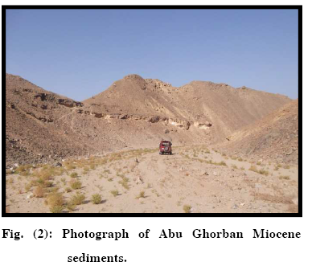
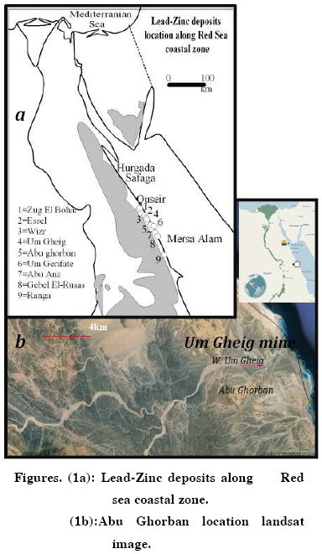

Methods of study
Field work consisted of sampling surface sections (viz; bed rock and detrital overburden samples) along profiles traversing the fault and fault zone, adits and pits to cover the zone of mineralization in W. Abu Ghorban. A total of 66 samples were collected. Laboratory work included thin sections and polished thin sections examination (viz; 30 sections) in both refracted and reflected polarized light. A total of 7 oxidized and disseminated ore containing bed rock samples were submitted for X-ray diffraction analysis. The X-ray diffraction (XRD) analysis was carried out using the Panalytical X'Pert pro (2009 model & date up to 2011) with Cu tube and Ni filter starting [°2Th.] At 4.01 and ended at 89.99 position with step size 0.02 at the Lab. Of Petroleum Research Center. Moreover, to achieve the chief goal of this study, a total of 23 bed rock samples were analyzed for Pb, Zn, Sr and associated ore elements using X Ray Fluorescence (XRF) technique. Furthermore, 30 detrital overburden samples and 13 mineralized samples were analyzed for both Pb and Zn ore element using atomic absorption (A.A.). The chemical analyses were done in the Nuclear Material Authority using XRF and Atomic Absorption instruments. The XRF accuracy of the analyses was checked by running a number of international standard reference samples as unknowns and comparing the analytical results with stated reference values. The Calibration of A.A. is performed using calibration solutions at five different levels with international standard reference. The quality control measures such as stability, sensitivity and resolution check using an optimization solution prior to analysis were taken. Using the graphical method⁽¹³⁾, the systematic and random errors for the used instruments is considered permissible.

Lithostratigraphy
At Wadi Abu Ghorban, the Pb-Zn mineral deposit is hosted in lithological units of Miocene age ^{(6, 11)}). The Miocene and younger sediments in Wadi Abu Ghorban exhibit marked lithological change laterally and vertically (Fig. 2). They rest dis-conformably and with a depositional dip on older rocks.
The beds of Miocene and later sediments along the Red Sea coast formed the subject of classical work of Beadnell⁽¹⁾ and Cox⁽⁵⁾. The more recent workers classified these sediments into formations and members, the most recent of which are those given in Table (1) after Said⁽¹⁸⁾ for the region south W. Um Gheig and Hassaan⁽¹¹⁾ for the region from Ras Benas to Esh el Mellaha range. In Wadi Abu Ghorban, the rock units exposed shown in figure (3) are from base to top: Late

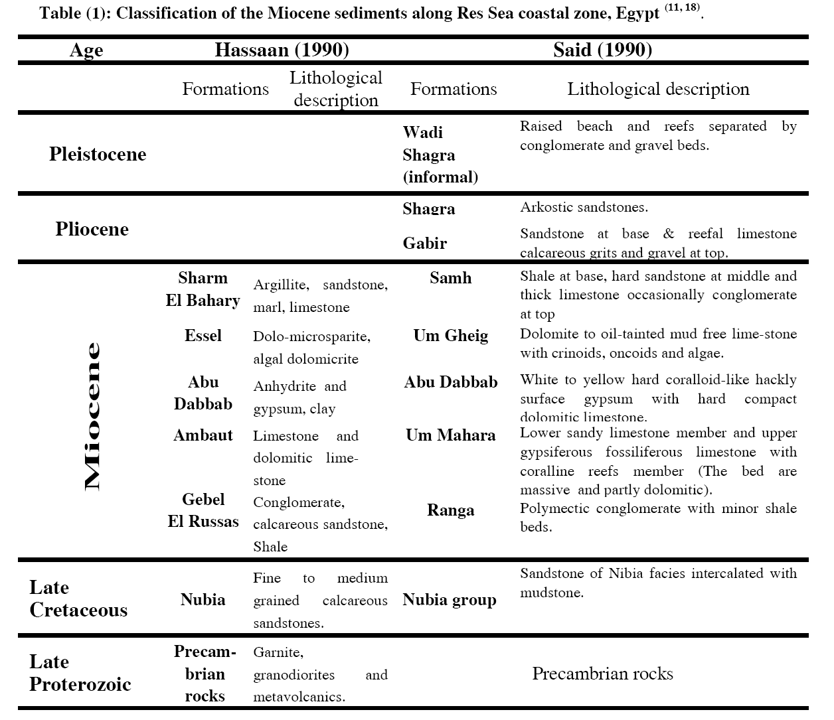
Proterozoic igneous and metamorphic rocks, Gebel el Rusas Formation (Fm.), Ambaut Fm., Abu Dabbab Fm., Sharm el Bahary Fm. And undifferentiated Neogene - Quaternary deposits. The rock types of each formation are given in Table (1).
The Mineralization
The central part of Abu Ghorban Pb-Zn occurrence has the coordinates, Lat. 25°41´40" N and Long. 34° 29´ 20" E. Abu Ghorban Pb-Zn occurrence is mainly function in lithological and structural factors. This mineralization is confined to the NW strike zones of faults and joints, whereas the highest mineralization is obviously outcropping in the intersecting zones of NW and sub-latitudinal faults. However, along with the structural controlling factor, the lithology played an important role in the Pb-Zn accumulation and concentration in its present position. Lead-zinc mineralization exists in calcareous rock units (clayey limestone and sandy limestones) this is probably due to their chemical activity with
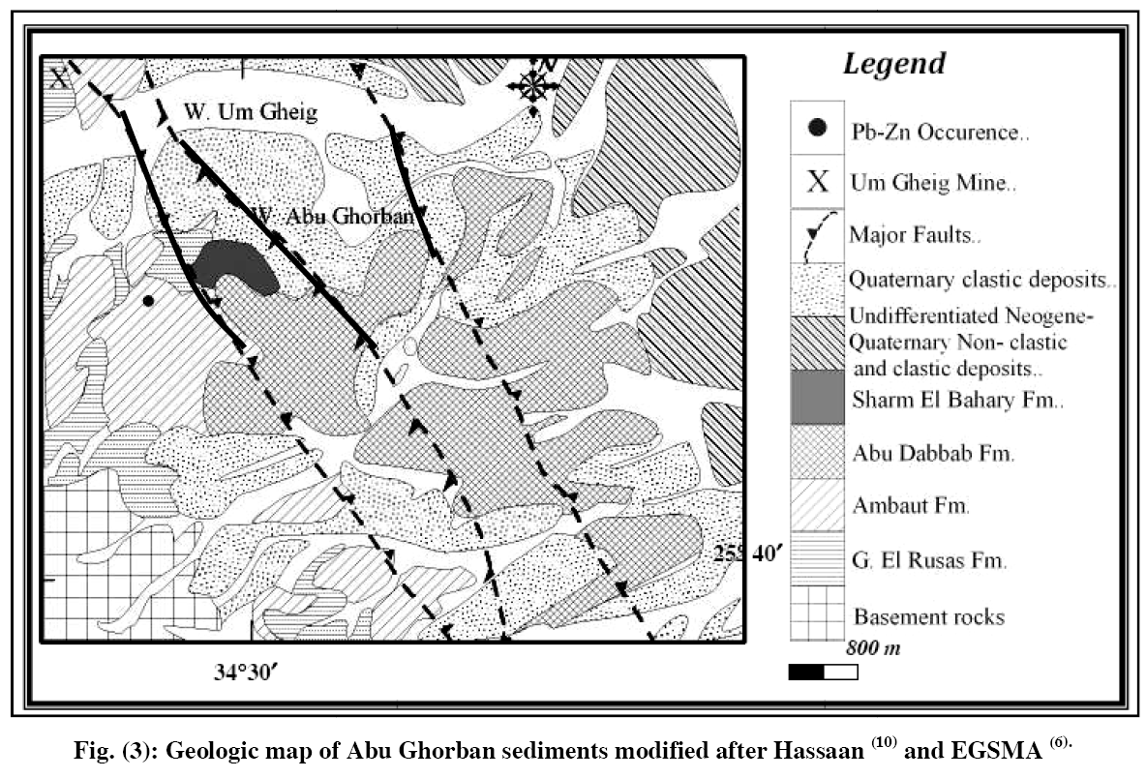
the Pb-Zn bearing hydrothermal solutions. Meanwhile, the Pb-Zn mineralization in the oxidation zone is marked with limonitization and hematization. Meantime, this mineralization in oxidation zone extends for ~ 120 m length and ~10m width and occurs as thick nests of Pb and Zn secondary minerals as well as hydroxides of Fe and Mn. The sulphide ore body is recorded in sandy limestones consists of argillic–dolomite breccias surrounded by Abu Dabbab formation, which forms the hanging wall of the deposit, and rimmed by marl rock units.
Celestite occurrence is located on the right bank of the upper reaches of Wadi Abu Ghorban, seven kms from the seashore and around 800 m to the south of Abu Ghorban Pb-Zn occurrence. The central part of the locality has the following coordinates, Lat. 25°41´10" N and Long. 34° 29´ 20" E. The outcrops in the occurrence area comprise clastic-carbonate-evaporite Miocene deposits (Fig. 4a). Meanwhile, celestite mineralization is recorded within the fracture zone striking NW, confined to brecciated limestones (Fig. 4b) of Ambaut Fm. And hematized evaporite deposits of Abu Dabbab Fm. The NW fracture zone consists chiefly of brecciated variegated (owing to presence of lead, zinc and iron oxides, Fig (5) or bleached limestone, argillite and quartz fragments occasionally observed in the zone. Further celestite mineral is also detected within the fracture zone of bituminous limestone that, adjacent and rest onto granitoid rocks. The genesis of the ore is vague. The preliminary results of prospecting
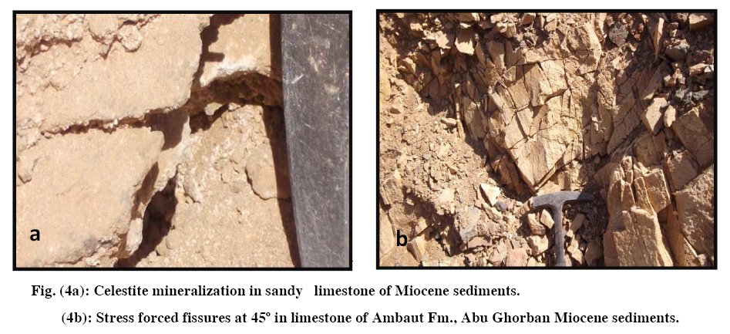
May give evidence to a type of strontium mineralization re-deposited by low temperature hydrothermal solution in its present position. Yet celestite was also present disseminated in high-porous and permeable sandstones and brecciated unaltered limestones, this may indicate a sedimentary digenetic type of strontium mineralization. It should also be mentioned that, celestite concentrations are met with close to the contact between the basal clastic-carbonate and evaporite beds, forming pitchs and flat mode of occurrence. Consequently, the celestite concentration is probably controlled by lithstratigraphic and structural factors as the case is with the Red Sea belt polymetallic mineralization^{(6).}. The results obtained by studying the thin polished sections of both transparent and opaque minerals in refracted (Figs. 6-10) and reflected (Figs. 11-16) light that assured using XRD analysis (Figs. 17a to 17f) reveal presence of galena (pbs), sphalerite (zns) and celestite srso₄. Oxidized ores are defined as a type of ores in which over 30% of Pb and Zn occur in combination with O₂ as minerals of carbonates, oxides, beside sulphides⁽⁴⁾. The specificity of these oxidation zones is conditioned by active sulphides oxidation processes which cause creation of aggressive sulfuric solutions (to ph under 1⁽¹⁵⁾). Acid rains are of great importance in ore minerals and non-metallic minerals transformation in technogenic landscapes. Nitrogen oxides NO x (to 30-50%) contained in acid precipitation and products of their interaction with water act as catalysis in the process of ore minerals oxidation and leaching^{(15).} Above the water level, with constantly changing conditions in the oxidized zone, a large mix of different Pb and Zn and other polymetallic secondary oxidized minerals are recoded, namely; Cerussite [Pb (CO)₃], shannonite [Pb₂OCO₃], lanarkite [Pb₂(SO₄)O], lead oxide sulphate [pbso₄.pbo], lead silicate hydroxides [Pb₁₀(Si₂O₇)₃(OH)₂], smithite [agass2], embolite [Ag(Br,Cl)], smithonite [znco₃], hemimorphite [Zn₄Si₂O₇(OH)₂.H₂O], zinc sulphite [znso₃], zinc chromium oxides [zncr₂o₄], and strontium dolomite [mgsr(CO₃)]. The ore minerals show different
Styles particularly impregnation in dolomitic limestone, cement of breccias, replacement ore and open space filling in the dissolution cavities and fractures. Principal recorded gangue minerals are calcite, dolomite, ankerite and quartz. The ore minerals that are hosted by the Miocene carbonate rocks show hydrothermal dolomitization, dissolution and brecciation⁽¹¹⁾. A regular decrease in the primary ore mineral in the mineralized rock samples is manifested with the general trend of decreasing hematiztion of the host rocks (viz; limonte and hematite) and dolomitization (viz; smoky dolomite).

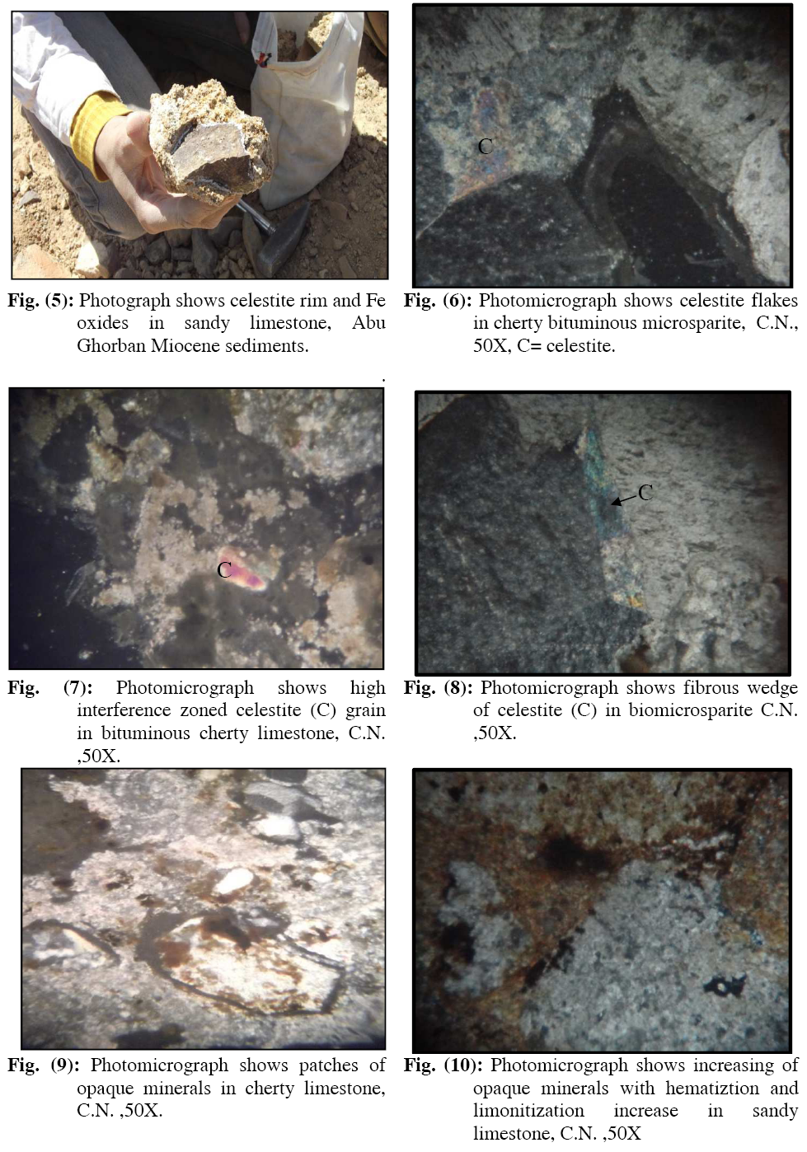

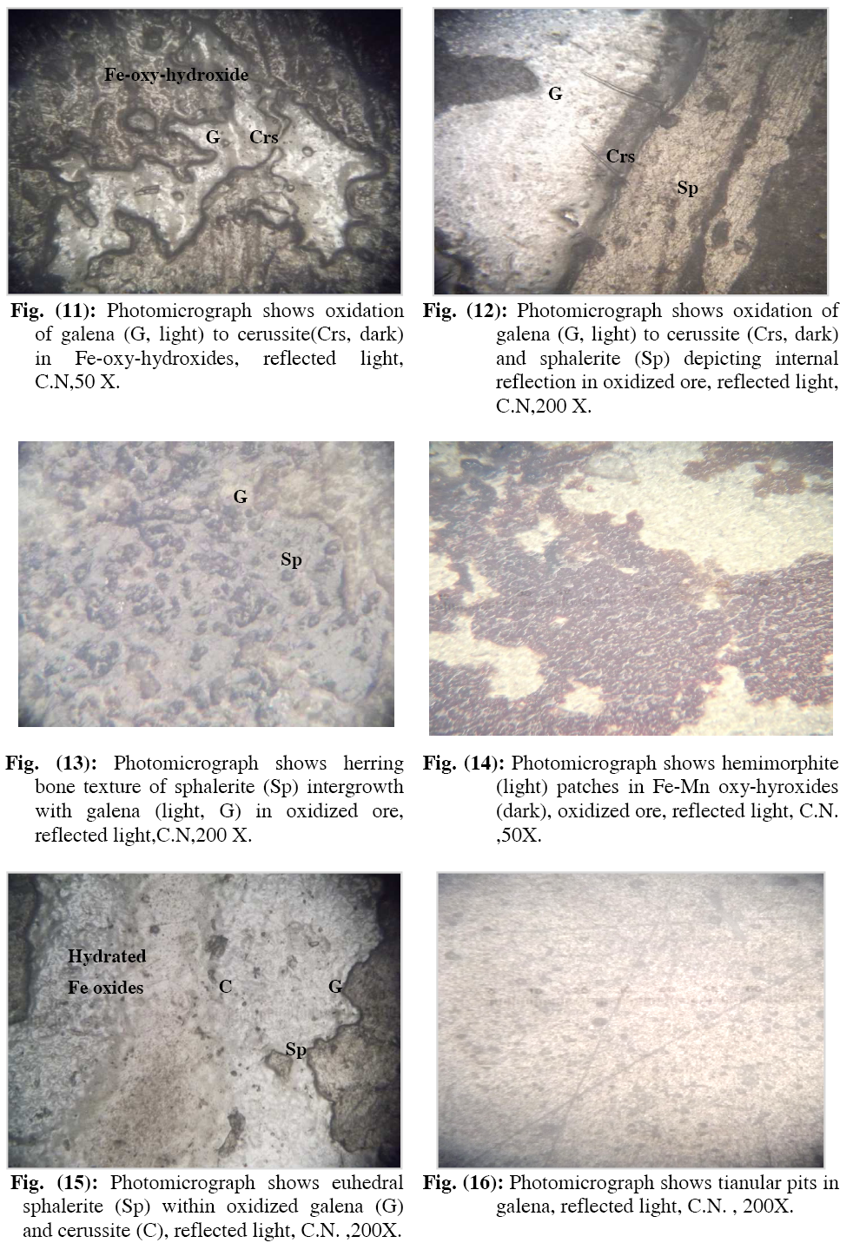

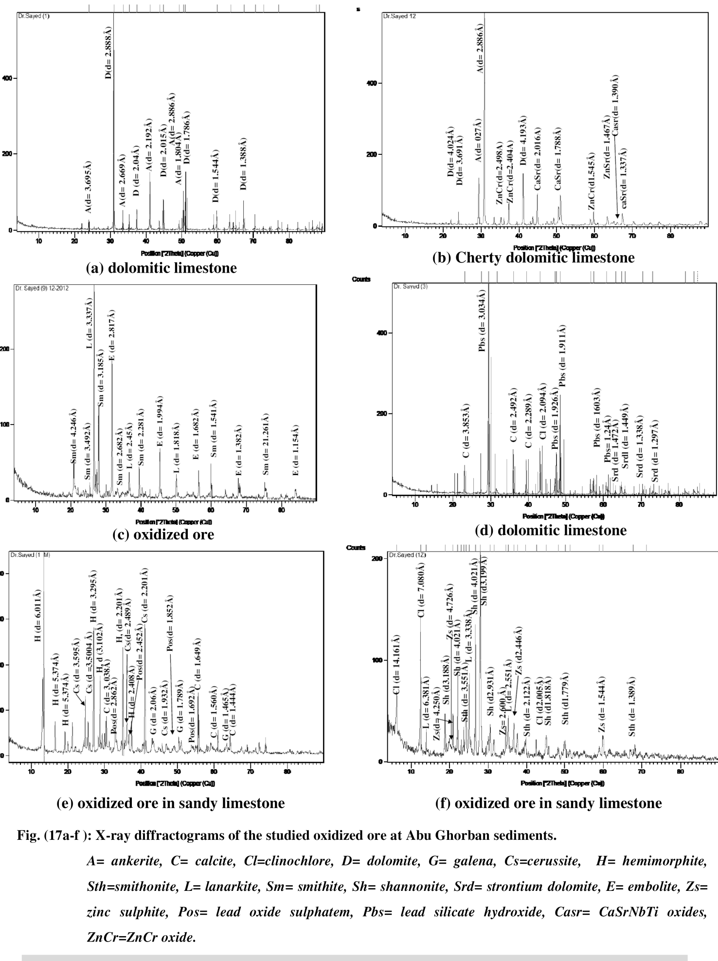

Cerussite [pbco₃], and shannonite [Pb₂OCO₃], are lead carbonate minerals, usually found in the upper oxidized zone of lead ore deposits. It is a very common weathering product of galena and other lead ore minerals. Because of the weak mobility of Pb ion, there is a possibility of the development of Pb carbonates during the initial phase of oxidation. This occurs because of the influence of acidic solutions that allow the oxidation of Pb⁺² ions. Cerussite ores are characterized by a high content of non-oxidized galena (up to 26% of Pb content) and silver⁽³⁾. Moreover, Smithonite [znco₃] is often found as a secondary mineral in the oxidation zone of zinc ore deposits. It can also be observed in sedimentary deposits and as a direct oxidation product of sphalerite.
Thirteen analyses that collected from 3 adits in the site of the mine recorded Pb, Zn and Mo (Table, 2). From the table it is obvious that, the Pb is in range from 1270 to 280 ppm. The highest content of Pb is recorded in adit III, where rocks are traversed by the fault zone, while in adit II, far from the fault zone, Pb exhibits lower content. Zinc and Mo distribution behaves similar to Pb, where Zn content ranges from 3400 to 480 ppm while Mo from About 200 to 20 ppm. The highest content of both Zn and Mo is recorded also in adit III representing the fault zone. Zn content is much lower in adit II and adit I compared to its content in adit III, while Mo exhibits similar behavior in the oxidation zone of adits II and I. This distribution is related to the difference in mobility of the 3 elements in the oxidation zone, where Zn is more mobile than Pb. Meanwhile Mo distribution is related to that of Pb. Galena and sphalerite are recorded in the studied samples, beside cerussite, smithonite and hemimorphite. Such results reflect the difference of mobility of these elements. This difference in distribution is manifested by the 30 analyses of overburden (Table 3) collected along profile perpendicular to the fault zone accumulated at the foot of the slope of the oxidation zone. In this respect, Zn reaches up to 1000 ppm and Pb up to 250 ppm. However, high Pb and Zn contents are recorded in two samples representing a site of accumulation of transported overburden of the fault zone weathering products. In this respect the hematization in the fault zone is characterized by hydrate Fe and Mn oxides. The highest anomalous content of both Pb and Mo is recorded in the overburden located nearby the fault zone. The limestone of Ambaut Formation is considered by⁽¹¹⁾, as the capping rock of Pb-Zn sulphide. Such rock unit is considered unfavorable for Pb and Zn
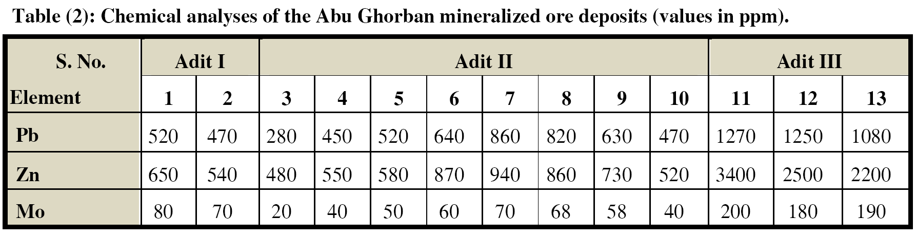
Accumulation due to its low permeability and porosity compared to sandy limestone and calcareous sandstones. The accumulation and localization of the sulphide ore minerals and Celestite along the fault zone in cherty limestone is attributed to its low porosity, low permeability and compactness, forming pitch and flat modes. The recorded zoning sequence from the deeper level to the top and lateral zoning along extension of the ore body of Um Gheig⁽¹¹⁾ is Fe, followed by Zn, followed by Pb. The analyses representing the oxidized mineral-ization zone show predominant Zn content compared to that of Pb. This most probably reflects that, the studied oxidized mineralized zone represents an intermediate zone of Abu Ghorban deposit. This zone is a mixed zone of the lower and the upper zones of both Pb and Zn. Moreover, the recorded smithite and embolite which are low temperature silver arsenic sulphide and Ag bromide chloride minerals support such interpretation as well. Moreover, these minerals favour that, this oxidized mineralized zone represents an upper part of a deposits, its lower part chiefly sphalerite at deeper level can be expected. Twenty three XRF analyses of the bed rocks indicated presence of Cu (up to 219 ppm), Pb (up to 82 ppm), Sr (up to 9932 ppm) and Zn (up to 699 ppm). These values may reflect presence of disseminated ore minerals.

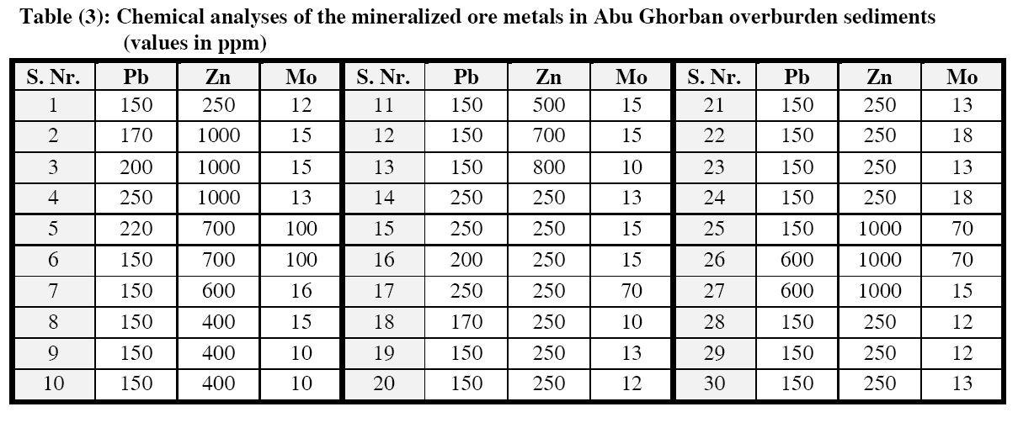

Conclusions
- The primary recorded ore minerals are galena (pbs), sphalerite (zns) and celestite srso_{4.} The supergene minerals are cerussite [Pb (CO)₃], Shannonite [Pb₂OCO₃], Lanarkite [Pb₂(SO₄)O], lead oxide sulphate [pbso₄.pbo], Lead silicate hydroxides [Pb₁₀(Si₂O₇)₃(OH)₂], smithite [agass₂], embolite [Ag Br Cl], smithonite [znco₃], hemimorphite [Zn₄Si₂O₇(OH)₂.H₂O], zinc sulphite [znso₃], zinc chromium oxides [zncr₂o₄], strontium dolomite [mgsr(CO₃)] and strontium sulphite. Principal gangue minerals are calcite, dolomite, ankerite and quartz.
- The mineralized zone show hydrothermal dolomitization, dissolution and brecciation. A regular decrease in the primary ore mineral in the mineralized zone rock samples is manifested with the general trend of hematization (limonite and hematite) and dolomitization (smoky dolomite) of the host rocks.
- In the site of the mineralized zone diverse distribution patterns of Pb, Zn and Mo is recorded. The highest contents of Pb (up to 1270 ppm) , Zn (up to 3400 ppm) and Mo (up to 200 ppm) are recorded at the contact with the fault plane. Such results are related to the different mobility of the three elements and the litho-structural effect of the host rocks.
- High contents of both Zn and Mo and to less extent to Pb are recorded in the overburden located nearby the fault zone as well.
- The presence of anomalous Cu, Pb, Sr and Zn in the bed rocks reflects probable presence of disseminated ore minerals.
- The localization of the deposit along the fault zone is attributed to low porosity, low permeability and compactness of cherty limestone. Moreover, the mode of occurrence of both Pb-Zn and celestite deposits as pich and flat is related to the same reason.
- The recorded smithite and embolite which are low temperature silver minerals favour that, this oxidized mineralizion represents an upper part of sulphide deposit where at deeper level sphalerite zone could be expected.

Lithogeochemical studies to re-evaluate the perspectives of Abu Ghorban deposit are recommended by drilling to reach the deeper levels.

Acknowledgment:
The author is deeply indebted to Prof. Dr. M.M. Hassaan, Al-Azhar University, for valuable advises, continuous help in interpretation of the results and effective suggestions and criticism of the manuscript. The author would like to convey sincere thanks and extreme appreciation to Prof. Dr. M. M. Ali and Prof. Dr. A. El-Afandy, President and Vice-president of the Egyptian NMA respectively, for the help offered to analyze the samples, supporting, and continuous encouragement.

References
- Beadnell, H.J.L., (1924): Report on the geology of the Red Sea Coast between Qoseir and Wadi Ranga. Petrol. Bull., No. 13, Government Press, Cairo.
- Bissada, N.A., (1970): Contributions to the mineralogy and geochemistry of Miocene lead-zinc deposits U.A.R.; M.Sc. Thesis, Cairo Univ., 114 p.
- Cabala, J, (1996): Occurrence of cerussite and oxidation degree of Pb sulphides in zn-Pb ores of Oklsz-zawiercie area, 230, Nr. 1335, p.223-242.
- Cabala, J, (2001): development of oxidation in Pb-Zn deposits in Olkusz area, In; Mineral deposits at the beginning of the 21st Century, Balkema, p.121-124.
- Cox L.R. (1929): Notes on the post Miocene Ostreidae and Pectinides of the Red Sea region with remarks on the geological significance of their distribution. Pp. 165-209, London.
- EGSAMA / Sibai Party (1974): On the result of prospecting work for rare and non-ferrous metals and gold in the area of wadies Um Gheig, Sitra, El Dabbah and Abu tundub conducted by Sibai party 4/73 during 1973-1974. EGSMA. Internal report.
- El-Kholy, S.B., Hashad, AH. & Selim, E.T.M., (1970): Lead isotopes and trace elements in some Miocene Red Sea galenas; Pure Appi. Geophys. 81, 135-150.
- El-Shazly, E.M., (1959): Controls of Tertiary ore deposition in Egypt; Chron. Mines Outre-Mer Rech. Min., No. 275, 139-146.
- Gindy, A.R., (1961): Radioactivity and Tertiary volcanic activity in Egypt; Econ. Geol., 56, 557-568.
- Hassaan M.M. (1974): Geochemical methods of prospecting for Lead-Zinc deposits in Eastern Desert of Egypt, Ph. D. Dissertation, Leningrad, Mining Institute, Leningrad, USSR, 150.
- Hassaan M.M. (1990): Studies on lead zinc sulphide mineralization in the Red Sea coastal zone, Egypt: Proc. 8th Symp. IGADO, Otowa, Canada, pp. 835-847.
- Kotchin, G.G., Bassyoni, F.A., Abdel Aziz, A.T., Shalaby, T.M. & El-Hammady, M.Y., (1970): Lead-zinc mineralization of the Red Sea coast; in Studies on Some Mineral Deposits of Egypt; Egypt. Geol. Surv.,38-42.
- Kvyatkovskiy, E.M., Kritsuk, I.N., Nuoppenen, T.I. & Omeltchenko, M.M., (1973): Geochemical Methods of Prospecting; Leningrad Min. Inst., 186 p. (in Russian).
- Maric, L., Jurkovic, J., Galvic, S., and Zalocar, b., (1959): Report on Pb and Zn ore exploration of Abu Anz area, quseir district, Red Sea coat, Egypt given in Sabet et al., (1976).
- Pavliukova, V. A., and Markovich, T. I, (2006): geochemical processes occurring in cryogenic zones of sulphide deposits oxidation assisted by nitrogen compound. Chemistry of sustainable development 14, 83-86.
- Sabet, A.M., Tsogoev, V.B., Bordonosov, V.P., Beloshitsky, V.A., Kuznetsov, D.N. & Hakim, H.A., (1976): On some geological and structural peculiarities of localization of the polymetal mineralization in the Middle Miocene sediments along the Red Sea Coast; Ann. Geol. Surv. Egypt, 6, 223-236.
- Said, R., (1962): The Geology of Egypt; Elsevier, 377 p.
- Said, R. (1990): Red Sea caostal plain In: Said, R. (Ed.), The Geology of Egypt. Balkema, Rotterdam, pp. 345–359.
- Soliman, S.M. & Hassaan, M.M., (1969): Contributions to the geology and geochemistry of the lead-zinc and sullur deposits of Gebel El Rousas, Anz and Ranga localities, Eastern Desert., Egypt; Proc. 6th Arab Sci. Cong., Damascus, 415, 591-660.
- Soliman, S.M., (1961): Geology of the manganese deposits of Um Bogma, Sinai and its position in die African manganese production; Genre. Organ. Iron &Steel, 1st Iron &. Steel Congr. Cairo, p. 22.

12/11/2012

