Lead Nitrate Induced Basic Amino Acid Alterations In Liver Of Albino Rats: Chromatographic Studies.

Shabnum Nabi

Interdisciplinary Brain Research Centre
Jawaharlal Nehru Medical College, Aligarh Muslim University, Aligarh, U.P.
shabnum_nabi@yahoo.com

Abstract: Lead is one of the most toxic metals that pollute the natural environment due to human interference and exploitation of nature. As lead cannot be degraded, it accumulates in the atmosphere, water, food and in organisms living in contaminated areas. In an attempt to study the mechanism of its toxicity, the present experiment was designed to assess the effects of lead nitrate on lysine, arginine and histidine in liver cells of rats. For the present work, six male wistar rats (3months old) were divided into saline controls(C) and lead nitrate treated group (LN). Treated rats were intoxicated with LN at a dose of 1mgkg body weight intraperitonially once a day for seven consecutive days at an interval of 24hours while control animals received a corresponding volume of isotonic saline. Health and weights of rats were monitored daily. All the animals were sacrificed on 8th day following the last exposure. Three paper strips were taken on which nine spots were placed and the results revealed absence of Arginine in T2 treated liver homogenate, Histidine was absent in T1 and T3 liver homogenate, while Lysine was found absent in all the three homogenates (T1, T2, T3) on comparing with control rats. In summary, depletion of basic amino acids in liver cells during lead nitrate intoxication support the hypothesis that their decline leads to early ageing and growth retardation in experimental animals.
[Shabnum Nabi. Lead Nitrate Induced Basic Amino Acid Alterations In Liver Of Albino Rats: Chromatographic Studies. N Y Sci J 2014;7(4):32-35]. (ISSN: 1554-0200). http://www.sciencepub.net/newyork. 6

Keywords: Lead nitrate, Lysine, Arginine, Histidine, Liver, Rat

1. Introduction
Lead has been recognized as a poison from ancient times to the present (Cantarow and Trumper, 1944 and Oliver, 1914). Recently, attention has been focused on the subtle effects of environmental exposure at levels presently considered normal in our industrialized age (Needleman, 1980; Needleman, 1992; Mahaffey, 1985; Landsdown and Yule, 1986; Rutter and Russell, 1983 and A.S.T.D.R., 1988).The recognition that lead produces intellectual impairment in children, as well as other health effects, has resulted in the progressive tightening of the regulation of the uses of lead in the United States and other countries, including the phase out of lead from gasoline (U.S. Environmental Protection Agency, 1984), a decrease in the amount of lead allowable in drinking water, and abatement of lead from buildings contaminated with lead paint.
Although lead is a common element in the earth’s crust, its ubiquitous presence in bioavailable forms in the environment is due largely to the activities of humans (Smith, 1986 and Lin-Fu, 1985). The industrial revolution and the addition of lead to gasoline in the 1920s have resulted in dramatic increases in environmental lead levels (Elias and Hirao, 1975 and Mushak, 1992). Present environmental levels are estimated to be several orders of magnitude above preindustrial levels (National Academy of Sciences, 1980). The body burden of lead in human bones is presently 500-fold greater than in prehistoric times, and the present day diet of Americans contains 100 times more lead than prehistoric diets (National Academy of Sciences, 1980).
The aim of the present investigation is to check the effects of lead nitrate on basic amino acids in the liver cells of rats. In addition, aim was to find out the most affected amino acid from lead nitrate.

2. Material and Methods
Six male albino rats (Rattus norvegicus) of the wistar strain (3months old) weighing 200±20g were obtained from the central animal breeding house, J. N. Medical College, A. M. U., Aligarh and were housed in polyethylene plastic cages with paper cutting as bedding and open wire tops. Three animals were housed per cage. Rats were fed rat chow for 7 days of acclimation. Rats were randomly segregated into two weight-matched groups. Rats were provided with tap water and their designated diets supplied ad libitum. Treated groups were housed in an animal facility with ambient room temperature maintained at 24±2ºC, humidity 50±5% with a 12-h light/12-h dark cycle. Rat health and body weights were assessed daily throughout the study. Animals were used according to the guidelines of the committee on care and use of experimental animal resources. The ethics protocol was approved by the laboratory animals’ maintenance and usage committee of J. N. Medical College, A. M. U., Aligarh.
Preparation of tissue homogenate
At the end of experimental period, rats were deprived of food for 24h. Animals were sacrificed by decapitation without using anesthesia on the scheduled day between 10:30-11:30am. Liver was immediately dissected out and washed with chilled saline (4ºC), thawed and homogenized with homogenizer in a proportion of 1:10w/v ice-cold phosphate buffer (50mM; pH 7.4). Aliquotes of homogenates were used to detect the basic amino acid levels by paper chromatography technique.
3. Results
The results of present work are based on the comparative account of amino acids in unknown mixtures in the form of liver homogenates, three controls and another three treated with lead nitrate against three basic amino acid standards.
In the present experiment, three paper strips were taken on which nine spots were placed. On first strip (Photograph 1), 3spots of basic amino acids were mounted, on second strip (photograph 2), 3 spots of treated liver homogenates were placed and on third strip (photograph 2), 3 spots of control liver homogenates were spotted. The distance travelled by the standard amino acids against other six homogenates (3 treated and 3 controls) in each of the three strips and the solvent front was calculated.
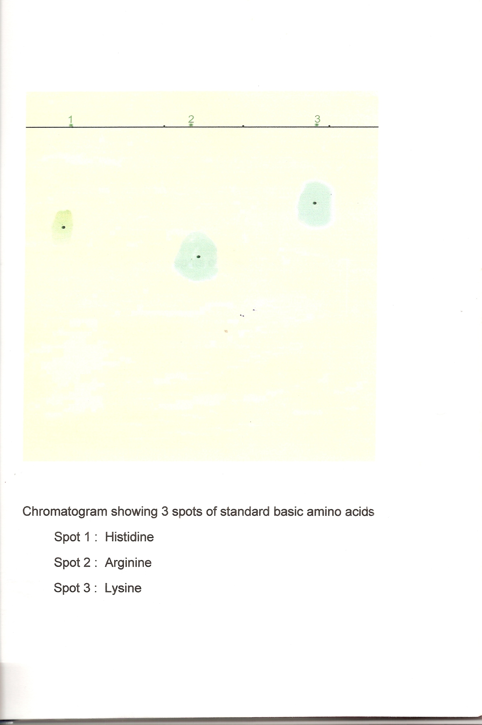

Photograph 1: Paper strip 1 showing spots of basic amino acids
Rf values in paper strip first (A’)
Spot A₁ (AAL- Histidine mono) = 0.35cm
Spot A₂ (AAL-Arginine mono) = 0.81cm
Spot A₃ ₍AAL-Lysine mono) = 0.32cm

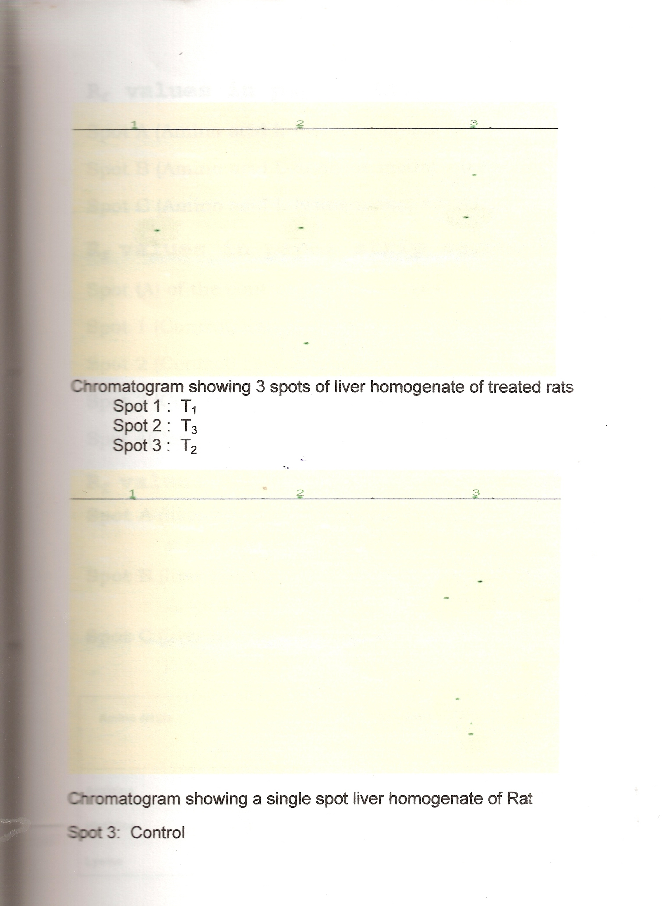
Photograph 2: Paper strip 2 & 3 showing spots of treated and control rats simultaneously.

Rf values in paper strip second (B’)
Spot A₁ of control gave four spots
Spot 1(control) liver homogenate = 0.33cm
Spot 2(control) liver homogenate =0.37cm
Spot 3 (control) liver homogenate =Spot 1 =0.63cm
Spot 2 =0.69cm
Spot (A₂) of control gave two spots
Spot 1 (control) liver homogenate =0.59cm
Spot 2 (control) liver homogenate =0.65cm
Spot (A3) of control gave three spots
Spot 1 (control) liver homogenate =0.35cm
Spot 2 (control) liver homogenate =0.38cm
Spot 3 (control) liver homogenate =0.67cm
Rf values in paper strip third (C’)
Spot A [liver homogenate treated (T1)] =
Spot 1 = 0.56cm, Spot 2 = 0.81cm
Spot B [liver homogenate treated (T2)] =
Spot 1 =0.37cm, Spot 2 =0.45cm
Spot C [liver homogenate treated (T3)] =
Spot 1 =0.61cm, Spot 2 =0.57cm, Spot 3 =0.82cm

Table 1. Variations in basic amino acids in liver cells during lead nitrate intoxication.
AMINOACIDS | Rf values
 | STANDARD | CONTROL |  |  | TREATED
 |  | C1 | C2 | C3 | T1 | T2 | T3
ARGININE | 0.81 | 0.81 | 0.82 | 0.84 | 0.81 | _- | 0.82
HISTIDINE | 0.35 | 0.37 | 0.34 | 0.33 | _- | 0.37 | _-
LYSINE | 0.32 | 0.33 | 0.35 | 0.31 | _- | _- | _-

4. Discussions
The present experiment demonstrated the absence of basic amino acids after chronic low-level exposure to lead in the organs like liver of the rat. It has been reported earlier that heavy metals are involved in varieties of disorders like hypertention, renal and hepatic disorders. Lead is a toxic metal and it is present in various ecosystems like soil, air and water, which are the fundamental necessities of animals and humans. It is further reported that lead modulates many enzymes, disulfhydril status of proteins.
Arginine, a crystalline basic amino acid is obtained from the decomposition of vegetable tissues and proteins. It is a guanidine derivative yielding urea and ornithine on hydrolysis by liver enzyme Arginase. Since Arginine was found absent in one of the treated liver homogenates (T2) and as Arginine gets converted into urea and ornithine, excreated in the form of urine. Therefore, absence of Arginine in the treated rat, may lead to the toxicity of the body and even death of the animal.
The second basic amino acid lysine, a hydrolytic cleavage product of digestive protein, is essential for growth and repair of tissues and its absence may lead to growth retardation and alter tissue repairing.
In the present study, Histidine absence was also observed in two of the three liver homogenates of lead treated animals. this may be because of the effect of lead nitrate on the liver cells of the treated rats which might have changed the conformation of these basic amino acids present in them. Since Histidine is concerned with the enzymatic activity of rat liver malic enzyme during ageing, therefore, absence of Histidine in the treated rats is likely to cause ageing in them.
Hence it is concluded that chronic low level exposure to lead results in conformational changes of basic amino acids in the liver cells of rats leading to early ageing, growth retardation and alter tissue repairing.

Acknowledgements:
Author is grateful to theUniversity Grants Commission, New Delhi for financial support to carry out this work.

Corresponding Author:
Dr. Shabnum Nabi
Department of Zoology
Aligarh Muslim University
Aligarh, Uttarpradesh 202002, India
E-mail: shabnum_nabi@yahoo.com

References
- Cantarow, A. and Trumper, M. Lead poisoning, Baltimore, MD: Williams and Wilkins, 1944.
- Oliver, T. Lead Poisoning, from the Industrial, Medical and Social Points of View. New York: Paul B. Hoeber, 1914.
- Needleman, H.L. Low Level Lead Exposure: the Clinical Implications of Current Research. New York: Raven Press, 1980.
- Needleman, H.L. Human Lead Exposure. Boca Raton, FL: CRC Press, 1992.
- Mahaffey, K.R. Dietary and Environmental Lead: Human Health Effects. New York: Elsevier, 1985.
- Landsdown, R. and Yule, W. Lead Toxicity: History and Environmental Impact. Baltimore, MD: Johns Hopkins University Press, 1986.
- Rutter, M. and Russell, R. Lead vs. Health: Sources and Effects of Low Level Exposure. Chichester: Wiley and Sons, 1983.
- A.S.T.D.R. The Nature and Extent of Lead Poisoning in Children in the United States: A Report to Congress. Atlanta, GA: Agency for Toxic Substances and Disease Registry, 1988.
- U.S. Environmental Protection Agency. Regulation of fuels and fuel additives: lead phase down. Fed. Reg., 49(150):31032-31050(1984).
- Smith, M. Lead in history. In: Lead Toxicity: History and Environmental Impact (Lansdown R, Yule W, eds). Baltimore, MD: Johns Hopkins University Press, 1986; 7-24.
- Lin-Fu, J.S. Historical perspective on health effects of lead. In: Dietary and Environmental Lead: Human Health Effects (Mahaffey KR, ed). New York: Elsevier, 1985; 43-64.
- Elias, R., Hirao, Y & Pattersson, C. Impact of present levels of aerosol Pb concentrations on both natural ecosystems and humans. In: International Conference on Heavy Metals in the Environment. Vol II. Ottawa, Canada: National Research Council of Canada, 1975; 257-271.
- Mushak, P. Perspective defining lead as the premier environmental health issue for children in America: criteria and their quantitative application. Environ Res., 59: 281-309 (1992).
- National Academy of Sciences, Committee on Lead in the Human Environment. Lead in the Human Environment. Washington: National Academy of Sciences, 1980.

3/30/2014

