Temperature dependent hopper development period of Acrida exaltata Walker (Orthoptera: Acrididae) in Kashmir, India.

S. Tariq Ahmad

Entomology Research Unit, Postgraduate Department of Zoology, University of Kashmir, Srinagar, Jammu & Kashmir-190006, India
drtariqiari@yahoo.co.in, drtariqento@kashmiruniversity.ac.in

Abstract: This paper is based on experimental studies carried out in the laboratory with the aim to study the effect of temperature on hopper development period of Acrida exaltata. The species under study was subjected to two different temperatures viz. 25⁰C and 30⁰C in B.O.D. cabinets. At 25⁰C males emerged after 96.01 days and that of females after 111.15 days while as at 30⁰C males and females emerged after 82.77 and 93.59 days, respectively. Increase in temperature not only decreases the overall development period but also of individual instars proportionally. The ANOVA results were significant clearly indicating that the development period is decreased by increase in temperature.
[S. Tariq Ahmad. Temperature dependent hopper development period of Acrida exaltata Walker (Orthoptera: Acrididae) in Kashmir, India. N Y Sci J 2014;7(4):36-39]. (ISSN: 1554-0200). http://www.sciencepub.net/newyork. 7

Keywords: Temperature, hopper development, A. exaltata, Kashmir

1. Introduction
Temperature plays an important role in the life processes of many organisms. This is especially true in poikilothermic ectotherms which rely on outside sources of heat to maintain internal body temperature. Temperature affects the rate at which biochemical processes take place and can affect metabolism, developmental rate, reproduction and body size. The Insects are particularly sensitive to changes in temperature. Extremes in temperature can have severe negative effects on an organism (e.g. desiccation and deactivation of enzymes) causing thermal death. The temperatures at which severe negative effects occur define the tolerance range of an organism which estimates the range of temperatures over which survival is possible (Huey and Stevenson 1979). While temperatures outside of the tolerance range lead to death, the effects of less extreme sub-optimal temperatures are usually more subtle (e.g., prolonged developmental time and diapause and decreased fecundity and body size). The effects of temperature on development and reproduction in grasshoppers can be substantial and have been well documented. A study by Begon (1983) showed that when 4th instars of Chorthippus brunneus were exposed to a radiant heat source, developmental rate could be 5.6 times greater than when the grasshoppers were not exposed. The same study also showed that adult females held in cages with longer periods of radiant heat laid more egg pods than females in cages with shorter periods of radiant heat. Putnam (1963) conducted a study that shows development time in three species of grasshopper ranging from 53 days at 24ºC to 17 days at 38ºC. In another study by Willot (1992) on four species of Acrididae, development and reproduction were either zero or very low at temperatures below 25ºC, while the optimum temperature for growth and development was between 35ºC and 40ºC. Taeniopoda eques required 60 days from nymph to adult at 25°C and only 35 days at 30°C (Whitman 1986). Parker (1930) showed an increase from 27°C to 32°C reduced length of larval development by 27 days in Melanopus mexicanus. While these studies show that temperature increases as small as 4°C can cut development time in half, it is likely that the more important parameter is how close the temperature approximates the optimal temperature. Almost all studies show that increases in temperature can increase development but the amount of increase and actual benefits associated with these increases depend highly on the thermal biology of the organism in question. Temperature increases development by increasing biological processes in general but this can also have a negative side effect. Increased metabolic rates tend to shorten an organism’s life span. In one study conducted on Camnula pellucida, adults survived for 16 days at 37ºC and 32.6 days at 27ºC (Uvarov 1966a).

2. Material and Methods
To study the effect of temperature on development, grasshoppers were reared in cages under laboratory conditions. Cages with dimensions 51×51×61 cms having aluminium bottom and screen sides and top were stocked with 100 Ist instars, hatched within the last 24 hours. Newly hatched hoppers were kept in cages for observations on hopper development at 25ºC and 30ºC. Nymphs were provided with fresh food twice daily. Grasshoppers were monitored daily for moulting. Each day grasshoppers were counted and the number surviving and the number at each stage were recorded. The stage of any dead grasshopper was also recorded. Males and females were reared in separate cages.

3. Statistical Analysis
Data obtained from experimental groups were subjected to one-way analysis of variance (ANOVA), (MS Excel 2007, PRIMER software) with repeated measures and significant means were determined using Tukey’s Multiple Comparison Test (TMCT). Separate histograms for different temperature treatments were produced using MS Excel.

4. Results
Temperature played an important role in the development of Acrida exaltata. In general increase in temperature decreased the developmental period of hoppers and vice-versa. Newly hatched hoppers were kept individually in rearing cages (51×51×61 cms) for observations on hopper development (both males and females) at 25ºC and 30ºC, respectively. The mean development period for Ist instar larva (male) was 12.4±1.07 at 25⁰C and 9.2±0.63 at 30⁰C (p < 0.05) while as that of the mean development period for IInd instar larva (male) was 14.2±0.788 at 25⁰C and 13.2±1.22 at 30⁰C (p < 0.05), respectively. Similarly, the mean development period for IIIrd instar larva (male) was 18.2±1.135 at 25⁰C and 16.6±1.34 at 30⁰C (p < 0.05) while to that of the IVth instar larva (male) was 22.77±0.97 at 25⁰C and 19.66±1 at 30⁰C (p < 0.05). Finally, the mean development for Vth instar larva (male) was 16.22±1.20 at 25⁰C and 12±0.86 at 30⁰C (p < 0.05). The total development period in case of males was 96.01 days at 25⁰C and 82.77 days at 30⁰C. The mean development period for Ist instar larva (female) was 13.6±0.96 at 25⁰C and 11.4±1.07 at 30⁰C (p < 0.05). The mean development period for IInd instar larva (female) was 17.6±1.34 at 25⁰C and 12.2±1.22 at 30⁰C (p < 0.05). The mean development period for IIIrd instar larva (female) was 20.4±1.17 at 25⁰C and 16.4±1.42 at 30⁰C (p < 0.05). The mean development period for IVth instar larva (female) was 25.33±1.32 at 25⁰C and 21.66±1.22 at 30⁰C (p < 0.05). The mean development period for Vth instar larva (female) was 19.11±0.92 at 25⁰C and 17.33±1.22 at 30⁰C (p < 0.05). Total development time in this study was 96.01 days and 111.15 days at 25⁰C for males and females, respectively. At 30⁰C, the total development time for males and females was respectively, 82.77 and 93.59 days. Minimum development time of 12.22±0.83 days were taken by Vth instar male to transform into the adult at 25⁰C while at 30⁰C in case males it was Ist instar which showed faster development. In other words, it took significantly 9.2±0.63 days to transform into IInd instar. In case of females at 25⁰C, Ist instar took the least time of 13.6±0.96 days to form IInd instar while at 30⁰C least development time 11.4±1.07 days was again taken by Ist instar. Among males and females subjected to two different temperatures, least development time was taken by Ist instar male (9.2±0.63 days) at 30⁰C while the highest time taken during development was taken by IVth instar female (25.33±1.32 days) at 25⁰C (Fig.1 and Fig.2). Both males and females were affected by the temperature significantly although to the different extent. Study revealed that temperature affected development process of males, females as well as hopper development period significantly. The results are summarised in tables I and II.

Table I: Effect of temperature on the development of male instars at 25⁰C and 30⁰C.
Hopper instars | AT 25^{O}C  Males | AT 30^{O}C  Males
1st Instar | (12.40±1.070)ª | (09.20±0.630)^{b}
2nd Instar | (14.20±0.788)ª | (13.20±1.220)^{b}
3rd Instar | (18.20±1.135)ª | (16.60±1.340)^{b}
4th Instar | (22.77±0.970)ª | (19.66±1.000)^{b}
5th Instar | (16.22±1.200)ª | (12.00±0.860)^{b}
5th Instar-Adult | (12.22±0.830)^{n.s.} | (12.11±1.050)^{n.s.}
Values within each row that do not share the same superscript are significantly different (^{a-b}P<0.05). The data was evaluated by one-way ANOVA followed by Tukey’s test to detect the effect of temperature on development. Differences were considered to be statistically significant if p < 0.05.

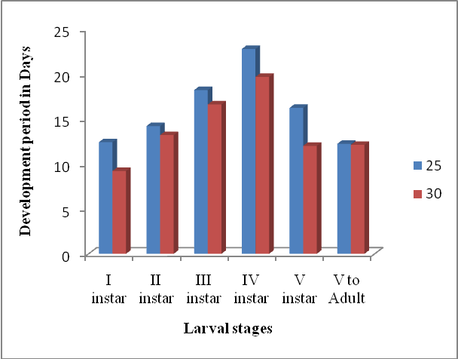
Figure 1: Effect of Temperature on development of Male instars

Table II: Effect of temperature on the development of female instars at 25⁰C and 30⁰C.
Hopper instars | At 25⁰C  Females | At 30⁰C  Females
1st Instar | (13.60±0.960)ª | (11.40±1.07)^{b}
2nd Instar | (17.60±1.340)ª | (12.20±1.22)^{b}
3rd Instar | (20.4o±1.170)ª | (16.40±1.42)^{b}
4th Instar | (25.33±1.320)ª | (21.66±1.22)^{b}
5th Instar | (19.11±0.920)ª | (17.33±1.22)^{b}
5th Instar-Adult | (15.11±0.927)^{n.s.} | (14.60±0.86)^{n.s.}
Values within each row that do not share the same superscript are significantly different (^{a-b}P<0.05). The data was evaluated by one-way ANOVA followed by Tukey’s test to detect the effect of temperature on development. Differences were considered to be statistically significant if p < 0.05.

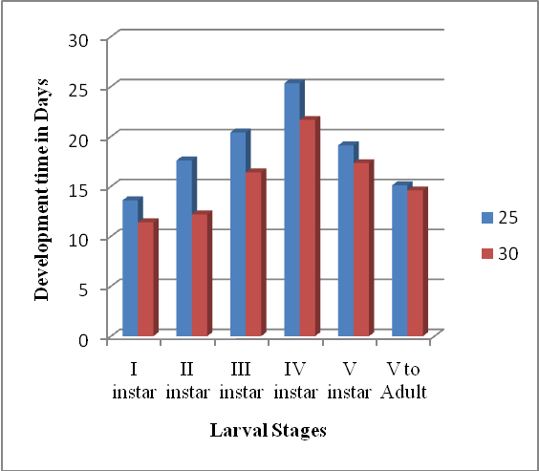
Figure 2: Effect of Temperature on development of Female instars

5. Discussions
Total development time in this study was 96.01 days and 111.15 days at 25⁰C for males and females respectively. At 30⁰C the total development time for males and females was respectively 82.77 and 93.59 days. Minimum development time i.e., 12.22±0.83 days were taken by Vth instar male to transform into the adult at 25⁰C while at 30⁰C in case males it was Ist instar which showed fast development i.e., it took only 9.2 days to transform into IInd instar. In case of females at 25⁰C Ist instar took the least time 13.6 days to form IInd instar while at 30⁰C least development time was also taken by Ist instar i.e., 11.4 days. Among males and females at both the temperature least development time was taken by Ist instar male (9.2 days) at 30⁰C while the highest time taken during development was taken by IVth instar female (25.33days) at 25⁰C. Both males and females were affected by the temperature significantly although to the different extent. Study revealed that temperature effects development process significantly. More the temperature, faster will be the development. As we know that increase in temperature increases the metabolic rate. Parker (1930) in his extensive experiments with several American grasshoppers also clearly indicated a shortening of hopper period and an accelerated rate of development with rising temperature. Observations made by Symmons et.al., (1974) on Schistocerca gregaria showed that the temperature range between 30–40⁰C was favourable for development. Shamshad Ali (1982) carried out observations on the effect of temperature and humidity on the development and fertility-fecundity of Acrida exaltata. The results also showed that the increase in temperature decreases the development period in Acrida exaltata.

Acknowledgements:
The author is highly thankful to the Head, P.G. Department of Zoology for providing the laboratory facilities.

Corresponding Author:
Dr. Tariq Ahmad
Entomology Research Division
Department of Zoology
University of Kashmir
Srinagar, J&K 190006, India
E-mail: drtariqiari@yahoo.co.in,
drtariqento@kashmiruniversity.ac.in

References
- Ali, S. 1982. Effect of temperature and humidity on the development and fertility-fecundity of Acrida exaltata. Proc. Indian Acad. Sci. (Anim. Sci.) 3:267-273.
- Begon, M. 1983. Grasshopper populations and weather; the effects of insolation on Chorthippus brunneus. Ecol. Entomol. 8:361-370.
- Huey, R.B. & Stevenson, R.D. 1979. Integrating thermal physiology and ecology of ectotherms; a discussion of approaches. Amer. Zool. 19:357-366.
- Parker, J. P. 1930. Some effects of temperature and moisture upon Melanopus mexicanus and Camnula Pellucida Scudder (Orthoptera). Mont. Agric. Exp. Sta. Bull. 223.
- Putnam, L. G. 1963. The progress of nymphal development in pest grasshoppers (Acrididae) of western Canada. Can. Entomol. 95:1210-1216.
- Symmons et.al., (1974). The production of distribution maps of the incubation and development periods of the desert locust, Schistocerca gregaria (Orthoptera: Acrididae); Bull. Entomol. Res. 64:443-451.
- Uvarov, 1966a. Grasshoppers and Locusts: A Handbook of General Acridology, Vol. 1. Cambridge University Press, London, England.
- Uvarov, 1966b. Grasshoppers and Locusts: A Handbook of General Acridology, Vol. 2. Cambridge University Press, London, England.
- Whitman, D.W. 1986. Developmental thermal requirements for the grasshopper Taeniopoda eques (Orthoptera: Acrididae). Annals of the Entomological Society of America 12:711-714.
- Willot, S. J. & Hassall, M. 1998. Life history responses of British grasshoppers (Orthoptera: Acrididae) to temperature change. Functional Ecology. 12:232-241.

4/1/2014

