Architectural vision through Factors impacting on the safety against buildings’ collapse Egypt Delta a case study

Reda Mahmoud Hamada Aly

Architectural Engineering Department, Faculty of Engineering, Al-Azhar University, Egypt.
Reda211070@yahoo.com

Abstract: The factors affecting the safety of buildings are various, and it needs giving care to these factors throughout the various building stages, starting at the beginning of their design or implementation or even after finishing them, and during occupying or their maintenance. These factors can be classified into: natural factors (such as environmental, climatic, wind, heat, humidity, radiation, light, earthquakes, volcanoes, floods and the nature of the soil) and unnatural factors (like design mistakes, lack of building protection and fire, …. etc). Still, all the mentioned factors affecting the building and construction enterprises ramify throughout the research to grant a vast research space. Owing to the utmost importance the characterizes this matter, we constituted and clarified the main object of our present study which in fact lies in the analysis of some factors that contribute to the cracking of buildings and finally their ultimate collapse. Through it, we will come to the causes that led to the lean and collapse of the cases subjected to our study, as well as defining the most appropriate method to set the imperatives which can protect buildings against natural and unnatural factors. Having analyzed these causes, we can comprehend how much negligence was there that marked the stages of design and implementation (unless both are marked with such negligence) in a way that complies to the right contract criteria of design and implementation. First case in the city of Tanta, Two and third cases in the city of Al-Mahala Al-Kobra and a fourth in the city of Kafr-Elsheikh have been studied and it was concluded that the lean and collapse causes lied in design and implementation faults alongside the lack of comply to the building regulating laws, according to what our study mentioned in detail and Non -securing the buildings against the fire.
[Reda Mahmoud Hamada Aly. Architectural vision through Factors impacting on the safety against buildings’ collapse Egypt Delta a case study. N Y Sci J 2014;7(4):93-106]. (ISSN: 1554-0200). http://www.sciencepub.net/newyork. 16

Keywords: Building collapse, Earthquakes impact, Building safety.

1- Introduction
The nature and relevance of this study, centers on exposure of numerous buildings to a serious damage which leads sometimes to partial or total collapse, and presenting the impact of these harms on the buildings. This is considered as one of the biggest problems facing the developing countries. This is mainly due to the imbalance between two processes: building construction, and pre-study of the various factors affecting the building. The safety of any building is affected by a double –sided process, i.e. naturally inherent problems, and man-made factors.
As for those natural problems, they are those occurrences that cause damage to buildings and affect the human regarding the healthy, social and even the psychological. As for those man-made problems we mean the problems resulting from the negligence of applying the protective requirements with their various stages so as to avoiding the dangers of neglect and lack of sufficient awareness among people. current research to these influences and the role of the architect and construction and the extent of their affecting on the facilities with a statement types and characteristics, as well as the study of the importance of design (both architectural or construction) resistant, both problems is the seriousness of the buildings, especially if that affect in a way or another to reduce the life expectancy of installations and the rapid deterioration, there is no doubt that the ignorance of the study of influences on the safety of the buildings may cause the deterioration of many of them, the process study the effects of the factors affecting the integrity of the buildings direct and indirect cannot be considered separately from the rest of the housing problems. The following are the most important reasons which result in flawing and collapse of the buildings according to the importance and the speediness of its effect on the buildings[1].
The following are the main reasons for eating cracked and collapsed buildings, depending on their importance and speed of impact on buildings.

2-Neglectingtheeffect of the forces of Earthquakes
The effect of earthquakes and wind on any concrete building is that they affects the building through horizontal forces. Which are variable in value and the trend according to the site of building in a map of the country in which it's situated, close or far from the coastal areas (as for wind), or the focus of the main earthquake area which is known in this country(as for earthquake). These horizontal force inconsistent in its concept together to balance the building for the similar one of the main force that most engineers used to design on the bases of its impact only, neglecting the effect of horizontal forces, consider it non-main and less effective but this idea in designing proved it is wrong because the effect value of wind and earthquakes on many buildings is great than lump appreciation that depends on the engineer regardless of making the necessary calculation for this matter[2].
We can define the earthquakes as"land quake and short-term shaking, happens suddenly and we can't control it, hitting the rocks of the earth layers in temporary period's according to its moving and sliding, it's difficult to predict its occurrence in current time." And these shakings move in all directions in different ways, it can be divided into three types, Tremors anchored from the bottom to the top, Horizontal tremors and circular tremors, the destructive effect of earthquakes depends on the nature of the ground and its structures and things built on it and the nature of the earthquake in terms of power, speed and duration of building that exposure to the earthquake[3].
2-1-conditions of architectural design- resistant to earthquake
The stage of architectural and structural design for building is considered the most important condition in architectural design that helps in resisting earthquakes, and the specifications of Egyptian Buildings for resisting earthquakes in1992 put specific characteristics for any building to be resistant to earthquakes, if any architect attempts to make any design without controlling such issues, he will face several problems related to the ability of resistance[2].
We can divide the Architectural considerations for buildings resistant to earthquakes according to Egyptian specifications "conditions of architectural design in earthquake-resistant buildings" 1992.Especially if they concern with the basic concept in architecture, e-g strength, in terms (3-4-7) under theme "architectural requirements" to the following:
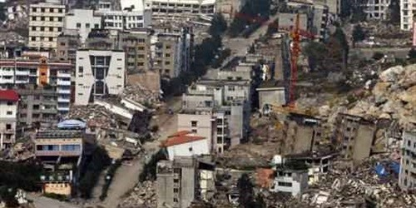
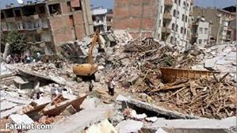
Fig.1. the extent of the impact of the destructive earthquakes on some buildings[4].

Table(1): Conditions of architectural design resistant to earthquakes[3].
Conditions of architectural design resistant to earthquakes
Considerations related to construction compounds in the building. | Consideration related to construction shape of the building.
Distribution of construction compounds and its structural importance. | The whole shape of the building.
Windows and doors. | Building height and the fit of ribs length.
Earthquake separators. | Buildings with legs(ground floor open).
Stairs. | Angles and corners.
Rooftops, balconies and construction of walls. | Anchored defections.
Wall and non- structural partitions. | Adjacent buildings.
Columns and beams. | Density of construction in horizontal projection and its distribution.

In short we can say that earthquakes affect negatively on buildings through big horizontal forces and cross shakings as a result of soil movement, that leads to cracking and collapsing unless the buildings are designed in a way that resist these forces[5].To avoid the harmful effects which may happen as a result of the earthquakes forces, there must be an efficient study to the areas which may expose to the earthquakes and we should study the shake rate which may occur as a result of these earthquakes through using the world measurement of Richter which shows the strength of the earthquake. During the design stage, we should pay great attention to this phenomenon in the reinforced concrete and ordinary works, and also in buildings' works and at the places building joined with each other according to the Egyptian code[6].
3- Building on a soil unsuitable for the establishment
When we think in establishing any building, the first thing we search for and the first thing we meet is the soil on the which we will build. Thus, the study of the soil is the first scientific step in establishing any building. The prevalent thinking in place is the maximum exploitation of the soil and loading it with the maximum load, and this increases the importance of studying the soil before establishing any project[7]. The soil defects or problems are the factors which affect the building safety. The defects attributed to the soil are varied and diverse, including shortcoming in proper studies that should be suffient for soil nature and the conditions it may be expose for, or the improper choice for the foundations according to the nature of the loads transported from the building to the soil or the choice based on the soil characteristics and the extent of its endurance or the foundation level which isn't appropriate for the nature of the soil layers. The ground nature has many aspects designer should regard in its type, characteristics, the high level of the underground water, the type of the salts in itas well as direct and indirect reasons which impact negatively on buildings[8]. For example argillaceous earth is one of the most dangerous soil types which appear as tenacious soil and when it exposes to water, it loses its strength. This type of the soil can be found in sand and shingle used in the concrete works[6].The effect of soil on the building depends highly on the soil type, solidity and the difference of the soil type from one place to another place according to the site. In general the soil that has many problems is the soil which causes additional problems form the geometrical point of view as a result of conditions of its formation or the changes in the environmental surrounding circumstances. The soil types which probably cause problems to the foundations are:
- The collapsible soil: such as sand loss, sand tenacious soil, sand dunes soil and the derelict soil. This collapse may occur when the soil is engulfed with water or during the shakes.
- The bulgeable soil: such as clay stone[1].You may note that the foundations built on this type of the soil expose to large vertical push as result of the soil bulge during the exposure to the water. These forces may lead to the building cracking unless buildings were designed to resist the hogging especially the light one[9].
- The soft muddy soil: The muddy soil is the soil with high pressure and its resistance to the cutting is low and the stature coefficient is low. This soil creates big problem during the foundation or during dealing with it, the most common types of this soil is the ordinary mud with the soft stature[7].
- The filling up soil: The filling up is a mixture of the resistance and debris, it cannot carry the massive effort, and it is disassembled soil which can be formed by the human being. The filling up may be modern or old (foundations, remains of old buildings, monuments and tunnels on low level of the soil). Foundation on the filling up is one of the known dangers, so these layers must be removed to reach to the normal and valid ground appropriates for building and foundation according to the approved report of the soil[6]. In any case we mustn't build on the filling up layers because it is incoherence material. We must sure that there are no monuments or tunnels as it happened in Al Qobary housings in Alexandria[10].
To overcome all these problems, we must install the sensors with sufficient number in order to determine the soil characteristics according to the project importance, the buildings' shape and heights in addition to the site relief and the type of using the building (residential- administrative- commercial- amusing…etc). We must also follow what is recommendations of the sensors' report regarding the type of foundations appropriate to the soil endurance.
4- The shortcomings in the design or the details' stage
The shortcomings in the constructional and architectural design or inall other specialties that we need in building are considered one of the most important reasons of the cracks or the buildings' collapse. The degree of the influence differentiates from beginning between the simple cracks and the middle or the large cracks, finishing up with full collapse[11].As an importance matter, we can monitor some points which lead to the collapse of the buildings as follows:
- Errors in the calculations either in loads or in constructional system.
- The invalidity of the assumptions on which the design we made the design.
- Non caring with all environmental surrounding circumstances, such as the materials which have harmful effect on the concrete, or moisture and harmful fumes.
- The resistance of the used materials or the concrete components is lower than the stresses they face.
- Non efficiency of the specifications or not dealing with the defects of the case[12,8].
- The negligence of the soil stresses and non-reliance on accurate sensors.
- None caring with the circumstances surrounding the building such as the increasing in the level of the underground water.
- Non existence of detailed working especially the drawings of steel separation and different sections as well as the detailed drawings of the constructional sections[6].
- Shortcomings in the constructional design and inaccuracy of its calculations (error in the constructional calculations), dead and live loads may be calculated in inaccurate way.
- The negligence of some external loads such as wind, earthquakes and other natural factors.
- Ignoring the design of some separators of extension, shrinkage, dropping and the constructional separators.
- Ignoring the circumstances surrounding the site which affect on the design such as the level of the underground water, the type of the neighboring buildings' foundations and the probable change in the level of the underground water.
- Inaccuracy of the architectural or the constructional design(or the both of them), the inconsistence of each design with the other or of constructional drawings with the code or shortcomings in constructional or architectural designs with its all types which may not be shown by the designer clearly on the drawings[11].
5-The application errors and non-caring about specifications and general requirements
The natural and unnatural factors which affect the buildings are considered one of the main reasons that contribute in cracking or collapsing these buildings. In fact these factors aren’t completely considered during the design or the implementation. The working stage plays an important role in accelerating the building collapsing, for example, some buildings are collapsed by the excavation and back filling processes which are carried out by un-experienced persons who don’t recognize its risks[13]. The reasons which get back to the wrong way execution that is common in this field and leads to building cracking and collapsing include:
- The engineer who carries out the task isn’t acquainted with the general specifications and special requirements of the engineering profession and the construction materials. As the negligence of certain specification can result in collapsing all correct steps which have been taken before.
- The negligence of certain specifications can destroy all correct steps which have been taken before.
- The ignorance of treatment process, we find that concrete efficiency is less than 35% as well as ignoring the isolation works.
- None caring with the quality observation, as the quality setting is considered as a learning school which must be studied carefully and we must know its correct concept. And must be studied in all engineering colleges and institutes. The quality setting begins from the quarries, then site, storehouses and factories in all stages with its all items. Every engineer must know how to set the quality of all materials and this must be done in the laboratory and in the field[6].
- Executing the works in a way which is contrary to all general specifications and specified technical specifications for many reasons.
- The negligence in executing some items mentioned in the executing drawings, the negligence is considered as massive danger to the building such as removing the rain waters from the roofs and none caring with the obliquity none caring with the other works[14].
- Non reliance on good reports issued from trusted sources regarding the soil and bases works. Despite the danger of the sensors’ works, some owners don’t make sensors for the soil or they make them in shadow way in order to complete the license documents. Some owners neglect executing the recommendations of the actual sensors and others entrust to inexperienced persons to make these sensors because of the high cost. Some owners also neglect the applying of the sensors’ specifications and execute them in wrong way[13].
- The bad manufacturing and preparing to the reinforcement steel and none following the sound flushing and extensions ways for the neighboring seas.
- The segregation in the concrete during the pouring process or in the readymade concrete cars.
6 - The bad case of the used materials
We must care with all materials which are inserted in the ordinary and reinforced concrete such as the mixture water, treatment water, the reinforcement steel, sand, shingle, cement and other concrete additions as well as the all materials used in the construction process. Incidental observation isn’t enough, but the regular tests must be made for these materials, writing its down and giving it enough interest which is not less than the caring given to the tests of concrete stress and operation tests as well as other site tests (which are implemented or taken from the site)[6]. Actually, using invalid materials which aren’t compliance with the specifications or using badly-stored materials, exposed to the damage during the execution processes is considered as a frivolous play with the buildings safety and those who use them[14].
7- Non -securing the buildings against fire
There are some disasters which must be predicted when we think about construction, such as establishing the building in earthquakes area or the probabilities of breaking out fire. The building must be designed in the way that stands for the fire for many hours without demolishing. There must be protection from fires resulted from the defects of the electric connections, gas or combustible materials whether these materials found in constructing materials, covers or the used furniture in order to prevent the occurrence of cracking and collapsing resulting from these fires. We can overcome these fires through proper alert system and studied manner for resisting[12]. Fires is considered from disasters which can't be predicted as it happens suddenly, It occur either through the user’s negligence or as result of errors in the design or execution. Fires is also one of the most dangerous reasons which lead to buildings, cracking and collapsing, since it has a negative effect on the building such as damaging the finishes, doors, windows and all combustible materials. Then, it affects negatively on constructing materials of the building, in addition to the danger of using water in putting out the fire, since water leads to the sudden cooling to the concrete, and thisin turn leads to cracks in the concrete skeleton and the partial or the total collapsing. Thus, buildings with its all kinds, commercial, industrial and stores in particular must have a system for protection from the fire, whether through the reinforced concrete, making efficient concrete cover, using fire alert equipment or through providing different fire extinguishers and training the personnel on it[6].
8-Neglecting the maintenance
During the last period, we note that there mush collapsing of buildings all over the country because there is no maintaining of these buildings and the weakness of the drainage system, the absence of the regular maintenance, the absence of owners’ union for putting maintenance plan around the year as well as non existence of observation institution such as the districts' presidents for executing decisions issued after October earthquake 12\10\ 1992, either by reversing the building or demolishing it[15].The most important reasons which lead to the cracking or collapsing the building during the maintenance are:
- Performing the maintenance on large scale without study or by using materials lead to steel damages.
- Setting up additional pillars in sizes that can't be born by the bases or the soil.
- Performing the maintenance by an unspecialized team and using improper materials.
- Ignoring weight, stress and safety coefficients during the maintenance.
- Breaking of the bearing walls [16].
- When the engineer doesn’t follow the design principals, the building status will be deteriorated. The role of building designers in reducing the maintenance works in many factors exemplified in:
- Choosing construction and finishing materials with high quality and long suppositional age to reduce the works of maintenance and its costs.
- Choosing the companies working in the field of building construction with good reputation and high quality in the execution.
- Choosing clever workers who are well trained on carrying to avoid performance defects.
- The necessity of making the necessary tests for different materials at the site before, during and after using and installing them to be sure of its safety, quality and matching with specifications .
- Designers should consider the works and costs of maintenance during the design stages to reduce the time and the cost of maintenance works without affecting the building activities.
- Exchanging experiences with the maintenance team to know the maintenance problems in different buildings in order to avoid and reduce them in the future.
- Training the designers on defining the maintenance requirements, their costs, significance and their effects[17].
9- Explosion of the ray’s equipments
Explosion the ray's equipment in the laboratories and hospital sand neglecting to isolate these places from the rays, is considered one of the most important and dangerous reasons that leads to buildings' cracking and collapsing. These explosions result in discharging massive quantity of air which causes strong pressure on the pillars and reinforcement steel. We can overcome this problem through caring with the isolation against the rays such as isolation by lead, whether in laboratories or hospitals[13].
10- The moisture
Moisture plays an important role in defining the building’s suppositional age, so it's necessary for building supervisors to perform maintenance works as fast as possible. The negligence of this matter can result in collapsing the whole building. All buried parts in the whole buildings and final roofs need to be isolated completely against all moisture causes in any case .As isolating layers can isolate all isolated elements from entering moisture and spoiling it[18,10].The various causes of moisture in buildings affect negatively on them, for example, buildings, exposure to the penetration of moisture can lead to the damage of finish materials and constructing elements…..etc. The moisture can also reach the reinforcement steel and makes it rust and accordingly it will be eroded, moisture can also affect on the building constructing efficiency that can lead to the partial or total collapsing if we neglect treating it for long time[19]. So we must care about isolation as one of the main causes for most defects which occur in the buildings[11]. In general, the isolation of buildings against moisture is one of the most important matters in protecting buildings, whether this protection is from above, under, inside or outside[20]. one can summarize the negative effects of the moisture can as follows:
- It damages electricity installation and air conditioning.
- It leads to the inconsistence of cement on walls which in turn leads to separating paints from the surfaces. And the salting of walls, floors and roofs of buildings which shows bad architectural view.
- It damages all covers such as wallpaper and all covers installed whether on walls or floors.
- It helps to propagate insects which cause creating diseases and create healthy problems for the residents of these buildings.
- The moisture It also leads to decompose the buildings materials in general which can lead to steel rust. Seen Fig.2.
- It increases the activity of mites, fungi and harmful bacteria in the building woods, which leads to inclination, damage and spoiling these woods and building materials in general as well as the bad odors[21].
In order to overcome the moisture and its causes, we must follow the basic steps to provide good isolation, this can be summarized as follow:
- Choosing the proper materials used in the isolation and that match the specifications required in the design as well as kind of building and surrounding circumstances that affect the way of execution.
- Making a design which appropriate for the necessary isolation layers regarding its coherence and the thickness of each layer.
- Carrying out the isolation process that mach the specifications of used materials with the correct rates that have been designed[5].

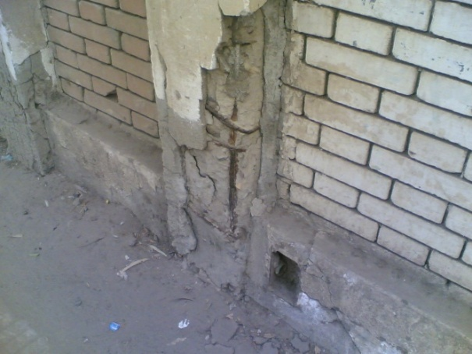
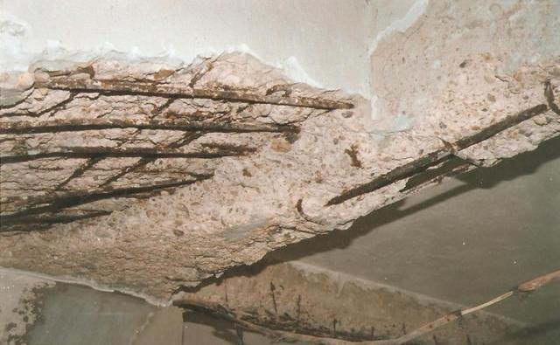
Fig.2. Shows the steel rust which leads to the fall of the concrete cover and cement on the column and ceiling[4].

11- The Stage of occupation and using the building
Marked deterioration in the general level of already existing houses is a direct result of the ignoring the maintenance work and also the bad use of buildings in general and health care devices in particular which were installed in it are the most important reasons that expose the building for danger and cause the fast need for maintenance because of occurrence of damage resulted in either lack of awareness of users how to deal with these element or due to the lack of suitable building materials which were selected with the use or with the purpose for which the building has been setup and during the building occupancy it may be exposed for damage that requires a maintenance operations[21].

.
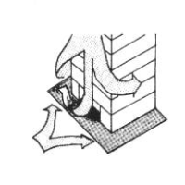 | 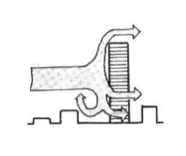
The submersible entrance reduces wind speed at the entry doors. | A building that much higher than nearby buildings and thus exposed to a lot of loads as a result of wind.
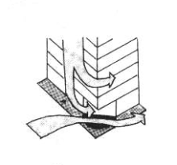 | 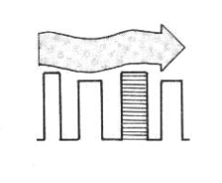
The submersible pillars can show the intensity of the concentration of the wind at the corners of the buildings. | Similar rise building with nearby buildings is protected.
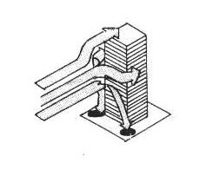 | 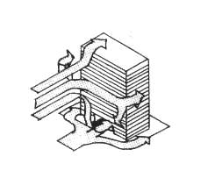
In high-rise buildings, the effect of wind pressure is focused on the bases | Opening in the building at the basement can lead to wind speed.
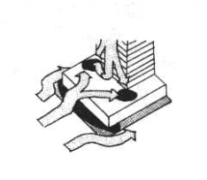 | 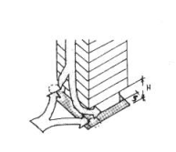
Roofs of first floors, which are more likely to expose than the rest of the building exposed to the wind more than their bases. | The least wide first floors are exposed to lower pressure according to their kinds.

Fig.3. The effects of wind pressure on some models of high-rise buildings[5].

12- The effect of wind on the safety of the buildings
Statistics indicate that more than sixty thousand persons have been victims of wind agitation since 1900 and up till now. Ruins of the buildings killed some of them and others died of drawing due to tornadoes and strong winds when they stormed the shores of seas cities
There must be enough information at the architectural design to study the effect of the wind on the safety of the buildings. Such as Cyclones this phenomenon is one of the heaviest air turbulence and more causing ruin and destruction, but fortunately its effects remain tight spaces and a little recurrence. Cyclones have a tremendous impact. It can uproot small buildings and destroy them simply as well as trees and similar things. And account Tornadoes on the surface of the earth, with a top speed of 320 km/j. Tornadoes hit all kinds of building, telephones lines and electricity wires. They crash out everything that surrounds them…etc. The United States and Australia are the most popular countries in which tornadoes are frequently repeated.
The wind pressure affects the buildings horizontally or vertically with the external surfaces of the building. The strength of the affecting forces subject to many factors such as the nature of the building, its height, its averages, its other dimensions, the weather nature to the place where the building will be built, the wind speed, the air density, the direction of the wind, the building type, nature and its location. Moreover, there must be proportionality between the heights or the lengths of the building sides, since the proportionality of the horizontal projections and facets help the building to resist the wind, So we find that the building with unfamiliar shapes don’t grant the stability or the balance against and pressure strength from the wind power strength[1]
13-The effect of the heat
Heat is one of the most important elements of the climate which impact on the building. It passes to the upper layer with the load current and has therefore represented an influential factor in the temperature of the air near buildings[1]. So isolation of heat isn't less than isolation of the humidity, especially in the upper floors. But it has great importance in the concrete protection from the effect of high temperature which causes dilation of iron and the occurrence of tattoo and cracks in the concrete. protecting concrete from low temperatures saves concrete and protects it from the impact of frost, and varying degrees temperatures in summer and winter. Exposing concrete to high temperature in summer and low temperatures in winter causes a serious damage in terms of expansion of concreted iron. An important reason is also ignoring to protect the frontage of the building with its whitewashing since it protects the building from the effect of the temperature and air saturated with salt and sulfur[22].We can mention some of the effects of heat on buildings as Follows:

- One of the most influential increasing effects of the heat is that caused by the spoiling caused by mixing materials with water and the change in dimensions which occurs as a result of extending and contraction in particles of matter and after the vanishing of heat, the material is trying to become homogeneous again and returning to normal case. For example; numbness in reinforced concrete because of the expansion of rebar and contraction in greater degree than what is happening as we took into account due to the phenomenon of expansion and contraction.
- When liquid and homogeneous material is exposed to an increase in a temperature, an expansion is happened on and internal matter particles. But, in some cases, we can't make re-homogeneity as long as there is a change in temperature.
- Occurrence of cracks between the reinforced concrete and building works is clear in places such as steel beams and trusses, unless we leave enough place to stretch.

14-The effect of air pollution on buildings
Polluting air by sulfur dioxide gas (especially in condition of high temperature and humidity), leads to erosion of stone walls and metal structures for building and other elements used in the manufacture of buildings because of they contain oxides. Smoke which result from motor vehicle exhaust, fires, volcanoes and industries of all types, lead to contamination of the views of building and distortion of its architectural shape. In addition to the atomic bombings and what is generated of huge amounts of fissile radiative compounds. They're dispersed into the air and emit radiative waste as carbon, iodine and others, which have a very dangerous impact on buildings and population[1]. In addition, air pollution the magnitude of pollutants and organic materials has an impact on all types of buildings. Especially the parts buried in the soil that reach up to the level of underground water. And groundwater movement determines the danger attacking by sulfur if it increased about 0.3gm/l. Because it reacts with cement and transmit it into Gypsum, then penetrates into the interior and leads to concrete cracking and crumbling, then penetrates into the interior and leads to concrete cracking and crumbling[10]. So the absence of protection for or inappropriate protection for building in all its various elements and which prone to harsh surrounding circumstances like coastal, continental or changing atmosphere or saturated vapors of chemical or salts leads to deterioration of the elements of installation and discoloration, rust and cracking which may eventually lead to the collapse, and within installations prone to such extreme conditions; for example, but not limited, coastal buildings and pile foundations[12].

15- The effect of the soil contamination on the buildings
Through the experiment, we concluded that the concrete exposure to the saturation, then repeated dryness can destroy the concrete. It is known that the water which is contaminated by the sewerage water contains high rate of sulfur and it is also known that most coastal areas are covered with sea water. Asa result of the evaporation and water confinement, the soil in these areas is contaminated by the salt which affect the buildings. By dissolving the hard salt found in inside the ground or the salt leaked from the sewerage, they form a solution which attacks the cement and destroys it. As result of the interactions which lead to the extension and bulge of the concrete, accordingly, the defects occur. In addition, during the rains, the air pollutants are absorbed, so the acid rains affect the soil formation and the construction materials. Moreover, the drainage of the liquid wastes on the ground through the leakage which leaks to the deep layers of the soil with contaminating the surface layer results in large shortage and changes on the soil characteristics, the matter which affect the soil on the which the building will be built. It is likely that the wastes, whether solid or liquid, launch materials with strange components, destiny and strange chemical structure which harm and affect the soil negatively[20,1].

16- The errors of the urban planning
The increase of the constructing and residential destiny in the areas where there is no sewage net prepared to contain this increase is considered one of the factors which affect directly on the buildings and results in the continuous overflowing of the sewage, which in its turn produces dangerous wastes and leads to the erosion and weakness of the buildings' foundations[10].The heights of the sewage net which are more than the designed height also have the same negative effect of the bad planning.

17 - Case no.1 Damages due to fires occurred at Company of Baie-Al-Masnouaat’s building, at Tanta city
A case of study, The fire broke out within the company of commodities sales (Baie-Al-Masnouaat), it consists of 4 stories building, and extended to the commercial shops at Al Khan St.
17 -1-Preview
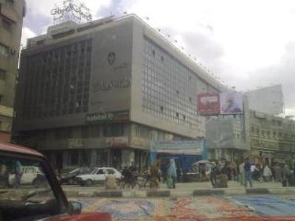  Before the fire | 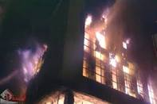  During the fire
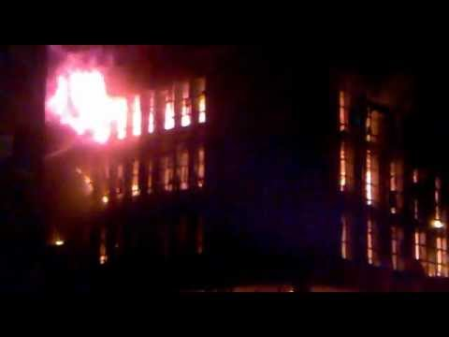  During the fire | 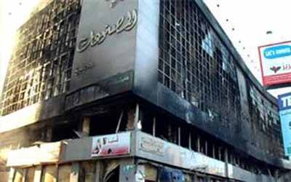  After the fire
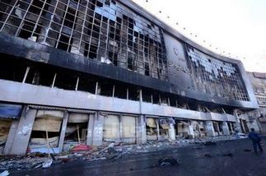  After the fire | 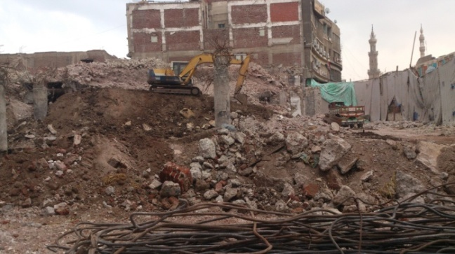  on 15/3/2014
Fig.4. Cracks and collapses the buildings because of the fire eruption[4,author].

17-2-Explanation of Fire and flaw mentioned
Tanta suffered from a huge fire. Through one of the eye-witness at Al Khan commercial district we knew that the fire begun from the fire ignition at one of the random kiosks for the peddlers. The primary investigations made by the security directorate at Al Gharbya governorate revealed that kerosene ring was the cause of the fire ignition at the company of Baie-Al-Masnouaat– Tanta. Then, the fires extended to the neighboring kiosks. When the people collapsed the fired kiosks, this helped to extend the fires and accordingly they hit the company and the neighboring commercial shops. The primary report issued by the center of researches and engineering consultations at the faculty of engineering- Tanta University, recommended necessity of the immediate vacation to the company and the surrounding buildings fearing of the sudden collapsing, since the building with its current case is considered unsafe[23,24].

18 - Case no.2 the collapse of a multi-stories building at Mahallah town
The present case study is a collapse for a multi-story building of 13 floors, which occurs at great Mahalla. This building was constructed at Nov., 2009 and collapsed at March, 2012. Fig.5. shows the collapse reasons, where the main report derived from the field records of district presidency of second major camp, proclaimed that the citizens have built a 13multi-stories building without a license.

18 -1-Preview and Study
From the initial observation, according to the report prepared by the committee formed by the Governor that the building has slipped entirely on adjacent agricultural land with all of its components, including the foundations and concrete structure. Also, the Committee notice existence of a stream away with distance of three meters from the fence which adjacent to the building. Finally, the Committee suggested that the collapse of the building was due to sliding at its foundation levels, as a result of rising of this foundation level above the level of bottom of the waterway, Figs.6,5.

18-2 Explanation of Failure
The reasons of collapsing the building may be the result of the following causes:
- The leakage of water from the broken water pipe which is left without repairing for two days before the collapsing of the building, this broken pipe is found in middle of the reinforced flat foundation, whereas the geometrical principals of the soil mechanics stipulated that the levels of water pipes or the sewage pipes next to the site are higher than the foundation rate in order to prevent the explosion or the damage of the pipes which in its return leads to the water leakage under the foundation.
- The absence of concrete retaining walls which are designed for bearing the loads resulted from the building weight and soil with foundation depth deeper than the level of the watercourse adjacent to the building and depending only on the wall of the Compound which consists of the red brick and the concrete columns. (whereas in the geometrical principals of the soil mechanics stipulate that if the foundations were near to natural slide of the ground, the soil must be protected from losing its ability to resist the cutting, as result to the slide and slide resistance by building retaining walls, metal curtains or making the foundation with a depth which is deeper than the slide surface for avoiding the sudden movement)[8,12]. The retaining walls are establishments which are used for supporting and providing the balance for the soil, since the case doesn’t provide the balance with natural slide[25].
- Fit the side lengths of the building gives the overall structure, this proportionality in the horizontal projections and destinations of the design factors that help to resist the building of the wind, Buildings with unusual shapes do not give the building stable and poise against any strong pressure from the strong wind. One of the main important reasons for collapse is the low level of foundation (1.5m from the ground level) which raises the tendency of building to overturning under wind load effect.
- Change the fluctuation of the water level in the soil as a result of increased groundwater from collapsed nearby or watering gardens, or leakage of water from the grids or sewer or drains or trees close to the origin, may cause collectively or individually in the appearance of defects of origin, and this is due to the soil water content may have a significant impact on their properties in terms of susceptibility to compression and swelling and endurance for loads[26, 27].

All these factors (together or separated) which may cause the soil slide from the eastern corner of the building which leads to the building slide from the same corner, the slide increases for two days, then the building collapsing as its shown in fig.5.

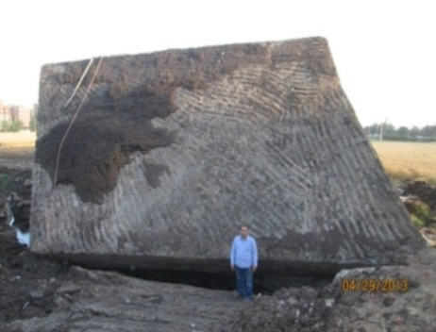
waterway
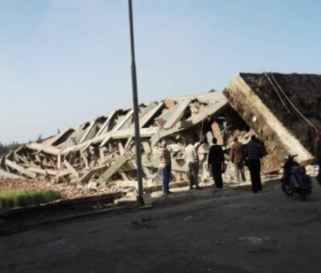
Waterway
Fig.5. shows the collapsing of the building as result of the slide of its foundations` in the neighboring agricultural land [26,author].

Brick Wall
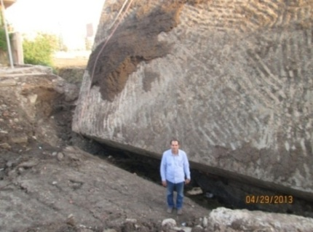

Fig.6. A section and an image show the relation of the retaining wall and the waterway to the building [Author].

19- Case No3 the inclination of two building at Mahallah town
The third case study was an inclination of two 13 multi-story building, and occurs at the street of Wabour El Mayah, the second district–great Mahalla, Fig.7.The first building (tower of Al Shoney) was constructed at 3/2006 and the inclination noticed at 12/2007. The second building (tower of Pearl) was constructed at 1/1988 and the inclination noticed at 12/2007, Figs. 7. The main report from real records of district presidency of second district, stating that, the tower of El shoney was recently constructed, there was a horizontal space between this tower and the hope tower reach to 10 cm at the tenth floor, and cracks were marked at tower of Pearl.

19-1- Preview
There was existence of construction at El shoney tower may lead to increased tendency of inclination of the two towers, Fig.7.

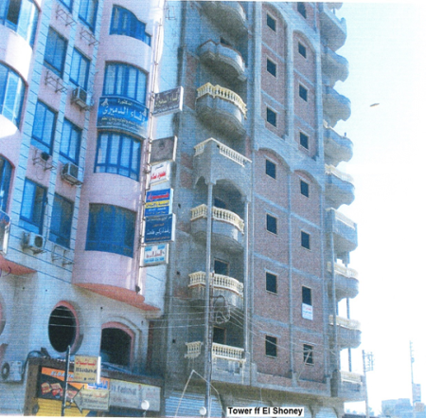 | 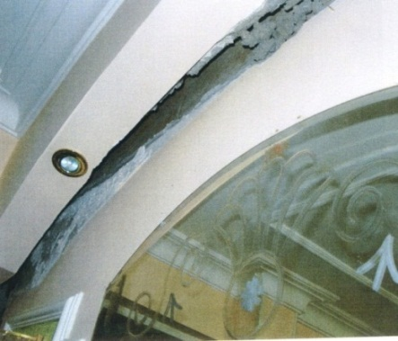  Separator
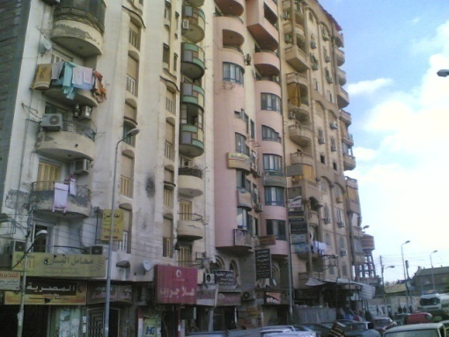 | 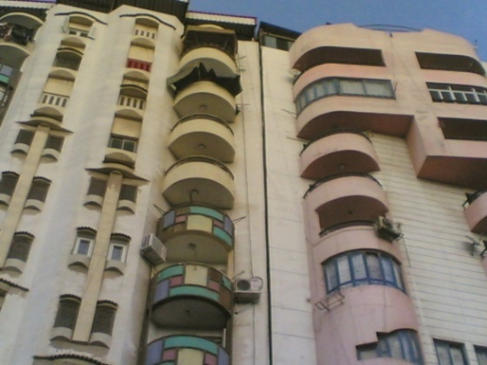  Separator
Fig.7. Emerging gaps between the oblique building and buildings adjacent[23,author].

19-2-Explanation of Lean
From the initial observation, according to the report prepared by the committee formed by the Governor that, a fall occurs at the bottom of the buildings, which moved together as one bloc, result from the following:
- Non-existence of expansion joint between the two building and the different nature of loads in each building.
- Lack of correct implementation of the retaining piles beside tower the hope during foundation stage of El shoney tower, led to withdrawal of small-grained soil from the bottom of El hope tower during dewatering of groundwater.
- Non-completion of the nature fall for the recently constructed building, while the other building was completely falling naturally.
- was the work of displaced water during periods of construction as a result of the high water table in addition to sewage, which the owner with the sliding part soft soil was removed during construction de-watering.
Prevent leakage of water from the bottom (on the entire land area within the boundaries of the barrier) and through the work of a curtain to prevent leakage of water from top to bottom. So that the thickness of the soil (soil weight) over the largest curtain of water impetus for moving higher on the curtain. So, if what we were drawing water from above the curtain, the water will not be limited and will not enter the water from the sides through the barrier or from the bottom through the curtain and thus the water content below the surrounding buildings will not be affected the water level will not get moved to the soil under the foundation, as well as guarantee the lack of any movements or Hbutat in facilities and services surrounding the project[28,29].
20- Case No4 the collapse of building at Kafr El-Sheikh city
A study was a collapse of a 14 multi-story building (basement floor +a ground floor +12 other frequent stories + roof rooms), and occurs at Al-Kantra El.bydaa street –Kafr El-Sheikh city, Fig.8.
20-1-Preview and Study
It's noticed that there is a remarkable lean of the building that is estimated by 40cm towards south.(The highest point of the building moved in a southern direction by 40cm). There is also a lean towards west estimated by 75cm. (The highest point of the building moved in a western direction by 75cm.),and the building exceeds the allowed maximum height as it reaches about 45m from the street level, And It's noticed that there is a stream running along the front side of the building in the west also there is a barrier across this stream in the south side of the site.
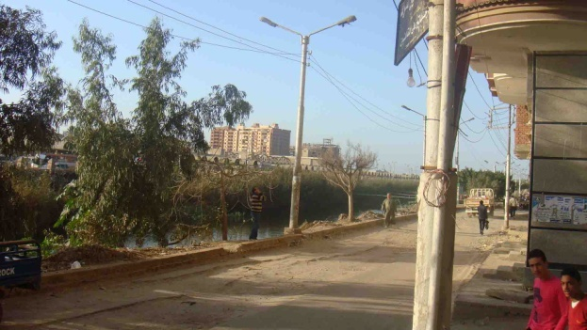
waterway
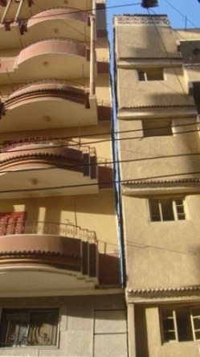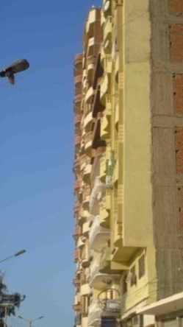
Separator

Slope
Fig.8. Gap between the oblique building and the adjacent neighbor [Author].

20-2-Explanation of Lean
From preview and study, it is evident that the building lean is due to the lack of adherence to the report of sail and foundation research, particularly, the report was issued for a building consists of a ground floor+ 11 typical floor. And what is done in reality is a building consists of basement floor + ground floor + 12 typical floor + roof.

This results in reducing the level of foundations and basis which in turn led to decrease the distance between loads and the compressible soil. Add to that, the report recommends that the allowed net strain at the foundation level never exceeds 1kg/cm², in case of using a bash of reinforced concrete, it also recommends using somehow deep foundations in case the strain is above 1kg/cm² and the existing building has basement floor+ ground floor+ 12 typical floor + roof that makes the actual foundation strain on the ground higher than 1kg/cm²[30].

21- Conclusion
The recommendations shall be presented under subheadings that are considered as the main stakeholders in the industry. The following roles are expected in this regard.
- The factors which affect the buildings' safety attack the whole elements of the building without distinguishing between constructional or architectural elements. Here, the importance of the architect' participation of the buildings without distinguishing between constructional or architectural elements of the complete participation of the architect in the that design which resists the factors affecting the safety of the buildings appeared by good aware choice to the shape of the buildings and construction to the design, whether regarding the architecture or the constructional importance. So the damage that may occur in the building can repaired according to the importance of the building for use.
- The importance of the specifications quality and the design and execution processes is considered as safety input to the building's users. It is considered as one of the most important inputs regarding the improving of the competitive ability of the labors organizations. Since this input increases the levels of efficiency and effectiveness, it is considered as the core of importance in all works. It focuses on improving the personnel's performance and meeting their needs which achieve the best and effective use of all organizational processes through providing the proper climate. The architect is the person who imagines the general shape of the building and controls it. The building shape includes its size in the space, the place and the position of the internal and external walls surely this affects the performance of the constructional elements found at the building.
- 3-The factors which affect in the danger are represented in the relation between the occurrence and the exposure to it, this means that the rate of exposure for a building with certain style may be more than the rate of exposure for a building with another style, in the case of earthquake, the effect of the event must be studied in order to understand and define the danger.
- The study of the influences on the building's safety is the most necessary matter with the need to the tight censorship and observation for quality of the engineering projects in order to save the people and properties. This can be accomplished through the integration of the relations between the different parties relate to the design such as the architect, the civil engineer, the specialist of the healthy works, electricity, the works of air conditioning, communications, fire and in particular after the occurrence of many disasters in Egypt which resulted from the absence of the necessary censorship on the execution or because of the absence of the efficient awareness during making the amendments to the buildings, in particular the constructional amendments.
- In order to achieve the research goals in the light of the quality levels and revising the inputs and outputs of the productive activity. We must go towards adopting and applying the quality systems and achieving the integration of the information systems in addition to the development of strategies and the work systems applied now according to the modern scientific principals in the light of the practices of distinguished works' organizations.
- We must know the factors affecting the buildings' safety aiming to define the role of the architect and his responsibilities regarding the recruitment of the architectural elements in order to support the buildings' abilities to face the factors affecting the buildings' safety. In other words we meant presenting the architectural considerations which affect on the building's resistance during the exposure to the factors which affect its safety. According to the constructional concept with its different specialties, the successful architectural design is the main factor in increasing the efficiency of building's resistance against the factors affecting its safety if the architect puts in his mind achieving the protection from the factors which affect the building's safety during the design.
- The architect's estimating knowledge with the factors affecting the building's safety doesn’t include only the design process but it also includes the execution factors and the construction materials, since these branches constitute an integration for establishing safe building. The sound choice to the materials used in the construction works is very important matter regarding the extent and the strength of the building. Before defining the materials and the manner of construction, there must be previous knowledge with the extent of harmony between these materials and its reactions to the factors affecting them.
- The rules and regularities which were made and the buildings and construction rules as a base put by the different authorities for protecting the buildings from the factors which affect the buildings' safety. These rules and laws are considered as the first tool for applying the programs and plans of the urban development.
- One of the most important filed which must be handled in Egypt is to explore the extent of shortcoming and the individuals' ignorance to the rules of building and construction as well as overlooking establishing the buildings according to the conditions and standards which guarantee the safety and security of the users. The most important legislations and buildings' conditions are the conditions and requirements of dividing the lands, the requirements and legislations of buildings, residents, heights, protection from the fires and disasters and the rules which prevent granting the licenses to the violative projects which affect the building's safety.
- The positivity of working with specialized persons in all fields of the construction and building and presenting alternatives in the proper place and time in order to create the integration between the legislations and the safety coefficients. This means that the right of signature regarding the building safety is entitled to the engineer regarding the experience and specialization. The engineer must make the architectural studies and he must know the project's architectural program and its different elements in order to be put in the architectural projections. The engineer also must put in his mind during the design the good architectural projections as well as the good design to the safe ways of escape in case of disasters. He also must consider the building's general architectural formation without yielding to imported architectural shapes without awareness or establishing buildings without windows in order to make aesthetic appearance without awareness, or the extravagance in applying modern architectural theories exposes building to unsafely.
- The quality is an important element to find the scientific methodology for the administration and planning the censorship during the different geometrical stages which begin from the design stage, the execution materials, the finish materials and organizing the needs necessary for performing the quality different activities, so they can cover the aspects of management, financing, the geometrical techniques and defining the proper order relates to the priorities of the execution activities of the projects to guarantee the best use.

21- References
- H.N. Mohamed, "Analytical study for the factors influencing on the safety of construction and users ", MSc Thesis, Al-Azhar University,2003.
- K. I. Wahked, "Design of concrete structures for resisting wind and earthquakes", Scientific Library,-Cairo- 1996.
- H. A. M. Abbas, "Design considerations for accommodation of Toshka", MSc, Al-Azhar University, 2009.
- Google earth, 19/1/2013, Pm:12.00
- K. I. Wahked, "Reasons for collapse of buildings - Methods of repair and maintenance", Scientific Library, Fourth Edition, Cairo -2006.
- G.H. Mohammed, "Collapse of the buildings - Causes of engineering and legal liability - The law of construction, demolition, restoration liability engineer ,the contractor and the owner, military decisions suggestions", Second Edition - Cairo -1997.
- A. El-Kassabi, " Engineering Soil Technology-Soil Mechanics", Scientific Books House-Cairo-Fourth Edition-1999.
- A. M. Abdullah Sheikh, "Experience propose dexpert system for diagnosis of the causes of cracking in concrete structure sand methods of treatment", PhD Thesis, Cairo University, 2011.
- A. Radwan, "Scientific principles and basics of soil mechanics", Dar dawn for publication and distribution, 1998.
- M. M. Abbas, Hulusi, "The implementation of foundation and resistance of collapses for buildings and modern additions for concrete", Publishing House of Universities,1997.
- M. Kamal, S. Aziz, "Modern methods for repairing and strengthening, and protection of concrete", Modern Chemicals for Construction, 2005.
- S. Abul-Magd, and others "Cracked concrete structures -Methods of repair", Publishing house of universities, Third Edition, Cairo 2007.
- H. M. Gomaa, "Collapse of buildings - the causes of engineering, legal responsibility, and Suggestions", Cairo - 2005.
- S. Al-Attar and M. Sabri, "Entrance for management and planning of building maintenance", MSc Thesis, Cairo University, 1995.
- S. A. Khttab, "Bases of lowered buildings", Golden peace for Printing, - JORDAN - 2008.
- http://ar.wikipedia.org/wiki/%D8%AA%D8%B4%D9%88%D9%87%D8%A7%D8%AA_%D8%A7%D9%84%D9%85%D8%A8%D8%A7%D9%86%D9%8A.
- W. S. Khalil, "Evaluation of actual performance after occupancy of finishing for building (approach to improve the efficiency of the maintenance of buildings)", PhD Thesis, Cairo University, 2007.
- F. A. Haider, "Engineering Encyclopedia in masonry and building construction, "Delta Center for Print, Asportinj- Alexandria- Cairo, Fifth Edition -1997.
- R. M. Salam, "Causes of damages for concrete and methods of repairs and protections - The theoretical bases and practical applications", Second Edition, 2010.
- H. M. Gomaa, "Isolation and protection of Concrete Structures against Moisture, Heat, Corrosion and Chemicals", Dar contemporary, Cairo - 2008.
- R. M. Hamada, "The study of negative effects of moisture on buildings and the role of maintenance ", Scientific Journal of Al-Azhar Engineering 2013.
- H. M. Gomaa, "Cracks and Repairs", Fifth Edition, 2008.
- http://digital.ahram.org.eg/articles.aspx?Serial=879247&eid=960.
- http://al-mashhad.com/News/78086.as px#sthash.FnKfDQPG.dpuf.
- O. M. Shafei, " Retaining Walls", Dar ElRateb, Alexandria-1986.
- Report of the Committee installations ramshackle housing and neighborhood, Second Mahalla al-Kubra-20/3/2013.
- Report of the General Directorate of UrbanPlanningstructure,2013
- Report of the Ministry of Housing, Utilities and Urban Development, a technical inspection on the construction work-13/8/2008.
- Report of the National Center for Research on housing and utilities,2008
- Report of the Center for Research and Consulting Engineering- University of Kafr El-Sheikh, 2013.

4/12/2014

