The impact of brand awareness, brand loyalty, brand associations, perceived quality and brand image on Sony brand products from the perspective of consumers

Azam Abdullahi Lakeh¹, Hamid Reza Mir Riahi², Ali Askari Rad²

^{1.} Lecturer in the Islamic Azad University (International Branch Khalije Fars)
^{2.} MBA – Business Management, Islamic Azad University (International Branch Khalije Fars), Abadan, Iran
hrmr2000@yahoo.com

Abstract: The brand is one of the most valuable assets of a firm. Based on concepts - such as brand management for brand value - due to its rightful place in the minds of customers, it's so important. This study has emphasized the model Aaker (1991) and a consumer-based approach, the survey in order to achieve the dimensions of brand equity in the Aaker (Perceived quality, brand loyalty, brand awareness, brand associations, brand image) from the consumer's perspective. In this study, 145 individuals with regard to the choice of Sony's consumer brands as sample And using the software SPSS and AMOS structural equation modeling methods to analyze data obtained deals. The results indicate an overall model test measurements indicate significant relationships between latent variables and indicators of good and fit the model variables.
[Azam Abdullahi Lakeh, Hamid Reza Mir Riahi, Ali Askari Rad. The impact of brand awareness, brand loyalty, brand associations, perceived quality and brand image on Sony brand products from the perspective of consumers. N Y Sci J 2015;8(2):7-14]. (ISSN: 1554-0200). http://www.sciencepub.net/newyork. 2

Keywords: brand awareness, brand association, brand loyalty, brand image, perceived quality

1. Introduction
Brands of product identification growing companies in the market today, the role is undeniable. Making a strong brand is the ultimate goal of many organizations. Today, brands are the most valuable assets of the company. Brand owners are increasingly the economic and strategic value. Marketing managers are trying to create and maintain, no programming necessary for companies will lead to many problems. Marketing managers or executives are often marketing concepts such as understanding customer needs, localization, advertising promotional activities well know and have a lot of experience in their implementation. But all in all what they are having difficulty in marketing products and services that marketing concepts cannot operate in enhancing brand value. In fact, they arent understand concepts such as brand management and brand value whatsoever.

2. Literature Review
2.1. Brand Awareness
Brand awareness is a key and essential element of brand equity which is often overlooked (Aaker, 1996), and it is a prevalent selecting factor among customers (Cobb-Walgren et al., 1995). Aaker (1996) defines brand awareness as the durability of a brand that embedded in the customer memory. Therefore, brand awareness will be created by ongoing visibility, enhancing familiarity and powerful associations with related offerings and buying experiences (Keller, 1998). Keller (1993, 1998) further argues that brand awareness could influence customer decision making in buying goods via strong brand association. Pitta and Katsanis (1995) have argued that there is an inter-relationship between brand awareness and brand association by asserting that the brand awareness of a product can be produced in the consumer’s mind prior to brand association of the product is built and embedded in the consumer’s memory. Atigan et al. (2005) and Pappu (2005) have also pointed out the correlation between brand association and brand awareness.
2.2. Brand Association
Aaker (1991) believes that brand association and brand equity are strongly interrelated to each other because brand association enhances the memorable of a particular brand. According to Keller (1998), brand association can be created via the association with attitudes, attributes and benefits respectively. Brand association also acts as an information collecting tool (van Osselaer & Janiszewski, 2001) to execute brand differentiation and brand extension (Aaker, 1996). James (2005) also discusses that highly effective association helps to boost brand and equity. In addition, Yoo et al. (2000) and Atilgan et al. (2005) have stated that strong brand association leads to higher brand loyalty.
2.3 Brand Loyalty
Aaker (1991) defines brand loyalty as symbolizes a constructive mind set toward brand that leading to constant purchasing of the brand over time. Aaker (1991) also argues that brand loyalty is an essential element when it comes to evaluate a brand in terms of value because loyalty can generate profit. According to Assael (1992, p.87-89) and Samuelsen and Sanvik (1997, p. 1123-1128), there are two approaches being used to understand the brand loyalty that have completely outclassed in the marketing literature. The first approach in marketing literature is behavioural approach to brand loyalty in which the advocators believe that constant purchasing of one brand over time is an indicator of brand loyalty. The second approach in the marketing literature is cognitive approach to brand loyalty in which the advocators argue that behaviour solely does not reflect brand loyalty. According to Yoo (2000), brand loyalty has the power to impact on customer decision to purchase the same product or brand and decline to shift to competitors’ brands. As a result, Yoo (2000) concludes that brand loyalty is the core of brand’s value. In addition, Strategic Marketing and Research Techniques (2008) discover that there is a strong positive relationship between customer loyalty and brand image.
2.4 Brand Image
Brand image could be defined as a brand that is brought to the consumer’s mind by the brand association (Keller, 1993). Brand image can be also defined as consumer’s thoughts and feelings about the brand (Roy and Banerjee, 2007). Aaker (1991) asserts that brand image could be a set of association which is significant to the consumers. Based on Bearden and Etzel (1982) as well as Park and Arinivasan (1994) arguments, brand image is closely related to the uniqueness of a particular product classification. According to Hsieh and Li (2008), strong brand image does create a superior brand message of a particular brand over the rivalry brand. Consequently, customer’s behaviour will be affected and determined by brand image (Burmann et al., 2008). Consumers employ a product’s brand image in deriving overall perceptions of the specified product, a product with higher brand image may be inferred by consumers as product of superior quality and value (Richardson et al. 1994). Furthermore, Jacoby et al. (1971) conduct an experiment research and have discovered that consumers’ perception of quality and value are significantly affected by brand image.
2.5 Perceived Quality
According to Aaker (1996), one of the main elements of brand equity is perceived quality and perceived quality itself is an essential part of study in evaluating brand equity. According to Aaker (1991, p. 85-86), perceived quality can be defined as the overall perception of customers about brilliance and quality of products or services in comparing with the rivalry offering. Zeithaml (1988), Erenkol and Duygun (2010) states that quality of product is different from perceived quality; because of the perceived quality is the buyer subjective appraisal for product. Therefore, perceived quality cannot necessarily be fairly determined because perceived quality in itself is a summary construct (Aaker, 1991, p. 85-86). Zeithaml (1988) asserts that perceived quality can act as a key influencing factor in determining consumer’s choices. According to Motameni and Shahrokhi (1998) and Yoo et al. (2000), perceived quality is positively related to the brand equity.

3 Research questions
Based on the foregoing in connection with the following research questions will be addressed:
1- do brand awareness have a direct impact on Sony's brand?
2- do brand loyalty have a direct impact on Sony's brand?
3- do brand association have a direct impact on Sony's brand?
4- do perceived quality have a direct impact on Sony's brand?
5- do brand's image have a direct impact on Sony's brand?

4 Research Hypotheses
In order to answer these questions with regard to the conceptual model, as were five hypotheses:
H1: Brand awareness has a direct impact on Sony's brand.
H2: Brand loyalty has a direct impact on Sony's brand.
H3: Brand association has a direct impact on Sony's brand.
H4: Perceived quality have a direct impact on Sony's brand.
H5: Brand's image has a direct impact on Sony's brand.

5. Methodology
5.1 Research Design
Descriptive research design was adopted in this study to conclude the inferences derived from the hypothesized testing (Malhotra, 2004).
5.2 Questionnaire Design
Basically the questionnaire was designed and separated into two parts, part 1 and part 2. Part 1 consists of measuring brand equity elements, which include; brand awareness, brand association, brand loyalty, brand image and perceived quality. In part 2, the questionnaire data and information that related to the respondents were elaborated, such as gender, age, educational qualification, work experience and employment status .It should be noted that all of the data analysis by statistical program SPSS- 20 and AMOS- 22 has been performed. Items that being used for measuring Brand Awareness were adopted from Atilgan et al. (2005) and Yoo et al. (2000). Items that being used for measuring Brand Association and Brand Loyalty were adopted from Kim and Kim (2005) and Yoo et al. (2000). Lastly, the measurement items of Brand Image and Perceived Quality were adopted from Kim and Kim (2005). For the purpose of conducting this research, the researchers has chosen five point likert scales from “Strongly disagree” (1) to “Strongly agree” (5) for all the tested constructs (Kim & Kim, 2005).
5.3 Sampling
In this research, the target population covers all the existing full time in Iranian governmental company (Abadan oil Refining Company) are employed. 145 potential respondents were used as a sampling size and in order to choose the potential respondents in this survey convenience sampling technique has been adopted.
5.4 Run poll
Data analysis as part of the process of scientific inquiry, one of the cornerstones of the study.In other words, this problem has been developed to meet the researcher or deciding whether to approve or reject the hypothesis or theory that is intended for research use various methods of analysis. It is therefore important to analyze the obtained data alone is not sufficient to answer the research question and interpretation of these data is necessary. The data should be analyzed and interpreted the results of this analysis. . It should be noted that all of the data analysis by statistical program SPSS- 20 and AMOS- 22 has been performed. A total of 145 respondents participated in the survey. Respondents answered 21 questions that were divided into 5 sections: Four questions on the role of brand awareness, 5 questions for brand loyalty, Five Questions to associate the brand, and four questions for understanding the quality of the product. In this section we analyze the data to determine the relationships between variables were expressed and carried.
5.5 Inferential statistics
Inferential step is a step in which researchers conjecture or surmise that the first thing to do research on the topic and examined the research hypothesis stated. According to studies, as well as information obtained from the sample during the test phase, there are several statistical methods to test the hypothesis that the procedure is almost identical. In order to test the hypothesis of multiple regression analysis using AMOS software is used and commonly referred to as structural equation analysis.
5.6 Test the measurement model
Amos model test measurement software includes analysis confirms that the discriminant validity deals. This concept suggests that the observed variables or items of a questionnaire to measure exactly how their structures. So here we are five structures and these structures should rebound to examine our items.
The first structure: Brand awareness is a role that has four items.

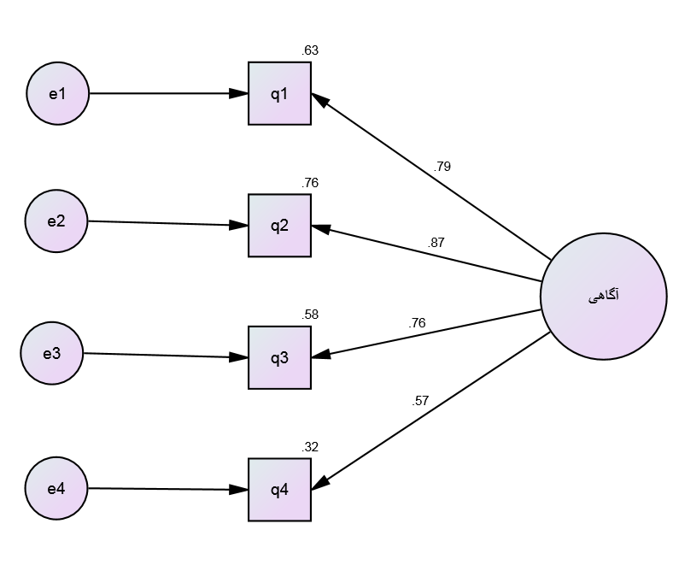

Brand
Awareness

As can be seen in this part of the second question of 0.87 is the maximum load on the structure itself. Also obtained the degree of freedom chi-square value of the order of 4.121 and 2 are obtained.
The second structure: Brand loyalty is with five items.

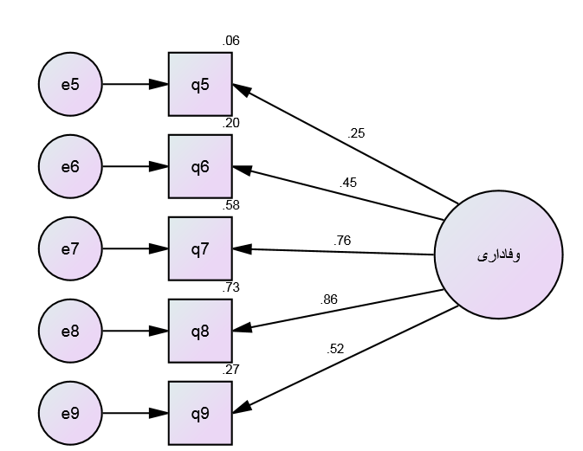

Brand
Loyalty

This is seen as the eighth question of 0.86 is the maximum load on the structure itself. Also obtained the degree of freedom chi-square value of the order of 14.508 and 5 has been obtained.
Third structure: brand associated with 5 items.

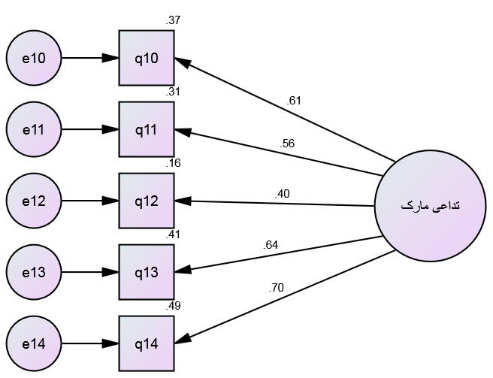

Brand
Association

As seen in this part of the fourteenth question of 0.7 is the maximum load on the structure itself.
The chi-square value obtained degrees of freedom, respectively, 14.261 and 5 have been obtained.
Fourth structure: The perceived of quality brand has 4 items.

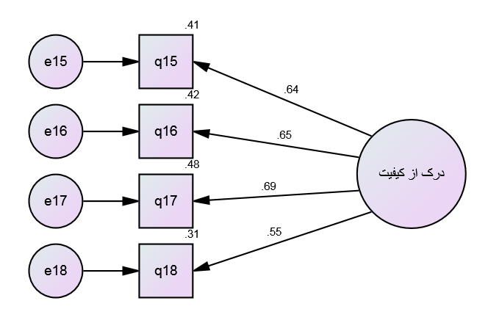

Perceived
Quality

As seen in this part of the seventh question, which is equivalent to 0.69 times the largest structure of its own?
Also obtained the degree of freedom chi-square value of 2.497 and 2, respectively, were obtained.
Fifth structure : Brand image is with 3 items.

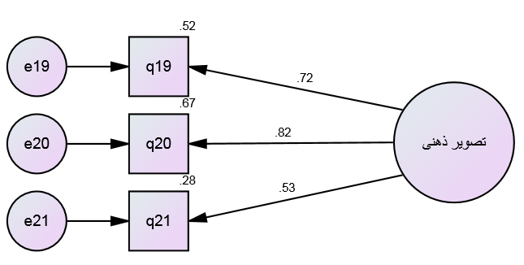

Brand
Image

As seen in this part of the twentieth question which is equivalent to 0.82 times the largest structure of its own.
Also obtained the degree of freedom chi-square value of zero and zero, respectively, were obtained.

5.7 The results showed significant factor loadings above models:

1-First structure (brand awareness)
 |  |  | Estimate | S.E. | C.R. | P | Label
q4 | <--- | q61 | 1.000
q3 | <--- | q61 | 1.380 | .211 | 6.549 | ***
q2 | <--- | q61 | 1.490 | .215 | 6.920 | ***
q1 | <--- | q61 | 1.328 | .199 | 6.685 | ***

As seen from the t-test (index C.R.) and indicate the amount P val between the first item and structures.

2- Second structure (brand loyalty)
 |  |  | Estimate | S.E. | C.R. | P | Label
q9 | <--- | q62 | 1.000
q8 | <--- | q62 | 1.591 | .282 | 5.643 | ***
q7 | <--- | q62 | 1.473 | .259 | 5.679 | ***
q6 | <--- | q62 | .851 | .204 | 4.165 | ***
q5 | <--- | q62 | .403 | .154 | 2.620 | .009

As seen from the t-test (index C.R.) and indicate the amount P val between the Second item and structures.

3- Third structure (brand association)
 |  |  | Estimate | S.E. | C.R. | P | Label
q14 | <--- | q63 | 1.000
q13 | <--- | q63 | .961 | .170 | 5.649 | ***
q12 | <--- | q63 | .588 | .151 | 3.902 | ***
q11 | <--- | q63 | .726 | .140 | 5.195 | ***
q10 | <--- | q63 | .802 | .146 | 5.492 | ***

As seen from the t-test (index C.R.) and indicate the amount P val between the Third item and structures.

4- Fourth structure (perceived quality)
 |  |  | Estimate | S.E. | C.R. | P | Label
q18 | <--- | q64 | 1.000
q17 | <--- | q64 | 1.125 | .221 | 5.083 | ***
q16 | <--- | q64 | .996 | .201 | 4.964 | ***
q15 | <--- | q64 | 1.060 | .214 | 4.952 | ***

As seen from the t-test (index C.R.) and indicate the amount P val between the fourth item and structures.

5- Fifth structure (brand image)
 |  |  | Estimate | S.E. | C.R. | P | Label
q21 | <--- | q65 | 1.000
q20 | <--- | q65 | 1.570 | .317 | 4.950 | ***
q19 | <--- | q65 | 1.488 | .284 | 5.247 | ***

As seen from the t-test (index C.R.) and indicate the amount P val between the fifth item and structures.
Other indicators that the model is fitted to derive the optimal model according to the following table:

Index | Model 1 | Model 2 | Model 3 | Model 4 | Model 5
PMR | 0.014 | 0.044 | 0.031 | 0.015 | 0
AGFI | 0.926 | 0.883 | 0.884 | 0.959 | -
GFI | 0.985 | 0.961 | 0.961 | 0.992 | 1
RMSEA | 0.086 | 0.115 | 0.113 | 0.042 | 0.464
CFI | 0.991 | 0.938 | 0.927 | 0.995 | 1
NFI | 0.983 | 0.911 | 0.896 | 0.978 | 1

As you can see, all the indicators are intended to suggest that all models are a good fit.
5.8 Check a general model based on all the components and also all the items:
This section examines a general model described and evaluated and whether the model fit is good. To do this we have used the software AMOS. This test is called the measurement model.
In this section we have two types of variables: A latent variable values are not known, and we said we have to construct a variable whose value is determined based on the estimated and measured rating questionnaire and we have the privilege directly.

Our general model is the following diagram:
Covariance matrix of latent variables

 | q65 | q64 | q63 | q62 | q61
q65 | .168
q64 | .098 | .202
q63 | .190 | .150 | .268
q62 | .110 | .109 | .217 | .211
q61 | .087 | .074 | .163 | .125 | .183

The relationship between latent variables

 |  |  | Estimate | S.E. | C.R. | P | Label
q61 | <--> | q62 | .125 | .033 | 3.788 | ***
q62 | <--> | q63 | .217 | .047 | 4.575 | ***
q63 | <--> | q64 | .150 | .038 | 3.964 | ***
q64 | <--> | q65 | .098 | .028 | 3.449 | ***
q61 | <--> | q63 | .163 | .036 | 4.514 | ***
q61 | <--> | q64 | .074 | .025 | 2.927 | .003
q61 | <--> | q65 | .087 | .024 | 3.571 | ***
q62 | <--> | q64 | .109 | .033 | 3.308 | ***
q62 | <--> | q65 | .110 | .030 | 3.669 | ***
q63 | <--> | q65 | .190 | .038 | 5.006 | ***

As it is seen as the amount of P val between all variables in the above table is zero (except one which is 0.003) showed significant relationships between the latent variables.

Other parameters of this model are:

Index | Chi-square | PMR | GFI | AGFI | NFI | CFI | RMSEA
model | 291.968 | 0.043 | 0.838 | 0.792 | 0.772 | 0.894 | 0.066

As seen in the indicators are favorable, indicating that the model is a good fit.
5.9 Applications and research proposals:
As the results indicate that it is given the dimensions of awareness, loyalty, association, quality video at a major role in the brand's reputation and brand equity will increase. Therefore, the authors suggest that future research:
1. Given that many models to explain the scope and concept of brand equity, it is planned, Favorable market conditions in other models tested.
2. The company-based, or a combination of financial transparency brand equity in order to exploit their research;
3. Research on the factors affecting the dimensions of brand equity in order to strengthen and improve the effectiveness of the desired dimensions of brand equity is flexible.
4. The research model to other brands and product groups are distinguished tested with results comparable to the results obtained.
5. Successful organizations are built on the concept of equity and transferred to enjoying their successful experiences empowering others to identify more local companies.

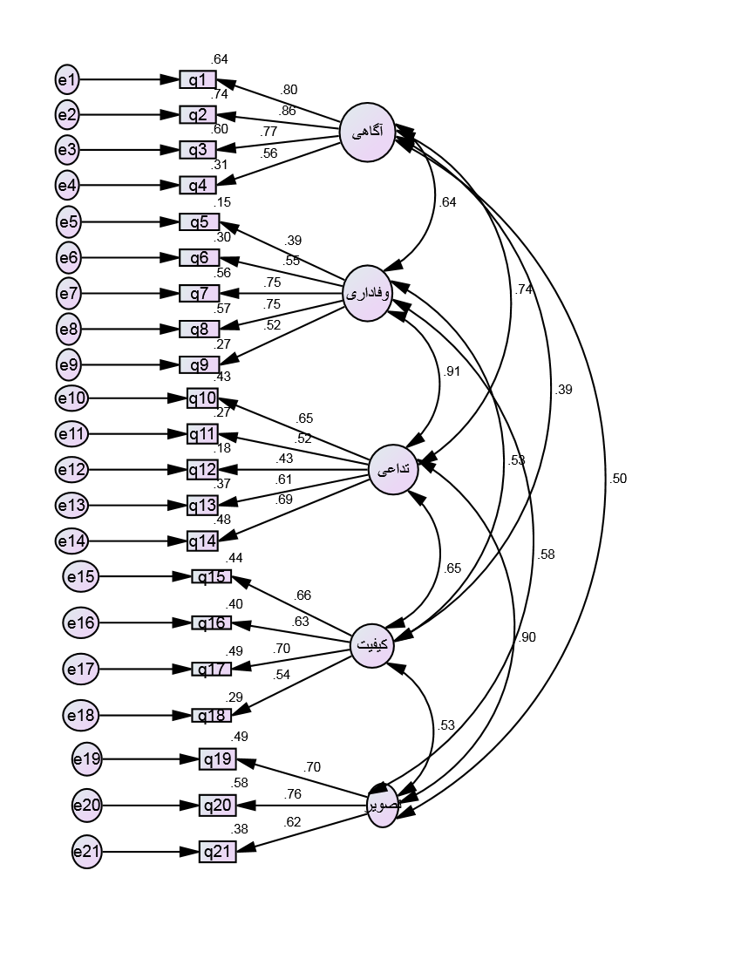
Image

quality

association

Loyalty

awareness

References:
- Aaker, D. A. (1991). Managing brand equity. New York: The Free Press.
- .Aaker, D. A. (1996). Managing brand equity: Capitalizing on the value of the brand name. New York: The Free Press.
- Aaker, D. A., & Joachimsthaler, E. (2000). Brand Leadership. New York: The Free Press.
- Assael, H. (1992). Consumer behavior and marketing action. Boston: PWS-Kent Publishing.
- Atilgan, E., Aksoy, S., & Akinci, S. (2005). Determinants of the brand equity: A verification approach in the beverage industry in Turkey. Marketing Intelligence & Planning, 23(3), 237-248. http://dx.doi.org/10.1108/02634500510597283.
- Baron, R. M., & Kenny, D. A. (1986). The moderator-mediator variable distinction in social psychological research: Conceptual, strategic and statistical considerations. Journal of Personality & Social Psychology, 51, 1173-1182. http://dx.doi.org/10.1037/0022-3514.51.6.1173.
- Bearden, W. O., & Etzel, M. J. (1982). Reference group influence on product and brand purchase decisions. Journal of Consumer Research, 9, 183-194. http://dx.doi.org/10.1086/208911.
- Blackston, M. (1995). The qualitative dimension of brand equity. Journal of Advertising Research, 35(4), 2-7.
- Burmann, C., Schaefer, K., & Maloney, P. (2008). Industry image: Its impact on the brand image of potential employees. Journal of Brand Management, 16(3), 159-176.
- Cavana, R. Y., Delahaye, B. L., & Sekaran, U. (2001). Applied business research: Qualitative and quantitative methods. Queensland: John Wiley & Sons.
- Churchill, G. A., & Brown, T. J. (2004). Basic marketing research. Ohio: South Western.
- Cobb Walgren, C. J., Ruble, C. A., & Donthu, N. (1995). Brand equity, brand preference and purchase intention. Journal of Advertising, 24(3), 25-41.
- Easterby Smith, M., Thorpe, R., & Lowe, A. (2003). Management research: An introduction. California: SAGE Publications.
- Erenkol, A. D., & Duygun, A. (2010). Customers perceived brand equity and a research on the customers of Bellona which is a Turkish furniture brand. The Journal of American Academy of Business, 16(1).
- Farquhar, P. H. (1989). Managing brand equity. Journal of Marketing Research, 1, 24-33.
- Farquhar, P. H., Han, J. Y., & Ijiri, Y. (1991). Recognizing and measuring brand assets. Marketing Science Institute. MA: Cambridge.
- Fiske, S. T., & Taylor, S. E. (1995). Social cognition. New York: McGraw-Hill.
- Gladden, J. M., & Milne, G. R. (2004). Examining the importance of brand equity in professional sport. In S.
- Rosner, & K. Shropshire (Eds.), The Business of Sports. Massachusetts: Jones and Bartless Publishers.
- Hair, J. Jr., Wolfinbarger, M., Bush, R., & Ortinau, D. (2009). Essentials of marketing research. Ohio: McGraw-Hill.
- Howitt, D., & Cramer, D. (2011). Introduction to SPSS statistics in psychology for version 19 and earlier (5th ed.). Essex: Pearson Education Limited.
- Huang, R., & Sarigöllü, E. (2011). How brand awareness relates to market outcome, brand equity, and the marketing mix. Journal of Business Research, 07136.
- Jacoby, J., Olson, J., & Haddock, R. (1971). Price, brand name, and product composition characteristics as determinants of perceived quality. Journal of Applied Psychology, 55(6), 570-579. http://dx.doi.org/10.1037/h0032045.
- James, D. (2005).Guilty through association: Brand association transfer to brand alliances. Journal of Consumer Marketing, 22(1), 14-25. http://dx.doi.org/10.1108/07363760510576518.
- Kapferer, J. N. (2005). The new strategic brand management. London: Kogan-Page.
- Keller, K. L. (1993). Conceptualizing, measuring and managing customer based brand equity. Journal of Marketing, 57, 1-22. http://dx.doi.org/10.2307/1252054.
- Keller, K. L. (1998). Strategic brand management: Building, measuring and managing brand equity. London: Prentice Hall International.

1/28/2015

