The Rapid Propagation Technique of the Medicinal Plant Clinacanthus nutans by Tissue Culture

Bihua Chen ^{1,2,3}, Juan Zhang ^{1,2}, Cui Zhang ³, Yumei Xiao³

^{1.} Fujian Academy of Forestry Sciences, Fuzhou 350012, China
^{2.} Key Laboratory of Timber Forest Breeding and Cultivation for Mountainous Areas in Southern China, Fuzhou 350012, China
^{3.} Fujian Qingliu County Forestry Bureau, Qingliu 365300, China
chenbihua@hotmail.com

Abstract: The traditional medicinal plant Clinacanthus nutans is usually propagated by cutting propagation which has low reproductive capacity. The development of rapid propagation methods for C. nutans is needed to satisfy human demand for its medicinal products. This study developed a pratical tissue culture micropropagation technique for C. nutans by shoot initiation instead of callus induction. The results showed the optimal proliferation medium for C. nutans was Murashige and Skoog (MS) with 1.0 mg L⁻¹ BA + 0.02 mg L⁻¹ NAA providing 3.9 multiplication rate. A rooting medium composed of ½ MS + 0.25 mg L⁻¹ IBA provided 100% rooting and vigourous plantlets. These methods provide reliable mass-propagation of C. nutans for medicinal purposes.
[Chen B, Zhang J, Zhang W, Zhang C, Xiao Y. The Rapid Propagation Technique of the Medicinal Plant Clinacanthus nutans by Tissue Culture. N Y Sci J 2015;8(2):23-27]. (ISSN: 1554-0200). http://www.sciencepub.net/newyork. 4

Keywords: Clinacanthus nutans (Burm. f.) Lindau; tissue culture; medium; plant growth regulator

Abbreviation: BA-benzyladenine; NAA-naphthaleneacetic acid; IBA-indole butyric acid

1. Introduction
Clinacanthus nutans (Burm. f.) Lindau (namely Sabah Snake Grass) is a perennial herb belonging to the family Acanthaceae, widely known as a traditional medicinal plant in Southeast Aisa such as Malaysia, Thailand and China (Guangxi, Guangdong, Yunnan, and Hainan Province) due to its medicinal properties in treating skin rashes, insect and snake bits, skin lesions caused by virus, diabetes mellitus, fever and diuretics, and Dengue disease (Lau et al., 2014; Kunsorn et al., 2013; Goonasakaran, 2013; Sakdarat et al., 2006; Sakdarat et al., 2009; Shim et al., 2013; Sujittapron et al., 2010; Tuntiwachwuttikul et al., 2004). It grows on the low altitude area from 500 to 620 meters, especially under the scattered forests and bushes on the low altitude. The possibility of employing the C. nutans extract acted as an antioxidant substance to ameliorate the oxidative damage (Pannangpetch et al., 2007). Eight compounds namely 132-hydroxy-(132-S)-chlorophyll B, 132-hydroxy-(132-R)-chlorophyll B, 132-hydroxy-(132-S)-phaeophytin B, 132-hydroxy-(132-R)-phaeophytin B, 132-hydroxy-(132-S)-phaeophytin A, 132-hydroxy-(132-R)-phaeophytin A, purpurin 18 phytyl ester and phaeophorbide A have been discovered (Sakdarat et al., 2006). Recent study found C. nutans extracts are antioxidant with antiproliferative effect on cultured human cancer cell lines (Arullappan et al., 2014; Yong et al., 2013). The C. nutans extract had anti-cancer roles was discovered in China (Wang et al., 2013). The leaves of C. nutans were found rich in amino acids, trace elements and bioactive chemical constituents in China suggesting that C. nutans was of high nutritional value (Yi et al., 2012)．
In China, the rare C. nutans is usually propagated by cutting propagation, which is low proliferation freqency. In Malaysia, Ying (2013) and Gunasekaran (2014) succeeded in callus induction but no result in plantlet regeneration. No literature shows the tissue culture propagation technique of C. nutans is achieved. Therefore it is necessary to carry out a rapid propagation method for C. nutans.

2. Material and Methods
The stocks of C. nutans were collected from Shanghai China. The stems with 2-3 nodes from C. nutans were used as explants. The explants were immersed in 70% ethanol for 30 seconds, rinsed in sterilized water, transferred to 0.1% HgCl₂ for 12 min, and then rinsed in sterilized water four to five times. The explants were cut into pieces with one node each then transferred onto shoot initiation medium. The shoot initiation medium comprised: (1) MS + 1.0 mg L⁻¹ BA + 0.1 mg L⁻¹ NAA containing 30 g L⁻¹ sugar and 5.5 g L⁻¹ carrageenan (produced in Quanzhou, Fujian, China), pH 5.8. The explants were incubated in the dark or under weak light for 30 days.
The multiplication media comprised: (2) MS + 1.0 mg L⁻¹ BA + 0.1 mg L⁻¹ NAA; (3) ½MS + 1.0 mg L⁻¹ BA + 0.1 mg L⁻¹ NAA; (4) MS + 1.0 mg L⁻¹ BA + 0.02 mg L⁻¹ NAA; or (5) ½ MS + 1.0 mg L⁻¹ BA + 0.02 mg L⁻¹ NAA, each containing 30 g L⁻¹ sugar and 5.5 g L⁻¹ carrageenan, pH 5.8. The shoots were subcultured every 30 days. There were 30 jars of each medium and 3 replication for the same experiment. The shoots were maintained under 15–25 μmol m⁻² s⁻¹ irradiance (12 h d⁻¹) (Chen, 2009, 2012; Chen et al., 2014) with a room temperature of 26 ± 2°C. Shoot number and average shoot length were measured after each passage, and shoot vigour was observed macroscopically. Shoot multiplication rate was calculated as the average coefficient of multiplication (Sánchez and Vieitez, 1991; Hung and Trueman, 2011).
Shoots of 2.5-cm length were then transferred to one of four rooting media: (6) ½MS + 0.1 mg L⁻¹ IBA; (7) ½ MS+ 0.25 mg L⁻¹ IBA; (8) ½ MS+ 0.5 mg L⁻¹ IBA; or (9) ½ MS+ 1.0 mg L⁻¹ IBA, each containing 20 g L⁻¹ sugar and 6.0 g L⁻¹ carrageenan, pH 5.8. There were 30 jars of each medium and 3 replication for the same experiment. The shoots were maintained under 15–25 μmol m⁻² s⁻¹ irradiance (12 h d⁻¹) with a room temperature of 26 ± 2°C. Rooting percentage, root number, root length and plantlet height were recorded at the end of 60 days in rooting medium. Plantlets were then transplanted into rectangle plastic baskets containing red core soil (natural local soil) in greenhouse.
Data were analysed by analysis of variance (ANOVA) (for 3–6 means), with a post-hoc Tukey’s test if the ANOVA was significant. Means are provided with standard errors, and means were considered significantly different at P < 0.05.

3. Results
The induction rate of the explants was 63.6%, i.e. 21 of total 33 explants were initiated (Figure 1).
Shoot multiplication rate was highest (3.90 ± 0.06 shoots per passage) in full-strength MS medium (Table 1). Shoot multiplication rate and shoot growth vigour did differ between MS and ½ MS media in either 0.1 mg L⁻¹ NAA or 0.02 mg L⁻¹ NAA, but 0.1 mg L⁻¹ NAA reduced the multiplication rate and caused roots. However, continuous culture in full-strength MS medium supplemented with 0.1 mg L⁻¹ NAA caused numerous roots. continuous culture in half-strength MS medium supplemented with either 0.1 mg L⁻¹ NAA or 0.02 mg L⁻¹ NAA caused slight yellowing and limited shoot elongation (1.87 ± 0.03 cm). Rooting in the multiplication passage was not encouraged bacause it caused the proliferation rate decreased. Shoot length and vigour were greatest in MS medium containing 1.0 mg L⁻¹ BA and 0.02 mg L⁻¹ NAA (double ‘a’), and no root was found in this medium (Table 1) (Figure 2).

Table 1. Effect of basal medium and plant growth regulators on proliferation, length and growth vigour of C. nutans shoots
Medium | BA (mg L⁻¹) | NAA (mg L⁻¹) | Average multiplication rate | Average shoot length (cm) | Shoot growth vigour
MS | 1.0 | 0.1 | 2.73 ± 0.12 b | 3.53 ± 0.09 a | All leaves green. Vigorous shoots. Roots. ++
½MS | 1.0 | 0.1 | 1.63 ± 0.09 d | 1.87 ± 0.03 b | Slight yellowing of lower leaves. Slow shoot growth. Roots. +
MS | 1.0 | 0.02 | 3.90 ± 0.06 a | 3.33 ± 0.03 a | All leaves green. Vigorous shoots. No root. +++
½MS | 1.0 | 0.02 | 2.13 ± 0.09 c | 1.60 ± 0.06 c | Slight yellowing of lower leaves. Slow shoot growth. No root. +
Means (± SE) with different letters within a column are significantly different (ANOVA and Tukey’s test; P < 0.05; n = 30 jars). ‘+++’: good; ‘++’: intermediate; ‘+’: poor

Table 2. Effect of plant growth regulators on rooting frequency, root number, root length and plantlet height of C. nutans
Medium | IBA (mg L⁻¹) | Average rooting rate (%) | Average root number per plantlet | Average length per root (cm) | Average plantlet height (cm) | Growth vigour
½MS | 0.1 | 100.0 | 2.23 ± 0.11 b | 4.73 ± 0.74 a | 10.43 ± 0.44 a | All plantlet grew vigourly; leaves green; shoot elongating. +++
½MS | 0.25 | 100.0 | 2.47 ± 0.13 ab | 4.64 ± 0.29 a | 9.39 ± 0.43 ab | All plantlet grew vigourly; leaves green; shoot elongating. +++
½MS | 0.5 | 100.0 | 2.33 ± 0.06 ab | 5.49 ± 0.23 a | 9.54 ± 0.17 ab | All plantlet grew vigourly; leaves green; shoot elongating. +++
½MS | 1.0 | 100.0 | 2.73 ± 0.03 a | 4.44 ± 0.13 a | 7.32 ± 0.81 b | All plantlet grew vigourly; leaves green; shoot elongating. +++
Means (± SE) with different letters within a column are significantly different (ANOVA and Tukey’s test; P < 0.05; n = 30 jars). ‘+++’: good; ‘++’: intermediate; ‘+’: poor

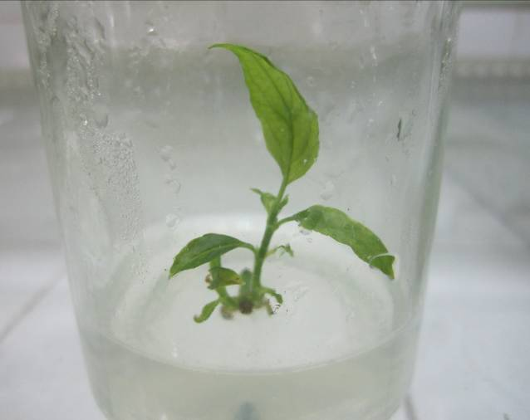 | 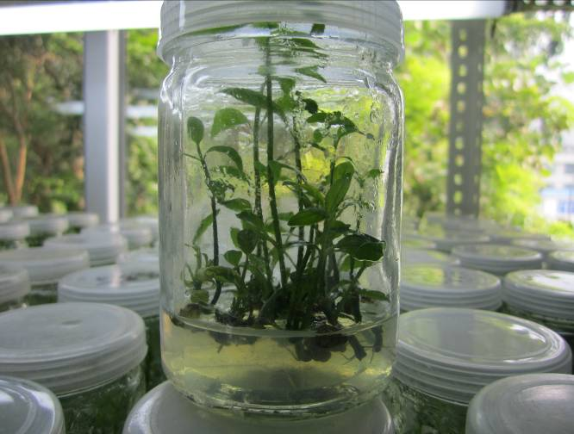
Figure 1. The explant initiated of C. nutans | Figure 2. Proliferation of C. nutans shoots in MS medium containing 1.0 mg L⁻¹ BA, 0.02 mg L⁻¹ NAA
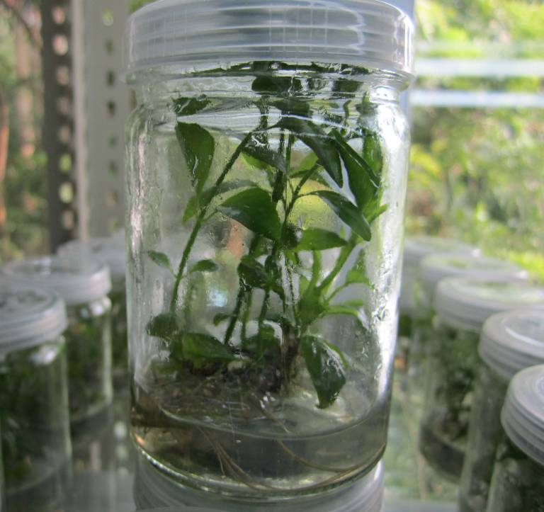 | 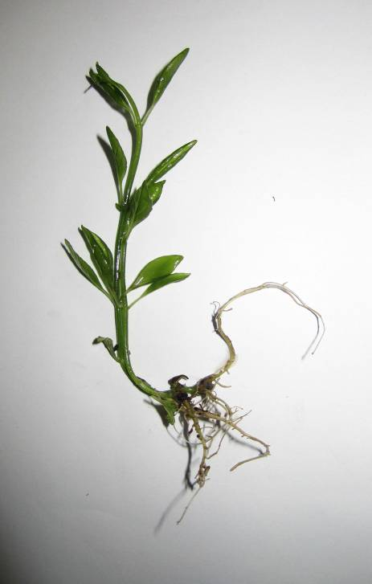
Figure 3. Rooting of C. nutans shoots in ½MS medium containing 0.25 mg L⁻¹ IBA

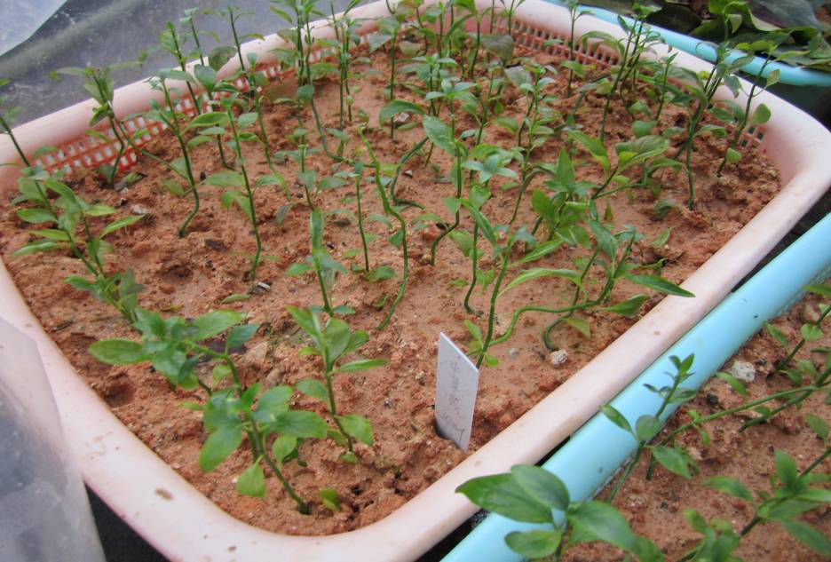
Figure 4. Survival plantlets of C. nutans in the greenhouse

Conversion to plantlets was high (100.0%) in all rooting media (Table 2). However, the optimal combination of highest rooting frequency (100.0%), avearge root number per plantlet (2.47 ± 0.13), root length (5.49 ± 0.23 cm) and plantlet height (9.54 ± 0.17 cm) was obtained with the ½ MS medium supplemented with 0.25 or 0.5 mg L⁻¹ IBA. The plantlets on the two media grew vigourly with normal green leaves and elongating shoots (Figure 3). The plantlets acclimatized readily to glasshouse conditions, with 100% survival (Figure 4).

4. Discussion
The optimal medium for C. nutans propagation was MS + 1.0 mg L⁻¹ BA + 0.02 mg L⁻¹ NAA, which provided a multiplication rate of 3.9 shoots per passage during passages of 30-d duration. Annual shoot production was, therefore, approximately 3.9¹²=12,381,557, which allows mass-propagation of C. nutans in a tissue culture facility. The shoot multiplication rate increases, but shoot size diminishes, during long-term production possibly due to cytokinin accumulation. Thus, BA and NAA concentrations could be adjusted during long-term propagation to maximize shoot production and quality (Chen et al, 2014).
The low inorganic salt and nitrogen concentrations of hall-strength MS medium reduced shoot elongation and caused slightly yellowing of leaves. The high inorganic salt concentration of full-strength MS medium accelerated shoot elongation and the shoots grew with normal green leaves. The medium containing 0.1 mg L⁻¹ NAA caused rooting in the proliferation stage indicated 0.1 mg L⁻¹ NAA was too much for the propagation of C. nutans.
The use of ½ MS as the basal medium supplemented with IBA from 0.1 to 1.0 mg L⁻¹ provided virtually 100% rooting but the optimal combination of highest avearge root number per plantlet, root length and plantlet height was obtained with the ½ MS medium supplemented with 0.25 or 0.5 mg L⁻¹ IBA. There were not significant different between ½MS medium supplemented with 0.25 and 0.5 mg L⁻¹ IBA. Considering the economic factor, ½ MS medium supplemented with 0.25 mg L⁻¹ IBA was selected as the rooting medium, which could lower the production cost during mass propagation.
The callus induction and plantlet regeneration for C. nutans is not easy to achieved (Ying, 2013; Gunasekaran, 2014). The extracts from the callus and suspension cells used for drugs are controversial since it may contain residual composition of plant growth regulators.
Compared to other medicinal plants, tissue culture technique of C. nutans achieved more easily than that of Tripterygium wilfordii and Dendrobium officinale (Chen, 2009; Chen et al, 2014).

Acknowledgements:
The research was funded by Fujian Forestry Administration Department, China.

Corresponding Author:
Dr. Bihua Chen
Fujian Academy of Forestry Sciences
Xindian, Jin'an, Fuzhou
Fujian 350012, China
E-mail: chenbihua@hotmail.com
References
- Arullappan S, Rajamanickam P, Thevar N, Kodimani C C. In Vitro Screening of Cytotoxic, Antimicrobial and Antioxidant Activities of Clinacanthus nutans (Acanthaceae) leaf extracts. Tropical Journal of Pharmaceutical Research 2014;13 (9):1455-1461.
- Chen B. In vitro propagation of a medicinal plant: Tripterygium wilfordii Hook f. Forestry Studies in China 2009;11:174-8.
- Chen B. Study on the tissue culture technique of Liriodendron chinense × L. tulipifera. Hubei Forestry Science and Technology 2012;3:10-13.
- Chen B, Trueman SJ, Li J, Li Q, Fan H, Zhang J. Micropropagation of the Endangered Medicinal Orchid, Dendrobium officinale. Life Sci J 2014;11(9):526-530.
- Goonasakaran S A. Preliminary Antimicrobial and Phytochemical Analysis of Clinacanthus nutans and Azadirachta indica, Master Thesis, Technological University of Malaysia, Johor, Malaysia, 2013.
- Gunasekaran U. Callus Induction and Plant Regeneration Studies of Clinacanthus nutans (Sabah Snake Grass), Bachelor Thesis,Tunku Abdul Rahman University, Kuala Lumpur, Malaysia, 2014.
- Kunsorn P, Ruangrungsi N, Lipipun V, Khanboon A, Rungsihirunrat K. The identities and anti-herpes simplex virus activity of Clinacanthus nutans and Clinacanthus siamensis. Asian Pac J Trop Biomed 2013:3(4):284-290.
- Lau K W, Lee S K, Chin J H. Effect of the methanol leaves extract of Clinacanthus nutans on the activity of acetylcholinesterase in male mice. Journal of Acute Disease 2014;3(1): 22-25.
- Pannangpetch P, Laupattarakasem P, Kukongviriyapan V, Kukongviriyapan U, Kongyingyoes B, Aromdee C. Antioxidant activity and protective effect against oxidative hemolysis of Clinacanthus nutans (Burm.f) Lindau. Songklanakarin J. Sci. Technol 2007;29 (Suppl. 1):1-9.
- Sakdarat S, Shuyprom A, Ayudhya T D N, Waterman P G, Karagianis G. Chemical composition investigation of the Clinacanthus nutans Lindau leaves. Thai Journal of Phytopharmacy 2006;13(2):13-24.
- Sakdarat S, Shuyprom A, Dechatiwongse N A T, Waterman P G, Karagianis G. Chemical composition investigation of Clinacanthus nutans Lindau leaves. Thai J Phytopharmacol 2006;13(2):13-24.
- Sakdarat S, Shuyprom A, Pientong C, Ekalaksananan T, Thongchai S. Bioactive constituents from the leaves of Clinacanthus nutans Lindau. Bioorganic & Medicinal Chemistry 2009;17:1857-1860.
- Shim S Y, Aziana I, Khoo BY. Perspective and insight on Clinacanthus nutans Lindau in traditional medicine. International Journal of Integrative Biology 2013;14(1):7-9.
- Sittiso S, Ekalaksananan T, Pientong C, Sakdarat S, Charoensri N, Kongyingyoes B. Effects of Compounds from Clinacanthus nutans on Dengue Virus Type 2 Infection. Srinagarind Med J 2010; 25 (Suppl):272-275.
- Tuntiwachwuttikul P, Pootaeng-on Y, Phansa P, Taylor W C. Cerebrosides and a monoacylmonogalactosyglycerol from Clinacanthus nutans. Chem Pharm Bull 2004; 52(1):27-32.
- Wang X E, Zhong X W, Zhang W X, Wang Y F. Analysis of the chemical constituents of Clinacanthus nutans and their anti-cancer roles. China Pharmacy 2013;24(43):4104-4107.
- YI B, XU W T, Deng D, Deng T. Analysis of Amino Acids, Trace Elements and Chemical Constituents from the Leaves of Clinacanthus nutans. Pharm J Chin PLA 2012;28(5):396-399.
- Ying N Y. Establishment of Axenic Explants and Callus Culture of Clinacanthus nutans (Rumput Belalai Gajah), University Malaysia Sarawak, Kota Samarahan, Malaysia, 2013.
- Yong Y K, Tan J J, The S S, HuiMah S, Ee G C L, Chiong H S, Ahmad Z. Clinacanthus nutans Extracts Are Antioxidant with Antiproliferative Effect on Cultured Human Cancer Cell Lines. Evidence-Based Complementary and Alternative Medicine 2013:1-8.

1/28/2015

