E-Health In Sindh: Study Of Initiatives, Challenges And Implications

Shazma Tahseen¹, Shah Muhammad Kamran²

¹ Department of Information Technology, Liaquat University of Medical and Health Sciences Jamshoro Sindh Pakistan.

² School of Economics, Huazhong University of Science and Technology (HUST) Wuhan, P R China.

Abstract: Objectives: The main objective of the present study was to examine e-health progress focusing on initiatives and challenges in usage and implementation of e-health programs in medical universities of Sindh. Methodology: A survey type study was focused on the challenges being faced by medical institutes and organizations while implementing e-health systems. The method of data collection used was questionnaire from medical professionals and health care providers beside this; interviews were also conducted with prominent administrative heads for expert opinion. Results: At the time of survey there was seven degree awarding institutes in the province, two are in Hyderabad and five are in Karachi. All the Seven medical universities were included in survey and they all positively responded except one. Conclusion: To increase the chances of success, it is important to assess the readiness of health-care institutions before implementing e-health programs. If users are not well aware about technology they won’t be able to judge or accept it positively ultimately resulting negative effects instead of improvements. There is a need of comprehensive policy and master plan before initiating a project.
[Shazma Tahseen, Shah Muhammad Kamran. E-health in sindh: study of initiatives, challenges and implications. N Y Sci J 2015;8(2):37-40]. (ISSN: 1554-0200). http://www.sciencepub.net/newyork. 7

Keywords: Initiatives, Challenges, E-Health, ICT, Sindh.

1. Introduction
The use of ICT in health care is referred to as “e-health”, which has been defined by World Health Organization (WHO) as “the cost-effective and secure use of ICT in support of health and health-related fields, including healthcare services, health surveillance, health literature, and health education, knowledge and research” (Khoja, 2008b). ICT is at the heart of modern healthcare systems and services and can distribute information worldwide, in particular to the developing world. Many countries are greatly emphasizing on the implementation of e-health projects in order to use ICT to improve the efficiency and effectiveness of the health care system. National and international e-health initiatives are challenged by deep-rooted problems and lack of infrastructure and investment. World Population is increasing day-by-day that has the converse effect on available life-living resources and thus causes to face challenges like increased poverty, food insecurity, social & economic disparities, digital divide and deteriorating climatic situation. As per estimates, the world population has crossed 7 billion in the year 2011, more than 80% of whom live in developing countries. Developed countries account for only 17.8% of the total world population. (World Population Prospects, the 2010 Revision, population division, United Nations, 2011). By this divide of population in developed and developing countries it is obvious that most of the problems are being faced by the developing world. In developing countries besides other challenges and problems, providing better health care is also a greater issue. Situation of Pakistan is not different from other developing countries, have not enough clinical and medical resources in terms of human resources and infrastructure. It is the 6th most populous country in the world – more than 180 million people, where 65% of the population lives in rural areas. Khoja et al (2008) highlighted the serious health issues related to rural-urban disparity in delivery of healthcare services in Pakistan, he further stated that the population is concentrated in the villages and small towns and medical services in those areas are far from sufficient. Ratio of the number of doctors to population is 1:1555, and for the case of specialists it gets even worse 1:12800 (Androuchko and Malik, 2008). Poor management of the health sector cannot help to solve all these problems.

Table 1: Total number of doctors across provinces
Province | Number of Doctors
Punjab/Federal Area | 57653
Sindh | 57889
K.P.K | 16595
Balochistan | 4181
A.J.K. | 2574
Total | 142682
Source: PMDC (September, 2012).

E-health is comparatively new to Pakistan and many initiatives are being taken, The Telemedicine Association of Pakistan was formed in March 2005 with the objectives to implement better E-health services and provide an umbrella for all telemedicine activities in the country. Telemedicine/tele-health was introduced in 1998 by Elixir technologies, in Taxilla and Gilgit. The pilot project initiated in Taxilla was a step to consultation through email and named as Tele-consultation Project while in Gilgit same facility was introduced with addition of live voice chat. These projects showed that telemedicine can be used successfully for provisioning of specialist care in remote areas of the country. A telemedicine training centre was established in Pakistan with the support of USA to train the medical staff about telemedicine applications where initially 45 doctors/ nurses were trained. Pakistan space agency SUPARCO established a satellite based telemedicine network in Sindh province, initially it was limited to Karachi and Shikarpur (Malik, 2007).
This study is novel as the medical universities of Sindh are studied, focusing on challenges and barriers in usage and implementation of e-health programs.

2. Methodology
This study was focused on the challenges being faced by medical institutes and organization while implementing e-health systems. For clear understanding and analysis a framework was followed and questionnaire was designed accordingly. The method of data collection used was questionnaire from medical professionals and health care providers beside this; interviews were also conducted with prominent administrative heads for expert opinion.
3. Results
Medical universities in Sindh are autonomous bodies, however, Ministry of Health, Government of Sindh and PMDC (Pakistan Medical & Dental Council) regularly monitor their education & quality of services and directions according to policies. At the time of survey there was seven degree awarding institutes in the province, two are in Hyderabad and five are in Karachi. All the Seven medical universities were included in survey and they all positively responded except one.
Policy and Experience
Regarding e-health no policy exists at any university, only two out of six universities have constituted committees to formulate policy, somehow all showed positive concerns about e-health programs and the linkage between ICT and Health for better health care.
Motivational Factors
Motivation is the crucial base for initiating programs. Various motivational factors were listed for respondents to select as many as appropriate. Most of the institutes highlighted cost-effectiveness as an attraction towards e-health which leads moderate price for good quality e-health product/services. Patient’s journeys, hospital visits and hospital admissions are too much time consuming activities; implementation of e-health applications can reduce the consumption of time. Highly motivating factor for (04 out of 06) universities to implement ICT in health is its time saving ability of the beneficiaries. Office automation is another strong motivating factor for the use of ICT in health; it is also the most implemented application of e-health. Four out of six universities are being attracted by the e-health to automate the administrative tasks but practically almost every university using e-health applications for administration and management. Four out of six universities showed their desire to improve the quality or effectiveness of the care or treatment that is delivered. Another free option was given to the respondents of the questionnaire in which they were requested to inform about any other motivating factor to adopt e-health applications, only one institute responded to this. The same institute is implementing and adopting e-health to innovate the processes and services being delivered, collaborative research is also motivating towards e-health.
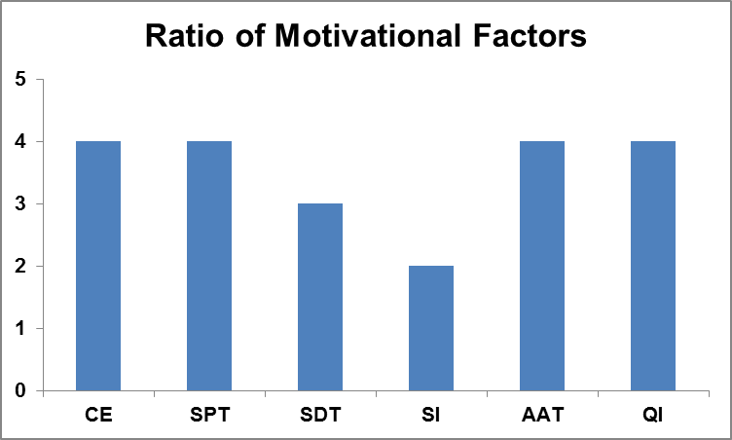
Figure 1: Ratio of motivational factors adopting e-health Priority areas for e-health services:

Priority areas for e-health services:
E-health covers vast and different areas of services and processes, as institutes implement/adopt it for different reasons with different priorities. Following table shows the priority list stated by the universities.

Table 2: Priority Areas
Priority Area | MODE
Patient’s Electronic Record System | 1
Hospital Information System | 2
E-Learning | 3
Telemedicine | 4
E-Administration (billing and  administrative data management) | 5
E-Conferencing | 6
Tele-Homecare (remote monitoring) | 7
Tele-Consultancy | 8

Running and discontinuation of projects
Almost all of the institutes are working on some e-health projects in Sindh, namely HMIS, Health Care Management System, Distance Learning Education Program, iPath and Open MRS and few others. Most of the projects were in progress at the time of survey. Whereas some of the respondents also stated that few of the projects had been discontinued due to the following reason:
- No proper plan/ policy.
- Lack of financial support
- Inadequate resources
- Poor / weak infrastructure
- Lack of awareness among users.
The reasons of discontinuation of projects vary from university to university.
Financial Issues
Proper allocation of funds is of greater importance for initiating and running a project successfully. Survey results showed that three of the universities have allocated separate funds for e-health whereas rests of the universities don’t. Government organizations such as HEC were also mentioned as fund provider for e-health programs, while some private companies are also a financial supporter for few universities regarding e-health projects.

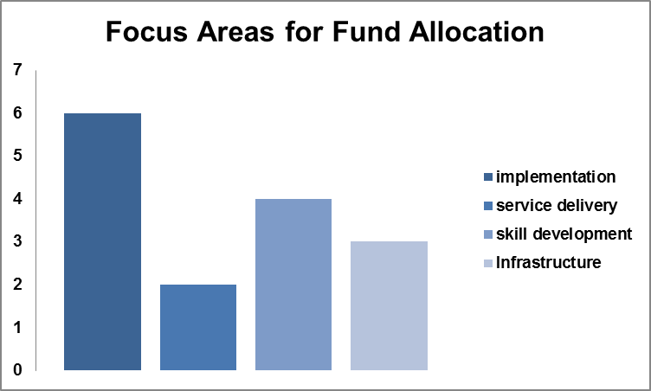
Figure 2: Focus Areas for fund allocation on different areas of e-health

The following chart presenting the percentage of proportion of overall funds allocation by medical universities of Sindh on different areas of e-health.
HR Development/Capacity Enhancement
Survey results showed that Key personnel in medical universities of Sindh normally have intermediate and advanced skills of IT. Five of the universities have included ICT Training as part of curricula and four out of six medical universities of Sind are collaborating with other institutes for e-health programs. All four universities those collaborating with other institutes are sharing their knowledge (reports, patients records, literature, research), two are also sharing their professionals to gain knowledge/ benefit from experience. One institute among two is engaged in joint projects and research in the vast field of e-health. Three universities also organizing events to create awareness about e-health generally in masses and especially in health professionals.

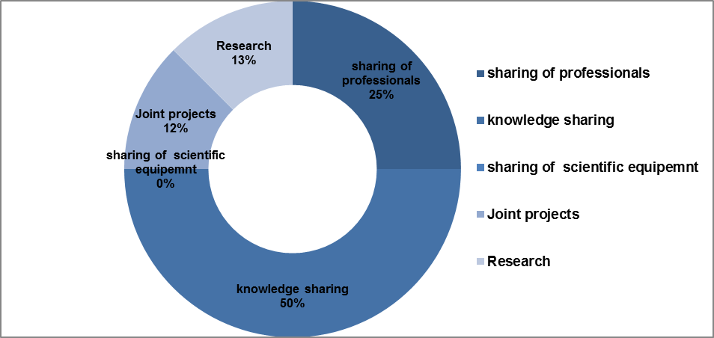
Figure 3: Collaboration with other institutes for e-health programs

Infrastructure
Every medical degree awarding institute of Sindh has a separate full-fledged information technology (IT) department to support general IT activities whereas four out of six universities has also established advance IT infrastructure for specialized e-health applications such as HMIS and EHR.

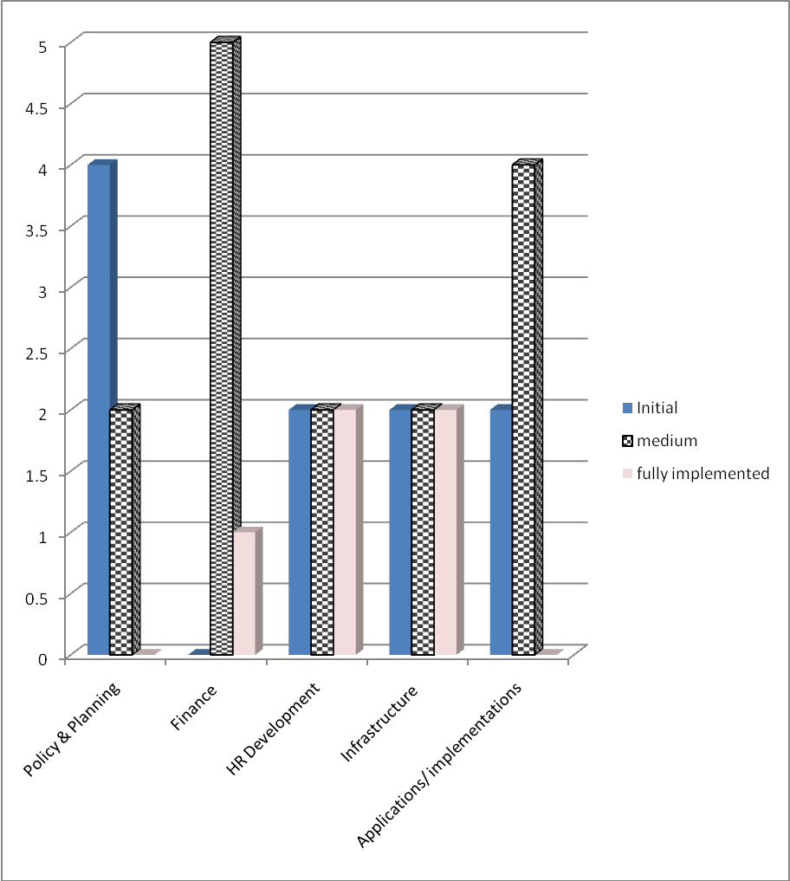
Figure 4: Overall position of E-Health in Universities

E-Health Status in Medical Universities of Sindh
On the basis of data collection and survey analysis the following graph shows the overall position of E-Health in Universities in Sindh.

4. Discussion
With regard to e-health, Sindh province overall status is at medium level after studying various factors such as: policy and planning, financial issues, HR development, Infrastructure etc. E-health is not yet a priority for government and no any formal e-health policy exists. E-health is not even revealed in the health policy of year 2011, though almost every institute has realized the potential of e-health. Only few of the institutes have started working on policy formulation by constituting bodies to work on. Separate funds for e-health projects are not allocated, some corporate sector are financing e-health projects and HEC is also facilitating pilot projects, whilst many of the projects have been discontinued just because of lack of funds and poor planning.
Another reason for projects failure is lack of documentation and coding. In case of personnel replacement with others, it consumes a lot of time to get clear understanding of system due to absence of proper coding and paper work. E-health skilled human resource is available and competent enough to initiate and carry on the basic e-health projects. Basic IT infrastructure is available in health sector, most of the institutes have provided computers, printers and internet accessibility to their staff, whereas some institutes have specialized e-health infrastructure using latest technology working on various projects.

Conclusion
In the recent worse status of health sector in Pakistan and province as well, e-health can contribute more to improve conditions of health in terms of accessibility and quality of health care, but uses of ICT in health is at its infancy stage facing many challenges and barriers.
To increase the chances of success, it is important to assess the readiness of health-care institutions before implementing e-health programs. If users are not well aware about technology they won’t be able to judge or accept it positively ultimately resulting negative effects instead of improvements. There is a need of comprehensive policy and master plan before initiating a project. Finally, research concludes that there is a lot of work to be done in e-health requires more improved plans and projects to make betterment in health services.

Corresponding Author:
Shazma Tahseen
Department of Information Technology, Liaquat University of Medical and Health Sciences Jamshoro Sindh Pakistan.

References

Ahmed S. Mujtaba et al, 2012. Telemedicine: need of time. Journal of Pakistan Medical Association. October 2012.
- Androuchko, V. and Malik, A.Z, 2008.Pakistan – How To Speed Up the Introduction of E-health Services in Developing Countries.
- Boncana G. Heidi, 2013. Using e-health to Improve Health Delivery in Bangladesh. Knowledge for health.
- Eysenbach, G. 2001. What is e-health? Journal of Medical Internet Research (Jmir.org) 3 (2): e20. Retrieved 15-04-2012.
- Fedorov, G, 2007. E-health in Asia and the pacific challenges and opportunities. UNESCAP, Bangkok, October, 2008.
- Khoja,S. and Scott, R. 2008. Developing a Conceptual-Framework for E-Health Readiness Assessment Tools for Developing Countries.
- Khoja, S. et al, 2008. E-health readiness assessment: promoting "hope" in the health-care institutions of Pakistan. Journal of World hospitals and health services, 44(1). pp 36-8.
- Mishra, S. et al. 2008.The Current Status of e-health Initiatives in India, making the e-health connection, Bellagio Italy July 13 – August 08 2008.
- Moehr, J.R. et al. 2006.Success factors for tele-health—A case study. International journal of medical informatics 75, 755–763.
- Nora, E. 2012. Telemedicine in Developing Countries: Challenges and Successes. Harvard College Global Health Review (HCGHR). February 1, 2012.
- Pagliari, C. et al. 2005. What Is e-health (4): A Scoping Exercise to Map the Field. Journal of Medical Internet Research (Jmir.org) 7 (1): Retrieved 15-04-2012.
- Wright, D. 1998. Telemedicine and developing countries. A report of study group 2 of the ITU Development Sector. J Telemed Telecare4 Suppl 2:1-85.
- WHO, 2010. TELEMEDICINE opportunities and developments in member states. Global Observatory for e-health series. Volume: 2.

World Health Organization, 2011. Atlas e-health country profiles: based on the findings of the second global survey on e-health.

Zafar A. Malik, 2007. Telemedicine Country Report-Pakistan.

2/3/2015

