**Concrete waste production and the cost of three different concrete work methods in construction projects: a case study approach in Iran**

Amir B. Meibodi, Dr. H. Kew, Dr. H. Haroglu

School of Civil Engineering and Construction, Kingston University London, KT1 2EE, UK

[amir.meibodi@kingston.ac.uk](mailto:amir.meibodi@kingston.ac.uk)

**Abstract:** In recent decades, construction waste has become a serious environmental problem in many large cities around the globe. The construction sector in Tehran (the capital of Iran) produced 50,000 tonnes of waste each day in 2010 alone. Furthermore the growing young population, changing lifestyles and rising demand for housing increases the consumption of construction material, hence generating more waste. Two main materials are used to construct buildings in Iran: steel and concrete. It is therefore important to pay attention to concrete construction waste in Iran. There are different methods of concrete construction and each of these approaches has its own weaknesses and strengths in terms of minimising concrete waste. This paper aims to explore the three methods of concrete construction that are used in the Iranian construction industry, namely in-situ concrete, ready-mixed concrete and pre-fabricated concrete elements. The use of ready-mixed concrete and pre-fabricated concrete elements are known as the two effective methods for minimising concrete waste as opposed to traditional in-situ concrete construction. A case study in Tehran was used to illustrate the concrete waste generation of the three different methods in a construction project. It also explores the cost aspect of each method when implementing. In this case study, structured observations and note taking have been conducted to record the performance of each method. The use of a digital camera has also been used to record each method. The findings revealed that the use of pre-fabricated concrete elements generates less on-site concrete waste than the other two methods while in-situ concrete is found to be the most cost effective.

[Amir B. Meibodi, H. Kew, Dr. H. Haroglu. **Concrete waste production and the cost of three different concrete work methods in construction projects: a case study approach in Iran.** *N Y Sci J* 2015;8(2):74-80]. (ISSN: 1554-0200). <http://www.sciencepub.net/newyork>. 13

**Keywords:** On-Site (IN-Situ) Concrete, Pre-fabricated concrete, concrete waste, Ready Mix concrete, Waste minimization

**1. Introduction**

In recent decades, construction waste has become a significant environmental problem in many large cities around the globe [1]. Construction and demolition (C&D) waste is considered as one of the major producers of the total waste stream due to its massive amount. It is somehow revealed that the material waste in a great number of construction sites is over the acceptable limits [2]. For instance, in Australia the National Waste Minimization and Recycling Strategy has estimated that each year 14 million tonnes of solid waste is disposed to the landfill [2]. Teo et al. [3] reported that in Canada construction waste is estimated about 30 per cent of solid waste. In the USA, it produces approximately 20 per cent of overall landfill waste volume while it produces more than 50 per cent in the UK. In Hong Kong in 2001, the construction and demolition sector has produced more than 40 per cent of the total waste [4]. The Construction industry in Tehran produced 50,000 tonnes of waste each day in 2010 alone [5]. In Tehran the average construction and demolition waste generation is about 4.64 kg *per capita* per day based on reports from Tehran Municipality Waste Management [6].

Furthermore in Iran the growing young population, changing lifestyles and rising demand for housing increase the consumption of construction material, hence generating more waste in the future [7]. Therefore, minimisation of construction and demolition waste has become a sensitive topic among experts in the construction sector [8].

In order to minimize the construction waste, apart from waste quantification, which is the initial requirement for the waste minimisation process [9], cost has also traditionally been one of the major elements in the waste minimisation process ([10]; [11]).From a financial point of view, although waste generated by construction and demolition is a problem for the clients, it is also a problem for the contractors, which could eventually lead to profit loss or even bankruptcy [12].

Concrete has been proved to be a leading construction material for more than a century. It is estimated that the global production of concrete is at an annual rate of approximately 2.5 tonnes per capita [13]. Concrete also has been one of the main waste materials in construction projects [14].

There are different methods for concrete works and each of these methods has its own weaknesses and strengths in terms of minimising concrete waste or the cost of concrete works. The use of ready-mixed concrete and pre-fabricated concrete elements are known to be the two effective methods for minimising concrete waste as opposed to in-situ concrete construction ([15]; [9]; [16]; [17]). In-situ concrete is the traditional form of concrete construction, which was the main method used for concrete works until the early part of the 20th century [18]. Further explanation about these three methods has been described in the next section.

This paper aims to explore the cost and waste production of the three methods of concrete works that are currently used in the Construction Industry, namely in-situ concrete, the use of ready-mixed concrete and use of pre-fabricated concrete elements. In order to retrieve in-depth data, a case study research was conducted [19], based on the design and build of a seven story residential building project in north Tehran/Iran.

**2. Background on concrete waste management**

According to Lu and Yuan [20] current construction and demolition waste management research has mostly focused on the use, demolition, recycling, and disposal of construction materials. Therefore, future research is recommended to be extended in the production and delivery of construction materials such as concrete. As stated above, the use of ready mix concrete and pre-fabricated concrete elements are two effective methods for minimising the concrete waste in comparison with the traditional in-situ concrete ([15]; [9]; [16]; [17]; [21]; [22]). This section explains more about the three concrete work methods, which are investigated in this research case study.

*Pre-fabricated concrete elements*

Previous studies illustrate that using pre-fabricated concrete elements instead of in-situ concrete can reduce the construction and demolition waste [9]. There is an estimation, which shows that by using pre-fabricated concrete elements, the amount of waste can be reduced by between 20 to 50 per cent rather than waste generated on the similar site using traditional construction methods [21]. Poon et al. [22] claims that the use of pre- fabricated concrete elements has exposed a significant decrease in the amount of waste production by approximately 30 to 40 per cent. Pre-fabricated building components can contribute considerably to “zero waste production” because of the dry construction works on site, flexibility in installation, high adaptability, and the reuse of the elements [23]. Although pre-fabricated concrete elements and in-situ concrete are conducted with the same process, the manufacturers pre-fabricated elements are produced under more controllable conditions. The following functions are some of the waste reduction reasons of pre-fabricated concrete methods to compare with the equivalent concrete work in-situ [21]:

* Prevention of long and continuous concrete making and pouring operations
* Significant decrease or even prevention of temporary shuttering
* Controlled curing of concrete
* Enhanced quality controls at the manufacturers
* Any unforeseeable stop during the concrete works because of weather conditions

*Ready mix concrete*

As it is claimed by the ready mix concrete manufacturers,modern formwork systems and efficient site management minimise ready-mixed concrete wastage, by less than two per cent [24]. There is very little waste associated with ready-mixed concrete as the precise volume required can be delivered ([25]; [26]). Ready mix concrete is used wildly all over the world for concrete works, for instancethere are around 1200 ready-mix concrete plants in the UK, producing 23.5 million cubic meters of concrete each year [27].

*In-situ concrete*

The method of pouring the liquid concrete material into forms at the building site is called in-situ concrete [28]. This was the main method used for concrete works until the early part of the 20th century [18].

There are studies all over the world in relation to the comparison of these three methods of concrete work. For instance the work of De Silva and Vithana [9] compared the three methods together in Sri Lanka. In the UK, a WRAP case study compared the Pre-cast concrete with In-situ concrete in terms of waste production [23]. However, there is limited information for comparison of the afore-mentioned three methods in Iran due to inadequate use of pre-fabricated concrete elements in Iranian construction industry. As a result, it is hoped that the case study used in this paper may shed some light on use of adequate methods in terms of concrete waste minimisation. The reason to use a case study approach is because case studies demonstrate valuable insights in situations where existing knowledge is limited as recommended by Harris and Ogbonna [29].

**3. Methodology**

In order to explore the cost and waste production of the three methods of concrete works, a case study was conducted. According to Hong et al., [10] case studiesinvolve the analysis of real world problems, which can be experienced or observed. The nature of this research was exploratory followed by descriptive research. According to Fellows and Liu [19], a descriptive case study is aimed at systematically identifying and recording a certain phenomenon or process.

The data collection methods used in this case study were face-to-face semi-structured interviews accompanied by the collection of hard documentary data, and the audit of cost and waste arising.

The case study used in this paper was the design and build of a 7-story residential building project with the concrete frame structure in North Tehran. Each floor above the basement had the same floor plan and sections, therefore volume of concrete works used at each floor was equal. The concrete works for the building’s structure was conducted from March 2013 and June 2013.

Contractor X used three methods for casting concrete made elements as follows:

* In-situ concrete (making and pouring): for floors 5&6
* Ready mix concrete: for floors 3&4
* Pre-fabricated concrete elements: for floors 1&2

The total floor space was approximately 2,100 m2. Construction of the concrete frame structure took approximately 3 months. Costs of any expenditure have been recorded both by the researcher, and the contractor. The contractor agreed to provide the recorded data for the research.

According to White [31], purposive sampling is used when there is a specific reason for selecting a certain participant in a study in order to retrieve the relevant data to meet the research objectives. The contractor was chosen from a list of first-grade construction contractors in Tehran [32]. After correspondence with the municipality of Tehran, and the Civil Engineering Organization of Tehran, a list of contractors who had the planning permission for constructing concrete structure buildings was prepared. According to the author’s experience, usually in Iran both in-situ concrete and ready mix concrete are used in one project in different stages. However for this study, a company who would use all these three methods in one project was needed. This is because in this research having the same conditions (e.g. same environment, same contractor and personnel, same management and so forth) for all the three methods had been contemplated. Therefore after corresponding with 4 contractors, finally Contractor X consented to use these three methods of concrete works together because firstly: the contractor was also client of the project, and secondly: the contractor was interested in investing in the pre-fabricated concrete industry. The contractor requested to receive a copy of the results at the end of the research study. The process of choosing the case study, which consisted of finding the appropriate contractor and project, took approximately four months, from November 2012 to February 2013.

Due to ethical considerations, the name of the contractor has not been published for confidentiality purposes. In addition, the data retrieved from the research has been stored securely with other research documents.

In order to collect, two main methods comprising of Interviews and Audits were conducted [33]. Firstly, face-to-face semi-structured interviews were conducted with the contractor’s personnel. For statistical data collection, a total number of six interviews were conducted with the site supervisor (one interview after completion of each floor). For financial data collection one interview was conducted with the contractor’s accountant. Secondly, Audits included the audit of cost and audit of waste arising. They involved a combination of: visual inspections of the site waste generated during concrete works; and analysis of company documents to determine quantities of waste arising and also process costs.

The two sets of data for each concrete work method were collected and then the average was calculated and used in the study [31]. Total cost for each method was calculated according to ICBC [34].

The total waste generated from each method was calculated based on the following equations [9].

*W=* *MA –* *MR* (4)

*W (%)=(W / MR)* x 100 (5)

Where *W* is amount of Waste generated in cubic meter, *MA* is quantity of actual material (concrete) used by volume, and *MR* is quantity of required materials based on the structural drawings, or in other words, *MA* is Purchased amount in cubic meter, and *MR* is measurements of concrete works in the project’s plan in cubic meter.

**4. Results and discussion**

Table 1:Cost, and concrete waste generation of methods

|  |  |  |  |  |
| --- | --- | --- | --- | --- |
| Concrete work method | Total amount of concrete works (m3) | Cost per cubic meter of concrete | W=Total waste generated (m3) | W (%) |
| In-situ Concrete (Floors 5 & 6) | 470 | Equal to £ 72 | 4.5 | 0.96 |
| Ready Mix Concrete (Floors 3 & 4) | 470 | Equal to £ 103 | 4.3 | 0.91 |
| Pre-Fabricated Elements (Floors 1 & 2) | 470 | Equal to £170 | 0.04 | 0.01 |

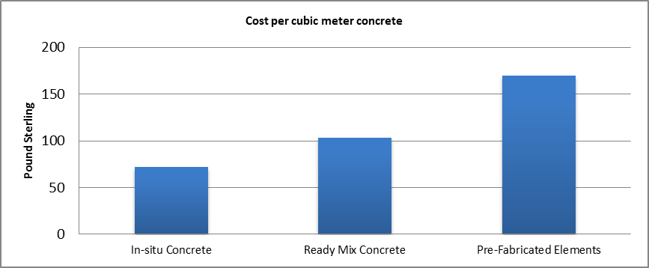

Fig. 2. Total cost of methods per cubic meter

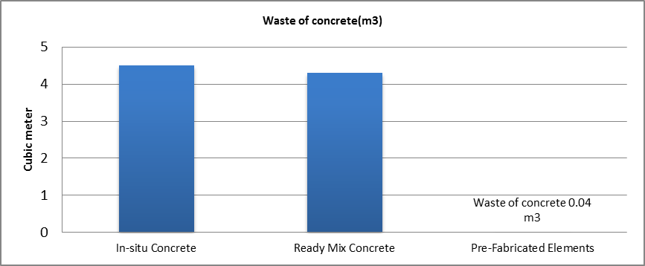

Fig. 3. Concrete waste production of methods

The total cost of each method and waste generation in the case study are presented in table 1, and illustrated in Fig 2 and 3.

In order to find out the proportion of each method’s expenditure, the percentage of cost for each method are needed.

The percentage of cost of each methods by the total cost of concrete works, are presented in table 2 have been achieved.

In order to find out the proportion of the concrete waste generation of each method, waste of each method has been divided by the total amount of concrete waste generated by all three methods. The reason for doing this is the plan volume of concrete works in each floor was equal.

Table 2: Percentage of cost of methods

|  |  |
| --- | --- |
| Concrete work method | *Percentage of Cost* |
| In-situ Concrete  (Average of floor 5 & 6) | 20.8 % (*PCIN*) |
| Ready Mix Concrete  (Average of floor 3 & 4) | 29.9 % (*PCRM*) |
| Pre-Fabricated Elements  (Average of floor 1 & 2) | 49.3 % (*PCP*) |

Table 3: Waste of concrete By Volume:

|  |  |  |  |
| --- | --- | --- | --- |
| Concrete work method | Total Concrete works | Waste of concrete | *Percentage of waste in total*  *concrete waste* |
| In-situ Concrete (Average of floor 5 & 6) | 235 m3 | 2.25 m3 | 50.9% (*PWIN*) |
| Ready Mix Concrete (Average of floor 3 & 4) | 235 m3 | 2.15 m3 | 48.3 % (*PWRM*) |
| Pre-Fabricated Elements  (Average of floor 1 & 2) | 235 m3 | 0.02 m3 | 0.8 % (*PWP*) |

Table 3 illustrates the percentage of concrete waste of each method by the total amount of concrete waste for all concrete works.

Finally, in order to illustrate the differences between the methods in a more comprehensible way, the following figures have been drawn, which show the cost (Fig. 5) and wastes generation (Fig. 4) proportions associated with each method.

 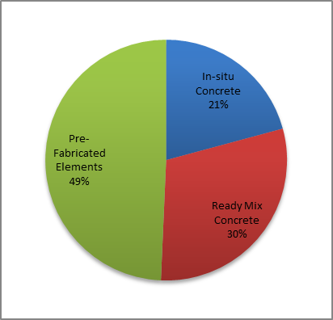

Fig. 4. Percentage of concrete waste generation of methods. Fig. 5. Percentage of cost of methods

The result of the Observation case study indicates that the use of pre-fabricated concrete elements in this case study has the most cost and least on-site concrete waste in comparison with the other two methods. On the other hand, in-situ concrete (Making concrete on-site) has the least cost, and the most concrete waste production. However the amount of waste generated from using Ready mix concrete can significantly increase by poor purchase management, the excess ordering of materials, large quantity of concrete remains in pump car and pump pipe and poor quality workmanship at the site level [9]. It therefore appears that the Iranian contractors would prefer to use either In-situ or ready mix concrete instead of pre-fabricated elements due to the high cost of using pre-fabricated concrete elements. The contractor rather pays the tax for the wastes instead of paying nearly double the concrete price in order to reduce the waste by maximum 0.95 percent.

**5. Conclusion and recommendation**

This case study approach aimed to examine the cost, and concrete waste production ofthree different methods of making and pouring concrete in a construction project in Tehran. The research approach used in this study was the Triangulation approach, which is a combination of the quantitative and qualitative approach. Data collection methods used was interviews accompanied by the collection of hard documentary data. Semi-structured interviews, and audits of cost and waste arising were conducted.

The result of the case study indicates that use of pre-fabricated concrete elements has the most cost (£170 per cubic meter of concrete) and the least on-site concrete waste (0.01% waste production) than the other two methods. In-situ concrete has the least cost (£72 per cubic meter of concrete), and the most concrete waste production (0.96% waste production). Furthermore, although there is a significant reduction in material waste when pre-fabricated elements are used, the consultants and contractors are still not interested in the usage of this method in their projects in the Iranian construction industry due to the high costs involved with the pre-fabricated construction.

Some recommendations for implementation are highlighted. The waste of ready mix concrete should be reduced by proper purchase management, the accurate ordering of materials as well as decreasing the quantity of concrete, which remains in the pump car and pump pipe. In addition, the high quality workmanship at the site level, education and training could also help with reducing waste.

**References**

1. Begum, R.A., Siwar, C., Pereira, J.J., Abdul Hamid Jaafar, A.H., (2006), ”A benefit–cost analysis on the economic feasibility of construction waste minimisation: The case of Malaysia”, Resources, Conservation and Recycling 48 (2006) 86–98.
2. Kulathunga, U., Amaratunga, D., Haigh, R. and Rameezdeen, R. (2006), "Attitudes and perceptions of construction workforce on construction waste in Sri Lanka", Management of Environmental Quality, Vol. 17 No. 1, pp. 57-72.
3. Teo, M.M.M. and Loosemore, M. (2001), "A theory of waste behaviour in the construction industry", Construction Management and Economics, Vol. 19 No. 7, pp. 741-51.
4. Wong, E.O.W. and Yip, R.C.P. (2004), "Promoting sustainable construction waste management in Hong Kong", Construction Management and Economics, Vol. 22 No. 6, pp. 563-6.
5. TMWM (The organization of Tehran Municipality Waste Management), (2011), “*The summary of annual performance of Tehran Municipality Waste Management Organization* (in Persian)”. Available from: http://pasmand.tehran.ir/Default.aspx?tabid=41 / (accessed 9.7.12).
6. Saghafi, M.D. and Teshnizi, Z. A. H. (2011), “Building deconstruction and material recovery in Iran: An analysis of major determinants”, International Conference on Green Buildings and Sustainable Cities. Available online at www.sciencedirect.com, Procedia Engineering 21 (2011) 853 – 863.
7. Ardakani, M. and Madani, H. (2009), “*An* *overview of construction and demolition wastes Management”* (in Persian), Tehran: Building and Housing Research Center (in press).
8. Lam, P.T.I., Chan, E.H.W., Poon, C.S., Chau, C.K., Chun, K.P., 2010, Factors affecting the implementation of green specifications in construction Journal of Environmental Management 91 (2010) 654–661.
9. De Silva, N. and Vithana, S. (2008), “Use of PC elements for waste minimization in the Sri Lankan construction industry”, Structural Survey 26. 3 (2008): 188-198).
10. Hong, T. and Ji, ch. and Park, H. (2012), “Integrated model for assessing the cost and CO2 emission (IMACC) for sustainable structural design in ready-mix concrete”, available at Elsevier, Journal of Environmental Management 103 (2012) 1-8).
11. Jaillon, L., Poon, C.S., Y.H. Chiang, Y.H., 2008, “Quantifying the waste reduction potential of using prefabrication in building construction in Hong Kong”, Waste Management 29 (2009) 309–320.
12. Ekanayake, L.L. (2000), "A design based building waste assessment (BWAS) prediction model for Singapore", unpublished MSc thesis, National University of Singapore, Singapore.
13. Neville, A.M., Neville on concrete, Farmington Hills, Michigan, ACI International, 2003.
14. Kofoworola, O.F., Gheewala, S.H., 2009, Estimation of construction waste generation and management in Thailand, Waste Management 29 (2009) 731–738.
15. Bakhtiar, K.A., Li, Y.S., and Misnan, S.H., 2008. A framework for comparison study on the major methods in promoting sustainable construction practice. *Journal Alam Bina* 12(3), 55-69.
16. Osmani, M., Glass, J., and Price, A.D.F., 2007, “Architects’ perspectives on construction waste reduction by design”, Waste Management 28 (2008) 1147–1158.
17. Tam, W.Y.V., 2008. “On the effectiveness in implementing a waste-management-plan method in construction”, *Waste Management* 28 (2008) 1072–1080.
18. CCANZ, 2014, In-situ concrete, available at [www.ccanz.org.nz/page/In-Situ-Concrete.aspx](http://www.ccanz.org.nz/page/In-Situ-Concrete.aspx) (30/07/2014).
19. Fellows, R. F. and Liu, A. M. (2008), “Research Methods for Construction”, 3rd edition, blackwell publishing Ltd.
20. Lu, W., Yuan, H., (2011) “A framework for understanding waste management studies in construction”, Waste Management 31 (2011) 1252–1260).
21. WRAP. “Current Practices and Future Potential in Modern Methods of Construction– Final report”. 2007. Document available on [www.wrap.org.uk](http://www.wrap.org.uk).
22. Poon, C.S., Yu, A.T.W., Wong, S.W. and Cheung, E. (2004b), "Management of construction waste in public housing projects in Hong Kong", Construction Management and Economics, Vol. 22 No. 7, pp. 675-89.
23. WRAP, Offsite Construction Case Study, WAS 003-003, 2007, Available at http://www.wrap.org.uk/sites/files/wrap/Pre-cast%20concrete%20-%20Full%20case%20study.pdf.
24. The Concrete Centre, Concrete Credentials: Sustainability, MPA, 2010,ISBN:978-1-904818-72-2, available at: http://www.concretecentre.com/online_services/publication_library/publication_details.aspx.
25. WRAP, (2013), Ready-Mix Concrete Resource Efficiency Action.
26. brmca, sustainability report (2013), available at**:** [www.brmca.org.uk/sustainability.php](http://www.brmca.org.uk/sustainability.php).
27. Sealey, B.J. and Phillips, P.S. and Hill, G.J. (2001), “Short communication Waste management issues for the UK ready-mixed concrete industry”, available at Resources, Conservation and Recycling 32 (2001) 321–331, www.elsevier.com/locate/resconrec.
28. Britannica, 2014, In-situ concrete, available at [www.britannica.com/EBchecked/topic/284418/in-situ-concrete](http://www.britannica.com/EBchecked/topic/284418/in-situ-concrete) (30/07/2014).
29. Harris, L.C. and Ogbonna, E. (2002) “The unintended consequences of cultural inter-Ventions: a study of unexpected outcomes”, *British Journal of Management*, **13**(1), 31–49.
30. Yin, R. K. (2009), *Case study research: Design and methods.* Newbury Park, fourth edition. CA: Sage.
31. White, B. (2000) *Dissertation Skills for Business and Management Students*. South-Western CENGAGE Learning.‬‬
32. IBCC (Book of Construction Contractors of Iran), 2012, Iran’s ministry of planning and budgeting, available at www.oldpmn.mporg.ir/ContractorCompanies.aspx.
33. Jones, J., Jackson, J., Tudor, T., and Bates, M., 2012, “Strategies to enhance waste minimization and energy conservation within organizations: a case study from the UK construction sector”, Waste Management & Research 30(9) 981–990.
34. ICBC (Iran’s construction Bills of Quantity list) (2013-2014), Iran’s ministry of planning and budgeting, available at [www.fehrestbaha.ir/index.php/1391-06-21-12-23-38/189--92](http://www.fehrestbaha.ir/index.php/1391-06-21-12-23-38/189--92).

2/15/2015