The Environmental Effects of Amalgam Tooth Fillings

Abdulsalam. I. Rafida¹, Abdulhmid.M. Alkout¹ and Abdultif. M. Alroba²

¹Tripoli University Faculty of medical Technology, Tripoli, Libya
²Department Environment Sciences and Engineering - Academy of Libyan for Graduate Studies, Libya
Abdulsalam_62rafida@hotmail.com

Abstract: This study investigates the heavy metal content in the saliva of persons with amalgam tooth fillings. For this purpose, samples of saliva have been collected based on two factors i.e. the number of amalgam fillings in the mouth (one, two or three fillings), and the time factor i.e. the time since the fillings have been in place (less than a year and more than a year). Samples of saliva have also been collected from persons with no amalgam tooth fillings for control. The samples that have been collected so far, have been examined for the basic heavy metal content featuring amalgam, which include mercury (Hg) and silver (Ag). However, all the above mentioned elements have been detected in the samples of saliva of the persons with amalgam tooth fillings, though with varying amounts depending on the number of fillings. Thus for persons with only one filling the average quantities were found to be 0.00061 ppm and 0.033 ppm for Hg and Ag respectively. On the other hand for persons with two fillings the average quantities were found to be 0.0012 ppm and 0.029 ppm for each of the two elements respectively. However, in order to understand the chemical reactions associated with amalgam tooth fillings in the mouth, the material have been treated outside the mouth using some nutrient media. Those media included drinking water, fizzy drinks and hot tea. All three media have been found to contain the three elements after amalgam treatment. Yet, the fizzy drink medium was found to contain the highest levels of those elements.
[Abdulsalam. I. Rafida, Abdulhmid.M. Alkout and Abdultif. M. Alroba. The Environmental Effects of Amalgam Tooth Fillings. N Y Sci J 2015;8(5):48-52]. (ISSN: 1554-0200). http://www.sciencepub.net/newyork. 8

Keywords: Amalgam, Mercury, Silver.

1. Introduction
Amalgam is one of the oldest materials to be used for tooth treatment. It is made up by mixing a powder and liquid to give a material that solidifies when injected into tooth cavities. The Chinese were the first to use that material, followed latter by the Europeans. In the early nineteenth century some scientists in Europe were strongly opposed to the use of this material led by a German chemist called Stook in 1945 who noticed the damage caused by the fumes of mercury to some medical doctors while preparing the material for treating their patients (Westcott, A. 1996 and Molin C. 1992).
However, mercury is known to constitute an important ingredient of many industries particularly the paper industry, in the manufacture of equipments for measuring temperature (thermometers) and blood pressure, and as an electric conductor in electric lamps. So, given its wide use, mercury has become a main hazard to the environment and efforts have been made to minimise the health risks associated with the use of mercury-based materials (Abdul Muniem, 1998). Mercury released from amalgam used for tooth treatment and other waste from medical labs has been estimated to make 5 % of the total (World Health Organization (WHO), 2005). It has also, been discovered that those who become exposed to mercury fumes at dental clinics particularly pregnant women and children could possibly develop allergic symptoms. However, long periods of exposure could result in very serious health risks including kidney failure (Life Sciences research Organization, LSRO, 2005).

2. Material and Methods
Samples of saliva have been gathered from patients at random, who have tooth fillings featuring the material under investigation. The experimental samples have been subdivided into four groups as follows: the control group (with no tooth fillings), a group with one filling, a group with two fillings and a group with three or more fillings (See Table 1).
Some freshly prepared filling material has been introduced into human nutrients and left for the same period of time (24 houres) follows:
1- Drinking water free of any additives (before adding the filling material the water does not contain any silver-based or mercury-based materials)
2- Fizzy drink with the following ingredients: water, CO2 gas, caramel colouring, phosphoric acid, caffeine, preservatives, natural flavour.
3- Hot tea featuring the following ingredients: caffeine, vitamins B, C and E, Fluorine, gamma-amino butyric acid, catechine, thiamine.
For evaluating the heavy minerals under investigation samples of saliva and fluid food materials have been prepared through digestion and condensation method using nitric acid (HNO3, 65 %). The evaluation was made with the help of the atomic absorption machine nov AA400 produced by Analaytik Jena-Ltd. The machine is highly sensitive with a power of detection of (0.01) nanogram / Liter.

Table (1): The sampling scheme.
Group | Number of samples
 | Life span of the filling less than a year (number of samples) | Life span of the filling more than a year (number of samples)
No fillings | 4 | 4
One filling | 4 | 4
Two fillings | 4 | 4
Three or more fillings | 4 | 4

3. Results and Discussions
One Tooth Filling:
Mercury:
From the results shown on Table (2) and Fig (1) it could be seen that mercury has been more or less present in all samples under investigation including the control samples and the samples featuring individuals with one tooth filling. However, while the control samples have shown very low concentration i.e. 0.0003 ppm on average, the filling samples have obviously shown high concentration i.e. 0.0015 ppm on average. Yet, the concentration for samples featuring fillings of less than one year old has ranged between 0.0008 ppm and 0.002 ppm. On the other hand the samples featuring fillings more than one year old have shown concentration ranging between 0.0006 ppm and 0.0047 ppm. At this point it could be noteworthy that as the filling became older less mercury would be released into the mouth. Also, it is worth mentioning that the above values are below the limits that are considered toxic to the human body as prescribed by the (WHO, 2004) and (Agency for Toxic Substance and Disease Registry, ATSDR, 2006).

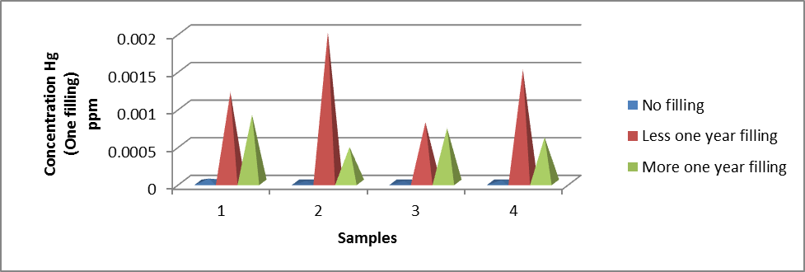
Fig (1): show mercury concentration in samples of saliva featuring persons with one tooth filling.

Table (2): Mercury concentration in samples of saliva featuring persons with one tooth filling.
Concentration Hg  No filling  ppm | Concentration Hg  One tooth filling  (Less one year filling)  ppm | Concentration Hg  One tooth filling  (More one year filling)  ppm
0.00005 | 0.0012 | 0.0009
0.00002 | 0.002 | 0.00047
0.00002 | 0.0008 | 0.00072
0.00003 | 0.0015 | 0.0006

Silver:
From the results shown on Table (3) and Fig (2) silver (Ag) element has been present in all samples of saliva including the control samples. The control samples have shown an average silver content of (0.013 ppm), while that average becomes higher in the samples featuring tooth fillings.
Yet, the highest silver content appeared to be associated with fillings less than one year old ranging between 0.021 ppm to 0.07 ppm. In the meantime samples featuring more than one year old fillings have shown an average silver content ranging between 0.013 ppm and 0.07 ppm. It becomes obvious that the silver content increases in samples of saliva featuring persons with tooth fillings. It is also obvious that those results exceed the safety levels allowed by some organizations such as (United States Environmental Protection Agency, USEPA, 1991), and (WHO, 2004). Those results appear to be consistent with Pizzichini et al., 2011 who has concluded that that the elements of mercury and silver are ubiquitous in saliva produced by persons with tooth fillings.
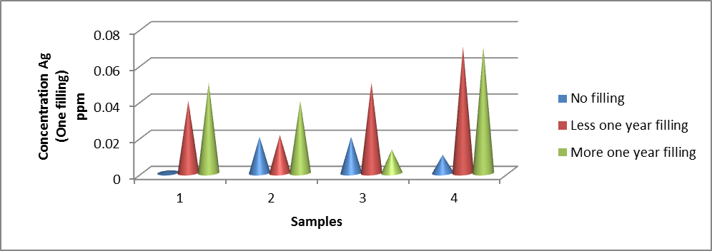
Fig (2): Show silver concentration in samples of saliva featuring persons with one tooth filling.

Two Tooth Filling:
Mercury:
From the results on Table (4) coupled with Fig (3) it could be seen that mercury (Hg) is present in the control samples as well as saliva samples featuring persons with two fillings. But nonetheless the control samples have shown very low mercury content with an average of 0.00004 ppm. On the other hand the samples associated with tooth fillings have shown higher mercury contents averaging 0.0013 ppm. In this regard samples featuring fillings less than one year old show averages ranging between 0.00021 ppm to 0.0006 ppm. However, for samples featuring more than one year old fillings the averages range between 0.00012 ppm to 0.0007 ppm, indicating that less amounts of mercury are being released into the mouth with increasing age of the fillings.
The above values are less than the levels prescribed by international organizations such (WHO, 2004) and (ATSDR, 2006) that might cause health risks to humans.

Table (3): Silver concentration in samples of saliva featuring persons with one tooth filling.
Concentration Ag  No filling  ppm | Concentration Ag  One tooth filling  (Less one year filling)  ppm | Concentration Ag  One tooth filling  (More one year filling)  ppm
0.001 | 0.04 | 0.05
0.02 | 0.021 | 0.04
0.02 | 0.05 | 0.013
0.01 | 0.07 | 0.07

Table (4): Mercury concentration in samples of saliva featuring persons with two tooth filling.
Concentration Hg  No filling  ppm | Concentration Hg  Two tooth filling  (Less one year filling)  ppm | Concentration Hg  Two tooth filling  (More one year filling)  ppm
0.00005 | 0.0003 | 0.0007
0.00002 | 0.0006 | 0.0004
0.00002 | 0.00021 | 0.00021
0.00003 | 0.0004 | 0.00009

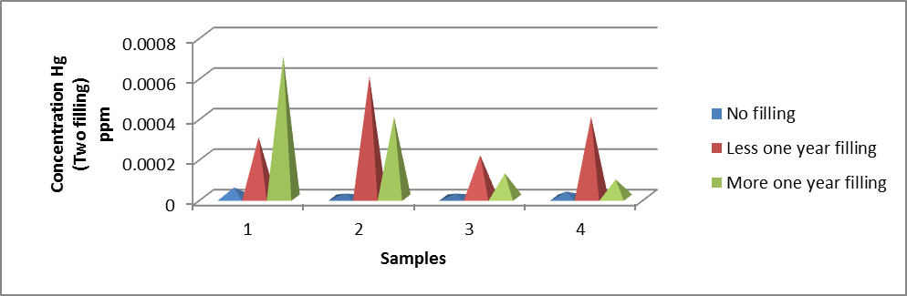
Fig (3): show mercury concentration in samples of saliva featuring persons with two tooth filling.

Silver:
The results shown on Table (5) coupled with Fig (4) would indicate the presence of silver in all samples including the control samples. The control samples show an average silver content of 0.013 ppm and this average increases in samples associated with tooth fillings. However, for samples less than one year old the average silver content ranges between 0.03 ppm to 0.09 ppm, while for fillings more than one year old the average silver content ranges between 0.05 ppm and 0.25 ppm. At this point it could be concluded that the increasing silver content exists in the saliva of persons with tooth fillings. The results indicate that the silver content has always exceeded the safety limits prescribed by international organizations such as (USEPA, 1991) and (National Institute of Occupational Safety and Health, NIOSH, 2003).
Table (5): Silver concentration in samples of saliva featuring persons with two tooth filling.
Concentration Ag  No filling  ppm | Concentration Ag  One tooth filling  (Less one year filling)  ppm | Concentration Ag  One tooth filling  (More one year filling)  ppm
0.001 | 0.04 | 0.05
0.02 | 0.03 | 0.08
0.02 | 0.09 | 0.25
0.01 | 0.07 | 0.1

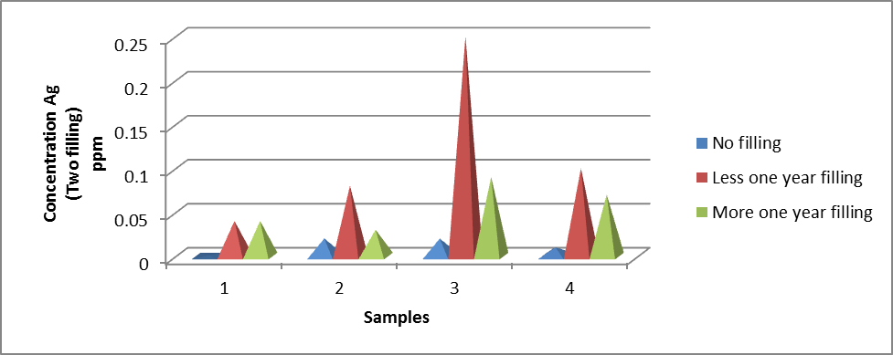
Fig (4): show silver concentration in samples of saliva featuring persons with two tooth filling.

Three Tooth Filling:
Mercury:
From Table (6) and Fig (5) mercury is present in all samples including the control samples and samples featuring persons with three fillings. However, despite the low mercury content in the control samples averaging 0.00004 ppm, and yet for persons with fillings that average goes up to reach 0.0012 ppm. On the hand for persons with fillings less than one year old the average mercury content ranges between 0.00005 ppm and 0.0003 ppm, while for persons with fillings more than one year old the silver content show averages ranging between 0.0005 ppm and 0.007 ppm. It is obvious that mercury released into the mouth is a function of increasing age of filling as well as the number of fillings i.e. increasing amounts of mercury are released into the mouth with increasing number of fillings and older age of fillings. The above shown amounts are less than the safety limits prescribed by (WHO, 2004) and (ATSDR, 2006).

Table (6): Mercury concentration in samples of saliva featuring persons with three tooth filling.
Concentration Hg  No filling  ppm | Concentration Hg  Two tooth filling  (Less one year filling)  ppm | Concentration Hg  Two tooth filling  (More one year filling)  ppm
0.00005 | 0.00005 | 0.007
0.00002 | 0.00006 | 0.0009
0.00002 | 0.00003 | 0.0005
0.00003 | 0.00004 | 0.0008
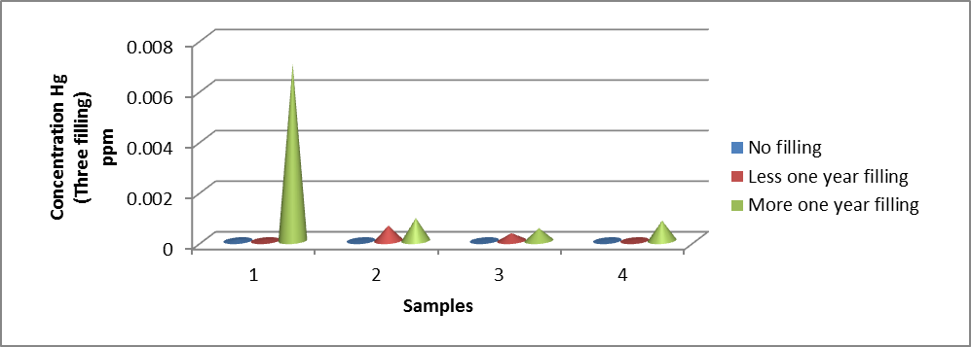
Fig (5): show mercury concentration in samples of saliva featuring persons with three tooth filling.

Silver:
From Table (7) and Fig (6) the silver element is present in all samples including the control samples and the samples featuring persons with three tooth fillings. The control samples have shown an average silver content of 0.02 ppm, and yet that average increases for persons with tooth fillings. However, the fillings of less than one year old have shown averages very close to the control samples. But nonetheless those averages more or less go up with samples featuring persons with fillings more than one year old averaging between 0.02 ppm and 0.04 ppm. In other words silver is always present in saliva featuring persons with tooth fillings. But the above results so far do not exceed the safety limits prescribed by (USEPA, 1991) and (NIOSH, 2003). The results associated with persons with three fillings appear to be consistent with some studies such as Omar, 2008 and Barregard, 1993 in relation to the safety limits of mercury in the human body.

Table (7): Silver concentration in samples of saliva featuring persons with three tooth filling.
Concentration Ag  No filling  ppm | Concentration Ag  One tooth filling  (Less one year filling)  ppm | Concentration Ag  One tooth filling  (More one year filling)  ppm
0.001 | 0.02 | 0.02
0.05 | 0.03 | 0.04
0.02 | 0.03 | 0.04
0.01 | 0.02 | 0.03

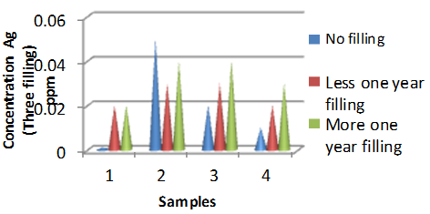
Fig (6): show silver concentration in samples of saliva featuring persons with three tooth filling.

Mercury and Silver after treating the tooth fillings with some liquid nutrients:
The results on Table (8) and Fig (7) show the results of mercury and silver content after treating the tooth fillings with some liquid nutrients. For drinking water mercury has shown an average concentration of 0.0569 ppm, while the concentration has been 0.0416 ppm for tea, and 0.0318 for fizzy drink. It is obvious that the mercury concentration is high for all media, which exceed the safety limits prescribed for drinking water by the local authorities in Libya and by the WHO. On the other hand for silver concentration the results are 0.005 ppm, 0.004 ppm and 0.004 ppm for drinking water, tea and fizzy drinks respectively. Those values still fall within the safety limits prescribed by the above mentioned organizations, though the results indicate that treatment with liquid nutrients tend to release the elements under investigation.

Table (8): mercury and silver concentration after treating the tooth fillings with some liquid nutrients.
Types human nutrients | Concentration mercury  ppm | Concentration silver  ppm
Fizzy drink | 0.0318 | 0.004
Drinking water | 0.0569 | 0.005
Hot tea | 0.0416 | 0.004

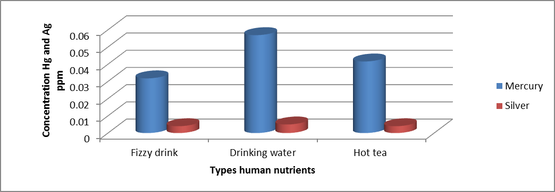
Fig (7): show mercury and silver concentration after treating the tooth fillings with some liquid nutrients.

Conclusion:
The results obtained from this study indicate that the elements of mercury and silver are always associated with tooth fillings. However, despite the high mercury content in all samples featuring tooth fillings, and yet those level have not exceeded the safety limits prescribed by the international organizations. Silver element on the other hand has also been associated will tooth fillings, but in all samples the amounts have always exceeded the safety limits as indicated by the above shown results. Also, it has become evident that some nutrients play a major role in the release of some heavy metals from the tooth fillings into the saliva and then into the different parts of the body.

References
- Abdul Munie. N. (1998) Environmental Impacts of Chemicals. Press Cairo University, Egypt. Stirilng G.
- Agency for Toxic Substance and Disease Registry, (ATSDR). (2006) Medical Management Guidelines for Mercury.
- Barregard. L (1993) Biological monitoring of exposure to heavy metals. Scand J work Enivron Health, Vol 19, pp: 45-49.
- Life Sciences Research Organization, (LSRO). (2005) Review and Analysis of the Literature on the Health Effects of Dental Amalagams.
- Molin. C. (1992) Amalgam- fact and fiction. Scand J Dent Res, Vol 100 (1), pp 66-73.
- National Institute of Occupational Safety and Health, (NIOSH). (2003) Occupation Hygienists, Vol, 49, pp:375- 585.
- Omar. M, A (2008) Environmental Chemistry. press Dar- Scientific Book, Cairo, Egypt.
- Pizzichini, M and F. Sugheriui (2001) Release of mercury from dental amalgam and its influence on salivary antioxidant activity. J. Science of Total Environment Vol. 284, pp:19-25.
- United States Environmental Protection Agency (USEPA). (1991) Guidelines for Developmental Toxicity Risk Assessment.
- Westcott. A. (1996) Report to the onondongia medical Society on metal paste (amalgam). Am J Dent Sci IV, 1st ser, 1844, pp: 175-201.
- World Health Organization (WHO). (2004) Concise International Chemical Assessment Document 50: Human Health Aspect. Press in Geneva, Switzerland.

5/4/2015

