Modeling Surface Water Quality Upstream Cairo Drinking Water Plants

M.A. Reda^{1,2}, Samia Abou El- Ftouh Mohamed², P.H.S. Riad², H.A. El Gammal³ and M.M. Nour El Deen²

¹Greater Cairo Water Company, Cairo, Egypt
²Irrigation and Hydraulic Dept., Faculty of Engineering, Ain Shams University, Cairo, Egypt
³National Water Research Center, Ministry of Water Resources and Irrigation, Cairo, Egypt
mohamedahmedreda@yahoo.com

Abstract: The population growth, economic development, with the consequent anthropogenic activities in Egypt and global climate change pose to reduce the quality trends of surface water resources. The limited amounts of rainfall make the country dependent mainly on the Nile River. The management of river water quality is a major environmental challenge. Cairo, sits on the River Nile south of the Mediterranean Sea, just upstream of the point where the river widens into the Delta. Cairo has an average reach length along the river about 50 km (from Km 900 to km 950 Referenced to Aswan High Dam). This research study area covers Cairo governorate along the River Nile, bounded by El Saff town at Km 877.00 from the South and El Kanater town at Km 953.00 from the North. This area is of particular importance in the study of surface water quality because; industrial and municipal wastes, agricultural and run-off from developing areas were mixing with river flow and surrounding water body thereby deteriorating the water quality. This study mainly aims to develop Water Quality Management Information System (WQMIS) capable of proposing the required managent scenarios to improve water quality upstream Cairo drinking plants and control the pollution sources. The collected data were utilized in three phases of analysis. In the first phase water quality indices (WQIs) were calculated using Canadian Water Quality Index (CWQI). In the second phase, mathematical model (MIKE11 model developed by Danish Hydraulic Institute (DHI), Denmark) was formulated to simulate a conservative WQ parameter (salinity of river water). This model was calibrated and used to simulate different scenarios to improve study reach water quality. Three WQ parameters (dissolved oxygen (DO), biochemical oxygen demand (BOD) and chemical oxygen demand (COD)) were modeled. In the third phase, The Water Quality Management Information System (WQMIS) was constructed for assessing and predicting the situation of the WQ status under current and future conditions. The study management scenarios showed that the maximum water quality improvement can be achieved under integrated management approach of study reach water quality based on the application of drain effluent treatment, drinking water plant sludge disposal treatment and increasing the study reach flow.
[M.A. Reda, Samia Abou El- Ftouh Mohamed, P.H.S. Riad, H.A. El Gammal and M.M. Nour El Deen. Modeling Surface Water Quality Upstream Cairo Drinking Water Plants. N Y Sci J 2015;8(5):61-73]. (ISSN: 1554-0200). http://www.sciencepub.net/newyork. 10

Keywords: Surface Water, CWQI, MIKE 11, Drinking Water Plants, WQMIS.

1. Introduction
Water quality management has been identified as one of the elements of sustainable development, which aim to achieve sustainable use of our water resources by protecting and enhancing their quality while maintaining economic and social development. Water quality management involves the identification and assessment of point and non-point source pollutants and their sources, and then determining the best management practices to control those pollutants to improve water quality status.
Given the importance of water for the socio-economic development of the country, the government of Egypt is committed to take all necessary means and measures to manage and develop the water resources of the country in a comprehensive and equitable manner. Accordingly, the Ministry of Water Resources and Irrigation has recently launched a National Water Resources Plan for Egypt (NWRP). The latter is a comprehensive document which describes how Egypt will safeguard its water resources in the future, both with respect to quantity and quality, and how it will use these resources in the best way from a socio-economic and environmental point of view (NWRP,2010).
Furthermore, to confront the prevailing water scarcity, Egypt has endorsed several policies to achieve both integration and decentralization of water management to the lowest possible level. Ministry of Water Resource and Irrigation is implementing the Strategy of Water Resources Management 2050 to fulfill the later objectives including the establishment of water user associations, the transfer towards integrated water management districts, and matching irrigation demands systems (MWRI, 2010).
The MIKE 11 model, developed by the Danish Hydraulics Institute (DHI) in the early seventies, has been used worldwide since 1979 for predicting in-stream concentrations. The model has been efficiently used for water quality evaluation in the South Asian Subcontinent where Kazmi and Hansen (1997) have applied it for Yamuna River in India and Kamal et al. (1999) for Buriganga River in Bangladesh. This model has also been applied by various researchers in other continents of the world.

2. Material and Methods
2.1 Study Area
Cairo, sits on the River Nile about 160 kilometers south of the Mediterranean Sea, just upstream of the point where the river widens into the Delta. Cairo has an area of 353 km² with an average reach length along the river about 50 km (from Km 900 to km 950 Referenced to Aswan High Dam). The study area covers Cairo governorate along the River Nile, extended to El Saff town at Km 877.00 from the South and El Kanater town at Km 953.00 from the North, (Figure1).

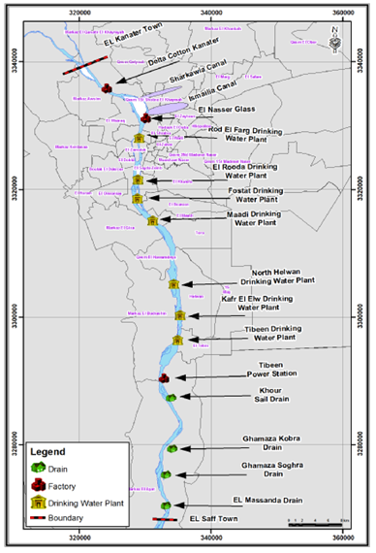
Figure (1) Study area layout

2.2 Sampling Sites
Surface Water samples were collected from various sampling locations of rivers, canal, drains and industrial pollution sources of study area. The measured data include 48 locations including 4 locations for drains, 3 locations for industrial pollution sources and 7 locations for waste water from drinking water plants sludge disposal. The collection and various chemical analysis for water quality parameter is done at Cairo Drinking water Company Central Laboratory. Figure (2) illustrates sample sites.

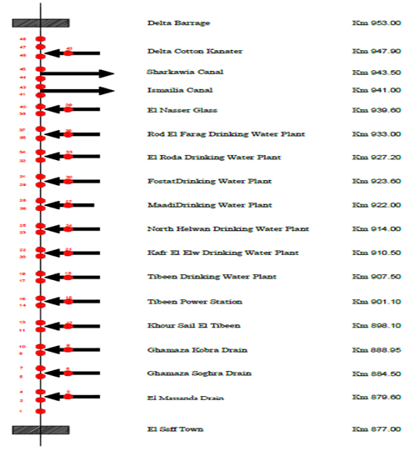
Figure (2) Sample Locations

2.3 Sampling Analysis
Samples were collected in polythene bottles and analyzed for various water quality parameters as per standard procedures given in APHA, Standard Methods, 1992. These samples were tested for pH, Dissolved Oxygen (DO), Total Dissolved Salts (TDS), Biological Oxygen Demand (BOD), Chemical Oxygen Demand (COD), Fecal Coliform (FC), Iron, Nitrates and Ammonia. The samples measured and analysis had done in the central lab of Cairo drinking water company. Three consecutive water quality parameters data sets for years 2012,2013 and 2014 were assessed and grouped to satisfy model calibration, run and validation requirements.
2.4 Calculation of Water Quality Index (CCME – WQI)
The observed values of samples were compared with standard values recommended by Egyptian drinking water quality standards (objectives), Law 48/1982 with its ministerial and decree 92/2013 regarding the protection of the River Nile and waterways from pollution.
For fecal coliform, as there exists no Egyptian standard for it, the used objective was previously determined by WHO (1989) as a guideline for use of water for unrestricted irrigation (1000/MPNml). The methodology of WQI determination is based on Calculations of the index based on scope (F1) - number of parameters that exceed the water quality guidelines; frequency (F2) – number of times that the guide lines are not respected and the amplitude (F3) – the difference between non-complaint measurement and the corresponding guidelines, (Rita et al., 2011). Based on the above WQI values, the water quality is rated as excellent, good, fair, marginal and poor for human consumption shown in Table (1).

Table (1) Water Quality Index Rating Classification
Rank | WQI Value | Description
Excellent | 95-100 | Water quality is protected with a virtual absence of threat or impairment; conditions very close to natural or pristine levels; these index values can only be obtained if all measurements are within objectives virtually all of the time.
Good | 80-94 | Water quality is protected with only a minor degree of threat or impairment; conditions rarely depart from natural or desirable levels.
Fair | 65-79 | Water quality is usually protected but occasionally threatened or impaired; conditions sometimes depart from natural or desirable levels.
Marginal | 45-64 | Water quality is frequently threatened or impaired; conditions often depart from natural or desirable levels.
Poor | 0-44 | Water quality is almost always threatened or impaired; conditions usually depart from natural or desirable levels.
Source: Canadian Council of Ministers of the Environment (CCME, 2003)

2.5 MIKE 11 Calibrations
MIKE11 model was calibrated using water quality data set collected during 2012. Salinity was chosen for calibration process because it is considered a conservative material and it is an excellent water mass tracer. Figure(3) shows the comparison between observed and simulated represented in GIS map for Electric Conductivity (EC) in μS/cm units at various locations of study area.

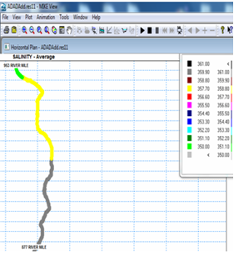  Figures (3) Simulated Salinity,2012 | 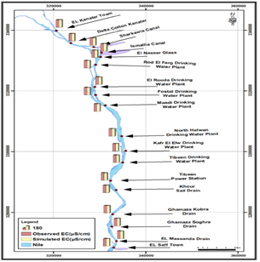  Figures (4) Simulated and Observed Salinity,2012

2.6 Running of MIKE 11
After calibration of MIKE11 model, the model was successfully executed as described in last sections. The input dataset used for this model run is water quality data for year 2013.
The Hydraulic Dynamic Module (HD), Advection-Dispersion Module (AD) and Ecological Laboratory Module (ECO Lab) were used for the Purpose of simulation in this research. In MIKE 11 environment some of the models that can be selected are dependent on other modules in a simulation and it is therefore required to have more modules selected (e.g., Selection of ECO Lab, which will form the basis of the water quality simulation selects AD-model and HD model also). Therefore for performing the water quality model, HD model and AD model were run. Water Quality modeling takes place through the ECO Lab model entry where DO, BOD, COD and FC as water quality parameters were selected from the ECO Lab templates.
2.7 Water Quality Management Scenarios
Water quality management scenarios are simulated using 2013 WQ data set and the pre-calibrated model as a base condition. The main objective of this simulation is to propose alternative solution to improve the water quality of the study reach; however five scenarios using Mike11 HD, AD and EcoLab modules are designated as explained in Table (2).

Table (2) Management Scenarios Description
Scenario | Description
Base condition | Pre-Simulated model with 2013water quality dataset
Scenario (1) | Treatment of four polluted drains (El Massanda, Ghamaza Soghra, Ghamaza Kobra and Khour Sail drains) using wetland technique in order to reduce pollution loads.
Scenario (2) | Stopping the sludge disposal effluent from the treatment processes of seven DWPs (Tibeen, Kafr El Elw, North Helwan, Maadi, Fostat, El Roda and Rod El Farag) and using sludge treatment alternatives.
Scenario (3) | Twenty percent increase in study reach discharge over the maximum discharge in low demand period in order to dilute the effect of pollution concentrations.
Scenario (4) | Increase the drains discharge by 20 percent
Scenario (5) | Combination of scenario (1), scenario (2) and scenario (3)

3. Analysis and Results
3.1 WQI Results
Figure(5) illustrates the study area spatial variation of mean annual water quality parameters along the study reach, WQI according to Law (48)/1982 guidelines with its ministerial decree 92/2013 regarding the protection of the River Nile and waterways from pollution –

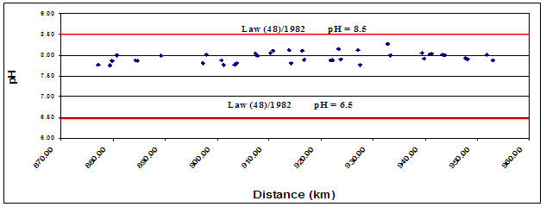
Figure (5a) Study Area Mean Annual pH, 2013.

From Figures (5a), it can be noted that the mean annual study area pH values are ranged from 7.75 to 8.27. These values were within the permissible limits (6.5-8.5) of law 48/1982 and its ministerial decree 92/2013.

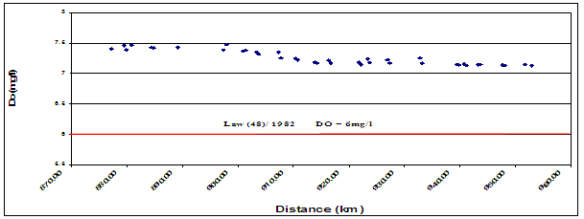
Figure (5b) Study Area Mean Annual DO, 2013.

From Figure (5b), it can be noted that the mean annual study area DO values are varied between 7.13 to 7.48 mg/l. These values were within the permissible limits (minimum permissible 6mg/l) of law 48/1982 and its ministerial decree 92/2013. The relative decrease of dissolved oxygen concentrations in some locations may be related to pollutants discharge’s which contain high amount of organic matter.

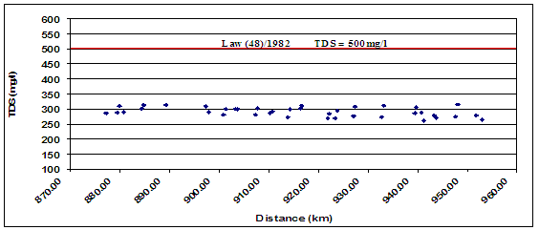
Figure (5c) Study Area Mean Annual TDS, 2013.

From Figure (5c), it can be noted that the mean annual study area TDS concentrations are varied from 261 to 314 mg/l. These values were within the permissible limits (maximum permissible 500 mg/l) of law 48/1982 and its ministerial decree 92/2013.

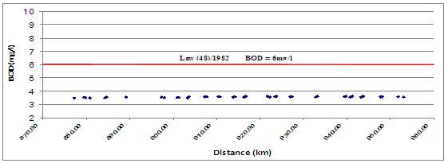
Figure (5d) Study Area Mean Annual BOD, 2013

From Figure (5d), it can be noted that the mean annual organic substances concentrations represented by the biological oxygen demand (BOD) for the study area are varied from 3.49 to 3.61 mg/l . These mean values are within the permissible limits (maximum 6 mg/l) of law 48/1982.

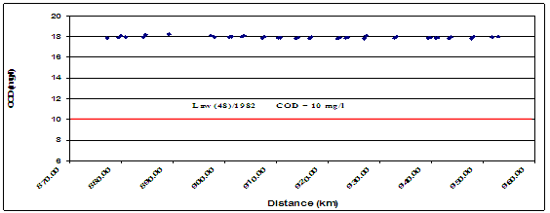
Figure (5e) Study Area Mean Annual COD, 2013

From Figure (5e), it can be noted that study area's COD values showed slight, but steady increase from south to north. The mean annual COD concentrations are varied from 17.81 to 18.22 mg/l. These mean values violate the permissible limits (maximum 10 mg/l) of law 48/1982. This increase may be due to the discharge of industrial effluents into the Nile by some factories, in addition to the discharge of municipal wastewater (untreated and detergent-carrying wastewater) and other wastes into the river.

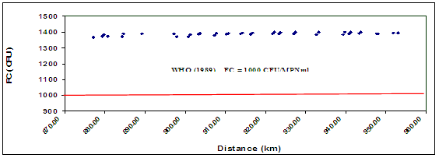
Figure (5f) Study Area Mean Annual FC, 2013

Because of Law 48/1982 did not specify a standard for fecal coliform (FC) counts for the ambient water quality of the Nile River. Therefore, the value given by the WHO (1989) as a guideline for use of water for unrestricted irrigation (1000/MPNml) has been taken as a guide for the evaluation of the water quality in this study. The mean annual F.C. values for the study area are varied from 1370 to 1399 FCU as shown in Figure (5f). The high mean values of FC may be related to the discharge of industrial effluents and domestic wastewater into the River Nile.

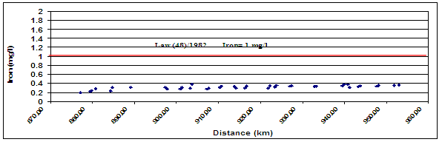
Figure (5g) Study Area Mean Annual Iron, 2013

From Figure (5g), it can be noted that the mean annual Iron concentrations for the study area are varied from 0.22 to 0.39 mg/l. These values were within the permissible limits (maximum permissible 1mg/l) of law 48/1982 and its ministerial decree 92/213.

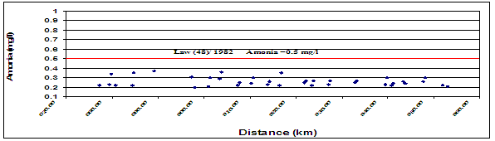
Figure (5h) Study Area Mean Annual Ammonia, 2013

From Figure (5h), it can be noted that the mean annual Ammonia concentrations for the study area are varied from 0.20 to 0.37 mg/l . These values were within the permissible limits (maximum permissible 0.50 mg/l) of law 48/1982 and its ministerial decree92/213.

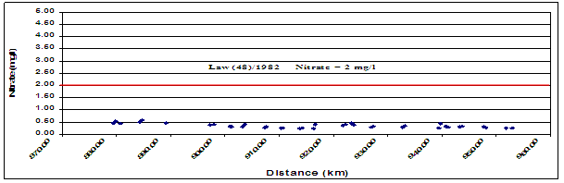
Figure (5i) Study Area Mean Annual Nitrate, 2013

From Figure (5i), it can be noted that the mean annual Nitrate concentrations for the study area are varied from 0.23 to 0.56 mg/l. These mean values were within the permissible limits (maximum permissible 2.00 mg/l) of law 48/1982 and its ministerial decree 92/213.

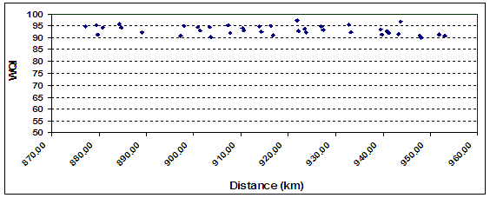
Figure (5j) Study Area Mean Annual Water Quality Index

Generally, WQI for the study reach can be categorized into two types “Good water” and “excellent water". The mean annual WQI values for the study area are ranged from 90.12 to 97.36. A relative decreasing of River Nile water quality status expressed by WQI after pollution sources locations.
3.2 Study Area Water Quality Modeling
In this part water quality model MIKE11 was adopted to simulate the water quality status. This model was calibrated and validated to simulate different scenarios for improving water quality problems in the study area. In this study, three years datasets are used to simulate River Nile at Cairo reach in MIKE11 model. The model was run and analysis based on this output datasets.
5.2.1 Model Calibration
Figures (6a) and (6b) and show the comparison between observed and simulated profiles EC (μS/cm) at various locations of study area.
3.2 Management Scenarios Results
3.2.1 Scenario (1) Treatment of Four Polluted Drains Using Wetland Technique
Figures (7a,b and c) illustrates the output of scenario(1) upstream Cairo drinking water plants along the study reach compared with the base condition of pre-calibrated model.
It can be noted from Figures (7a), (7b) and (7c) that:-
- Upstream Cairo drinking plants, an average reduction percentage in BOD level with value of 32.77%, an average decrease in COD concentrations percentage with value of 5.39% and an average reduction percent in FC level with value 6.42% were achieved under the application scenario(1).
- Surface drains effluents pollution concentration contributes in varying the studied water quality parameters upstream Cairo drinking water plants.
3.2.2 Scenario (2) Treatment of drinking water plant sludge disposal
Figures (8a,b and c) illustrates the output of scenario(2) upstream Cairo drinking water plants along the study reach compared with the base condition of pre-calibrated model.

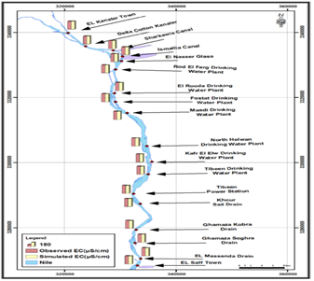  A | 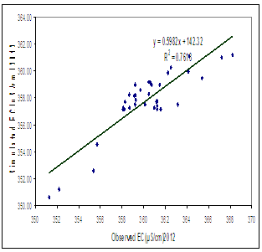  B
Figures (6a and b) Observed and Simulated Mean Annual EC(μS/cm), 2012

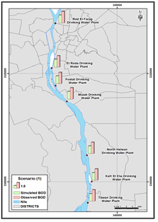  A | 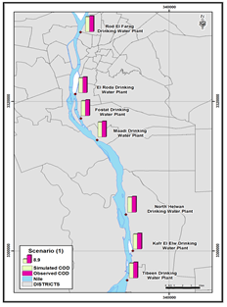  B | 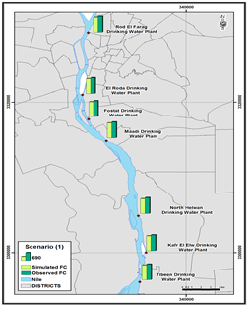  C
Figures (7a,b and c) output of scenario(1) upstream Cairo drinking water plants

It can be noted from Figures (6a), (6b) and (6c) that:-
- Upstream Cairo drinking plants, an average reduction percentage in BOD level with value of 9.94%, an average decrease in COD concentrations percentage with value of 4.64% and an average reduction percent in FC level with value 6.56% were achieved under the application scenario(2).
- A relatively minor effect for pollution concentration from DWP sludge disposal in water quality conditions.

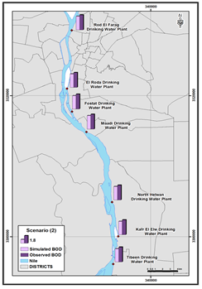  A | 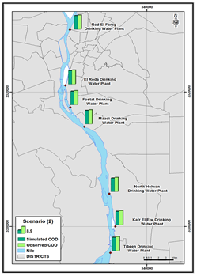  B | 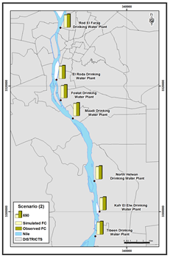  C
Figures (6a,b and c) output of scenario(2) upstream Cairo drinking water plants

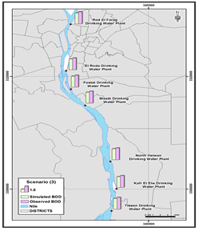  A | 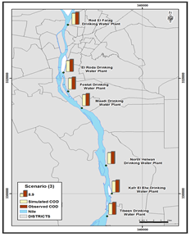  B | 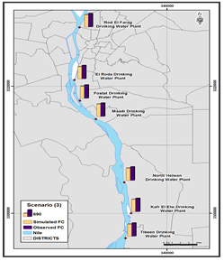  C
Figures (9a,b and c) output of scenario(3) upstream Cairo drinking water plants
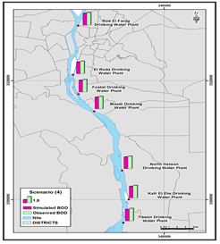  A | 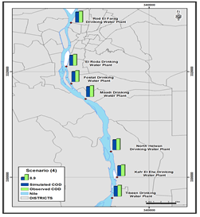  B | 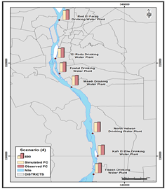  C
Figures (10a,b and c) output of scenario(4) upstream Cairo drinking water plants

3.2.3 Scenario (3) Increasing the Study reach flow up to 20 percent over the maximum discharge in low demand period
Figures (9a,b and c) illustrates the output of scenario(3) upstream Cairo drinking water plants along the study reach compared with the base condition of pre-calibrated model.
It can be noted from Figures (9a), (9b) and (9c) that an average reduction percentage in BOD level with value of 8.12%, an average decrease in COD concentrations percentage with value of 9.47% and an average reduction percent in FC level with value 8.04%were achieved under the application scenario(3).

3.2.4 Scenario (4) Increase the drains discharge by 20 percent
Figures (10a,b and c) illustrates the output of scenario(4) upstream Cairo drinking water plants along the study reach compared with the base condition of pre-calibrated model.
It can be noted from Figures (10a), (10b) and (10c) that an average reduction percentage in BOD level with value of 6.87%, an average decrease in COD concentrations percentage with value of 8.26% and an average reduction percent in FC level with value 6.85%were achieved under the application scenario (4).
3.2.5 Scenario (5) Increasing study reach flow, treatment of polluted drains using wetland technique and treatment of drinking water plant sludge disposal sources.
Figures (11a,b and c) illustrates the output of scenario(5) upstream Cairo drinking water plants along the study reach compared with the base condition of pre-calibrated model.

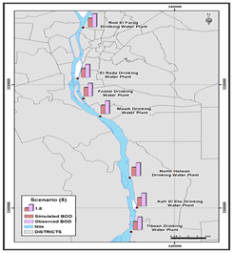  A | 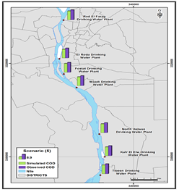  B | 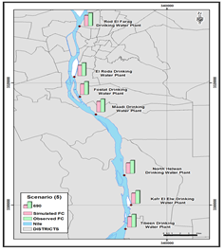  C
Figures (11a,b and c) output of scenario(4) upstream Cairo drinking water plants

It can be noted from Figures (11a), (11b) and (11c) that an average reduction percentage in BOD level with value of 33.25%, an average decrease in COD concentrations percentage with value of 11.07% and an average reduction percent in FC level with value 18.76%were achieved under the application scenario(5).
Table (3) and Figure(12) illustrate the improvement in water quality upstream seven drinking water plant (Tibeen drinking water plant, Kafr El Elw drinking water plant, North Helwan drinking water plant, Maadi drinking water plant, Fostat drinking water plant El Roda drinking water plant and Rod El Farag drinking water plant) under various management scenarios.

Table (3) Water quality improvement upstream Cairo drinking water plants under various management scenarios
Scenario Description | Mean BOD Reduction Percent | Mean COD Reduction Percent | Mean FC  Reduction Percent
Drains treatment by using wetland | 32.77 | 5.39 | 6.42
Treatment of DWPs sludge disposal | 9.94 | 4.64 | 6.56
Increasing the Study reach flow by 20 % | 8.12 | 9.47 | 8.04
Increase the drains discharge by 20% | 6.87 | 8.26 | 6.85
Increasing study reach flow, treatment of polluted drains using wetland technique and treatment of DWPs sludge disposal | 33.25 | 11.07 | 18.76

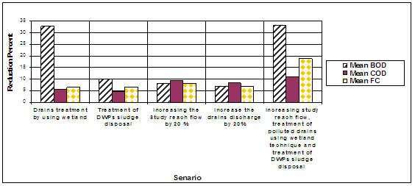
Figure(12) Water quality improvement upstream Cairo drinking water plants under various management scenarios

From previous results of management scenarios, it is clear that the behavior of the river upstream Cairo drinking water plants response to varying in water quality conditions. Scenario (5) appears the most significant impact on the study reach water quality parameter; however an integrated approach would be needed for the management of study reach water quality based on the application of drain effluent treatment, drinking water plant sludge disposal treatment and increasing the study reach flow.

4. Conclusions
The following conclusions were derived based on the results of the study:-
  - The CCME-WQI index was calculated depending on the standard of Egyptian law 48/1982. CCME-WQI calculations were done on monthly basis along one year (from January; 2013 to December; 2013). From these calculations, the water quality classified from good to excellent quality level at the studied reach. However, the WQI study on this reach shows that the water can be used for different purposes.
  - The results of various water quality parameters proved that the water quality at the study area is impacted by a relatively high concentration of COD and FC due to the presence of different sources of pollution. This deterioration is most probably due to the accumulation of industrial effluents, domestic and agricultural discharges directly into the river. Therefore this study might assist the decision makers in the pollution control upstream Cairo drinking water plants where the CCME-WQI gives an effective over view about the study area which is required intensified monitoring activities.
  - The hydraulic and water quality parameters upstream Cairo drinking water plants could be successfully simulated using MIKE11 model by using three years data sets (2012, 2013 and 2014). The main objective of this simulation is to test and evaluate the different scenarios for improving the water quality of study reach.
  - From the analysis of the management scenarios for the MIKE11 model for the study reach, it concluded that increasing of study reach discharge or drains discharge do not affect significantly on the water quality upstream Cairo drinking water plants, as in scenario (3),(4). While applying integrated management approach of Scenario (5) appears the most significant impact on the study reach water quality parameter.
  - Moreover, this study information can introduce a great value for water users (public), planners, policy makers, and scientists reporting on the state of the environment.

References
- CCME, (2003). “Canadian water quality guidelines for the protection of aquatic life: chapter 4”. Canadian Environmental Quality Guidelines, Winnipeg, Manitoba.
- Chinmoy, C and Razinddin . 2002. Determination of Water quality Index (WQI) of a degraded river in Asansol industrial area (Weast Bengal). Nat. Envt. And Pro. Tech. 1(2): 181- 189.
- DHI (2008). Reference Manual of MIKE 11: a microcomputer based modeling system for rivers and channels. Danish Hydraulic Institute, Hoersholm, Denmark.
- Foundation for Water Research (1994). A planning guide for the management of urban wastewater discharges during wet weather. Urban Pollution Management (UPM), United Kingdom.
- Kamal, M.M., Malmgren-Hansen, A., and Badruzzaman, A.B.M. (1999). Assessment of pollution of the river Buriganga, Bangladesh, using a water quality model. Water Science and Technology, 40 (2): 129–136.
- Kazmi, A.A. and Hansen, I.S. (1997). Numerical models in water quality management: a case study for the Yamane River (India). Water Science and Technology, 36(5): 193-200.
- Kumar, J.I. “An assessment of seasonal variation and water qualit index of Sabarmati River and Kharicut canal at Ahmedabad, Gujarat”, Electronic Journal of Environmenal, Agricultural and Food Chemistry, Vol. 10, No. 5, pp. 2248-2261, 2011.
- MWRI, (2004); “The Egyptian Water Strategy Till 2017’, Planning Sector - Ministry of Water Resources and Irrigation, Cairo, Egypt.
- MWRI, (2010); “Water Resources Development and Management Strategy in Egypt – 2050”, in Arabic, Ministry of Water Resources and Irrigation, Cairo, Egypt.
- Rita, N., Kumar, Rajal Solanki and Nirmal WHO (1989) Health Guidelines for the Use of Wastewater in Agriculture and Aquaculture. Report of a WHO Scientific Group, Technical Report Series No. 778, WHO, Geneva.

5/4/2015

