Decomposition of rabbit carcasses in different habitats at Jeddah city, kingdom of Saudi Aarabia

Layla A.H. Al-Shareef and Mashel M.F. Almazyad

Faculty of Science-Al Faisaliah, King Abdulaziz University, Ministry of Education, Kingdom of Saudi Arabia (Layladr@hotmail.com)

Abstract: Three different habits were chosen to carry out this study; agriculture, desert and coastal habitats in Jeddah city, Kingdom of Saudi Arabia at autumn-winter season, during the period from 28 November 2015 to 7 January 2016. Rabbits were killed by cutting trachea, and then used as animal models in the experiment. Stages of decomposition were observed. Weather data; ambient temperature, relative humidity and rainfall rate were recorded during period of study. Duration of carcass decomposition and rate of decomposition at all stages were determined in each different habitat. The duration of carcass decomposition in desert habitat was longer than in both agriculture and coastal habitats. There was a significant difference in the rate of decomposition between different stages within a habitat, but the rate of decomposition between habitats was not different significantly.
[Layla A.H. Al-Shareef and Mashel M.F. Almazyad. Decomposition of rabbit carcasses in different habitats at Jeddah city, kingdom of Saudi Aarabia. N Y Sci J 2017;10(4):1-8]. ISSN 1554-0200 (print); ISSN 2375-723X (online). http://www.sciencepub.net/newyork. 1. doi:10.7537/marsnys100417.01.

Keywords: Carcass decomposition, decomposition stages, Jeddah, rabbit carcass.

1. Introduction:
Decomposition is a natural and necessary process responsible for the reversion of organic material, such as dead plant or animal matter to the ecosystem. Carrion or dead animal matter is considered as food source for a varied community of organisms [1]. Indeed, in the absence of any scavenger vertebrates, arthropods (mainly insects), are the main decomposers. They attract to animal remains within hours or less of death [2]. Carrion decomposition is fundamental to forensic entomology, because although carrion decomposition is a continuous process, it can be defined into visually discernible stages [3], that are linked to the succession of specific insect groups. Therefore, when the pattern of arthropod succession and the decomposition stage of a carrion are known, analysis of the arthropod fauna can be used to estimate the post-mortem interval (PMI) [4, 3, 5]. The composition and succession of arthropod is influenced by the physical state of the remains [6] and the decomposition environment [7, 8, 9, 10]. Estimating of the PMI requires comprehensive information of cadaver decomposing process which helps to detect expected pattern of insect succession. These data is specific to each country and biogeographic habitat [11, 12, 13, 14, 15]. This knowledge is essential to establish the key arthropod species witch correlate with all stages of decomposition carcass, and it will potentially be used in allowing any future accurate PMI evaluation. However, such information within the different habitats in Jeddah city of the Kingdom of Saudi Arabia is rarely.

2. Materials and Methods:
2.1. Site descriptions:
The study was performed during autumn 2015 to winter 2016 in Jeddah city which is located in the middle of the eastern shore of the Red Sea, west of the Kingdom of Saudi Arabia (latitude 29.21 north & longitude 39.7 east). Three different types of habitat were selected to carry out this study. The first habitat was an agricultural area which was a farm existed at 50 km northwest of Jeddah city, and included palm trees and grasses, with dark, moist soil, and the study period in this site lasted from 28 November to 8 December 2015. The second habitat represented by desert area located at one km away from Dahban Highway main road, the soil was sandy, at the period from 13 to 25 December 2015. The third habitat was coast area located in South Obhor district at 300 m away from the Red sea shore, there was no soil or plants present in this area, and the study period lasted from 28 Decembe 2015 to 7 January 2016.
2.2. Animal model:
Domestic rabbits (Lepus cuniculus) obtained from local shops were used as animal models. They were deferent in colors but similar in weight, between 1.4 and 2.5 kg. In each study area, 10 rabbit carcasses were used.
2.3. Field protocols
The rabbits were killed by cutting trachea without decapitation (according to principles of Islam) and immediately weighted and placed inside the cages to prevent vertebrate animals from reaching to the carcasses. These cages were made of metallic material, measured 65x55x45 cm³ with 2 cm² mesh to allow insects access. One side of the cage had a small door (20cm x 15cm) to allow placing and taking out of the carcass. The study sites were visited daily to observe physical features of carcasses and to detect the duration of decomposition stages. Every 2, 4, 7, 10 days after death the carcass were weighted and the percentage of carcasses weight were estimated. Photographs were taken to record the physical changes. The daily maximum and minimum temperatures and humidity were recorded in each three areas using digital thermohygrometer. The rainfall rate was obtained from faculty of meteorology environment and arid land agriculture of King Abdulaziz University.
  - Statistical analysis:
In this study, the method of factorial experiments analysis was used which executed in randomized complete block design with three replicates. This method included using “F test”, and its results summarized in “ANOVA (analysis of variance) table”, and then “Dancun’s test” was used to compare significant factors, according to Snedicor [16].

- Results:
In the recent study, four stages of rabbit carcass decomposition were determined; fresh, bloated, decay and dry. They were observed visually by morphological characteristic on the carcass. Description modified from Reed [17] was illustrated in this study. The fresh stage began at the time from the point of death until the onset of bloating (fig.1). At this stage, there were no morphological changes visible on the carcass, nor noticeable odor, but insects were attracted to the remains. The bloated stage immediately followed the fresh stage. There was a build-up of gases within the body resulted from anaerobic protein decomposition, producing a swollen appearance (fig.2). Green skin staining was noticed (fig.3) due to internal autolytic and bacterial breakdown of hemoglobin. The physical changes in this stage were accompanied by the release of a powerful smell of decomposition. The decay stage was identified when the carcass deflated due to insects piercing the carcasses. There was a fewer odor, and large amount of maggot can be seen feeding on the carcasses, extensive fluid leakage was evident (fig.4). At the end of this stage large maggots have migrated away from the carcasses to pupate. The dry stage began when the carcass was reduced to dry skin, cartilage, fur and bones, and continues until most of the flesh from the carcass was consumed by insects (fig.5). There was no odor in this stage.

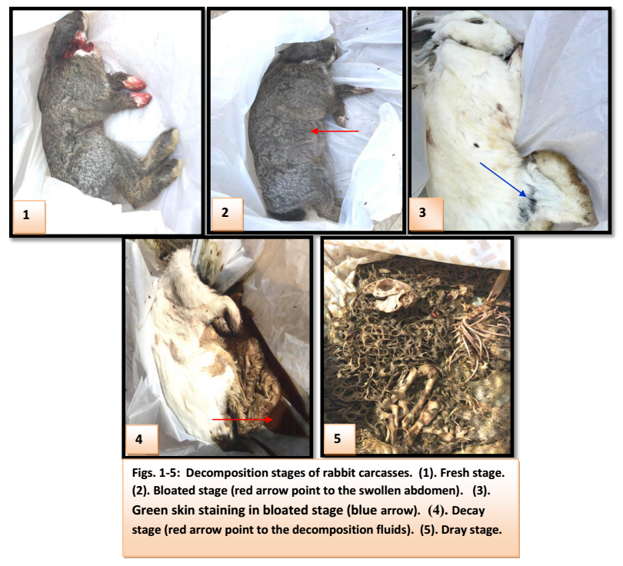

3.1. Duration of carcass decomposition:
During this study duration of carcass decomposition was determined in different stages; fresh, bloated, decay and dray, in three different habitats; agriculture, desert and coastal. Table (1) clear that in agriculture and coastal habitat the duration of carcass decomposition were similar in fresh, bloated decay and dray stages, 2, 2, 3, 4 days, respectively. The maximum temperatures, relative humidity, and rainfall rate in agriculture habitat were 32.39⁰C, 55.55% and 0.41 mm/day, and in coastal habitat were 28.19⁰C, 53.20% and 0.40 mm/day (table 2). In desert habitat the duration of carcasses decomposition was 2 days in fresh stage, 2 days in bloated stage, 3-4 days in decay stage and 3-5 days in dray stage. The maximum temperature in this habitat was 27.28⁰C, with relative humidity 48.42%, and no rainfall at this period. Whereas, all duration of carcass decomposition was 11 days in agriculture and coastal habitat and 11.5 days in desert habitat.

Table (1). Duration of decomposition stages of rabbit carcasses in different habitats
Habitat | Durations (days)
 | Fresh | Bloated | Decay | Dray | Total duration
Agriculture | 2 | 2 | 3 | 4 | 11
Desert | 2 | 2 | 3-4 (3.5) | 3-5 (4) | 11.5
Coast | 2 | 2 | 3 | 4 | 11

Table (2): Climatic conditions in the different habitats during the period of study
Habitat | Stage | Temperature (⁰C) |  |  | R.H.%  Mean | Rainfall (mm)
 |  | Max. | Min. | Mean
Agriculture | Fresh | 34.2+1.41 | 25.20+0.00 | 29.2+0.42 | 63+5.66 | 0.00
 | Bloated | 32.04+0.85 | 25.4+0.00 | 28.55+0.212 | 66.00+4.243 | 0.00
 | Decay | 28.67+1.15 | 23.0+1.0 | 25.93+0.55 | 56.67+3.44 | 1.5+1.5
 | Dray | 29.40+1.19 | 22.2+2.01 | 25.63+0.71 | 39.75+19.05 | 0.00
For all duration |  | 32.39+1.65 | 24.11+2.25 | 26.89+1.66 | 55.55+16.84 | 0.41+0.97
Desert | Fresh | 25.9+0.71 | 18.30+0.42 | 22.5+0.28 | 51+4.24 | 0.00
 | Bloated | 29.40+0.849 | 18.10+1.838 | 24.00+1.414 | 39.00+2.828 | 0.00
 | Decay | 27.25+0.60 | 21.98+0.73 | 24.28+0.68 | 49.00+2.16 | 0.00
 | Dray | 26.88+0.88 | 19.92+2.08 | 23.66+0.74 | 49.40+5.77 | 0.00
For all duration |  | 27.28+1.30 | 20.28+1.94 | 23.80.0.91 | 48.42+5.47 | 00.0
Coast | Fresh | 32+0.28 | 23.2+1.13 | 27.45+0.78 | 55.5+2.12 | 00.0
 | Bloated | 26.80+0.283 | 19.60+2.263 | 23.45+1.485 | 62.5+7.778 | 2.00+2.828
 | Decay | 26.03+0.80 | 18.37+1.10 | 22.17+0.40 | 47.67+6.51 | 0.00
 | Dray | 28.80+0.91 | 20.55+0.53 | 24.50+0.88 | 53.5+6.61 | 0.00
For all duration |  | 28.19+2.39 | 20.19+2.06 | 24.09+2.08 | 53.20+77.42 | 0.40+1.26

3.2. Rate of carcass decomposition:
In this study, percentage of carcasses weight were determined through different stages; fresh, bloated, decay and dray, in three different habitats; agriculture, desert and coastal. The results of statistical analysis were summarized in ANOVA table (table 3). It was clear that factor of decomposition stages with highly significant effect, but study habitats factor did not affect significantly on the rate of carcass decomposition. The interaction between these two factors was not significant (table 3).
When “Dancun’s test” was used to compare percentage of carcass weight (table 4) under the effect of the tow factors; decomposition stages and study habitats, we found that, in agriculture habitat the percentage of carcass weight in fresh stage (94.87%) at maximum temperature and relative humidity were 34.2⁰C and 63% did not differ significantly from bloated stage; 85.26% at 32.04⁰C and 66%, but each of them was highly significant than in decay stage; 44.89% at 28.67⁰C and 56.67%, which in turn more significantly than in dray stage; 19.17% at 29.4⁰C and 39.75%. As well as in desert habitat, the percentage of carcass weight in fresh and bloated stages were not different significantly (95.16% and 85.45%, respectively) at maximum temperature 25.9⁰C and 29.4⁰C and relative humidity 51% and 39%, but both were more significant than in decay stage; 40.1% (at 27.25⁰C, 49%) which was in turn more than in dray stage significantly; 25.63% at 26.88⁰C and 49.4%. In coastal habitat, the percentage of carcass decomposition in fresh stage; 95.16% (at 32⁰C and 55.5%) and bloated stage; 85.45% (at 26.8⁰C, 62.5%) were not differ significantly, but both were higher significant than in decay stage; 40.10% (at 26.03⁰C, 47.67%) which in turn was more significant than dray stage; 61.58% at 28.8⁰C, 53.5% (fig.6). Regardless of the habitats, in general the percentage of carcass weight was decreased significantly during decomposition stages from fresh (95.27%), to bloated (86.14%), then decay (43.02%), dray stage (22.62%) (fig.7).

Table (3): ANOVA for rabbit carcasses weight during decomposition stages in different habitats.
Source of Variance |  | Degree of Freedom |  | Sum of squares |  | Mean sum of squares |  | F-cal | F-table |  | Notes
Replicates |  | 2 |  | 0.217674418 |  | 0.108837209 |  | 0.791543336 | 19.462, 99.466 |  | NS
Treatment |  | 11 |  | 153.2220005 |  | 13.92927277 |  | 101.303802 | 2.247, 3.214 |  | **
Stages |  | 3 |  | 152.0684712 |  | 50.68949039 |  | 368.6508392 | 8.617, 26.505 |  | **
Habitats |  | 2 |  | 0.062725664 |  | 0.031362832 |  | 0.228093324 | 8.617, 26.506 |  | NS
Stages*Habitats |  | 6 |  | 1.090803695 |  | 0.181800616 |  | 1.322186297 | 2.864, 4.649 |  | NS
Error |  | 22 |  | 3.56 |  | 0.162009656
Total |  | 35
S2 | 0.162009656 |  |  |  |  |  | Bayesian least significant different for 0.01, 0.05 Confidence levels
 |  |  |  |  |  |  |  |  | 0.01 | 0.05
S²_{X} FOR 4 | 0.013500805 |  | S_{x} FOR 3 |  | 0.12 |  | Bayesian L.S.D. for 3 |  | 0.407456 | 0.305592
S²_{X} FOR 5 | 0.018001073 |  | S_{x} FOR 4 |  | 0.13 |  | Bayesian L.S.D. for 4 |  | 0.47049 | 0.352867
S²_{X} FOR 12 | 0.054003219 |  | S_{x} FOR12 |  | 0.23 |  | Bayesian L.S.D. for 12 |  | 0.814912 | 0.611184

NS; Not Significant. *; Significant (0.05). **; Highly Significant (0.01)

Table (4): Comparison of treatments’ means of carcass weight with respect to the factors habitats and decomposition stages, and the interaction between them.
Stages | Habitats
 | Agriculture | Desert | Coast | Stages` means
Fresh | 94.87±1.13 Aa | 95.16±1.82 Aa | 94.15±1.48 Aa | 95.27±1.72 A
Bloated | 85.26±2.98 Aa | 85.45±0.28 Aa | 86.25±1.25 Aa | 86.14±1.69 B
Decay | 44.89±1.77 Ba | 40.10±2.76 Ba | 38.63±1.38 Ba | 43.02±4.78 C
Dray | 19.17±5.83 Ca | 25.63±5.63 Ca | 23.82±9.53 Ca | 22.62±6.04 D
Area` means | 61.05±32.09 a | 61.58±30.81 a | 60.71±31.70 a | 61.76

Small letters for the horizontal comparisons Capital letters for the vertical comparisons
(L.S.D. Bayesian) for 3 Means =2.93 (L.S.D. Bayesian) for 4 Means =3.39
(L.S.D. Bayesian) for 12 Means =5.87 Weight estimated in percentage.

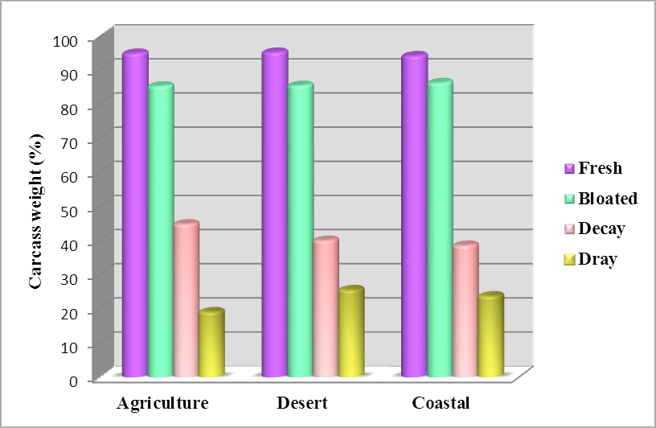
Fig. (6). Comparison carcass weight during decomposition stages in different habitats.

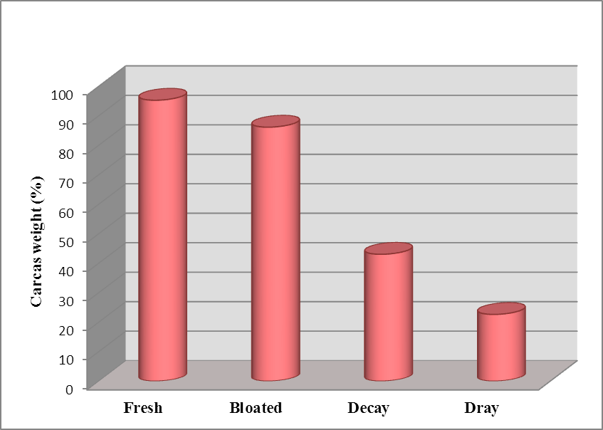
Fig. (7). Comparison carcass weight during decomposition stages

4. Discussion:
Decomposition of dead animal is a continuous process occurs through several stages of possible distinguish. These stages vary in its rate and characteristics depending on environmental conditions and type of carrion. Animals were used as experimental models instead of human bodies in several previous studies, because the stages of decomposition that a human corpse undergoes are almost the same as in a non-human, although caution in the use of timetables produced in non-human studies is necessary, even if a good model such as a pig is employed [18, 19].
Bornemissza [20] described five stages of decomposition in the carrion of guinea pigs, Also, Payne [21] studied five stages in pig carcasses; however, Reed [17] reported four stages of decomposition. Cornabay [22] used the carrion of toads and lizards where no stages of decomposition can be visually observed. In the present study the decomposition process was obvious in the form of four succession stages (fresh, bloated, decay and dry). These observable stages were defined also by Rodriguez & Bass [4], Braack [23], Tantawi et al. [24] and Bharti & Singh [25]. We must keep in mind the fact that decomposition is a continuous process and separate stages do not actually exist in nature [26].

4.1. Duration of carcass decomposition:
In the recent study we found the duration of decomposition period in desert habitat (11.5 days) was slightly longer than in agriculture and coastal habitat (11days). This result due to the little rise in maximum temperature in each of agriculture (32.39⁰C) and coastal habitat (28.19⁰C) than desert habitat (27.28⁰C) which characterized by drought, whereas the rainfall rate in each agriculture and coastal habitat was 0.41 mm/day. Goddard & Lago [27] stated that when temperatures are high, the duration of decomposition becomes short. Tantawi et al. [24] reported that rabbit carcasses in summer season, took only 4.5 days to reach dry stage when average daily temperatures were 28ºC, but in winter 51.5 days were required for carcasses to reach the dry stage when average daily temperature ranged from 13.6⁰C to 16.6⁰C. In Czech Republic, Petr Kocˇárek [28] found that rat carcass in higher temperature in summer (31⁰C-33⁰C) decayed much faster than those in spring (29-30⁰C) and autumn (21⁰C) resulting long time to reach dry stage in autumn than summer and spring. According to Archer & Elgar [2] high amount of rainfall reduced the length of decay stage by increasing mass loss. In Malaysia, Azwandi & Abu Hassan [29] recorded that in the wet season monkey carcasses needed less time to reach the dry remains stage of decomposition in oil palm plantation.
We recorded the duration of decomposition stages as 2 days in fresh stage, 2 days for bloated stage, 3 days in decay stage and 4 days for dray stage in each of agriculture and coastal habitat, where the average of maximum temperature ranged from 28.19⁰C to 32.39⁰C and relative humidity from 55.55% to 53.20%. These stages were 2, 2, 3-4 and 3-5 days for fresh, bloated, decay and dray stage, respectively in desert habitat and the maximum temperature was 27.28⁰C and relative humidity 48.42%. Al-Mesbah [30] in Kuwait recorded that, the length of decomposition stages were: fresh stage; 1-2 days, bloated; 3-7 days, decay; 8-14 days and dry;10-14 days at average temperature from 16.86⁰C to 19.56 ⁰C.

4.2. Rate of carcass decomposition:
In the recent study, while the overall rate of decomposition between habitats was similar, there was, however, a significant difference in the rate of decomposition between different stages within a habitat. In agriculture habit the higher maximum temperature and relative humidity in fresh (34.2⁰C, 63%) and bloated stage (32,04⁰C, 66%) increasing the rate of decomposition that led to significant loose in the percentage of carcasses weight from fresh and bloated stage to decay (at 28.67⁰C, 56.67%) then dray stage (29.4⁰C, 39.75%). We found the same result in rest of habitats, where rising of temperature in fresh and bloated stages in each of desert (at 25.9⁰C, 29.4⁰C) and coastal habitat (32⁰C, 26.8⁰C) encourage decomposing rate causing significant losing in the percentage weight of carcass in decay stage followed by in dray stage in agriculture ( at 27.25⁰C, 26.88⁰C) and costal habitat ( at 26.03⁰C, 28.8⁰C).
Rates of decomposition is influenced by a variety of environmental factors, including temperature [31], which especially affects bacterial activity [1] and developmental rates of carrion associated insects [32, 33]. However, Shean et al. [34] and Moura et al. [35] stated that maximum temperature was more important than minimum temperature in influencing on decomposing rates, and corpses in cooler months maintain a fresh appearance for more time. On the other hand, Reed [17], Payne [21], Wasti [36] reported that rate of decomposition was influenced by humidity less than temperature. In contrast, Galloway et al. [37], Mann et al. [38] and Moura et al [35] stated that humidity was important factor acting on decomposition rates. Hewedicaram [39] found that in arid zones, high temperature in combination with low humidity dehydrated small carcasses and accelerated the mummification. In addition, the weight of the carcasses also affects the decomposition rate [40].

Conclusion:
This study proved that at the climatic conditions of Jeddah city during the period from autumn to winter season, the duration of rabbit carcass in desert habitat was slightly longer than in both agriculture and coastal habitats. There was a significant difference in the rate of decomposition between different stages within a habitat, but the rate of decomposition between habitats was similar.

References:
  - Putman RJ (1983). Carrion and dung: the decomposition of animal wastes, The Institute of Biology’s Studies in Biology No. 156, Edward Arnold, London, 1983.
  - Archer MS, Elgar MA (2003). Yearly activity patterns in southern Victoria (Australia) of seasonally active carrion insects. Forensic Science International, 132: 173-176.
  - Goff ML (1993). Estimation of postmortem interval using arthropod development and successional patterns. Forensic Science Review, 5: 81-94.
  - Rodriguez WC, Bass WM (1983). Insect activity and its relationship to decay rates of human cadavers in East Tennessee. J Forensic Sci 28: 423-432.
  - Campobasso CP, Vella GD, Introna F (2001). Factors affecting decomposition and Diptera colonization. Forensic Science International, 120: 18-27.
  - Avila FW, Goff ML (1998). Arthropod succession patterns onto burnt carrion in two contrasting habitats in the Hawaiian Islands. Journal of Forensic Science, 43: 581–586.
  - Goff ML (1992). Problems in estimation of postmortem interval resulting from the wrapping of a corpse; a case study from Hawaii. Journal of Agricultural Entomology, 9: 237-243.
  - Centeno N, Maldonado M, Oliva A (2002). Seasonal patterns of arthropods occurring on sheltered and unsheltered pig carcasses in Buenos Aires province (Argentina). Forensic Science International 126(1): 63-70.
  - Voss SC, Forbes SL, Dadour IR (2008). Decomposition and insect succession on cadavers inside a vehicle environment. Forensic Science Medical and Pathology, 4: 22 32.
  - Wells JD, Greenberg B (1992). Interaction between Chrysomya rufifacies and Cochliomyia macellaria (Diptera: Calliphoridae): the possible consequences of an invasion. Bulletin of Entomological Research, 82: 133–137.
  - Wolff M, Uribe A, Ortiz A, et al. (2001). A preliminary study of forensic entomology in Medellin, Colombia. Forensic Science International, 120: 53-59.
  - Tabor, K.L., Fell, R.D. and Brewster, C.C. 2005. Insect fauna visiting carrion in Southwest Virginia. Forensic Science International, 150: 73-80.
  - Sharanowski, BJ, Walker EG, Anderson GS (2008). Insect succession and decomposition patterns on shaded and sunlit carrion in Saskatchewan in three different seasons. Forensic Science International, 79: 219-240.
  - Bonacci T, Brandmayr TZ, Brandmayr P, Vercillo V, Porcelli F (2011). Successional patterns of the insect fauna on a pig carcass in southern Italy and the role of Crematogaster scutellaris (Hymenoptera, Formicidae) as a carrion invader. Entomological Science, 14: 125-132.
  - Voss SC, Cook DF, Dadour IR (2011). Decomposition and insect succession of clothed and unclothed carcasses in Western Australia. Forensic Science International, 211: 67-75.
  - Snedicor G (1958). Statiscal methods. The lowa state university. Press Ames. Iowa, USA.
  - Reed HB (1058). A study of dog carcass communities in Tennessee, with special reference to the insects, Am. Midl. Nat 59 (1958) 213–245.
  - Lane RP (1975). An investigation into Blowfly (Diptera: Calliphoridae) sucession on corpses. J Nat Hist 9: 581-588.
  - Catts EP, Goff ML (1992). Forensic entomology in criminal investigations. The Annual Review of Entomology, 37: 253–72.
  - Bornemissza GF (1956). An analysis of arthropod succession in carrion and the effect of its decomposition on the soil fauna, Aust. J. Zool 5 (1956) 1–12.
  - Payne JA (1965), A summer carrion study of the baby pig Sus scrofa Linnaeus, Ecology 46; 592–602.
  - Cornabay BW (1974). Carrion reduction by animals in contrasting tropical habitats, Biotropica 6 (1974) 51–63.
  - Braack LEO (1986) Arthropods associated with carcasses in the northern Kruger National Park. S Afr J Wildl Res 16: 91-98.
  - Tantawi TI, El-Kady EM, Greenberg B, El-Ghaffar HA (1996). Arthropod succession on exposed rabbit carrion in Alexandria, Egypt. J Med Entomol 33: 566-580.
  - Bharti M (2003). Insect faunal succession on decaying rabbit carcasses in Punjab, India. J Forensic Sci, Vol. 48, No. 5.
  - Schoenly K, Reid W (1987). Dynamics of heterotrophic succession on carrion arthropod assemblages: discrete seres or a continuum of change?, Oecologia (Berl.) 73 (1987) 192–202.
  - Goddard J, Lago PK (1985) Notes on blow fly (Diptera: Calliphoridae) succession on carrion in Northern Mississippi. J Entomol Sci 20: 312-317.
  - Kocˇárek P(2003). Decomposition and Coleoptera succession on exposed carrion of small mammal in Opava, the Czech Republic. European Journal of Soil Biology 39 (2003) 31–45.
  - Azwandi A, Abu Hassan A (2009). A preliminary study on the decomposition and dipteran associated with exposed carcasses in an oil palm plantation in Bandar Baharu, Kedah, Malaysia. Tropical Biomedicine 26(1): 1–10 (2009).
  - Al-Mesbah HA (2010). Study of forensically important necrohagous Diptera in Kuwait. Master thesis. University of Central Lancashire. Faculty of Science, Forensic and Investigation Department UK. 124 pp.
  - Doenier CC (1940). Carcass temperature and their relation to winter blowfly populations and activity in the southwest, J. Econ. Entomol 33 (1940) 166–170.
  - Ash N, Greenberg B (1975). Developmental temperature responses of the sibling species Phaenicia sericata and Phaenicia pallescens, Ann. Entomol. Soc. Am 68 (1975) 197–200.
  - Smith KGV (1986). A Manual of Forensic Entomology. Trustees of the British Museum (Natural History), London, 1986.
  - Shean BS, Messinger L, Papworth M (1993). Observations of differential decomposition on sun exposed v. shaded pig carrion in Coastal Washington State. JFSCA 38: 938-949.
  - Moura MO, Carvalho CJB, Monteiro-Filho ELA (1997). A preliminary analysis of insects of medical-legal importance in Curitiba, state of Paraná. Mem Inst Oswaldo Cruz 92: 269-274.
  - Wasti SS (1972). A study of the carrion of the common fowl, Gallus domesticus, in relation to arthropod succession, J. Georgia Entomol. Soc 7 (1972) 221–229.
  - Galloway A, Birkby WH, Jones A, Henry TE, Parks B (1989). Decay rates of human remains in an arid environment. JFSCA 34: 607-616.
  - Mann RW, Bass WM, Meadows L (1990). Time since death and decomposition of the human body: variables and observations in case and experimental field studies. JFSCA 35: 103-111.
  - Hewedicaram KA, Goff ML (1991). (Effect of carcass size on rate of decomposition and arthropod succession pattern, Am. J. Forensic Med. Pathol 12 (1991) 235–240.
  - Gunn A (2006). Essential Forensic Biology, John Wiley & Sons, Ltd., Chichester.

3/15/2017

