Effect of Manure Compost on Heavy Metal Translocation and Bio-Concentration Factors in Soils from an Old Municipal Dumpsite

Kehinde Olajide Erinle^{1, 2}*, Tolulope Yetunde Akande², Joseph Urhie², Tope Daniel Bitire³

^{1.} School of Agriculture, Food and Wine, University of Adelaide, Adelaide SA 5005;
^{2.} School of Resources and Environment, Northeast Agricultural University, Harbin 150030, P. R. China;
³. Agronomy Department, University of Ibadan, Nigeria
Kehinde.Erinle@adelaide.edu.au

Abstract: A study was conducted with Leucaena as the test crop to investigate the bioavailability of heavy metals (chromium and nickel) from dumpsite soil treated with manure compost. The application of manure increased number of leaves and plant biomass, compared to unamended controls. Generally, heavy metals were higher in the plant root than in the shoot. But application of manure decreased Cr concentration in the root below the control; contrarily, Ni was increased in roots of manure treated than control plants. Cr in the shoot did not differ significantly among the treatments, but increase in manure levels further decreased Ni concentration in the shoot, compared with the control plants. Metal translocation factor (TF) >1 was noted for Ni only in the control plants, but manure application decreased Ni translocation. Chromium translocation was generally <1. Bioconcentration factor (BCF) was generally <1, but higher for Ni than Cr. Hence, Leucaena might be suitable for phytoextraction of nickel, but application of manure could make Leucaena suitable for phytostabilization in a contaminated soil.
[Erinle KO, Akande TY, Urhie J, Bitire TD. Effect of Manure Compost on Heavy Metal Translocation and Bio-Concentration Factors in Soils from an Old Municipal Dumpsite. N Y Sci J 2017;10(4):51-59]. ISSN 1554-0200 (print); ISSN 2375-723X (online). http://www.sciencepub.net/newyork. 6. doi:10.7537/marsnys100417.06.

Keywords: Manure; phytoremediation; heavy metals; translocation factor; bioconcentration factor

1. Introduction
Landscape architecture is a field of Environmental Management which studies the design of outdoor public areas, landmarks, and structures to achieve environmental, social-behavioral, or aesthetic outcomes. The conversion of old landfills and municipal dumpsites to parks and recreational centers is a common idea in landscape architecture. According to Harnik et al. (2006), there are more than 1,000 parks and public recreational sites that are created on old landfills. Parks and playgrounds are green areas in cities where dwellers (mainly children and seniors) can spend their outdoor free time, thus the highest possibility of the human and soil interaction can be presumed here (Puskás, 2014). Parks built on old landfills thus have a higher chance of exposing visitors to risk of heavy metals toxicity.
In Hungary, heavy metal excesses in soils of urban play grounds and parks have been reported, to exceed the heavy metal threshold values regulated by the Hungarian government (Puskás, 2014). Likewise, Okorie et al. (2011) reported high heavy metal contents in city soils from Newcastle Upon Tyne, UK; Luo et al. (2012) also reported high mean concentration of cadmium, cobalt, copper and lead metals in urban soils in Xiamen, China. According to World Health Organization (WHO), the metals of most immediate concern are chromium, copper, zinc, iron, cadmium and lead (Hisfa et al., 2010).
Studies have revealed various potential routes of exposure to heavy metal toxicity in humans (Appleton et al., 2013). Of these, oral ingestion is common among children who frequent recreational parks and playgrounds through intentional or accidental ingestion of soils, dirty hands and toys (Hu et al., 2012, Luo, Ding, 2012). The consumption of such toxic substances can seriously deplete some essential nutrients in the body causing a decrease in immunological defenses, intrauterine growth retardation, impaired psycho-social behavior, disabilities associated with malnutrition and a high prevalence of upper gastrointestinal cancer (Oyedele et al., 2006; Arora et al., 2008). Other harmful effects of ingestion of heavy metals include the formation of complexes with proteins, in which carboxylic acid (-COOH), amine (-NH₂), and thiol (-SH) groups are involved. When metals bind to these groups, they inactivate important enzyme systems, or affect protein structure, which is linked to the catalytic properties of enzymes; these modified biological molecules lose their ability to function properly and result in malfunction or death of the cells (Dhar, 1973).
Phytoremediation, an option in bioremediation, is defined as an emerging technology which uses selected plants to clean up contaminants from the environment in order to improve the quality of the environment (Tangahu et al., 2011). The use of soil amendment has also been described as a component of phytoremediation (Salt et al., 1998). Where the toxicity levels of pollutants do not encourage growth and survival of plants meant for remediation, the soil amendment is applied to encourage plant growth and survival. However, the application of soil amendment can decrease heavy metal bioavailability, thus shifting them from “plant available” forms to fractions associated with organic matter, carbonates or metal oxides (Walker et al., 2004) consequently resulting in the reduction of metals uptake by the installed plants.
Thus, the aim of the present study was to investigate the effect of the addition of poultry manure compost on the uptake of some heavy metals (chromium and nickel) from an old municipal dumpsite soil. In addition, the influence of treatment application on the partitioning of heavy metals into below and above ground parts of the plant was evaluated. Leucaena leucocephala (Lam.) de Wit (Leucaena) was used as the test plant. Leucaena is known as the 'miracle tree' because of its worldwide success as a long-lived and highly nutritious forage tree, and its great variety of other uses (Shelton and Brewbaker, 1998). The results obtained in this study can inform on precautionary measures to take, especially in the establishments of urban parks and recreational centers on old landfills and dumpsites.

2. Material and Methods

Soil, manure compost and Plant materials
The experiment was conducted in the screen house of the Agronomy Department, University of Ibadan (7º24’N; 3º48’E), Nigeria. The soil used for this study was collected at a depth of 0 - 15 cm from an old municipal dumpsite at Ajibode area, Ibadan, Oyo State, Nigeria. The soil was first sieved prior to collection in nylon mesh bags, afterwards was transported to the laboratory, and was air dried on plastic sheets. Poultry manure compost was collected from the University farm. Seeds of Leucaena leucocephala were obtained from Agronomy Department of the University of Ibadan and were sown directly in the dumpsite soils after soils were properly mixed with respective quantity of manure. The experiment was performed using three levels of the composted poultry manure - 0, 20, and 40 mg·kg⁻¹, with five replicates, each with 5 kg topsoil. The polythene bags containing the soil were arranged randomly on experimental tables.

Soil and Plant analyses at final harvest
At the end of the experiment (90 days), soils were collected from each treatment and analyzed for the heavy metal contents. Similarly, the plants were separated into shoot and root parts after carefully washing with distilled water, and were dried at ambient temperature. Dry weight of plant samples was taken after oven drying to constant weight at 105ºC for 24 hr. Plant samples were thereafter ground to 20 mesh size using a stainless Wiley Mill and 1 g of each grounded sample was separately digested in a 5: 1 ratio of concentrated nitric and perchloric acids. The cooled samples were diluted to 25 mL and filtered using Whatman no. 42 filter paper. The filtrate was finally made up to 50 mL and then analyzed for heavy metal concentration (Ni and Cr) using the Buck scientific model GVP 210 atomic absorption spectrophotometer. Soil parameters measured included pH (soil: water at 1: 2.5, v/v), soil organic carbon (Walkley-Black titration method), total nitrogen (semimicro-Kjeldahl method), exchangeable bases (Ca, Mg, K, and Na; extracted in 1M NH₄OAc and quantified with flame atomic absorption spectrophotometer), heavy metal content (digested in HCl-HNO₃-HF-HClO₄ and analyzed with atomic absorption spectrophotometer), and particle size distributions.

Statistical analyses
To investigate the phytoremediation mechanism for heavy metals, the translocation factor (TF) and bio-concentration factor (BCF) were determined using the formula given below.
Translocation factor (TF) was calculated as the metal concentration (mg·kg⁻¹) ratio of shoot to root.
TF= (C _{shoot}/C _{root})…… (Equ. 1) (Yoon et al., 2006)
Bio-concentration Factor (BCF) was calculated as metal concentration (mg·kg⁻¹) ratio of plant to soil.
BCF= (C _{shoot}/C _{soil})….…. (Equ. 2) (Li et al., 2007)
Data on plant growth parameters (height, number of leaves, plant dry weights) and concentration of heavy metals in shoots and roots were subjected to a one-way ANOVA and Tukey-Kramer honest significant difference (HSD) tests were used for pair-wise comparisons of all treatments. Statistical significance was tested at the level of 0.05. Data are presented as means of five replicates. All statistics were computed using SPSS v19.0.

3. Results

Soil physicochemical properties
The result of physicochemical analyses indicated that the soil is sandy loam with slightly alkaline pH of 7.3. The soil organic carbon and total nitrogen are 8.0 g·kg⁻¹and 0.74 g·kg⁻¹ respectively. Exchangeable bases in the soil are Ca, 38 cmol·kg⁻¹; Mg, 3.3 cmol·kg⁻¹; K, 0.5 cmol·kg⁻¹ and Na, 0.9 cmol·kg⁻¹. Heavy metal analysis showed the presence of the following heavy metals in the soil (mg·kg⁻¹), Pb, 241; Cr, 105; Ni, 60; Co, 28 and Cd, 4. Result of particle size distributions indicated that the soil has proportions of clay (134 g·kg⁻¹), sand (746 g·kg⁻¹) and silt (120 g·kg⁻¹).

Effects of manure compost on plant growth parameters (height, number of leaves, plant dry weights)
Figure 1 shows the effect of compost manure on plant height (cm) and number of leaves in Leucaena seedling. Application of manure at 20 and 40 mg·kg⁻¹ per soil did not show significant effect on plant height, but significantly increased number of leaves, compared to the control plants. Both levels of manure did not affect number of leaves differently from one another.

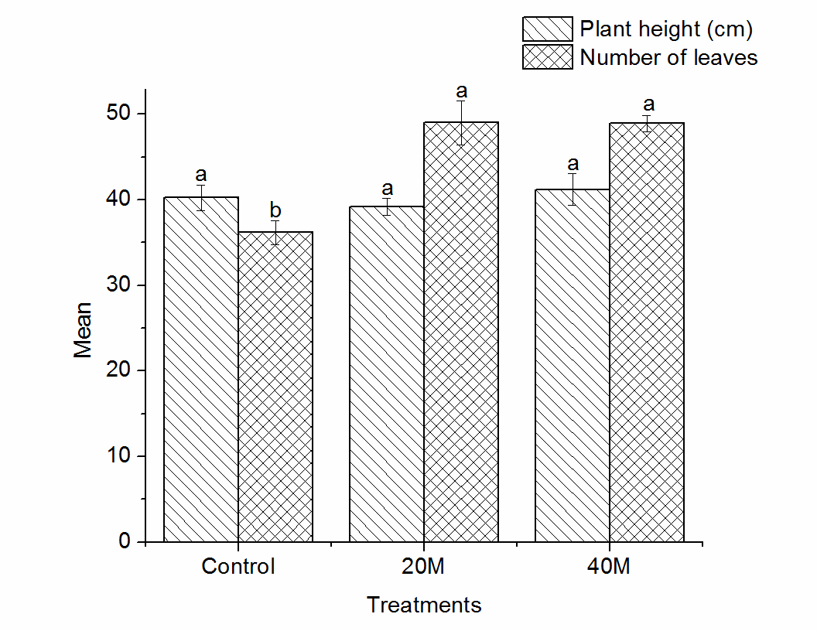
Figure 1: Effect of manure compost on Plant height (cm) and number of leaves in Leucaena leucocephala seedlings. Different alphabets indicate significant differences among treatments according to the Tukey-Kramer honest significant difference (HSD) tests (P< 0.05).

Result of plant dry weights (root and shoot) is shown in Figure 2. Obviously, increase in the rate of manure application significantly increased dry weight of root and shoot. Least dry weights were observed in the control plants. Root and shoot dry weights increased by 15.79% and 16.08%, respectively, with increase in manure application from 20 mg·kg⁻¹ to 40 mg·kg⁻¹.

Effects of manure compost on heavy metal uptake in Leucaena seedlings
Application of manure compost to Leucaena seedlings and its effect on chromium uptake into the plant parts is presented in Figure 3. Leucaena seedlings, in the absence of manure compost, showed the tendency to extract chromium into the root part at high concentrations (3.52 mg·kg⁻¹).
Compared to the control plants, application of manure compost at 20 mg·kg⁻¹ suppressed root Cr content by 58.18% (2.05 mg·kg⁻¹); whereas application of manure at 40 mg·kg⁻¹ further suppressed root Cr content by 64.01% (2.25 mg·kg⁻¹). It is noteworthy to indicate that increase in rate of manure compost significantly suppressed root-Cr content by 13.95% (0.21 mg·kg⁻¹). Chromium translocation into the above ground portion of the plant was not affected by manure application. No significant difference was observed between the control plants and the seedlings treated with 20 and 40 mg·kg⁻¹ compost.

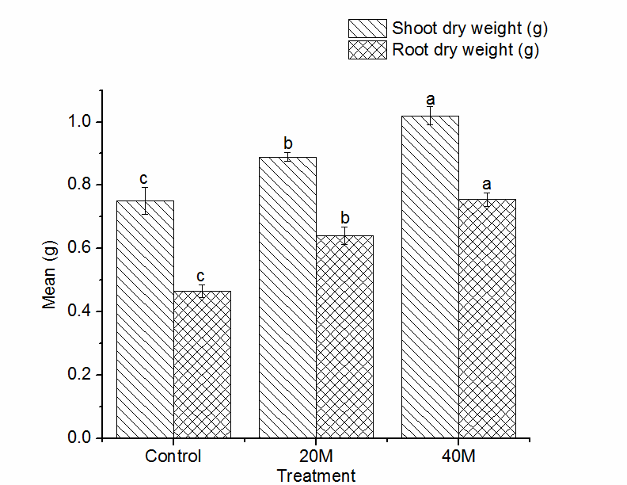
Figure 2: Effect of manure compost on shoot and root dry weight (g) of Leucaena leucocephala seedlings. Different alphabets indicate significant differences among treatments according to the Tukey-Kramer honest significant difference (HSD) tests (P< 0.05).

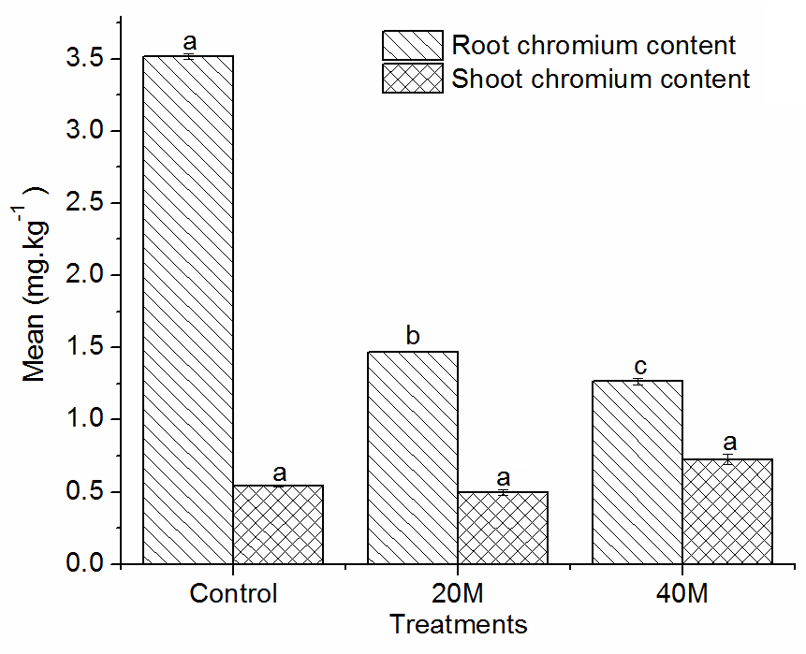
Figure 3: Effect of manure compost on Chromium (Cr) accumulation in Leucaena leucocephala seedlings. Different alphabets indicate significant differences among treatments according to the Tukey-Kramer honest significant difference (HSD) tests (P< 0.05).

Nickel accumulation in Leucaena seedlings treated with manure compost is described in Figure 4. Nickel was absorbed in the roots of Leucaena plants at significantly (p < 0.05) lower rates in unamended plants; indicating that the plant is able to accumulate minimal Ni content in its root portion naturally. Nickel content in the root of Leucaena seedlings increased by 5.88% (0.39 mg·kg⁻¹) with increase in manure application from 20 mg·kg⁻¹ to 40 mg·kg⁻¹, but was not significant. Compared with the control plants, application of manure at 20 mg·kg⁻¹ increased Ni in the root by a significant 25.78% (1.61 mg·kg⁻¹); whereas further increase in manure application to 40 mg·kg⁻¹ increased Ni in the root by a significant 30.14% (2.00 mg·kg⁻¹), compared with the control plants. Nickel concentration in the shoot portion showed a different pattern. Application of manure at 20 mg·kg⁻¹ did not have a significant effect on Ni translocation into the shoot portion, compared to the control plants; whereas further increase in the manure to 40 mg·kg⁻¹ significantly decreased Ni translocation into the plant shoot portion.

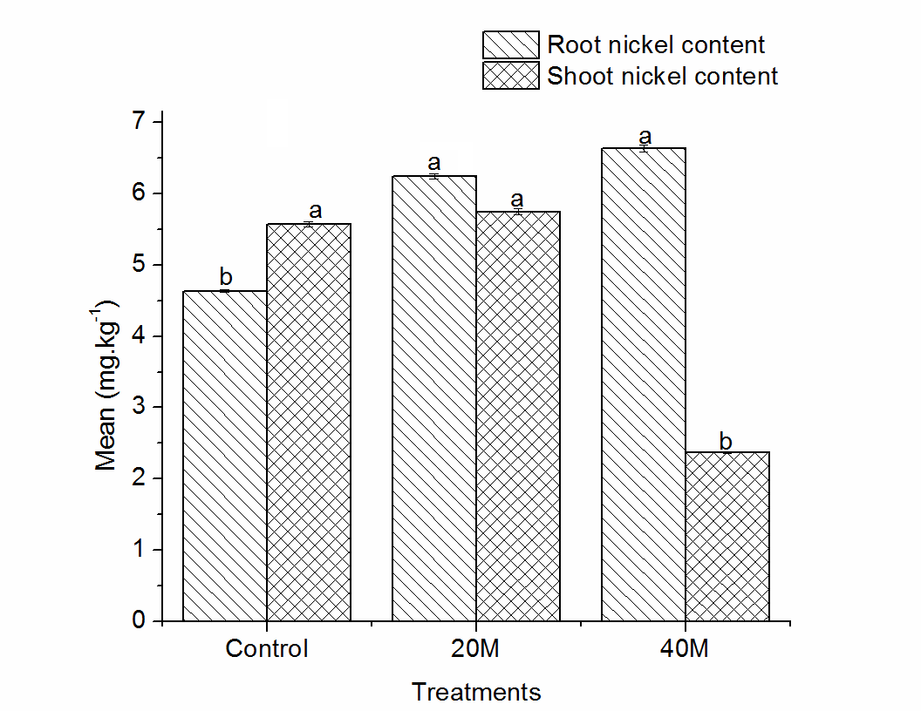
Figure 4: Effect of manure compost on Nickel (Ni) accumulation in Leucaena leucocephala seedlings. Different alphabets indicate significant differences among treatments according to the Tukey-Kramer honest significant difference (HSD) tests (P< 0.05).

Effects of manure compost on bio-concentration and translocation factors in Leucaena seedlings
In order to determine the phyto-extraction potential of Leucaena, the translocation factor (TF) and bio-concentration factor (BCF) of the metals in the plant were evaluated according to equations (1) and (2) in the Materials and method section, respectively. In the result presented in Table 1, a TF (Cr) < 1 was realized for all treatments (0.155 – 0.573). However, highest TF (Cr) was realized in plants treated with 40 mg·kg⁻¹ manure compost (0.573), whereas the lowest TF (Cr) was realized in the control plants (0.155). On the other hand, the control Leucaena plants had a TF> 1 for Ni (1.203), and was significantly higher (p < 0.05) compared to plants treated with manure at both rates (Table 1). Translocation factor for Ni decreased significantly with further increase in manure rates from 0.921 to 0.358. Application of 20 mg·kg⁻¹ manure compost suppressed TF (Ni) by 23.44%, whereas further increase in manure compost rate to 40 mg·kg⁻¹ suppressed TF (Ni) by 70.24%, compared to the control plants. Increase in manure rate suppressed the TF (Ni) in the seedlings by 61.13%. It is worthy of note that treatments that showed least significant effect on TF (Cr) showed highest significant effect on TF (Ni), and vice versa.

Table 1: Effect of composted manure application on plant biomass and phytoremediation parameters of Leucaena leucocephala seedlings
Manure (mg/kg) |  | TF %  (Cr) | TF %  (Ni) | BCF %  (Cr) | BCF %  (Ni)
0 |  | 0.155^{c} | 1.203ª | 0.005^{b} | 0.093^{b}
20 |  | 0.337^{b} | 0.921^{b} | 0.005^{c} | 0.096ª
40 |  | 0.573ª | 0.358^{c} | 0.007ª | 0.040^{c}

Means in the same column with different alphabets indicate significant differences among treatments according to the Tukey-Kramer honest significant difference (HSD) tests (P< 0.05). TF: Translocation Factor; BCF: Bio-concentration Factor
Bio-concentration factor, which measures the metal concentration (mg·kg⁻¹) ratio of plant shoot to soil, was determined for chromium and nickel in the Leucaena seedlings (Table 1). In all, the BCF obtained was much lower than 1. However, highest BCF (Cr) was realized in plants treated with 40 mg·kg⁻¹ manure compost (0.007); whereas highest BCF (Ni) was realized in plants treated with 20 mg·kg⁻¹ manure compost (0.096). Conversely, the lowest BCF (Ni) was realized in plants treated with 40 mg·kg⁻¹ manure compost (0.040), while the lowest BCF (Cr) was realized in plants treated with 20 mg·kg⁻¹ manure compost (0.005).

Relationship between plant dry weights and heavy metal partitioning
Table 2 shows the corresponding relationship between heavy metal content (mg·kg⁻¹) and its effect on dry weight (g) of Leucaena seedling. In the result, a significant but negative correlation was noted between the shoot Ni concentration and shoot and root dry weights (p < 0.05; r = -0.81; r = -0.76); however, a highly significant and positive correlation was noted between the root Ni concentration and shoot and root dry weights (p < 0.01; r = 0.94; r = 0.97). Shoot Cr concentration showed a positive correlation with shoot and root dry weights (p > 0.05; r = 071; r = 0.65), but was not significant; while the root Cr concentration showed a highly significant but negative correlation with the shoot and root dry weights (p < 0.01; r = -0.89; r = -0.94). Application of composted manure showed a highly significant and positive correlation with shoot and root dry weights (p < 0.01; r = 0.98; r = 0.98).

Table 2: Correlation pattern between treatments, plant part heavy metal content, and plant biomass
Parameters | Root Ni (mg/kg) | Shoot Cr (mg/kg) | Root Cr (mg/kg) | Shoot dry weight (g) | Root dry weight (g) | Treatments
Shoot Ni | -0.62 | -0.97** | 0.53 | -0.81* | -0.76* | -0.84*
Root Ni |  | 0.48 | -0.99** | 0.94** | 0.97** | 0.94**
Shoot Cr |  |  | -0.38 | 0.71 | 0.65 | 0.73
Root Cr |  |  |  | -0.89** | -0.94** | -0.90*
Shoot dry weight |  |  |  |  | 0.97** | 0.98**
Root dry weight |  |  |  |  |  | 0.98**
*. Correlation is significant at the 0.05 level; **. Correlation is significant at the 0.01 level

4. Discussion

Application of manure compost increased plant growth parameters (height, number of leaves, plant dry weights)

The result of soil analysis showed that the soil used in this study is not fertile and therefore cannot support efficient crop development. Thus, application of manure on the soil was essential to support crop growth. Furthermore, in our result, we observed there was no significant difference in the height of the control plants and the manure treated plants; but number of leaves increased significantly with manure application (Fig. 1). According to Stewart et al. (2000), application of manure compost improves nutrient cycling. Manure is a more easily mineralizable organic matter source whose nutrients are more readily available to plants. This may explain the higher biomass yield obtained with the application of the manure. Similar results were also reported for Brassica juncea (Clemente et al., 2005), Zea mays (Thomas and Dauda, 2015) and Lycopersicon esculentum (Adekiya and Agbede, 2016) seeded in fresh cow manure or poultry manure amended soils, respectively, with the highest biomass yields obtained from plants grown in the amended soils. Liu et al. (2009) also reported the promotive effect of compost application on seed yield in wheat plant grown in Cd-polluted soils.
Plant dry weight (shoot and root) of Leucaena seedlings showed improved response with the applied manure (Fig. 2). This is in agreement with the report of Liu, Chen (2009), who reported enhancement of dry-matter yield in maize plants after treatment to farm yard manure. Such enhancement could be attributed to the release of additional nutrients, improved buffering capacity, and enhanced nutrient cycling as a result of manure decomposition. This result is in agreement with Clemente et al. (2006) and Ejoh et al. (2012).

Manure compost enhanced heavy metal translocation in Leucaena seedlings
Generally, chromium concentration was higher in Leucaena root than in the shoot (Fig. 3); while nickel was only higher in the root than in the shoot in the presence of organic amendment (Fig. 4). According to Lin et al. (2003), uptake of metal concentration by roots depend on some factors which include metal speciation, soil characteristics, and type of plant species. Park et al. (2013) has noted that metal(loid)s bioavailability in the soil could be as a result of root-induced changes in soil properties. Other factors that may influence metal(loid) bioavailability in the soil include root-induced pH changes, metal binding by root exudates, root-induced microbial activities, among others (Park et al., 2016). The root and its environment have the major impact on heavy metal absorption. Metal mobility and bioavailability may be dependent on rhizosphere processes. Liu et al. (2007) reported increased cadmium, arsenic and mercury concentrations in rice root than shoot. The effect of manure application in decreasing metal uptake into the shoot portion was also shown in our result, where manure application strictly restricted Ni and Cr concentrations to the root portion. The use of dairy manure biochar has also been reported to immobilize Lead (Pb) and atrazine in contaminated soils (Cao et al., 2011). Likewise, Gul et al. (2016) reported higher heavy metal concentrations (including Ni and Cr) in the root than the shoot of maize seedlings treated with composted manure. Alamgir et al. (2011) also reported that application of farm yard manure decreased cadmium and lead uptake in Amaranths seedlings; but heavy metal concentration was higher in the root than shoot at all levels of the amendment.
Heavy metal immobilization by organic amendments has been attributed to a number of reasons. Clemente, Walker (2005) reported that manure provides binding sites for metals thus reducing their availability to plant roots. In Cao et al. (2011), Pb immobilization was due to its conjugation with the manure-containing phosphorus to form insoluble hydroxypyromorphite. According to Walker et al. (2004) and Bolan et al. (2014), manure-containing humic acids have immobilizing effects on metal(loid)s. Likewise, manure application has been reported to increase soil organic matter, electrical conductivity (EC) as well as pH (Zhao et al., 2014). And since the mobility of heavy metals depend on soil organic matter and pH (Abechi et al., 2010), increase in these soil properties with the application of manure could have consequently caused a decrease in heavy metal mobility for easy uptake by plant roots. Whalen et al. (2000) has explained that the higher pH in manure-amended than un-amended soils was attributed to buffering from bicarbonates and organic acids in the manure. Thus, lower availability of the metal(loids)s from soils to plants will result in a lower uptake and accumulation in the plant tissues.

Manure compost on heavy metal bio-concentration and translocation factors in Leucaena seedlings
The translocation factor, TF, is described as the ratio of heavy metals in plant shoot to that in plant root (Yoon et al., 2006); if TF > 1, then the plant can be considered an accumulator. The bio-concentration factor, BCF is the transfer of heavy metals from growth media to plants (Li et al., 2007); If BCF > 1, then the plant can be considered an accumulator. BCF or TF <1 indicates the plant is not suitable to be an accumulator of the metal. Plant species with TF values >1 were considered suitable for phytoextraction and generally requires translocation of heavy metals into harvestable plant parts i.e., shoots (Muddarisna et al., 2013, Yoon et al., 2006). In our result, Chromium translocation factor (TF (Cr)) increased with increasing manure quantity (0.155 - 0.573). TF (Cr) was found in the order of 0.155 (control) > 0.337 (20 mg·kg⁻¹ manure) > 0.573 (40 mg·kg⁻¹ manure). Nickel translocation factor (TF (Ni)) was highest in the control plants, but decreased with increase in manure application. TF (Ni) was found in the order of 0.358 (40 mg·kg⁻¹ manure) > 0.921 (20 mg·kg⁻¹ manure) > 1.203 (control). The highest TF (Ni) value was 1.203. Ghosh and Singh (2005) reported that high root to shoot TF of heavy metals indicated that the plant has vital characteristics to be used in phytoextraction of these metals. It is easy for plants with TF > 1 to translocate metals from root to shoots (Al-Qahtani, 2012). This can also be noticed in our result where Ni concentration was higher in Leucaena shoot than root of the control plants.
BCF (Ni) followed the order 0.096 (20 mg·kg⁻¹ manure) > 0.093 (control) > 0.040 (40 mg·kg⁻¹ manure). The highest BCF (Ni) value was noted in plants with lower manure rate; but highest BCF (Cr) was noted with 40 mg·kg⁻¹ manure application. BCF (Cr) was generally lower than BCF (Ni). Generally, BCF was less than 1 (BCF < 1), which indicates the plant is not suitable to be an accumulator of the metal. As stated by Zhao et al. (2003), plant biomass, bio-concentration factor and soil mass are the three variables that define the phytoremediation potential of a given plant species. Low BCF values indicate to a great extent, that such plant had difficulties in mobilizing the elements (Marchiol et al., 2004). In our result, high root to shoot translocation of Ni shows that the Leucaena plant might have vital characteristics to be used in phytoextraction of the metal. However, low root to shoot translocation of Cr was noted, which could mean that the plant does not have capability to phytoextract Cr in its contaminated medium. The elevated concentration of Ni in the root of Leucaena plants after treatment with manure compost indicated the plant might be suitability for phytostabilization (Yoon et al., 2006); whereas, phytostabilization of Cr with Leucaena may occur in the absence of compost.

Relationship between plant dry weights and heavy metal partitioning
As shown in Table 2, a significantly high but negative correlation was noted between root Cr or shoot Ni and plant biomass (shoot and root dry weights). As noted by Sethy and Ghosh (2013), exposure to heavy metals could induce abnormal effects on a plant, such as decrease in germination, reduced root and shoot elongation and dry weights. Gunawardana et al. (2011) also reported least root and shoot biomass in plants grown in unamended control medium compared to plants grown with amendments. Similar decrease in dry biomass was reported in Indian mustard grown in multiple-metal contaminated soil (Quartacci et al., 2006).

Conclusion

In this report, application of manure compost on heavy metal bioavailability and growth of Leaucaena leucocephala was studied. Application of the manure compost increased number of leaves and plant biomass, but did not significantly affect plant height. On the other hand, manure application to Leucaena seedlings significantly reduced heavy metal concentrations in the shoot than in the root portion.

In the result of heavy metal uptake by Leucaena, the measured heavy metals showed contrasting responses to the applied manure compost. Firstly, manure application decreased Cr content in the plant root. Further translocation of Cr into the above ground portion was restricted to the level of the control plants, in the presence of manure compost. This indicated that application of manure compost reduced chromium at both above ground and below ground level in the Leucaena seedlings. Secondly, Ni concentration was increased in the root portion of Leucaena, compared to the shoot portion; application of manure increased Ni in the root above the control plants. Whereas, application of manure brought the Ni concentration to either same level with control plants, or even lower.

Manure application seemed to have suppressive effect on heavy metal uptake into above ground portion, as presented in this study. Leucaena might be suitable for phytoextraction of nickel, but application of manure could make Leucaena suitable for phytostabilization in a contaminated soil.

Acknowledgement

The authors wish to thank the Soil Analytical Laboratory of the Agronomy department, University of Ibadan for assistance in sample analyses, and the Soil Science department of the Federal University of Agriculture, Abeokuta, for supporting other aspects of the work.

Corresponding Author:
Dr. Kehinde O. Erinle,
School of Agriculture, Food and Wine,
University of Adelaide, Adelaide SA 5005
South Australia
Telephone: +61-449-792-468
E-mail: Kehinde.Erinle@adelaide.edu.au

References
- Abechi E, Okunola O, Zubairu S, Usman A, Apene E, Evaluation of heavy metals in roadside soils of major streets in Jos metropolis, Nigeria. Journal of Environmental Chemistry and Ecotoxicology, 2010. 2(6): p. 98-102.
- Adekiya A, Agbede T, Effect of methods and time of poultry manure application on soil and leaf nutrient concentrations, growth and fruit yield of tomato (Lycopersicon esculentum Mill). Journal of the Saudi Society of Agricultural Sciences, 2016.
- Al-Qahtani KM, Assessment of heavy metals accumulation in native plant species from soils contaminated in Riyadh City, Saudi Arabia. Life Science Journal, 2012. 9(2): p. 384-92.
- Alamgir M, Kibria M, Islam M, Effects of farm yard manure on cadmium and lead accumulation in Amaranth (Amaranthus oleracea L.). Journal of Soil Science and Environmental Management, 2011. 2(8): p. 237-40.
- Appleton J, Cave M, Palumbo-Roe B, Wragg J, Lead bioaccessibility in topsoils from lead mineralisation and urban domains, UK. Environmental Pollution, 2013. 178: p. 278-87.
- Arora M, Kiran B, Rani S, Rani A, Kaur B, Mittal N, Heavy metal accumulation in vegetables irrigated with water from different sources. Food Chemistry, 2008. 111(4): p. 811-15.
- Bolan N, Kunhikrishnan A, Thangarajan R, Kumpiene J, Park J, Makino T, et al., Remediation of heavy metal (loid) s contaminated soils–to mobilize or to immobilize? Journal of Hazardous Materials, 2014. 266: p. 141-66.
- Cao X, Ma L, Liang Y, Gao B, Harris W, Simultaneous immobilization of lead and atrazine in contaminated soils using dairy-manure biochar. Environmental Science & Technology, 2011. 45(11): p. 4884-89.
- Cavender ND, Atiyeh RM, Knee M, Vermicompost stimulates mycorrhizal colonization of roots of Sorghum bicolor at the expense of plant growth. Pedobiologia, 2003. 47(1): p. 85-89.
- Clemente R, Escolar Á, Bernal MP, Heavy metals fractionation and organic matter mineralisation in contaminated calcareous soil amended with organic materials. Bioresource Technology, 2006. 97(15): p. 1894-901.
- Clemente R, Walker DJ, Bernal MP, Uptake of heavy metals and As by Brassica juncea grown in a contaminated soil in Aznalcóllar (Spain): the effect of soil amendments. Environmental Pollution, 2005. 138(1): p. 46-58.
- Dhar SK. Metal Ions Biological System. World Resources Institute: Heavy Metals and Health. New York: Plenum1973.
- Ejoh OE, Adenipekun CO, Adeniyi OA, Effect of Pleurotus tuberregium Singer and micro organisms on degradation of soil contaminated with spent cutting fluids. New York Science Journal 2012. 5(10).
- Ghosh M, Singh S, A review on phytoremediation of heavy metals and utilization of it’s by products. Asian J Energy Environ, 2005. 6(4): p. 18.
- Gul S, Naz A, Khan A, Nisa S, Irshad M, Phytoavailability and Leachability of Heavy Metals from Contaminated Soil Treated with Composted Livestock Manure. Soil and Sediment Contamination: An International Journal, 2016. 25(2): p. 181-94.
- Gunawardana B, Singhal N, Johnson A, Effects of amendments on copper, cadmium, and lead phytoextraction by Lolium perenne from multiple-metal contaminated solution. International Journal of Phytoremediation, 2011. 13(3): p. 215-32.
- Harnik P, Taylor M, Welle B, From Dumps to Destinations: The conversion of landfills to parks has great potential for cities. American Society of Landscape Architechture, 2006.
- Hisfa M, Ismat N, Abida T, Phytoremediation of Cu(II) by Calotropis procera roots. New York Science Journal, 2010. 3(3).
- Hu X, Zhang Y, Ding Z, Wang T, Lian H, Sun Y, et al., Bioaccessibility and health risk of arsenic and heavy metals (Cd, Co, Cr, Cu, Ni, Pb, Zn and Mn) in TSP and PM2. 5 in Nanjing, China. Atmospheric Environment, 2012. 57: p. 146-52.
- Li M, Luo Y, Su Z, Heavy metal concentrations in soils and plant accumulation in a restored manganese mineland in Guangxi, South China. Environmental Pollution, 2007. 147(1): p. 168-75.
- Lin Q, Chen Y, Chen H, Yu Y, Luo Y, Wong M, Chemical behavior of Cd in rice rhizosphere. Chemosphere, 2003. 50(6): p. 755-61.
- Liu L, Chen H, Cai P, Liang W, Huang Q, Immobilization and phytotoxicity of Cd in contaminated soil amended with chicken manure compost. Journal of Hazardous Materials, 2009. 163(2): p. 563-67.
- Liu Y, Wang X, Zeng G, Qu D, Gu J, Zhou M, et al., Cadmium-induced oxidative stress and response of the ascorbate–glutathione cycle in Bechmeria nivea (L.) Gaud. Chemosphere, 2007. 69(1): p. 99-107.
- Luo XS, Ding J, Xu B, Wang YJ, Li HB, Yu S, Incorporating bioaccessibility into human health risk assessments of heavy metals in urban park soils. Science of the Total Environment, 2012. 424: p. 88-96.
- Marchiol L, Sacco P, Assolari S, Zerbi G, Reclamation of polluted soil: phytoremediation potential of crop-related Brassica species. Water, Air, and Soil Pollution, 2004. 158(1): p. 345-56.
- Muddarisna N, Krisnayanti B, Utami S, Handayanto E, Phytoremediation of mercury-contaminated soil using three wild plant species and its effect on maize growth. Applied Ecology and Environmental Sciences, 2013. 1(3): p. 27-32.
- Okorie A, Entwistle J, Dean JR, The application of in vitro gastrointestinal extraction to assess oral bioaccessibility of potentially toxic elements from an urban recreational site. Applied Geochemistry, 2011. 26(5): p. 789-96.
- Oyedele D, Asonugho C, Awotoye O, Heavy metals in soil and accumulation by edible vegetables after phosphate fertilizer application. Electron J Environ Agric Food Chem, 2006. 5: p. 1446-53.
- Park JH, Choppala G, Lee SJ, Bolan N, Chung JW, Edraki M, Comparative sorption of Pb and Cd by biochars and its implication for metal immobilization in soils. Water, Air, & Soil Pollution, 2013. 224(12): p. 1711.
- Park W-P, Koo B-J, Chang AC, Ferko TE, Parker JR, Ward TH, et al., Dissolution of Metals from Biosolid-Treated Soils by Organic Acid Mixtures. Applied and Environmental Soil Science, 2016. 2016.
- Puskás I, Farsang, A., Csépe, Z. and Bartus, M, Heavy metal exposure and risk characterization of topsoils in urban playgrounds and parks (Hungary). Geophysical Research Abstracts, 2014. 16(EGU2014-641.).
- Quartacci M, Argilla A, Baker A, Navari-Izzo F, Phytoextraction of metals from a multiply contaminated soil by Indian mustard. Chemosphere, 2006. 63(6): p. 918-25.
- Salt DE, Smith R, Raskin I, Phytoremediation. Annual Review of Plant Biology, 1998. 49(1): p. 643-68.
- Sethy SK, Ghosh S, Effect of heavy metals on germination of seeds. Journal of Natural Science, Biology and Medicine, 2013. 4(2): p. 272.
- Shelton H, Brewbaker J, 2.1 Leucaena leucocephala–the most widely used forage tree legume. Forage Tree Legumes in Tropical Agriculture St Lucia Queensland: Tropical Grassland Society of Australia Inc http://www fao org/ag/AGP/AGPC/doc/Publicat/Guttshel/x5556e06 htm, 1998.
- Stewart B, Robinson C, Parker DB, Examples and case studies of beneficial reuse of beef cattle by-products. Land application of agricultural, industrial, and municipal by-products, 2000: p. 387-407.
- Tangahu BV, Sheikh Abdullah SR, Basri H, Idris M, Anuar N, Mukhlisin M, A Review on heavy metals (As, Pb, and Hg) uptake by plants through phytoremediation. International Journal of Chemical Engineering, 2011. 2011.
- Thomas EY, Dauda SO, Comparative Effects Of Compost And Poultry Manure On Bioavailability Of Pb And Cu And Their Uptake By Maize (Zea mays L.) New York Science Journal, 2015. 8(7).
- Walker DJ, Clemente R, Bernal MP, Contrasting effects of manure and compost on soil pH, heavy metal availability and growth of Chenopodium album L. in a soil contaminated by pyritic mine waste. Chemosphere, 2004. 57(3): p. 215-24.
- Whalen JK, Chang C, Clayton GW, Carefoot JP, Cattle manure amendments can increase the pH of acid soils. Soil Science Society of America Journal, 2000. 64(3): p. 962-66.
- Yoon J, Cao X, Zhou Q, Ma LQ, Accumulation of Pb, Cu, and Zn in native plants growing on a contaminated Florida site. Science of the Total Environment, 2006. 368(2): p. 456-64.
- Zhao F, Lombi E, McGrath S, Assessing the potential for zinc and cadmium phytoremediation with the hyperaccumulator Thlaspi caerulescens. Plant and Soil, 2003. 249(1): p. 37-43.
- Zhao Y, Yan Z, Qin J, Xiao Z, Effects of long-term cattle manure application on soil properties and soil heavy metals in corn seed production in Northwest China. Environmental Science and Pollution Research, 2014. 21(12): p. 7586-95.

3/25/2017

