Primary Productivity of Owalla Reservoir, Osun State, Southwest, Nigeria.

Omoboye, H. Y.* and Adeniyi, I. F.

Zoology Department, Obafemi Awolowo University, Ile-Ife, Osun State, Nigeria.
*Correspondent: yettyabioye@yahoo.com, helenabioye@gmail.com

Abstract: This study investigated primary productivity of Owalla Reservoir, Osun State, Nigeria. This was with a view to providing relevant information on the primary productivity of the reservoir. Sampling period covered rainy and dry seasons. Seven Sampling stations were selected on the reservoir for this study (designated 1, 2, 2 3, 4, 5, 6 and 7). At Stations 1 and 3, only surface water samples were collected for primary productivity while water samples were collected from three levels of water column (surface, mid-depth and close to the bottom) of the reservoir at other stations (Stations 2, 4, 5, 6, and 7). Primary productivity was determined using Oxygen Method. The data obtained were subjected to appropriate statistical analysis. The gross primary productivity of Owalla Reservoir during the study period ranged from 17.28 to 126.72 KCal/M³/day. The respiration of Owalla Reservoir during the study period ranged from 1.73 to 103.68 KCal/M³/day while the net primary productivity of Owalla Reservoir during the study period was in the range of 4.90 - 45.22 KCal/M³/day. Net productivity accounted for 34.7% of the Gross Productivity. Respiration accounted for 65.3% of the Gross Productivity. The mean value of the net productivity of the reservoir decreased vertically from surface to the bottom. The mean respiration decreased towards the dam site while the vertical variation generally showed decrease vertically from the surface level to the bottom of the reservoir (P≤0.05). Gross primary productivity decreased down the reservoir column from the surface to the bottom and there was very highly significant difference (P≤0.001) in mean value at the three vertical depths. The reservoir can be classified as oligotrophic based on its primary productivity level. However, the lake should be subjected to regular proper monitoring.
[Omoboye, H. Y. and Adeniyi, I. F. Primary Productivity of Owalla Reservoir, Osun State, Southwest, Nigeria. N Y Sci J 2017;10(4):87-93]. ISSN 1554-0200 (print); ISSN 2375-723X (online). http://www.sciencepub.net/newyork.12. doi:10.7537/marsnys100417.12.

Keywords: Primary productivity, Respiration, Oligotrophic, Owalla Reservoir.

1. Introduction
This work involved water sampling of Owalla Reservoir over the two seasons of the year, the analysis of the water samples for determining the primary productivity of the reservoir. Primary production is the manufacture of organic compounds from atmospheric or aquatic carbon (IV) oxide, principally through the process of photosynthesis, with chemosynthesis being much less important (Global Change, 2008). The flow of energy through any ecosystem starts with the fixation of sunlight by plants and other autotrophic organisms. In this way the plant accumulates energy and this energy is called primary production. The rate at which this energy accumulates is called primary productivity. The total energy accumulated is gross primary production, however, since plants use some of this energy themselves, it is not all available for the food web. The difference between what is accumulated and what is available for the food web is called net primary production. Planktonic productivity and respiration can be separated from overall community activity by the use of the light-and-dark bottle oxygen technique (Hall, 1972; Nixon, 1974). The primary productivity of a water body is the manifestation of its biological production. It is an ultimate outcome of photosynthesis that forms the basis of ecosystem functioning since it makes the chemical energy and organic matter available to the entire biological community. The chlorophyll bearing organisms utilize solar energy and convert it into chemical energy in the form of carbohydrate molecules by taking carbon dioxide and water from the environment (Patra, 1985). All freshwater ecosystems (lakes, rivers, ponds, streams, wetlands) are home to various life forms, often collectively referred to as the food chain or food web. Therefore, the numbers and variety of living organisms in a freshwater food web are dependent on the productivity of the ecosystem. Of course, the available energy is constantly changing with daily and seasonal cycles, and the raw materials are continuously cycling (water cycle, carbon cycle, nitrogen cycle, phosphorus cycle) through and within the ecosystem. These fluctuations also help to determine the shorter-term productivity of the system. The greater the primary production within an ecosystem, the more living biomass that can be supported within the food web. This work was conducted to study the spatial and seasonal changes in primary photosynthetic productivity of Owalla Reservoir.

2. Material and Methods
2.1. Study Area
The investigated water body is Owalla Reservoir (Figure 1) which is one of the largest surface water bodies in Osun State and one of the largest water bodies in South West Nigeria. The reservoir is located in Irepodun Local Government Area of Osun State within Latitudes 07º55¹ N – 07º60¹ N and Longitudes 004º30¹ E – 004º 35¹E with a surface area of 12km² (1200 ha). It is located about 17 km upstream of the existing Erinle/Ede reservoir. The reservoir was formed in 1989 as an impoundment of the River Erinle within the Osun River sub basin of the Ogun Osun River Basin of Nigeria. It is part of the water bodies impounded by the old Oyo State (now Oyo and Osun States) for the purpose of water storage to supply water to a number of towns in the states (Osogbo, Ede, Ile-Ife, Gbongan, Erin-Osun, Ilobu and Ifon-Osun) while fisheries development of the reservoir is a major secondary benefit.

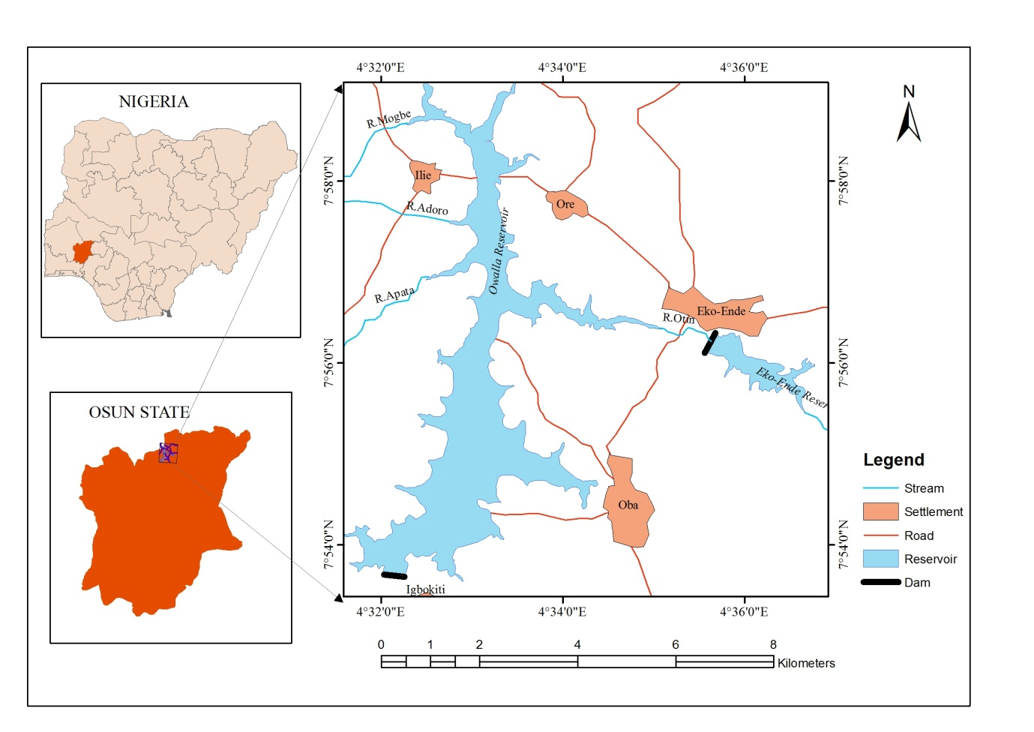
Figure 1: The map of Osun State showing Owalla Reservoir (Ikpe, 2012)

The study area is characterized by two distinct climatic seasons namely: dry season from November to March or April and the rainy season from April to October. Specifically, the study area is under Koppen’s Af humid rainforest climate (Adediji and Ajibade, 2008). The study area constitutes a part of the Basement Complex of Southwestern Nigeria and it is characteristically underlain by hard crystalline igneous and metamorphic rocks. These rocks constitute the prominent outcrops and inselbergs that define topographic highlands (Cita. Del Consult, 1994).
Surface materials are characterized by relatively deeply weathered soil profile or regolith in the low lying areas, due to the relatively humid climate condition. Greater proportion of the soils are ferruginous tropical red (laterites) associated with Basement Complex terrains (Moshood and Shinichi, 2009). The soil of the area vary from moderately to strongly leached, and have low to medium humus content, weakly acidic to neutral on surface layers and moderately to strongly acidic sub-soil (Smith and Montgomery, 1962).
The area falls within the lowland tropical rain forest vegetation (Moshood and Shinichi, 2009), characterized by emergent trees with multiple canopies lianas (Adediji and Ajibade, 2008). Most of the original vegetation has given way to secondary forest and derived savannah.
2.2. Selection and Description of Sampling Stations
For this study, seven sampling stations (Stations 1, 2, 3, 4, 5, 6, and 7) were established along the horizontal axis of the reservoir (Figure 2). Stations 2 and 5 are located at the middle basin. Stations 1, 3, 4 and 6 are established at the riverside portion of the reservoir while Station 7 is located towards the deepest portion of the reservoir close to the dam, mid-point from the shores. A permanent floating material was used to indicate the location of each of the seven sampling stations for easy subsequent recognition. The grid co-ordinates of each station were measured and recorded using a Global Positioning System (GPS) handset.

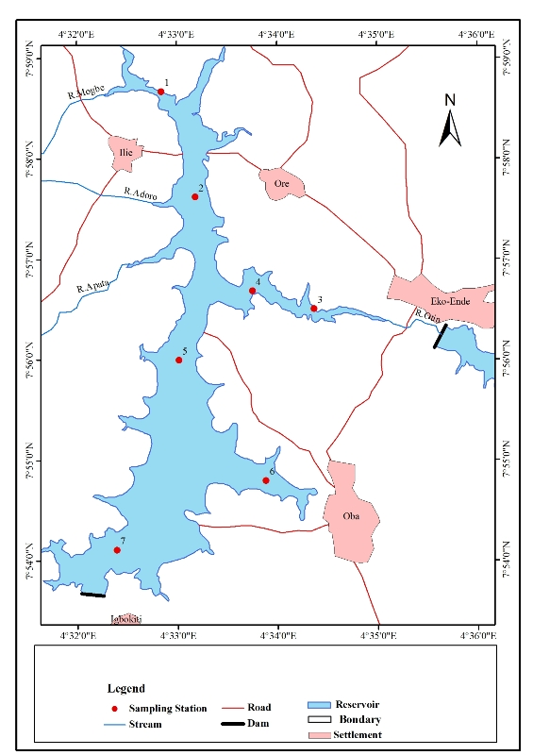
Figure 2: Map of Owalla Resevoir showing the investigated Sampling Station (Ikpe, 2012)

2.3. Sampling Programme and Field Determination
At Stations 1 and 3, only surface water sample were collected. Samples were collected from three levels through the water column (surface, mid-depth and close to the bottom) of the reservoir at other stations (Stations 2, 4, 5, 6, and 7). An improvised water sampler (2.5 L Capacity) was used for water sampling at sub-surface depths of the reservoir.
2.4. Primary Productivity Determination
The primary productivity was determined using the oxygen dark and white bottle method (APHA, 1992). Water samples were collected from the reservoir through the vertical profile (surface, mid-depth and bottom) at each sampling station. At each station three water samples were collected into three oxygen bottles (two light bottles, one dark bottle). The first or initial bottle (IB) was used for the determination of initial dissolved oxygen concentration in the reservoir, the second light bottle (WB) was used to collect sample for the oxygen produced during photosynthesis over a period of time under incubation while the third dark bottle (BB) was used to determine the oxygen used up in respiration over the same period of illumination. The samples were transported to the laboratory. The white bottles for photosynthesis were made water-tight, ensuring the water inside could not pour out and that extra water could not enter using paper tape to bind the cork very well. The bottles were then placed in a transparent bowl containing water that was enough to cover the bottles in a slant position. The bottles for respiration determination were wrapped with black nylon and were placed in a dark cupboard over the period of the experiment. The two processes (photosynthesis and respiration) were carried out simultaneously while the initial oxygen concentration was fixed at the onset of the experiment. After six hours of the experiment, the white bottle and black bottles were harvested fixed with Winkler’s reagents and titrated for DO as was done for initial oxygen bottles (Odum, 1956). The productivity and respiration was calculated as follows:

Dissolved Oxygen (DO) in mg/L = $\frac{N x t/v x 800}{ Volume of Sample}$
$\frac{N/40 x t/v x 8000}{50}$= t/v x 4

Net Productivity (Kcal/M³/day) = DO (WB - IB) (mg/L) x 2 (12 hours ÷ 6) x 3.6
Respiration (Kcal/M³/day) = DO (IB - BB) (mg/L) x 4 (24 hours ÷ 6) x 3.6
Gross Productivity (Kcal/M³/day) = Net Productivity + Respiration
Where, t/v = Titre value, N= Normalty of Sodium Thiosulphate (Na₂S₂O₃).

3.0 Results
The mean value of the net productivity of the reservoir decreased vertically from surface to the bottom (Table 2). There was a very highly significant (P=0.001) difference in the mean value of the net productivity along the three depth profile. The net productivity of Owalla Reservoir was higher at the upper basin than at the lower basin but there was no significant difference (P=0.05) among stations along the horizontal axis (Table 1). On the other hand, the mean value of net productivity was higher (19.8±1.6 KCal/M³/day) in dry season than in the rainy season (19.7± 1.7 KCal/M³/day) but the difference was not statistically significant (P≤0.05) as shown in Table 3. Net productivity accounted for 34.7% of the Gross Productivity. Respiration decreased towards the dam site while the vertical variation generally showed decrease vertically from the surface level to the bottom of the reservoir (P=0.05) (Table 2). On the other hand, there was no significant difference in the horizontal variation of mean value ± sem of respiration along the main axis of the reservoir (Table 1). Also, in dry season, the mean respiration (36.9±2.9 KCal/M³/day) of Owalla Reservoir was higher compared to that of the rainy season (33.1±4.2 KCal/M³/day) but there was no significant difference (P>0.05) in these seasonal mean values as shown in Table 3. Respiration accounted for 65.3% of the Gross Productivity. The regression of Net Productivity (y axis) on Respiration (x axis) during both seasons (Figure 4) showed a low positive correlation (a = 11.54, b = 0.37, r = 0.46). The mean value ± sem of gross productivity at the upper basin was the highest (63.0±7.5 KCal/M³/day) and that of the mid basin was the lowest (53.0±3.6 KCal/M³/day) but there was no significant statistical difference (P>0.05) in horizontal variation (Table 1). Gross primary productivity decreased down the reservoir column from the surface to the bottom and there was very highly significant difference (P≤0.001) in mean value at the three vertical depths (Table 2). However, the mean value ±sem of gross primary productivity was slightly greater (P>0.05) in the dry season (57.8± 4.9 KCal/M³/day) than that of the dry season (55.2 ± 4.2 KCal/M³/day) (Table 3). The regression of Net Productivity and Respiration (y axis) on Gross Productivity (x axis) during both seasons (Figure 3) showed a high positive correlation (a = -10.2, b = 0.433, r = 0.796).

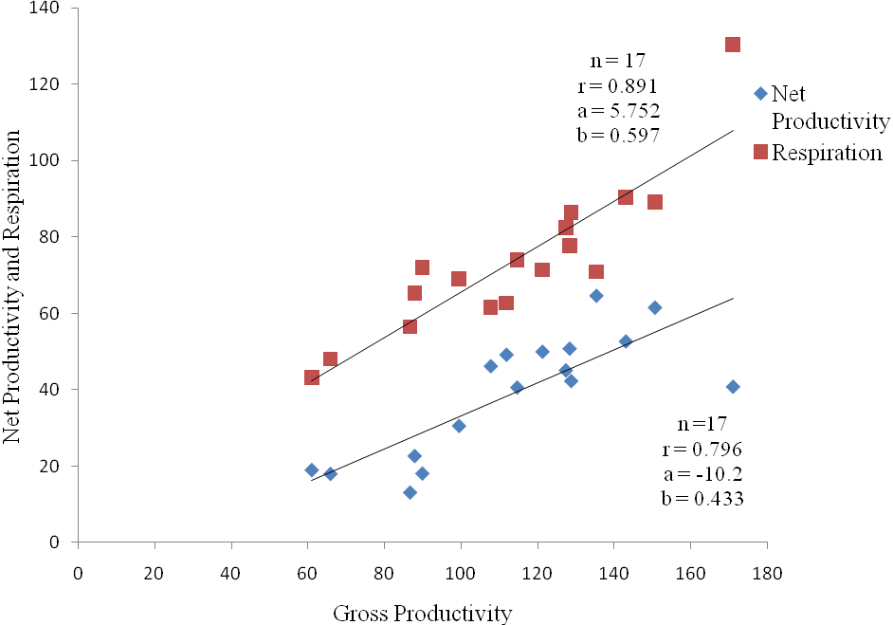
Figure 3: Regression of Net Productivity and Respiration on Gross Productivity in Owalla reservoir

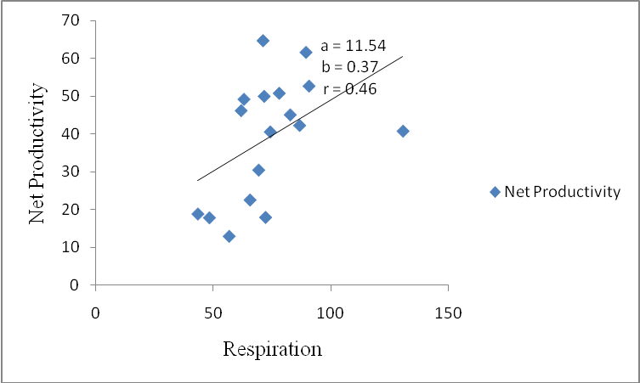
Figure 4: Regression of Net Productivity on Respiration in Owalla Reservoir

Table 1: ANOVA statistics of the horizontal variation of the mean productivity (KCal/M³/day) of Owalla Reservoir
Parameter | Upper Basin | Mid-Basin | Lower Basin | ANOVA
 | Mean±SE | Mean±SE | Mean±SE | F | P
 | n=16 | n=28 | n=24
Net Productivity | 42.7±6.3 | 34.4±2.6 | 35.6±4.1 | 1.031 | 0.362
Respiration | 32.3±6.4 | 26.3±2.6 | 23.8±3.2 | 1.134 | 0.328
Gross Productivity | 73.9±7.5 | 61.2±3.6 | 57.9±4.6 | 0.936 | 0.398

Table 2: ANOVA statistics of the vertical variation of the mean productivity (KCal/M³/day) of Owalla Reservoir
Parameter | Surface | Mid-Depth | Bottom | ANOVA
 | Mean±SE | Mean±SE | Mean±SE | F | P
 | n=28 | n=20 | n=20
Net Productivity | 25.4±1.1 | 21.8±2.3 | 9.8±1.0 | 28.63 | 1.21E-09***
Respiration | 42.0±3.6 | 38.0±4.3 | 28.5±3.8 | 3.137 | 0.05*
Gross Productivity | 67.4±3.9 | 59.7±4.8 | 39.2±4.2 | 11.6 | 0.00049***
* Significant (P≤0.05)
**Very highly Significant (P≤0.001)

Table 3: ANOVA statistics of the mean seasonal productivity (KCal/M³/day) of Owalla Reservoir
Parameter | Dry Season | Rainy Season | ANOVA
 | Mean±SE | Mean±SE | F | P
 | n=34 | n=34
Net Productivity | 19.8± 1.6 | 19.7 ±1.7 | 0.304 | 0.583
Respiration | 36.9± 2.9 | 33.1± 4.2 | 0.596 | 0.443
Gross Productivity | 57.8± 4.9 | 55.2± 4.2 | 0.001 | 0.973

4.0. Discussion
Primary productivity through the water column was higher at the surface than at other levels. The higher primary productivity at the surface followed the pattern of underwater light penetration in a typical reservoir which decreases with increase in depth and turbidity, This may also be the reason for decrease in gross primary productivity in the rainy season and increased gross productivity during the dry season as also reported by other researchers such as Egborge (1970); Gupta and Gupta (2006); Akinyemi and Nwakwo (2006); Atobatele and Ugumba (2008). Also, the decrease in gross primary productivity in the rainy season may be attributed to the light inhibition due to cloud cover as well as high water current during the season as posited by Madhupratap et al. (2001).
As noted by Mohanty et al. (2014), the net productivity, gross productivity and respiration of Owalla Reservoir were higher at the upper basin than at the lower basin. The organic matter entering the system, through flooded riverine system may cause increase in oxygen through increased phytoplankton photosynthetic activities with increased demand of dissolved oxygen for the oxidation of allochthonous organic matter.
The ratio of net primary production to gross primary production is essential for the evaluation of the amount of net production available to the consumers (Singh and Singh, 1999). The ratio of net primary production to gross primary production as well as net primary production to respiration was 0.36 and 0.60 respectively during rainy season and 0.34 and 0.54 during dry season while horizontally it was 0.68 and 1.32 at the upper basin and 0.62 and 1.50 at the down basin. The ratio of net primary productivity to respiration value was less than 1 for both rainy season and dry season (0.60, 0.54) but higher than one (1) at the upstream stations and downstream stations (1.32, 1.50). This may be attributed to reduced penetration of light into water due to suspended particulate matter leading to reduced photosynthetic activities and in turn a decrease in productivity during rainy season. The increase in water temperature which was likely to stimulate the growth of microbial population and in turn the utilization of more oxygen for their metabolic activities (Moharana and Patra, 2013; Ahmld and Singh, 1987; and Dash et al., 2011) during the dry season may also account for the less than one ratio during the dry season.
In conclusion, Owalla Reservoir is productive with great potential to support rich aquatic community and fishery production. The reservoir can be classified as oligotrophic based on primary productivity level. However, the lake should be subjected to regular proper monitoring because of the likely effect of some human activities (like open space defaecation, washing and bathing with detergents and soaps and grazing of cows around the water shed) observed during the study. Such activities may add nutrient to the water body leading to algal bloom which in turn will cause deterioration in water quality resulting in the loss of aquatic organisms.

Acknowledgements:
The Authors are grateful to the Department of Zoology, Faculty of Science, Obafemi Awolowo University, Ile-Ife, Osun State, Nigeria.

Corresponding Author:
Mrs. Helen Yetunde Omoboye
Department of Zoology Obafemi Awolowo University Ile-Ife, Osun State, Nigeria.
Telephone: +2348066141057
E-mail: yettyabioye@yahoo.com,
helenabioye@gmail.com

References
- Adediji, A. and Ajibade, L. T. (2008). The change detection of major dams in Osun State, Nigeria using remote sensing (RS) and GIS techniques. Journal of Geography and Regional Planning, 1 (6): 110 -115.
- Ahmd, S. H. and Singh A. K. (1987). Seasonal; fluctuations of primary production and fish yields in mangle's tank, Patna City (Bihar). Geobios, 14: 62-66.
- Akinyemi, S. A. and Nwankwo, D. I. (2006). Biological productivity of two reservoirs in Osun State, Nigeria. International Journal of Science Technology Research, 3(2): 16 - 22.
- APHA, (1992). American Public Health Association, Standard Methods for the Examination of Water and Wastewater, 18th edition APHA, Washington, D.C.
- Atobatele, O. E. and Ugwumba, O. A. (2008). Seasonal variation in the physico-chemical parameters of a small tropical reservoir (Aiba Reservoir, Iwo, Osun State, Nigeria). African Journal of Biotechnology, 7(12): 1962-1971.
- Citadel Consult, (1994). “Osun State Water Corporation Feasibity Study Report on the design of Eko-Ende Water Supply Scheme”.
- Dash, S., Patra, A. K. and Adhikarim, S. (2011). Primary Productivity of Kharasrota river (India). J. Ecophysiol. Occup., 219-225.
- Egborge, A. B. M. (1970). The hydrology and plankton of the River Oshun, Western State, Nigeria. M. Sc. Thesis, University of Ibadan, 126 pp.
- Global Change (2008). The flow of energy: primary production to higher trophic levels. The Reagents of the University of Michigan. Retrieved Dec. 07, 2010 from http://www.globalchange.umich.edu.
- Graneli, E., and C. Haraldson. 1993. Can increased leaching of trace metals from acidified areas influence phytoplankton growth in coastal waters? Ambio, 22: 308–311.
- Gupta, S. K. and Gupta, R. C. (2006). General and Applied Ichthyology (Fish and Fisheries), Chand and Company Ltd. Ram Nagar, New Delhi, 130 pp.
- Hall, C. A. S. (1972). Migration and metabolism in a temperate stream ecosystem. Ecology, 53: 585-604.
- Madhupratap, M., Nair, K. N. V., Gopalakrishnan, T. C., Haridas, P., Nair, K. K. C., Venugopal, P. and Gauns, M. (2001). Arabian Sea oceanography and fisheries of the west coast of India. Current Science, 81: 355-361.
- Mohanty, S. S., Pramanik, D. S. and Dash, B. P. (2014). Primary Productivity of Bay of Bengal at Chandipur in Odisha, India. International Journal of Scientific and Research Publications, 4(10): 2250-3153.
- Moharana, P. and Patra, A. K. (2013). Primary productivity of Bay of Bengal at Digha in West Bengal, India. Indian Journal of Life Science, 3(1): 129-132.
- Moshood, N. T. and Shinichi, O. (2009). Hydrogoechemical Assessment of Metals Contamination in an Urban Drainage System: A Case Study of Osogbo Township, SW Nigeria. Journal of Water Resources and Protection, 3: 164 – 173.
- Nixon, S. W. (1974). Salina Systems. In: Odum, H.T., Copeland, B. J., & McMahan, E.A. (eds), Coastal ecological system of United States, vol 3. The conservation foundation, Washington D. C., pp. 318-341.
- Odum, H. T. (1956). Primary Productivity in flowing waters. Limnol. Oceanogr., 1: 120.
- Patra, A. K. (1985). Proceedings of National Academy of Science, India. (B) IV: 290 – 295.
- Singh, A. K. and Singh, D. K. (1999): A comparative study of the phytoplanktonic primary production of River Ganga and Pond of Patna (Bihar). India. Journal of Environmental Biology, 20: 263-270.
- Smith, A. J. and Montgomery, F. R. (1962). Soil and Land Use in central Western Nigeria. The Government Printer, Ibadan. 265 pp.

4/2/2017

