Eradicating Rumors that Spoil the Organizations' Internal Peace:Management Technical Functions as Functions in its Behavioral Functions

Dr. Amgad Hamed Omara

Assist. Prof., in Business Administration Dept., Vice-Dean for Education and Students' Affairs, Faculty of Commerce, Menoufia University,Egypt
Email:amgadomara63@yahoo.com

Abstract:Why managers may fail to use normally the best of their subordinates in actualizing the management technical functions?Why rumors may succeed to prevent people's compliance to their managers? Is there anything managers should do to avoid rumors negative effect on the organizations' coherency or internal peace, particularly in terms of the employees-managers relationship? This research is methodically providing an answer to these questions. It has theoretically gone to establish through a conceptual framework and hypothetical model the relationship between the above noted aspects as key research variables. It has practically investigated 336 units of a probability random sample that's representing a population of 6370 employees; who are non-top-managers staffto end, through examining its hypothetical model in the reality of 91 Egyptian internal and Nile media centers' workplace,that managers' failure to practice some behavioral functions that’s building a trust-based relationship with their subordinates is to large extent a reason of the employees-managers incoherency,which leads to the spread of negative rumors and then organization's peace deficiency, and this in turn results in sort of the managers failure to fulfill, through their resistant and/or incompliant employees, the main technical functions of management.
[Amgad Hamed Omara.Eradicating Rumors that Spoil the Organizations' Internal Peace:Management Technical Functions as Functions in its Behavioral Functions. N Y Sci J2017;10(4):119-144]. ISSN 1554-0200 (print); ISSN 2375-723X (online).http://www.sciencepub.net/newyork. 17. doi:10.7537/marsnys100417.17.

Keywords:Management technical functions, rumors negative effect, organization's coherency, first class organization's peace deficiency, second class organization's peace deficiency, organization's instability, management behavioral functions, employees-management trust, organization running circles, organizations soft circles

Introduction:
It is very common in management literature to have too many authors who point out that the manager’s job is technically looked at as getting things done through the best of others (Kipping&Usdiken 2014, and Joullié 2016). But we are not sufficiently allowed by the same literature to understand exactly the conditions that make managers able to do so.Implicitly, there was an articulation that normal circumstances are going to be there all the time. Actually, it is not true; sometimes the incident does not come as being wished.
Whenever this happened, the capability of the manager to get things done through the best of others is too large extent going to be idled (Banks et al., 2016 and Purg&Sutherland2017). In other words, managers won't be able to actualize practically their technical functions (DeRue et al., 2011 and Owen 2015). They cannot be able to use the organization people for getting the objectives attained; the real execution of planning function will be doubtful (Stout et al., 1999, Barricket al., 2013 and Abrahamson et al., 2016). Cooperation between people as much as units will be harmfully affected;the key output of organizing function is going to be exceedingly missing in the workplace (Hernes&Weik2007, Schultz&Hernes2013 and Hernes 2014b). Outlyingdeviation from the varied forms of directing will be the common characteristic;theambiance of resistance and rejection wins throughpeople failure to listen to their managers (Liden et al.,1997, Le Blanc et al., 2012, and Helin et al., 2014). Controlling is expected to be sort of merely monitoring to the frail performance; since there is no need for being involved inmaking comparison between the works as theyareactually done and as they should be done;criteria or standardizations become far useless (Tangirala et al., 2007, Hernes 2008,Thompson 2011 and Zhou et al., 2012).
The assumption that managers are enduringly metwith a normal occurrencehasdeceivably put management authors as well as practitioners at a fake rest (Mckinley &Scherer 2000, Tsoukas&Chia 2002, Botha et al., 2008, and Pentland et al., 2011). When winds bring what chips do not crave, we cannot say that managers are going to be able tomake use of their main functions; planning, organizing, directing, and controlling, to get people do their best for getting things done (Brown&Duguid 1991, Wren et al., 2002, Wu et al., 2010, and Banerjee 2011).
The query to crop up for hub-revolving around, how could managers uses their technical functions to utilize people doing their best,so as to get things done, while the latter are refusing to do so?
Literature Review:
- The deficiency of organization's peace
In terms of the terminal language, there were two concepts to differentiate between them, so as to simplify even partially the research focal point. On the one hand, the organization's stability that's normally come to consideration within the context of the relationship between the organization and its external environment (Srivastva&Fry 1992, McDonald&Warburton2003, and Winch 2017), since stability is going to be in risk due to the organization's incapability to face an inevitable change occurred in/or by the external environment (Feldman 2003,Ruebottom 2007, and Smith&Lewis 2011). It is something related to the incompetence of the organization's whole entity in facing the supreme effect of the outside powers (Burchell 2003 and Vaara et al., 2016).On the other hand the deficiency of organization's peace that's happened because of the management inability to manage the components and variables of the organizations internal environment, due to the people's resistance or rejection to do so, it occurs because ofthe organization's inner factors falling down.
However, the original reason of organizations' instability is external (Gustafson&Reger 1995 and Farjoun 2010), while the original reason of organizations' peace-deficiency is internal; regardless of the reason's stemming-source whether it is internal or external. More consideration to the difference could be analytically made known when recognizing that, in terms of organizations' people, Instability used to come as unwilling or undesirable matter (Burchell 2004, Burchell&Kolb 2006 and Walker et al., 2007), while peace deficiency is intentionally occurred as willing and desirable matter, although it is classified as a negative organizational phenomenon. In instability case, it is not a condition to find people working against management (Leana&Barry 2000 and Klarner &Raisch 2013), while in the peace deficiency people used to be opponents to management, resisting any compliance. In most cases instability may be sourced due to the lack of managing the non-human resources (Leana&Rousseau 2000 and D'Adderio et al., 2013), while peace deficiency case is resulted from the inability to manage human resources.
In theory organization's peace was cerebrallytackled in accordance with too many views (Kay 1980, Orlikowski 1995, and Armenakis&Harris, 2002). However there has been a partial focal point,which was adopted by every single one of the various streams of those authors who were involved in having a say relating to such a proportionally sophisticated area (Burns 2004,). Even though, the core that's focused on by the different streams has not come out of what so called,together, the soft issues of organization. Those like; commitment(Sims 2002and Kilic 2009), loyalty (Preko&Adjetey 2013 and Iqbal et al., 2015), affiliation (Belderbos&Zou 2007), citizenship (Ilies et al., 2006), communications (Argenti et al., 2005 and Lewis et al., 2006), interpersonal relations (Skarlicki&Folger 1997 and Schnake 2007), climate (Zhang&Liu 2010), conflict (Barki 2004andOmisore&Abiodun2014), stress (Kroth, 2007), ambiguity (Burns 2004), creativity (Ford&Gioia 2000, Williams 2001, Zhou&Whitmore 1997 and George 2003), mentorship (Sosik&Veronica 2000 and Towry 2013), agility (Nikos&Kimon 2002 and Nejatian&Zarei2013), engagement (Saks 2006),justice (Cropanzano et al., 2007),teamwork (Longenecker&Neubert 2000 and Trent2004), and some other fields.
Despite it is proper to be intellectually convinced that theoff-course treatment to any one of the above mentioned soft organization's aspects,will most probably result in sort of shortage in the organization's peace, it should be highlighted that there was insufficient amount of authors' attention to something that should be rather considered as sort of basic or critical organizations' peace deficiency,which has to be there, before going to think inthe dearth rife in such soft issues;those are the most probably nominated as credible circles of the organizations peace deficiency.
Pointing here, is to the deficiency in organization's peace that's basically representedin the incapability of managers to actualize,in the course of organization's people effort, the main functions of management (Barnard 1973 andDutton&Duncan 1987),as a consequence of people'sorientation to adopt resistancerather than compliance. Herein, organizations are going to be vulnerable to a first or highest class type of peace deficiency, that's unlike the above mentioned second class formsof peace deficiency,it is the riskiest one. This peace-deficiency may make threats on the organizations'existence or continuity;wheneverit ishappened it may take them to the collapse and failure.
- The rumors effect onthe organization's peace:
During the World War II,,Gordon W. Allport and Leo Postman, the Harvarduniversity psychologists, hadgone to define rumor in their book (1947) as; a specific proposition for belief, passed along from person to person, usually through word of mouth, without secure standards of evidence being present.Since this date, there has been too much oral and written work that's academically tackled the different aspects relevant to rumors (Bordia&DiFonzo 2004, Kimmel 2009, and Matsuda 2011). Sometimes, authors were interested in the rumors' sourcing (Back et al., 1950, Bordia&Rosnow 1995 and Liu et al. 2011),causes (Sekiya 2003, Ohuchi et al., 2008 and Yoshino 2012 ), types (Kapferer 1992, Kamins et al., 1997, and Zhu et al., 2012), prevalence (Sudbury 1985, Bordia&DiFonzo 2002, and Trpevski, D. 2010 ), psychology (Watson 1987, Cornwel&Hobbs 1992, and Bordia&Rosnow, 1998), behavior (Rosnow 1980, Koenig 1985, Kelley 2004), characteristics (Knopf 1975, Kapferer 1990, andFine&Turner 2001), ambiguity (Prasad 1935, Turner 1993, and Wert&Salovey 2004a),flourishing (Morin 1971, Pendleton 1998, and Wert&Salovey 2004b,), consequences (Cane 1966, Bordia 1994, and Kawai 2011), action/reaction (Peterson&Noel 1951, Rosnow, 1988, and Kimmel 2004), effect (Bordia et al., 1999, DiFonzo&Bordia 2000 and Fineet al., 2014), understanding (Shibutani 1966, DiFonzo&Bordia 1997 and Rosnow 2001), maintenance (Rosnow et al., 1986, Smith et al., 1999, and DiFonzo&Bordia 2002), and some other times they were too much engaged inrumors treatment (Rosnow 1988, 1991, and Ohuchi et al., 2008).
It istautology to notify that management scholars were not an exception, in terms of theircrucial contributions in all the aforementionedrumor related aspects (Schachter&Burdick 1955and DiFonzo et al., 1994).
Traditionally, there was a rumor mathematic formula that could be rather utilized in managing rumors (Allport and Postman 1947). This considered that the size, circulation, intensity, and reliance of a rumor (R) is a functionalresult of the relation between the level of rumor's importance;in the recipients' view (i)(Rapoport&Rebhun 1952 and Xia 2015) and the level of rumor's ambiguity; that’s (a) (Rosnow&Fine 1976, Garcia 2017). This relationship is not additive but multiplicative (Moreno, et al., 2004 and Liu&Zhang 2014), it takes the form of; R = i x a.That's why most of the efforts exerted in relation to rumor management were actually focused in reducing either (i) or (a) or even both of them (Nekovee 2007 and Zhang, Y. 2017),the zero of (i) or (a) result in the zero of(R).
This research is focusingon one of the (i) reducing approaches,it investigates to what extent the people trust in organization's managers, may prevent, far minimize,or even completely stop, their importance with those negatively affecting rumors (Zhao 2013 and Han 2014).It argues that although there are an endless number of reasons that may lead to one type or even both types of peace deficiency, rumors, even if they are internally or externally sourced, are the biggest reason behind both the surface and deepdeficiency of the organization's peace. It may negatively affect the managers' capability to make safe one or all the organizations' soft components.
Sometimes such a negative effect may go either directly or evolutionary to hinder the managers' capability to carry out properly their basicor technical functions. In this, the talk is about two kinds of rumors one is the surface or superficial affecting rumors that results in a second class deficiency of organization's peace while the other is the deep or profound affecting rumors that leads to a first class deficiency of organization's peace.
Both the first and second class of organizations' peace deficiency may occur either separately or in conjunction.In this research we are actually considering a collective case, when rumors come as a reason of organization's peace deficiency at second class, first class, or even both the types together.However, more concern is particularly given to the two latter cases whereas the first class peace deficiency is existed.
Organization used to be conceptually known as a social entity that has been established, designed, and directed to get certain pre-set goals attained. Within which cooperation couldn't be left for the spontaneous occurrence, but it has to be deliberately isolated from other types of social behavior to be dealt with in a particular way. That's subjecting the cooperation among organizations' people to the factor of management functions; planning, organizing, directing, and controlling.
Accordingly, the more the capability of managers to practice, as it should be, the management functions, the more the fitness of cooperation among people, the more the capability of getting the objectives done. Oppositely, when rumors hinder the capability of managers to practice their technical functions, cooperation toward objective is going to be less fitting, then the peace and also the existence of the organization is going to be undoubtedly vulnerable to a big danger.
To sum up, the research focal point is twofold; (1) To what extent the negative rumors widespread may make managers unable to utilize the effort of organizations' people, in properly actualizingthe management technical functions, so as to get things being effectively done. (2) Towhat extent creating the people's trust in management, via management practicing to certain pre-requisite behavioral functions, will be the safeguard of practicing the normally technical functions. In other words, to what extent the technical functions of managers are functions in their behavioral ones.
Research Problem:
Subsequent to 25th of January 2011hitherto, the Egyptian media organizations were permanentlyvulnerable to sort of doubt, in relation to the national security role that should be performed by these organizations. This viewwas actually adopted by the majority of Egyptian society people. Private as well as public media makers were collectively exposed to the samepublic view. The internal and Nile centers ofmedia(ICOM&NCOM), which have formally beenbelonged to the body of state information service, and those for long have geographically been positioned everywhere in all the Arab Republic of Egypt governorates,were not an exception from this suspicious stance. Too many negative rumors have publicly been released here and there to accuse and attack the national role they are playing.
The call included in rumors were hub-revolving around its support to the political streams working against the state stability, looking forward to a radical change through making destruction to the deep nation institutions.This rumors does not stop at the level of the public community talk but it has leaked from outside to inside these centers,to be vast adopted and believed by the internal public of workers.
The out-to-in transferringrumor has negatively gone through to penetrate and spoil the internal coherency of these organizations;thisparticularly was in terms of the relationship betweenthe top-managers and other organization people. The latter have become completely fed up of what they listen to; they consider that the top managers are no way responsible about what is going on. They have become far away of their managers;they do nottrust them anymore. Nature of the work partially done via these centers has devotedtoward adopting negative orientations. This was owing to the links and/or agreements which have been conducted by top-managers of these centers with their foreign counterparts within the context of the international co-ordinations.
Here, it is precious to highlight that in the light of people’s own convinces, most of the foreign countrieshave largely supported the direction tooccur a revolutionary whole radical change;this no way makes matters worse.
ICOM&NCOM have been put in a mess; they have actually become exposed to the state of internal peace-deficiency,which greatly embodied in the inability of the top managers to actualize, through the weak effort of the resistingpeople who are not ready to trust their managers any more, the technical functions of management.
In order to explore this, practically in the workplace, 50 employees from ten centers which are positioned in ten governorates were interviewed.
Ten structured group interviews were conducted with five people in each to cover all the selected ten governorates' centers. Every single one in each group was asked two questions.
One was about the extent to which he considers that the top-manager of his center can actualize the main technical functions of management through the best of the organization' people. Worthy mentioning that this question was repeated concerning every one of management four technical functions; planning, organizing, directing and controlling.
The answers to this question were recorded on a three-cell scale.
The other question was conditionally built on the answer to the previous one; it was if you tend to agree with the claim included in the first question, to what extent you consider that people doing so, because of the widespread of the negative rumors around the role done by these centers.
The responses to this question were recorded according to the same type of three-cell scale.The results of interviews are collectively put on show by the Table (1).

Table (1): Indicating the research problem in reality
Cases  & scale  M. .Sub  -functions | Ability/inability to actualize technical functions through people's best |  |  | W. Average | inability due to rumors negatively affecting internal coherency |  |  | W. Average
 | able | neutral | unable |  | disagree | neutral | agree
 | F % | F % | F % |  | F % | F % | F %
planning | 8 16 | 6 12 | 36 72 | 2.56 | 2 6 | 3 8 | 31 86 | 2.81
organizing | 7 14 | 7 14 | 36 72 | 2.58 | 3 8 | 1 3 | 32 89 | 2.81
directing | 6 12 | 7 14 | 37 74 | 2.62 | 2 5 | 2 5 | 33 89 | 2.84
controlling | 7 14 | 8 16 | 35 70 | 2.56 | 2 6 | 1 3 | 32 91 | 2.86
All  functions | 7 14 | 7 14 | 36 72 | 2.58 | 2.25 | 1.75 | 32 88.8 | 2.83
Source: Exploratory study

In terms of the top-managers ability to actualize planningvia the people, as shown in the first line of the table above, have gone to agree with the say that their top-managers are unable to actualize such a function. 36 of interviewees which equal to 72%of the piloted whole number were considering the top managers inability to actualize properly planning function. On the other side 14 interviewees have oppositely gone to consider either they are able;8 interviewees, or to some extent able/unable;6 interviewees.Both the latter two types of interviewees represent together around 28%from the whole investigated number.
This was further confirmed by the weighted average that was equal 2.56, which reflects general tendency toward seeing the inability of actualizing such a technical function by the top managers.Furthermore31out of the 36or 86% of the investigated employees, who have gone to consider the top-managers inability, were returning this inability to the prevalence of rumors which negatively affected the internal coherence of organization, in terms of the relationship between people and management.About 5 employees or 14%of the same number, pointed out to some other reasons in justifying the inability of the top-managers.The calculated weighted average generally reflectingthe majority tendency to the top-managers' inability was 2.81, which is greater than the middle cell ranking value or 2 by more than 0.8.
For the organizing function, the received data that's contained by the previous table second line, have indicated that the number of interviewees who have considered the inability of the top-managers to actualize properly such a technical function was 36 equal to 72% while others' number was 14 or 28%. This was supported by a calculated weighted average equal 2.58.
From the 36 employees who were hintingto the inability of top-managers concerning the appropriate actualization to this function, there were 32 or 89% who returned this orientation to the widespread of unconstructive rumors which severely affecting the organization peace. Calculating the weighted average, it was far greater than 2.
In the third line of the above demonstrated table, Only 13 or 26% compared with 37 or 74% out of the whole investigated number or 50 have considered the top-managers ability to actualize the directing function as it should be. The former group opinion was less important due to the added up value of the weighted average which was 2.62. From the 37 employees who are representing the majority opinion, there were33 or 89%who vindicated the inability of the top-managers regardinginappropriate performance to the directing function within the context of the bad rumors' effect on the people's reaction to directions.
In relation to control the target interviewees were categorized into two groups, the big number group that was 35 or about 70% was falling in the area of considering the inability of the top-managers to carry out suitably the function of controlling.The small number group was 15 employees or 30% constituted the opposite opinion.
The tendency of the former group direction was confirmed through the value of weighted average that was 2.56. 32employees or about 91% out of the former group number were convinced that the reason beyond the top manager's inability to control as it should be is rumors.There has been a supportive weighted averageon the same course; it was 2.86.
As shown in the last raw by the table above, averages was to be vertically calculated to reflect the investigated interviewees'views concerning the collective actualization of all the management technical functions. It was found that 36 or about 72%versus 14 or about 28% of employees have adopted the opinion of top-managers inability to actualize properly the management technical functions. From those there were 32 interviewees who have gone to see rumors as the reason behind this inability.
The weighted averages' values that confirmed the two cases were 2.58 and 2.83 in order.
Based upon, the case content analysis that was necessary to preface the research problem in the first portion, and additionally, the analysis of the data gotten by the exploratory study that was necessary to show the real existence of the problem in the workplace reality of thecenters in second portion, the research problem could be statement- expressed as "there is ICOM & NCOMpeace deficiency that’s represented in the inability of the top-managers to actualize through the effort of their people the management technical functions as it should properly done" as a consequence there have been some queries to propose so as to articulate the area of hypothesizing; to what extent this may be occur due to the rumors that are negatively affect the internal coherency of these organizations in a way that gets people resist rather than comply to the managers,if so, to what extent this rumors effect,whichfar destroys these organizations'coherency is preciously affected by the employees' distrust in their managers. In other words to what extent the lack of practicing the behavioral functions of management makes it a hard obstruction for managers to be superior examplesto their employees who could easily gain the latter'srespect and support against the call of rumors.
Does the failure in actualizing properly the management technical function, that's seen as organizations' peace deficiencyreturn to the failure of facing the rumors negative effect that damage the organizations' internal coherency and/or peace?
Does the failure in facing the rumors effect in turn return to the failure to gain the employees trust and credibility because of the lack of practicing properly the management behavioral functions?
In short, to what extent the proper execution of the management technical function is a function in the appropriate execution of the management behavioral functions.
Research Conceptual Framework:
In order to get properly the core area to be highlighted in this research, it was essential to consider the perplexity and/or overlapping in understanding some concepts. In the field literature there has been undeniable deal of misunderstanding to the disparity between organization's instability and organization' peace deficiency.
In this, we believe that instability is really existed when organization fail to face an external environment factor, although it is internally a people-management coherent entity. In the other side peace deficiency or absence is truly established, when organization fail to deal with an internal or external environment factor that spoils its coherency, particularly in terms of the people-management relationship. In this research, instability is not considered; the concern is selectively directed to the issue of peace deficiency or absence.
In Figure (1) it is pointed out that organization's peace deficiency contains two main types. The second class type of deficiency that's cropped up as clear phenomenon, whenever there is a shortage in some soft organization issues such as; climate, loyalty, affiliation, interpersonal relations and other alike areas. It is generally embodied in reality by the lack or shortage in the soft circles of the organization's entity.
The first class type is far different; it used to be deeply touching the running circles of organization's entity. It harm the managers capability to actualize there technical functions, normally through people's best, so as to get things appropriately done.In this research we consider the latter or first class type of organizations' deficiency.
The in and out factors that may be latent beyond the occurrence of organizations deficiency are too many. Herein rumors are collectively nominated as one of its biggest reasons.Based upon literature, rumor could be perceived as a multiplicative relation between the importance it takes from receivers and the ambiguity they feel around it. It is generally mentioned by literature that the one who is interested in managing rumors has to zero either importance or ambiguity; it is tautology to say or both of them.
In the same Figure (1) it was highlighted that when peace deficiency is considered as second class it is preferable not to work against people's importance, this may cost a lot, managers should alternatively depend upon removing ambiguity, they have to use the output of their MIS to supply people with clarifying information and launch de-marketing programs against rumor.
However, this is not the case to interest in by this research. The importance is directed to the first class type of peace deficiency. Thus, it may be critical to go through the other path of reducing people's importance with the rumor.
Creating trust in management was hypothetically the approach to adopt in order to make managers able to actualize their technical functions. Nonetheless, the latter cannot get the trust and compliance of the former, to fit performing the technical function, but through being a good example in the view of their people. They have to be more believable than the rumor' call sources.
Doing so, as it is hypothetically proposed, is conditionally based upon practicing some other pre-requisite functions. Those are described as four groups of management behavioral functions; deed-based functions, thinking-based functions, emotion-based functions, and character-based functions.
Concisely, this research theo-hypothetical path is outlined the research problem within the context of a first class organization peace deficiency, that's represented in the inability of managers to actualize properly their technical function, the direct reason to this was hypothetically come back to the prevalence of rumors, that affect the organization coherence, this in turn cannot be removed but through reducing people importance with its built-in call, this hardly occur but through adopting behavioral functions for gaining trust.
As so the question to go up is to what extent the managers have to practice another kind of functions to be able to carry out their basic functions? In other words, to what extent the actualization of the management technical functions is going to be a function in its behavioral functions?
Research Area of Hypothesizing:
- Hypothetical model
As shown by the Figure (2), the variables, sub-variables and relations that collectively word and formulate the research hypotheses were clearly portrayed.The dependent variable, that's briefly come in place of the research problem, was expressed as the inability of ICOM & NCOM managers' to actualize their basically technical functions through the best of organization's people; this considered as a first class organization peace deficiency. Within such a context, four sub-variables were taken into consideration; the managers' inability to actualize planning, the managers' inability to actualize organizing,the managers' inability to actualize directing andthe managers' inability to actualize controlling. Worthy mentioning to point out that the very common details of each technical function were covered as sub-sub variables. The mediator or intermediate variable was the prevalence of rumors that's hurt the organization internal coherency or peace in terms of the people-management relationship. We were carefully paying attention to all the rumors' aspects normally affecting such a sort of coherence. Those sub-variable were the source, the cause, the value or worth, the vague, the amount, and the effect.

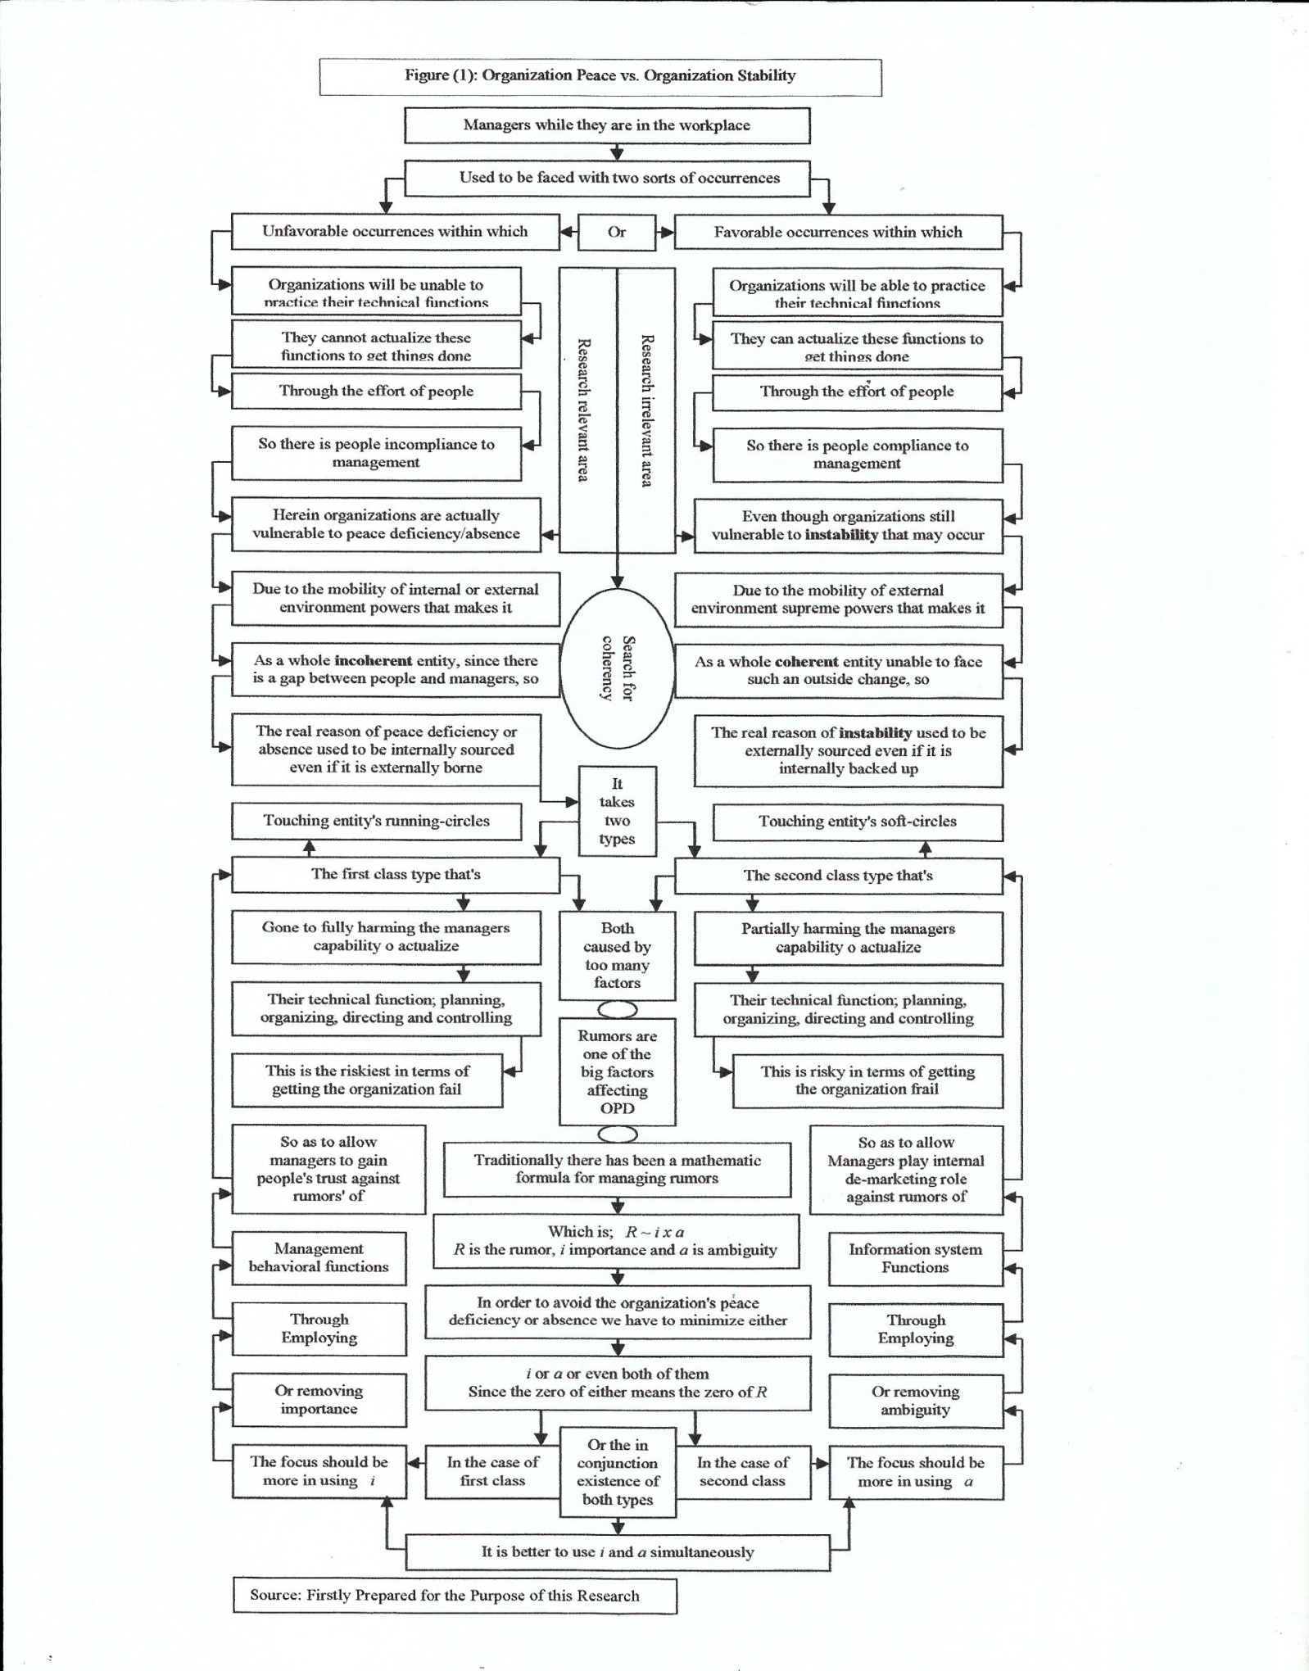
Figure (2) articulating the research hypothetical model
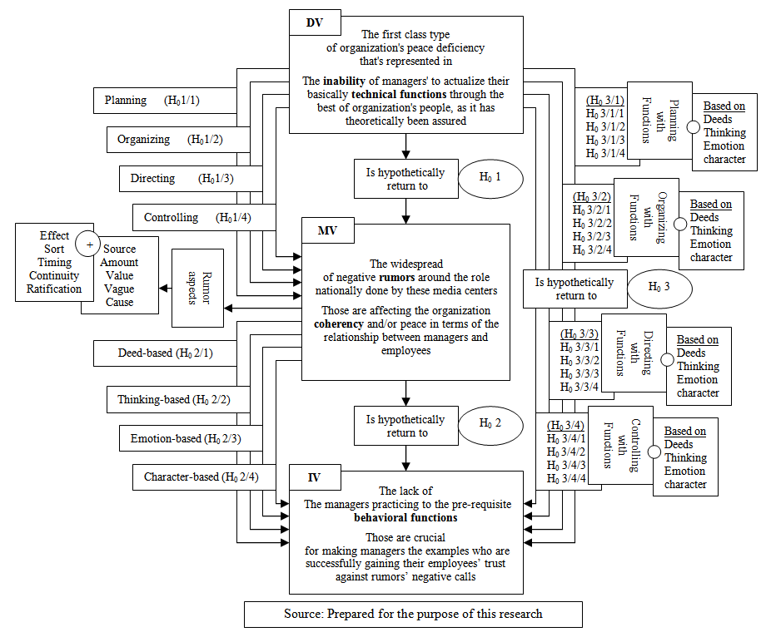

The independent variable was the lack of practicing the behavior functions, those considered as necessarily required for defending against rumors through strongly building people's trust in management. There were four types of behavioral functions to keep eye on; the deed-based functions, the thinking-based functions, the emotion-based functions and the character based functions. The way these variables and sub-variables was worded and formulated to put up the hypotheses and sub-hypotheses is comprehensively shown next.
- Research Hypotheses:
- There is no statistically indicative significant relationship between; on the one hand, the managers' inability to actualize their technical functions through people's effort, and on the other hand, the widespread of the rumors negatively affecting the organization coherence in terms of the people-to-managers relationship. (H₀ 1)
- There is no statistically indicative significant relationship between; the managers' inability to actualize planning and the widespread of the rumors negatively affecting the organization coherence in terms of the people-managers relationship. (H₀ 1/1)
- There is no statistically indicative significant relationship between the managers' inability to actualize organizing and the widespread of the rumors negatively affecting the organization coherence in terms of the people-managers relationship. (H₀ 1/2)
- There is no statistically indicative significant relationship between the managers' inability to actualize directing and the widespread of the rumors negatively affecting the organization coherence in terms of the people-managers relationship. (H₀ 1/3)
- There is no statistically indicative significant relationship between the managers' inability to actualize controlling and the widespread of the rumors negatively affecting the organization coherence in terms of the people-managers relationship. (H₀ 1/4)
    - There is no statistically indicative significant relationship between; on the one hand, the widespread of the rumors negatively affecting the organization coherence and peace in terms of the people-to-managers relationship, and on the other hand, the lack of practicing behavioral functions that create peoples' trust in managers' against rumors. (H₀ 2)
- There is no statistically indicative significant relationship between; on the one hand, the widespread of the rumors negatively affecting the organization coherence in terms of the people-managers relationship, and on the other hand, the lack of practicing the deed-based management functions.(H₀ 2/1)
- There is no statistically indicative significant relationship between; on the one hand, the widespread of the rumors negatively affecting the organization coherence in terms of the people-managers relationship, and on the other hand, the lack of practicing thinking-based management functions. (H₀ 2/2)
- There is no statistically indicative significant relationship between; on the one hand, the widespread of the rumors negatively affecting the organization coherence in terms of the people-managers relationship, and on the other hand, the lack of practicing emotion-based management functions. (H₀2/3)
- There is no statistically indicative significant relationship between; on the one hand, the widespread of the rumors negatively affecting the organization coherence in terms of the people-managers relationship, and on the other hand, the lack of practicing character-based management functions. (H₀2/4)
- There is no statistically indicative significant relationship between; on the one hand, the managers' inability to actualize their technical functions through people's effort,and on the other hand, the lack of practicing behavioral functions that create peoples' trust in managers. (H₀ 3)
- There is no statistically indicative significant relationship between; on the one hand, the managers' inability to actualize,the planning function through people's effort and on the other hand, the lack of practicing the varied management behavioral functions. (H₀3/1)
- There is no statistically indicative significant relationship between; on the one hand, the managers' inability to actualize, the planning function through people's effort and on the other hand, the lack of practicing the deed-based management functions. (H₀3/1/1)
- There is no statistically indicative significant relationship between; on the one hand, the managers' inability to actualize, the planning function through people's effort and on the other hand, the lack of practicing the thinking-based management functions. (H₀ 3/1/2)
- There is no statistically indicative significant relationship between; on the one hand, the managers' inability to actualize, the planning function through people's effort and on the other hand, the lack of their practicing the emotion-based management functions. (H₀ 3/1/3)
- There is no statistically indicative significant relationship between; on the one hand, the managers' inability to actualize, the planning function through people's effort and on the other hand, the lack of their practicing the character-based management functions. (H₀ 3/1/4)
- There is no statistically indicative significant relationship between; on the one hand, the managers' inability to actualize, the organizing function through people's effort and on the other hand, the lack of practicing the varied management behavioral functions. (H₀3/2)
- There is no statistically indicative significant relationship between; on the one hand, the managers' inability to actualize, the organizing function through people's effort and on the other hand, the lack of practicing the deed-based management functions. (H₀ 3/2/1).
- There is no statistically indicative significant relationship between; on the one hand, the managers' inability to actualize, the organizing function through people's effort and on the other hand, the lack of practicing the thinking-based management functions. (H₀ 3/2/2).
- There is no statistically indicative significant relationship between; on the one hand, the managers' inability to actualize, the organizing function through people's effort and on the other hand, the lack of practicing the emotion-based management functions. (H₀ 3/2/3)
- There is no statistically indicative significant relationship between; on the one hand, the managers' inability to actualize, the organizing function through people's effort and on the other hand, the lack of practicing the character-based management functions. (H₀ 3/2/4)
- There is no statistically indicative significant relationship between; on the one hand, the managers' inability to actualize, the directing function through people's effort and on the other hand, the lack of practicing the varied management behavioral functions. (H₀3/3)
- There is no statistically indicative significant relationship between; on the one hand, the managers' inability to actualize, the directing function through people's effort and on the other hand, the lack of practicing the deed-based management functions. (H₀ 3/3/1)
- There is no statistically indicative significant relationship between; on the one hand, the managers' inability to actualize, the directing function through people's effort and on the other hand, the lack of practicing the thinking-based management functions. (H₀ 3/3/2)
- There is no statistically indicative significant relationship between; on the one hand, the managers' inability to actualize, the directing function through people's effort and on the other hand, the lack of practicing the emotion-based management functions. (H₀ 3/3/3)
- There is no statistically indicative significant relationship between; on the one hand, the managers' inability to actualize, the directing function through people's effort and on the other hand, the lack of practicing the character-based management functions. (H₀ 3/3/4)
- There is no statistically indicative significant relationship between; on the one hand, the managers' inability to actualize, the controlling function through people's effort and on the other hand, the lack of practicing the varied management behavioral functions. (H₀ 3/4).
- There is no statistically indicative significant relationship between; on the one hand, the managers' inability to actualize, the controlling function through people's effort and on the other hand, the lack of practicing the deed-based management functions. (H₀3/4/1).
- There is no statistically indicative significant relationship between; on the one hand, the managers' inability to actualize, the controlling function through people's effort and on the other hand, the lack of practicing the thinking-based management functions. (H₀3/4/2).
- There is no statistically indicative significant relationship between; on the one hand, the managers' inability to actualize, the controlling function through people's effort and on the other hand, the lack of practicing the emotion-based management functions. (H₀ 3/4/3)
- There is no statistically indicative significant relationship between; on the one hand, the managers' inability to actualize, the controlling function through people's effort and on the other hand, the lack of practicing the character-based management functions. (H₀ 3/4/4)

Research Methodology:

- Population and sample:
The target population was the employees who are working in 91 media centers, which are geographically widespread to be positioned nearly in all governorates of Egypt. Those are collectively working as followed to the body of the state's media service. Specifically, in the internal media sector; both in the 64internal media centers and in the27 media Nile centers.
The size of population was 6370 employees, divided into two categories; one is the media technical workers that contains about two third of the previous number or 4247 informative employees, and the other is media technical and administrative workers that contain the rest of the same number or about 2123 administrative employees. The whole number of the listed population, was utilized to specify the sample size in accordance with two successively connected equations of; (n = z² *p *q / d² and then n₀ = n / (1+ n/N). or [n = (1.96)² * 0.80 * 0.20/ (0.04)² = 354.3876, then n₀ = 354. 3876 / 1+ (354. 3876 / 6370) = 335.7 or approx. = 336 sampling units.
Due to the availability of a wholly well-known population in terms of the employees' names as well as work addresses and positions, the sample type that employed was the probability sample. The population homogeneity, in terms the measurement objective, was a sufficient reason to depend on the simple random sample. Sampling unit, which has precisely been dealt with was the non-top-management staff; or those who are informative, technical, and administrative staffs.
Worth mentioning to highlight that the top-managers were representing the axis around which the research subject is hub-revolving. Since, the importance was directed to utilizing equally both the non- administrative or informative, technical, and administrative staffs' views, to judge on the success/failure of the top-management in actualizing properly, via people's effort, the management technical functions.
Thus, the distribution of the sample was dual-considered according to the proportional representation of the target employees' two types, and then in consistent with such a proportional existence of the target two types of centers' as well. As shown in sections (1and 2) by the Table (2) this was just a fair sample representation to the population two sections in the two types of media centers.
- Instrumentation:
- Instrument type:
Questionnaire was the instrument that was depended on to survey the sampling units' opinion regarding all the detailed variables and sub-variables, which included in the research varied hypotheses. It was the most fitting data collection tool to use in this research due to the short nature and very immovable indication of the included attributes. Besides, the easy to access simple random sample was a far encouraging factor to utilize such an instrument to satisfy the research purpose of measurement.

Table (2): Phases of Questionnaire Distribution and Sample Representation
The whole population | 6370
Number of Distributed Questionnaire
The whole sample |  | 336
Distribution according to employees' type |  | Informative Employees  224 |  | Admin.& Tech. Employees  112
Distribution according to centers' type |  | Internal Centers  158 | Nile Centers  66 | Internal Centers  79 | Nile Centers  33
Number of Initial and Correct Responses
Responding according to employees' type |  | Informative Employees  202 |  | Admin.& Tech. Employees  88
Responding according to centers' type |  | Internal Centers  150 | Nile Centers  52 | Internal Centers  63 | Nile Centers  25
Correct responses in accordance with the employees' type |  | Informative Employees  182 |  | Admin.& Tech. Employees  68
Correct responses in accordance with the centers' type |  | Internal Centers  143 | Nile Centers  39 | Internal Centers  47 | Nile Centers  21
Sample Representation according to the original number of questionnaires
Distribution phase or(cumulative1) |  | 0.470 | 0.196 | 0.235 | 0.098
Responding phase or(cumulative 2) |  | 0.446 | 0.155 | 0.179 | 0.083
Correct ion phase or (cumulative 3) |  | 0.426 | 0.116 | 0.140 | 0.063
Difference 1  Cumuli 1- cumuli 2 |  | 0.024 | 0.041 | 0.056 | 0.015
Difference 2  Cumuli 1- cumuli 3 |  | 0.044 | 0.080 | 0.095 | 0.035
All cumulative differences > 0.01
Sample Representation according to the changing number of questionnaires
Distribution phase or  (cumulative1) |  | 0.470 | 0.196 | 0.235 | 0.098
Responding phase or  (cumulative 2) |  | 0.517 | 0.179 | 0.217 | 0.086
Correct ion phase or  (cumulative 3) |  | 0.572 | 0.156 | 0.188 | 0.084
Difference 1  Cumuli 1- cumuli 2 |  | _ | 0.017 | 0.018 | 0.012
Difference 2  Cumuli 1- cumuli 3 |  | _ | 0.040 | 0.047 | 0.014
All cumulative differences > 0.01
Source: prepared as a key phase in the research field study

- Instrument design:

In depth questionnaire was designed to cover three axes. The first has come to characterize, in four aspects, the dependent variable. That was hub-revolving around measuring the ability/inability of the top-managers to actualize - through the employees' efforts – the main technical functions of management; planning, organizing directing and controlling. Every single one of these function has signified five sub-functions. This has been fully shown in the first section of the Table (3).
The second has existed to represent the mediator or intermediating variable. That was relevant to a query about the prevalence of rumors that's destroying the organization's coherency and/or peace in terms of the relationship between the employees and top-managers. Ten attributes which have to be interested in, in such a portion, were; the source, reason, quantity or size, ambiguity, continuity, effect, importance, timing and duration, credibility, and type, see the second section in the same Table (3).
The third has been there to embody the independent variable or the lack of the top-managers practicing to the management behavioral functions. Those proposed within the context of four categories; the deed-based, the thinking-based, the emotion-based and the character-based functions,which are suggested as crucial for creating employees-to-managers confidence and as consequence organization coherence, see the third section in Table(3).
In breadth, the scale that employed was a Likert-type one, since there was a little bit modification that's made just for being more fitting to the research purpose of measurement. It was a five-cell scale as well, so as to stretch more frankly the real categorization of the respondents' opinions concerning every single one of the encompassed attributes. However, all the included questions were closed end types, since there was no need for applying the open ended ones.
- Reliability and validity:
Establishing the validity, about twenty individual-interviews have been held, each one has approximately taken two hours and half. Ten Interviews were held with the employees who are non-top-management staffs, in both the target types of media centers.
Five interviews were conducted in each type, so as to reflect precisely the practical view, while the other ten interviews were held with the academic staffs, who are specifically specialist professors in the broad domain of management to reflect the scholar view.
The objective was, on the one hand, to confirm the face validity through excluding word and form deficiency and irrelevancy, on the other hand, to verify the content validity as well through ensuring that item and non-item aspects are the most suitable in terms of quantity and quality to measure the concepts for which they were existed in questionnaire.
As a result, many rather than few extractions and adjustments in different portions of the questionnaire, concerning wording, formulation, logic, sequence, and layout have been occurred to give a prime indication of consistency.
Moreover, with return to the Table (3) validity was statistically proved again when examining reliability, since the minimum square roots of alpha in the case of both the sub-groups and groups of the questionnaire's contained variables, were (0.89) and (0.88) in order, if the item excluded, while they were (0.95) and (0.94) in order as well, if the item included.
Targeting the fifty non-top-managers, who were interviewed before to explore the research problem, so as to examine the questionnaire's reliability, it was found that there is big deal of homogeneity amongst the investigated employees' responses concerning the included items; Item-sub-group and item-group correlations have been statistically inspected to show lowest limits of correlation coefficient equal (0.90) and (0.79) in order. This actually indicates a very high level of the built-in variables' consistency.
In addition to this, it has come out that the highest value of alpha if item excluded from the sub-groups is (0.93), this was lower than the lowest value of alpha if all items included in the same sub-groups which was (0.94). Besides the maximum values of alpha if item deleted from the groups was (0.92), this in turn was lower than the minimum value of alpha if all items did not deleted from the same groups, which was (0.93). As a consequence, the valid questionnaire was statistically accepted as reliable as well.
- Instrument administration:
As it was pointed out before in Table (2) questionnaire was proportionally distributed on the varied sections of the population's representing simple random sample. This was two-levels considered according to; the type of targeting sample units and then the type of media centers.
Because of the short-content and attribute built-in questionnaire the distribution was conveniently occurred through two different ways of delivering/receiving; either face-to-face (269) questionnaires or by e-mail (67) questionnaires.
Duration of about three months was given to finish this research phase; a month for delivering, a month for filling or answering, and a month for receiving. The responding number of investigated employees was entirely represented in (290) received questionnaires; (202) questionnaires from informative employees and (88) questionnaires form technical & administrative employees. The total correct number of questionnaires that were successfully utilized for statistical data analysis to satisfy the research purpose of measurement was (250) questionnaires; (188) questionnaires from informative employees and (62) questionnaires form technical & administrative employees.
- Sample representation:
Because of the waste occurred in the number of dependable questionnaires, which could be finally utilized to conduct the statistical testing of the research hypotheses, this is counted by the difference between the number of distributed questionnaires and the number of correct delivered ones, it was important to give the matter of ensuring that the factual number of sample, that's reflecting the view of just (250) respondents is on course or still representing the research population as much as the initially specified sample, that's designed to reflect the views of (336) respondents.
As a consequence Kolmogorov-Smirnov test that based on a comparison of the cumulative proportion of the observed values in each category with the cumulative proportion in the same category for the initially specified sample is used. The reason was to test whether the distribution of the observed data (number and category of respondents) differs significantly from initially specified sample or not.
In section (3) by the Table (2) it was shown that by the usage of the initial sample size or (336) employees as a fixed or immovable dividing denominator and the sample sections number of employees as numerators, the cumulative proportions were (0.470, 0.196,0.235, and 0.098) for the level (1) of distributed or delivered questionnaires, (0.446, 0.115, 0.179, and 0.083) for the level (2) of responded or returned questionnaires, and (0,426, 0.116, 0.140, and 0.063) for the level (3) of dependable or correct questionnaires.

Table (3): Questionnaire's Reliability and Validity
Variables& Codes |  | Variables | Codes | Sub-Variables | Codes | ISGC | AIIEFSG | AIIIISG | VIIEFSG | VIIIISG | IGC | AIIEFG | AIIIIG | VIIEFG | VIIIIG
The managers' failure to actualize  through people's effort the management  technical functions | The dependent  VariableA | The  inability  to actualize  Planning | A 1 | Strategy | A 1/1 | 0.93 | 0.91 | 0.94 | 0.95 | 0.96 | 0.90 | 0.88 | 0.95 | 0.94 | 0.97
 |  |  |  | Policy | A 1/2 | 0.92 | 0.89 |  | 0.94 |  | 0.87 | 0.87 |  | 0.93
 |  |  |  | Programs | A 1/3 | 0.95 | 0.92 |  | 0.96 |  | 0.91 | 0.81 |  | 0.90
 |  |  |  | Tactics | A 1/4 | 0.96 | 0.93 |  | 0.96 |  | 0.91 | 0.83 |  | 0.91
 |  |  |  | Techniques | A 1/5 | 0.93 | 0.91 |  | 0.95 |  | 0.90 | 0.90 |  | 0.95
 |  | The  Inability  to actualize  organizing | A 2 | Activities | A 2/1 | 0.91 | 0.93 | 0.96 | 0.96 | 0.98 | 0.87 | 0.90 |  | 0.95
 |  |  |  | Functions | A 2/2 | 0.96 | 0.88 |  | 0.94 |  | 0.84 | 0.86 |  | 0.93
 |  |  |  | Relations | A 2/3 | 0.95 | 0.89 |  | 0.94 |  | 0.85 | 0.83 |  | 0.91
 |  |  |  | Authorities | A 2/4 | 0.94 | 0.92 |  | 0.96 |  | 0.88 | 0.84 |  | 0.92
 |  |  |  | Responsibilities | A 2/5 | 0.99 | 0.88 |  | 0.94 |  | 0.91 | 0.86 |  | 0.93
 |  | The  inability  to actualize  directing | A 3 | Orders | A 3/1 | 0.95 | 0.89 | 0.95 | 0.94 | 0.97 | 0.86 | 0.81 |  | 0.90
 |  |  |  | Communication | A 3/2 | 0.98 | 0.89 |  | 0.94 |  | 0.88 | 0.85 |  | 0.92
 |  |  |  | Motivation | A 3/3 | 0.99 | 0.92 |  | 0.96 |  | 0.89 | 0.86 |  | 0.93
 |  |  |  | Leadership | A 3/4 | 0.97 | 0.91 |  | 0.95 |  | 0.89 | 0.83 |  | 0.91
 |  |  |  | Taming opp. | A 3/5 | 0.94 | 0.86 |  | 0.93 |  | 0.88 | 0.87 |  | 0.93
 |  | The  Inability  to actualize  controlling | A 4 | Criteria | A 4/1 | 0.97 | 0.88 | 0.94 | 0.94 | 0.96 | 0.92 | 0.85 |  | 0.92
 |  |  |  | Measures | A 4/2 | 0.96 | 0.91 |  | 0.95 |  | 0.89 | 0.88 |  | 0.94
 |  |  |  | Measurement | A 4/3 | 0.95 | 0.87 |  | 0.93 |  | 0.87 | 0.83 |  | 0.91
 |  |  |  | Comparison | A 4/4 | 0.98 | 0.85 |  | 0.93 |  | 0.90 | 0.85 |  | 0.92
 |  |  |  | Correction | A 4/5 | 0.96 | 0.86 |  | 0.93 |  | 0.89 | 0.82 |  | 0.91
The prevalence of rumors the negatively affected the organization coherency in terms of people's-managers relationship | The intermediating  variable B | Source | B 1 | Keyexplanations:  ISGC = item sub-group correlationAIIEFSG = alpha if item excluded from sub-group  AIIIISG = alpha if item included in sub-groupVIIEFSG =validity if item excluded from sub-group  VIIIISG = validity if item included in sub-group IGC = item group correlation  AIIEFG = alpha if item excluded from group AIIIIG = alpha if item included in group  VIIEFG = validity if item excluded from group VIIIIG = validity if item included in group. |  |  |  |  |  |  | 0.95 | 0.84 | 0.93 | 0.92 | 0.95
 |  | Reason | B 2 |  |  |  |  |  |  |  | 0.91 | 0.92 |  | 0.96
 |  | Sort | B 3 |  |  |  |  |  |  |  | 0.92 | 0.90 |  | 0.95
 |  | Size | B 4 |  |  |  |  |  |  |  | 0.96 | 0.82 |  | 0.91
 |  | Effect | B 5 |  |  |  |  |  |  |  | 0.98 | 0.79 |  | 0.89
 |  | Ambiguity | B 6 |  |  |  |  |  |  |  | 0.94 | 0.85 |  | 0.92
 |  | Importance | B 7 |  |  |  |  |  |  |  | 0.93 | 0.87 |  | 0.93
 |  | Continuity | B 8 |  |  |  |  |  |  |  | 0.90 | 0.89 |  | 0.94
 |  | Timing | B 9 |  |  |  |  |  |  |  | 0.97 | 0.78 |  | 0.88
 |  | Credence | B 10 |  |  |  |  |  |  |  | 0.94 | 0.85 |  | 0.93
The lack of top-managers' practicing  to the management behavioral functions that damages  the employees-to-managers trust | The independent  variables C | The  lack of practicing  the deeds-based  management  function | C 1 | talks | C 1/1 | 0.91 | 0.84 | 0.94 | 0.92 | 0.96 | 0.87 | 0.80 | 0.94 | 0.89 | 0.96
 |  |  |  | Says | C 1/2 | 0.95 | 0.82 |  | 0.91 |  | 0.80 | 0.80 |  | 0.89
 |  |  |  | Respecting | C 1/3 | 0.92 | 0.83 |  | 0.91 |  | 0.83 | 0.81 |  | 0.90
 |  |  |  | Listening | C 1/4 | 0.92 | 0.81 |  | 0.90 |  | 0.81 | 0.80 |  | 0.89
 |  |  |  | Examples | C 1/5 | 0.94 | 0.82 |  | 0.91 |  | 0.85 | 0.80 |  | 0.89
 |  |  |  | Behaviors | C 1/6 | 0.93 | 0.84 |  | 0.92 |  | 0;81 | 0.82 |  | 0.91
 |  |  |  | Hinting | C 1/7 | 0.99 | 0.83 |  | 0.91 |  | 0.82 | 0.82 |  | 0.91
 |  |  |  | Pointing | C 1/8 | 0.98 | 0.81 |  | 0.90 |  | 0.86 | 0.80 |  | 0.89
 |  |  |  | Simulation | C 1/9 | 0.96 | 0.83 |  | 0.91 |  | 0.85 | 0.83 |  | 0.91
 |  |  |  | Actions | C 1/10 | 0.93 | 0.81 |  | 0.90 |  | 0.84 | 0.81 |  | 0.90
 |  |  |  | Reactions | C 1/11 | 0.95 | 0.83 |  | 0.91 |  | 0.85 | 0.82 |  | 0.91
 |  |  |  | Interactions | C 1/12 | 0.95 | 0.82 |  | 0.91 |  | 0.88 | 0.80 |  | 0.89
 |  |  |  | Language | C 1/13 | 0.94 | 0.84 |  | 0.92 |  | 0.86 | 0.82 |  | 0.91
 |  |  |  | Expressing | C 1/14 | 0.96 | 0.81 |  | 0.90 |  | 0.80 | 0.79 |  | 0.89
 |  |  |  | Motions | C 1/15 | 0.98 | 0.82 |  | 0.91 |  | 0.88 | 0.80 |  | 0.89
 |  |  |  | Imitations | C 1/16 | 0.97 | 0.83 |  | 0.91 |  | 0.89 | 0.81 |  | 0.90
 |  |  |  | Commitments | C 1/17 | 0.99 | 0.81 |  | 0.90 |  | 0.87 | 0.79 |  | 0.89
 |  |  |  | Stability | C 1/18 | 0.92 | 0.81 |  | 0.90 |  | 0.82 | 0.81 |  | 0.90
 |  |  |  | Cooperating | C 1/19 | 0.93 | 0.84 |  | 0.92 |  | 0.83 | 0.83 |  | 0.91
 |  |  |  | Locomotive | C 1/20 | 0.91 | 0.89 |  | 0.94 |  | 0.88 | 0.86 |  | 0.93
 |  |  |  | Life-style | C 1/21 | 0.95 | 0.90 |  | 0.95 |  | 0.86 | 0.85 |  | 0.92
 |  |  |  | Normality | C 1/22 | 0.94 | 0.92 |  | 0.96 |  | 0.83 | 0.88 |  | 0.94
 |  |  |  | Situational | C 1/23 | 0.92 | 0.88 |  | 0.94 |  | 0.85 | 0.85 |  | 0.92
 |  |  |  | Proactive | C 1/24 | 0.92 | 0.90 |  | 0.95 |  | 0.81 | 0.87 |  | 0.93
 |  |  |  | Involving | C 1/25 | 0.95 | 0.88 |  | 0.94 |  | 0.88 | 0.84 |  | 0.92
 |  | The  lack of practicing  the thinking-based  management  functions | C 2 | Intellectual | C 2/1 | 0.98 | 0.89 | 0.95 | 0.94 | 0.97 | 0.90 | 0.80 |  | 0.89
 |  |  |  | commenting | C 2/2 | 0.96 | 0.88 |  | 0.94 |  | 0.91 | 0.82 |  | 0.91
 |  |  |  | interpretation | C 2/3 | 0.93 | 0.80 |  | 0.89 |  | 0.88 | 0.79 |  | 0.89
 |  |  |  | analyzing | C 2/4 | 0.91 | 0.83 |  | 0.91 |  | 0.81 | 0.80 |  | 0.89
 |  |  |  | methodical | C 2/5 | 0.95 | 0.84 |  | 0.92 |  | 0.87 | 0.79 |  | 0.89
 |  |  |  | Focusing | C 2/6 | 0.94 | 0.85 |  | 0.92 |  | 0.85 | 0.81 |  | 0.90
 |  |  |  | Concentration | C 2/7 | 0.90 | 0.81 |  | 0.90 |  | 0.88 | 0.82 |  | 0.91
 |  |  |  | Memorial | C 2/8 | 0.94 | 0.86 |  | 0.93 |  | 0.79 | 0.83 |  | 0.91
 |  |  |  | Creativity | C 2/9 | 0.91 | 0.88 |  | 0.94 |  | 0.82 | 0.84 |  | 0.92
 |  |  |  | Understand | C 2/10 | 0.99 | 0.81 |  | 0.90 |  | 0.86 | 0.80 |  | 0.89
 |  |  |  | Negotiating | C 2/11 | 0.98 | 0.81 |  | 0.90 |  | 0.84 | 0.79 |  | 0.89
 |  |  |  | Asking | C 2/12 | 0.91 | 0.86 |  | 0.93 |  | 0.83 | 0.82 |  | 0.91
 |  |  |  | Answering | C 2/13 | 0.96 | 0.80 |  | 0.89 |  | 0.80 | 0.78 |  | 0.88
 |  |  |  | Explaining | C 2/14 | 0.93 | 0.90 |  | 0.95 |  | 0.85 | 0.87 |  | 0.93
 |  |  |  | Simplifying | C 2/15 | 0.93 | 0.86 |  | 0.93 |  | 0.79 | 0.84 |  | 0.92
 |  |  |  | Suggesting | C 2/16 | 0.96 | 0.82 |  | 0.91 |  | 0.88 | 0.80 |  | 0.89
 |  |  |  | Wondering | C 2/17 | 0.94 | 0.85 |  | 0.92 |  | 0.81 | 0.81 |  | 0.90
 |  |  |  | Reasoning | C 2/18 | 0.92 | 0.84 |  | 0.92 |  | 0.84 | 0.83 |  | 0.91
 |  |  |  | Estimation | C 2/19 | 0.91 | 0.82 |  | 0.91 |  | 0.86 | 0.79 |  | 0.89
 |  |  |  | quick-witted | C 2/20 | 0.93 | 0.84 |  | 0.92 |  | 0.85 | 0.81 |  | 0.90
 |  |  |  | intimation | C 2/21 | 0.92 | 0.85 |  | 0.92 |  | 0.81 | 0.83 |  | 0.91
 |  |  |  | sequential | C 2/22 | 0.90 | 0.87 |  | 0.93 |  | 0.85 | 0.83 |  | 0.91
 |  |  |  | self-discipline | C 2/23 | 0.95 | 0.83 |  | 0.91 |  | 0.83 | 0.81 |  | 0.90
 |  |  |  | Connecting | C 2/24 | 0.96 | 0.85 |  | 0.92 |  | 0.84 | 0.84 |  | 0.92
 |  |  |  | convincing | C 2/25 | 0.92 | 0.80 |  | 0.89 |  | 0.83 | 0.77 |  | 0.88
 |  | The  lack of practicing  the emotion-based  management  functions | C 3 | Loyalty | C 3/1 | 0.91 | 0.81 | 0.94 | 0.90 |  | 0.80 | 0.79 |  | 0.89
 |  |  |  | Psycho-power | C 3/2 | 0.96 | 0.80 |  | 0.89 |  | 0.84 | 0.77 |  | 0.88
 |  |  |  | Warmth | C 3/3 | 0.92 | 0.85 |  | 0.92 |  | 0.81 | 0.83 |  | 0.91
 |  |  |  | Changing | C 3/4 | 0.94 | 0.88 |  | 0.94 |  | 0.79 | 0.84 |  | 0.92
 |  |  |  | Soft powering | C 3/5 | 0.95 | 0.84 |  | 0.92 |  | 0.81 | 0.81 |  | 0.90
 |  |  |  | Affecting | C 3/6 | 0.92 | 0.84 |  | 0.92 |  | 0.86 | 0.82 |  | 0.91
 |  |  |  | Kindness | C 3/7 | 0.90 | 0.86 |  | 0.93 |  | 0.84 | 0.85 |  | 0.92
 |  |  |  | Appreciating | C 3/8 | 0.97 | 0.80 |  | 0.89 |  | 0.86 | 0.80 |  | 0.89
 |  |  |  | Open-minded | C 3/9 | 0.95 | 0.83 |  | 0.91 |  | 0.79 | 0.80 |  | 0.89
 |  |  |  | Encompass | C 3/10 | 0.93 | 0.88 |  | 0.94 |  | 0.84 | 0.86 |  | 0.93
 |  |  |  | Sensitivity | C 3/11 | 0.95 | 0.85 |  | 0.92 |  | 0.82 | 0.82 |  | 0.91
 |  |  |  | Favoring | C 3/12 | 0.94 | 0.81 |  | 0.90 |  | 0.80 | 0.78 |  | 0.88
 |  |  |  | Supporting | C 3/13 | 0.97 | 0.85 |  | 0.92 | 0.96 | 0.85 | 0.84 |  | 0.92
 |  |  |  | Charitable | C 3/14 | 0.99 | 0.88 |  | 0.94 |  | 0.79 | 0.87 |  | 0.93
 |  |  |  | Helpful | C 3/15 | 0.91 | 0.82 |  | 0.91 |  | 0.86 | 0.80 |  | 0.89
 |  |  |  | Scarifying | C 3/16 | 0.94 | 0.84 |  | 0.92 |  | 0.89 | 0.81 |  | 0.90
 |  |  |  | Self-denying | C 3/17 | 0.93 | 0.86 |  | 0.93 |  | 0.88 | 0.83 |  | 0.91
 |  |  |  | Inspiring | C 3/18 | 0.95 | 0.87 |  | 0.93 |  | 0.87 | 0.85 |  | 0.92
 |  |  |  | Promising | C 3/19 | 0.96 | 0.88 |  | 0.94 |  | 0.79 | 0.86 |  | 0.93
 |  |  |  | Acceptability | C 3/20 | 0.93 | 0.80 |  | 0.89 |  | 0.85 | 0.77 |  | 0.88
 |  |  |  | Readable | C 3/21 | 0.92 | 0.82 |  | 0.91 |  | 0.84 | 0.80 |  | 0.89
 |  |  |  | Accessing | C 3/22 | 0.91 | 0.89 |  | 0.94 |  | 0.81 | 0.86 |  | 0.93
 |  |  |  | Differentiate | C 3/23 | 0.94 | 0.80 |  | 0.89 |  | 0.84 | 0.78 |  | 0.88
 |  |  |  | Accessible | C 3/24 | 0.91 | 0.84 |  | 0.92 |  | 0.80 | 0.82 |  | 0.91
 |  |  |  | Affiliation | C 3/25 | 0.97 | 0.80 |  | 0.89 |  | 0.87 | 0.79 |  | 0.89
 |  | The  lack of practicing  the character-based  management  functions | C 4 | initiation | C 4/1 | 0.96 | 0.82 | 0.95 | 0.91 | 0.97 | 0.86 | 0.80 |  | 0.89
 |  |  |  | positivism | C 4/2 | 0.93 | 0.85 |  | 0.92 |  | 0.81 | 0.83 |  | 0.91
 |  |  |  | ethical | C 4/3 | 0.94 | 0.80 |  | 0.89 |  | 0.89 | 0.78 |  | 0.88
 |  |  |  | variety | C 4/4 | 0.96 | 0.84 |  | 0.92 |  | 0.86 | 0.82 |  | 0.91
 |  |  |  | Clarity | C 4/5 | 0.99 | 0.83 |  | 0.91 |  | 0.88 | 0.81 |  | 0.90
 |  |  |  | Frankness | C 4/6 | 0.95 | 0.84 |  | 0.92 |  | 0.79 | 0.82 |  | 0.91
 |  |  |  | Sociability | C 4/7 | 0.93 | 0.81 |  | 0.90 |  | 0.85 | 0.79 |  | 0.89
 |  |  |  | Trustworthy | C 4/8 | 0.93 | 0.86 |  | 0.93 |  | 0.89 | 0.84 |  | 0.92
 |  |  |  | Trusting | C 4/9 | 0.95 | 0.84 |  | 0.92 |  | 0.85 | 0.81 |  | 0.90
 |  |  |  | Changeable | C 4/10 | 0.92 | 0.82 |  | 0.91 |  | 0.86 | 0.80 |  | 0.89
 |  |  |  | time pointing | C 4/11 | 0.92 | 0.86 |  | 0.93 |  | 0.88 | 0.83 |  | 0.91
 |  |  |  | uniqueness | C 4/12 | 0.98 | 0.83 |  | 0.91 |  | 0.83 | 0.80 |  | 0.89
 |  |  |  | exceptionality | C 4/13 | 0.95 | 0.81 |  | 0.90 |  | 0.79 | 0.77 |  | 0.88
 |  |  |  | braveness | C 4/14 | 0.93 | 0.85 |  | 0.92 |  | 0.85 | 0.83 |  | 0.91
 |  |  |  | dependable | C 4/15 | 0.91 | 0.83 |  | 0.93 |  | 0.84 | 0.80 |  | 0.89
 |  |  |  | independency | C 4/16 | 0.94 | 0.82 |  | 0.91 |  | 0.83 | 0.82 |  | 0.91
 |  |  |  | sincerity | C 4/17 | 0.99 | 0.81 |  | 0.90 |  | 0.82 | 0.77 |  | 0.88
 |  |  |  | challenging | C 4/18 | 0.93 | 0.85 |  | 0.92 |  | 0.87 | 0.82 |  | 0.91
 |  |  |  | believable | C 4/19 | 0.92 | 0.82 |  | 0.91 |  | 0.81 | 0.81 |  | 0.90
 |  |  |  | Functionalist | C 4/20 | 0.94 | 0.87 |  | 0.93 |  | 0.87 | 0.85 |  | 0.92
 |  |  |  | Deeming easier | C 4/21 | 0.92 | 0.87 |  | 0.93 |  | 0.84 | 0.83 |  | 0.91
 |  |  |  | Civilized | C 4/22 | 0.96 | 0.81 |  | 0.90 |  | 0.88 | 0.78 |  | 0.88
 |  |  |  | brilliant | C 4/23 | 0.98 | 0.83 |  | 0.91 |  | 0.86 | 0.81 |  | 0.91
 |  |  |  | exceptionality | C 4/24 | 0.94 | 0.85 |  | 0.92 |  | 0.80 | 0.81 |  | 0.90
 |  |  |  | Willing | C 4/25 | 0.97 | 0.84 |  | 0.92 |  | 0.83 | 0.81 |  | 0.90
Source: Field Study

Then the comparison was made first between level 1 and level 2 (cumulative 1- cumulative 2) and second between level 1 and level 3 (cumulative 1- cumulative 3), with consideration to the equivalent sections, to result in differences ranged from (0.95 to 0.15), in other words all differences were greater than (0.01). This revealed that there is no significant difference, and the sample still representing the research population.
In section (4) by the same Table (2) it was highlighted as well that employing the real phase-changing sample size or (336, 290 and250) as movable dividing-denominator and the sample sections number of employees as numerator, the cumulative proportions were (0.470, 0.196,0.235, and 0.098) for the level (1) of distributed or delivered questionnaires, (0.517, 0.179, 0.217, and 0.086) for the level (2) of responded or returned questionnaires, and (0,572, 0.156, 0.188, and 0.084) for the level (3) of dependable or correct questionnaires.
Then the comparison was made, first between level 1 and level 2 (cumulative 1- cumulative 2) and second between level 1 and level 3 (cumulative 1- cumulative 3), with consideration to the equivalent sections, to result in differences of lowest limit equal (0.12), in other wards all differences were greater than (0.01).
This indicated that there is no significant difference, and the sample, twice again, still representing the research population.
- Research limits:
In addition to the nature of the period started at 25thof January 2011and the particular actions subsequent to this date, that have had undeniable time-effect in conducting such a research, we consider two sorts of research limits.
The academic limit, within which it is theoretically interested in three axes; the managers' failure to practice through the employees' best the management technical functions, the effect of rumors on the people-managers coherency that make the former resist complying, as it should be, to the latter, and the failure of managers to practice the behavioral functions that build the people-to-managers trust, so as to avoid rumors' negative effect. Any other subject is academically irrelevant.
The practical limit is focused on examining the existence of research problem and testing the relevant hypotheses to clear up its reasons in the reality of the workplace of the internal and Nile media centers. Within which we are particularly considering the informative, technical, and administrative employees who are non-top-management staff. Other sorts of media institutions are field-study irrelevant.

Research Field Study:
Testing hypothesis (H_{o}1):
In order to prove that the null hypothesis (H_{o}1) is correct/incorrect or to what extent there is a significant relationship between the (DV) which is the failure of the media centers' top-managers to actualize - through the organization peoples' effort - the four management technical functions as it should properly be occurred, and the (MV)which is the wide prevalence of the rumors that are hitting the role done by these centers to affect negatively their organizational coherence and peace.The former was separately represented by (4) forms of factor analysis; F(A1/1-1/5),F (A2/1-2/5), F (A3/1-3/5) and F (A4/1-4/5),while the latter was exemplified as well by just one form of factor analysis F (B1-10).
Then two statistical techniques were employed to examine such a relationship; one was (X²)and the other was the regression analysis, the results have come as shown in Table (4) and the followed(4)supportive graphs.
On the one hand, the minimum values of (X²) according to Pearson and Likelihood ratios were (2453.742),(850.781)in order < its tab. values those were (26.3),(32.00) respectively at levels of sig.(0.05) and (0.01), df equal (16), while (P) was(0.0) in all cases. On the other hand the lowest value of (β)was (0.819) while the (P) for all the (T) values were (0.0) as well, this prove that there is a significant relationship between both variables.
With the purpose of showing the denotation of this relationship, the lowest values of (F & T) were (472.826, 21.745) < their tab. Values those (3.92, 1.98) at Sig.(0.01), df(1,248) & (248) in order,and the (P) was (0.0) for each.
This proves that this relationship, in terms of type, is - somehow - a causal one, the (MV) is a reason of the (DV). Even if we recognize that this is non-parametrically regression-based causality is unlike the one parametrically established by experimentation since the latter is focused on considering (IV) as the one and full reason of (DV). The positive signals of all the (β) values were sufficiently indicating a positively direct relationship between both the examined variables. Liner by Liner (X²) values were at least (163.332)> its tab. value that's previously pointed out at the same level of Sig.(0.05) and df (16), while (P) was (0.0) in all cases as well, which prove that this relationship is a liner one. This was supported as well by establishing the simple regression in each case as shown by the (4) graphs followed to the same table above, to clarify that the dots represented the two variables on the strait line were more than (80%) in all the investigated relationships.

This was clearly established by the values of (R) coefficient those were over (0.80).Within the context of using regression this is indicating that the (DV) is a function in (MV). The strength of such a relationship was twice-proved; in terms of the direction, since the minimum value of (R) was (0.810), also regarding the form as the minimum value of (R²) was (0.656).
As a consequence, the null sub-hypotheses (H_{o} 1/1), (H_{o} 1/2), (H_{o} 1/3), and (H_{o} 1/4) were rejected to accept alternatively the reverse hypothesis of each so as to prove that there is a significant and statistically indicated relationship between; on the one hand, the top-managers' failure to actualize - through the best of organization's people - the management technical functions; planning, organizing, directing and controlling and on the other hand, the widespread of rumors that are suspecting the role being done by the media centers to affect negatively their internal coherence and peace. This is collectively proving the opposite hypothesis to the null hypothesis (H_{o} 1).

Table (4) : The Relationship between the Dependent V. (A) and the Intermediating V. (B), Supported by Four function-indicating Graphs
Variables  and  Codes | Testifying the Relationship |  |  |  |  |  | Testifying its Denotation  Type, Direction, Form and Degree
 | Pearson  (Chi)² |  | Likelihood  Ratio (Chi)² |  | Linear by  Linear (Chi)²
 | Cal.  Value | Sig.  (P) | Cal.  Value | Sig.  (P) | Cal.  Value | Sig.  (P) | Reg.  Co. (β) | Cal.  (F) | Sig.  (P) | Cal.  (T) | Sig.  (P) | R  Co. | Co.  R²
FB & FA1 | 4684.322 | 0.00 | 1047.081 | 0.00 | 170.600 | 0.00 | + 0.819 | 539.657 | 0.00 | 23.231 | 0.00 | 0.828 | 0.685
FB & FA2 | 2453.742 | 0.00 | 851.276 | 0.00 | 169.104 | 0.00 | + 0.837 | 524.905 | 0.00 | 22.911 | 0.00 | 0.824 | 0.679
FB & FA3 | 2706.427 | 0.00 | 923.905 | 0.00 | 163.332 | 0.00 | + 0.819 | 472.826 | 0.00 | 21.745 | 0.00 | 0.810 | 0.656
FB & FA4 | 2457.054 | 0.00 | 850.781 | 0.00 | 168.115 | 0.00 | + 0.831 | 515.455 | 0.00 | 22.704 | 0.00 | 0.822 | 0.675
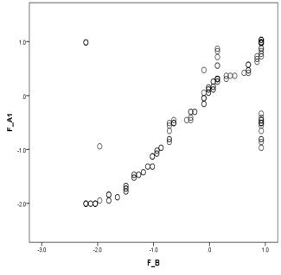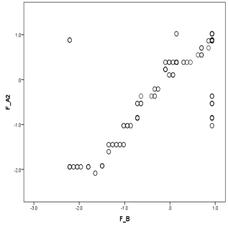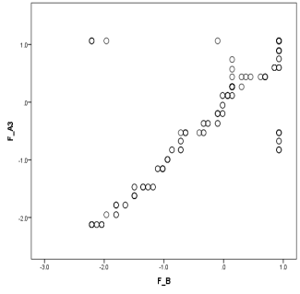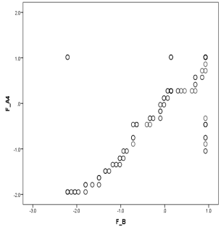
Source: Based upon Empirical study

Testing hypothesis (H_{o}2):
In order to prove that the null hypothesis (H_{o}2) is correct/incorrect or to what extent there is a significant relationship between the (MV) which is the wide prevalence of the rumors that are hitting the role done by the media centers to affect negatively the organizational coherence and peace of these centers and the (IV) which is the failure of these centers' top-managers in pre-requisitely practicing another four management behavioral functions to gain the employees trust against organizational incoherence and peace deficiency.
The former was collectively represented by one form of factor analysis; F (B1-10),while the latter separately exemplified as well by (4)forms of factor analysis; F (C1/1-1/25),F (C2/1-2/25),F (C3/1-3/25) and F (C4/1-4/25).
Then two statistical techniques were employed to examine such a relationship; one was (X²)and the other was the regression analysis, the results have come as shown in Table (5) and the followed(4)supportive graphs. On the one hand, the minimum values of (X²) according to Person and Likelihood ratios were (3736.345),(917.951)in order < its tab. values those were (26.30),(32.00.) respectively at levels of sig (0.05) and (0.01), df equal (16),while (P) was(0.0) in all cases. On the other hand the lowest value of (β) was(0.657) while the (P) for all the (T) values were (0.0) as well, this prove that there is a significant relationship between both variables.

Table (5) : The Relationship between the Intermediating V. (B) and the Independent V. (C), Supported by Four function-indicating Graphs
Variables  and  Codes | Testifying the Relationship |  |  |  |  |  | Testifying its Denotation  Type, Direction, Form and Degree
 | Pearson  (Chi)² |  | Likelihood  Ratio (Chi)² |  | Linear by  Linear (Chi)²
 | Cal.  Value | Sig.  (P) | Cal.  Value | Sig.  (P) | Cal.  Value | Sig.  (P) | Reg.  Co. (β) | Cal.  (F) | Sig.  (P) | Cal.  (T) | Sig.  (P) | R  Co. | Co.  R²
FC1 & FB | 3736.345 | 0.00 | 917.951 | 0.00 | 107.538 | 0.00 | + 0.657 | 188.528 | 0.00 | 13.731 | 0.00 | 0.814 | 0.663
FC2 & FB | 4508.392 | 0.00 | 1061.435 | 0.00 | 144.271 | 0.00 | + 0.768 | 341.634 | 0.00 | 18.483 | 0.00 | 0.861 | 0.741
FC3 & FB | 4624.389 | 0.00 | 1081.645 | 0.00 | 161.710 | 0.00 | + 0.808 | 459.432 | 0.00 | 21.434 | 0.00 | 0.806 | 0.648
FC4 & FB | 4726.497 | 0.00 | 1073.004 | 0.00 | 162.825 | 0.00 | + 0.815 | 468.590 | 0.00 | 21.647 | 0.00 | 0.809 | 0.654
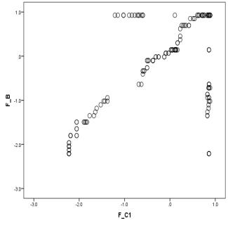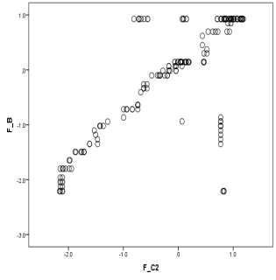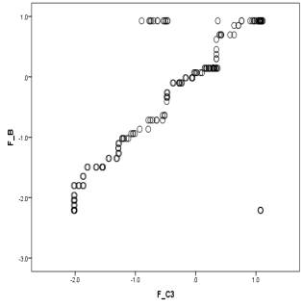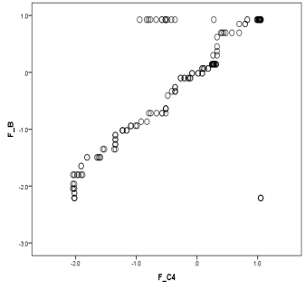
Source: Based upon Empirical study

With the purpose of showing the denotation of this relationship, the lowest values of (F&T) were (188. 528, 13.731) < their tab. Values those (3.92, 1.98) at Sig.(0. 05), df(1,248)&(248) in order, and the (P) was (0.0) for each. This proves that this relationship, in terms of type, is - somehow - a causal one, the (MV) is a reason of the (DV).Even if we recognize that this is non-parametrically regression-based causality is unlike the one parametrically established by experimentation since the latter is focused on considering (IV) as the one and full reason of (DV). The positive signals of all the (β)values were sufficiently indicating a positively direct relationship between both the examined variables. Liner by Liner(X²)values were at least (107.538)> its tab. value that's previously pointed out at the same level of Sig(0, 05) and the same df (16), while (P) was (0.0) in all cases, which prove that this relationship is a liner one. This was supported as well by establishing the simple regression in each case as shown by the (4) graphs followed to the same table above, to clarify that the dots represented the two variables on the strait line were more than (80%) in all the investigated relationships, this was clearly established by the values of (R) coefficient those were over (0.80).Within the context of using regression this is indicating that the (DV) is a function in (MV). The strength of such a relationship was twice-proved; in terms of the direction, since the minimum value of (R) was (0.806), also regarding the form, as the minimum value of (R²) was (0.648).As a consequence, the sub-hypotheses (H_{o} 2/1), (H_{o} 2/2), (H_{o} 2/3), and (H_{o} 2/4) were rejected to accept alternatively the reverse hypothesis of each so as to prove that there is a significant and statistically indicative relationship between; on the one hand, the (MV) which is the wide prevalence of the rumors that are hitting the role done by the media centers to affect negatively the internal coherence and peace of these centers and the other hand, (IV) which is the failure of these centers' top-managers in practicing at a considerable level an additional four management behavioral functions to gain the employees trust against such kind of rumors. This is collectively proving the opposite hypothesis to the null hypothesis (H_{o}2).
Testing hypothesis (H_{o}3):
Testing hypothesis (H_{o}3/1):
In order to prove that the null hypothesis (H_{o}3/1)is correct/incorrect or to what extent there is a significant relationship between the (DV) which is the failure of the media centers' top-managers to actualize - through the organization peoples' effort - the management technical function of planning and the (IV) which is the failure of these centers' top-managers in pre-requisitely practicing another four management behavioral functions to gain the employees' trust against organizational incoherence and peace deficiency, the former was collectively represented by one form of factor analysis; F (A1/1-1/5), while the latter separately exemplified as well by (4) forms of factor analysis; F (C1/1-1/25),F (C2/1-2/25),F (C3/1-3/25) and F (C4/1-4/25).
Then two statistical techniques were employed to examine such a relationship; one was (X²)and the other was the regression analysis, the results have come as shown in Table (6) and the followed (4)supportive graphs. On the one hand, the minimum values of (X²) according to Pearson and Likelihood ratios were (6858.503),(1233.340)in order < its tab. values those were (26.30),(32.00.)respectively at levels of sig(0.05) and (0.01), df equal (16),while (P) was(0.0) in all cases. On the other hand the lowest value of (β)was (0.783) while the (P) for all the (T) values were (0.0) as well, this prove that there is a significant relationship between both variables.

Table (6) : The Relationship between the Sub-Dependent V. (A1) and the Independent V. (C) ), Supported by 4 Function-indicating Graphs
Variables  and  Codes | Testifying the Relationship |  |  |  |  |  | Testifying its Denotation  Type, Direction, Form and Degree
 | Pearson  (Chi)² |  | Likelihood  Ratio (Chi)² |  | Linear by  Linear (Chi)²
 | Cal.  Value | Sig.  (P) | Cal.  Value | Sig.  (P) | Cal.  Value | Sig.  (P) | Reg.  Co. (β) | Cal.  (F) | Sig.  (P) | Cal.  (T) | Sig.  (P) | R  Co. | Co.  R²
FC1 & FA1 | 6858.503 | 0.00 | 1233.340 | 0.00 | 156.193 | 0.00 | + 0.783 | 417.383 | 0.00 | 20.430 | 0.00 | 0.792 | 0.627
FC2 & F A1 | 8587.795 | 0.00 | 1437.570 | 0.00 | 186.379 | 0.00 | + 0.856 | 738.129 | 0.00 | 27.169 | 0.00 | 0.865 | 0.749
C3 & F A1 | 9090.880 | 0.00 | 1423.328 | 0.00 | 234.481 | 0.00 | + 0.960 | 4005.31 | 0.00 | 63.288 | 0.00 | 0.970 | 0.942
FC4 & F A1 | 9083.492 | 0.00 | 1443.678 | 0.00 | 235.505 | 0.00 | + 0.962 | 4327.98 | 0.00 | 65.787 | 0.00 | 0.973 | 0.946
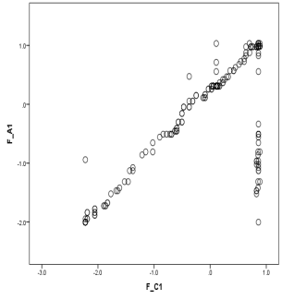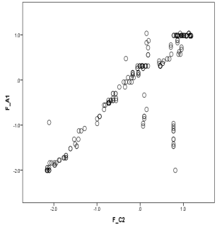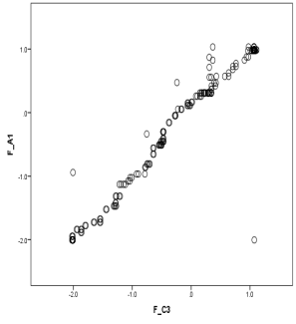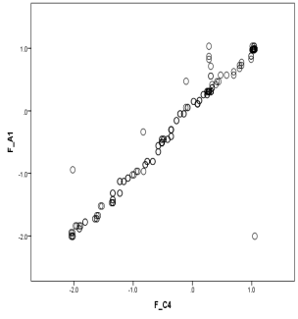
Source: Based upon Empirical study

With the purpose of showing the denotation of this relationship, the lowest values of (F&T) were (417.383, 20.430) < their tab. Values those equal (3.92, 1.98) at level of Sig. (0.05), df (1,248)&(248) in order, and the (P) was (0.0) for each. This proves that this relationship, in terms of type, is - somehow - a causal one, the (MV) is a reason of the (DV).Even if we recognize that this is non-parametrically regression-based causality is unlike the one parametrically established by experimentation since the latter is focused on considering (IV) as the one and full reason of (DV). The positive signals of all the (β) values were sufficiently indicating a positively direct relationship between both the examined variables. Liner by Liner(X²) values were at least (156.1932> its tab. value that's previously pointed out at the same level of Sig. or (0.05)and same df (16), while (P) was (0.0) in all cases, which prove that this relationship is a liner one.
This was supported as well by establishing the simple regression in each case as shown by the (4) graphs followed to the same Table (6), to clarify that the dots represented the two variables on the strait line were more than(78%) in all the investigated relationships, this was clearly established by the values of (R) coefficient those were over (0.78).Within the context of using regression, this is indicating that the (DV) is a function in (IV). The strength of such a relationship was twice-proved; in terms of the direction, since the minimum value of (R) was (0.792), also regarding the form as the minimum value of (R²) was (0.627).
As a consequence, the sub-hypotheses (H_{o}3/1/1), (H_{o}3/1/2), (H_{o}3/1/3), and (H_{o}3/1/4) were rejected to accept alternatively the reverse hypothesis of each so as to prove that there is a significant and statistically indicative relationship between; on the one hand, the top-managers' failure to actualize– through the best of organization's people –the management technical function of planning and on the other hand, the failure of these centers' top-managers in practicing pre-requisitely another four management behavioral functions to gain the employees' trust against internal incoherence and peace deficiency. This is collectively proving the opposite hypothesis to the null hypothesis (H_{o}3/1).
Testing hypothesis (H_{o}3/2):
In order to prove that the null hypothesis (H_{o} 3/2)is correct/incorrect or to what extent there is a significant relationship between the (DV) which is the failure of the media centers' top-managers to actualize - through the organization peoples' effort - the management technical function of organizing and the (IV) which is the failure of these centers' top-managers in practicing pre-requisitely another four management behavioral functions to gain the employees' trust against organizational incoherence and peace deficiency, the former was collectively represented by one form of factor analysis; F (A2/1-2/5), while the latter separately exemplified as well by (4) forms of factor analysis; F (C1/1-1/25),F (C2/1-2/25),F (C3/1-3/25)and F (C4/1-4/25).
Then two statistical techniques were employed to examine such a relationship; one was (X²)and the other was the regression analysis, the results have come as shown in Table (7) and the followed (4)supportive graphs. On the one hand, the minimum values of (X²) according to Pearson and Likelihood ratios were (3134.211), (972.268)in order < its tab. values those were (26.30),(32.00.)respectively at levels of sig(0.05) and (0.01), df equal (16), while (P) was(0.0) in all cases. On the other hand the lowest value of (β)was (0.788) while the (P) for all the (T) values were (0.0) as well, this prove that there is a significant relationship between both variables.

Table (7) : The Relationship between the Sub-Dependent V. (A2) and the Independent V. (C), Supported by 4 Function-Indicating Graphs
Variables  and  Codes | Testifying the Relationship |  |  |  |  |  | Testifying its Denotation  Type, Direction, Form and Degree
 | Pearson  (Chi)² |  | Likelihood  Ratio (Chi)² |  | Linear by  Linear (Chi)²
 | Cal.  Value | Sig.  (P) | Cal.  Value | Sig.  (P) | Cal.  Value | Sig.  (P) | Reg.  Co. (β) | Cal.  (F) | Sig.  (P) | Cal.  (T) | Sig.  (P) | R  Co. | Co.  R²
FC1 & FA2 | 3134.211 | 0.00 | 972.268 | 0.00 | 151.561 | 0.00 | + 0.788 | 385.750 | 0.00 | 19.641 | 0.00 | 0.880 | 0.774
FC2 & F A2 | 3789.371 | 0.00 | 1149.856 | 0.00 | 183.127 | 0.00 | + 0.877 | 689.440 | 0.00 | 26.257 | 0.00 | 0.858 | 0.734
FC3 & F A2 | 3812.570 | 0.00 | 1142.549 | 0.00 | 230.031 | 0.00 | + 0.942 | 3007.33 | 0.00 | 54.839 | 0.00 | 0.961 | 0.924
FC4 & F A2 | 4089.891 | 0.00 | 1163.813 | 0.00 | 232.472 | 0.00 | + 0.926 | 3488.25 | 0.00 | 59.061 | 0.00 | 0.966 | 0.934
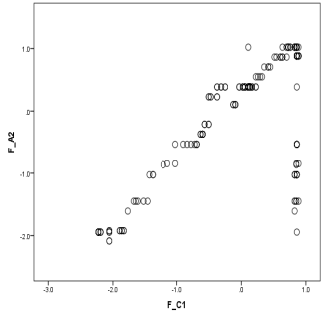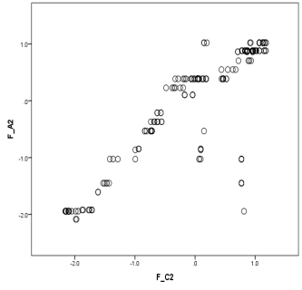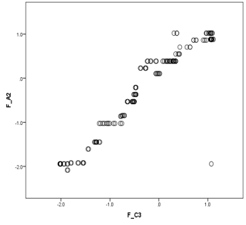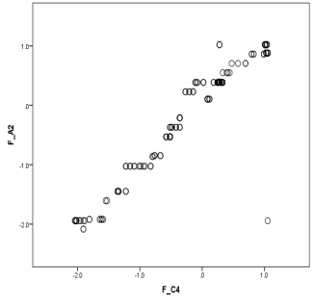
Source: Based upon Empirical study

With the purpose of showing the denotation of this relationship, the lowest values of (F&T) were (385.750, 19.641) < their tab. Values those equal (3.92, 1.98) at level of Sig. (0.05), df (1,248)&(248) in order, and the (P) was (0.0) for each. This proves that this relationship, in terms of type, is - somehow - a causal one, the (IV) is a reason of the (DV).Even if we recognize that this is non-parametrically regression-based causality is unlike the one parametrically established by experimentation since the latter is focused on considering (IV) as the one and full reason of (DV). The positive signals of all the (β)values were sufficiently indicating a positively direct relationship between both the examined variables. Liner by Liner(X²)values were at least (151.561)> its tab. value that's previously pointed out at the same level of Sig. (0.05) and same df (16), while (P) was (0.0) in all cases, which prove that this relationship is a liner one. This was supported as well by establishing the simple regression in each case as shown by the (4) graphs followed to the same table above, to clarify that the dots represented the two variables on the strait line were more than(85%) in all the investigated relationships, this was clearly established by the values of (R) coefficient those were over (0.85).Within the context of using regression this is indicating that the (DV) is a function in (IV). The strength of such a relationship was twice-proved; in terms of the direction, since the minimum value of (R) was (0.858), also regarding the form as the minimum value of (R²) was (0.734).As a consequence, the sub-hypotheses (H_{o} 3/2/1), (H_{o} 3/2/2), (H_{o} 3/2/3), and (H_{o}3/2/4) were rejected to accept alternatively the reverse hypothesis of each so as to prove that there is a significant and statistically indicative relationship between; on the one hand, the top-managers' failure to actualize– through the best of organization's people –the management technical function of organizing and on the other hand, the failure of these centers' top-managers in pre-requisitely practicing another four management behavioral functions to gain the employees' trust against organizational incoherence and peace deficiency. This is collectively proving the opposite hypothesis to the null hypothesis (H_{o} 3/2).
Testing hypothesis (H_{o}3/3):
In order to prove that the null hypothesis (H_{o}3/3)is correct/incorrect or to what extent there is a significant relationship between the (DV) which is the failure of the media centers' top-managers to actualize - through the organization peoples' effort - the management technical function of directing and the (IV) which is the failure of these centers' top-managers in practicing pre-requisitely another four management behavioral functions to gain the employees' trust against organizational incoherence and peace deficiency, the former was collectively represented by one form of factor analysis; F (A3/1-3/5), while the latter separately exemplified as well by (4) forms of factor analysis; F (C1/1-1/25),F (C2/1-2/25),F (C3/1-3/25)and F (C4/1-4/25). Then two statistical techniques were employed to examine such a relationship; one was (X²)and the other was the regression analysis, the results have come as shown in Table (8) and the followed (4)supportive graphs.
On the one hand, the minimum values of (X²) according to Pearson and Likelihood ratios were (3461.633),(1026.522)in order < its tab. values those were (26.30),(32.00.)respectively at levels of sig(0.05) and (0.01) ), df equal (16),while (P) was(0.0) in all cases.
On the other hand the lowest value of (β)was (0.781) while the (P) for all the (T) values were (0.0) as well, this prove that there is a significant relationship between both variables.

Table (8): The Relationship between the Sub-Dependent V. (A3) and the Independent V. (C), Supported by 4 Function-Indicating Graphs
Variables  and  Codes | Testifying the Relationship |  |  |  |  |  | Testifying its Denotation  Type, Direction, Form, and Degree
 | Pearson  (Chi)² |  | Likelihood  Ratio (Chi)² |  | Linear by  Linear (Chi)²
 | Cal.  Value | Sig.  (P) | Cal.  Value | Sig.  (P) | Cal.  Value | Sig.  (P) | Reg.  Co. (β) | Cal.  (F) | Sig.  (P) | Cal.  (T) | Sig.  (P) | R  Co. | Co.  R²
FC1 & FA3 | 3461.633 | 0.00 | 1026.522 | 0.00 | 151.780 | 0.00 | + 0.781 | 387.181 | 0.00 | 19.677 | 0.00 | 0.781 | 0.610
FC2 & F A3 | 4301.702 | 0.00 | 1193.611 | 0.00 | 179.498 | 0.00 | + 0.829 | 640.489 | 0.00 | 25.308 | 0.00 | 0.849 | 0.721
FC3 & F A3 | 4482.069 | 0.00 | 1187.091 | 0.00 | 222.650 | 0.00 | + 0.936 | 2095.56 | 0.00 | 45.777 | 0.00 | 0.946 | 0.894
FC4 & F A3 | 4446.270 | 0.00 | 1190.896 | 0.00 | 222.527 | 0.00 | + 0.965 | 2084.64 | 0.00 | 45.658 | 0.00 | 0.945 | 0.894
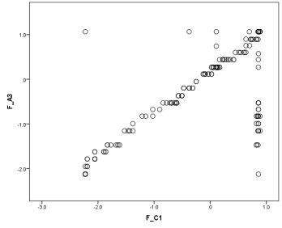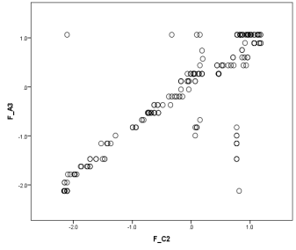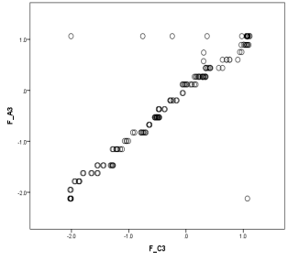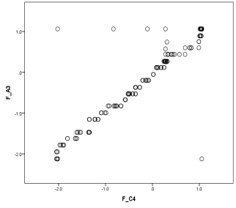
Source: Based upon Empirical study

With the purpose of showing the denotation of this relationship, the lowest values of (F&T) were (387.181, 19.677) < their tab. Values those equal (3.92, 1.98) at level of Sig. (0, 05), df (1,248)&(248) in order, and the (P) was (0.0) for each. This proves that this relationship, in terms of type, is - somehow - a causal one, the (IV) is a reason of the (DV).Even if we recognize that this is non-parametrically regression-based causality is unlike the one parametrically established by experimentation since the latter is focused on considering (IV) as the one and full reason of (DV). The positive signals of all the (β)values were sufficiently indicating a positively direct relationship between both the examined variables. Liner by Liner (X²)values were at least (151.580)> its tab. value that's previously pointed out at the same level of Sig.(0.05)and same df (16), while (P) was (0.0) in all cases, which prove that this relationship is a liner one.
This was supported as well by establishing the simple regression in each case as shown by the (4) graphs followed to the same Table (8), to clarify that the dots represented the two variables on the strait line were more than(78%) in all the investigated relationships, this was clearly established by the values of (R) coefficient those were over (0.78). Within the context of using regression this is indicating that the (DV) is a function in (IV). The strength of such a relationship was twice-proved; since in terms of the direction, the minimum value of (R) was (0.782), also regarding the form as the minimum value of (R²) was (0.610).
As a consequence, the sub-hypotheses (H_{o} 3/3/1), (H_{o} 3/3/2), (H_{o} 3/3/3), and (H_{o} 3/3/4) were rejected to accept alternatively the reverse hypothesis of each so as to prove that there is a significant and statistically indicative relationship between; on the one hand, the top-managers' failure to actualize– through the best of organization's people –the management technical function of directing and on the other hand, the failure of these centers' top-managers in practicing pre-requisitely another four management behavioral functions to gain the employees' trust against internal incoherence and peace deficiency. This is collectively proving the opposite hypothesis to the null hypothesis (H_{o} 3/3).
Testing hypothesis (H_{o}3/4):
In order to prove that the null hypothesis (H_{o} 3/4)is correct/incorrect or to what extent there is a significant relationship between the (DV) which is the failure of the media centers' top-managers to –via the organization peoples' effort - the management technical function of controlling and the (IV) which is the failure of these centers' top-managers in practicing pre-requisitely another four management behavioral functions to gain the employees' trust against organizational incoherence and peace deficiency, the former was collectively represented by one form of factor analysis; F (A4/1-4/5), while the latter separately exemplified as well by (4) forms of factor analysis; F (C1/1-1/25),F (C2/1-2/25),F (C3/1-3/25)and F (C4/1-4/25). Then two statistical techniques were employed to examine such a relationship; one was (X²) and the other was the regression analysis, the results have come as shown in Table (9) and the followed (4) supportive graphs. On the one hand, the minimum values of (X²) according to Pearson and Likelihood ratios were (3416.711), (937.982)in order < its tab. values those were (26.30),(32.00.) respectively at levels of sig(0.05) and (0.01), df equal (16), while (P) was(0.0) in all cases. On the other hand the lowest value of (β) was(0.796) while the (P) for all the (T) values were (0.0) as well, this prove that there is a significant relationship between both variables.

Table (9) : The Relationship between the Sub-Dependent V. (A4) and the Independent V. (C), Supported by 4 Function-Indicating Graphs
Variables  and  Codes | Testifying the Relationship |  |  |  |  |  | Testifying its Denotation  Type, Direction, Form and Degree
 | Pearson  (Chi)² |  | Likelihood  Ratio (Chi)² |  | Linear by  Linear (Chi)²
 | Cal.  Value | Sig.  (P) | Cal.  Value | Sig.  (P) | Cal.  Value | Sig.  (P) | Reg.  Co. (β) | Cal.  (F) | Sig.  (P) | Cal.  (T) | Sig.  (P) | R  Co. | Co.  R²
FC1 & FA4 | 3416.711 | 0.00 | 937.982 | 0.00 | 154.923 | 0.00 | + 0.796 | 408.399 | 0.00 | 20.209 | 0.00 | 0.789 | 0.622
FC2 & F A4 | 3719.790 | 0.00 | 1062.096 | 0.00 | 184.208 | 0.00 | + 0.885 | 705.074 | 0.00 | 26.553 | 0.00 | 0.860 | 0.740
FC3 & F A4 | 4125.461 | 0.00 | 1094.633 | 0.00 | 235.349 | 0.00 | + 0.963 | 4275.75 | 0.00 | 65.389 | 0.00 | 0.972 | 0.945
FC4 & F A4 | 4174.142 | 0.00 | 1092.147 | 0.00 | 236.053 | 0.00 | + 0.985 | 4521.61 | 0.00 | 67.234 | 0.00 | 0.974 | 0.948
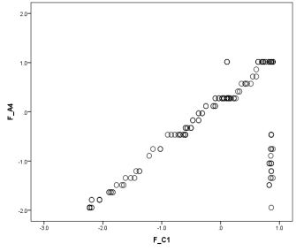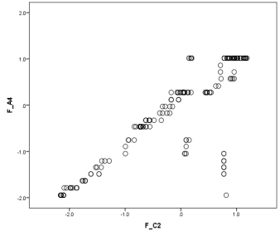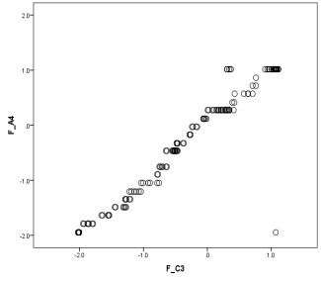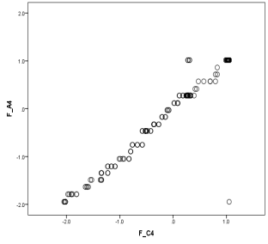
Source: Based upon Empirical study

With the purpose of showing the denotation of this relationship, the lowest values of (F&T) were (408.399, 20.209) < their tab. Values those equal (3.92, 1.98) at level of Sig. (0.05), df (1,248)&(248) in order, and the (P) was (0.0) for each.
This proves that this relationship, in terms of type, is - somehow - a causal one, the (IV) is a reason of the (DV).Even if we recognize that this is non-parametrically regression-based causality is unlike the one parametrically established by experimentation since the latter is focused on considering (IV) as the one and full reason of (DV).
The positive signals of all the (β)values were sufficiently indicating a positively direct relationship between both the examined variables. Liner by Liner(X²) values were at least (154.923)> its tab. value that's previously pointed out at the same level of Sig. (0.05) and same df (16), while (P) was (0.0) in all cases, which prove that this relationship is a liner one.
This was supported as well by establishing the simple regression in each case as shown by the (4) graphs followed to the same table above, to clarify that the dots represented the two variables on the strait line were more than(78%) in all the investigated relationships, this was clearly established by the values of (R) coefficient those were over (0.78).Within the context of using regression this is indicating that the (DV) is a function in (IV). The strength of such a relationship was twice-proved; in terms of the direction, since the minimum value of (R) was (0.789), also regarding the form, as the minimum value of (R²) was (0.622).
As a consequence, the sub-hypotheses (H_{o} 3/4/1), (H_{o} 3/4/2), (H_{o} 3/4/3), and (H_{o} 3/4/4) were rejected to accept alternatively the reverse hypothesis of each so as to prove that there is a significant and statistically indicative relationship between; on the one hand, the top-managers' failure to actualize– through the best of organization's people –the management technical function of controlling and on the other hand, the failure of these centers' top-managers in pre-requisitely practicing four management behavioral functions to gain the employees' trust against internal incoherence and peace deficiency. This is collectively proving the opposite hypothesis to the null hypothesis (H_{o} 3/4).
Overall interpretive &analytical discussion:
Based upon hitting the reality of the research target media centers workplace, it could be highlighted that the research hypothetical path, which has covered within the context of two interrelated hypotheses, three main variables; the dependent variable or the incapability of practicing the management technical functions, the intermediate variable or the negative effect occurred by rumors on the organization coherence and peace, and the independent variable that's the deficiency or lack of practicing the management behavioral functions, has made plain the following:
First, the failure of the top-managers to practice, as it should be, the technical functions of management through the best of the media organizations' people, and this could be briefly shown by demonstrating the latter's intentional actions that are really eye-witnessed in these centers' workplace:
- Deviating deliberately far out of the clearly pre-set goals.
- Working haphazardly the work strategy in terms of the objectives' position, terms, priority, or ordering.
- Exploiting negatively the flexibility allowed to the applied policies and programs.
- Lagging carelessly in executing the work tactics to the extent of time wasting.
- Preferring the personal techniques to the work legalized ones in getting the wok performed.
- Practicing obvious forms of organization disloyalty and low level of organizational citizenship.
- Encouraging unjustifiably the types of organization-individual goal-conflict and interpersonal conflict.
- Disabling the upward communications to hide the direction of the base line work.
- Being carless of the formal authority and even the exposure to punishment.
- Disrespecting the formal organizational relations to be replaced by negatively informal ones.
- Fostering excessively the work interface points on the account of creating the integration areas.
- Complaining from the whole organization climate to justify the calls for unjustifiable change.
- Claiming stress due to the rejection of performing the regularly normal burdens and duties of work.
- Spreading a destructive organizational culture of frustration and laziness due to the expected failure of getting utility.
- Thinking deeply in the ways to reject the managers' instructions and/or orders and swirling for violating them.
- Creating misleading, misunderstanding, overlapping and confusion room of the downward communications.
- Searching for some other informal or even illegal sorts of compensation, out of salary and incentives system.
- Putting back the effect of managers as formal leaders by creating alternatively informal ones who work oppositely.
- Establishing many informal organizations to replace and work negatively against the whole formal organization.
- Ignoring or even neglecting being subjected to the criteria of management controlling in work performance.
- Based upon personal claims and just talk for getting more work prestigious rather than gaining the top management real approval of actual work achievements.
- Paying no care to the correction of the deviations from the developed standards of work.
To sum up, the organization people who are actually fallen in committing such a kind of negative actions are providing unsuspicious evidence that they are not allowing their top-managers to practice, as it perfectly should be, the management technical functions. This crops up a question, how could the latter actualize such technical functions in the absence of their subordinates' best, or in other words while there organizations' people working against rather than for? Top managers have failed to gain their subordinates conditional empowerment to actualize the technical functions. Why things have gone into the unrequested course, this will be the subject of the next portion.
Second, the failure of the top-managers to gain the empowerment by the organizations' people, which is conditionally required for actualizing the technical functions of management, could be returned to some step-by-step logically ordered reasons as follows:
- Top-managers were incapable to face the widespread rumors that strongly stricken the national role done by these media centers before, during, and after the actions of January 2011.
- These organizations have been accused by rumors' promoters as working for the interest of some foreign agendas on the account of the Egyptian nation interest.
- It was a very sensitive treason relevant issue, that's covered by too much vague as well as public opinion importance, in addition to the least amount of information sources.
- Tackling negatively these organizations' role, has actually affected the people's trust in their top-managers.
- They have greatly believed in the calls contained by these rumors. They have been fallen as a prey to these rumors.
- They have made sort of projection on their top managers, since they have logically considered them as the most responsible about this role.
- They have been found distrusting their top-manager; the rumors' calls were stronger than the level of their trust in top-managers. The employees-to-managers relationship was shattered.
- Organizations have become in the front of vertical incoherency, this in turn negatively affect the organization internal peace.
- The deficiency of such a peace is directly an internal source of organizations collapse, that's quickly destroying the capability of organization to keep continuing.
- Organizations' peace deficiency is unlike organization instability, since the latter may occur due to an external threat while the organization is fully coherent to face it.
Despite the fact that negative rumors, gossip, chitchat, and stories are seriously dangerous in terms of their mobility, transition and infectious effect, they would not have any value in this research case, if they didn't affect the people's trust in their top managers and as a consequence the organization coherence and peace.
So creating trust in management is a key issue that originally has to be considered as a base for gaining organizational coherency and peace. Why people were easily gone to believe and/or trust the promoters of rumors on the account of believing and/or trusting their top-managers, this will be clarified in the next portion.
Third, the failure of the top-managers to practice and/or actualize a pre-requisite base of behavioral functions, those relevant to managers as effectual people or leaders, in order to exist a prefacing room of actualizing through people the managers' technical functions.
The lack, shortage, and even the absence of practicing such behavioral functions was the reason that gradually leads to the peoples distrust in their managers, they cannot see them as strong examples to follow; the examples that makes them over any attempts of suspicion.
Alternatively, they look to their managers' moral credit inside themselves astoo much weaker than the big accusation contained by the attacking rumor's call. They have become suspicious of their managers' honesty in terms of working on course to fulfill the national serving role required by the organizations to which they belong.
The climate of distrust that's created by the rumor around the role done by the media centers has greatly gotten bigger because it is relevant to an issue against the interest of Egyptian nation; it is an issue of treason.
That’s why the organizational incoherence and internal peace deficiency were normal consequences in such a case. However this was easily occurred due to the absence of a preventive wall that could be allowed by performing some management behavioral functions. Those functions that should be based upon the managers’ deeds, thinking, emotions, and character are outlined and top-categorized as being shown by Exhibit (1).
The word is for managers, for being out of suspicion you should be trustworthy, and to be that latter one you have to work behaviorally before technically for permanently getting your subordinates’ trust suggested itself, otherwise you will be vulnerable to the rumors that cause the organization incoherency and peace deficiency.
Results and Recommendations:
This research has ended to a main conclusion that the deficiency of practicing the management behavioral functions, which greatly help in establishing a preventive wall of employees-to-managers trust, was a precious reason for the organizations vulnerability to the negative effect of rumors, that spoiled the organizations' coherence and the internal peace, in a way that hinders the capability of managers to utilize using the best of their subordinates in properly actualizing the management technical functions.
Herein it should be considered that the addition proposed by this research, is to highlight for the readers the fact that those previously outlined hundred behavioral functions and may be some alike further ones as well, have to be collectively viewed not only as a management relevant issue but also as an organization relevant issue. Working such functions or idling them is something that greatly touch in depth the organizations' existence and continuity. Shortage in adopting this outlook will seriously be a reason for organizations incoherence and as a consequence falling in the internal peace deficiency that may lead to organizations decline and/or collapse, whatever the threatening mediators, those most probably fronted by the negative rumors.
As shown in the Figure (3), it is recommended to turn the organizations attention for utilizing a three-dimensional model that may help in practically establishing a measure for those aspects substantially affecting the prevalence/restriction of organizations' internal coherency and peace.

Exhibit (1):Outlining the suggested management behavioral functions
Deed-based  Functions. | Thinking-based  Functions. | Emotion-based  Functions. | Character-based  Functions.
Deeds  Says  Talks  Listening  Examples  Behaviors  Hinting  Pointing  Pointing out  Actions  Reactions  Interactions  Language  Expressing  Motions  Imitations  Commitments  Stability  Cooperating  Locomotive  Life-style  Normality  Situational  Proactive  Involving | Thinking  Commenting  Interpretation  Analyzing  Methodical  Focusing  Concentration  Memorial  Creativity  Understanding  Negotiating  Asking  Answering  Explaining  Simplifying  Suggesting  Wondering  Reasoning  Estimation  Quick-witted  Intimation  Sequential  Self-discipline  Connecting  Convincing | Affiliation  Loyalty  Psycho-power  Warmth  Changing  Soft powering  Affecting  Kindness  Appreciating  Open-minded  Encompassing  Sensitivity  Favoring  Supporting  Charitable  Helpful  Scarifying  Self-denying  Inspiring  Promising  Acceptability  Readable  Accessing  Differentiating  Accessible | Willing  Initiation  Positive  Ethical  Variety  Clarity  Frankness  Sociability  Trustworthy  Trusting  Changeable  Time pointing  Uniqueness  Exceptionality  Braveness  Dependable  Independency  Sincerity  Challenging  Believable  Functionalist  Deeming easier  Civilized  Brilliant  promising
Source: firstly prepared for the purpose of this research

Figure (3): A proposed three-dimensional model indicating organizational peace or peace deficiency
Source: Firstly prepared for the purpose of this research

In this measure organizations should be interested in focusing on the following important axes at three levels:
- The level of managers espousing to the management behavioral functions, this could be indicated by testing the managers practicing and/or actualizing of the previously mentioned deed-based, emotion-based, thinking-based, and character-based actions.
- The level of the subordinates-to-managers trust/distrust, which could be indicated by testing the prevalence of the pillars of trusting managers; those gradually enrooted by actualizing the behavioral management functions which effectually performed by managers as leaders. Versus the pervasiveness of the pillars of distrusting managers, those gradually enrooted as well through the subordinates adoption to too many internal and external threatening factors, like believing in negative rumors. The comparison between the foundation of trust and distrust pillars in management should be a never ending task, as long as there is an existing organization.
- The level of the managers’ capability/incapability to utilize the subordinates' best for properly practicing the management technical functions. Those commonly known as planning, organizing, directing and controlling. This could be indicated by the employees' commitment to the planning-based, organizing-based, directing-based, controlling-based sub-functions. Particularly the organizations' mission, objectives, strategies, policies, relations, instructions, leadership, communications, criteria, and development.
Further Research Topics

- Using positive rumors for building the organizations coherency and peace.
- Actualizing management behavioral functions for establishing a coherent organizational climate.
- Some links to be significantly considered between management issues and organizational issues.
- Employing rumors to pave the way for making already supportive management decisions.
- The role of soft versus running circles in sourcing the organizations' peace deficiency.
- Using MIS to face the rumors threatening internally the organization peace deficiency.

References:

- Allport, G. & Postman, L. (1946). An analysis of rumor. Public Opinion Quarterly, 10(4): 501-517.
- Allport, G. & Postman, L. (1947). The psychology of rumor. New York: Holt, Rinehart & Winston.
- Back, K., Festinger, L. Hymovitch, B., Kelley, H., Schachter, S.,&Thibaut, J. (1950). The methodology of studying rumor transmission. Human Relations, 3: 307-312.
- Bommel, J.V., (2003). Rumors. The journal of Finance, 58(4):1499-1520.
- Bordia, P.&DiFonzo, N. (2002) “When social psychology became less social: Prasad and the history of rumor research,” Asian Journal of Social Psychology 5(1):49-61.
- Bordia, P. (1996). Studying verbal interaction on the Internet: The case of rumor transmission research. Behavior Research Methods, Instruments & Computers 28(2):149-151.
- Bordia, P., & DiFonzo, N. (2004). Problem solving in social interactions on the Internet: Rumor as social cognition. Social Psychology Quarterly, 67:33-49.
- Bordia, P.,& Rosnow, R. (1995). Rumor rest stops on the information highway: A naturalistic study of transmission patterns in a computer-mediated rumor chain. Human Communication Research, 25:163-179.
- Bordia, P., DiFonzo, N., & Chang, A. (1999). Rumor as group problem-solving: Development patterns in informal computer-mediated groups. Small Group Research, 30, 8-28.
- Cane, V. R. (1966). A note on the size of epidemics and the number of people hearing a rumor. J. R. Stat. Soc. Ser. B, 28, 487-490.
- Caplow, T. (1947). Rumors in War. Social Forces, 25: 298-305.
- Castells, M. A. (1999). Rumors: Uses, interpretations, and images. New Brunswick: Transaction Publishers.
- Corley, K. G. and Gioia, D.A. (2011). Building Theory about Theory Building: What Constitutes a Theoretical Contribution? Academy Management Review,36:1, 12-32.
- Cornwell, D.& Hobbs, S. (1992). Rumor and Legends: Irregular Interactions between Social Psychology and Folkloristics. Canadian Psychology, 33(3):609-613.
- Daley, D. & Kendall, D. (1964). Epidemics and rumors. Nature, 204, E.A.I. (1118).
- Daley, D. & Kendall, D. (1965). Stochastic rumors. Journal of Applied Mathematics, 1:42-55.
- DiFonzo N, Bordia P. (2007) Rumor, gossip and urban legends. Diogenes, 54(1):19–35.
- DiFonzo, N. and Bordia, P. (1994) “Reining in Rumors,” Organizational Dynamics 23(1):47-63.
- DiFonzo, N.,&Bordia, P. (1997). Rumor and prediction: Making sense (but losing dollars) in the stock market. Organizational Behavior and Human Decision Processes, 71:329-353.
- DiFonzo, N.,&Bordia, P. (2000). How top PR professionals handle hearsay: Corporate rumors, their effects, and strategies to manage them.Public Relations Review, 26:173-190.
- DiFonzo, N.,&Bordia, P. (2002). Rumor and stable-cause attribution in prediction and behavior.Organizational Behavior and Human Decision Processes, 88: 329-353.
- Donovan P. (2007). How idle is idle talk? One hundred years of rumor research. Diogenes, 54(1):59–82.
- Dowd, S., Davidhizar, R., Dowd, L. (1997). Rumors and gossip: a guide for, the health care.Health Care Supervisor, 16:65–70.
- Festinger, L. et al. (1948). A Study of a Rumor: Its Origin and Spread. Human Relations, 1:464-485.
- Fine, G. A.,&Turner, P. A. (2001). Whispers on the color line: Rumor and race in America. Berkeley: University of California Press.
- Fine, G. A., Heath, C.,&Campion-Vincent, V. (2010). Rumor mills: The social impact of rumor and legend. Chicago: Aldine.
- Galford, R.&Drapeau A. (2003). The enemies of trust. Harvard Business Review; 81:89–95.
- Gregg, R. (2003). Office gossip: a surprising source of liability. Journal of Medical Practices Management, 19:71–4.
- Kamins, M.A., Folkes, V.S., and Perner, L. (1997) Consumer Responses to Rumors: Good News, Bad News. Journal of Consumer Psychology, 6(2):165-187.
- Kapferer, J.-N. (1990). Rumors: Uses, interpretations, and images. New Brunswick, NJ: Transaction.
- Kapferer, J.N. (1992). How rumors are born. Society, 29(5): 53-61.
- Kelley, S. R. (2004, September). Rumors in Iraq: A guide to winning hearts and minds. Master's thesis. Monterey, CA: Naval Postgraduate School.
- Kimmel, A. J. (2004). Rumors and rumor control: A manager's guide to understanding and combatting rumors. Mahwah, NJ: Erlbaum.
- Knapp, R. H. (1944). A psychology of rumor.Public Opinion Quarterly, 8: 22-37.
- Knopf, T. A. (1975). Rumors, race, and riots. New Brunswick, NJ: Transaction Books.
- Koenig, F. (1985). Rumor in the marketplace: The social psychology of commercial hearsay. Dover, MA: Auburn House.
- Matsuda, M. (2011). Rumors during the ongoing disaster (1), (in English), Chuo University.
- Miller, G.E. (2006). Rumor: An Examination of Some Stereotypes. Symbolic Interaction, 28(4):505-519.
- Morin, E. (1971). Rumor in Orleans. New York: Pantheon.
- Mullen P. B. (1972). Modern Legend and Rumor Theory. Journal of the Folklore Institute, 9(2/3): 95-109.
- Ohuchi, A., Mitsuyoshi, N.&Kisino, H. (2008). Damage due to harmful rumors suffered by 7 tourist sites in the vicinity of a disaster area during natural disasters: the model, the Index of the Extent of Damage, and the disaster portal, (in Japanese), The Operations Research Society of Japan.
- Pendleton, S.C. (1998). Rumor research revisited and expanded', Language& Communication, 1(18):69-86.
- Peterson, W. and Gist N. (1951), "Rumor and Public Opinion", American Journal of Sociology57(2): 159-167.
- Prasad, J. (1935) “Psychology of Rumor: A Study Relating to the Great Indian Earthquake of 1934,” British Journal of Psychology 26:1-15.
- Qazvinian, V., Rosengren, E., Radev, D.,&Mei, Q. (2011). Rumor has it: Identifying misinformation in microblogs. In Proceedings of EMNLP, 1589–1599.
- Rapoport, A.&Rebhun, L. I. (1952). On the mathematical theory of rumor spread. Bulletin of Mathematical Biology, 14:375-383.
- Rapoport, A.,&Rebhun, L. (1952). On the mathematical theory of rumor spread. Bulletin of Mathematical Biology, 14:375-383.
- Robertson, R. (2005). Rumors: Constructive or Corrosive. Medical Ethics, 31:540-541.
- Rosnow R.&Foster E. (2005). Rumor and gossip research. Psychological Science Agenda, 19(4):90-95.
- Rosnow, R. (1980). Psychology of rumor reconsidered. Psychological Bulletin, 87:578-591.
- Rosnow, R. (1988). Rumor as communication: A contextualist approach. Journal of Communication, 38:12-28.
- Rosnow, R. (1991). Inside rumor: A personal journey.American Psychologist, 46:484-496.
- Rosnow, R. (2001). Rumor and gossip in interpersonal interaction and beyond: A social exchange perspective. In R. M. Kowalski (Ed.), behaving badly: Aversive behaviors in interpersonal relationships (203-232). Washington, DC: A. Psychological Association.
- Rosnow, R. L.,&Fine, G. A. (1976). Rumor and gossip: The social psychology of hearsay. New York: Elsevier.
- Rosnow, R., Yost, J.,&Esposito, J. (1986). Belief in rumor and likelihood of rumor transmission. Language and Communication, 6:189-194.
- Scanlon T. J. (1977). Post-disaster rumor chains: A case study. Mass Emergencies, 2(126):22–27.
- Schachter, S.&Burdick, H. (1955). A field experiment on rumor transmission. Journal of Abnormal and Social Psychology, 50: 363-371.
- Sekiya, N. (2003). The social psychology of “harmful effects of rumors”: The reality and the mechanism of “harmful effects of rumors”, (in Japanese), Department of Social Information, Graduate School for Humanities and Social Sciences, Tokyo University.
- Shibutani, T. (1966). Improvised news: A sociological study of rumor. Indianapolis, IN: Bobbs-Merrill.
- Smith, L. C., Lucas, K. J.,&Latkin, C. (1999). Rumor and gossip: Social discourse on HIV and AIDS.Anthropology and Medicine, 6:121-131.
- Sommerich, P. (2016). Naïve Denies Takeover Rumors. Classical Music, 1017:7-9.
- Starbird, K., Maddock, J., Orland, M., Achterman, P.,&Mason, R.M. (2014). Rumors, False Flags, and Digital Vigilantes: Misinformation on Twitter after the 2013 Boston Marathon Bombing. In: Proceedings of iConference,iSchools.
- Sudbury, A. (1985). The proportion of the population never hearing a rumor. Journal of Applied Probability, 22:443-446.
- Takayasu, M., Sato, K., Sano, Y., Yamada, K., Miura, W.&Takayasu H. (2015). Rumor diffusion and convergence during the 3.11 earthquake: a Twitter case study. PLOS, 10:443-445.
- Tindale, R. et al. (2015). I heard that …: do rumors affect hiring decisions? International Journal of Selection and Assessment, Volume 23(3): 224–236.
- Trpevski, D. (2010). Model for rumor spreading over networks. Physical Review E, 81, Article ID: 056102.
- Turner, P. A. (1993). I heard it through the grapevine: Rumor in African-American culture. Berkeley, CA: University of California Press.
- Vosoughi, S.&Roy, D. (2015). A Human-Machine Collaborative System for Identifying Rumors on Twitter. In proceedings of the IEEE ICDM workshop on Event Analytics using Social Media Data (EASM). Atlantic City, New Jersey.
- Walia, R.&Bhatia, M. (2016).Modeling Rumors in Twitter: an Overview. International Journal of Rough Sets and Data Analysis (IJRSDA),3(4): 22-24.
- Watson, R. (1987). On the size of a rumors. Stochastic Processes and Their Applications, 1:141-149.
- Wert, S. R.&Salovey, P. (2004b). Introduction to the special issue on gossip. Review of General Psychology, 8:76-77.
- Wilson, A. (2015). An Epidemic of Rumors: How Stories Shape Our Perceptions of Disease. Western Folklore, 74(3): 378-379.
- Yoshino, A. (2012). An estimation of the damage caused by “harmful rumors. Graduate School of Global Environmental Studies, Kyoto University.
- Zheltukhina M. R., Slyshkinb, G. G., Ponomarenkoc, E. B., Busyginaa, M. V. and Omelchenkod A. V. (2016). Role of Media Rumors in the Modern Society. International Journal of Environmental&Science Education, 11(17):10581- 10589.
- Zheltukhina, M.R.&Omelchenko, A.V. (2011). Rumors functions in the modern media discourse. Horizons of Modern Philology, 3:35-40.
- Zheltukhina, M.R.&Razmerova, K.V. (2010). Rumors as a form of spontaneous information transfer in modern mass communication: Changing communication in the changing world. Volgograd: VAGS, 92-93.
- Zhu, Z., Liu, F.&Liao, D. (2012). Rumor Spreading and Degree-Related Preference Mechanism on a Small-World Network.Sociology Mind, 2:477-481.
- Zubiaga A, Liakata M, Procter R, Bontcheva K,&Tolmie P. (2015) Crowdsourcing the Annotation of Rumourous Conversations in Social Media. In: Proceedings of the World Wide Web Conference Companion. Web Science Track.
- Zubiaga A, Liakata M, Procter R, Bontcheva K,&Tolmie P. (2015). Towards Detecting Rumors in Social Media. Proceedings of the AAAI Workshop on AI for Cities.

4/25/2017

