Physical Characteristics, Seed Indices and Imbibitions of Rauvolfia vomitoria (L.) Seeds

Bello O. A¹, Adekunle V.A.J.¹ and Adesuyi O.F²

¹Department of Biology, Osun State College of Education, Ila-Orangun, Osun State, Nigeria
^{1,2}Department of Forestry and Wood Technology, FUTA
nikebello73@gmail.com

Abstract: Rauvolfia vomitoria (L.) is a species of tree in the family Apocynaceae. It is a shrub or a small tree that undergo exploitation in some West African countries. More concentration has been on the species of Rauvolfia, that is, Rauvolfia serpentine which makes Rauvolfia vomitoria lesser known species. Fruits of Rauvolfia vomitoria were purposively collected from UI (Oyo state) and FUTA (Ondo state) to determine Physical characteristics (colour). The fruits were depulped, leaving the seeds washed. The length (cm), width (cm) and weight (g) of 100 samples per location were measured to determine the influence of imbibitions and seed index and analyzed. A t-Test was used to analyze and compare the imbibition rate and seed index of the locations. The ripe fruits in Akure (red) while the fruits in Ibadan (orange). The unripe fruits in Futa (bottled green) while in U.I (pure green) colour. Mean Seed indices 0.51 (Akure), 0.63 (Ibadan). Imbibitions show a higher percentage of mean 0.013 at Akure than Ibadan (0.010). The mature fruits of Rauvolfia vomitoria are red and orange colour. Imbibitions show a higher mean 0.013 at Akure had the best imbibitions rate unlike Ibadan and might make the seeds to germinate faster than Ibadan.
[Bello O. A, Adekunle V.A.J. and Adesuyi O.F. Physical Characteristics, Seed Indices and Imbibitions of Rauvolfia vomitoria (L.) Seeds. N Y Sci J 2020;13(5):1-4]. ISSN 1554-0200 (print); ISSN 2375-723X (online). http://www.sciencepub.net/newyork. 1. doi:10.7537/marsnys130520.01.

Keywords: Imbibition, colour, Index, Seed, Characteristics

1. Introduction
Nigeria’s forests can be divided into two principal categories which are the woodlands and the forests of the savanna regions that are sources of fuel and poles, and rainforests of the southern humid zone that supply almost all the domestic timber with fuel wood as a byproduct. Nigeria’s forests gradually shrunk over the centuries, especially in the north, where uncontrolled commercial exploitation of privately owned forest began in the late nineteenth century. Towards the end of the 1800s, the colonial government began establishing forest reserves. By 1900 more than 970 square kilometers had been set aside. By 1930, this reserve had grown or developed. Deforestation among other things leads to significant environmental impacts and economic implications, in the form of shortage of fuel wood, fodder and food. Furthermore, tropical rainforest play crucial roles in maintaining climate locally through the hydrological cycle and globally through the carbon cycle. Hence, concerted efforts are necessary to halt the present escalating rate of destruction. 699km² has been encroached from the total forest reserve of 2,753km2 (25.40%) in Ondo State due to ineptitude and unwholesome practices of some forest staff, non-maintenance of forest reserves boundaries, customary tenure and activities of the enclave and cut out dwellers (Adetula,2001). Rauvolfia vomitoria is a species of tree in the family of the Apocynaceae. It is native to mostly tropical Africa which is commonly found in rampantly in Ondo State. Its English language names are swizzle stick, poison devil’s-pepper. In Nigeria, the Yorubas call it Asofeyeje. It is a shrub or a small tree up to 8m and the older parts of the plant contain no latex (Plate1). The branches are whorled and the nodes are enlarged and lumpy. Leaves are in threes, elliptic-acuminate to broadly lanceolate. Flowers are minute, sweet-scented, branches of inflorescences are distinctly puberulous with hardy any free corolla lobes. The fruits are fleshy and red in colour (Orwa et al., 2009). R. vomitoria undergo exploitation in some West African countries (Lissa, 2010). More concentration has been on the species of Rauvolfia, that is, Rauvolfia serpentine which makes Rauvolfia vomitoria lesser known species. Imbibition pressure is helpful in seed germination, growth of seedling through the soil, ascent of sap in plants, and so on.
2. Materials and Methods
Fruits of Rauvolfia vomitoria were purposively collected from UI (Oyo state) and FUTA (Ondo state) to determine Physical characteristics (colour). The fruits were depulped, leaving the seeds washed. The length (cm), width (cm) and weight (g) of 100 samples
per location were measured to determine the influence of imbibitions and seed index on seeds of R. vomitoria and analyzed. A t-Test was used to analyze and compare the imbibition rate and seed index of the two locations.

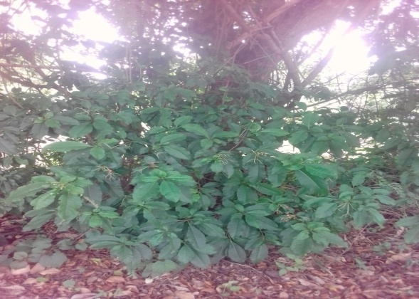
Plate 1: Habit of Rauvolfia vomitoria

Length and width were measured with a ruler and veneer caliper while electronic weighing balance was used to measure the weight of selected seeds in the laboratory. The imbibitions were derived by the differences between the final and initial weight and the seed index (dividing the seed length by the width).
2.1 Imbibition experiment:
Then filter paper placed inside each petri dish and seeds of R. vomitoria, respectively were weighed before putting inside the petri dish. Afterwards, twenty (20ml) of the water was added to each petri dish containing the 100 seeds and left for 3 – 4 hours to soak. After soaking, the seeds were put on dried clean filter paper to re-weight. At-test Experiment was conducted using the Statistical Package for Social Scientists (SPSS), t-Test was used to analyze and compare the imbibition rate and seed index of the two locations.

3. Results
3.1 Physical characteristics
The fruits of Rauvolfia vomitoria in Akure show darker colors (red) while the fruits in Ibadan show a lighter shade of color (orange). The unripe fruits of Rauvolfia vomitoria in Futa (Ondo state) have the color of bottled green and the ripe have red color. While the unripe fruits of Rauvolfia vomitoria in U.I (Oyo state) have the color of pure green and the ripe have orange color (Plates 2a, b and 3 a, b).
Plate 2a: Unripe Fruits at Akure

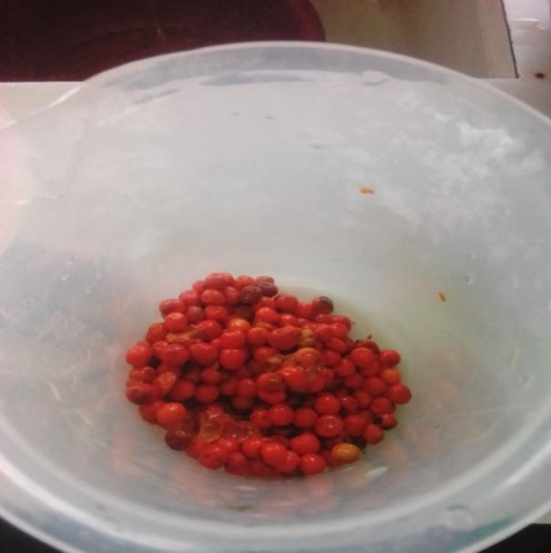
Plate 2b: Ripe Fruits at Akure

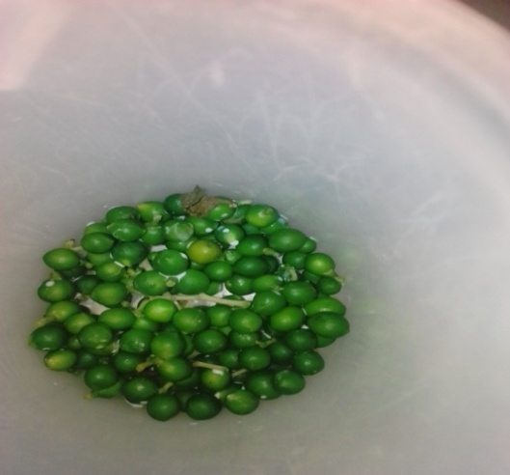
Plate 3a: Unripe Fruits at Ibadan

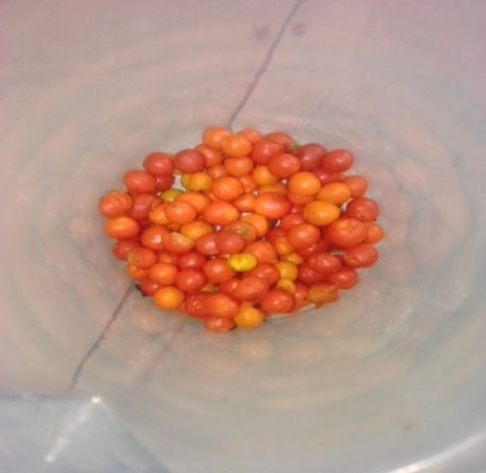
Plate 3b: Ripe Fruits at Ibadan

Table 1: Analysis of Variation of seed indices and sources on Rauvolfia vomitoria
 | Akure_seed index | Ibadan_seed index
Mean | 0.514423798 | 0.627142496
Variance | 0.020000582 | 0.027080611
Observations | 100 | 100
Pearson Correlation | 0.074915766
Hypothesized Mean Difference | 0
Df | 99
t Stat | -5.398607013
P(T<=t) one-tail | 2.30525E-07
t Critical one-tail | 1.660391157
P(T<=t) two-tail | 4.6105E-07
t Critical two-tail | 1.9842169

Imbibitions

Table 2: Analysis of Variation of imbibitions and sources on Rauvolfia vomitoria
 | Akure_imbibition | Ibadan_imbibition
Mean | 0.01297 | 0.00471
Variance | 9.2191E-05 | 8.73323E-06
Observations | 100 | 100
Pearson Correlation | -0.170827039
Hypothesized Mean Difference | 0
Df | 99
t Stat | 7.853549696
P(T<=t) one-tail | 2.46787E-12
t Critical one-tail | 1.660391157
P(T<=t) two-tail | 4.93575E-12
t Critical two-tail | 1.9842169

3.2 Seed indices
The seed index is calculated by dividing the length of the seeds of Rauvolfia vomitoria by the width of the seeds. Ibadan shows a higher percentage of the means indices 0.63 (Ibadan) than Akure (FUTA) 0.51 (Table 1). This implies that the sizes of the fruits and seeds of Rauvolfia vomitoria (Ibadan) are larger than the ones in Akure.
3.3 Imbibitions
Imbibition helps to show the rate of a seed can suck in water. Germination is a complex phenomenon during which the imbibed mature seed Imbibitions show a higher percentage of mean 0.013 at Akure unlike Ibadan (0.010) (Table 2).

4. Discussions
The colour of fruits is an important parameter to visually identify ripeness for most fruit varieties and rapid change in surface colour, often, from green to yellow can be seen during the maturity period of many fruits. Therefore when harvesting and marketing fruits, fruit surface colour can be used as maturity index, quality index as well as fruit damage index and can be a good parameter to determine the maturity of fruits from the day of harvest. Fruits have evolved a set of traits to attract and be consumed by seed dispersers. Fruit colour, size, accessibility, chemistry, infructescence morphology and crop size are among the most studied traits known to influence fruit choice by seed dispersers (Schaefer and Schaefer 2007). It is known that differences in the amount of some color pigments in seed coat result in color differences of seed coats. For example, it was found that in rapeseed, water uptake and tolerance to excessive water was significantly correlated with seed coat color and melanin pigment amount. Seed lots having red and black seed coat were found to have higher melanin pigment. In addition, colored types had a slow water uptake, low electrical conductivity value and high tolerance to slow water uptake. In yellow-colored seeds, lower melanin content and faster water uptake were observed (Zhang et al., 2008). Nerson (2002) found that immature seeds of watermelon cv. Sugar Baby uptake more water than mature seeds. Water uptake ratios in our study were found to be similar to those of Nerson (2002). In summary, it is proven that lighter colored fruits have higher tendency to germinate better than the darker coloured fruits.
Seed indices: Ibadan shows a higher percentage of the means indices 0.63 (Ibadan) than Akure (FUTA) 0.51 (Table 1). This implies that the sizes of the fruits and seeds of Rauvolfia vomitoria (Ibadan) are larger than the ones in Akure.
Imbibition: It helps to show the rate of a seed can suck in water. Germination is a complex phenomenon during which the imbibed mature seed must quickly shift from a maturation to a germination driven program of development and prepare for seedling growth (Prasad et al., 2016). In dry and dormant seeds, plant embryos and the surrounding endosperm display very limited metabolic activities, and Reactive Oxygen Species (ROS) production is speculated to be very low (Bailey et al., 2008). However, after seed imbibitions and during germination, metabolism rapidly resumes (Rajjou et al., 2012) and such a swift metabolic start seems to be correlated with increased Reactive Oxygen Species (ROS) production via various pathways and at sub cellular sites. Therefore, the higher the rate of imbibition, the greater the germination rate of the plants. Imbibition rate is calculated by subtracting the final weight of the seeds from the initial weight of seeds. A total number of 100 seeds were calculated. Imbibitions show a higher percentage of mean 0.013 at Akure unlike Ibadan (0.010). This implies that there is higher tendency of the plants of Rauvolfia vomitoria in Akure to germinate faster than the ones in Ibadan.

Conclusion
The mature fruits of Rauvolfia vomitoria are red and orange colour, respectively. Imbibitions show higher tendency in Akure seed to germinate faster than the ones in Ibadan.

References
- Adetula, T. (2001). Encroachment and its impact on forestry development. Journal of Tropical Forest Resources 17 (2):12 – 32.
- Adetula, T. 2008: Challenges of Sustainable Forest Management in Ondo State: Community based Forest Management System as a panacea. In: Research for development in Forestry, Forest products and natural resource management.
- Adeniyi, A.A., Brindley, G.S., Pryor, J.P., and Ralph, D.J. Yohimbine (2007). In the treatment of organism dysfunction. Asia.
- Lima, G.P., Pereira, C.R., Arnoux, D.S., Willadino, L.G., Camara, T.J.R. and Vianello, F., (2012). Polyamines, Gelling agents in Tissue Culture, Micropropagation of Medicinal Plants and Bioreactors. In Recent Advancesinplant In Vitro Culture (p.18). Retrieved from http://dx.doi.org/10.5772/51028.
- Lissa, F., (2010). Rauvolfia vomitoria: A growing plant KIA’I MOKU.
- Orwa, C.; Mutua; Kindt, R.; Jamnadass, R.; Anthony, S., (2009). Agroforestree Databas: a tree species which can be used in agroforestry.
- Osemeobo, G.J. (2005). Living on the Wild Plants: Evaluation of Rural Household Economy in Nigeria. Environmental Practice 7: 246-256.
- Prakash, S., Hoque, M.I. and Brinks, T. (2004). Low cost options for tissue culture technology in developing countries. In Proceedings of a Technical Meeting organized by the Joint FAO/IAEA Division of Nuclear Techniques in Food and Agriculture. Printed by the IAEA in Austria. 26-30.
- Rajjou L, Debeaujon I. (2008). Seed longevity: survival and maintenance of high germination Ability of dry seeds C.R. Biol. 331:796-805.
- Ramesh, Y. and Ramassamy, V. (2015). Influence of gelling agents in micropropagation of Banana var. Grand Naine. International Journal of Current Research in Biosciences and Plant Biology, 2(5), 174-178.
- Razdan, M.K. (2003). Introduction to plant tissue. 2nd edition. Oxford & IBH publishing Co. Pvt. Ltd. New Delhi, 27 – 9.
- Zhang, Y., Zhpu, J., Wu, T. and Cao, J. (2008). Shoot regeneration and relationship between Organogenic capacity and hormonal Contents in pumpkin Plant Cellular Organ Culture 93:323-331.

4/24/2020

