# Using Android OS Applications for mobile healthcare information management utilizing Cloud Computing: A comprehensive Review

Abdelmageid A. Ali1, Nahla F. Omran2 and Amal A. Alsayied2

1Department of Computer Science, Faculty of Computers and Information, Minia University, Minia, Egypt.

2Department of Mathematics (Computer Science), Faculty of Science South Valley University, Qena, Egypt.

[abdelmgeid@yahoo.com](mailto:abdelmgeid@yahoo.com); [nahlaafathy@yahoo.com](mailto:nahlaafathy@yahoo.com), [amal_a_a2002@yahoo.com](mailto:amal_a_a2002@yahoo.com)

**Abstract:** When there are problems in developing countries in the field of infrastructure technology, the need arose to use the concept of mobile cloud computing, which is a very modern concept, and the concept of e-health and its applications and requirements for its application; while defining the relationship between e-health and mobile cloud computing by employing the best to implement mobile health systems through a Firebase cloud-based model provided by Google to store health information and provide health services. This technology is very useful especially in developing countries due to lack of strong infrastructure and adequate financial support. He concluded that these systems can be applied from a theoretical and practical point of view in Egyptian hospitals, but this needs more practical studies in hospitals, and in this study we conducted a reference review of studies related to mobile health that rely on cloud computing using the android operating system.

**[**Abdelmageid A. Ali, Nahla F. Omran and Amal A. Alsayied. **Using Android OS Applications for mobile healthcare information management utilizing Cloud Computing: A comprehensive Review.** *N Y Sci J* 2020;13(5):23-35]. ISSN 1554-0200 (print); ISSN 2375-723X (online). <http://www.sciencepub.net/newyork>. 4. doi:[10.7537/marsnys130520.04](http://www.dx.doi.org/10.7537/marsnys130520.04).

**Keywords*:*** E-Healthcare, Cloud computing, Mobile cloud Computing, Android Os system, Firebase, Amazon’s S3, DICOM format, JPEG 2000.

**1. Introduction**

Mobile health is necessary and important to address several problems, consisting variants of access health services amongst human beings, poor health infrastructure in some countries, and presence deficiency in human resources working in the health field and the high cost of health services limited availability of financial resources [I]. By comparing mobile health with computer and network e-health services wired; mobile health services enable users to access health services with great ease and comfort, anywhere and anytime [2] The term mobile health (M-Health) includes the use regarding cell devices such as much smart phones mobile application, internet technology, networks and private sensors that are used wireless physical network technology to collect information from the human body, to provide services health, as well as health professionals such as doctors, nurses, and others as shown in Figure (!), mobile health can be considered one of e-health applications, because the concept of e-health is a comprehensive concept, it includes all the technology and tools that help deliver healthcare services, both via the computer Or mobile phones or other means [4] The emergence of the third generation of Mobile devices (3G) is a major transformation in many areas, including mobile health it gave new innovative opportunities to provide and deliver mobile health services everywhere and anytime [5].

Mobile health monitors have provided a lot of help to patients, as they can get access adequate medical care without having to go to the doctor. This technology provided many Benefits for patients and physicians a like. Doctors can also use time to concentrate on priority tasks [6].

**2. Mobile Cloud Computing**

One of the benefits from mobile cloud computing which give it a wide popularity are attributed to its possibility to reduce the consumption of power and augment manipulator practice by expanding computation/resource serious operations / applications from mobiles to clouds.

The known complain from the mobile devices usually representing in short life of batteries and limited supply and limited capacity of storage.

Mobile cloud computing has familiarized of floading, in order overwhelmed these restraints, where data store and additions are accomplished in the remote cloud as a substitute of the mobile device. The advantages of this approach `mobile cloud computing` including green cloud environment and an energy-efficient mobile network. The operation to perform

working out on a mobile instrument and broadcast of information from and to further devices is known as mobile communication [7]. This kind of communication is an advanced technology aimed to attainment linked and assembly utilize of information found centrally, computing devices and use of software with the organization of minor, portable wireless communication [7-8].

By this technique we can perform several applications on a one device, where the mobile communication can be easy and simple to perform multiple applications. Everything is extremely depending on the modern technology particularly in the advanced countries. Day by day there are an urgent need for using modern communications and consequently increasing in the number of consumers or users of mobiles. Therefore, the necessity to supply best class of facility at minimal cost and very minimum power similarly rises. The procedures of scattered computation on hybrid networks intercom/nested by mobile communication protocols and various mobile devices is defined as mobile computing.



**Figure 1 General concept of m-health systems [****3****].**

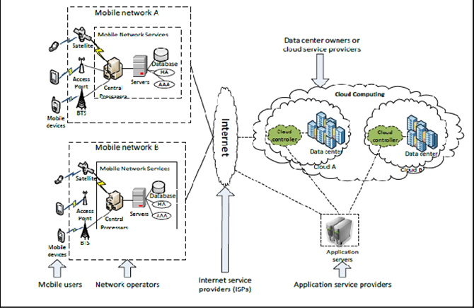

**Figure 2 Mobile Cloud computing Architecture[26]**

**2.1. Mobile cloud computing Architecture**

3. Main stations are provide the mobile networks which nourish the mobile devices with essential various data [11] tosatellite or base transceiver station (BTS) or access point. The functional interfaces and the connections of the networks in addition to the mobile devices are set up or monitoring by the above mentioned stations. Mobile consumer requirements for the communication regarding the material including the info conveyed to central processors. Mobile network services are supplied via the central processors which linked to servers.

Mobile network operatives furnish functions in accordance with mobile customers by means of AAA abbreviation. The letters AAA means an abbreviation of the words Authorization, Accounting and Authentication, primarily created about the home vicegerent (HA) and subscriber information stored among a data base yet the demand about a subscriber dispatched to the cloud via the Internet. At that point the demand treated by cloud controllers after supply mobile use services from the cloud.

These facilities are developed with the ideas of computing, service-oriented style and utility virtualization (e.g. application, database servers and web).

**2.2. Service-Oriented Architecture (SOA)**

SOA of mobile cloud computing composed of 3 layers as demonstrated in figure 3[8], and consists of the subsequent constituents:

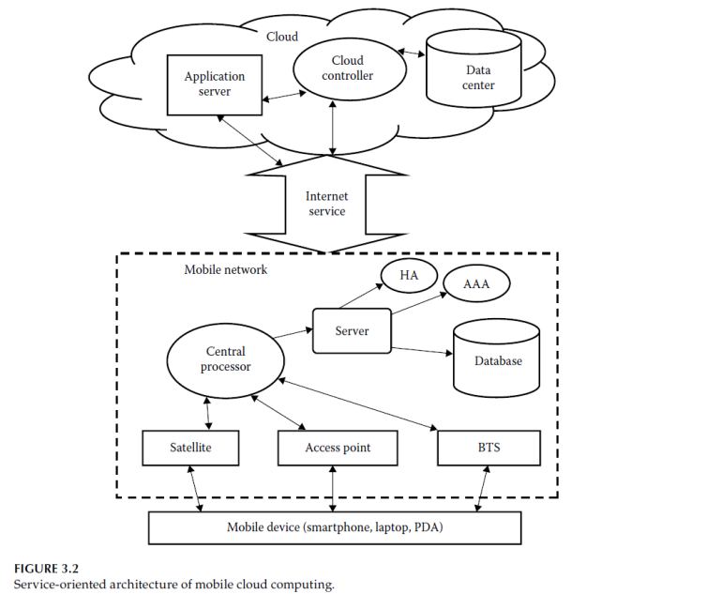

**Figure 3 service-oriented architecture of mobile cloud computing [****9****]**

2.2.1. Mobile network: Which are consists of mobile gadgets then network operators. Mobile devices may be laptops, PDA, smart phones, satellite phones and others. These apparatuses are attached to the network operator by way of the base transceiver stations (BTSs), get right of entry to points and satellites. They establish yet rule the ligature of the useful interface into network operator and mobile system. A mobile device's information and invitation, such as location and ID, are transmitted to the main processor then the network providers servers. At this point, operators supplies different services like AAA (authorization, authentication, and accounting)) depending on subscriber data stored in database and the HA (home agent).

2.2.2. Internet service: Which demonstrates the role of a channel among the cloud and the mobile network. Subscriber demands are transferred to the cloud through Internet service with maximum-speed, through utilizing advance 3G or 4G technologies such as WCDMA, MTS, HSPA, LTE, and other tools or wired connections, after that the customer can obtain smooth service from cloud.

2.2.3. Cloud service: the cloud controller processes the requests which gotten from users, and delivers service to the consumers depending on the consumer needs. As illustrated in fig.4, cloud has an insufficient service supplying layers. These service layers are deliberated in the mentioned points:

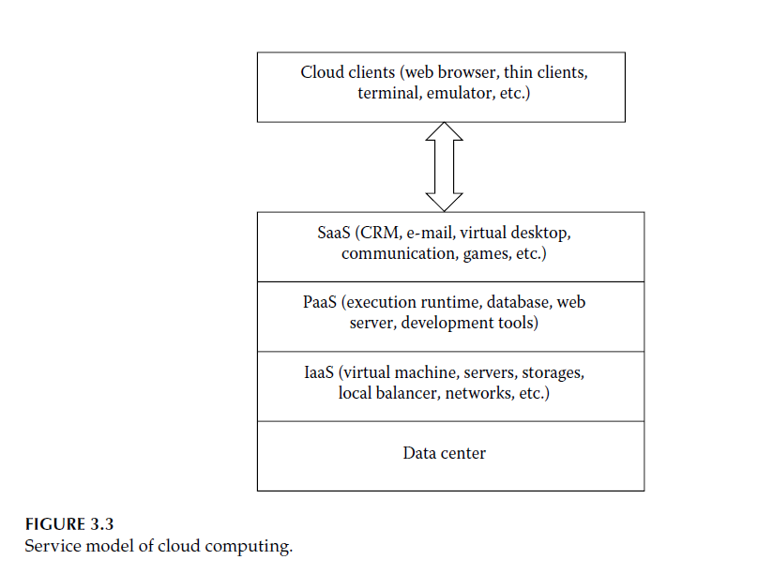

**Figure 4. Service model of cloud computing**

* 1. Data center layer: These data center layer supply the infrastructure and the hardware facilities for the cloud. In which, there are various servers linked with high power supply and networks of high-speed usually, they are built in minimal occupied area with a minimum risk of catastrophes.

b. Infrastructure service: laaS exited on the upper most of the data center layer. It supply stores, hardware, networking tools, and servers to its customers on a "pay as you use" base. It has a flexible environment, therefore, the infrastructures are subjected for changes according to the capacity of requirements and subjected for shrinkage or expansion easily depending on the customers' requests. S3 and Amazon EC2 are instances of laaS.

c. Platform service: PaaS (e.g. Google App Engine & Microsoft Azure) offers an incorporated platform or background for customers to test, build, and diffuse various requests. Some types of platform like NET, PHP and Java, and others are ready. d. Software service: SaaS is a software provision sample delivered by application service providers (ASPs). Software and the linked information are centrally presented on the cloud. SaaS can deliver many types of software resolutions like ERP, CRM, HRM, MIS and others, on request deprived of any devoted fitting in client location.

By this system, data storing and computations are progressed into the cloud in mobile cloud computing and the applicants obtains on-demand and unified service, and don’t concern about life of battery or the power of processing of their mobile apparatuses.

**2.3. Issues and Challenges of Mobile Cloud Computing**

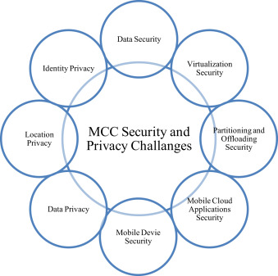

**Figure 5. Issues and Challenges of Mobile Cloud Computing**

**A)** **Operational Issues**

Operational concerns comprise computation of discharging cost and unloading methods. It calculates either discharging will be cost effective or not cost effective. In addition, flexibility organization and assembly procedures present [10].

1. **Offloading Methods**

**Client-Server Communication Technique**

Within the offloading procedure, communication is performed throughout remote method invocation (RMI), remote procedure call (RPC), and outlets amide the surrogate device and the off loader. However when the mobile nature or ad hoc of the device is regarded, it considered as a hindrance owing to these services must to be preinstalled in the mobile device. Accordingly, it limits the flexibility of the device. There are two types of systems named Spectra (10] and Chroma [10] are apply discharging computation through RPC via appealing functionalities in remote Spectra and local servers. Spectra client accesses a database, as soon as offloading is required from a device, which stocks data like the CPU load of the Spectra server, and existing accessibility, dependent on the resource pool, chooses at runtime and performs offloading. Hyraxis an application for a smartphone constructed on Hadoop ported on Android platform, disseminated in the form of terms represented on computation and data. Hyrax usages a collection of mobile devices as a mobile cloud and source supplier [11**]**. Hyrax Tube is an application capable for distributing mobile multimedia sharing and search, in the same time, enables the customers to search via multimedia files take in consideration, the locations, quality and time. Hyrax possess a main server called Code and Job Tracker instances and contact to every client mobile device. The main or central server not performed a job, but organizes jobs and information, whereas, Hadoop distributed file system (HDFS) threads run on the mobile devices and stocks the multimedia information.

**ii. Low bandwidth:** Which represent the great subjects among mobile cloud computing (MCd) to that amount requirement in conformity with keep tackled. Mobile cloud makes use of radio waves as are confined as evaluate in imitation of wired network. Available wave is distributed into one of kind mobile devices. So such has been three times slower within receiving access to velocity so compared according to wired network.

Security and Privacy: Persistence confidentiality is a chief interesting subject in mobile cloud computing. It is stiffer to rule terrorizations about mobile devices if paralleled in conformity with computer gadgets rJ cause in a wifi network in that place are more hazards concerning purity of the data out of the network.

Service Availability: communication is extra main impendence in cloud computing. Consumers oftentimes find complaints such as transmission outside covering, fall of network and crowding. Occasionally users acquire a signal of low frequency, in turn impacts the speed of arrival and capability of storage.

**Alteration of Networks:** Mobile cloud computing is utilized in various functioning method paying platform such as Windows Phone and android Apple ios. Therefore, it is appropriate with several systems. Intelligent Radio Network Access (RNA) technique is responsible for management of the presentation of various mobile platform networks.

vi-Energy source: The characteristic of most of mobile devices are consuming high energy in spite of having minimal power source. One of the important subject concerning mobile cloud computing is the growing battery use of mobile devices. It is expected that the mobile devices should possessing a battery of high life period to supply with enough energy to cover all applications and other process.

The off loading consumes high quantity of energy than local in case of the size of altered code is small. To ride this problem, some establishments attempt to discover the different ways to overcome this problem.

**B)** General Cloud Security: The following are some security risks which may be arisen when information is offloaded into the cloud [12):

1. Advantaged customer access: The data are no longer may be under the direct Logical, physical, and personal control of the user, when the sensitive information become offloaded to the cloud.

ii-Regulatory agreement: external audits and security certifications must be undergo by the providers of cloud service.

iii-Information situation: Precise physical situation of consumer’s information is not apparent, which may lead to misunderstanding in certain authorities and commitments on indigenous confidentiality necessities.

iv-Information separation: Generally, all the cloud data of consumers are stored in a public universe, therefore, each consumer’s information should be separated from the others' with effective encryption techniques.

v. Retrieval: when a technical mistake or disaster happens, it must be given a good recovery management schemes for information and services by cloud suppliers.

**C) Safety for Mobile customers**

Different kinds of malicious encryptions for an example worms, viruses, and other agents, generally influencing the mobile devices during an installing and downloading of giving of security software like McAfee, AVG, Avast and Kasperkey, can overcome or eradicate of these threats.

**Confidentiality**

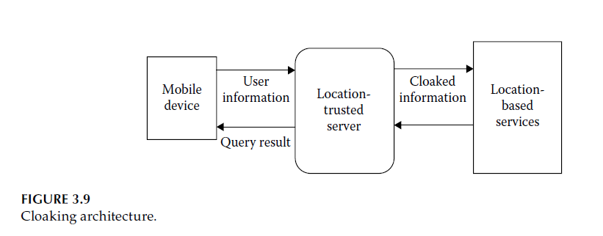

**Figure 6. Cloaking architecture.**

Nowadays, greatest numbers of mobile devices are supplied with GPS-enabled location-based service (LBS), and guide the consumers for the situation and time and different road services. Occasionally it conceals the confidentiality of a customer, to elucidate this problem a location­ trusted server (LTS) is applied [13]. The cooperation among the LBS and mobile device, leading to getting of data from mobile customer and produces a "cloaked region." The formed "cloaked region" is directed to the LBS. Accordingly, LBS can identify merely common information about customers without clear identification of the users, as illustrated in figure 6.

**2.4) Merits of Mobile Cloud Computing**

There are several promising merits of mobile cloud computing, may be arisen from using of a cloud environment will be given in the following:

**i. Increasing the lifetime of battery:** In mobile cloud computing, storing of information and their processing occur external in the cloud and to the device, consequently it spontaneously rises the lifetime of the battery of the mobile. Every great working out sanitations very speedily the battery as it expands a part of energy. Some researchers established that offloading task to cloud such as large-scale matrix calculation can minimize the save the battery energy by 45%, for an example a 45% energy saving is possible when chess game via cloud use [**14).**

As a result offloading and function relocation are efficient resolutions to expand thebattery lifetime of mobile devices.

**ii- Increasing store volume:** storage volume was a large restraint for a mobile device. Nonetheless mobile cloud computing supplies a very large volume of storage. There are some examples of storage of data provided by cloud to the consumers such as, Amazon's simple storage service and Dropbox and Flickr and Facebook considered as an application for image -sharing based on Mobile cloud computing.

**iii- Increasing the processing power:** Some applications like multimedia service, broadcasting, transcoding, playing games and others, demand high-processing energy, which can be performed obtainable by offloading functions into the cloud.

**iv- High consistency:** In mobile cloud computing, applications and information are kept in various computers, therefore, there is no way of damage of information. Tragedy administration has converted quicker due to accessibility from multi-location. Sometimes, the cloud supplied copyright to digital content like video and music, so barring unofficial delivery. Moreover, cloud offers safety services for an example authentication, malicious code detection, virus scanning, and other services. By this method the mobile cloud computing has enhanced dependability.

**v-On-demand service:** In mobile cloud computing, the customer can get a service on demand via the cloud easy due to elasticity of the cloud nature, so the customer not require to install dedicated software or hardware in their mobile devices to obtained anything from the cloud via using of Google Play Store at any time and in any amount.

**4. Android OS System**

Nowadays android operating system (OS) is flourished for clever tablets and mobiles; it is open supply software android is the close broadly old cellular operating system through the people. Primary intension concerning the manufacturing company used to be to boost a superior OS because of digital cameras, however then it was realized so need because such units used to be now not large sufficient consequently that diverted theirs interest to producing smart cellphone OS.

Android was since obtained by means of the Google within 2005 then unveiled its distribution of 2007 including composition over open handset alliance conducted through Google. Android cellular operating law is based totally concerning the Linux kernel and is raised by way of Google.

Android OS has its personal virtual desktop referred to as DVM who which is used for executing the android application. One of the motives to the prevalence about Google's os is the constant amelioration of its much versions, together with each and every latter certain providing extra superior features, faster access to the internet. Another motive for the Android is recognition is its strong adjuvant together with cell units manufactures, while it is important world competitor [15].

**3.1Android Architecture:**

**i. Application layer:** It is the just upper layer in android architecture. include All the functions kind of camera, Google maps, browser, sms, calendars, contacts are local applications it capabilities workshop with end person with the help regarding application framework in conformity with operate. [16).

**ii. Application** framework: Android services which are developing, this layer contain needed instructions or services. Developers be able reuse or lengthen the elements meanwhile current among APL In it layer, so are managers as enable the application because receiving access to data. These are as follows:

**iii. Android runtime:** In this section, all the android features are executed. Android has its own digital machine i.e. DVM (Dalvik Virtual Machine), which is used to execute the android application. With it DVK, customers are able in accordance with solve more than one features ate same time.



**Figure 7 Android Architecture**

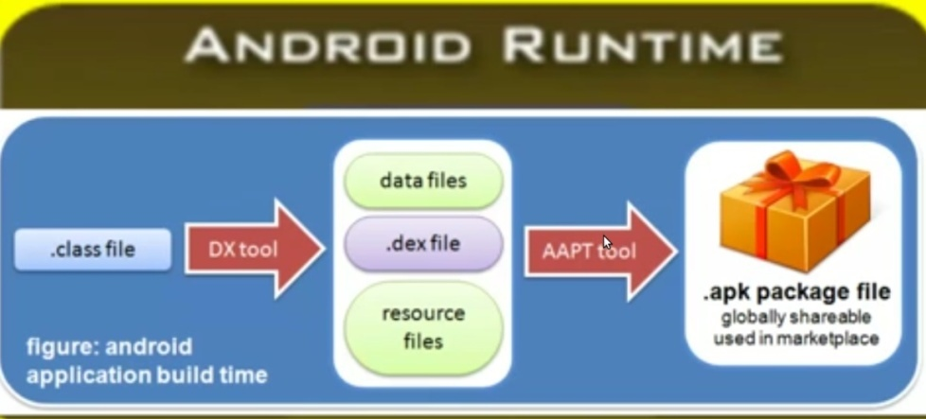

**Figure 8 Android runtime**

**3.2 Android Security**

**i. Physical access:**

Android has a combine of characteristics for assessing in the prevention of hackers throughout the unlock screen in case of the device is awakened from sleep. The standard unlock screen is considered as a slider which fundamentally halts the screen from being stimulated in your pocket. In addition, Android also approves ye according to set an uncover shape, PIN then password. Without the intruder recognizes the shape, PIN then password he can't find gets right of entry to in accordance with thy device. This is particularly useful after hold tiny kids outdoors of you cellphone or cease bad friends besides sending emails.

ii. Application permissions:

Each application that you set up on your device needs to specifically ask you for permission to implement definite tasks. This is achieved when you install the application. What this means in actual terms is that applications have restricted abilities. As well as limiting the abilities of applications, Android also controls how an application accesses the device's hardware. There is no direct hardware access allowed in Android; all access is through the several software layers which make up the Android OS. This means that trickster applications can't go around re-programming the microphone on your phone or transit the application permissions by talking directly to the video camera, etc.

**3.3. Comparison between Android OS and iPhone OS**

**Table 1. Compare between iOS and Android**

|  |  |  |
| --- | --- | --- |
|  | **iOS** | **Android** |
| Minimum Development Operating System Requirements | Mac OS X 10.6 | Windows XP  Linux  Mac OS X10.5.8 |
| Development Device | $99 iPhone 3G  $199 iPod Touch  $199 iPhone 4  $499 iPad | $399 Dev Phone 2(v1.6)  $529 Nexus One (v2.2) |
| IDE | Xcode | Eclipse 3.5 |
| GUI Creation | Xcode | XML |
| Language | Objective-C | Java (Dalvik)  Scripting (SL4A)  LogoBlocks (Appinventor) |
| Reference Website | http://developer.apple.com/iphone | http://developer.android.com/ |

**4. Literature Review and Related Work**

Somasundaram, *et al*. (18), had designed and developed "The HMS application" on their Android powered mobile phones to facilitate the health records, therapies and medical scanning records (e.g scanned images,….etc.) of disordered subjects. The data which exist in the cloud was controlled by the physicians (for uploading medicaments and medical scan records) and the hospital management staff. The Android OS reinforced the connection to the Cloud OS that permitted the patient to manage and upload medical images, text data, retrieve, and modify the data through REST API concepts such as HTTP URLs and the internet services.

The HMS application was examined in both the mobile and server ends. Checks were carried out on text files and on the medical scans (e.g. CT, MRI, Ultrasound, X-ray…..etc) of various file volumes which conveyed from cloud computing server, where the medical scans were held by the DICOM file format and compressed by JPEG2000 compression. The physician are uploaded the compressed images in the cloud server and then the mobile device will receive these images. EyeOS had tools like EyeOS Image which permit image file sizes up to 2MB. The maximum transmission time for the different medical images, using the EyeOS cloud server is demonstrated in the following table:

**Table 2. Show transmission time for medical images**

|  |  |  |
| --- | --- | --- |
| Medical image type (jpeg 2000 compression ) | File size | Transmission time (approx.) |
| MRI | 0.123MB | 2.75 sec |
| X-RAY | 0.125MB | 1.35 sec |
| CT | 0.278MB | 1.05 sec |
| ULTRASOUND | 0.318MB | 3.75 sec |

Vinutha *et al. [*19], had provided Electronic Hospital Management system operating Android OS and Cloud Computing via VPN connections. Businesses confirm safety to someone interrupting the encrypted data can’t read it by applying a VPN. Figure 9, illustrates the proposed system architecture presented from researchers for organizing and developing the electronic hospital management system application that employed VPN and cloud computing the connection.

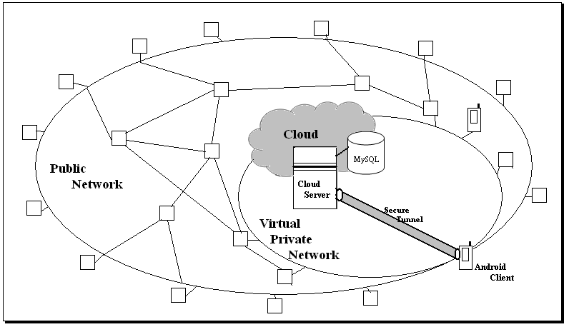

**Figure 9. System architecture [****19****].**

The Cloud Platform interface was connected to the Cloud Service module which handled and queued user requests. In this context, electronic hospital management system had been developed based on Google's Android mobile Operating System (OS) using the appropriate software development kit (sdk). Several mobile device vendors already supported it. The platform was adaptable to larger and traditional smart. phone layouted and supported a variety of connectivity technologies (CDMA, EV-DO, UMTS, Bluetooth, and Wi-Fi). It supported a great variety of audio, video and still image format, making it suitable for displaying medical content. It supported native multi-touch technology, which allowed tg: er manipulation of medical images and generally increased the application's usability. Medical records and related data (images and biosignals) were stored into a SQLite [20] file. SQLite was the database platform supported by Android. The file resided into a specific location at the Cloud and was retrieved on the device every time user needed to query data. The Experimental results the query was performed locally and the actual location of the data in the cloud was revealed to the applications. The database file was updated and uploaded into the Cloud every time user modifies data, respectively.

Jemal et al. [21) had proposed a new mobile medical web service system. through implement a medical cloud multi-agent system (MCMAS) using Google's Android 09ating system. The developed system has been assessing using the CloudSim Simulator. The performance of the MCMAS is compared with the traditional system in polyclinic ESSAL9'1A which showed that this prototype yields better reading than using usual application. several simulators have been developed for performance ana19s of cloud computing systems, such as GridSim, MicroGrid, GangSim and CloudSi m [22]. CloudSim is a generalized and extensible simulation toolkit and application which enables seamless modeling and experimentation of emerging cloud computing 1Jstem, infrastructures and application environments for single and internetworked clouds CloudSim was successfully deployed and performed experiments related to mapping of virtual machine son hosts.

Apurva Kumari, Divyankitha Mahesh Urs, Sindhya Kumari Nellaiappao, Suma Khursheed, [23] had developed an Android mobile application, which uses AWS cloud and Fitbit to detect fall and collect health data of an elderly adult regularly, which is then used for analysis by doctors. its called @HealthCloud.

The application can collect the data from wearable devices and sensors and the data is sent to the doctor for further diagnosis, by using fit bit which is a wearable device that collects health data such as walking steps, sleep time, calories burnt and heart rate. This data is sent to the doctor periodically for the doctor to take necessary action. To connect the fit bit device to this application, Fitbit provides APis to access the data from the device. Fitbit uses OAuth 2.0 to authenticate and authorize the users. To pair the application with the fitbit device, the user must enter the fitbit credentials. The u ser is authenticated using the Fitbit authorization API and an access token is generated for the user. This token is sent along with the all the requests to get the fitbit data. Experimental Result The presented health application is a solution for improving and increasing the lifespan of elderly. and accessing the patient data, without them going through the hassle of manually inserting it.

Suhiar M Zeki et al. [24] had developed Native Mobile Application bile for diagnosis of case and remotely monitoring blood pressure readings and heartbeat. The information of web application is preserved in server not in the device while the information of mobile application is stored in mobile, therefore, not need to install the application when use web application owing to storing the data in the server, so it is the greatest method for controlling huge information.

The investigators are applied Xamarin to build Android applications, offers the runtime and ties to make it all work, in this application not used not Java language but used C# Language and describe activities and User Interface (UI) in the typical Android way.

Xamarin applications influence acceleration of platform-specific hardware, and they're amassed for innate presentation [25]. The innate Presentations can more efficiently applied phone hardware like camera and accelerometers, offer capability to effort and attach to external sensors.

Xamarin Policy is the chief creator part of Xamarin, where Xamarin carrying three main parts of the Xamarin ecosystem.. Xamarin possessing a group of virtual machines, code APis, runtime engines, and code samples. The platform objectives Mac OS 10 applications, and the Microsoft Windows, Android and iOS apps, tablets and phones. Xamarin delivers an automatic online testing harness that permits application to be examined on thousands of real devices in the Cloud. The 3rd main part of the system is Xamarin Visions, where it observing service that paths application exclusions and crashes and assist the builders grow in real time what is occurring with applications customers. The Experimental findings demonstrate in table below define the First 6 months post using the healthcare system by smart Devices.

**Table 3: the First 6 months after appling the healthcare system using smart devices.**

|  |  |  |  |
| --- | --- | --- | --- |
| Month no | dealing without healthcare System | desktop app | healthcare system (smart devices) |
| 1 | 100% | 0% | 0% |
| 2 | 80% | 20% | 10% |
| 3 | 70% | 30% | 25% |
| 4 | 60% | 40% | 40% |
| 5 | 50% | 45% | 60% |
| 6 | 30% | 50% | 80% |

Mallikarjuna, [17], established application for mobile healthcare called Health Kit, this application are fully automatic disseminated environment, developed in Android operating system which is a prevalent healthcare information management system operating in cloud computing system.

Health Kit is Suggested application composed of several cloud services, the consumer running an application on Android OS, it composed of numerous modules like clinic module, cloud module patient health record, mobile user module and patient module (Fig. 10).

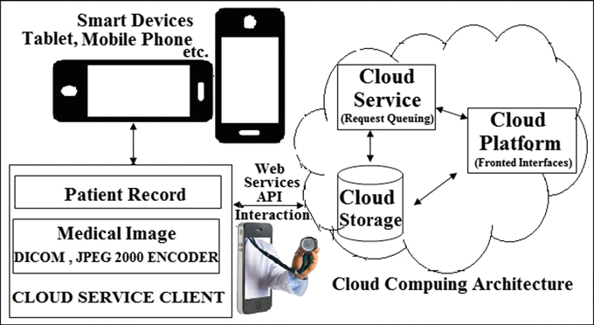

**Figure 10. Smart devices are connected to cloud computing architecture**

The investigational estimation has been accompanied with T mobile phone; it holds Android OS version 8.0. The Health Kit application are assessed with various network kinds like WLAN, 3G and 4G, as illustrated in Table 3, this assessment found that WLAN having less time transfer the information regarding response time in Amazon S3 cloud service.

**Table 4. Medical image transmission using Amazon S3 cloud service**

|  |  |  |  |  |
| --- | --- | --- | --- | --- |
| Image type (encoding) | File size (MB) | Time (size) | | |
| 3G network | 4G network | WLAN network |
| UT | 6.8 | 42.532 | 20.865 | 7.894 |
| CT (uncompressed) | 0.528 | 4.023 | 2.035 | 2.382 |
| CT (JPEG 2000) | 0.102 | 1.223 | 0.985 | 0.892 |
| MR | 0.721 | 9.738 | 4.256 | 3.894 |
| PET | 0.037 | 0.923 | 0.159 | 0.793 |
| Ultrasound | 0.482 | 3.892 | 1.236 | 3.251 |

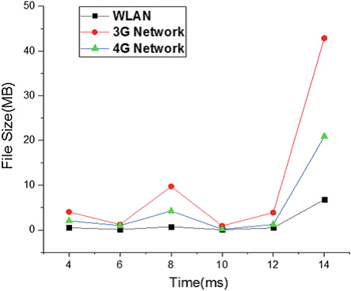

**Figure 11. Effective result on WLAN**

The drawbacks of current works and the positive characteristics among them, therefore, the advantages and disadvantages of the current works in healthcare are demonstrated in Table 5.

**Table 5. Show Merits and Demerits of Related Work.**

| **Related work** | **Merits** | **Demerits** |
| --- | --- | --- |
| M. Somasundaram, S. Gitanjali, T. C. Govardhani, G. Lakshmi Priya and R. Sivakumar, [18]  @ HMS application | 1-Seamless connection to CC  2-Image viewing using Dicom protocol, compressed by the JPEG standard  3-Interface: interface on mobile device  4-Platform: mobile cloud (Eyeos), Android and API (http)  5-Services: Connection to CC storage (e. g., patient health records) Image viewing | 1-Absence of remote consultations  2-No cloud appointment  3-Focus only on the medical imaging  4-Absence of security |
| Vinutha. S, C. K. Raju, Dr. M. Siddappa, [19] @ Ectornic hospital mangement system using vpn connection | 1-present a solution to ensure security  2- Interface: Cloud computing services  3-Platform: Sqllit database paltform, Android & sdk (software development kit  4-services: Connection to CC storage (e. g., patient health records)  Image viewing  Supports multitouch technology  Make mainpulation for medical images more better | 1-Just a prototype  2-Focus only on the medical imaging |
| Jemal. H, Zied. K, Mounir. B Ayed, [21] @MCMAS | Interface: interface on mobile device  Platform: mobile cloud (cloudSim), JADE and Android  Services:  Patient appointment  Remote consultation  Resources allocations  Connection to CC storage (e. g., patient health records)  Image viewing  Patient registration  Medical analysis results viewing | 1-Absence of security evaluation procedure |
| Apurva Kumari, Divyankitha Mahesh Urs, Sindhya Kumari Nellaiappan, Suma Khursheed, [23] @MoC Medicare mobile app | 1-Telemedicine system  2-Homecare management  3-Interface: interface on mobile device Specific connect with fitbit device  4-Platform: JADE and Android, Amazon cloud server.  5-services: sends a notification to a registered emergency contact of the user detect the fall of a user | 1-Specific patient (only monitor patients  with walking steps, sleep time, calories burnt and heart rate  2-Absence of security |
| Suhiar. M. Zeki, Dr. Abdul Monem. S. Rahma, [24]  @ Native Mobile app | 1-Interface: interface on mobile device & Web app  2-Platform: Xamarin Platform, Android & C# lang  3-services: remotely monitoring heartbeat, blood pressure readings | 1-Specific patient (only monitor patients with hypertension and remotely monitoring heartbeat)  2-Absence of security |
| Mallikarjuna. B, [17]  @ HealthKit app | 1-Interface: interface on mobile device Specific  2-Platform: JADE and Android, Amazon S3 cloud  3-services: Connection to CC storage (e. g., patient health records)  Image viewing using Dicom protocol, compressed by the JPEG 2000 coding. | 1. Absence of security evaluation procedure 2. Absence of remote consultations 3. No cloud appointment |

**5. Conclusion and Future Work**

Previous studies had shown that the health care system had many advantages for health care providers and patients, and mobile healthcare applications could reduce costs, improved monitoring, and increased efficiency for patients and beneficiaries, which were connected over wireless networks to the Internet, which enabled them to connect to the cloud. Through the use of the Android operating system and the use of the Firebase cloud platform, a free cloud service from Google, after implementing the healthcare system applications, it is expected to give very meaningful, accurate and timely information, as well as improve patient outcomes and provide safety and privacy for medical data on the server side Cloud Computing server.

**References:**

1. USAID, (2012), mHealth Compendium, USA, www.usaid.gov.VETAL WAVE CONSULTING, (2011), mHealth in Ethiopia: Strategies for a New Framework, USA, www.vitalwave.com.
2. Sun, Yongqiang; Wang, Nan; Guo, Xitong and Peng, Zeyu, (2013), UNDERSTANDING THE ACCEPTANCE OF MOBILE HEALTH SERVICES: A COMPARISON AND INTEGRATION OF ALTERNATIVE MODELS, Journal of 888 Electronic Commerce Research (JECR), vol., 14, No. 2, 183, Taiwan, www.jecr.org.
3. IEEE, (2012), Guest Editorial Introduction to the Special Section: 4G Health—The Long-Term Evolution of m-Health, china, www.ieee.org.
4. Leon, Natalie and Schneider, Helen, Medical Research Council of South Africa and University of the Western Cape, (2012), MHealth4CBS IN SOUTH AFRICA: A REVIEW OF THE ROLE OF MOBILE PHONE TECHNOLOGY FOR MONITORING AND EVALUATION OF COMMUNITY BASED HEALTH SERVICES MHealth4CBS IN SOUTH AFRICA, france, www.mrc.ac.za.
5. Istepanian, R.S.H, Good, A, Philip, N, (2013), XIII Mediterranean Conference on Medical and Biological Engineering and Computing 2013, Springer International Publishing, Spain.
6. V.Chan; P.Ray and N. Parameswaran, (2008), Mobile e-Health monitoring: an agent-based approach, IET Commun, Vol., 2, No., 2, 223-230, Australia, www.theiet.org.
7. R. Kamal, Mobile Computing, Oxford University Press, Inc., Oxford, U.K., 2008.
8. L. S. Ashiho, Mobile technology: Evolution from 1G to 4G, Electronics for You, 94–98, 2003.
9. Duffy, T. J. (2012). Programming with mobile applications: Android (TM), iOS, and Windows Phone 7 (1st Edition). Course Technology. Schewick, B. V. (2012). Internet architecture and innovation. The MIT Press.
10. N. Fernando, S. W. Loke, and W. Rahayu, Mobile cloud computing: A survey, Future Generation Computer Systems, 29(1), 84–106, 2013.
11. E. E. Marinelli, Hyrax: Cloud computing on mobile devices using MapReduce, Defense Technical Information Center, Ft. Belvoir, VA, 2009.
12. R. Buyya, C. Vecchiola, and S. T. Selvi, Mastering Cloud Computing, Tata McGraw-Hill Education, New Delhi, India, 2013.
13. J. Voas and J. Zhang, Cloud computing: New wine or just a new bottle? IT Professional, 11(2), 15–17, 2009.
14. E. Cuervo, A. Balasubramanian, D. K. Cho, A. Wolman, S. Saroiu, R. Chandra, and P. Bahl, MAUI: Making smartphone last longer with code offload, in Proceedings of the Eighth International Conference on Mobile Systems, Applications, and Services, San Francisco, CA, ACM, pp. 49–62, 2010.
15. http://www.ijera.com/An Overview of Android Operating System and Its Security Features.pdf .
16. Liang, “System Integration for the Android Operating System”, National Taipei University, 2010.
17. B. Mallikarjuna,"Mobile Healthcare Application Development on Android OS in Cloud Computing", in2018, Article in SSRN Electronic Journal · January 2018, pp.93-100.
18. M. Somasundaram, S. Gitanjali, T. C. Govardhani, G. Lakshmi Priya and R. Sivakumar,"Medical Image Data Management System in Mobile Cloud Computing Environment ", in2011, Article in International Conference on Signal, Image Processing and Applications With workshop of ICEEA 2011, pp.11-15.
19. inutha. S, C. K. Raju, Dr. M. Siddappa, " Development of Electronic Hospital Management System utilizing Cloud Computing and ndroid OS using VPN connectionsl," INTERNATIONAL JOURNAL OF SCIENTIFIC & TECHNOLOGY RESEARCH VOLUME 1, ISSUE 6, JULY 2012, pp. 59-61.
20. Charalampos Doukas, Thomas Pliakas, and Ilias Maglogiannis: “Mobile Healthcare Information Management utilizing Cloud Computing and Android OS” in the Proceedings of 32nd Annual International Conference of the IEEE EMBS Buenos Aires, Argentina, August 31 - September 4, 2010.
21. Jemal. H, Zied. K, Mounir. B Ayed.," An enhanced healthcare system in mobile cloud computing environment ", Vietnam J Comput Sci (2016) 3:267–277.
22. Rahul, M., Prince, J.: Study and comparison of various cloud simulators available in the cloud computing. Int. J. Adv. Res. Computer Sci. Softw. Eng. 3(9), 347–350 (2013)
23. Apurva Kumari, Divyankitha Mahesh Urs, Sindhya Kumari Nellaiappan, Suma Khursheed, "Mo C Medicare: An Android based fall detection and health monitoring system for the elderly", in2017, Research in researchgate Electronic Journal • October 2017, pp.1-5.
24. Suhiar. M. Zeki, Dr. Abdul Monem. S. Rahma, "Healthcare System Technology using Smart Phones and Web Apps (Case Study Iraqi Environment)", in2017, I. J. Engineering and Manufacturing, 2017, 3, 1-7.
25. Charalam lampos Doukas "Mobile healthcare information management" 2014.
26. Dinh H. T., Lee C., Nivato D. and Wang P.. (2011). A Survey of Mobile Cloud Computing: Architecture, Applications, and Approaches. *Wireless Communications and Mobile Computing*, p1-38.

5/6/2020