Effect of Intradialytic Aerobic Exercise on C-Reactive Protein for Chronic Kidney Disease Patients
Abdelrahman Salah Abdellah¹; Hany Ezzat Obaya²; Heba Ahmed Abdeen² and Essam kotb abd el latief³ ¹Demonstrator of Physical Therapy for Cardiovascular / Respiratory Disorders and Geriatrics, Faculty of Physical
Therapy, Deraya University, Minya, Egypt
²Assistant Professor of Physical Therapy for Cardiovascular / Respiratory Disorders and Geriatrics, Faculty of Physical Therapy, Cairo University, Egypt
³Lecturer of Internal Medicine, Faculty of Medicine, October 6 University, Egypt

Abstract: Background: Chronic kidney disease (CKD) is the progressive deficiency of renal function for months and years and frequently present with elevation in markers of inflammation especially serum C-Reactive Protein (CRP). CRP may have a clinical prediction for risk of cardiovascular disease (CVD) which is the leading cause of morbidity and mortality in patients with CKD. Aim of the Study: This study was conducted to evaluate the effect of 8 weeks intradialytic aerobic exercise on (CRP) for patients with chronic kidney disease. Subjects and Methods: Forty hemodialysis patients of both sexes with chronic renal failure participated in the study, their age ranged from 55 to 65 years old recruited randomly from hemodialysis unit of October 6 university hospital, Giza, Egypt. They were randomly divided into two groups (A & B). Study group (A) (30 patients) received 3 sessions per week for 2 months of intradialytic aerobic exercise while Control group (B) (10 patients) received only their medical treatment. All patients in both groups were assessed through serum CRP, Blood urea, creatinine lab tests and Borg rating of perceived exertion scale was used to assess functional activity before and after treatment. Results: The results showed that there was significant decrease in CRP, urea levels and significant positive decrease in Borg RPE scale scores in the study group pre and post treatment as compared to control group. Conclusion: Intradialytic aerobic exercise plays an important role in decreasing CRP, Urea and Borg RPE scores for patients on maintenance hemodialysis.
[Abdelrahman Salah Abdellah; Hany Ezzat Obaya; Heba Ahmed Abdeen and Essam kotb abd el latief. Effect of Intradialytic Aerobic Exercise on C-Reactive Protein for Chronic Kidney Disease Patients. N Y Sci J 2020;13(5):36-42]. ISSN 1554-0200 (print); ISSN 2375-723X (online). http://www.sciencepub.net/newyork. 5. doi:10.7537/marsnys130520.05.

Keywords: Intradialytic exercise, Aerobic exercise, Hemodialysis, CRP, CKD, Urea, ESRD.

Introduction
Chronic kidney disease (CKD) refers to the progressive and irreversible decline in renal function and is defined as kidney damage for ≥ 3months based on findings of abnormal structure or function or glomerular filtration rate (GFR) < 60 mL/min/1.73m2 for ≥ 3months with or without evidence kidney damage. There are five different stages of CKD, determined by measuring a patient’s estimated GFR (eGFR). (Dungey et al, 2013).
The numerous etiologies of CKD can be grouped as genetic, glomerular, vascular, and tubule interstitial diseases or due to urinary tract obstruction. Despite the vast number of causes, classification of renal function into the five stages and long-term management are usually similar. (Kumar et al, 2009).
According to 9th Annual Report of The Egyptian Renal Registry provided by Egyptian Society of Nephrology and Transplantation (ESNT), prevalence of end stage renal disease (ESRD) in Egypt raised to 483 patients per million. Mean age is about 49.8 ± 19
years. Males represented 55.2 % while females were about 44.8 %. Only about 4 % of patients are HBV positive while HCV positive patients are about 52.1% (El-Ballat et al, 2019).
Chronic kidney disease (CKD) is an important epidemic and public health problem, which occurs in many countries with an increasing prevalence. Over 50 million people throughout the world are known to have CKD and of these, more than 1 million require renal replacement therapies such as dialysis and renal transplantation. In recent years, the rising incidence of diabetes and hypertension, the most common two causes of CKD, have caused an increase in the prevalence of CKD. (Mohseni et al, 2013).
Hemodialysis (HD) is a replacement therapy used to compensate kidney functions in patients with end stage renal failure (ESRD). It is a process of removing uremic toxins and excess water from the blood. Dialysis may be used in case of acute kidney

function disturbance such as (acute kidney injury and previous acute renal failure), or in case of chronic kidney disease, or end-stage renal disease (Pendse et al, 2007).
Hemodialysis (HD) provides increased opportunities for endotoxin influx, recurrent infections, and immune activation leading to chronic
systemic inflammation. (Betjes, 2013).
End-stage renal disease (ESRD) patients tend to have multiple comorbidities, especially cardiovascular disease, mineral and bone disorder. Inflammation, endothelial dysfunction, and mineral bone disease (MBD) are critical factors contributing to morbidity and mortality in hemodialysis (HD) patients. Physical inactivity is a major factor contributing to chronic inflammation and protein-energy wasting. Consequently, physical inactivity and cardiovascular and bone morbidities can form a vicious cycle in ESRD patients. (Liao et al, 2016).
Chronic low-grade inflammation affects 40% to 50% of people with CKD, it is characterized by elevated levels of inflammation markers and has been associated with malnutrition, cardiovascular disease, and mortality. (Cruz et al, 2018).
Inflammation is a rapid and acute protective response to infection or trauma. Patients with chronic kidney disease frequently present with chronic elevations in markers of inflammation, a condition that appears to be exacerbated by disease progression and onset of hemodialysis. The activation of the complement pathway stimulates the degranulation of mast cells and the release of inflammatory cytokines. This has both local (redness, swelling, heat production, and pain) and systemic consequences (fever) due to changes in local blood flow and the effect of cytokines on the hypothalamus, respectively. Systemic inflammatory cytokines (Interleukin-1 (IL- 1), IL-6, and tumor necrosis factor-alpha (TNF-□) stimulate hepatocytes to secrete the acute-phase protein C-reactive protein (CRP), the most widely used marker of inflammation. Systemic inflammation is interlinked with malnutrition and muscle protein wasting and is implicated in a number of morbidities including cardiovascular disease: the most common cause of mortality in this population. (Dungey et al, 2013).
Apparently, in healthy subjects, higher levels of serum CRP are associated with greater risk of atherosclerosis and cardiovascular complications. The advantages of CRP test are lower cost and availability particularly in developing countries. Serum CRP concentration does not change with the changes in kidney function but in the early stage of kidney disease, serum CRP may be related to serum albumin levels which is affected by inflammatory response. Serum CRP has shown as a strong independent risk
factor for cardiovascular disease. Patients with higher baseline CRP will have significantly a greater risk of coronary artery event one year later. In one study of hemodialysis patients, serum CRP levels greater than
0.6 Mg/dL increased the odds of cardiovascular diseases by 1.73 times. In a study of hemodialysis patients, CRP level determined the outcome more than LDL-cholesterol. Other cytokines alone or in combination with CRP may be also considered for predicting future cardiovascular or non-cardiac complications. (Heidari, B, 2013).
Intradialytic exercises safer during the first 2 hours of the hemodialysis session because, after 2 hours of dialysis, shifting of fluid from the microvasculature to the interstitial during exercise can cause a rapid reduction in relative blood volume with accompanying cardiovascular decompensation which may preclude further exercise. (Shemy et al, 2016).
Exercise has been shown to have benefits on the potential improvements on cardiovascular outcomes, dialysis efficacy, physical function, health-related quality of life, and hs-CRP. There are three alternatives for dialysis patients, including exercise during HD, on non-dialysis days and at home. Among the three alternatives, intradialytic exercise is the most feasible and applicable choice for HD patients: First of all, it doesn’t involve any extra time, for doing exercise and dialysis at the same time. So, it leads to a lower drop-out rate and greater compliance. Second, patients are under the supervision of doctors and machines. Any complications can be detected and treated on the spot. Third, it is possible that intradialytic exercise can increase the solute removal, for exercise may increase the blood flow to muscle, and greater toxic agents can be removed by the dialyzer. (Sheng et al, 2014).
Exercise could enhance the removal of urea and creatinine. However, the mechanism is not entirely clear. It is known that large amounts of urea and creatinine are taken up and stored in low-perfusion tissues such as skeletal muscles, skin, and bones. On the other hand, exercise induces vasodilatation and augments muscle blood flow, therefore enhancing the perfusion between muscle fibers and capillaries. The increased perfusion induced by the exercise lead to a rise in the exchange between the intercellular and intravascular compartments within the skeletal muscles. The increased blood flow that follows exercise activity mobilizes the intramuscular urea and creatinine and transfer them into the systemic circulation and from there and through the HD filter outside the patients' body. It might be also suggested that the vasoconstriction of the nonworking muscles might induce a stronger stimulus, superior or additive to the vasodilatative one, leading to a reduction of the

perfused volume and thus a better/faster solute removal as a consequence. (Giannaki et al, 2011).

Subjects
This study was carried out on 40 patients of both sexes with chronic kidney disease on maintenance hemodialysis were recruited in the study. They were chosen from October 6 university hospital in Giza, Egypt. Their age ranged from 55 to 65 year. This study was conducted from November 2019 to Feburary2020.

Inclusion criteria:
  - Patients age ranged from 55 – 65 years.
  - Patients body mass index (BMI) ranged from 25 - 34.9 (overweight to class I obesity).
  - They were selected from October 6 university hospital.
  - Patients were diagnosed as chronic renal insufficiency on hemodialysis from 3 months at least.
  - They were medically and psychologically stable and have no restrictions to perform aerobic exercises with sufficient cognition and education to understand the requirements of the study.
  - All patients didn't receive any physical programs before they participate in the study.
  - All patients have vascular access through arteriovenous fistula.

Exclusion criteria:
  - All patients were examined by nephrologist to exclude the following criteria:
  - Patient with cardiovascular disorders as a complication of hemodialysis.
  - Disease that affect balance and interfere with aerobic exercises.
  - Patient developing cancer.
  - Inability to comprehend and follow instructions as in dementia or speech problems such as dysphasia. Design of the study:

Study Group (A):
Thirty patients (17 males and 13 females) who received intradialytic aerobic exercise for 30 minutes at the first 2 hours from the dialysis session in addition to medical treatment for 8 weeks.

Control Group (B):
Ten patients (6 males and 4 females). They received only their medical treatment for 8 weeks.

Methods
- Evaluation tools:
  - Serum CRP, blood urea and creatinine levels: a sample of blood was collected to assess the levels of Serum CRP, blood urea and creatinine for both groups A & B before and after treatment using Beckman coulter AU480 analysis system.
  - Weight and height scale: Mechanical TZ height and weight scale was used to determine the subjects’ height and weight to calculate the body mass
index for all participants before the study for the two groups.
  - Borg rating of Perceived Exertion (RPE) scale: was used to measure the level of exertional effort for both groups A & B before and after treatment.

Therapeutic methods:
Aerobic exercise:
Moderate aerobic exercise was applied once daily three times / week for 30-35 minutes in the first 2 hours of dialysis session for all patients participated in group (A) in the form of aerobic cycling exercise on leg ergometer cycle. Before starting aerobic exercise, every patient was instructed briefly and clearly about the nature of exercise and its effect in order to gain their confidence and cooperation through all the period of this study (8 weeks). Participants exercised at a rating of 11-13 on Borg RPE scale, which ranges from 6-20 points. The bicycle load was maintained to achieve an intensity of stress enough to determine a score of exertion between 11 and 13 points, which corresponds to an exercise of “mild” intensity to “quite hard” in this scale. The rotation speed on the bicycle pedal should remain close to 50 rpm within the 30 minutes of exercise in order to achieve a stable exercising intensity. (Henrique et al,2010).

Exercise session for the study group consisted of:
Warm-up phase: The patient started the exercise session with warm-up low intensity exercise at low speed of cycling for 5minutes to allow for conditioning of the body for the exercise.
Active phase: The patient cycled for 20–25min at the level of speed obtained at warm-up phase, after that the speed was increased in increments of nearly one cycle per second until the participant reached an intensity of stress with a score of fatigue between 11 and 13 points, which corresponds to an exercise of “mild” intensity to “quite hard” in Borg scale.
Cooling down phase: Afterward, the speed was decreased to low speed again and the session was terminated with cooling down for 5min as in warming up phase.

Statistical analysis
Descriptive statistics and unpaired t-test were conducted for comparison of subject characteristics between both groups. Chi squared test was conducted for comparison of sex distribution between both groups Normal distribution of data was checked using the Shapiro-Wilk test for all variables. Levene’s test for homogeneity of variances was conducted to test the homogeneity between groups. Unpaired t-test was conducted to compare the mean values of CRP, urea, creatinine and Borg scale between the study and control groups. Paired t-test was conducted for comparison between pre and post treatment in each group. The level of significance for all statistical tests

was set at p < 0.05. All statistical analysis was conducted through the statistical package for social studies (SPSS) version 25 for windows (IBM SPSS, Chicago, IL, USA).

3 - Results
- Subject characteristics:
Table (1) showed the subject characteristics of the study and control groups. There was no significant difference between both groups in the mean age, weight, height and BMI (p > 0.05). There was no significant difference in sex distribution between groups (p = 0.85).

Table 1. Comparison of subject characteristics between study and control groups:
 | Study group | Control group | MD | t- value | p-value
 | x¯± SD | x¯± SD
Age (years) | 58.23 ± 3.6 | 58.4 ± 4.37 | -0.17 | -0.12 | 0.9
Weight (kg) | 80.86 ± 9.84 | 79.9 ± 10.04 | 0.96 | 0.26 | 0.79
Height (cm) | 166.53 ± 5.67 | 165.4 ± 6.61 | 1.13 | 0.52 | 0.6
BMI (kg/m²) | 29.15 ± 3.27 | 29.37 ± 4.66 | -0.22 | -0.16 | 0.87
Females/Males | 13/17 | 4/6 |  |  | 0.85
x̄ , mean; SD, standard deviation; p value, probability value

Effect of treatment CRP, urea, creatinine and Borg scale:
- Within group comparison:
There was a significant decrease in CRP, urea, creatinine and a significant positive decrease in Borg scale scores post treatment compared with that pre treatment in the study group (p > 0.05). In control group there was a significant increase in CRP post treatment compared with that pre treatment (p > 0.001); however, there were no significant change in urea, creatinine and Borg scale post treatment (p > 0.05). (table 2, figure 1,2).

- Between groups comparison:
There was no significant difference in CRP, urea, creatinine and Borg scale between both groups pre- treatment (p > 0.05). Comparison between groups post treatment revealed a significant decrease in CRP, urea and a significant positive decrease in Borg scale scores (for same load pretreatment and overall increase in exertional capacity) of the study group compared with that of the control group (p > 0.05), while there was no significant difference between groups in creatinine post treatment (p > 0.05). (table 2, figure 1,2).

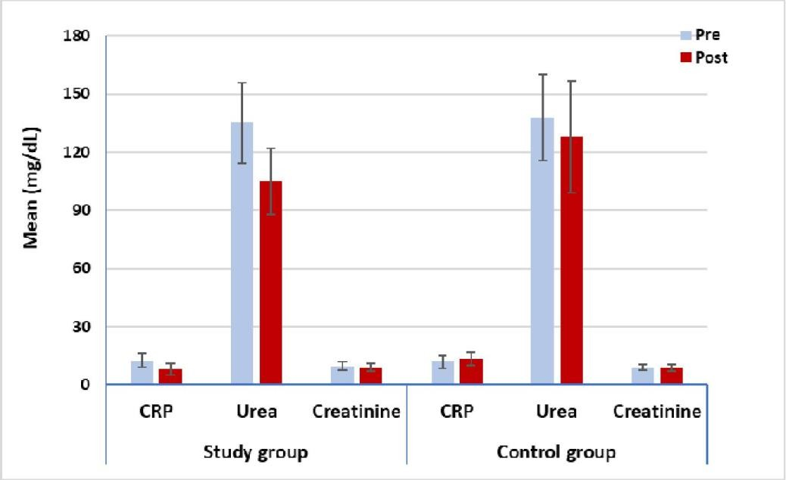

Figure (1): Mean CRP, urea and creatininepre and post treatment of the study and control groups.

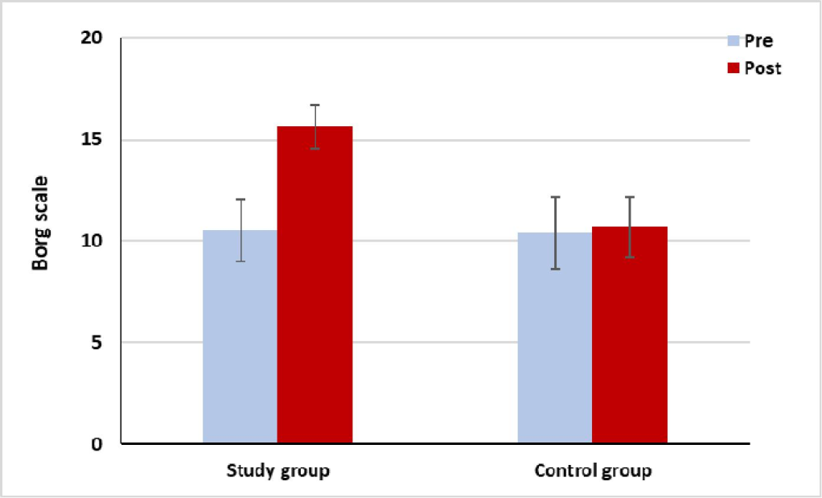
Figure (2). Mean Borg scalepre and post treatment of the study and control groups.

Table 2. Mean CRP, urea, creatinine and Borg scale pre and post treatment of the study and control groups:
 | Study group | Control group
 | x¯± SD | x¯± SD | MD | t- value | p value
CRP (mg/L)
Pre treatment | 12.67 ± 3.66 | 11.85 ± 3.27 | 0.82 | 0.63 | 0.53
Post treatment | 8.03 ± 2.8 | 13.2 ± 3.4 | -5.17 | -4.77 | 0.001*
MD | 4.64 | -1.35
% of change | 36.62 | 11.39
t- value | 8.98 | -5.81
 | p = 0.001* | p = 0.001*
Urea (mg/dL)
Pre treatment | 135 ± 20.84 | 137.7 ± 22.27 | -2.7 | -0.34 | 0.72
Post treatment | 105.03 ± 17.14 | 127.6 ± 28.83 | -22.57 | -2.34 | 0.03*
MD | 29.97 | 10.1
% of change | 22.2 | 7.33
t- value | 9.47 | 1.27
 | p = 0.001* | p = 0.23
Creatinine (mg/dL)
Pre treatment | 9.53 ± 2.22 | 9.11 ± 1.37 | 0.42 | 0.56 | 0.57
Post treatment | 9.05 ± 2 | 8.79 ± 1.86 | 0.26 | 0.37 | 0.71
MD | 0.48 | 0.32
% of change | 5.04 | 3.51
t- value | 2.35 | 0.62
 | p = 0.02* | p = 0.55
Borg scale
Pre treatment | 10.53 ± 1.52 | 10.4 ± 1.07 | 0.13 | 0.25 | 0.8
Post treatment | 15.63 ± 1.77 | 10.7 ± 1.5 | 4.93 | 7.9 | 0.001*
MD | -5.1 | -0.3
% of change | 48.43 | 2.88
t- value | -24.83 | -0.81
 | p = 0.001* | p = 0.43
x¯, mean; SD, standard deviation; MD, mean difference; p-value, probability value; *, significant

Discussion
The purpose of this study was to evaluate the effect of intradialytic aerobic exercise on (CRP) in CKD patients on hemodialysis. Forty adult patients randomly selected from hemodialysis unit of October 6 university hospital in Giza, Egypt. Their age ranged from 55 to 65 years. This study was conducted from November 2019 to February 2020. The participants were assigned into two groups the study group (A) treated by intradialytic aerobic exercise using a cycle ergometer 3 sessions per week for 8 weeks and the control group (B) that only received their medical treatment. All subjects in both groups were evaluated 2 times (pre and post treatment) through CRP, Urea and creatinine lab tests and Borg RPE scale for assessing physical exertion before and after treatment.

The finding of this study showed significant decrease of CRP, Urea levels and Borg RPE scores in the study group compared with the control group post treatment (P>0.05) and there is no significant difference between groups in creatinine post treatment (p > 0.05).
The results of this study were consistent with Fedewa et al (2017) who reported that the cumulative evidence gathered from peer-reviewed research published between 1993 and 2015 indicates that a small but significant decrease in CRP occurs following exercise training.
A recent study that supported the current study by Ting et al (2019) Eleven studies involving 1,250 participants were retrieved from the databases for analysis. The pooled results showed that aerobic exercise significantly reduced inflammatory markers. They concluded that aerobic exercise may have a positive effect on reduction of CRP, TNF-α, and IL-6 in middle-aged and older adults.
Another study agreed with this study by Dong et al (2019) who showed that CRP level in the intervention group was significantly lower than that before the intervention, and the difference was statistically significant. It is indicated that the training movement during dialysis can reduce CRP.
On the other hand, Viana et al (2014) concluded that their results showed no effects of aerobic exercise training on plasma IL-6 and/or CRP levels.
Brown et al (2018) were consistent with this study, they discussed that a significant increase in K urea (dialyzer urea clearance) mL/min was observed during IDE compared with dialysis at rest (5.5% ± 1.9% and 12.4% ± 2.6% increase for intensity of 55%
and 70%, respectively).
Mohseni et al (2013) also was in agreement with this study, they concluded that intradialytic aerobic exercise program resulted in significant improvement
in urea clearance. However, further investigations with larger samples may be required for the intervention to be prescribed as an adjunctive therapy to HD.
A study by Ferreira et al (2019) agreed with this current study, in their systemic review of 23 studies they concluded that aerobic intradialytic exercise may improve the Kt/V-urea (Urea removal) during the dialysis.
The results also in agreement with Afshar et al (2010) who compared the aerobic and resistance exercises to a control group for 8 weeks, and observed that both exercises reduced serum creatinine, with a greater effect of the aerobic exercise.
The results of Parsons et al (2004) contradicted with current study who reported that exercise during dialysis did not enhance removal of serum urea clearance. Alterations in the modality and the timing of exercise during dialysis may be required to elicit increases in serum urea clearance.
Bayoumi, M et al (2015) agreed in their study with this current study, they reported that exercise programs on hemodialysis patients have a positive significant decrease inpatients' Borg scores through the three months of followup.

Conclusion
Intradialytic aerobic exercise plays an important role in decreasing CRP, Urea and Borg RPE scores for patients of CKD on maintenance hemodialysis.

References
- Afshar, R., Shegarfy, L., Shavandi, N., & Sanavi,
S. (2010). Effects of aerobic exercise and resistance training on lipid profiles and inflammation status in patients on maintenance hemodialysis. Indian journal of nephrology, 20(4), 185.
- Bayoumi, M. M., & Al Wakeel, J. S. (2015). Impacts of Exercise programs on Hemodialysis Patients' Quality of Life and Physical Fitness. Quality in primary care, 23(4).
- Betjes MG (2013). Immune cell dysfunction and inflammation inend-stage renal disease. Nat Rev Nephrol 9(5):255–265.
- Brown, P. D. S., Rowed, K., Shearer, J., MacRae,
J. M., & Parker, K. (2018). Impact of intradialytic exercise intensity on urea clearance in hemodialysis patients. Applied Physiology, Nutrition, and Metabolism, 43(1), 101-104.
- Cruz, L. G. D., Zanetti, H. R., Andaki, A. C. R., Mota, G. R. D., Barbosa Neto, O., & Mendes, E.
L. (2018). Intradialytic aerobic training improves inflammatory markers in patients with chronic kidney disease: a randomized clinical trial. Motriz: Revista de EducaçãoFísica, 24(3). Cruz,

L. G. D., Zanetti, H. R., Andaki, A. C. R., Mota,
G. R. D., Barbosa Neto, O., & Mendes, E. L. (2018). Intradialytic aerobic training improves inflammatory markers in patients with chronic kidney disease: a randomized clinical trial. Motriz: Revista de EducaçãoFísica, 24(3).
6. Dong, Z. J., Zhang, H. L., & Yin, L. X. (2019).
Effects of intradialytic resistance exercise on systemic inflammation in maintenance hemodialysis patients with sarcopenia: a randomized controlled trial. International urology and nephrology, 51(8), 1415-1424.
- Dungey, M., Hull, K. L., Smith, A. C., Burton, J. O., & Bishop, N. C. (2013). Inflammatory factors and exercise in chronic kidney disease. International journal of endocrinology, 2013.
- El-Ballat, M. A. F., El-Sayed, M. A., & Emam,
H. K. (2019). Epidemiology of End Stage Renal Disease Patients on Regular Hemodialysis in El- Beheira Governorate, Egypt. The Egyptian Journal of Hospital Medicine, 76(3), 3618-3625.
- Fedewa, M. V., Hathaway, E. D., & Ward- Ritacco, C. L. (2017). Effect of exercise training on C reactive protein: a systematic review and meta-analysis of randomised and non- randomised controlled trials. Br J Sports Med, 51(8), 670-676.
- Ferreira, G. D., Bohlke, M., Correa, C. M., Dias,
E. C., & Orcy, R. B. (2019). Does intradialytic exercise improve removal of solutes by hemodialysis? A systematic review and meta- analysis. Archives of physical medicine and rehabilitation, 100(12), 2371-2380.
- Giannaki, C. D., Stefanidis, I., Karatzaferi, C., Liakos, N., Roka, V., Ntente, I., & Sakkas, G. K. (2011). The effect of prolonged intradialytic exercise in hemodialysis efficiency indices. Asaio Journal, 57(3), 213-218.
- Heidari, B. (2013). C-reactive protein and other markers of inflammation in hemodialysis patients. Caspian journal of internal medicine, 4(1), 611.
- Henrique, D. M., Reboredo Mde, M., Chaoubah, A., & Paula, R. B. (2010). Aerobic exercise improves physical capacity in patients under chronic hemodialysis. Arq Bras Cardiol, 94(6), 823-8.
- Kumar, P., & Kumar, C. M. (2009). Clark’s clinical medicine. Edinburgh: Saunders Elsevier.
- Liao, M. T., Liu, W. C., Lin, F. H., Huang, C. F., Chen, S. Y., Liu, C. C.,... & Wu, C. C. (2016). Intradialytic aerobic cycling exercise alleviates inflammation and improves endothelial progenitor cell count and bone density in hemodialysis patients. Medicine, 95(27).
- Mohseni, R., Zeydi, A. E., Ilali, E., Adib- Hajbaghery, M., & Makhlough, A. (2013). The effect of intradialytic aerobic exercise on dialysis efficacy in hemodialysis patients: a randomized controlled trial. Oman medical journal, 28(5), 345.
- Parsons, T. L., Toffelmire, E. B., & King-Van Vlack, C. E. (2004). The effect of an exercise program during hemodialysis on dialysis efficacy, blood pressure and quality of life in end-stage renal disease (ESRD) patients. Clinical nephrology, 61(4), 261-274.
- Pendse, S., Singh, A., & Zawada, E. (2007). Initiation of dialysis in Handbook of Dialysis, Daugirdas, JT, Blake, PG, Ing, TS.
- Shemy, M. B. E., Elghite Elhossiny Elkazeh, E. A., & Radwa, E. L. (2016). Efficacy of Exercise Program In Intra Hemodialysis On patients' Quality Of Life. Fedewa, M. V., Hathaway, E. D., & Ward-Ritacco, C. L. (2017). Effect of exercise training on C reactive protein: a systematic review and meta-analysis of randomised and non-randomised controlled trials. Br J Sports Med, 51(8), 670-676.
- Sheng, K., Zhang, P., Chen, L., Cheng, J., Wu, C., & Chen, J. (2014). Intradialytic exercise in hemodialysis patients: a systematic review and meta-analysis. American journal of nephrology, 40(5), 478-490.
- TING, Q. P., HUA, Z. G., RUI, X., YING, L. H., ZHAO, Y. B., JING, T., & DIAN, C. L. (2019). Effect of aerobic exercise on inflammatory markers in healthy middle-aged and older adults: a systematic review and meta-analysis of randomized controlled trials. Frontiers in aging neuroscience, 11, 98.
- Viana, J. L., Kosmadakis, G. C., Watson, E. L., Bevington, A., Feehally, J., Bishop, N. C., & Smith, A. C. (2014). Evidence for anti- inflammatory effects of exercise in CKD. Journal of the American Society of Nephrology, 25(9), 2121-2130.

5/6/2020

