Applications Of Laplace Transform To Differential Equations With Discontinuous Functions

Dr. Dinesh Verma

Associate Professor (Mathematics), Department of Applied Science
Yogananda College of Engineering and Technology (YCET), Jammu

Abstract: Most of the problems in different areas of science, engineering and technology are solved by the Laplace transformation method. In this paper, we will apply Laplace transformation method to differential equations with discontinuous functions. Laplace transformation makes it easier to solve the problems and makes differential equations with discontinuous functions simple to solve. This paper presents a new technological approach to solve differential equations with discontinuous functions.
[Dinesh Verma. Applications Of Laplace Transform To Differential Equations With Discontinuous Functions. N Y Sci J 2020;13(5):66-68]. ISSN 1554-0200 (print); ISSN 2375-723X (online). http://www.sciencepub.net/newyork. 9. doi:10.7537/marsnys130520.09.

Key words: Laplace transformation, Differential equations with discontinuous functions.
Sub area: Laplace transformation Broad area: Mathematics

Introduction
Laplace transformation is very useful tool in various areas of engineering and science. It helps us to find the solution of initial value problems involving homogeneous and non- homogeneous equations. It minimizes the problem of solving differential equations to an algebraic problem which becomes much easier to solve. It is very powerful technique, because it replaces operations of calculus by operation of algebra [1, 2, 3, 4, 5, 6,]. In this paper, we apply Laplace transformation method to differential equations with discontinuous functions.
Definition
Let f (t) is a function of t which is well defined for all t ≥ 0. The Laplace transformation [1, 2, 7, 8,] of f (t), denoted by f (p) or L {F (t)}, is defined as
L {F (t)} =, provided that the integral exists, i.e. convergent. The Laplace transformation of some derivatives [3, 4, 5, 6,] is ,
,
And so on.
Problem I: Using Laplace Transformations to solve
Where,
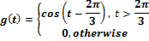
Taking Laplace transformation [1, 2, 7,] on both sides
Or
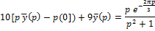
Now,
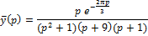
Or
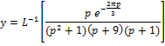
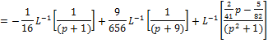
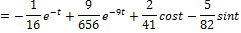
Hence 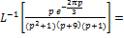
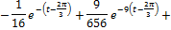
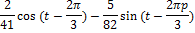

Problem II: Using Laplace Transformations to solve

Taking Laplace transformation [3, 4, 8,] on both sides
Or
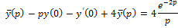
Or
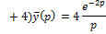
Or
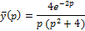
Or
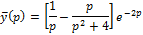
Hence
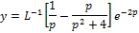
Or
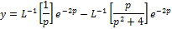
Or
Or
Problem III: Charge on capacitor and initial current is zero to solve for current in LC Circuit if L=1henry, C=1 fared
The differential equation
Solution: We have
Or
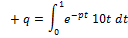
Taking Laplace transformation [6, 9, 10]on both sides
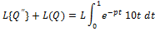
Or
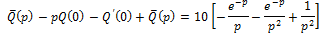
Or
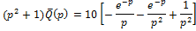
Or
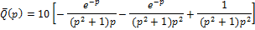
Or
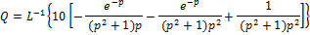
Or

Conclusion:
This paper has presented a new technological approach to solve differential equations with discontinuous functions. It may be finish that this technique is very foremost and accomplished in finding the solution of differential equations with discontinuous functions.

References
- Rohit Gupta, Rahul Gupta, Dinesh Verma, Eigen Energy Values and Eigen Functions of a Particle in an Infinite Square Well Potential by Laplace Transforms, International Journal of Innovative Technology and Exploring Engineering, Volume-8 Issue-3, January 2019.
- Rohit Gupta, Tarun Singhal, Dinesh Verma, Quantum mechanical reflection and transmission coefficients for a particle through a one-dimensional vertical step potential, International Journal of Innovative Technology and Exploring Engineering, Volume-8 Issue-11, September 2019.
- Rahul Gupta, Rohit Gupta, Dinesh Verma, Application of Convolution Method to the Impulsive Response of A Lightly Damped Harmonic Oscillator, International Journal of Scientific Research in Physics and Applied Sciences, Vol.7, Issue.3, pp.173-175, June (2019).
- Rohit Gupta, Rahul Gupta, Dinesh Verma, Laplace Transform Approach for the Heat Dissipation from an Infinite Fin Surface, Global Journal of Engineering Science and Researches, 6(2), February 2019, pp. 96-101. DOI- 10.5281/zenodo.2565939.
- Rohit Gupta, Rahul Gupta, Residue approach to mathematical analysis of the moving coil galvanometer, International Journal of Advanced Trends in Engineering and Technology, Volume 4, Issue 1, 2019.
- . Rahul Gupta, Rohit Gupta, Laplace Transform method for obtaining the temperature distribution and the heat flow along a uniform conducting rod connected between two thermal reservoirs maintained at different temperatures, Pramana Research Journal, Volume 8, Issue 9, 2018, https://pramanaresearch.org.
- N.P. Bali and Dr. Manish Goyal, A Text Book of Engineering Mathematics, 9th edition, 2014.
- Advanced engineering mathematics by H.K. Dass. Edition: Reprint, 2014.
- Advanced Engineering Mathematics by Erwin Kreysig 10th edition, 2014.
- Dr. Dinesh Verma, Engineering Mathematics.

5/16/2020

