SEM Observations on some species of genus PALMULA Lea 1883 (benthic foraminifera) and the Identification of a new genus HANENOPALMULA

Hatem A. Aly

Geology Department, Faculty of Science, Al-Azhar University, Cairo, Egypt
hateem135@yahoo.com

Abstract: The morphological features, inner and outer surface structures, and ultrastructure of the shell walls of Palmulawoodi Nakkady 1950, P. pilulata Cushman, 1938, P. ansaryi Anan 1994, P. suturalis Loetterle 1937, P. mokattamensis and unknown Palmula. sp. Aly et al., 2011 species of genus Palmula Lea 1883 are studied carefully by using a scanning electron microscope (SEM) techniques. The studied specimens of these species of genus Palmula Lea 1883 were collected from Kharga Shale Member (upper part of the Dakhla Shale Formation) early Paleocene at Naqb Refuf, Kharga Oasis, Western Desert; Esna Shale Formation, early Paleocene at the North Gunna section, Western Desert and from El Fashn Formation late middle Eocene at Bayad El Arab section, Beni Suef area, Nile Valley Egypt. The analysisof the examined specimens led to identification of a new benthic foraminiferal genus Hanenopalmula n. gen., of the Family Vaginulinidae Reuss, 1860. The new genus differs from the Palmula Lea 1883 in a number of ways. Its wall structure is made from one solid layer, in which prismatic calcite crystals extends from the inner to the outer surface. The proloculus portion is bullate, rises up to the shell surface. Chambers are coiled around the early stage in an arch-like manner. The widest point is very close to the primordial chambers. Finally, the outer shell surface is smooth and glistening. Furthermore, this study identifies the Hanenopalmula dabbosensis n species. This species differs from the Hanenopalmula woodi Nakkady, Hanenopalmula bignoti Anan 2002 in possessing wide and thick raises suture lines.
[Hatem A. Aly. SEM Observations on some species of genus PALMULA Lea 1883 (benthic foraminifera) and the Identification of a new genus HANENOPALMULA. Researcher 2017;9(5):13-25]. ISSN 1553-9865 (print); ISSN 2163-8950 (online). http://www.sciencepub.net/researcher. 2. doi:10.7537/marsrsj090517.02.

Keywords: Benthic foraminifera, systematic, new genus, Paleocene, Egypt.

1. Introduction
Genus PalmulaLea 1833 is well-known stratigraphically and geographically in Egypt and in different parts of the World. Stratigraphically, genus Palmula has a very long stratigraphic distribution. Loeblich and Tappan 1988 (p. 409) mentioned that the age of genus Palmula is ranging from Paleocene to Middle Miocene. It has been recorded from Lower Cretaceous to Middle Miocene. Holbourn and Kaminski (1995) recorded unknown Palmula species from lower Cretaceousat ODP Site 766 (Leg 123), Indian Ocean; Valchev et al., 2013 recorded Palmula budensis (Hantken, 1875) from upper Eocene to lower Oligocene at Republic of Macedonia.
Geographically, on the other hand, the genus seems to have a wide geographical distribution as well. It was recorded in Egypt by Nakkady (1950); Le Roy (1953); Ansary, (1955); Anan (1994); Aly et al. (2011) and others. Furthermore, it has been recorded from different parts of the World. It was recorded from New Jersey, USA by Rufus Bagg (1898); from Algeria by Dam and Sigal (1950); from Tunisia by Berggren et al. (1974) and Salaj et al. (1976); from Poland by Walkiewicz (1977); from Slovenia by Cimerman et al. (2006); from Macedonia by Valchev et al. (2013) and others. The Palmula woodi Nakkady 1950, Palmula pilulata Cushman 1938 and Frondicularia bignoti Anan 2002 those species under genus Palmula Lea are sufficiently morphologically distinct to warrant assignment to another genus as in (Text-fig. 2). This study proposes a new genus and assigns these Palmula species to this new taxon based on the morphological characters, inner and outer shell structure and shell wall ultrastructure.

2. Studied areas
The foraminiferal samples for this study it has been collected from three different localities in Egypt. The first is North Gunna section. This section is located in Farafra Oasis, Western Desert, about 10 kilometers northeast of Qasr El Farafra, just to the right of the main road (27° 51’ N, 28° 05’ E). The second location is the Bayad El Arab section, Beni Suef area, Nile valley. This section is located along the eastern bank of the Nile Valley, about 20 km northeast of Beni Suef City and about 110 km southeast of Cairo (29° 05’ N, 31° 15’ E). The third location is Naqb Refuf, Kharga Oasis, Western Desert (25° 55’ N, 30° 59’ E)(Text-fig. 1).

3. Material and methods
The specimens selected for this study are twospecimensof Palmulawoodi(Nakkady, 1950) and Palmula pilulata (Cushman, 1938) respectively. These specimens were collected by the current author in 2002 during the field work for his Ph.D. study from North Gunna section, Farafra Oasis, Western Desert (Text-fig. 1). In addition, three specimens from each of Palmula suturalis Loetterle 1937, Palmula ansaryi Anan 1994, Palmula mokattamensis Tadros, 1968 and unknown Palmula sp. Aly et al., 2011were selected from Northeast, Beni Suef, Nile Valley. Furthermore, two specimens of Palmula woodi Nakkady, 1950 from, Naqb Refuf, Kharga Oasis, Western Desert, Egypt were kindly provided by Professor Dr. Hewaidy, to whom the author is deeply thankful, were selected for further comparisons. One specimen from each species that mentioned above to use in this study was broken for a detailed examination ofthe inner and outer shell structure. Observation on the shell and wall ultrastructure of the studied specimens was carried out under magnifications from 80 to 16000 times by scanning electron microscope suits at both Leeds University, United Kingdom and at the Nuclear Material Authority (NMA), Cairo, Egypt.

4. Results
Genus Palmula was first identified and described by Lea (1833) as being “characterized by palmate shells, with angular striae that are indicates on the interior chambers” (Lea 1883, p. 219, pl. 6, fig. 228). Throughout this period, the literatures are rich by images of species under this genus name, but some of them do not carry out the same morphological characteristics as Lea’s description. The following paragraphs will introduce some of these forms to answer this question: how much that forms are concerned with the original description of Lea 1883.
Lea 1833 described a Palmula sagittaria as a new species that is characterized by depressed shell, being rounded on the edges, with six angular striae, and sublabiate oval aperture (Text-fig.2; 1a, b). Unfortunately, the figure of this species in Lea’s work is not clear. The present author made several attempts to track the holotype in USA museum depositories for further examination but none of these attempts was successful.
Nakkady (1950, p. 684) identified Palmula woodi as a new species that is characterized by its compressed test, coiled an early stage with rises above the general level of test (Text-fig. 2; 3). This species differs from Lea’s form in its having arched chambers in adult stage and its widest point closer to the proloculus portion. Nakkady (p. 685), also defined Palmula undulata (Text-fig. 2; 4) which differs from the Palmula sagittaria in having an inflated test with about 8 chambers in an early stage, which represents about half or slightly more of thetest size. Nakkady demonstrated that the test of this latter species is slightly arched and characterized by highly curved sutures in its early stage, the possession of 2-3 chambers in its latest stage, and radiate, terminal, and short necked aperture.
Loeblich and Tappan (1988, p. 409) considered the Palmula sagittaria Lea (Text-fig. 2; 2a-1c) a type species for the Palmula genus. They described that type species as a large, elongate test; flattened; with planispiral at an early stage with an uncoiled and rectilinear later portion. They described the chambers of their species as being broad and low strongly arched or chevron shaped. This species differs from the P. sagittaria Lea in its early stage is planispiral, elongated and contains on about 12 chambers. Its dimension is not the same and has no neck. Adult stage is rectilinear shape.
Anan (1994, p. 222) identified Palmula ansaryi (Text-fig. 2; 6) as a new species and indicated that its maximum height and width is exhibited in the uniserial stage. This form differs from Lea’s Palmula in its widest point is closer to the proloculus portion and its periphery is lobulate in early stage.
Anan 2002 attributed some of Palmula species to the genus Frondicularia (e.g., Frondiculariabignoti Anan 2002 (Text-fig. 2; 7); Frondiculariawanneri Nakkady, 1950; Frondicularia nakkadyi Futyan, 1976; and Frondicularia phosphatica Russo, 1934.

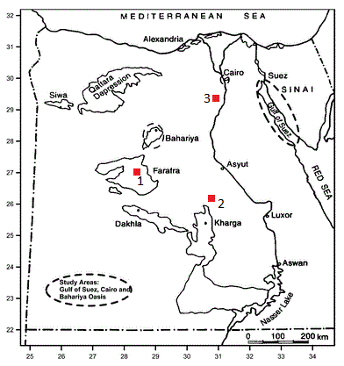
Text-fig. 1: Location map of selected samples; (1) North Gunna section, (2) Naqb Refuf section and (3) Bayad El Arab section.

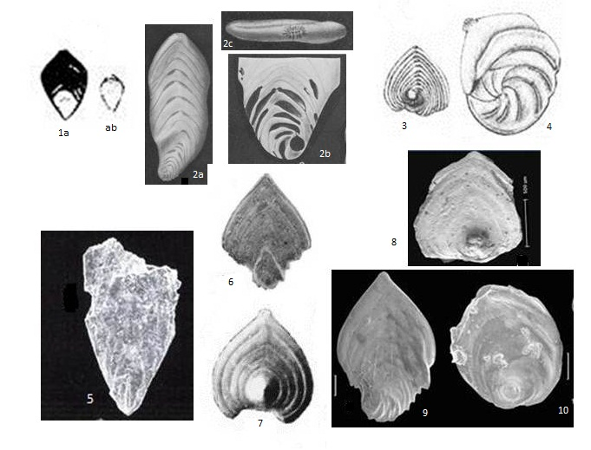
Text-fig. 2: 1 a, b Palmula sagittaria Lea; after (Lea 1833, p. 219, pl. 6, fig. 228) (Diam. l-20th, Length.2, Breadth.1, of an inch.). 2. a-c Palmula sagittaria Lea; after (Loeblich and Tappan 1988, p. 409, pl. 447, figs. 1-3) (2a, b side and apertural view x8 and 2c early stage view x20). 3. Palmula woodi Nakkady; after (Nakkady 1950, p. 684, pl. 89, fig. 24) (x6.8). 4. Palmula undulate Nakkady; after (Nakkady 1950, p. 685, pl. 89, fig. 25) (x42). 5. Palmula bundensis (Hantken); after (Horvath 2003, p. 18, pl. 4, fig. 7) (x98). 6. Palmula ansaryi Anan; after (Anan 1994, p. 222, fig. 8/14-15). 7. Frondicularia bignoti Anan; after (Anan 2010, p. 29, pl. 1, fig. 7) (x50). 8. Palmula woodi Nakkady; after (Aly 2007, p. 86, pl. 8, fig. 1). 9. Palmula suturalis Loetterle; after (Aly et al. 2011, p. 94, pl. 3, fig. 12). 10. Palmula pilulata Cushman; after (Aly et al. 2011, p. 94, pl. 3, fig. 11).

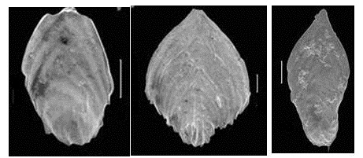
Text-fig. 3: 1 Palmula cushmani (Morrow); after Aly, et al. (2011, p. 94, pl. 3, fig. 9) 2. Palmula ansaryi Anan; after Aly et al. (2011, p. 94, pl. 3, fig. 8). 3. Unknown Palmula sp. after Aly et al. (2011, pl. 3, fig. 14).

The Frondicularia genus is characterized by thickened in the region of the aperture and its sutures are highly arched to angle at the midline of the test (Loeblich & Tappan, 1988, p. 400, pl. 440, figs. 21-23). The Frondicularia bignoti of Anan not thickened in the region of the aperture, also, its proloculus portion is bullate, and rises above the test level.
Horvath (2003, p. 18, pl. 3, fig. 7 and pl. 4, fig. 7) described the Palmula bundensis (Hantken) as strongly flattened test, the proloculus is fusiform followed by a few astacoline chambers and the midline is elevated (Text-fig. 2; 5). This form is broken and differs from the P. sagittaria in its later portion nearly rectilinear, highly perforate and the sutures are raised.
The Palmula woodi Nakkady after Aly (2007, p. 86, pl. 8, fig. 1) is very similar to the Nakkady’s form. Aly et al. (2011, p. 94, pl. 3, figs. 11, 12) they listed two species of genus Palmula with their distinctive morphological features; Palmula suturalisLoetterle (Text-fig. 2; 9) and Palmula pilulata Cushman, 1938 (Text-fig. 2; 10). The former species is characterized by large inflation in its early stage and inverted V shaped chambers in its later stage. The latter species Palmula pilulata Cushman, 1938 is distinguished by highly arched proloculus chambers that are rise above the test and begin and end around the proloculus.
The uncoiled part in (Text-fig, 2; 3,7,8 and 10) is built surrounding and including the proloculus. In other words, the early chamber is representing a nucleolus to the rest of the test. In the other forms, the proloculus is preceding the rest of the test not included in it.

5. Discussions
The morphological differences between the Hanenopalmula new genus and Palmula Lea 1833 can be easily recognized by careful examination of the ultrastructure of their walls and apertures. The studied specimens are differentiated into two morphologically distinctive groups (Text-fig. 2). The first group that is referred to as group A here includes specimens attributable to genus Palmula (Text-fig. 2; 1, 2, 5, 6, 9 and Text-fig. 3; 1-3). Members of this group are characterized by their large, elongated, flattened test with coiled and more inflated early stage. Furthermore chambers in late stage are numerous, 12-18 and of an inverted V shape. Sutures are distinctive and raised. Aperture is terminal and radiate. Outer surface of shells are perforate. The second group, referred to here as group B, includes specimens that are proposed as the new genus Hanenopalmula (Text-fig. 2; 3, 7, 8 and 10). This group is characterized by; palmate, compressed test. Early stage is closed coil, bullate, rising over the level of test. Chambers in late stage are numerous 8-12 arched in shapes. Sutures are narrow and slightly depressed. Outer surface of shells are smooth. Seven morphological features including inner & outer shell surface and the wall ultrastructure are diagnostic features of this genus and will be discussed in details as well. The following paragraphs present a comparison between the most diagnostic features that led to the proposal of the new genus Hanenopalmula.
- Early stage:
One of the most distinct features of genus Palmula is the inflation of an early coiled stage that is rise over the outer surface of the test. Careful examination of these features in group A (Pl. 1, figs. 4, 5) shows that the early stage in group A is wider than in group B and are showing a higher inflation and biconvex (Pl. 2, figs. 3, 4). The transvers section of group A shows that the early stage is planispiral (Text-fig. 4; 1, 2 and Pl. 1, fig. 6), keeled, gradually increasing in size as added (Text-fig. 4, 1, 2). The inner shell surface displays that these early stage consist of 8 interior chambers (Pl. 1, fig. 6), fine to dense perforate (Pl. 1, fig. 5). In contrast, the proloculus chambers in group B are rises over the test and are coiled, bullate and rounded. More details by SEM images of the broken specimens shows that the early part is consists of 2-3 interior chambers; the first chamber is frustule or cavity (Pl. 1, fig. 3); ornamented by 2-3 short and thick straight ribs (Pl. 1, figs. 1 & 2). Under (X645) magnification by ESM on the side view (Pl. 2, fig. 2), it is observed that the overgrowth on the outer shell surface are unequal on both sides. These pores do not seem to have any impact on the internal structure and in inner shell surface that generally retained at smooth texture (Pl. 1, fig. 3).
- Test form:
Furthermore, the shape of test in group A is large, elongate, sub rhomboidal in outline, inflated and with a variable position of its widest point from one species to another. This widest point could be located closer to the proloculus (Text-fig. 3; 1 and Pl. 1, fig. 4) to the middle of test (Text-fig. 3; 2) or closer to the apertural margin (Text-fig. 3; 3). In group B, on the other hand the test is palmate, elliptical, compressed and with its widest point on a straight line with the proloculus (Text-fig. 2; 3, 7, 8 and Pl. 1, fig. 1).
- Shape of chambers:
Another diagnostic feature in both of foraminiferal groups of this study is the presence of two types of chambers within the same form; proloculus chambers and uncoiled chambers. In group A the proloculus portion is consist of eight planispiral, curved chambers (Pl. 1, fig. 6). The adult chambers are starting from side and ending on the other side (Text-fig. 3; 1-3). Its shape are inverted V shaped, broadening towards the proloculus and narrowing towards the apertural end (Pl. 1, fig. 4). In group B, on the other hand, the proloculus part is comprised of two or three strongly arched chambers (Pl. 1, fig. 3) that rising above the level of outer shell surface (Pl. 1, figs. 1, 2). The adult chambers are arched and gradually increasing in size as added. It’s beginning and ending is located around the proloculus portion (Text-fig. 2; 3, 7, 8 and10) and (Pl. 1, figs.1, 2).

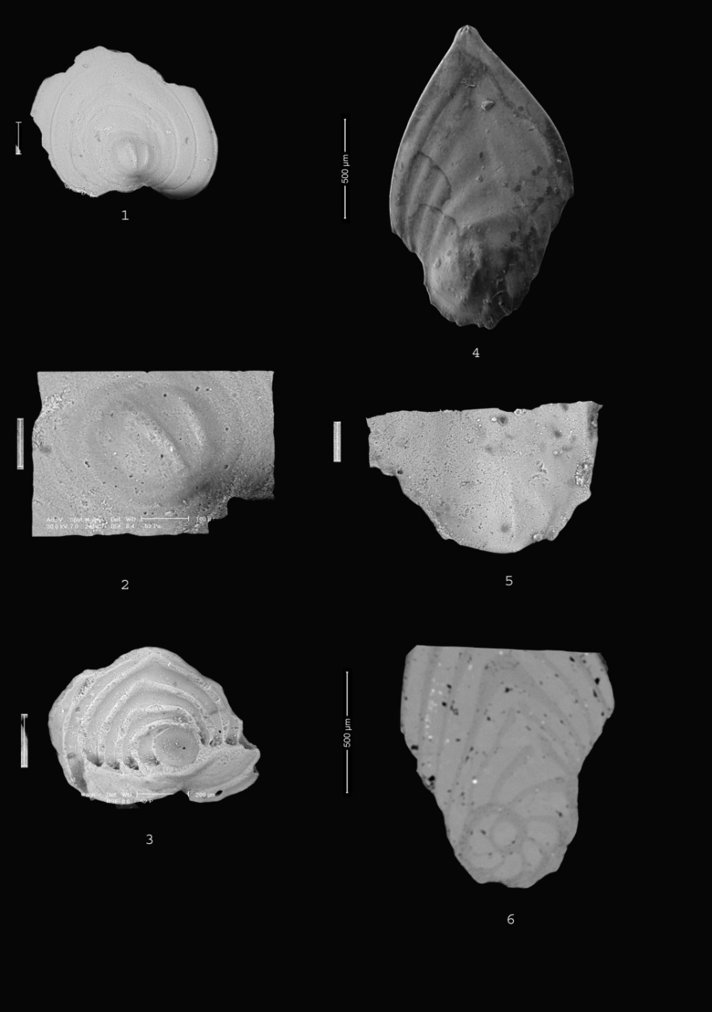
Plate 1
Fig.
- Outer view of the whole shell of Hanenopalmula woodi Nakkady, 1950. Dakhla Formation, Kharga Oasis. Paleocene age. (X 80).
- Early stage of Hanenopalmula woodi Nakkady, enlarged(X 241); note, the hole presumably made by some predator.
- Internal structure of Hanenopalmula woodiNakkady enlarged (X 80); note the inner aperture in proloculus chambers and in latest chambers.
- Outer view of the whole shell of Palmula suturalis Loetterle, 1937. El Fashn Formation, Beni Suef area. Late middle Eocene age (X168).
- Early stage of Fig. 4 enlarged (X 190); note, the raised sutures and wall perforate.
- Thin section of unknown Palmula Aly, 2011; note, the early stage is planispiral and some pores was presumably made by some predators.

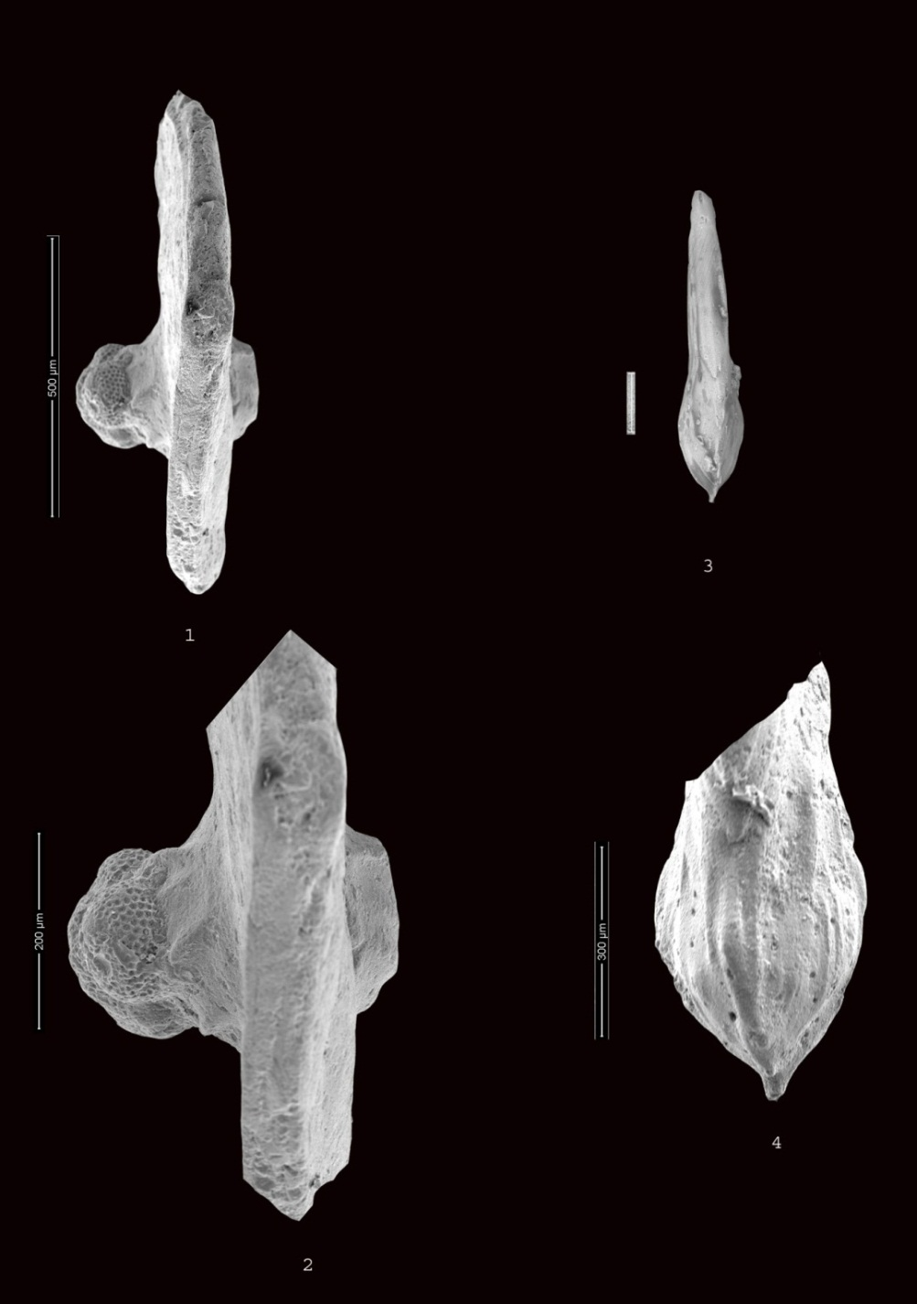
Plate 2
Fig.
- Lateral view of Hanenopalmula woodi Nakkady, (X367); note, the proloculus chambers are rise up the test level and the size of the test is uniform.
- Enlarged of Hanenopalmula woodi Nakkady (X645), note, the some planktic might be attached on the shell.
- Lateral view of Palmula suturalis Loetterle, 1937; showing the periphery of early stage is keeled.
- The early stage of figure 3 enlarged (X718); showing its biconvex, keeled and the perforate of wall shell.

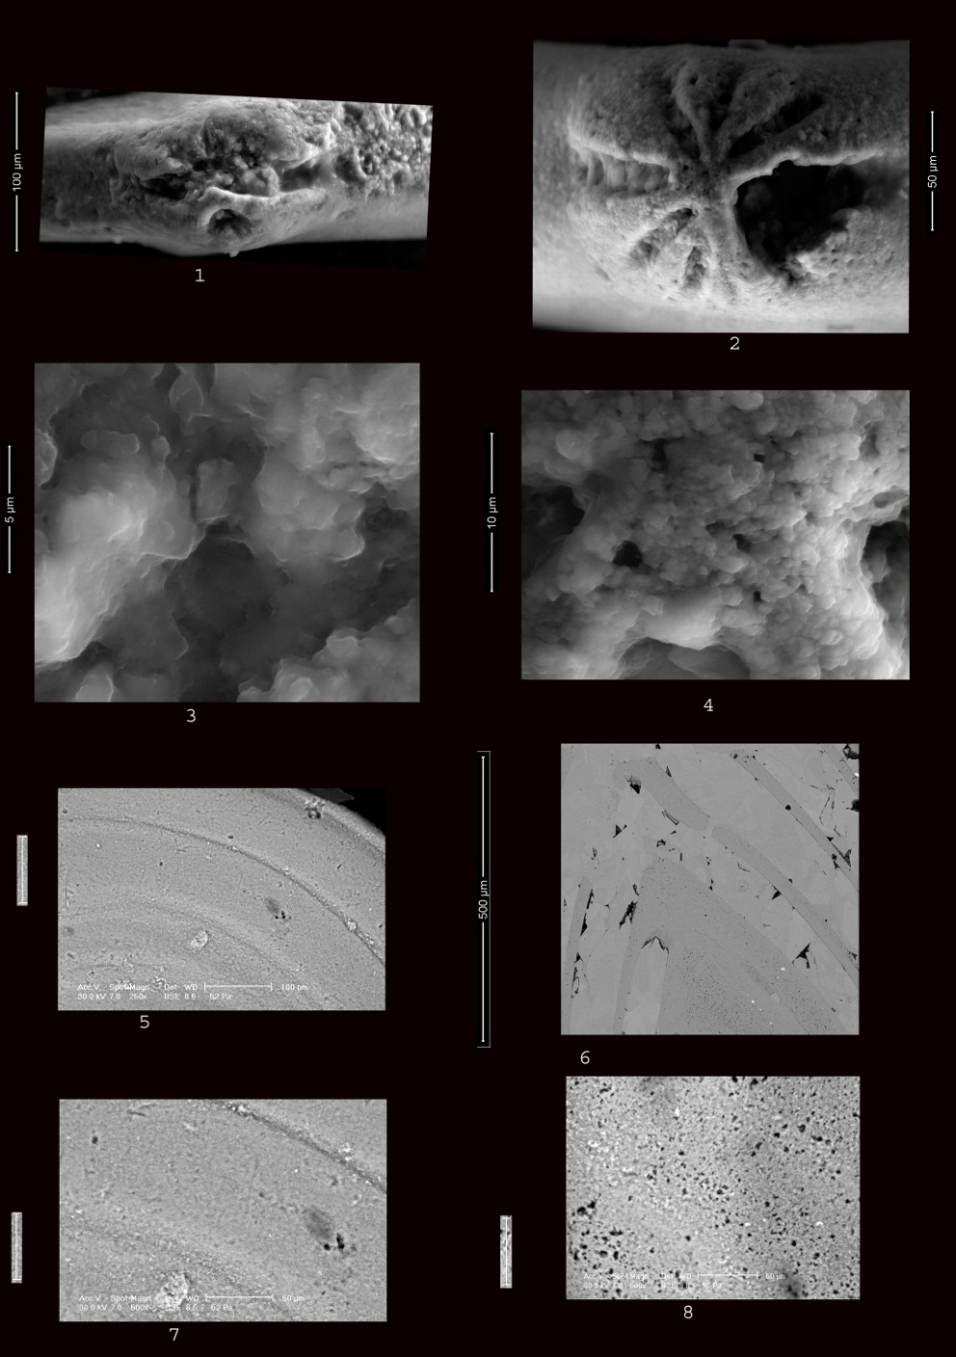
Plate 3
Fig.
- Apertural view of Hanenopalmula woodi, Nakkady (X1000).
- Apertural view of Palmula suturalis Loetterle (X1500).
- The same of Fig. 1 enlarged (X16000); note, the pores openings are very rare; it’s hard to see some of them.
- The same of Fig. 2 enlarged (X14000); note, the pores openings are easy to see it.
- Outer surface of Hanenopalmulawoodi Nakkady (X250); note, the shape of sutures is arched.
- Transvers break of the wall of unknown Palmula Aly (X500); note, the shape of chambers and sutures are inverted V shape.
- Enlarged of Fig. 5; note, the outer surface is micro perforate with some pores might be made by some predators (X500).
- Outer surface of Palmula suturalis Loetterle; note, its surface are highly perforate (X500).

- Sutures:
The suture lines in group A sutures are wide, raised and thicker at an early stage, flush to raised at the adult stage in other forms (Text-fig. 2; 9 and Text-fig. 3; 1-3). In group B the sutures are slightly depressed, narrow and arched (Text-fig. 2; 3, 7, 8, 10 and Pl. 3, figs. 5, 7). Inner shell sutures “septa” are raised and thick (Pl. 1, fig. 3 and Pl. 5, fig. 3).
- Wall
The outer wall of the specimens studied in group A is usually seen as having a soother finishing (Text-fig. 3; 1-3 and Pl. 1, fig. 4). Seen under high magnification (x190, x415 and x500), the specimen is highly perforate with irregularly distributed openings of irregular forms (Pl. 1, fig. 5, Pl. 2, fig. 4 and Pl. 3, fig. 6). However, the outer shell surface of group B is smooth (Pl. 3, figs. 4, 5) with some small pseudopores opining are randomly distributed, unequal in size and depth and are irregular in their shape (Pl. 1, figs, 1, 2). The size and position of these openings do not reflect the canaliculi openings (Pl. 5, figs. 1). Some of these pseudopores are seen on the inner surface (Pl. 1, fig. 3), which may have been caused by predators. The inner shell surface of group B is consisting of flatty packed, slight rough sand particles in their shape.
- Aperture
The internal aperture is shifted eccentrically in relation to medial axis of test in the early part, and then moved to the medial axis in following uncoiled stage (Pl. 1, fig. 3).
Wall ultrastructure
Transverse breaks of the wall of both groups A and B (Pl. 4, figs. 1-7 and Pl. 5, figs. 1, 2) and the surface of the inner aperture (Pl. 1, figs. 3, 6) also provide other means of differentiation between these forms. It is apparent that the thickness of shell wall in group A is 169µ (Pl. 4, fig. 5) whereas it is much less in group Bis 62.2µ (Pl. 4, fig. 1). This thickness variation in both groups may indicate that the test of group A is more inflated and in group B is more compressed. The chambers in group A have a semi rounded shape (Pl. 4, fig. 5), while those of group B have elliptical and elongated shape (Pl. 4, figs. 2 & 3). The wall in group A is consisting of thin lamellae of prismatic calcite crystals (Pl. 4, figs. 6 & 7). The calcite crystals are arranged from the inner and outer surfaces inward in two opposite directions, with inner empty spaces that appears as dark holes between the crystals (Pl. 4, fig. 7). These empty spaces are not observed on the inner layer (Pl. 5, fig. 2). The calcite crystals vary in their shape and size between the inner and outer layer. In addition, the calcite crystals on the outer layer are more granular than prismatic (Pl. 5, fig. 2). The wall in group B consists of distinct, long, opaque, radial, calcite crystals that extend from the inner to outer surface of test (Pl. 4, figs. 3, 4). The size of these crystals is volumetric and there is no pore openings observed between the crystals (Pl. 4, figs. 3, 4). Furthermore, additional to there is anorganic inner lining that cover the inner wall (Pl. 4, fig. 4). The inner shell surface of group A is rougher (Pl. 5, fig. 1) than the inner surface in group B (Pl. 5, fig. 2).
The above mentioned discussion indicates that, group A is easily distinguishable from group B because of the variation in their morphological features, the internal structure and wall surface. The author is strongly convinced that features in the group A are typically describing the Palmula Lea 1883 genus and those of group Bis to be regarded as a new genus, Hanenopalmula Aly 2017.
Stratigraphy
The Hanenopalmula Aly 2017 and Palmula Lea 1883 specimens were collected from three different stratigraphic rock units from different localities Kharga Shale Member (upper part of the Dakhla Shale Formation), Esna Shale Formation, and El Fashn Formation.
The Dakhla Shale Formation was measured for this study at Naqb Refuf section, Kharga Oasis. The age of this formation is Maastrichtian-Paleocene (Tantawy, et al. 2001). The Dakhla Formation is divided into three members; Mawhoob Shale Member at the base, Beris Mudstone Mband Kharga ShaleMb at the top (Awad and Ghobrial, 1966). The Dakhla Formation is of the Maastrichtian-early Paleocene age (Tantawy et al. 2001). The Kharga Member is divided into lower and upper parts respectively. The lower part lies above the Beris Mudstone Member of the late Maastrichtian age, below the upper Kharga Shale Member. The studied specimens were collected from the upper part of the Kharga Shale Member at Naqb Refuf, Kharga Oasis. This Member is consists of grey to greenish grey shales, intercalated with calcareous and pebbly.

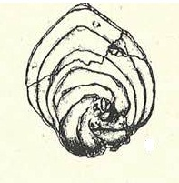
Text-fig. 4: Palmula pilulata Cushman, 1938, after Frizzell 1954, p. 97, pl. 5, figs. 5 &6

Mudstone beds that mark the beginning of early Paleocene (Tantawy et al. 2001). The second stratigraphic unit is the Esna Shale Formation, which is measured from North Gunna section, Farafra Oasis, Western Desert. The Esna Shale Formation is conformably overlying the Tarawan Formation of Paleocene age and underlying unconformably the Oligo-Miocene fresh water stromatolitic limestones. The Esna Shale Formation is 18 m thick and it is made of greyish green shale, in the basal part and dark green papery shale in the top part. This Formation is rich by planktic and benthic foraminiferal content. The third stratigraphic unit is El Fashn Formation that was measured at Bayad El Arab section, Beni Suef area, Nile Valley. El Fashn Formation conformably overlies the Qarara Formation of middle Eocene age and conformably underlies the Beni Suef Formation of upper Eocene age (Aly et al. 2011). The formation in the area is about 28 m thick and is made up of yellowish to greyish white, moderately hard, fossiliferous limestones, intercalated with yellowish white, fossiliferous marls. The limestone is well-bioturbated and contains abundant bivalves and echinoids assemblage near the base. On the basis of planktic and benthic foraminifera, this unit can be assigned to the late middle Eocene (Bartonian) (Abdel-Gaied and Abdel-Aziz 2005).

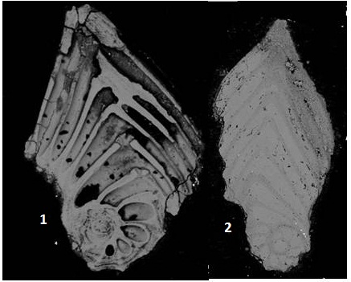

Text-fig.5: Transverse section photographed by SEM show the internal shells structure of Palmula spp.
Taxonomy
The classification of Loeblich and Tappan 1987 are follows here for the rank of genera.
Suborder Lagenina Delage & Hérouarad, 1896.
Superfamily Nodosariacea Ehrenberg, 1838.
Family Vaginulinidae Reuss, 1860.
Subfamily Palmulinae Saidova, 1981.
Genus Hanenopalmula Alyn. gen.
Type species: Palmula woodi Nakkady, 1950.
Etymology: The name is dedicated to Dr. Hanan Awad and Miss Hanin Aly.
Holotype: The specimens illustrated here (plate 5, fig. 4).
Paratype: The specimens illustrated here (plate 5, fig. 5).
Type locality: North Gunna section, Farafra Oasis, Western Desert, Egypt.
Occurrence: Hanenopalmula. genus is abundant in Esna Shale Formation and Paleocene part of the Dakhla Shale formation in Egypt.
Age: Paleocene.
Diagnosis: Test compressed, palmate; proloculus portion bullate; early chambers rises above level of the test; laterchambers arched; widest point very close to the proloculus portion; surface of test smooth; apertural terminal, radiate.

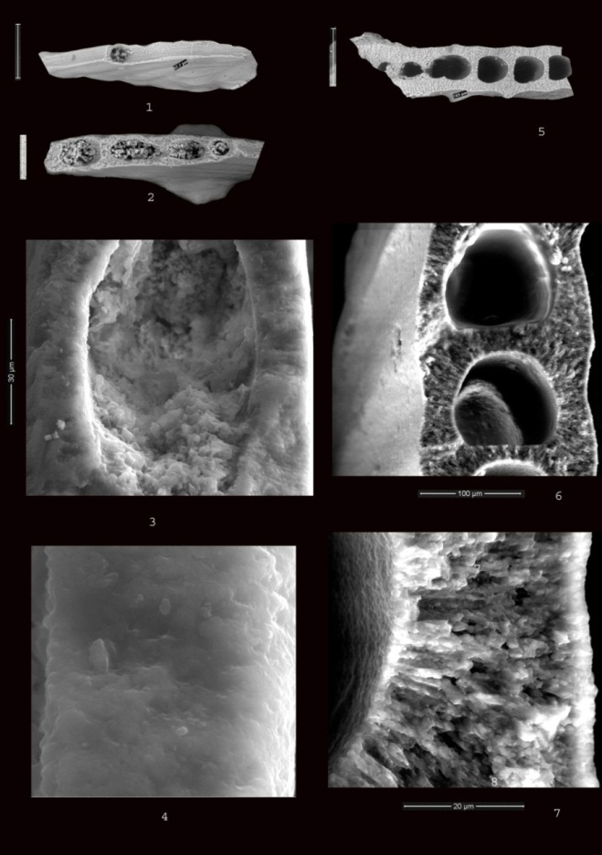
Plate 4
Fig.
- Side view of Hanenopalmula woodi; note, the thickness of the wall is 62.2µ.
- Transverse break of the wall of Fig. 1; note, shape of the internal chambers is elliptical (X253).
- Enlarged of Fig. 1; note, the calcite crystals is volumetric size and the inner chambers are filled out by sediments (X3500).
- Enlarged of one wall layer of Fig. 3; note, the wall is consist of one layer (X14000).
- Transverse break of the wall of Palmula cushmani (Morrow); note, the thickness of the wall is 169µ (X168).
- Transverse break of the wall of Fig. 5; note, the wall is consists of two thin layer (X3500).
- The same of Fig. 6 enlarged; note the prismatic calcite crystals and the pore openings (X6000).
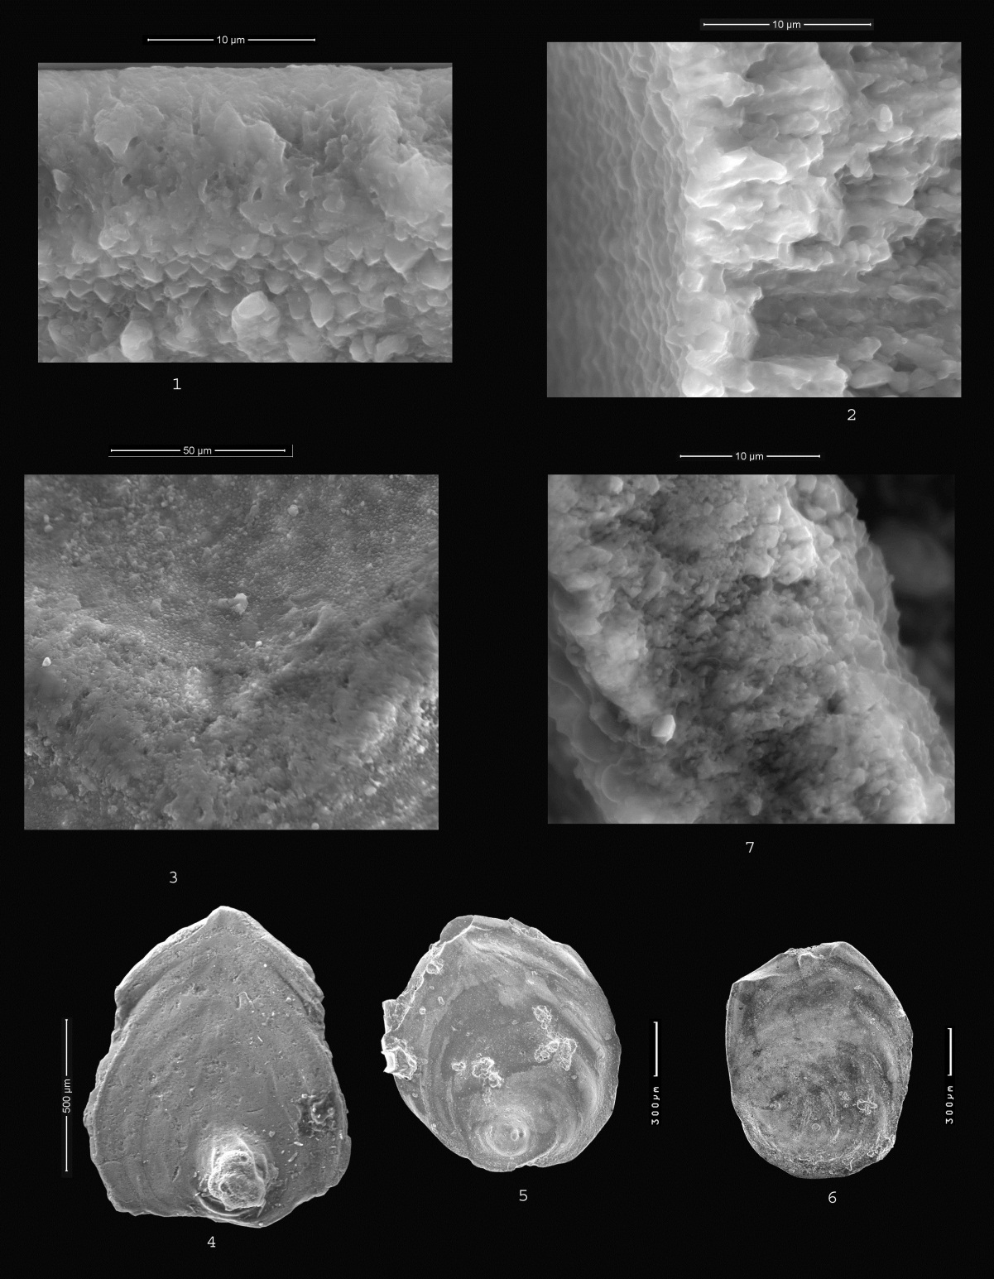
Plate 5
Fig.
- The inner shell surface of Hanenopalmula woodi; note, its rough (X12000).
- The inner shell surface of sample 7, plate 4; showing the inner wall surface is rough but by lesser degree than the Fig. 1(X12000).
- The inner surface of Fig. 1; note, thickness of the septa it’s thick, raised and wide(X2500).
- Hanenopalmula woodi Nakkady, 1950; note, the widest point and the proloculus portion are on the straight line (X218).
- Hanenopalmula dabbousensis Aly, 2017 (X195).
- Para type of Fig. 5 (X 175).
- The inner surface of Palmula cushmani; note, the thickness of septa is raised and wide (X10000).

Description:
Test is palmate or heart-shaped, compressed except in early stage (Pl. 1, figs. 1, 2). Proloculus portion is bullate, rising up the general level of the test (Pl. 1, figs. 1 & 2) and representing a nucleolus to the rest of the test (Text-fig. 2; 3, 7, 8 &10). Later stage is uniserial contains on 12 elongate, arched chambers, gradually increasing in size as added (Pl. 1, fig. 1 and Pl. 5, figs. 4, 5 &6), broading towards the proloculus portion and narrowing towards the apertural end. The beginning and ending chambers in late stage are located around the early chambers (Pl. 1, fig. 1 and Pl. 5, figs. 4, 5 & 6). The widest point is on a straight line with a proloculus part in its position (Pl. 5, fig. 4) or close to its early chambers (Pl. 5, figs. 5 & 6). Sutures at early stage are distinct, raised and straight. Sutures at the uniserial stage raised, wide and arched. The periphery is rounded (Pl. 5, fig. 6). Aperture terminal, radial carried on small neck (Pl. 1, fig. 4). Wall is calcareous, smooth and glistening.

Remarks:
The Hanenopalmula Aly 2017 a new genus differs from Palmula Lea 1883 in possessing compressed, palmate to heart shape test. Early chambers are representing nucleolus to the rest of the test. Chambers in late stage are strongly arched, and its beginning and its ending are located around the proloculus chambers. The widest point is located at an early stage. The wall ultrastructure is consist of one layer of solid, volumetric size calcite crystals, there are no pores opening are observed between the calcite crystals.
Hanenopalmula dabbousensis n. species Aly.
Plate 5, fig. 5 & 6.
Palmula pilulata Cushman, 1938; Aly et al. 2011, pl. 3, fig. 11.
Etymology: in the honor of Dr. Saad Dabbous, Dalhousie University, Canada.
Type species: new species.
Type locality: Beni Suef area, Nile Valley, Egypt.
Type section: Bayad El-Arab section.
Type stratum: El Fashn Formation.
Holotype: Plate 5, figure 5.
Paratype: plate 5, figures 6.
Stratigraphic range: Late Middle Eocene.
Description: Test is rounded and compressed. Early stage growth up on the shell surface, bullate. Surface at early stage is smooth. Uniserial chambers are about seven, rounded and strongly arched. Sutures are thick, wide and raised. Periphery is keeled. Apertural is terminal. Wall calcareous, ornamented by very small nodes and very fine perforate.
Remarks:
This species is differs from other Hanenopalmula spp. In its early stage is smoothly finishing. Surface is ornamented by micro perforate. Uniserial chambers are wide, rounded in shape. The sutures are wider and thicker than other Hanenopalmula spp. Periphery rounded and keeled.
Hanenopalmula woodi (Nakkady 1950).
Plate 5, fig.4.
Palmula woodi Nakkady 1950, p. 1950, p. 684, pl. 89, fig. 24.
Palmula woodi Nakkady 1950; Anan 2010, p. 30, pl. 1, fig. 11.
Description
Test is palmate, compressed broad towards the proloculus portion and narrowing towards the apertural end. Early stage is rising up the general level of the test. Uniserial chambers are about 10, arched and wide. Surface is finely perforate. The widest point is on a straight line with the proloculus portion. Sutures slightly depressed. Aperture is radial and terminal. Wall is calcareous.
Remarks: This species differs from the others Hanenopalmula spp. In its sutures at early stage are rounded and thick. Sutures in late stage are narrow and slightly depressed.

Conclusions
A Scanning Electron Microscope study of Hanenopalmula shells reveals the details of wall ultrastructure and the aperture characters. The shell ultrastructure indicated that the wall is formed of volumetric layer of crystalline calcite crystals. Such an ultrastructure is characterstic of one lamellar. The inner shell surface is rough. The early stage is close and coiled. Uniserial chambers are coiled and arched. The widest point of the shell is very close to the proloculus chambers.

Acknowledgments
The author wish to express his gratitude to Dr. Saad Dabbous, Dalhousie University, Canada, for critically reading the manuscript and for his great help in preparing this paper in its final form and deeply grateful to Professor Dr. Paul Wignall, Leeds University, United Kingdom, for reviewing the manuscript.

References
- Abd El-Gaied, I. M., and Abd El-Aziz, S. M., 2005. Middle and Late Eocene planktonic foraminiferal study of northeast Beni Suef Area, Egypt. The 4th international Conference on the Geology of Africa. Assiut, Egypt. v. 1, p. 657-686.
- Aleksander W., 1977. The genus Palmula and some other rare Nodosariidae (Foraminiferida) from the Korytnica Clays· (Middle Miocene; Holy Cross Mountains, Poland). A ctageologlcapolonica v. 27, n. 2, p. 1-142.
- Aly, H. A. 2007. Biostratigraphical Studies on the Upper Cretaceous-Lower Tertiary Successions in Farafra - Dakhla area, Western Desert, Egypt. Unpublished Ph.D. Thesis, Al Azhar Univ., Cairo, Egypt. 330 pp.
- Aly, H. A., Abd El-Aziz, S. M. and Abd El-Gaied, I. M., 2011. Middle and upper Eocene Benthic foraminifera from Wadi Bayad Elarab-Gebel Homret Shaibon area, norteastern Beni Suef, Nile Valley, Egypt, Egypt. Jour. Paleont., v. 11, p. 79-131.
- Anan H.S., 1994. Benthic foraminifera around Middle/Upper Eocene boundary in Egypt. M.E.R.C. Ain Shams Univ., Earth Sci. Ser., v. 8, p. 210-233.
- Anan, H.S., 2002a. Stratigraphy and paleobiogeography of some Frondiculariinae and Palmulinae benthic foraminiferal general in the Paleocene of Egypt (Misr). N. Jb. Geol. Paleont., Mh., v. 10, p. 629-640.
- Anan, H.S., 2002b. Two new benthic foraminiferal species from the Maastrichtian and Paleocene rocks of northern Egypt. M.E.R.C. Ain Shams Univ., Earth Sci. Ser., v. 16, p. 141-144.
- Anan H.S., 2010. Contribution to the Egyptian benthic foraminifera around the Paleocene/Eocene boundary in Egypt. Egypt. Jour. Paleontol., v. 10, p. 25-47.
- Ansary, S.E., 1955. Report on the foraminiferal fauna from the Upper Eocene of Egypt. Publ. Inst. Desert, Egypt. v.6, 160 pp.
- Awad, G. H. and Ghobrial, M. G., 1966. Zonal Stratigraphy of the Kharga Oasis. - Ministry of Industry, general Egyptian organization for geological research and Mining. Geol. Surv., v. 34, p. 1-77.
- Berggren, W. A., Aubert, I. & Tjalsma, R. C., 1974. Paleocene benthonic foraminiferal biostratigraphy, paleobiogeography and paleoecology of Atlantic-Tethyan regions. Woods Hole, p. 1-186.
- Cimerman, F., Jelen B. and Dragomirs, K., 2006. Late Eocene benthic foraminiferal fauna from clastic sequence of the Socka-Dobrna area and its chronostratigraphic importance (Slovenia). Geologua, v. 49. N. 1, p. 7-44.
- Cushman, J. A., 1938. Cretaceous species of Guembelina and related genera: Contributions from the Cushman Libratory for Foraminiferal Research, v.14, p. 2-28.
- Futyan, A. I., 1976. Late Mesozoic and Early Cenozoic benthic foraminifera from Jordan. Paleont. v. 19, n. 3, p. 517-537.
- Frizzle, D.L., 1954. Handbook of Cretaceous Foraminifera of Texas. Bureau of Economic geology, Univ. of Texas, Report of Investigations n. 22.
- Hantkin, M., 1875. A Clavulina Szaboiretegek Funage, Foraminiferak: Magyar Kir. Foldt. Int. evkonyve, v. 4, p. 1-82, 1-36pls.
- Lea, I., 1833, Contribution to Geology, Carey. Lea and Blanchard (Philadelphia), 227 pp.
- Le Roy, L. W., 1953. Biostratigraphy of the Maqfi section, Egypt. Geol. Soc. Amer., v. 54, p. 1-73, 1-11 pls., 4 figs.
- Loeblich, A. R., JR. and Tappan, H., 1988. Foraminiferal genera and their classification, Van Nosrand Reinhold Co., New York v. 2, p. 1- 970.
- Nakkady, S. E., 1950. A New foraminiferal funa from the Esna shales and Upper Cretaceous Chalk of Egypt: Paleont. v. 24, p. 675-692.
- Bagg, R. M., 1898. Cretaceous Foraminifera. Geol. Surv., U S A, Bulletin 88, p. 1-98.
- Salaj, J., Pozaryska, K. and Szczechura, J., 1978. Foraminiferida zonation and subzonation of the Paleocene of Tunisia. Acta Paleont. Polonica. v. 21, n. 2, p. 127-190, pls. 1-27.
- Tadros, S. F., 1968. “Geologic, Paleontologic and economic studies on some rocks from Mokattam area.” M. Sc. Thesis, Ain Shams Univ., 244 pp.
- Tantawy, A.A., Keller, G., Adatte T., Stinnesbeck, W., Kassab, A. and Schulte, P., 2001. Maastrichtian to Paleocene depositional environment of the Dakhla Formation, Western Desert, Egypt: sedimentology, mineralogy, and integrated micro-and microfossils biostratigraphies. Cretaceous Research v. 22, p. 795-827.
- Valchev, B., Stojanova, V., Juranov, S., 2013. Paleogene hyaline benthic foraminifera (Lagenina and Rotaliina) from the Republic of Macedonia. Review of the Bulgarian Geol. Soci. v. 74 parts 1–3, p. 81–110.
- Walkiewicz, A., 1977. The genus Palmula and some other rare Nodosariidae (Foraminiferida) from the Korytnica Clays (Middle Miocene; Holy Cross Mountains, Poland).

4/26/2017

