**Application of RETC Model in Determining the Hydraulic Functions of the Unsaturated Soil**

Mansour Sorkheh Nezhad1, Saeed Boroomand Nasab2

1Khuzestan Agricultural and Natural Resources Research and Education Center, Ahvaz, Iran

2Irrigation and Drainage Dept. Faculty of Water Sciences Eng. Shahid Chamran Univ, of Ahvaz Iran. Postal:61357-8-3151. Tell: +98 611 3135589, Fax: +98 611 3365670

[m.sorkheh1@gmail.com](mailto:m.sorkheh1@gmail.com)

**Abstract:** In the unsaturated medium soil transfer takes place as liquid or gas with translational motion or diffusion process. Translational motion is resulted by mechanical forces such as gravity and pressure difference and the diffusion induced displacement is caused by the chemical and thermodynamic potential gradient. In other words, the driving force of water in unsaturated soils is the total potential gradient. In the unsaturated state hydraulic conductivity is a function of soil moisture and soil moisture is a function of the metric potential or suction force. Thus the relationship between these two quantities and moisture is not a linear relationship and this non-linearity makes the differential equations governing the unsaturated flow nonlinear the solution of which is not easily possible for any limiting condition. Determining soil unsaturated hydraulic conductivity is time-consuming and expensive in the laboratory and the field. In this study using a number of suction and moisture measurement points, Brooks-Corey model, Van Genuchten’s 5-variable model and fitting these models by RETC software the relationship between suction and volumetric moisture content of the soil as well as the relationship between suction and hydraulic conductivity were determined. Finally, using this software, the comparison is made between the two models. It is observed that Brooks and Corey model has a good fit in the dry section of the soil moisture characteristic curve. Van Genuchten’s model that has been limited by n and m in addition to high R2 coefficient is more appropriate because of estimating a wide range of data and including the entire range of moisture.

[Sorkheh Nezhad M, Boroomand Nasab S. **Application of RETC Model in Determining the Hydraulic Functions of the Unsaturated Soil.** *Researcher* 2017;9(5):54-57]. ISSN 1553-9865 (print); ISSN 2163-8950 (online). <http://www.sciencepub.net/researcher>. 8. doi:[10.7537/marsrsj090517.08](http://www.dx.doi.org/10.7537/marsrsj090517.08).

**Keywords:** Unsaturated zone, diffusion, analytic functions, RETC software, soil moisture characteristic curve (SMC)

**1. Introduction**

Some soil physical properties such as unsaturated hydraulic conductivity as one of the most important characteristics governing the movement and transferring water and solutions within the soil is variable by changing the saturation degree and have no steady state. A plant is able to receive water and nutrients from the soil in unsaturated state. Among the most important environmental parameters of the unsaturated medium are the soil moisture characteristic curve and hydraulic conductivity. To predict the soil moisture characteristic curve’s parameters (θr, θs, Ks, α and n) in RETC Software the Brooks-Corey and Van Genuchten’s models with independent and dependent m and n and including the following two conditions are applied:

A: Mualem model: 

B: Burdine model: 

Van Genuchten offered the following equation to discuss the SMC in the suction range:



The figure obtained by this equation is sigmoid (S Form). In the above equation m and n are the experimental coefficients, θ is the moisture content in the suction h, θs is the saturated moisture percent and α is the reversed air suction. Brooks and Corey proposed the following empirical relationship to describe the relationship between moisture content and matrix potential:



In this model: 

is a coefficient obtained by fitting . The equation has been successful in describing coarse-textured soil moisture characteristic curve and disturbed specimens (with higher) and provides more accurate results in moisture close to the wilting point. But the results show a significant difference at moistures close to saturation and for fine-textured soils with appropriate structure (with lower) compared to the results of field and laboratory studies. The equation predicts the air entering the soil that that occurs during the soil drying as a decisive and sudden point which is not the case. Many equations are presented by scientists to solve this problem one of the most useful ones of which is presented by Van Genuchten. It is worth noting that the above models are true only in the case that the amounts of sand and clay particles vary between 5% - 50% and% - 60% respectively.

B: to estimate the hydraulic conductivity K(θ) and diffusion D(θ) of the unsaturated soils the Van Genuchten- Mualem and Van Genuchten- Burdine models are used:









Table 1. The geometric mean of Van Genuchten experimental values for different textures (adapted from Rawls et al. 1982)

|  |  |  |  |  |  |
| --- | --- | --- | --- | --- | --- |
| Texture |  |  |  | n |  |
| Sand | 0.020 | 0.417 | 0.138 | 1.592 | 504.0 |
| Loamy Sand | 0.035 | 0.401 | 0.115 | 1.474 | 146.6 |
| Sandy loam | 0.041 | 0.412 | 0.068 | 1.322 | 62.16 |
| Loam | 0.027 | 0.434 | 0.090 | 1.220 | 16.32 |
| Silt Loam | 0.015 | 0.486 | 0.048 | 1.211 | 31.68 |
| Sandy Clay Loam | 0.068 | 0.330 | 0.036 | 1.250 | 10.32 |
| Clay Loam | 0.075 | 0.390 | 0.039 | 1.194 | 5.52 |
| Silty Clay Loam | 0.040 | 0.432 | 0.031 | 1.151 | 3.60 |
| Sandy Clay | 0.109 | 0.321 | 0.034 | 1.168 | 2.88 |
| Silty Clay | 0.56 | 0.423 | 0.029 | 1.127 | 2.15 |
| Clay | 0.090 | 0.385 | 0.027 | 1.131 | 1.44 |

Table 2. The geometric mean of Van Genuchten experimental values for different textures (adapted from Carsel and Parrish 1988)

|  |  |  |  |  |  |
| --- | --- | --- | --- | --- | --- |
| Texture |  |  |  | ***n*** |  |
| Sand | 0.045 | 0.43 | 0.145 | 2.68 | 712.8 |
| Loamy Sand | 0.057 | 0.41 | 0.124 | 2.28 | 350.2 |
| Sandy loam | 0.065 | 0.41 | 0.075 | 1.89 | 106.1 |
| Loam | 0.078 | 0.43 | 0.036 | 1.56 | 24.96 |
| Silt | 0.034 | 0.46 | 0.016 | 1.37 | 6.00 |
| Silt Loam | 0.067 | 0.45 | 0.020 | 1.41 | 10.80 |
| Sandy Clay Loam | 0.100 | 0.39 | 0.059 | 1.48 | 31.44 |
| Clay Loam | 0.095 | 0.41 | 0.019 | 1.31 | 6.24 |
| Silty Clay Loam | 0.089 | 0.43 | 0.010 | 1.23 | 1.68 |
| Sandy Clay | 0.100 | 0.38 | 0.027 | 1.23 | 2.88 |
| Silty Clay | 0.070 | 0.36 | 0.005 | 1.09 | 0.48 |
| Clay | 0.068 | 0.38 | 0.008 | 1.09 | 80.4 |

The variables that must be estimated are n, θr, θs, and m. To determine the unsaturated hydraulic conductivity and soil moisture diffusion coefficient in addition to the above factors the variable Ks and L are also entered into the model. Thus the number of potential variables in determining SMC and soil hydraulic functions is 7 that can be fitted by RETC either collectively or individually.

Based on what has been discussed so far when using the RETC computer program, it is necessary to minimize the number of variables to be fitted. One possible way to achieve this goal is to consider θr and l constant. Assuming θr constant is very useful when less data is available about the moisture content near the wilting point. Another solution is to use interdependent m and n; unless the field or experimental data are less scattered and are available in a wide range of metric potential and hydraulic conductivity (in such cases it is better to use independent m and n).

To ensure about the results of RETC computer program it is better to consider all variables as unknown and implement the model by allocating suitable initial values (Tables (1) and (2)) and then determine the correlation between variables using the correlation matrix. If there is a high correlation between two variables, one of them could be considered constant. Usually the correlations between m and n and n and l are higher than the rest of variables that it is possible to consider m constant using m=1-(1/n) (for Mualem model) or m=1-(1/2n) (for Burdine model) and just include n in the equations. In the second case L=0.5(for Mualem model) or L=2 (for Burdine model).

**2. Materials and Methods**

A disturbed sandy loam soil specimen is selected and poured into eight PVC circular cylinders with the length of one meter and a radius of 10 cm in the laboratory. Then using the pressure plate extractor system the results in Table 3 are prepared.

Table 3. The result of *Sandy loam soil*

|  |  |  |
| --- | --- | --- |
| *Sandy loam* | | |
| Metric potential  (cm) | Volumetric  moisture | Hydraulic  Conductivity cm/day |
| 0 | 0.46 | 0 |
| 0 | 0.44 | 0 |
| 0 | 0.42 | 0 |
| 0 | 0.41 | 120 |
| 3 | 0.4 | 110 |
| 10 | 0.38 | 69 |
| 18 | 0.36 | 34 |
| 26 | 0.34 | 19 |
| 34 | 0.32 | 11 |
| 43 | 0.3 | 7.4 |
| 53 | 0.28 | 4.7 |
| 64 | 0.26 | 3.6 |
| 78 | 0.24 | 1.6 |
| 106 | 0.22 | 0.74 |
| 134 | 0.2 | 0.27 |
| 168 | 0.18 | 0.11 |
| 209 | 0.16 | 0.078 |
| 259 | 0.14 | 0.052 |
| 330 | 0.12 | 0.026 |
| 447 | 0.1 | 0.0048 |
| 1255 | 0.08 | 0.00041 |
| 3365 | 0.06 | 0.000067 |
| 6975 | 0.05 | 0.000045 |

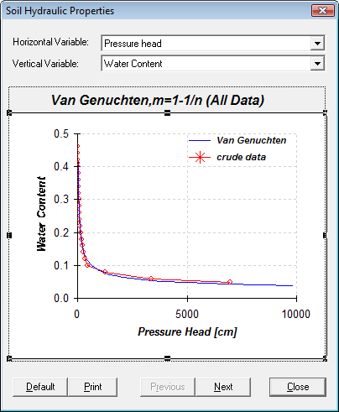

Figure 1. The relationship between suction and moisture ( Van Genuchten, m= 1-(1/n) )



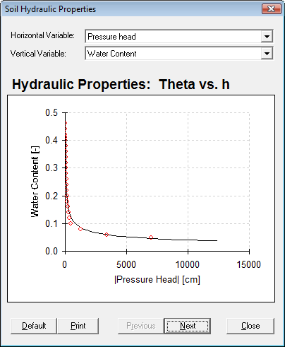

Figure 2. The relationship between suction and moisture (Corey & Brooks )

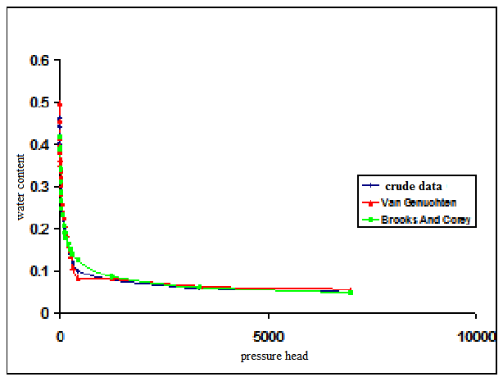

Figure 3. The relationship between water content and suction Van Genuchten, m= 1-(1/n) (Corey & Brooks)

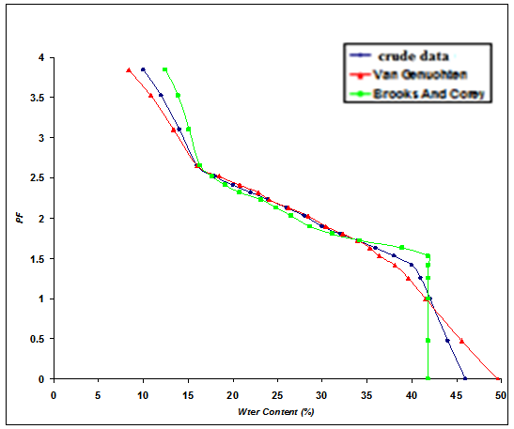

Figure 4. The relationship between hydraulic conductivity and suction Van Genuchten, m= 1-(1/n) (Corey & Brooks)

**3. Results and discussion**

Graphical results obtained from RETC Software for the case that the whole input data is used for fitting is as follows. As it can be observed the RETC Software has been able to present a good fit between the observed and predicted data.

**4. Results and Discussions**

To predict and estimate the hydraulic functions of the unsaturated part of the soil the most well-known models of determining soil moisture characteristic curve and soil unsaturated hydraulic conductivity i.e. Van Genuchten, Brooks and Corey for the SMC and Van Genuchten – Mualem and Van Genuchten- Burdine are presented. To fit these models the RETC software is used. It is observed that this software predicted and simulated the relations between matric potential and the moisture content with an excellent accuracy. RETC It is capable of calculating and predicting soil unsaturated hydraulic conductivity as a function of matric potential under any moisture accurately. Among the above models Brooks and Corey model showed a good fit in the dry section of SMC. Van Genuchten model limited m and n in addition to high R2 coefficient is more appropriate because of estimating a wide range of data and including the entire range of moisture: ( Table 4 ).

Table 4. The result of *between estimate, VG and B & C*

|  |  |  |  |  |  |  |  |
| --- | --- | --- | --- | --- | --- | --- | --- |
| Parameter | qr | qs | Ks | a | n | R2 | SSE |
| estimate | 0.065 | 0.41 | 106.1 | 0.075 | 1.89 | - | - |
| VG, m=1-1/n | 0.01978 | 0.424 | - | 0.038 | 1.5 | 0.991 | 0.0031 |
| B & C | 0.0005 | 0.418 | - | 0.068 | 0.35 | 0.981 | 0.00705 |

**References**

1. Sadeghzadeh, K, Abbasi, F. RETC software package application for analyzing SMC and hydraulic functions, scientific proceedings, technical and Agricultural Engineering,, 1998: 19 - 34.
2. Kashkouli, H.A., Zahrabi, N., Estimation of unsaturated hydraulic functions using RETC software, 2008.
3. Brooks, RH, AT Corey. Hydraulic properties of porous media. Hydrology, Colorado State Univ., Fort Collins, Colorado, 1964: Paper No. 3.
4. Brooks, RH, and AT Corey. Properties of porous media affecting fluid flow. Irrig. Drain. Div. ASCE.92 (IR2), 1966: 61-80.
5. Van Genuchten, M. Th., FJ Leij, SR Yates. The RETC code for quantifying the hydraulic functions of unsaturated soils. Res. Rep, USEPA, Ada, Ok, 1991: 600 2-91 065.

5/17/2017