**The Effect of Leaching in Reducing Salinity and Alkalinity in Parts of the Lands of South of Khuzestan Province**

Sorkheh-Nezhad, M. 1 and Mousavi, S.M.S.2

**1**Khuzestan Agricultural and Natural Resources Research and Education Center, Ahvaz, Iran

2Department of Irrigation and Drainage, Khuzestan Science and Research Branch, Islamic Azad University, Ahvaz, Iran

[m.sorkheh1@gmail.com](mailto:m.sorkheh1@gmail.com)

**Abstract:** In regions such as south of Khuzestan province where the surface of water table is salty and high, due to bullish movement of water through capillary tubes and the evaporation of water, minerals are moved into the earth, causing a brackish or salty and dirty soil. Considering the importance of soil as the best substrate for plant growth, as well as the most important human food supplier, reforming the saline and sodic soils is inevitable. This research was conducted in south of Khuzestan province in Darkhoein of Shadegan city. Source of water salinity and alkalinity of the soil is caused by the advance and retreat of wetland, and also due to the high, water table of the region, caused by rising saline groundwater under the influence of extreme volatility in the region. The aim of this study was to evaluate the impact of flooding intermittent leaching in soil improvement as well as drawing curves of desalination and desodification to determine the leaching of water. Leaching was done in four metal plots with dimensions of 1 × 1 m and carried out according to test and treatment plans. And after reaching the soil moisture of field capacity, sampling was done in depths of 0-25, 25-50, 50-75 and 75-100. Before the test, the three points of the plan were randomly divided into four sampling depths and sent to the laboratory to determine the physical and chemical properties. The results of field tests were analyzed by SPSS statistical software. The result indicates the fact that the results of the exponential equation showed good correlation with the results of field. Finally, using the exponential equations of model we attempt to draw curves of desalination and desodification. The results of sodium varieties of soils show that, for the improvement of the soil there is no need to use a soil amendment and modifying them is possible by using appropriate water.

[Sorkheh-Nezhad, M, Mousavi, S.M.S. **The Effect of Leaching in Reducing Salinity and Alkalinity in Parts of the Lands of South of Khuzestan Province.** *Researcher* 2017;9(5):66-72]. ISSN 1553-9865 (print); ISSN 2163-8950 (online). <http://www.sciencepub.net/researcher>. 11. doi:[10.7537/marsrsj090517.11](http://www.dx.doi.org/10.7537/marsrsj090517.11).

**Keywords**: saline and sodic soils, leaching, desalination, desodification, soil modification, periodic flooding

**1. Introduction**

Every day more lands are under cultivation and the waters are much more restrained. The result is that with the population growth and the expansion of agricultural, natural state of most lands is changed and with being saline and alkaline and the erosion and water logging, they lose productivity. In areas where the water table is salty and high, by the upward movement of water by force of the capillaries and the water evaporation, minerals are moved into the earth causing an alkaline and salty soil. Considering the importance of soil as the best substrate for plant growth, as well as the most important human food supplier, reforming the saline and sodic soils is inevitable. There are important differences in the types of saline-alkaline soils, which makes it impossible to provide a single practical recommendation for reform of the soil. The presence of soluble salts and exchangeable sodium are the fundamental problem of these type of salts. In the current studies using different amounts of water leaching and preparing multiple samples of soil and water, the amount of saline is examined.

So far, many studies were conducted on leaching soils and alkali, but due to large variations of soil properties in different areas, most of the results from other regions, were not directly usable in a specific area, and before using them, regional tests must take place. Fierman and Gardner (1958) in their laboratory studied on leaching in soil columns and came to the conclusion that major leaching is done when soil moisture is less than saturation. Nelson and Baker (1967) also proposed that to raise the efficiency of the leaching of soil, it is better that the moisture is less than saturation. Rio et al (1955) compared different amounts of water by pounding while soil moisture was unsaturated, he concluded that a depth of water is sufficient for leaching the same amount of soil, so that soil salinity is reduced to 80%. In this study, preparation and presentation of data of desalination and leaching of soils in parts of the lands were considered in the south of Khuzestan province, so that based on the result, steps towards the improvement of soils in the area can be taken.

**2. Materials and methods**

This research was conducted in south of Khuzestan in Darkhoein of Shadegan city. Region in terms of climate, was arid and semi-arid, which has long summers and mild winters. The average daily temperature is 24.9 and the warmest month is July with the maximum 51.2 degrees. The average annual rainfall is 161/8 mm, and average evaporation is 3222 mm. To do this research's field tests, the Karun river water was used. According to the saline-alkaline land, heavy textured soils and high groundwater level, the network of primary and secondary drains in this area has been implemented. The results of chemical analysis of water used for leaching is presented in table 1. The water quality was classified and Wilcox graph. According to the classification carried out, the use of such water in agriculture (irrigation) has the risk of high salinity and low sodium. Salinity, is caused by a decrease in water resources due to recent droughts and also according to the place of study area which is in downstream of the Karun River, and lack of attention to issues of water quality in the upper parts of Karun River.

Table 1. characteristics of water chemistry applied in leaching tests

|  |  |  |  |  |  |  |  |  |  |  |  |  |
| --- | --- | --- | --- | --- | --- | --- | --- | --- | --- | --- | --- | --- |
| Classified according to Wilcox chart | SAR | meq/lit | | | | | | | | T.D.S  mg/lit | EC  ds/m | PH |
| Total Anions | Hco3- | Cl- | So42- | Total Cations | Mg2+ | Ca2+ | Na+ |
| C4-S1 | 4.6 | 27.5 | 2.5 | 16 | 9 | 29 | 7 | 9 | 13 | 1572 | 2.37 | 7.3 |

Leaching method applied in this project, is periodic flooding. To plan and implement treatments of leaching, metal plots of 1 × 1 m with height of 50 cm were used. After installing in 15 cm deep in the soil, it formed a square meter plot. After construction of the four plots, each plot was surrounded by piles of earth to a height of 40 cm and a thickness of 30 cm, so that a 2 × 2 m plot was surrounding the metal plot. The plot was used as a protective basin to prevent the penetration of water and non-preferential effect on the test results during the leaching operation. Each protective plot was placed at a distance of 4 km from the other one so they did not impact each other. In the implementation of this method, treatment «A» was done with four replications, and leaching was done with water height of 100 cm for 5 courses (A1, A2, A3, A4 and A5) and 20 cm of water and with a period of 8 days.

The period considered in this case, is the time required for soil moisture to reach from saturated to capacity of the farm, which on experimental basis was 8 days for the soil used in the test. In this time after the disappearance of water from the surface of plot, 2 to 3 days were given to water for penetration, for the moisture to reach the field capacity. The considered depth for leaching of soil was one meter. And accordingly, soil samples were done to a depth of one meter and a depth of 0-25, 25-50, 50-75, and 75-100. To implement the plan, each of the plots for each treatment were given water as the considered depth (20 cm). And at the end of the interval between one period and before the start of the next period, sampling was done from the surface of the plots in four depths.

After each sampling, the sampling area was filled with the soil around and compressed by the cylinder rod, to prevent the possibility of occurrence of preferential flow. Also, it was tried that the next samples are taken as far as possible from this area to minimize the error caused by soil in the sampling place. Sampling was done the end of the interval between the two periods because after watering the plots, there was time for soil moisture distribution and sampling was done after that, so the results were more accurate. During leaching the necessary amount of water was given to protective plots, and it was tried that the water was at same level in model and protective plots. Also, to prevent water evaporation, the plots were covered with nylon sheets. Before starting the project, samples were taken from the soil randomly at three points of depths with a thickness of 25 cm, to a depth of one meter. After preparation of the saturation extract of the samples, physical and chemical characteristics of the soil were measured. Using the measured chemical properties, electrical conductivity (EC), sodium adsorption ratio (SAR) and exchangeable sodium percentage (ESP) of the soil were measured. Four profiles within the scope of testing to depths of 25, 50, 75 and 100 cm, was drilled. From each profile, using the ring pads, four undisturbed samples were taken for measurement of field capacity (FC) and bulk density.

**3. Results and discussions**

The results of measuring salinity values in terms of electrical conductivity (EC) and exchangeable sodium percentage (ESP) before leaching the soil (control) and then from different depths of soil is presented in the table (2). Results are expressed based on an average of four replications. The amount of exchangeable sodium percentage based on the United States Salinity Laboratory is calculated from the following empirical relationship (Alizadeh, 2003).

 (1)

Table 2. Results of chemical analysis of the soil samples (control) and after leaching

|  |  |  |  |  |  |  |  |  |  |
| --- | --- | --- | --- | --- | --- | --- | --- | --- | --- |
| ESP (%) | SAR | meq/lit | | | EC  ds/m | The depth of soil sampling | Functional water height (cm) | Treatment | |
| Mg2+ | Ca2+ | Na+ |
| 62.25 | 112.64 | 131 | 147 | 1328 | 98.60 | 0-25 | 0 | control | |
| 57.24 | 91.62 | 117 | 127 | 1012 | 87.10 | 25-50 |
| 49.31 | 66.80 | 103 | 130 | 721 | 76.30 | 50-75 |
| 50.76 | 70.74 | 87 | 100 | 684 | 69.7 | 75-100 |
| 41.14 | 48.24 | 32 | 85 | 369 | 55.40 | 0-25 | 20 | A1 | A |
| 56.64 | 89.41 | 67 | 100 | 817 | 76.00 | 25-50 |
| 56.69 | 89.59 | 88 | 117 | 907 | 85.90 | 50-75 |
| 56.98 | 90.67 | 70 | 96 | 826 | 77.80 | 75-100 |
| 31.33 | 31.79 | 20 | 47 | 184 | 19.32 | 0-25 | 40 | A2 |
| 47.23 | 61.52 | 40 | 90 | 496 | 46.40 | 25-50 |
| 57.92 | 94.19 | 63 | 150 | 972 | 80.80 | 50-75 |
| 55.35 | 84.91 | 79 | 103 | 810 | 79.10 | 75-100 |
| 18.04 | 15.78 | 18 | 26 | 74 | 9.60 | 0-25 | 60 | A3 |
| 22.87 | 20.95 | 30 | 47 | 130 | 14.90 | 25-50 |
| 44.17 | 54.50 | 38 | 90 | 436 | 52.00 | 50-75 |
| 47.23 | 61.52 | 40 | 90 | 496 | 46.60 | 75-100 |
| 9.8 | 8.22 | 11 | 34 | 39 | 6.92 | 0-25 | 80 | A4 |
| 12.95 | 10.94 | 30 | 45 | 67 | 12.34 | 25-50 |
| 29.25 | 28.88 | 15 | 30 | 137 | 29.80 | 50-75 |
| 41.31 | 48.58 | 38 | 85 | 381 | 37.60 | 75-100 |
| 6.58 | 5.63 | 16 | 30 | 27 | 5.22 | 0-25 | 100 | A5 |
| 7.72 | 6.52 | 50 | 87 | 54 | 8.10 | 25-50 |
| 21.21 | 19.10 | 25 | 45 | 113 | 13.36 | 50-75 |
| 28.97 | 28.51 | 20 | 47 | 165 | 17.58 | 75-100 |

According to United States of America laboratory of soil classification, the soil which was tested is among saline and sodic soils and based on classification of saline and sodic soils in Iran, in terms of salinity, the soil is in Class 4 S (high salinity problem) and in terms of sodium it is in Class 4 A (immense sodium problem). According to leaching periods in the table above, before the leaching the highest electrical conductivity was in a depth of 0-25cm, ie, 98.60 dS/ m, and after application of 100 cm leaching water salinity was reduced to 5.22 dS m. The percentage of exchangeable sodium in the 0-25 layer of soil before leaching was 62.25%, and after 100 cm of leaching water it was reduced to 6.58 percent. The cumulative layers of soil moisture deficit before using water leaching are provided in table (3). It is observed that moisture deficit (up to field capacity) for different layers for total is 13.17 cm to a depth of one meter. Thus, of the 20 cm of water for leaching in the first period, only 6.83 cm(20-13.17 = 6.83) can penetrate into deep water (gravitational) and get out of the bottom of the soil profile to a depth of one meter. This amount is equal to the depth of leaching water or drainage water from a depth of one meter of soil for first leaching. So, in terms of the total 100 cm of water that was applied, 86.83cm (100-13.17=86.83) of it can get out of the soil at one meter and thereby leaching the layers.

Table 3. Analysis of physically different layers of soil and water depth required for the lack of moisture in each layer

|  |  |  |  |  |  |  |  |  |  |
| --- | --- | --- | --- | --- | --- | --- | --- | --- | --- |
| Lack of soil moisture to field capacity (cm) | Weight of soil moisture at field capacity (% FC) | Bulk Density (gr / cm3) | Weight percent of soil moisture content | Layer thickness (cm) | Mechanical analysis of soil | | | | |
| soil pattern | percent | | | Soil depth (cm) |
| Clay | Silt | Sand |
| h=(e-b)*c*a /100 | e | c | b | a |
| 5.76 | 37.14 | 1.46 | 21.35 | 25 | C.L | 33 | 43 | 24 | 0-25 |
| 4.99 | 35.26 | 1.49 | 21.86 | 25 | C.L | 27 | 45 | 28 | 25-50 |
| 1.55 | 26.42 | 1.62 | 22.6 | 25 | Si.L | 13 | 65 | 22 | 50-75 |
| 0.87 | 25.32 | 1.65 | 23.2 | 25 | Si.L | 13 | 63 | 24 | 75-100 |

Data on soil salinity and exchangeable sodium percentage in the depths of 0-25, 0-50, 0-75 and 0-100 cm per application of leaching water depth as a percentage of residual salts after calculating the weighted average is shown in tables (4) and (5).

Table 4. The relationship between the different levels of leaching water depth and changes in remaining soil salinity to the washed soil salinity (percent)

|  |  |  |  |  |  |  |  |
| --- | --- | --- | --- | --- | --- | --- | --- |
| Treatment | Leaching water depth (cm) | exchangeable Salinity percent | Different depths of soil (cm) | | | | Average  ECe |
| 0-25 | 0-50 | 0-75 | 0-100 |
| A1 | 20 | Remaining | 56.19 | 70.76 | 82.94 | 88.96 | 74.71 |
| Washed | 43.81 | 29.24 | 17.06 | 11.04 | 25.29 |
| A2 | 40 | Remaining | 19.59 | 35.39 | 55.93 | 68.02 | 44.73 |
| Washed | 80.41 | 64.61 | 44.07 | 31.98 | 55.27 |
| A3 | 60 | Remaining | 9.74 | 13.19 | 29.20 | 42.54 | 23.67 |
| Washed | 90.26 | 86.81 | 70.80 | 57.46 | 76.33 |
| A4 | 80 | Remaining | 7.02 | 10.37 | 18.73 | 26.12 | 15.56 |
| Washed | 92.98 | 89.63 | 81.27 | 73.88 | 84.44 |
| A5 | 100 | Remaining | 5.29 | 7.17 | 10.18 | 13.34 | 9.00 |
| Washed | 94.74 | 92.83 | 89.82 | 86.66 | 91.00 |
| Average | | Remaining | 19.57 | 27.38 | 39.40 | 47.80 | 33.53 |
| Washed | 80.43 | 72.62 | 60.60 | 52.20 | 66.47 |

Table 5. Relationship between different levels of leaching water depth and changes in exchangeable remaining to washed sodium percentage

|  |  |  |  |  |  |  |  |
| --- | --- | --- | --- | --- | --- | --- | --- |
| Treatment | Leaching water depth (cm) | Exchangeable sodium percentage | Different depths of soil (cm) | | | | Average  ESP |
| 0-25 | 0-50 | 0-75 | 0-100 |
| A1 | 20 | Remaining | 66.10 | 81.82 | 91.51 | 96.31 | 83.93 |
| Washed | 33.90 | 18.18 | 8.49 | 3.69 | 16.07 |
| A2 | 40 | Remaining | 50.34 | 65.74 | 80.85 | 87.37 | 71.07 |
| Washed | 49.66 | 34.26 | 19.15 | 12.63 | 28.93 |
| A3 | 60 | Remaining | 28.98 | 34.23 | 50.40 | 60.26 | 43.47 |
| Washed | 71.02 | 65.77 | 49.60 | 39.74 | 56.53 |
| A4 | 80 | Remaining | 15.75 | 19.04 | 30.80 | 42.50 | 27.02 |
| Washed | 84.25 | 80.96 | 69.20 | 57.50 | 72.98 |
| A5 | 100 | Remaining | 10.57 | 11.97 | 21.04 | 29.37 | 18.24 |
| Washed | 89.43 | 88.03 | 78.96 | 70.63 | 81.76 |
| Average | | Remaining | 34.35 | 42.56 | 54.62 | 63.16 | 48.75 |
| Washed | 65.65 | 57.44 | 45.08 | 36.84 | 51.25 |

Reviewing the table (4) reflects the fact that the application of 100 cm of water, is leaching 94.71, 92.83, 89.82 and 86.66 percent of the initial salinity in the depths. Table 5 indicate that the use of 100 cm of water leads to leaching 89.43, 88.03, 78.96 and 70.63 percent of exchangeable sodium in the related depths. Analysis of the figures resulting from the leaching tests show that the salinity (EC) and exchangeable sodium percentage (ESP) of surface layers (0-25 cm) of soil before leaching is extremely high, and is higher than the bottom layers. This implies the existence of salty and shallow aquifer in the region which due to lack of rainfall and high evaporation of the area, has caused the accumulation of salts in the surface layer of soil. Figure 1 shows the graphs of percentage of reduction in salinity and exchangeable sodium according to the results of Tables (4) and (5) at different depths. Figure 1 reflects the fact that with increasing depth of leaching water, salts, and sodium remaining percentage was lower in the soil and at the depth of 0 -25 it is under the other curves. Based on figure 1, t a depth of 0 -25 cm by adding 20 and 40 cm of water, more than 80 percent of primary minerals were washed. But with rising waters in the next period, a substantial increase in mineral washing is not observed. Therefore, it is necessary to determine the correct depth to wash the salts and then add the amount of water to the soil. Because otherwise, the water is used less than the needed amount for the depths and less leaching occurs and salts and salinity problem may come back. And if the water is used more than then depth it leads to increased costs without significantly reducing its salts. Also in Figure 1 we see that along with 100 cm leaching water to wash salts, sodium washing occurs parallel with the salts. This indicates that there is no need to add the amendment.

In order to determine the exact amount of water required for leaching at different depths of soil profile it required to draw curves of desalination and Desodification. Digits in the table (6) show numbers calculated to draw aforementioned graphs the for tested soil. Balance electrical conductivity values (ECeq) and exchangeable sodium percentage balance (ESPeq) in leaching treatments after applying 100 cm leaching water, was calculated respectively 4.58 and 5.67 percent. In the table below  and  there are the values of the electrical conductivity of the soil, before and after leaching based on (ds / m), and the amount of sodium percentage of the initial and final soil profile, Dw is full depth of leaching water, DS is depth of soil sampling and D lw is Net depth of leaching water. The numbers in figures were analyzed by SPSS 16 statistical software. In this application, with the replacement of ratios of (ECf- Eceq / ECi - ECeq) curve for desalination or ESPf - ESPeq / ESPi - ESPeq) of curve of desodification instead Y (the dependent variable) ratio (Dlw / Ds) instead of X (independent variable), and with fitting the above digits, it was found that in this leaching method, the results of the equation give a better fit with the results of observational desalination and desodification digits.

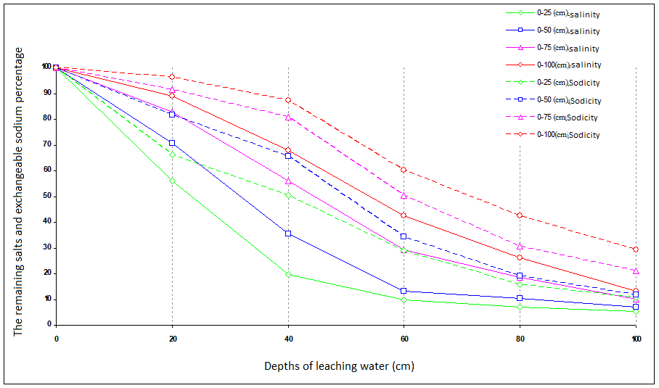

Figure 1. The relationship between the leaching water and remaining salinity and exchangeable sodium in different layers of soil profile

Table 6. Figures for drawing curves of desalination and desodification

|  |  |  |  |  |  |
| --- | --- | --- | --- | --- | --- |
| Depth of sampling of the soil per cm(DS) | Gross depth of leaching water per cm(Dw) | net depth of leaching water per cm(DLw) | DLw/DS |  |  |
| 0-25 | 20 | 14.24 | 0.57 | 0.54 | 0.63 |
| 40 | 34.24 | 1.37 | 0.16 | 0.45 |
| 60 | 54.24 | 2.17 | 0.05 | 0.22 |
| 80 | 74.24 | 2.97 | 0.02 | 0.07 |
| 100 | 94.24 | 3.77 | 0.01 | 0.02 |
| 0-50 | 20 | 9.25 | 0.19 | 0.69 | 0.80 |
| 40 | 29.25 | 0.59 | 0.32 | 0.62 |
| 60 | 49.25 | 0.99 | 0.09 | 0.27 |
| 80 | 69.25 | 1.39 | 0.06 | 0.11 |
| 100 | 89.25 | 1.79 | 0.02 | 0.03 |
| 0-75 | 20 | 7.70 | 0.10 | 0.82 | 0.91 |
| 40 | 27.70 | 0.37 | 0.53 | 0.79 |
| 60 | 47.70 | 0.64 | 0.25 | 0.45 |
| 80 | 67.70 | 0.90 | 0.14 | 0.23 |
| 100 | 87.70 | 1.17 | 0.05 | 0.12 |
| 0-100 | 20 | 6.83 | 0.07 | 0.88 | 0.96 |
| 40 | 26.83 | 0.27 | 0.66 | 0.86 |
| 60 | 46.83 | 0.47 | 0.39 | 0.56 |
| 80 | 66.83 | 0.67 | 0.22 | 0.36 |
| 100 | 86.83 | 0.87 | 0.08 | 0.21 |

So, to draw the curve of desalination and desodification by replacing the variables X and Y, exponential equation was derived as follows.

Desalination equation:

 (2)

Desodification equation:

 (3)

Figures (2) and (3) of curves of desalination and desodification based on the fitting show anexpontential relationship on the data. The process of desalination of desodification in tests carried out show the application of different rates of leaching water in soils of tested area has reduced salinity and led to desodification at a depth of one meter soil profile.

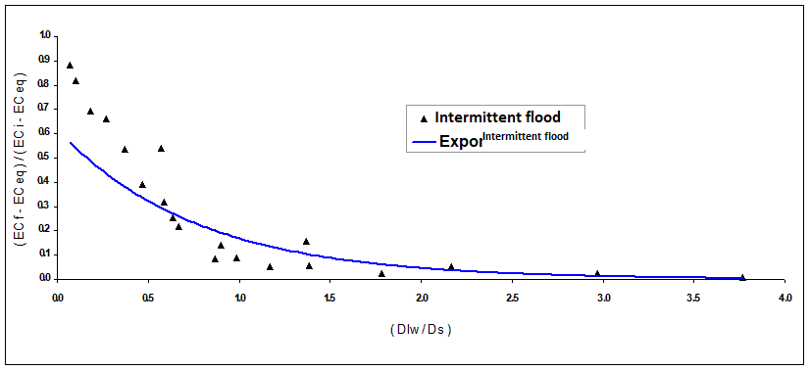

Figure 2. Curve of desalination Figure

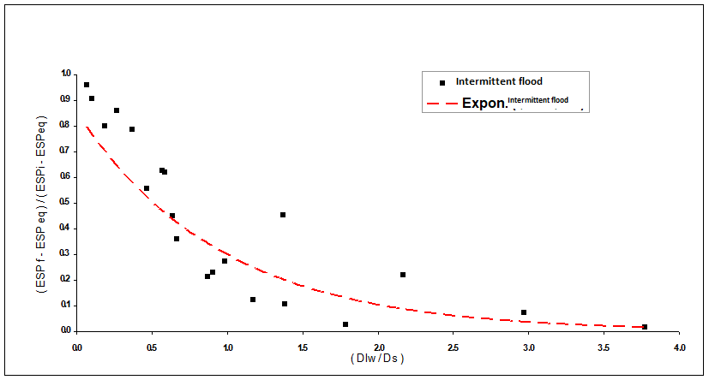

Figure 3. Curves of desodification

**4. Conclusion and Recommendations**

In this research to determine the effects of leaching by intermittent flooding to reduce salinity and alkalinity in parts of the land in Darkhoein in south of Khuzestan, we found that he amount of leaching water with depths of 100 cm has led to leaching 86.66% and 70.63% of salinity and exchangeable sodium of soil profile to a depth of one meter. So that the soil to a depth of 75 cm after the completion of the leaching had low salinity and had no sodium restriction, also at the 75-100 m had low salinity and alkalinity. And if more leaching water were used, restrictions have been removed. Therefore, if enough leaching water is provided and with proper condition of the drainage system, these soils can be modified. And because there are enough sources of calcium in the soil, after leaching of saline and sodic soils we do not face problem of Sodality Soils. And there is no need to use amendments in these soils. According to the estimation by inverse, power and exponential equations, it was found that figures obtained from field tests are a good fit with the results of the exponential equation. On this basis, the curves desalination and desodification were drawn to determine the required amount of water for leaching. Although the results of field tests of leaching are more valid because of the complex relationships between water and soils compared to the results of computer modeling and experimental methods in the study area, but because they are time consuming and costly, it is recommended to review and evaluate reliable computer models and laboratory methods using the results of field tests in each area. For the barren land reform, which has a high initial salinity it is recommended that after the soil salinity decreased to a certain extent (about 10 dS m), to continue land reform operation with salt tolerant plants in the growing season. This makes it possible to do leaching and culturing at the same time and a better use of water resources, because during the latter stages of leaching, the more the salinity of soil is close to the salinity balance in exchange for a certain amount of water, the less minerals are washed from the soil. Also, cultivation of plants develops soil structure and create biological activity in the soil, which is useful in reforming barren soils.

**References:**

1. Afyuni M. Mojtaba pour R. Nurbakhsh F. 1997. Reforming Saline and sodic soils. Printsof jihad Urmia University 0.216 p.

2. Bazr Afkan A.1996. the necessary initial leaching in agricultural land in Haft Tapeh. Thesis in martyr Chamran University.

3. Barzgar A.2008. sodium and salty soil: recognition and application. Martyr Chamran University, first edition, p 0.355.

4. Behzad M.Akhund Ali M.2002. the empirical equations of desalinization of saline soils in the region of Mollasani Khuzestan. Elmi Keshavarzi Journal, 25. Number 1.

5. Biggar J.w, Nilson D.R. 1967. Misible displacement and leaching phenomena. In. Irrigation of agricultural lands. Agronomy 11.254-274.

6. Elias-Azar Kh.2002. Reforming saline and sodic soils (soil and water management). Jihad Urmia University, first edition, p 0.330.

7. Gardner W.R, Fireman M.1958. Laboratory studies of evaporation from soil columns in the presence of a water table. Soil؛ 5:244-249.

8. Kashkouli H, Jalali A. 2009. Evaluation of water required for leaching soils and Sdymybh permanent flooding and intermittent leaching method and compare the results with experimental models in the lands of the southern province. Thesis in Chamran martyr University.

9. Mohsen-Far K.v et al, 2006. l leaching models in the South-East region of Khuzestan province. First Conference on Regional optimal utilization of water resources and river basins Karun. Shahr Kord University.

10. Pazira A, Keshavarz A. 1999. Determining the water needed land reform southeastern province sodium saline soils. Journal of Research in Agricultural Engineering. Print 4. N.6.

11. Reeve M, R.C. pillsbury, A.F, wilcox, L.V.1955. Reclamation of a saline and high boron soilin the coachellavally of California. Univ. Calif. Hilgardia,24:69-91.

5/18/2017