In-Vitro Antibacterial Effect Of Xanthium Strumarium And Combertum Molle On Staphylococcus Aureus And Streptococcous Agalactiae Isolated From Bovine Mastitis

Assefa Belay (DVM) ¹, Ayana Wubie (DVM) ²*

¹Addis Ababa University; College of Veterinary Medicine and Agriculture
² Lecture at Burie Poly Technic College; Department of Animal Health; P.o.box.75;
Email: ayanawb10@gmail.com
*Correspondence for the Author Ayana Wubie (DVM) Lecturer at Burie Poly Tecnic College; Department of Animal Health.

Abstract:-In-vitro antibacterial sensitivity test of selected medicinal plants was conducted at AAU, College of veterinary medicine and agriculture, Debre zeit from December 2013 to May 2014. The study carried out with the objective of determining and comparing of the in-vitro antibacterial effect of ethanol extracts of two medicinal plants; namely, Xanthium strumarium and Combertum molle on three isolations of each S. aureus and S. agalactiae from bovine mastitis cases. The plants for this study were selected based on previous research works and collected from their natural habitats in Debre zeit and Gonder. The leaf of X. strumarium, C. molle leaf and C. molle seed were processed and extracted by 95% ethanol. In these study X. strumarium and C. molle seed had good antibacterial activity on S. aureus and S. agalactiae but C. molle leaf had low antibacterial activity on S. aureus and S. agalactiae. The crude extracts of both plants inhibit the growth of S. aureus and S. agalactiae at all concentration (0.63% to 10%) except C. molle leaf at 0.63% concentration had no antibacterial effect on S. agalactiae. Both type of plants extraction were a dose dependent inhibition zone on the tested bacteria showing greatest activity at highest concentration of crude extracts. A wider zone of inhibition was observed on X. strumarium at all concentration than other extracts. The efficacies of 10% crude extract of X. strumarium and C. molle seed were comparable with conventional antimicrobial agent like Gentamycine. The findings suggest that there is a potential in the discovery of novel antimicrobial agents from medicinal plants and further study should be made in order to identify the active phytochemical constituents and on toxicity of active plant principles to determine their safety use.
[Assefa Belay (DVM), Ayana Wubie (DVM). In-Vitro Antibacterial Effect Of Xanthium Strumarium And Combertum Molle On Staphylococcus Aureus And Streptococcous Agalactiae Isolated From Bovine Mastitis. Rep Opinion 2017;9(5):79-86]. ISSN 1553-9873 (print); ISSN 2375-7205 (online). http://www.sciencepub.net/report. 13. doi:10.7537/marsroj090517.13.

Key words: in-vitro antibacterial effects, crude extracts, medicinal plants, staphylococcus aureus, streptococcus agalactiae, zone of inhibition

1. Introduction
A medicinal plant is any plant which is in one or more of its organ, contains substance that can be used for therapeutic purpose or which is a precursor for synthesis of use full drugs. The plant that posses therapeutic properties or exert beneficial pharmacological effect on the animal body are generally designated as medicinal plants (Edward, 2004).
It is reported that over 50 percent of all modern clinical drugs are natural product origin and natural product play an important role in drug development programs in the pharmaceutical industry (Bharathi et al., 2010).
Many African countries have begun to recognize the use of herbal remedies as important available partners to the conventional health care system (Maccorkl and Mathias, 1992). In Ethiopia, Madagascar and Tanzania practical steps are already being taken to ascertain efficacy and determine optimum dosage for several herbal drugs. As a matter of fact herbal medical care continues to remain the only type of health care for nearly 80 percent of the people and animals in Ethiopia while the remaining 20 percent swing between the modern and the traditional system of health care (Abebe, 1987).
The various literatures available shows that the significant role of medicinal plant in primary health care delivery in Ethiopia where 70% of human and 90% of livestock population. The major reasons why medicinal plant are demanded in Ethiopia are due to culturally linked traditions, the trust the communities have in the medicinal value of traditional medicine and relatively low cost in using them (Endeshaw, 2007).
Mastitis is the inflammation of the mammary gland tissue. Bovine mastitis is a result of complex interactions of infectious agents, the environment and the management practice. It is incriminated as an important disease constraint in dairy cow and is responsible for reduction in quality and quantity of milk and milk products (Radostits et al., 2007). Many pathogens can cause mastitis, but the majority of Intramammary infections is caused by a few bacterial species. The most important major pathogens involved with bovine mastitis worldwide are Staphylococcus aureus, Streptococcus uberis, Streptococcus agalactiae, Streptococcus dysgalactiae, Escherichia coli and Klebsiella spp (Olde Riekerink et al., 2008).
Mastitis is considered to be clinical when inflammation is accompanied with visible alterations of milk or udder gland. Clinical signs of mastitis include clotting and discoloration of milk, redness and swelling of the udder, fever and even death. Mastitis is considered to be subclinical when intramammary infusion is present but no visible signs occur (Schukken et al., 2003; somatic cell counts is used as a diagnostic tool to monitor subclinical mastitis in dairy herd worldwide (Reksen et al., 2008).
Currently, one of the greatest hazards regarding health preservation in human and veterinary medicine is the declining chance of successful anti microbial therapy due to resistance (Salisbury et al., 2002). Antibiotic resistance has become a global problem. Antibiotics have been of value in controlling many infection but they depend on judicious use to minimize the incidence of resistance forms (Danso and Vlas, 2002). Strategies to improve the current situation include research in finding new and innovative anti microbial from plants (Freeman, 1997).
In Ethiopia, traditional healers use a number of plants/herbs for the treatment of bovine mastitis. The efficacies of some of these plants/herbs have been tested against a range of causative agents of mastitis. In-vitro study conducted by Sahle (2002) indicated that Persicaria sengalensis, Cyphostema adenocaule and Cummis ficifolius, have shown some degree of growth inhibitory effect. Markos (2003) screened some herbal preparation against mastitis causing pathogens. Mengistu (2004) has screened six herbal preparations; namely, Brucea antidysentrica, C. molle, Cyphostema adenacuale, Persicaria senegalensis, Plantago lanceolata and Zahneria scabra on major isolates of bovine mastitis. Taddese (2007) has conducted in-vitro tests of c. molle on S. aureus isolate. Mohamedamin (2011) has conducted an in-vitro test of Laggera alata and Xanthium strumarium and also Haile (2012) has conducted an in-vitro test of X. strumarium and Grewia bicolor juss on S. aureus isolate and observed encouraging result. Therefore the current study was to estimate and compare the in-vitro antimicrobial effects of two phytopreparation; namely Xanthium strumarium and Combertum molle on Staphylococcus aureus and streptococcus agalactiae isolated from bovine clinical mastitis case.

2. Materials And Methods
2.1. Study Area
Study of in-vitro antibacterial effect of some selected medicinal plants on bacterial isolates was carried out from December 2013 to May 2014 in Debre zeit, Ethiopia. Debre-Zeit is located 45kms South East of Addis Ababa. The area is located at 9°N latitude and 40°E longitudes at an altitude of 1850 meters above sea level in the central high land of Ethiopia. It has an annual rainfall of 866mm of which 84% is in the long rainy season (June to September). The dry season extends from October to February. The mean annual maximum and minimum temperatures are 26°C and 14°C, respectively with mean relatively humidity of 61.3% (ADARDO, 2007).
2.2. Study Design
An experimental study on in-vitro antimicrobial efficacies on selected plants was conducted between December 2013 and May 2014 in Addis Ababa University, College of veterinary medicine and Agriculture, Debre zeit; Ethiopia.
2.2.1. Herbal material used for the study
Xanthium strumarium (“Cockleba” in Amharic) this is broad leaved, tap rooted herbaceous annual plant. Stems are erect, ridged, rough and hairy, and frequently branched, resulting in somewhat bushy plants from 20-150cm tall. It has small greed unisexual flower occurring in separate cluster at the end of the branches and main stem. The fruit is a brown, hard, woody bur from 0.4 to 0.8 inch long and covered with stout, hooked bristles. Its seeds are produced in a hard, spiny, oval double chambered, single seeded bur. It’s covered with stiff, hooked spines, which sticks to fur and clothing and can be quite difficult to extract. These remarkable burred seeds have allowed this plant to be carried all over the world by uspecting travelers. This plant reproduces only by means of its seed and weed easily dispersed through animals as the fruits have hooked bristles and 2 strong hooked beaks (Agharkar, 1991). The leaves were used to assess the antimicrobial effect on bacteria isolated from mastitis cases.
Combertum molle (“Agalo, Abalo” in Amharic, “Bika, Dadamata” in Oromiffa) this is a member of the family Combertaceae which is small deciduous tree growing up to 15 meters high with an often-crooked trunk, commonly branching to the base. The bark is dark brown to black and deeply grooved in squares. The leaves are oppositely arranged, elliptic to lanceolate, large that covered with soft hairs, rounded at the base. Flowers sweetly scanted, many crowded into greenish. The flowers generally appear before the leaves and the fruits yellowish, four-sided with wings (Mengistu, 2004). The leaves and seeds were used to assess the antimicrobial effect on bacteria isolated from mastitis case.

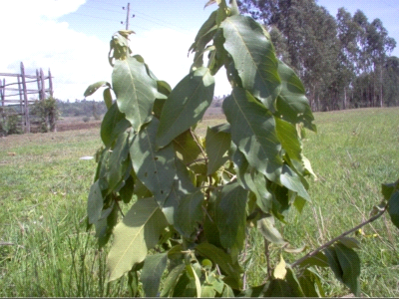

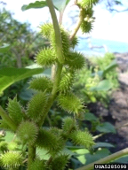
Figure 1: photograph of plants used for the test

a.Combertu molle b. Xanthium strumarium
2.2.2. Bacterial organisms used for the study
Two species of bacteria, S. aureus and S. agalactiae isolated from the clinical mastitis case and representing common bacterial pathogens was used for testing bacteria.
2.3. Study Methodology
2.3.1. Plant collection and pre extraction preparation
The plant was chosen based on the results Reported by previous research works on the leaf of the X. strumariu (Mengistu, 2004) and C. molle (Taddese, 2007) were collected from Debre zeit and Gonder, respectively. After collection, the plants were washed with tap water to remove unnecessary particles. Then air dried under shade and grounded by pestles and wooden mortars. The material was then sieved and weighed before maceration.
2.3.2. Preparation of crude extracts for in-vitro experiment
About 50 gm of each of the powdered herb leaf of X. strumarium and leaf and seed of C. molle were macerated in 95% Ethanol in a separate flask and mixed using manually by hand shacking. After it is allowed to stand for 6 days at room temperature, each sample was strained using a tea strainer to remove solids. The resulting filtrate was further filtered using filter paper to obtain a solution free of solids. The solution was concentrated in a rotary evaporator to remove the ethanol. The plant extracts of the two plants were taken out and put in evaporating dishes and kept in a dry oven at 40⁰C to remove the remaining solvent for 24 hours. The procedure was repeated in the same way to have sufficient amount of extracts. Finally, concentrated extracts were weighed, transferred and labelled with the respective plant names and stored at + 4⁰C until tested for antimicrobial activity.
2.3.3. Preparation of antimicrobial discs from herb extracts
Five serial dilutions with different concentrations (10 %, 5%, 2.5 %, 1.25 and 0.625 %) of each plant (X.strumarium and C.molle) extract were prepared using Dimethylsulfoxide. In the first test tube 2 ml of 10% stocked solution was added and each of the remaining four tubes was filled with 1ml of DMSO. A milliliter of 10% solution from the first tube was transferred to a second test tube to prepare 5%. The procedure continues by transferring 1ml of solution from the 5% preparation to a third test tube to get a 2.5% concentration, and the procedure continued in a similar manner until a 0.625% concentration is reached. Discs of 6mm diameter were impregnated by adding three drops from each reconstituted solution and allowed to dry at 37 ⁰C over night. Dried discs were used to determine antimicrobial effects of the respective plant types. Each disc was gently pressed down to ensure complete contact with the agar and the plates were inverted and incubated at 37 ⁰C for 24 hours. The diameter of zone of inhibition was measured in millimetres.
2.3.4. Preparation of the test bacteria
The bacteria was isolated from bovine mastitis by collecting fresh milk sample aseptically, from the dairy farm to culture on different agar medias to isolate S. aureus and S. agalactiae using primary and secondary biochemical tests. For the current study three well isolated colonies of each bacterium were used.
2.3.5. The in-vitro antimicrobial sensitivity test
The antimicrobial test of ethanol extract was conducted using agar disc diffusion method. Muller-Hinton agar (38gm) (Biotech UK) medium was used for antimicrobial sensitivity test, and was mixed with 1 litter of distilled water boiled to dissolve completely and autoclaved at 121⁰c for 15minutes. Mueller- Hinton agar medium was used and was supplemented with 5% sheep blood for S. agalactiae. Therefore, the agar was prepared by pouring 25 ml in a 90 mm sterile agar plates and left to set. The agar plates were incubated for 24 hrs at 37ºc to confirm their sterility. When no growth occurred after 24 hrs, the plates were considered sterile and used for antimicrobial sensitivity tests.
The three well isolated colonies of the same morphology were scooped using a wire loop from the nutrient agar and mixed using sterile normal saline, and agitated with a vortex mixer. The turbidity of the bacterial suspension was adjusted by comparing with 0.5 McFarland turbidity standards. McFarland turbidity standard was prepared by mixing 0.5ml of 1.175% aqueous solution of barium chloride (0.048 NBCL₂H₂O) with 9.95 ml of 1% sulfuric acid (0.036 NH₂SO₄). The standard and the test suspension were placed in a 10 ml sized tests tubes and compared against a white back ground with contrasting black lines until the turbidity of the test suspension equates to that of the turbidity standard. Adjustments of the turbidity were made by adding saline or colonies depending on the degree of turbidity.
A sterile swab was dipped in to the standardized suspension of the bacteria and excess fluid was expressed by pressing and rotating the swab firmly against the inside of the tube above the fluid levels. The swab was streaked in the three directions over the entire surface of the agar with objective of obtaining uniform inoculations and a final sweep with the swab was made against the agar around the rim of the Petri dish. The inoculated plates were allowed to stand for not more than 15 minutes and the discs were placed on the agar surface using a sterile forceps. Each disc was gently pressed with the point of the sterile forceps to ensure complete contact with the agar surface.
The appropriate crude extract impregnated discs and conventional anti biotic discs were applied at spaces of 24mm apart from center to center and 15 millimetre away from the edge of the plates. The plates turned upside down, labeled and incubated at 37⁰C for 24 hrs. Diameter of Zone of inhibition was measured using a caliber in millimetre and results were recorded as susceptible, intermediate or resistant by comparing with standard values for each conventional antibiotic disc (Gentamycine) (Quinn et al., 1999).
2.4. Data Analysis
Descriptive statistical methods were used for data analysis and results were presented as tables and figures.

3. Results
3.1. The Effects of Crude Extracts on Selected Bacteria
Each plant extracts of the two plant species were tested at different concentration levels (10%, 5%, 2.5%, 1.5%, 2.5%, 1.25%, and 0.63%) on two species of bacteria, and both of the plant extracts showed strong anti microbial activity against S. aureus and S. agalactiae. The alcoholic (ethanol) extracts of the plants inhibited the growth of S. aureus and S. agalactiae in all concentration (Tables 1, 2, and 3) and (Tables 4, 5 and 6) respectively. Except 0.63% concentration, Combertum molle leaf had no antibacterial effect on S. agalactiae (Table 5). The inhibition zone increases with the increase in concentration of the extracts of Xanthium strumarium leaf and C. molle leaf and seed. Considerable differences were observed against S. aureus inhibition by the X. strumarium leaf (Table 1) and C. molle leaf and seed (Table 2 and 3) at all concentration of ethanol extraction. This was also observed against S.agalactiae inhibition by X. Strumarium(Table 4), C. molle leaf and seed (Table 5 and 6 respectivelly) at all concentration of ethanol extraction.

Table 1: Zone of inhibition (mm) of ethanol extract of leaf of X.strumarium against S. aureus
Isolates Zone of inhibition at different concentration
 | 10% | 5% | 2.5% | 1.25% | 0.63%
1 | 21 | 19 | 17 | 16 | 13
2 | 20 | 18 | 16 | 15 | 13
3 | 21 | 20 | 19 | 17 | 16
Mean | 20.67 | 19 | 17.33 | 16 | 14

Table 2: Zone of inhibition (mm) exhibited by ethanol extract of C. molle leaf against S. aureus
Isolates Zone of inhibition at different concentration
 | 10% | 5% | 2.5% | 1.25% | 0.63%
1 | 12.5 | 8.5 | 8 | 6 | NI
2 | 13 | 9 | 8.5 | 7 | 2.5
3 | 12 | 8 | 7.5 | 6 | 2
Mean | 12.5 | 8.5 | 8 | 6.33 | 2.25

Table 3: Zone of inhibition (mm) exhibited by ethanol extract of C. molle seed against S.aureus
Isolates Zone of inhibition at different concentration
 | 10% | 5% | 2.5% | 1.25% | 0.63%
1 | 20 | 17 | 12.5 | 10 | 7
2 | 22 | 19 | 14 | 11 | 8
3 | 20 | 18 | 15 | 11 | 8
Mean | 20.67 | 18 | 13.83 | 10.67 | 7.83

Table 4: Zone of inhibition (mm) exhibited by ethanol extract of leaf of X. strumarium against S. agalactiae
Isolates Zone of inhibition at different concentration
 | 10% | 5% | 2.5% | 1.25% | 0.63%
1 | 21 | 20 | 18 | 11 | 6
2 | 22 | 21 | 18 | 16 | 7
3 | 20 | 18 | 17 | 11 | 8
Mean | 21.33 | 19.67 | 17.67 | 12.67 | 7

Table 5: Zone of inhibition (mm) exhibited by ethanol extract of leaf of C. molle against S. agalactiae
Isolates Zone of inhibition at different concentration
 | 10% | 5% | 2.5% | 1.25% | 0.63%
1 | 13 | 9 | 5.5 | 3 | NI
2 | 12 | 9 | 5.5 | 3 | NI
3 | 14 | 9 | 6 | 4 | NI
Mean | 13 | 9 | 5.67 | 3.33 | NI

Table 6: Zone of inhibition (mm) of crude extracts of C. molle seed against S. agalactiae
Isolates Zone of inhibition at different concentration
 | 10% | 5% | 2.5% | 1.25% | 0.63%
1 | 17 | 16.5 | 15 | 14 | 13
2 | 18 | 16 | 14 | 12 | 11
3 | 19 | 18 | 15.5 | 12 | 9
MEAN | 18 | 16.83 | 14.83 | 12.67 | 11

3.2. Effect of 10% Herbal Extracts in Comparison with Conventional Antibiotic Discs
In general the size of the diameter of inhibition zone exhibited by 10% concentration of the plant extracts was found comparable to those of noble antibiotic discs (Gentamycine). The dimethyl sulfoxide impregnated disc hasn’t showed any inhibition against the test organism which implies that the inhibition observed was exclusively by the crude extracts (Table; 7).

Table 7: mean zone of inhibition in millimeter for the effect of 10% ethanol leaf extracts of X. strumarium and C. molle, and C. molle seed herbs compared to positive control (Gentamycine) and negative control (dimethyl sulfoxide) on S. aureus and S. agalactiae
Type of diagnostic discs | diameter of MZI (mm) on | diameter of MZI (mm) on
S. aureus | S. agalactiae
C. molle leaf | 12.5 | 13
X. strumarium leaf | 20.67 | 21.33
C. molle seed | 20.67 | 18
Gentamycine | 20 | 20
dimethyl sulfoxide | NI | NI

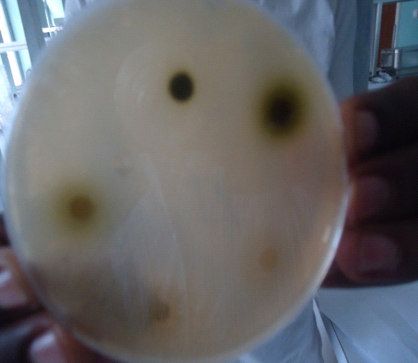
X. strumarium on S. aureus

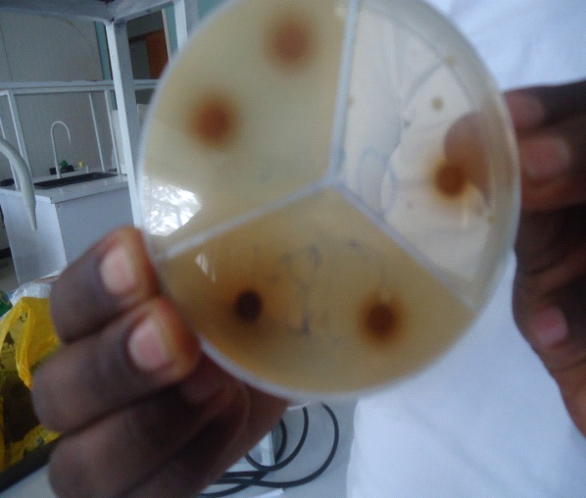
Combertum molle seed on S. aureus

Fig 1: Mean zone of inhibition (mm) exhibited by ethanol extract of leaf of X. strumarium, C.molle leaf and seed against S. aureus.

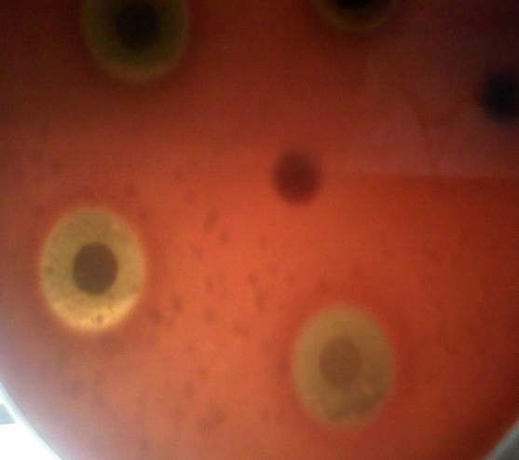

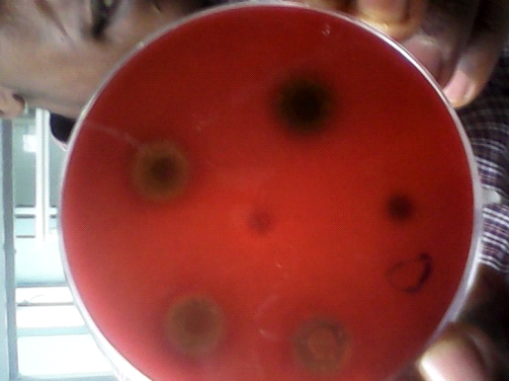
Combertum. molle seed on S. agalactiae Combertum. molle leaf on S. aglactie

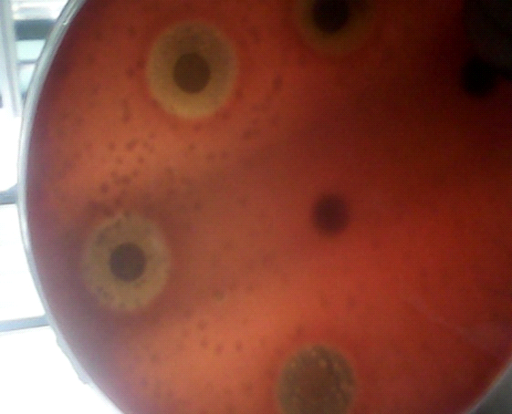
X. strumarium on S. agalactiae
Fig 2: Mean zone of inhibition (mm) exhibited by ethanol extract of leaf of Xanthium strumarium, leaf of C.molle and seed of C.molle against S.agalactiae

4. Discussion
In this study the antimicrobial susceptibility test was conducted on two species of bacteria which are most pathogenic to mastitis namely S. aureus and S. agalactiae isolated from bovine mastitis and two medicinal plants namely C. molle and X. strumarium at different concentration of ethanol extraction. Commercially available antibiotic discs (Gentamycine) were used to compare 10% of ethanol extraction of these medicinal plants. The result indicated that S. aureus and S. agalactiae were susceptible to C. molle seed and X. strumarium leaf and intermediate to C. molle leaf compare to positive controlled (Gentamycine) (Table 7).
In general the diameter of conventional antibiotic disk and crude extracts impregnated discs are equal. The diameter of inhibition zone exhibited by 10% concentration of the plant extracts was found almost comparable to those of noble antibiotic discs (Gentamycine). The dimethyl sulfoxide impregnated disc hasn’t showed any inhibition against the test organism which implies that the inhibition observed was exclusively by the crude extracts (Table, 7).
The dimethyl sulfoxide used as the solvent to make different concentrations was used as a negative control and there was no inhibitory effect. In this study the effect observed by the extract of X. strumarium and C. molle seed on S. aureus and S. agalactiae showed a good inhibitory effect than the extraction of C. molle leaf on tested organisms in all concentrations (10%, 5%, 2.5%, 1.25% and 0.63%).
The leaf of C. molle and X. strumarium, and C. molle seed had been studied for their antimicrobial effect on S. aureus while there was no work done on X. strumarium antibacterial effect against S. agalactiae. In this study, inhibition of growth at all concentration were recorded against S. aureus and S. agalactiae isolates, but the value of 10% concentrations of C. molle leaf against S. aureus lower compared to the finding obtained by Tadesse (2007) and higher than Mengistu (2004). The value of X. strumarium almost equivalent to the finding obtained by Haile (2012) and lower than Mohamedamin (2011). The value of C. molle seed higher compared to the finding obtained by Tadesse (2007). Finally, the value of 10% concentration C.molle leaf against S. agalactiae higher compared to Mengistu (2004). This difference may be due to the method of antimicrobial sensitive test adopted, the solvent used to prepare the bacteria, extraction method, storage condition and other unnoticed factors.
The crude extract of X. strumarium mean zone of inhibition on S. aureus isolates lower compared to antibacterial effect on S. agalactiae. However, the mean zone of inhibition of C. molle leaf on test bacteria was almost the same while C. molle seeds had good inhibitory effects on S. aureus than S. agalactiae. This holds true for leaf of the C. molle though its inhibition zone diameter which is relatively lower than that of C. molle seed and x. strumarium against the tested bacteria.
Finally, 10% phytopreparation were compared with conventional antimicrobial discs and the efficacy of this preparation at the mentioned concentration was satisfactory particularly of the seed of C. molle and X. strumarium. Comparison of herbal preparation with conventional antimicrobial discs was made only by the size of mean zone of inhibition obtained by each test material impregnated discs against S. aureus and S. agalactiae. The mean inhibition zone obtained by Gentamycine was almost comparable to that obtained by seed of S. molle and S. strumarium.
The comparison among this test materials suggest that the herbal preparations do have a capacity to inhibit the growth of S. aureus and S. agalactiae with a similar or a different manner to that of conventional agents, though there is no established standard formula to judge the level of zone of inhibition to say as resistant, intimidate and susceptible for phytopreparation.

5. Conclussion And Recommendation
C molle leaf, C. molle seed and X. strumarium extracted by ethanol and tested in-vitro antibacterial effect on S. aureus and S. agalactiae at different concentrations. 10% crude extracts of X. strumarium and C. molle seed has a comparable anti bacterial effect to conventional antibiotic discs. This result indicated that their future potential use in the synthesis of new medicaments. One way to control drug resistant problem is through the development of alternative antibacterial by screening and testing medicinal plants for their possible antimicrobial effects. Wide spread use of antibiotic for the treatment of bovine mastitis has a potential to cause contamination of milk, which has become a subject of public health concern, therefore medicinal herbs/plants are natural and safe approaches to improve the problem. Among the herbs crude extract of X. strumarium performed well against both tested organisms. Further studies should be made in order to identify the active photochemical constituents and evaluate their effectiveness using in-vivo and in-vitro methods so that produce commercially. In addition toxicity studies of the active plant principle should be done in order to determine their safety margines.

Acknowledgment
The author acknowledges his GOD and GOD' S mother ST. VIRGIN MERRY to give health, wisdom and strength in author’s work and for his perfect protection and guidance of author’s life.
The author acknowledges prof. Fekadu Regassa for his unreserved help, advice, valuable encouragement, intellectual guidance, friendly approach, material and financial support and devotion of time to correct this paper.

References
- Abebe, D. (1987): Plants in the health care delivery system of Africa. In: Leeuwenberg, A.J.M. (Ed). Medicinal and poisonous plants of the topics, proceeding symposium of the international botanical congress. Berlin. Pp: 73-87.
- ADARDO, (2007): Ada’a District Agricultural and Rural Development Office.
- Aghark, S.P. (1991): Medicinal plants of Bomby presidency. Pbl. Scientific publishers, Jodhpur., 1: 230.
- Bharathi, B., Padmini, R., Swamidoss, D. and George, W. (2010): Phyto chemical analysis and anti bacterial activity of Solanum trilobatum against HIV associated bacterial pathogens. Int. J. P.H. Sci., 2: 598-605.
- Danso, A.A. and Vlas, T.D. (2002): Interpretation of low praziquanntel cure rates of Schistosomia monsoni. Trend in parasitol., 18: 95-143.
- Edwards, R. (2004): No remedy coast insights for herbal ransack. New Sci., 181: 10-11.
- Endeshaw, B. (2007): studies on actual situation of medicinal plant in Ethiopia, (Unpublished MSc thesis, AAU).
- Freeman, C.D. (1997): Anti microbial resistance; implication for the clinician. J. of critical care nur., 20: 21-35.
- Haile, W. (2012): An in-vitro antimicrobial effect of X.strumariumand Grewia Bicolor or Juss on S. aureus isolated from bovine mastitis (Unpublished DVM thesis, AAU).
- MacCorkle, C. and Mathias, M. (1992): Ethinoveterinary medicine in Africa. Africa. 62: 59-93.
- Markos, T. (2003): Survey and screening of selected traditionally used medicinal plants for treatment of bovine mastitis and skin disease in Kembata, southern Ethiopia (UN published DVM thesis, AAU).
- Mengistu, A.K. (2004): The effect of Herbal Preparation on S. aureus and S. agalatiae isolated from clinical bovine mastitis (Unpublished MSc thesis, AAU).
- Mohamedamin, K. (2011): An in-vitro antimicrobial effect of l. alata and X.strumariumon S. aureus isolated from bovine mastitis (Unpublished DVM thesis, AAU).
- Olde Riekerink, R. G., Barkema, H., W., Kelton, D., F. and Scholl, D., T. (2008): Incidence rate of clinical mastitis on Canadian dairy farms. J. Dairy Sci., 91: 1366-1377.
- Quinn, P.J., Carter, M.E., Markey, B.K. and Carter, G.R. (1999): Clinical veterinary microbiology. London, Mosby International Ltd. UK., Pp: 96-117.
- Radostits, O.M., Gay, C.C., Blood, D.C. and Hinchllif, K.W. (2007): Mastitis. In: Veterinary Medicine 9th ed., Haracourt Ltd, London. Pp: 174-758.
- Reksen, O., Solverød, L. and Osterås, O. (2008): Relationships between milk culture results and composite milk somatic cell counts in Norwegian dairy cattle. J. Dairy Sci., 91: 3102-3113.
- Sahle, S. (2002): A study on medicinal plants used in the traditional veterinary practices for treatment of bovine mastitis in selected sites of central Ethiopia (UN published DVM thesis, AAU).
- Salisbury, J.G., Nicholas, T.J. and Lammerding, A.M. (2002): A risk analysis frame work for the long term management of antibiotic resistance in food producing animals. Int. J. Antimicrob. Agen., 20: 153-164.
- Schukken, Y., Hertl, J., Bennett, G., González, R., Rauch, B., Welcome, F., L. and Gröhn, Y., T. (2009): Effects of repeated gram-positive and gram-negative clinical mastitis episodes on milk yield loss in Hostein dairy cows. J. Dairy Sci., 92: 3091-3105.
- Taddese, T. (2007): In-vitro Antimicrobial effects of Combertum molle on S.aureus isolates (UN published DVM thesis, AAU).

5/21/2017

