Comparative study between frontal and posterior parietal ventriculo-peritoneal shunts in management of hydrocephalus

Prof. Dr. Abdelhalim Moasa, Dr. Mohamed Hasan and Mohamed Abdelrazek

Department of Neurosurgery, Faculty of Medicine, Al-Azhar University, Cairo, Egypt.
mh.razaak@gmail.com

Abstract: Background: Shunting procedures specifically ventriculoperitoneal shunts are the main line of treatment for management of hydrocephalus despite available new techniques and systems of shunting. Associated complications should be recognized and managed proper- ly, but the most recognized complications are shunt obstruction which its prevalence through surgical approach is discussed here. Two approaches (frontal and parietal) are used to insert ventriculoperitoneal shunt. In this study we prospectively examined patterns of shunt failure in patients with symptoms of shunt malfunction. Two approaches were compared to determine which one is more associated with shunt failure. Methods: 30 patients with symptoms of shunt malfunction over 4 years period were retrospectively examined, in 15 cases who were shunted through frontal approach and in 15 patients whose shunts were inserted through posterior parietal approach. 10 cases of malfunction observed. All data was analyzed with SPSS software then the failure rate for frontal versus parietal approach was compared. Results: Significant difference in malfunction rate between these two approaches re- gardless of underlying cause of ventriculoperitoneal shunt failure was observed, with the less failure rates through frontal approach. Conclusion: Although proximal obstruction is the most common cause of ventricu- loperitoneal shunt failure and frontal approach demonstrated less failure rate, but as it is known placing the catheter tip away from the choroids plexus is the most important factor avoiding obstruction.
[Abdelhalim Moasa, Mohamed Hasan and Mohamed Abdelrazek. Comparative study between frontal and posterior parietal ventriculo-peritoneal shunts in management of hydrocephalus. Researcher 2018;10(3):11-15]. ISSN 1553-9865 (print); ISSN 2163-8950 (online). http://www.sciencepub.net/researcher. 3. doi:10.7537/marsrsj100318.03.

Keywords: hydrocephalus, ventriculoperitoneal shunt complication, CSF shunt.

1. Introduction
The ventricul operitoneal shunt is the CSF shunting device usually used to treat hydrocephalus. All shunting systems regularly malfunction despite the best efforts of physicians and biomedical engineers [1]. Mechani- cal complications and infection are the most common problems account for shunt failure [2] although these malfunctions caused by material, construction, and technical errors during shunt placement or revision and mechanical failure [1]. Malfunction of ventricular catheter is made by choriods plexus, ventricular ependyma or debris [3,4].
Although the patients age, sex and underling condition in some studies do not influence the shunt complication rate, age and the etiology of the hydrocephalus remains to be the most important complicating factors. For example in- fants make up the large majority of patients who undergo first insertion of a CSF shunt device [2]. It should be mentioned that the longevity of shunt was very variable and shunt obstruction could happen at any time, hense, we did not in- clude it in our study. Many improvements in ventricular fluid diversion devices have occurred in recent years, but maintaining adequate shunt function continues to be a challenge.

2. Methods
A prospective study was performed on30pediatric patients who had under gone ventriculoperitoneal shunt at our institution within one year. Each patient had a complete chart review consist of age, sex, primary etiology of shunting and surgical approach of shunting.
Shunt malfunction data was recorded and Statistical analysis of the results was performed using IBM SPSS software package version 22.0. Qualitative data were described using frequency and percentage. Comparison between different groups regarding categorical variables was tested using Chi square, Fisher's exact test or Cochran-Armitage test as appropriate. Significant results are quoted as two-tailed probabilities. P-values <0.05 were considered statistically significant.

3. Results
30 Patients were included in this study who had been operated for ventriculoperitoneal shunt 15 cases posterior parietal approach and in 15 frontal approach were performed. Sociodemographic characteristics of studied sample. Almost half of the patients (40%) were between 0 and 6 months. Males comprised 56% of the sample while females formed 43.3% (table1).
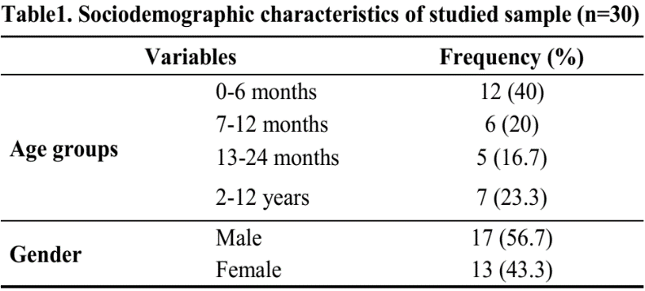

The most frequent indication for shunt insertion was congenital hydrocephalus (63.3%), followed by post traumatic cause forming 13.3 % of cases. Most cases weren't associated with another pathology (83.3%). however, 4 cases had lumbar meningocele and only one case was associated with cerebellar hypoplasia. Most procedures weren't associated with complications (70%) table 2, figure 1.

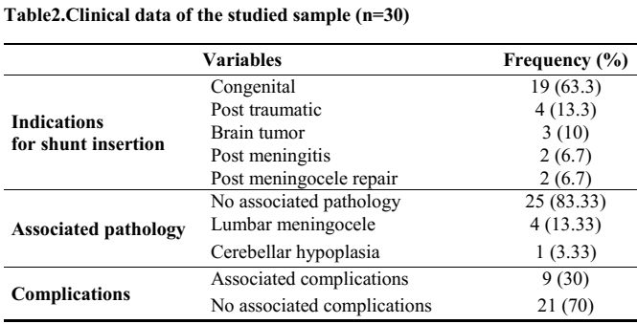

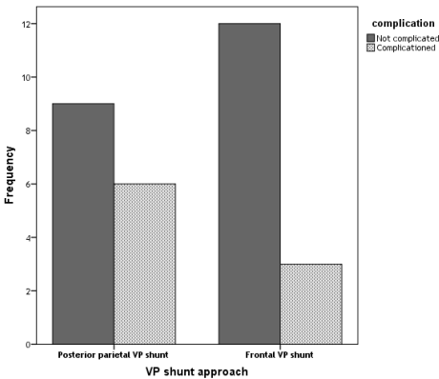
Figure 1. Distribution of age groups among different shunt insertion approaches

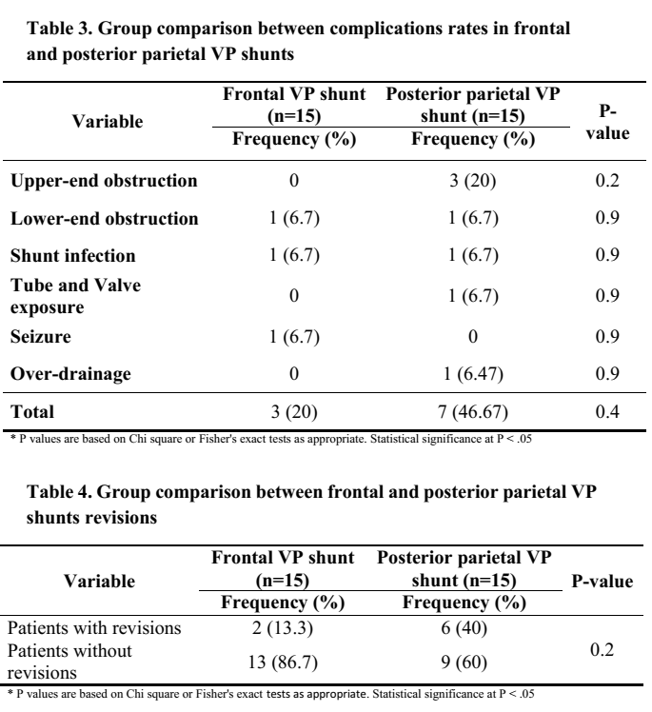

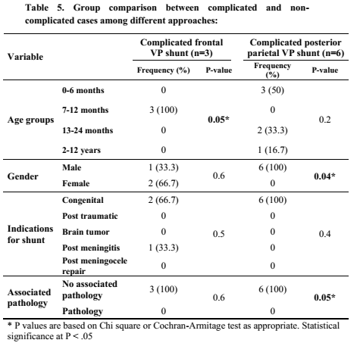

Posterior parietal VP shunt showed a total higher rate of complications, 7 cases (46.6%), than that in frontal VP shunt, 3 cases (20%). However such difference in rate of complications wasn't statistically significant (p=0.4) (table 3). Similar to complications, revision rate in posterior parietal VP shunt, 6 cases (40%) was higher than that in frontal VP shunt, 2 cases (13.3%). However, such difference was found statistically insignificant; (p-value=0.2) (table 4).
Table 5 shows the association between complication rate in the two approaches and different variables. Regarding frontal VP shunt, there was statistically significant difference between occurrence of post-operative complications and different age groups (p=0.05). However, occurrence of post-operative complications didn't show statistical significant difference with gender (p=0.6), different indications for shunt insertion (p=0.5) or presence of other associated pathology with hydrocephalus (p=0.6). Regarding posterior parietal VP shunt, there was statistically significant difference between occurrence of post-operative complications and gender (p=0.04) as well as associated pathology with hydrocephalus (p=0.05).

4. Discussion
The placement of a ventriculo-peritoneal shunt is one of the basic neurosurgical procedures used to treat hydrocephalus. VP shunts were done according to choice of insertion mostly into frontal or posterior parietal VP shunt. The complications of shunting procedures such as shunt infection, dysfunction or penetration are common and may lead to failure of the procedure necessitating shunt removal in most of the patients and instant or late reinsertion of a new device is usually indicated (5).
In our study, the most age distribution of patients with hydrocephalus treated with VP shunts was less than 12 months (60 %). Male patients were more than female patients.
The most common indication for initial shunt insertion was patients with congenital hydrocephalus about (63.3%), while patients with post-traumatic hydrocephalus were about (13.3%).
The overall shunt complication rate in our study within a short term follow up period of up to sixth months was (33.3%), Shunt malfunction due to occlusion of the proximal ventricular catheter was reported in 10% of the patients in our study in comparison to distal occlusion, which represented (6.6%).
The proximal catheter can be blocked by adherent choroid plexus in 10% of the shunted patients, by debris or blood in the ventricular system, which occludes the catheter lumen, by brain tissue or, in certain cases, by another pathologic process, such as tumor tissue growing around the catheter tip. Infection is a common cause of shunt blockage (by pus, inflammatory debris or increased protein in the CSF).
Sainte-Rose found that mechanical shunt complications account for more than half of all shunt failures [10]. These complications are not easily avoided; standard teaching dictates that the shunt tip should be placed in the frontal horn anterior to the choroid plexus. This objective is probably more easily reached with a catheter placed via a frontal burr hole, as mentioned by Albright (11).
In our study, Shunt complications occurred more frequently in posterior parietal VP shunts, (25%) in comparison to frontal VP shunts, (10%).
In our study of the 15 patients that were treated by frontal VP shunts, two patient (13.3%) required revision compared with six patients (40%) who were treated with posterior parietal VP shunts and required revision. Although the revision rate in patients treated with frontal VP shunts was less than that in patients treated with posterior parietal VP shunts.
In our study, infection was (6.6%) for all shunted patients, which is similar to the rates found in most series, which show no statistical difference between the two procedures (5).
The experience of the surgeon and use of perioperative and post-operative antibiotics with minimal handling of the shunt apparatus by an experienced, two-person surgical team, and the scheduling of all shunts and shunt revisions early in the day and prior to other scheduled procedures, appear to be the most important factors in preventing such infections. Shunt infections increase in proportion to the length of procedure and the volume of operating-room traffic (6).
The ventricular catheter shunt malfunction remains the most common problem after insertion of a VP shunt. Surgical technique and approaches have been revised through the years in an effort to limit shunt malfunctions. This investigation on the surgical approaches for ventricular catheter placement demonstrates that there is no difference in proximal catheter malfunction rate related to a frontal or parietal approach. We provide further evidence to support the conclusion that the most important factor for prevention of proximal catheter malfunction is the final catheter tip position in relation to the choroid plexus (6).
In our study demonstrated that proximal catheter obstruction was the most common cause for shunt malfunction and choroid plexus was the primary culprit for catheter obstruction. Subsequently, several studies were performed using stereotactic and endoscopic guidance systems to assist with optimal placement of proximal shunt catheters. Surgeons collectively agree that optimum placement of the proximal catheter tip is away from choroid plexus in the frontal horn. To achieve this catheter placement, neurosurgeons typically choose a frontal or parietal approach (8).

5. Conclusion
Ventricular catheter shunt malfunction is the most common problem after insertion of a ven- triculoperitoneal shunt [7]. This study on the surgical approaches for ventriculoperitoneal shunt insertion demonstrated that malfunction rate via frontal approach was less than parietal approach. Nonetheless, it is known that final catheter tip position in relation to the choroids plexus considered being the most important factor in prevention of proximal catheter malfunction.

References
- Ventureyra EC, Higgins MJ. A new ventricular catheter for the prevention and treatment of proximal ob- struction in cerebrospinal fluid shunts. Neurosurgery 1994; 34: 924 - 926.
- Di Rocco C, Marchese E, Verladi F. A survey of the first complication of newly implanted CSF shunt devices for the treatment of nontumoral hydrocephalus. Cooper- ative survey of the 1991 - 1992 Education Committee of the ISPN. Childs Nerv Syst 1994; 10: 321 - 327.
- Ivan LP, Choo SH, Venturegra ECG: Complications of Ventriculoatrial and ventriculo periotoneal shunts in a new children's hospital canjsurg 1980; 23: 566-568.
- Wissam Jassim Sagban and Zaki Noah Hasan. Surgical-outcome and Complication Differences between Frontal and Posterior Parietal VP Shunts in Iraqi British Journal of Medicine & Medical Research. 10(11):, Article no. BJMMR.18551 ISSN: 2231-0614, 2015.
- Grosfeld JL, Cooney DR. Smith J Intra - abdominal complications following ventriculoperitoneal shunt pro- cedures. Pediatrics 1974; 54: 791 - 996.
- Choux M, Genitori L, Lang D, Lena G. Shunt implantation: reducing the incidence of shunt infection. J Neurosurg 1992;77(6):875–80.
- Dickerman RD, McConathy WJ. Failure rate of frontal versus parietal approaches for proximal catheter placement in ventriculoperitoneal shunt. Journal of Clin- ical Neuroscience 2005; 12(7): 781-783.
- Albright AL. Haines SJ, Taylor FH. Function of parietal and frontal shunts in childhood hydrocephalus. J Neurosurg 1988; 69: 883 - 886.
- Sainte-Rose C, Piatt JH, Renier D et al. Mechanical complications in shunts. Pediatr Neurosurg 1991–1992; 17: 2–9
- Colak A, Albright AL, Pollack IF: Follow-up of children with shunted hydrocephalus. Pediatr Neurosurg 1997, 27:208–21.

3/5/2018

