Determinants of Adaptation Measures to Climate Change by Arable Crop Farmers in Owo Local Government Area of Ondo State, Nigeria

*¹Fatuase AI, ¹Aborisade AS, Omisope ET²

¹Department of Agricultural Technology, Rufus Giwa Polytechnic, Owo, Ondo State, Nigeria
² National Agricultural Extension and Research Liaison Services, Ahmadu Bello University, Zaria, Nigeria
firstwalefat@yahoo.com

Abstract: This study examined determinants of adaptation measures to climate change by arable crop farmers in Owo Local Government Area of Ondo State, Nigeria. The study drew a sample of 120 crop farmers through a multi-stage sampling technique and the data obtained were analyzed using descriptive statistics and Tobit regression model. Result revealed that majority of the farmers perceived climate to be changing. The findings also revealed that agricultural systems (96.7%), household livelihoods (86.7%), protective measures (70.8%), soil conservation techniques (55.8%) and farming operation (41.7%) were the main adaptation measures employed by the farmers. Household size, education, farm size, income, experience and access to extension agents were the factors that were statistically and significantly affected the rate of utilizing adaptation measures using Tobit model. The main barriers limiting the farmers from fully adapting to climate change were inadequate funds (98%) and information to climate change (81%). It is therefore recommended that climate change adaptation advocacy should be intensified by creating more awareness on climate change couple with more innovative and effective adaptation measures that are accessible, available and affordable by the crop farmers.
[Fatuase AI, Aborisade AS, Omisope ET. Determinants of Adaptation Measures to Climate Change by Arable Crop Farmers in Owo Local Government Area of Ondo State, Nigeria. World Rural Observ 2015;7(1):49-57]. ISSN: 1944-6543 (Print); ISSN: 1944-6551 (Online). http://www.sciencepub.net/rural. 7

Key words: Adaptation, barriers, climate change, crop farmers, perception

1. Introduction
Adaptations are adjustments or interventions, which take place in order to manage the losses or take advantage of the opportunities presented by changing climate (IPCC, 2001a). Nhemachena and Hassan (2007) reported adaptation as the process of improving society’s ability to cope with changes in climate conditions across time scales, from short term (e.g. seasonal to annual) to the long term (e.g. decades to centuries). The IPCC (2001b) defines adaptive capacity as the ability of a system to adjust to climate change (including climate variability and extremes), to moderate potential damages, to take advantage of opportunities, or to cope with the consequences. Also, adaptation measures help farmers guard against losses due to increasing temperatures and decreasing precipitation (Hassan and Nhemachena, 2008).
Adaptation and mitigation can both be used to reduce the negative impacts of climate change. Mitigation refers to reducing climate change by reducing the GHG emissions (IPCC, 2001a). Although mitigation targets uprooting the major causes of climate change and offers long-run solutions while adaptation is much more important for the group of developing countries. Fusel (2007) opined that emphasis should be focused on adaptation because human activities have already affected climate, climate change continues given past trends, and the effect of emission reductions will take several decades before showing results, and adaptation can be undertaken at the local or national level as it depends less on the actions of others.
The goal of an adaptation measure should be to increase the capacity of a system to survive external shocks or change. The assessment of farm-level adoption of adaptation strategies is important to provide information that can be used to formulate policies that enhance adaptation as a tool for managing a variety of risks associated with climate change in agriculture (Nhemachena and Hassan, 2007). And it should be known that adaptation to climate change requires that farmers first notice that the climate has changed, and then identify useful adaptations and implement them (Maddison, 2006).
There are different ways of adapting to climate change in agriculture (Bradshaw et al., 2004; Kurukulasuriya and Mendelsohn, 2008; Mertz et al., 2009 cited in Fatuase and Ajibefun, 2013) and many agricultural adaptation options have been suggested in the literature (Gbetibouo, 2009). Moreover, different factors affect the use of any of these adaptation methods (Nhemachena and Hassan, 2007; Hassan and Nhemachena, 2008 and Deressa et al., 2011). Bradshaw et al., (2004) reported that crop diversification, mixed crop-livestock farming systems, using different crop varieties, changing planting and harvesting dates, and mixing less productive, drought-resistant varieties and high-yield water sensitive crops are important adaptation options in the agricultural sector. Again, Hassan and Nhemachena (2008) also showed that better access to markets, extension and credit services, technology, farm assets (labour, land and capital) and information about adaptation to climate change, including technological and institutional methods, affect adaptation to climate change in Africa. A review of literature on adoption of new technologies also identified farm size, tenure status, education, access to extension services, market access and credit availability, agroclimatic conditions, topographical features, and the availability of water as the major determinants of the speed of adoption (Maddison, 2006).
Adaptations encompass a wide range of scales (local, regional, global), actors (farmers, firms, government), and types:
- micro-level options, such as crop diversification and altering the timing of operations;
- market responses, such as income diversification and credit schemes;
- institutional changes, mainly government responses, such as removal-preserve subsidies and improvement in agricultural markets and
- technological developments- the development and promotion of new crop varieties and advances in water management techniques (Smith and Lenhart, 1996; Mendelsohn, 2001; Smith and Skinner, 2002; Kurukulasuriya and Rosenthal, 2003 cited in Fatuase and Ajibefun, 2013).
Agricultural adaptation involves two types of modifications in production systems (Nhemachena and Hassan, 2007). The first is increased diversification that involves engaging in production activities that are drought tolerant and or resistant to temperature stresses as well as activities that make efficient use and take full advantage of the prevailing water and temperature conditions, among other factors. Crop diversification can serve as insurance against rainfall variability as different crops are affected differently by climate events (Orindi and Eriksen, 2005; Adger et al., 2003). The second strategy focuses on crop management practices geared towards ensuring that critical crop growth stages do not coincide with very harsh climatic conditions such as mid-season droughts. Crop management practices that can be used include modifying the length of the growing period and changing planting and harvesting dates (Orindi and Eriksen, 2005).
Several recent climate change impact modeling studies have incorporated adaptation (Nhemachena and Hassan, 2007). They include Nicholls and Leatherman (1995) for coastal zones; Mendelsohn et al. (1994) and Rosenzweig and Parry (1994) for agriculture, and Sohngen and Mendelsohn (1998) for timber which were all cited in Fatuase, 2012. These studies showed the importance of adaptation measures in substantially decreasing potentially adverse impacts of climate change and in strengthening the benefits associated with changes in climate (Helms et al., 1996; Schimmelpfenning 1996; Mendelsohn and Neumann, 1999 cited in IPCC, 2001b and Nhemachena and Hassan, 2007).
Rosenzweig and Parry (1994) showed that there is great potential to increase food production under climate change in many regions of the world if adaptation is taken into consideration. In another study, Dowing (1991) showed that adaptation has the potential to reduce food deficits in Africa from 50 to 20 percent.
Therefore, this study will go a long way to opine adaptation strategies and the rate of utilizing them by arable crop farmers in the study area to combat the effects of climate change and as well proffer policy recommendations of relevance to crop production in the agricultural zone and the nation at large, on how to boost food production vis-a-vis food security.
1.1 Objective of the study
The general objective of the study is to examine determinants of adaptation measures to climate change by arable crop farmers in Owo Local Government Area (LGA) of Ondo State, Nigeria.
The specific objectives are to:
- examine farmers’ perception about climatic variables;
- identify climate risk adaptation in the study area;
- determine the rate of utilizing climate change adaptation measures; and
- identify major barriers to adaptation strategies in the study area.

2. Methodology
The study was carried out in Owo LGA of Ondo State, Nigeria. Owo LGA is one of the eighteen LGAs in Ondo State that is known for crop production with high capacity of forest reserve. The total population of the people in Owo LGA is 196,729 (NPC, 2006). The geographical coordinates are 7⁰ 11′ North and 5⁰ 35′ East of the equator. The area enjoys lowland tropical rain forest climate type with distinct rainy season (April – October) and dry season (November – March). The temperature ranges between 21⁰ and 28⁰C with high humidity. The South westerlies and the Northeastlies winds blow in the rainy and dry (Harmattan) seasons respectively. The area is largely agrarian. Agriculture is the mainstay of the Owo LGA’s economy. It employs over 75% of the Owo LGA working population. The area produces crops like cassava, yam, cocoyam, maize, vegetables, cowpea, cocoa, oil palm, plantain and fruits like cashew, mango and orange (citrus). The area is endowed with forest products such as trees like Tick, Mahogany, Messenia, Obeche etc. and animal products like grasscutter, snail, crocodile, monkey etc.
Data Collection and Sampling Techniques: Primary data were used for this study. Primary data were collected through direct personal interview and structured questionnaire to obtain pertinent information on farmers’ perception about climate change, adaptation measures employed as a result of climate change and barriers encountered in adapting to climate change effects. A multistage sampling technique was used for the selection of respondents. Stage one involved the purposive selection of Owo LGA being one of the LGAs in the State that has forest reserve and the area has been experiencing a lot of deforestation and other farming activities which could worsen the consequent effects of climate change most especially among the rural farming households. In stage two, the LGA was stratified into eleven wards following the administrative and political stratification while in stage three, ten wards were randomly selected from the eleven wards that made up Owo LGA. Lastly in stage four, simple random sampling was also used to select 12 crop farmers from each ward and thus, making a total of 120 respondents.
Analytical Techniques: Data collected were analyzed using descriptive statistics (such as frequency table, percentage and charts) and Tobit regression model.
Model Specification: The Tobit regression model was used to determine the rate of utilizing adaptation measures in combating climate change effects in the study area. This showed how explanatory variables influence the probability of employing adaptation measures by the arable crop farmers. The censored regression model is expressed below following Tobin (1958); McDonald and Moffit (1980); Wooldridge (2002).
Y_{i}* = X_{i}β + e_{i}
Where ei ᴖ N(0,Ɵ²); Y* is a latent variable that observed for value greater than г and censored otherwise (Wooldridge, 2002).
The observed Y is defined by the following measurement equation:

The model will therefore assume that г =0 i.e. the data are censored at 0. Thus, the model is re-write as:
Where: ith is the number of respondents
Y_{i} is the limited dependent variable, it is discrete if farmers do not empoly adaptation measure (it assumes zero value in this case) and continuous if employed adaptation measure i.e. equal to Y_{i}*
Y_{i}* = is the rate of utilizing adaptation measures and it is defined as “NAM/TNA” - where “NAM” is the number of the adaptation measures that was employed by the arable crop farmer in the study area and “TNA” is the total number of adaptation measures available and posed to the farmers. The index that was derived from the formula (NAM/TNA) ranges from zero (0) to one (1).
Y_{i}* > 0 implies that Y_{i}* is observed
Y_{i}* < 0 implies that Y_{i}* is not observed.
In analysing the data using STATA 12 package, the left-censoring limit was specified as zero (0) while the right-censoring limit was specified as one (1).
X_{i} is a vector of explanatory variables
β is a vector of unknown coefficients and
e_{i} is an independently distributed error term.
The explanatory variables specified as determinants of rate of utilizing adaptation measures are defined as follows:
X₁ = Marital status of household head (Dummy =1 if married; 0, if otherwise)
X₂ = Household size (number)
X₃ = Sex of household head (Dummy =1 if male; 0, if otherwise)
X₄ = Age of the respondents (year)
X₅ = Educational status (Dummy = 1 if educated; 0, if otherwise)
X₆ = Farm size (hectare)
X₇ = Access to extension agent (Dummy = 1if access; 0, if otherwise)
X₈ = Annual income (Naira)
X₉ = Access to credit (Dummy = 1 if access; 0, if otherwise)
X₁₀ = Farming experience (year)

3. Results and discussion
3.1 Summary of the Variables Used
The summary of the characteristics of the arable crop farmers involved in this study is presented in Table 1. About 87% of the respondents had married with the majority of them (75%) were male households. This implies that the study was dominanted by male and married households. Rate of utilizing adaptation measure is expected to be high as the average age of the farmers were 57.9 years’ old and the majority of them (80%) were less than 60 years’ old. This indicated that most of them were still agile and productive in adopting any adaptation measures efficiently and effectively. The household size was fairly large with the mean age of about 8 persons per house while 6 – 10 persons per house formed the majority (50.8%). The numbers of farmers that were educated from the sampled respondents were slightly above average (55.8%) but this is still expected to have a significant effect on the rate of utilizing adaptation measures in the area. The average farm size was 1.7ha with the majority (40.8%) of the farmers cultivate between 1 to 2 ha of land for arable crops. Over 69% of the respondents did not have access to extension services and 80% did not have access to credit/loan in the study area. This might has negative implications on the rate of utilizing adaptation measures. The estimated average household income was N356,197.00 while the majority of the farmers (35.0%) earned between N200,000 to N400,000 per annum. Despite the minimum age interviewed was 30 years’ old, majority of the respondents (45.0%) had a good experience in crop farming activities which could be translated into having experience on climatic conditions and how it has been affecting their crop productions in the area.
3.2 Farmers’ Perception about Climatic Variables
This section revealed the actual perception of climate change by arable crop farmers in the study area. The study showed that majority of the farmers perceived significant changes in climate. The changes were disaggregated based on the climatic variables such as temperature, rainfall and sunshine.

Table 1: Descriptive Statistics for the Factors Used in the Tobit Regression Model
Variable | Majority (%) | Mean | Standard deviation | Minimum | Maximum
Marital status | Married (86.7) | - | - | - | -
Household size | 6 – 10 (50.8) | 8.1 | 4.8 | 1 | 23
Sex | Male (75.0) | - | - | - | -
Age | 50 – 60 (45.0) | 57.9 | 23.1 | 30 | 91
Educational status | Educated (55.8) | - | - | - | -
Farm size | 1 – 2 (40.8) | 1.7 | 4.5 | 0.1 | 13
Access to extension agent | Not access (69.2) | - | - | - | -
Household income | 200,000 – 400,000 (35.0) | 356,197 | 270,112 | 45,000 | 1,200,000
Access to credit | Not access (80.0) | - | - | - | -
Farming experience | 20 – 30 (45.0) | 23.7 | 19.9 | 2 | 67
Source: Computed From Field Survey Data, 2014.

3.2.1 Farmers’ Perception on Changes in Temperature

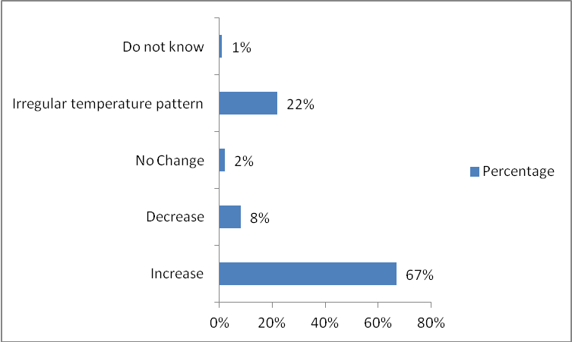
Figure 1: Farmers’ Perceptions of Changes in Temperature in the Study Area
Source: Computed From Field Survey Data, 2014.

Majority of the sampled farmers (67%) perceived an increase in temperature over the years as depicted in Figure1. About 22% of the farmers also noticed that changes in temperatures have been irregular and unpredicted in the study area while 8%, 2% and 1% of the respondents perceived changes in temperatures to decrease, stay the same and do not know the behaviour of the temperature over the years respectively. Without iota of doubt, it was obvious that farmers in the Owo communities perceived changes in temperatures which are greatly affecting their farming systems and practices. The changes have made most of the arable crop farmers engaged in various adaptation measures that could combat the negative consequence of climate change. The result was in line with many studies in the literature that also perceived increase in temperature over the years (Apata el al., 2009; Derresa et al., 2010; Mengistu, 2011; Fatuase, 2012).
3.2.2 Farmers’ Perception on Changes in Rainfall
Figure 2 showed the responses of the farmers on the changes in rainfall patterns in the study area. In contrary to changes in temperatures, majority of the respondents (57%) perceived a decrease in the amount of rainfall while 38% of them noticed unprecedented and irregular patterns of rainfall. The remaining respondents (5%) perceived changes in rainfall to be increased. The behaviour of rainfall was so significant that none of the respondent chose “stay the same” and “do not know” options. The farmers complained of short but heavy rainfall that came with storms and winds thereby destroy farm produces. Delay in its coming and unexpected break during the season were also reported by the farmers. Their perceptions on rainfall patterns were in support of several studies in Africa (Apata el al., 2009; Gbetibouo, 2009; Derresa et al., 2010; Mengistu, 2011; Fatuase, 2012) that reported a decrease in the amount of rainfall over the years.

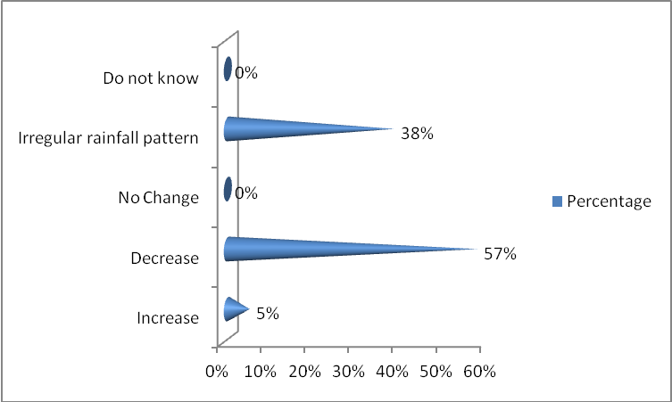
Figure 2: Farmers’ Perceptions of Changes in Rainfall in the study area.
Source: Computed From Field Survey Data, 2014.

3.2.3 Farmers’ Perception on Changes in Sunshine hours
Farmers’ perception on the changes in sunshine hours was showed in Figure 3 in which majority of the farmers (82%) perceived changes in sunshine hours to be increased. Many of them complained that the sun stays longer and more itchy than before and thereby affect farming activities. This has also made them looked for the ways in their own knowledge, to adapt to the effects of sunshine hours on their crops. About 16% of them noticed irregularity in the sunshine hours while only 2% perceived no change. This result was inline with Fatuase (2012) in his study carried out in Ekiti State that majority of the farming households perceived sunshine hours to be increased.

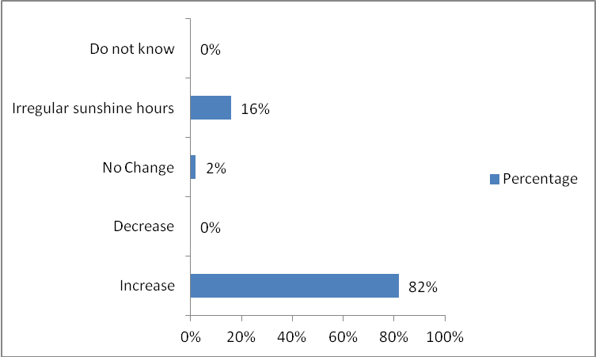
Figure 3: Farmers’ Perceptions of Changes in the Intensity of Sunshine hours in the study area.
Source: Computed From Field Survey Data, 2014.

3.3 Adaptation Measures by Arable Crop Farmers in the Study Area
The adaptation measures were captured by asking farmers what coping strategies are they employing in the face of anticipated climate change, that is, changes in temperature, unprecedented rainfall, increase and decrease in amount of rainfall and other weather extremes. The options reported by the farmers might be profit driven rather than climate change driven but since there is missing link, we assumed that their actions are driven by climate change (Maddison, 2006; Nhemachena and Hassan, 2007; Deressa et al., 2011 and Fatuase and Ajibefun, 2013). Therefore, the crop farmers’ responses on adaptation measures adopted were grouped under four broad categories of adaptation to climate change as shown in Table 1.
Soil Conservation techniques: The result showed that about 56% of the respondent were employing soil conservation techniques on their farms. Farmers’ specific adaptation measures listed in this category include practising of irrigation, mulching, planting of tree (afforestation), planting of cover crops and leguminous crops such as melon, cowpea, sweet potato and groundnut.
Agricultural Systems: Majority of the respondents (96.7%) employed various agricultural systems as one of the options to combat climate change effects. The specific adatation options listed in this category are mixed cropping, planting different varieties, early planting and harvesting, different planting dates and changing of site.
Protective Measures: It was revealed that 70.8% of the respondents adopted various protective measures to survive the adverse effects of climate change and the specific adaptation in this category include increase in the use of agrochemicals (such as herbicide, fungicide, insecticide, pesticide e.t.c), increase in the use of inorganic fertilizer most especially some days prior to sowing, increase in the use of organic manure and change of row orientation in respect to slope.
Househlod’s livelihoods: Here, crop farmers reported livehoods strategies they were using in coping with the current trend of climate anomalies. About 87% of the farmers specifically employed the following livelihoods as adaptation options: undertake non-farm economic activities, avoid selling remain food stocks, rationing of food, reduce expenditure and migration.
Farming Operations: It was observed that 41.7% of the respondents employed various farming practices as their means of adpating to climate change. The specific adaptation options in this category are using of resistant crops, zero tillage, minimium tillage, full tillage, drainage and modern equipment utilization.
All these adaptation measures were simultaneously adopted by the crop farmers in the study area in order to make them survive the adverse effects of climate change and as well remain in the business of crop production. The frequency of utilizing the adaptive measures were ranked as first, second, third, fourth and fifth for agricultural system, household’s livelihoods, protective measures, soil conservation techniques and farming operations respectively.

Table 2: Distribution of the Adaptation Measurs by Respondents
Adaptation strategies | Frequency | Percentage | Ranking
Soil conservation techniques | 67 | 55.8 | 4th
Agricultural systems | 116 | 96.7 | 1st
Protective measures | 85 | 70.8 | 3rd
Household’s livelihoods | 104 | 86.7 | 2nd
Farming operations | 50 | 41.7 | 5th
*Multiple choices allowed
Source: Computed from Field Survey Data, 2014.

3.4 Determinant Factors and Rate of Utilizing Adaptation Measures in the Study Area
The study examined the rate of utilizing adaptation measures in the study area by dividing numbers of adaptation measures employed by a respondent by the total numbers of adaptation measures that have been identified in the literature to be available in the study area and which were posed to the respondents to choose as applicable. The rate was measured in form of index which ranges from 0 to 1 as depicted in Table 3. The average rate of utilizing adaptation measure was 0.38 which implies that 38% of the available adaptation measures were utilized by an average respondent in combating the effects posed by climate change. Majority of the respondents (34.17%) had an index between 0.21 and 0.40 while about 42% had an index greater than equal 0.41. The results re-established the fact that farmers utilized different adaptation measures simultaneously in combating the effects of changes in climate in the area.

Table 3: Rate of Utilizing Adaptation Measures
Index | Frequency | Percent | Cumulative percent
0.00 – 0.20 | 29 | 24.16 | 24.16
0.21 – 0.40 | 41 | 34.17 | 58.33
0.41 – 0.60 | 32 | 26.67 | 85.00
0.61 – 0.80 | 10 | 8.33 | 93.33
0.81 – 1.00 | 08 | 6.67 | 100.00
Total | 120 | 100.00
Source: Computed from Field Survey, 2014

Tobit regression model was used to determine factors influencing the rate of utilizing adaptation measures in the study area. The indices derived using the formula (NAM/TNA) were model into the Tobit regression. The index serves as a dependent variable which ranges from 0 to 1; and specified as left-censoring limit to be 0 while the right-censoring limit to be 1. The likelihood ratio statistics as indicated by χ² statistics (65.09) are highly significant (P < 0.001), suggesting the model has a strong explanatory power. The results of the analysis as shown in Table 4 revealed that household size, educational status, farm size, household income, farming experience and access to extension agents were the main factors that were statistically significantly determined the rate of utilizing adaptation measures in the study area. All the coefficients of statistically significant variables were positive in influencing the rate of utilizing adaptation measures except the household size which was negative. This implies that a unit increase in any of their value will increase (or decrease, in the case of negative coefficient) the likelihood of utilizing adaptation measures. Household size is the function of spouses, children and dependants staying and eating under the same household head. Ordinarily, this will make the farming households to accomplish various agricultural tasks as a result of higher labour endowments as reported by Deressa et al. (2011). But the findings was contrary becuase most of the family labours have been released to other sectors of the economy, especially educational sector thereby making the children and other dependants have little or no regards for farming activities in the study area. Education increases the probability of utilizing adaptation measures because higher level of education is often hypothesized to increase the probability of adopting new technologies (Daberkow and McBride 2003; Adesina and Forson 1995 cited in Gbetibouo, 2009), greater access to information on climate change and agricultural productivity (Deressa et al., 2011). Larger farm has higher chance of utilizing adaptation measures. This connotes with several studies in the literature (Gbetibouo, 2009; Deressa et al., 2011; Fatuase and Ajibefun, 2014). The probable reason was in line with the report of Daberkow and McBride (2003) cited in Gbetibouo (2009) who opined that given the uncertainty and the fixed transaction and information costs associated with innovation, there may be a critical lower limit on farm size that prevents smaller farms from using several adaptations. As these costs increase, the critical size also increases. It follows that innovations with large fixed transaction and/or information costs are less likely to be adopted by smaller farms (Gbetibouo, 2009). The results also showed that an increase in household income will increase the probability of utilizing more adaptation measure. It has been reported that adaptation is costly but with the availability of enough capital, farmers will have money to embark on modern adaptation technologies. It is a popular say that experience is a best teacher. Increase in the years of farming will likely increase the rate of utilizing adaptation measures. The reason is because experienced farmers have better knowledge and information on changes in climatic conditions and crop management practices (Nhemachena and Hassan 2007). It was also found out that access to extension agent was significant in influencing the rate of utilizing adaptation measures. The more the farmer has access to extension services, the more the chance of utilizing many adaptation measures. This is because extension agents assist the farmers to make decisions that would guide them against the consequences of climate change and by exposing them to latest information and technical skills that will boast their crop production despite the changes in climate.

Table 4: Results of Tobit regression model in determining factors influencing the rate of utilizing adaptation measures
Explanatory Variable | Coefficient | Standard Error
Constant | 0.855 | 1.719
Marital status (X₁) | 0.263 | 0.135
Household size (X₂) | -0.201* | 0.101
Sex (X₃) | -0.018 | 1.238
Age (X₄) | -0.299 | 0.197
Educational status (X₅) | 0.362* | 0.081
Farm size (X₆) | 3.552* | 1.615
Access to extension agent (X₇) | 0.073* | 0.035
Annual income (X₈) | 4.50E-06* | 1.56E-06
Access to credit (X₉) | 0.079 | 0.051
Farming experience (X₁₀) | 0.415* | 0.077
Sigma | 0.609 | 0.089
Note: * means significant at 5% level; LR Chi² (9) = 65.09; Prob > chi² = 0.001; Log likelihood = - 96.11; Pseudo R² =0.489
Source: Computed from Field Survey, 2014

3.5 Barriers to Adaptation to Climate Change
The analysis of main barriers to adaptation to climate change in this context means the constraints and challenges faced by the crop farmers to fully employ and adopt most of the adaptation measures identified above. Therefore, lists of likely challenges faced by the farmers in adapting to climate change as found in the literature were posed to the farmers to choose as applicable to them. Figure 1 shows that at least the farmers in the study area faced one difficulty or the other. Inadequate funding and information on climate change with 98% and 81% respectively, were the main problems facing by the farmers. This was followed by poor potential for irrigation (78%), inadequate knowledge know-how (67%), shortage of labour (40%) and shortage of land (20%). The crop farmers complained of lack of credit facilities most especially formal source of credit as a main barrier to adaptation. Deressa et al. (2008) and Onyeneke & Madukwe (2010) reported that adaptation to climate change is costly. Therefore, lack of finance/capital hinders farmers from getting the necessary resources and technologies that could facilitate adaptation to climate change. It was observed that radio/television and extension agents were the major sources of information on climate change in the study area. Epileptic supply of electricity does not make them to have access to the latest news on climate change and its variability while extension agents were not punctual in their farms again. The cost of constructing irrigation is said to be unaffordable by the respondents and few farmers still find it difficult in applying some of the modern adaptation measures. It was also observed that family labour that are supposed to be assisting the farmers in the farm are being released to western education, thereby making farmers depend solely on hired labour that are very scare and costly in the area. Due to the civilization and urbanization, many agricultural lands including forest reserves have been opening up to non-farming activities (such as housing, industries, schools, churches etc.) therefore, reduce farmland drastically. The other barriers mentioned were bad road network, high cost of farm implement and agrochemicals.

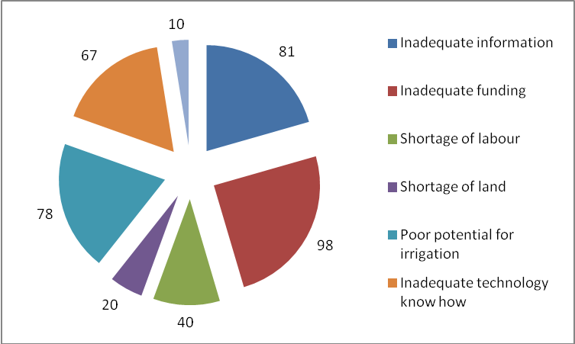
Figure 4: Percentage of Barriers to Adaptation Strategies by the Crop Farmers in Owo LGA, Ondo State.
*Multiple choices allowed
Source: Computed from Field Survey Data, 2014.

4．Conclusion and Recommendation
The perceptions of the arable crop farmers had confirmed that climate is changing in the study area. Majority of the farmers perceived changes in temperature and sunshine hours to be increased while a decrease in the amount of rainfall was as well perceived in the study area. Despite the challenges of climate change, it is very obvious that the arable crop farmers in the study area were employing one adaptation measure or the other to cope with the adverse effects of climate change. It can be concluded that crop farmers employed agricultural systems, household livelihoods, protective measures, soil conservation techniques and farming operations which were ranked as first, second, third, fourth and fifth respectively as the main broad adaptation measures in the study area. The result of the rate of utilizing adaptation measures was high (34.17%) between the index of 0.21 and 0.40. The factors that were statistically significant in determining the rate of utilizing adaptation measures were found out to be household size, educational status, farm size, household income, farming experience and access to extension agent using tobit regression model. Despite the fact that most of the crop farmers were taking steps to adjust to the effects of climate change, inadequate funds and information on climate change had been identified as the main limiting factors to the full utilization of the adaptation measures in the study area. Therefore, it is recommended that the researchers should come up with effective and affordable adaptation measures that could complement those ones currently employed by the farmers. Government should subsidize agricultural inputs most especially climate-resistant crops and make them accessible and available to the farmers. This could also be coupled with availability of credit at affordable interest rate and as well making the source close to the farming households with litle or no itch in obtaining the loan. Climate change information, communication and services should be intensified by all the stakeholders by creating more awareness. Government should employ more extension experts on climate change that could train and guide farmers on the appropriate adaptive measures to combat effects of climate change. This will also have more impact if radio/television and mobile phone channels of communication could be engaged with educative climatic change programmes and the issue of stable power and other social amenities cannot be left out for sustainable achievement. Irrigation, planting of trees, post harvesting processing and packaging, and other modern agricultural practices that will boost food availability and supply should be encouraged so that the nation could be food secured.

Correspondence to:
Fatuase, A Isaac
Department of Agricultural Technology, Rufus Giwa Polytechnic, Owo, Ondo State PMB1019, Nigeria
firstwalefat@yahoo.com

References
- Adger, W.N.; Huq, S.; Brown, K.; Conway, D. and Hulme, M. (2003). Adaptation to climate change in the developing world. Progress in Development Studies 3:179-195.
- Bradshaw, B.; Dolan, H. and Smith, B. (2004). Farm-Level Adaptation to Climatic Variability and Change: Crop Diversification in the Canadian Prairies. Climatic Change 67, 119-141.
- Deressa, T.T.; Hassan, R.M.; Alemu, T.; Yusuf, M. And Ringler, C. (2008). Analyzing the Determinants of Farmers’ Choice of Adaptation Methods and Perceptions of Climate Change in the Nile Basin of Ethiopia. International Food Policy Research Institute (IFPRI) Discussion Paper No. 00798. Environment and Production Technology Division, IFPRI, Washington D.C.
- Deressa, T.T., Hassan, R.M., Ringler, C. (2011). Perception of and adaptation to climate change by farmers in the Nile basin of Ethiopia. The Journal of Agricultural Science 149, 23–31.
- Downing, T.E. (1991). Climate Change and Vulnerable Places: Global Food Security and Country Studies in Zimbabwe, Kenya, Senegal and Chile. Oxford, UK: Environmental Change Unit, Oxford University.
- Fatuase, A. I. (2012). Perception and Adaptation to Climate Change among Arable Crop Farming Households in Ekiti State, Nigeria. Unpublished M.Tech. Thesis in the Department of Agricultural and Resource Economics, Federal University of Technology, Akure, Ondo State, Nigeria.
- Fatuase, A. I. and Ajibefun, I. (2013). Adaptation Strategies: A case study of rural farming households in Ekiti State, Nigeria. Proceedings of the Impacts World 2013, International Conference on Climate Change Effects, Potsdam, May 27-30. Germany 2013.
- Fatuase, A.I. and Ajibefun, I. (2014). Perception and Adaptation to Climate Change among Arable Crop Farmers in Selected Communities of Ekiti State, Nigeria. Journal of Agricultural Faculty of Gaziosmanpasa University, Vol.31, No.3, 101-114.
- Fussel, H. (2007). Vulnerability: A generally applicable conceptual framework for climate change research. Global Environmental Change 17(2), 155-167.
- Gbetibouo, G.A. (2009). Understanding Farmers’ Perceptions and Adaptations to Climate Change and Variability: The Case of the Limpopo Basin, South Africa. IFPRI Discussion Paper No. 00849. Cited 3 May, 2009.
- Hassan, R. and Nhemachena, C. (2008). Determinants of climate adaptation strategies of African farmers: Multinomial choice analysis. African Journal of Agricultural and resource Economics 2(1), 83-104.
- (IPCC) Intergovernmental Panel on Climate Change (2001a). Climate Change 2001: Impacts, adaptation, and vulnerability. Intergovernmental Panel on Climate Change. Cambridge, UK: Cambridge University Press.
- (IPCC) Intergovernmental Panel on Climate Change (2001b). Climate change: The scientific basis. Retrieved from http://www.ipcc.ch/.
- Maddison, D. (2006). The perception of and adaptation to climate change in Africa. CEEPA. Discussion Paper No. 10. Centre for Environmental Economics and Policy in Africa. Pretoria, South Africa: University of Pretoria.
- Nhemachena, C. and Hassan, R. (2007). Micro-Level Analysis of Farmers’ Adaptation to Climate Change in Southern Africa. IFPRI Discussion Paper No. 00714. International Food Policy Research Institute. Washington DC.
- (NPC) National Population Commissions (2006). Nigeria: Report on the Survey of Demographic and Health Survey. Retrieved from http:www.nigeria/npc/.
- Onyeneke, R.U. and Madukwe, D.K. (2010). Adaptation Measures by Crop Farmers in the Southeast Rainforest Zone of Nigeria to Climate Change. Science World Journal. Vol 5 (No 1) 2010.
- Orindi, V.A. and Eriksen, S. (2005). Mainstreaming adaptation to climate change in the development process in Uganda. Ecopolicy Series 15. Nairobi, Kenya: Africa Centre for Technology Studies (ACTS).
- Rosenzweig, C. and Parry, M.L. (1994). Potential impact of climate change on world food supply. Nature 367:133-138.
- Wooldridge, J. (2002). Econometric Analysis of Cross Section and Panel Data. Cambridge: MIT Press.

1/27/2015

