Study on Dynamic Behavior of SFRC and RCC Plates Using Finite Element Method

* S. Elavenil, ** G. M. Samuel Knight

* Professor in Civil Engineering, Ph. D., S. R. M. Institute of Science and Technology, Tamilnadu 603203, India. Email address: s_elavenil@yahoo.com

** Professor of Structural Engineering, Ph. D. Anna University, Chennai 600025, Tamilnadu, India

Abstract: Fibre reinforced concrete has been proved as reliable and promising composite construction material having superior performance characteristics compared to conventional concrete. Considerable amount of literature is available on engineering properties of steel fibre reinforced concrete (SFRC) based on static tests. Very little information is reported on dynamic behavior of SFRC. The paper reports the response of fibre reinforced concrete plate and conventional concrete plates under impact load by modeling technique using ANSYS-5.5 a finite element package. Dynamic analysis is done considering three different thickness of plate for all sides fixed condition, the parameters of frequency, displacement, velocity and acceleration are obtained and comparative graphs are drawn for displacements and acceleration. Conclusions are arrived based on the obtained graphs. [The Journal of American Science. 2006;2(4):1-8].

Keyword: concrete; fibre; steel fibre reinforced concrete (SFRC)

INTRODUCTION
Plates are initially flat structural elements, having smaller than the other dimensions. Plates may be classified into three groups; thin plates with small deflections, thin plates with large deflections and thick plates.
The plates in structures exhibit large displacements during certain dynamic loading conditions. Such structures may call for non linear analysis though some of them can be satisfactorily approximated by linear equations. In structural mechanics a problem is non linear if the stiffness matrix and or the load vector depends on the displacements. Non-linearity in structures can be classified as material non linearity and geometric non- linearity. Thin plates and shells constitute a class of problems for which the non-linearity is mainly from geometric effects. Non-linear approximations are more difficult to formulate, and solving these equations may cost heavily compared to linear approximations. However, non linear analyses are taken up more often than in the past due to declining computational costs.
Navier’s solution for simply supported rectangular plates is perhaps the first complete solution followed later by Levy. Several mathematical techniques e.g., Ritz, Galerkin and other variational methods have been widely used to determine the dynamic behaviour of plates of different shapes with different boundary conditions.
Systematic investigations of dynamic behavior of SFRC have been taken up only during the past few years. So very little information is reported on dynamics behavior. Random oriented fibre reinforced concrete has been proved as a reliable and promising composite construction material having superior performance characteristics compound to conventional concrete. Ncorporation of discrete fibres in concrete has been found to improve the impact resistance, Flexural strength, direct tensile strength, cracking resistance, wear, shock and shatter resistance and fatigue resistance of hardened concrete. Movement of impact resistance is about 3 times the conventional concrete. The uniform dispersion of steel fibre throughout the concrete provides isotropic strength properties which are not exhibited by conventional reinforced concrete.
Potential applications of fibre reinforced concrete are in areas where the use of conventional concrete has severe limitations and in areas where other materials give less than adequate performance. Used with considerable success in paving, hydrostatic and short Crete applications of precast products. Used in airport runways, precast manhole covers prestressed beams, tunnel linings, blast and earthquake resistant structures, patching, thin precast roofing and flooring elements, precast pipes and poles, carparks, bridge decking, industrial flooring, precast thin elements such as folded plates and shells wall panels, caissons, repairs of dams, bridges, machine bases and frames. Used in biological shielding of atomic reactors and also to under water front marine structures which have to resist deterioration at the air-water interface and impact loadings.

ANALYTICAL INVESTIGATION
The dynamic analysis for RCC & SFRC plates were carried out by Eigen value solution using ANSYS 5.5 package. To analyse the plate using ANSYS 5.5 package, the following sequence of operations were carried out and they are the creation of model, finite element incidences, end conditions, loads application, solution-analysis type, analysis of the input and the extract of output of results.
The plate has been discritized into 900 elements using convergence criteria principle. All elements size 20 x 20 mm. The element selected is 4 noded shell element. The element chosen has the ability of bending and membrane stresses, 6 DOF at every node are allowed and stiffness and large deflection are determined.

Plate size - 600*600*20 mm, 600*600625 mm, 600*600*30 mm
Modal analysis was done to determine the natural frequency of the system. Transient analysis was done to calculate the dynamic displacement, velocity and acceleration of the system. The boundary condition used was all sides fixed.

MATERIALS PROPERTIES

For R.C.C plate
Youngs modulus (E) = 2.5 x 10⁴ N/mm²
Density (p) = 2.5 x 10⁻⁵ N/mm³
Poissons Ratio (μ) = 0.20

For SFRC plate
Youngs modulus (E) = 2.8 x 10⁴ N/mm³
Density (p) = 2.6 x 10⁻⁵ N/mm³
Poissons Ratio (μ) = 0.23

THEORETICAL EQUATIONS FOR FINDING NATURAL FREQUENCY OF SQUARE PLATE.
Natural frequency for Clamped square plates:
P = λ √ D/ma⁴ rad/s

Where,
D = flexural rigidity
= Eh^{3 /} 12 (1-μ²) N/mm²
E = Modulus of elasticity N/mm²
h = thickness of plate mm
μ = Poisson’s ratio
m = mass per unit area = ρh N-s²/mm²
a = side of the square plate mm
λ = λ₁, λ₂, λ₃ …

where
λ₁ = 36
λ₂ = 73.8
λ₃ = 73.8
λ₄ = 109

Natural frequency for simply supported square plate
P_{mn =} √D/m π² [m²/a² + n²/a²] rad/s

DISCUSSION OF THE TEST RESULTS
For analysis, a plate with dimensions 600mm*600mm with varying thickness of 20mm, 25mm, and 30mm along with all sides fixed condition was chosen. Dynamic analysis is done for different parameters like frequency, time period, displacement and acceleration.

Boundary condition: All sides fixed

Material properties:

For RCC
Young’s modulus (E) = 2.5 x 10⁴ N/mm²
Density (p) = 2.5 x 10⁻⁵ N/mm³
Poisons ratio (r) = 0.20

For SFRC
Young’s modulus (E) = 2.8 x 10⁴ N/mm²
Density (p) = 2.6 x 10⁻⁵ N/mm³
Poisons ratio (r) = 0.23

RESPONSE OF THE PLATE
From the observation made on the frequency values obtained in Table 1, Table 2, it has been discussed that the frequency values are higher in SFRC plates when compared to RCC plates. The evaluated theoretical value is also almost related to FEM results. The stiffness of plates is also increased in SFRC than that of RCC.
Refers to the values of displacement and acceleration obtained which are tabulated in Tables 3 - 6, it has been observed that the displacement and acceleration are getting reduced and a large variations were noticed in all sides fixed SFRC plates than that of RCC plates
From the values of acceleration determined, it has been noticed that the acceleration is getting reduced when compared to all sides fixed SFRC plates than that of the RCC plates. We could also observe the same behaviour of plates on various thickness of plates.
From the values of displacements determined, it could be observed that the displacements are less in SFRC plates to that of RCC plates. We could also notice the same behaviour of plates on various thickness of plates.

CONCLUSION
By increasing the thickness of the plate by 25 % the reduction in the field variables namely displacement and acceleration are around 70 %. The SFRC plate is observed giving less displacement and acceleration to that of the RCC plate by 22 %.The reduction in displacement and acceleration in plates with all sides fixed to that of plates with all sides simply supported is between 35 -50 %.The SFRC plate seems to have better stiffness characteristics leading to higher frequency than that of the RCC plates.

Table 1. FREQUENCIES OF PLATES FROM ANSYS
THICKNESS  OF PLATE | MODE | FREQUENCY (cyc/sec)
THICKNESS  OF PLATE | MODE | FIXED |  | SIMPLY SUPPORTED
THICKNESS  OF PLATE | MODE | SFRC | RCC | SFRC | RCC
20 mm | 1 | 3.095 | 2.962 | 1.699 | 1.626
20 mm | 2 | 6.310 | 6.039 | 4.245 | 4.063
20 mm | 3 | 6.310 | 6.039 | 4.245 | 4.063
20 mm | 4 | 9.294 | 8.896 | 6.787 | 6.496
25 mm | 1 | 3.869 | 3.703 | 2.123 | 2.032
25 mm | 2 | 7.887 | 7.549 | 5.306 | 5.079
25 mm | 3 | 7.887 | 7.549 | 5.306 | 5.079
25 mm | 4 | 11.617 | 11.119 | 8.484 | 8.120
30 mm | 1 | 4.642 | 4.443 | 2.548 | 2.438
30 mm | 2 | 9.465 | 9.059 | 6.367 | 6.094
30 mm | 3 | 9.465 | 9.059 | 6.367 | 6.094
30 mm | 4 | 13.941 | 13.343 | 10.181 | 9.744

Table 2. FOUR SIDES FIXED RCC PLATE DISPLACEMENT & ACCELERATION
TIME | DISPLACEMENT x 10⁻² (mm) |  |  | ACCELERATION (mm/s² )
Sec. | 20 mm | 25 mm | 30 mm | 20 mm | 25 mm | 30 mm
0.1 | 0.256 | 0.155 | 0.079 | 21.23 | 19.86 | 15.21
0.2 | 0.581 | 0.297 | 0.172 | -32.1 | -21.115 | -18.01
0.3 | 0.31 | 0.005 | -0.101 | 49.32 | 37.254 | 24.091
0.4 | -0.403 | -0.241 | -0.08 | -50.101 | -43.567 | -28.067
0.5 | 0.29 | -0.102 | 0.199 | 56.371 | 52.364 | 32.363
0.6 | 0.623 | 0.347 | -0.151 | -62.488 | -54.343 | -39.647
0.7 | 0.05 | -0.296 | 0.24 | 75.118 | 58.297 | 44.024
0.8 | -0.542 | 0.375 | -0.201 | -86.339 | -67.238 | -51.234
0.9 | 0.659 | -0.321 | 0.288 | 107.419 | 97.846 | 72.324
1.0 | -0.594 | 0.436 | -0.234 | -135.254 | -112.34 | -96.235

Table 3. FOUR SIDES FIXED SFRC PLATE DISPLACEMENT & ACCELERATION
TIME | DISPLACEMENT x 10⁻² (mm) |  |  | ACCELERATION (mm/s² )
Sec. | 20 mm | 25 mm | 30 mm | 20 mm | 25 mm | 30 mm
0.1 | 0.241 | 0.154 | 0.06 | 15.487 | 10.257 | 4.023
0.2 | 0.575 | 0.295 | 0.17 | -18.254 | -13.945 | -7.235
0.3 | 0.291 | -0.012 | -0.07 | 34.387 | 18.389 | 11.876
0.4 | -0.322 | -0.199 | -0.04 | -38.487 | -26.143 | -19.387
0.5 | 0.283 | -0.05 | 0.176 | 47.253 | 34.251 | 24.102
0.6 | 0.58 | 0.298 | -0.13 | -53.431 | -42.301 | -32.78
0.7 | 0.001 | -0.201 | 0.182 | 63.433 | 51.947 | 39.163
0.8 | -0.472 | 0.304 | -0.169 | -70.178 | -62.439 | -46.972

Table 4. FOUR SIDES SIMPLY SUPPORTED RCC PLATE DISPLACEMENT & ACCELERATION
TIME | DISPLACEMENT x 10⁻² (mm) |  |  | ACCELERATION (mm/s² )
Sec. | 20 mm | 25 mm | 30 mm | 20 mm | 25 mm | 30 mm
0.1 | 0.701 | 0.301 | 0.325 | 22.31 | 20.325 | 16.232
0.2 | 1.2 | 0.614 | 0.327 | -35.367 | -29.661 | -20.101
0.3 | 0.372 | 0.298 | -0.152 | 52.844 | 34.432 | 24.259
0.4 | -1.003 | -0.523 | -0.273 | -61.193 | -43.645 | -29.451
0.5 | -0.856 | -0.568 | 0.378 | 76.873 | 58.697 | 37.471
0.6 | 1.354 | 0.683 | -0.342 | -94.949 | -86.327 | -42.763
0.7 | 0.05 | -0.622 | 0.403 | 121.013 | 99.699 | 50.211
0.8 | -1.206 | 0.723 | -0.334 | -163.185 | -111.672 | -52.364

Table 5. FOUR SIDES SIMPLY SUPPORTED SFRC PLATE DISPLACEMENT & ACCELERATION
TIME | DISPLACEMENT x 10⁻² (mm) |  |  | ACCELERATION (mm/s² )
Sec. | 20 mm | 25 mm | 30 mm | 20 mm | 25 mm | 30 mm
0.1 | 0.701 | 0.298 | 0.254 | 20.888 | 12.498 | 7.438
0.2 | 1.18 | 0.608 | 0.352 | -26.144 | -14.561 | -9.736
0.3 | 0.171 | 0.182 | 0.1 | 36.121 | 19.113 | 13.384
0.4 | -0.791 | -0.432 | -0.264 | -47.791 | -24.291 | -22.86
0.5 | -0.623 | -0.541 | 0.353 | 53.313 | 30.411 | 29.475
0.6 | 1.203 | 0.612 | -0.256 | -71.816 | -36.787 | -33.247
0.7 | -0.04 | -0.549 | 0.355 | 92.194 | 42.493 | 40.367
0.8 | -1.02 | 0.635 | -0.301 | -113.216 | -50.134 | -48.366
0.9 | 1.24 | -0.599 | 0.368 | 123.13 | 58.337 | 57.324
1.0 | -1.06 | 0.667 | -0.346 | -135.576 | -69.282 | -68.347

Mode shapes of the plate
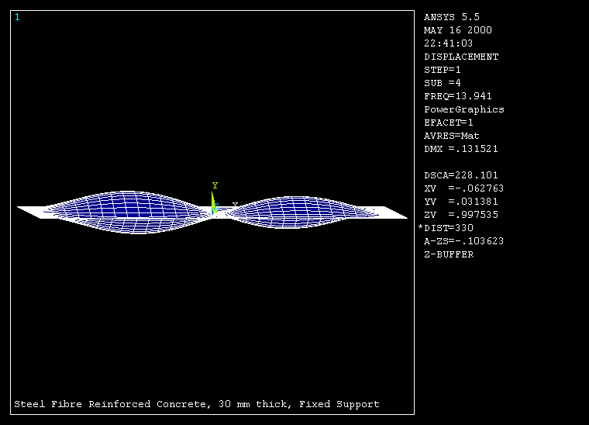

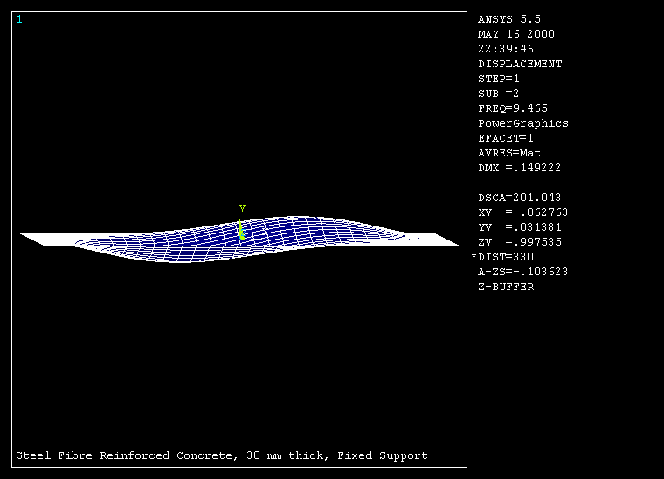

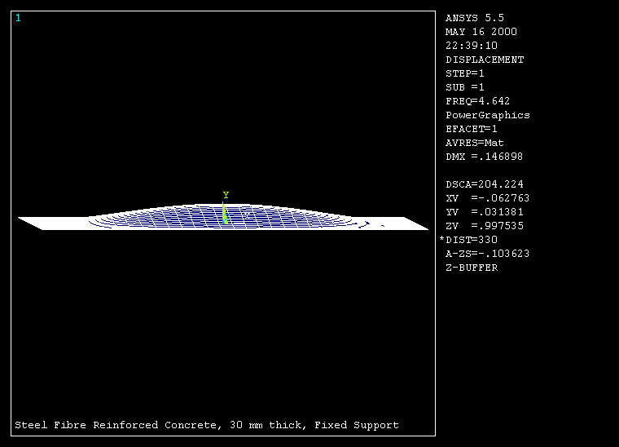

Correspondence to:
S. Elavenil
Professor in Civil Engineering, Ph. D.
S. R. M. Institute of Science and Technology
Tamilnadu 603203, India
Email address: s_elavenil@yahoo.com

G. M. Samuel Knight
Professor of Structural Engineering, Ph. D.
Anna University, Chennai 600025 Tamilnadu, India,

Received: September 12, 2006.

References
- Duggon and Ochoa, Natural Frequency behaviour of damaged composite materials. Journal of Sound and Vibration. 1992;158(3):540– 545.
- Straznicky et al. Damage resistance in composite material. in Proc., Tenth International Conference on composite materials, Whistler B.C., Canada, pp: 607-614,1995.
- Nurick and conoly. Response of clamped single and doubled stiffened rectangular plates subjected to blast loads. in Proc., Third International Conference on structures under shock and impact, Madrid, Spain, June 94, pp:207 – 220.
- P. J. Deolasi, P. K. Data and D. L. Prabhakara,’Buckling and vibration of rectangular plates subjected to partial edge loading, Journal of Structural Engineering. 1955;22(3):135 – 144.
- Mallikarjuna and T. Kant. Dynamics of fibre reinforced unsymmetrically laminated composite – Sandwitch plates using a refined theory with finite elements. Journal of Structural Engineering, 1991;18 (3):89 – 98.
- D. L. Prabakara and P. K. Datta. Static and Dynamic behaviour of rectangular plates with internal flaws subjected to a pair of concentrated loading, Journal of Structural Engineering. 1997;23 (4):183 – 187.

