Research Article
Influence of Subchronic Exposure of Profenofos on Biochemical Markers and Microelements in Testicular Tissue of Rats

Afaf A. El-Kashoury
Department Of Mammalian And Aquatic Toxicology, Central Agricultural
Pesticides Laboratory, Agricultural Research Center, Giza, Egypt, imankam_2@hotmail.com
____________________________________________________________________________
ABSTRACT: To investigate the effect following subchronic exposure to the organophosphorous insecticide of common name profenofos, which extensively used in agriculture, on the key enzymes of fertility and the concentration of microelements in testicular tissues in male albino rats. Methods: Adult male albino rats were orally administered with profenofos at a does of 23.14 mg/kg body weight per day for 60 days, emulsifying in 0.4 ml tap water. The control group received equal volume of tap water. Twenty-four hours after the last treatment the rats were sacrificed using anesthetic ether. Epididymus and testes were collected, cleaned and weight. Then epididymus prepared in buffer saline and spermatozoa were examined with light microscopy for concentration and motility. Testes were fractionated and supernatant of testicular homogenate was obtained by centrifugation, activities of alkaline and acid phosphatases, lactate dehydrogenase and total protein as well as concentration of microelements; Copper, Iron, Zinc and Selenium were measured. Moreover, the testes were histologically examined. Results: The epididymus and testes weights were significantly decreased. Reduction in sperm count was recorded in cauda epididymus in profenofos treated group, associated with decreased motility. Total protein (TP) level exhibited an elevation in testicular tissue in comparison with the control group. There was significant decrease in the activities of alkaline and acid phosphatase (ALP and ACP) and lactate dehydrogenase (LDH). A totally different trend was observed for the level of microelements; Copper (Cu), Zinc (Zn), Iron (Fe) and selenium (Se) where a sharp augmentation in the element levels was noticed in profenofos-treated rats compared with the control group. Treatment-dependent histopathological changes were seen in testes. Conclusion: Profenofos alters testicular functions possible by inhibition the activities of marker enzymes and inducing alteration in microelements levels, thereby disrupting male reproduction. [Journal of American 2009: 5(1), 19-28] (ISSN: 1545-1003)

Key words: Profenofos, Lactate dehydrogenase

1. INTRODUCTION
Organophosphorous insecticides (OPIs) have been considered as genuine alternatives to chlorinated (O'Ch) insecticides due to their broad-spectrum pesticidal properties and relatively shorter persistence after applications (Sharma et al., 2005). OPIs in addition to their intended effects like control of insects or other pests are sometimes found even to effect non-target organisms including human beings (Chantelli-Forti et al., 1993; Chaudhuri et al., 1999). Exposure to low level OPIs is known to produce a variety of biochemical changes, some of which may be responsible for the adverse biological effects reported in humans and experimental animals (Sutatos, 1994). There is growing concern that environmental chemicals both natural and man-made, having estrogenic property may be causing a variety of reproductive disorders in wildlife and human population (Chitra et al., 1999). The testes of humans and other mammals are highly susceptible to damage produced by genetic disorders, environment or occupational exposure to chemical or other means. Specific causes of testicular damage have been catalogued (Jadaramkunti and Kaliwal, 2002). Mainly, much data are available about biochemical analysis of seminal plasma. However, not many studies have been conducted in animals yet (Pesch et al., 2006). Analysis of enzyme activities and concentrations of microelements can estimate integrity and function of testes, in man; analysis of seminal plasma enzymes and microelements has been performed accurately and much is known about the importance of the "right contents" of seminal plasma (Pandy et al., 1983; Chia et al., 2000; Huang et al., 2000 and Stanwell-Smith et al., 1983). It has been reported that, pesticides with such properties have been shown to cause overproduction of reactive oxygen species (ROS) in both intra and extra cellular spaces, resulting in a decline of sperm count and infertility in wildlife and human (Gangadharan et al., 2001).

Trace elements, such as Copper (Cu), Zinc (Zn), and Selenium (Se) have a pivotal role in the spematogensis (Homma-Taked et al., 2003) Ionic environment has a high influence on sperm function (Hamameh and Gatti, 1998), profenofos belongs to the phosphorothioate class of OPIs. It widely used for a variety of agricultural and public health applications, previous studies suggest that profenofos considered as one of the male reproductive toxicant (Moustafa et al., 2007). In spite of the extensive use of profenofos in crop protection and in the household, information related to its effects on health with particular reference to reproductive toxicity are scarcely. Therefore, the objective of this study was to clarify the effect following subchronic exposure to profenofos on testicular functions by measuring the fertility indices (sperm count and motility), the activity of specific enzymes that responsible of spermatogenesis (alkaline and acid phosphatases and lactate dehydrogenase) and total protein level as well as concentrations of the essential microelements; Copper (Cu), Iron (Fe), Zinc (Zn) and Selenium (Se) in testicular tissue of male rats.

2. MATERIALS AND METHODS
The active substance profenofos produced by Syngenta multi national comp. under trade name: Selecron 72% EC was used. Tap water was used for preparing emulsion of profenofos immediately before use and orally administered into animals by osophageal intupation (per OS.). The median lethal dose (LD₅₀) of profenofos (per OS.) was determined according to Weil (1952) and its value was 185.13 mg/kg body weight.

In this investigation, thirty male Wistar albino rats, rattus norvegicus were obtained from the breeding unit of the Egyptian organization for the Biology and vaccine production, Egypt. Male rats initially weighing 150+10g were used. Animals were allowed to be acclimatized to laboratory conditions; of temperature at 25+2⁰C, humidity (30-70%) and light (12-h dark: 12-h light) and kept on balanced diet and water ad libitum for 2 weeks prior to the experiment. Animals were housed throughout the experiment in polypropylene cages (with each cage housing five animals) containing paddy husk as bedding.
2-3 Experimental Design. Rats were randomly divided into two comparable groups as follows, First group: (n = 10) served as normal control and animals were received the vehicle (tap water). Second group: (n = 20) animals were orally dosed for 60 days with profenofos at 23.14 mg/kg body weight (4 doses/week). Clinical signs were monitored daily and animals were weighed twice weekly throughout the experiment and the dose was adjusted accordingly.

After completion of treatment period (60 days), animals were anaesthetized with ether and sacrified. The testes and epididymus were removed immediately, cleaned of the adhering tissues and weighted. Fertility-related parameters (sperm count and motility) were performed by dissecting out the Cauda epididymus and teasing it in a known volume of normal saline at 37⁰C. Sperm counting was done using a haemocytometer according to the method of Feustan et al. (1989). The right testes were kept in a deep freezer (-40⁰C) for biochemical estimations and microelements detection. Left testes were removed and fixed in 10 % formalin for routine histopathology.

Frozen testes were washed with saline solution, then minced and homogenized (10% W/V) in ice-cold saline, using a chilled glass-teflon porter-Elvehjem tissue grinder tube. The homogenate was centrifuged at 10,000 xg for 20 min. at 4 ⁰C and the resultant supernatant used for determination of protein contents, Tp (Bradford, 1976); alkaline phosphatase, ALP (Babson, 1965) and acid phosphatase ACP (Babson and Read, 1959). Also, a 10% homogenate of testes was prepared in ice-cold 0.1M phosphate buffer, the homogenate was centrifuged at 12,000 xg for 30 min. at 4⁰C. the supernatant used for determination of lactate dehydrogenase, LDH (Moss and Henderson, 1994).

For the histopathological observations at light microscopic level, fresh testes were immersion fixed in 10% formalin saline. Following an overnight fixation, the specimens were dehydrated in ascending grades of alcohol, cleared in benzene and embedded in paraffin wax. Blocks were made and 5um thick sections were double stained with hematoxylin and eosin and observed under microscope (Banchraft et al., 1996).

The concentrations of the microelements Copper (Cu), Iron (Fe), Zinc (Zn) and Selenium (Se) in testicular tissues were measured according to the procedure which reported in AOAC (2004), by using atomic absorption spectrophotometer (Thermo Jarel Ash-AA-ScanI).

Data analysis and evaluation of statistical significance among different values determined was done using the student's t-test. Statistical differences with a value of p<0.05 were considered significant (Snedecor and Cochran, 1980).

3. RESULTS
The variations in the testes and epididymus weights of animals subjected to profenofos treatment are shown in Table (1). There was significant decrease (p<0.05) and (P<0.001) in weights of the testes and epididymus, respectively, as compared to control group.

Table 1
Effect of oral administration of profenofos on testes and
epididymus weights of rats after sub-chronic exposure (60 days)
Parameter | Control group | Profenfos-treated group 23.14 mg/kg body weight
Testes weight (g) | 1.52  ± 0.040 | 1.40  ± 0.004*
Epididymus weight (g) | 0.37  ± 0.014 | 0.02  ± 0.008***
Data represent mean ± SE, n = 5, * P< 0.05, *** P< 0.001 (Student’s t-test)

The effect of oral administration of profenofos for 60 days on sperm count and motility in cauda epididymus is shown in Table (2). The spermatozoal density (count) increased significantly (p<0.05) in profenofos-treated group in comparison with the control group. Similarly, spermatozoal motility was also found to be significantly decreased (p<0.001).

Table 2
Effect of oral administration of profenofos on semen parameters in cauda
epididymus of rats after sub-chronic exposure (60 days):
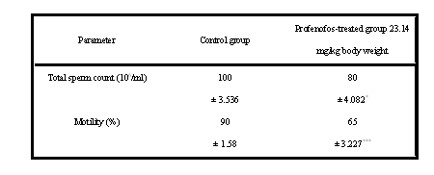
Data represent mean ± SE, n = 5, * P<0.05 , *** P<0.001 (student’s t-test)

Results of testicular biochemistry have been depicted in Table (3). Alkaline (ALP), acid (ACP) phosphatese and lactate dehydrogenas (LDH) activities were recorded to have decreased (p<0.001, p<0.05 and p<0.01, respectively) in profenofos-treated group as compared to control group. In addition, total protein level was found to be significantly raised (p<0.05) in treated group in comparison with the control group.

Table 3
Effect of oral administration of profenofos on some testicular
biochemical parameters in rats after sub-chronic exposure (60 days)

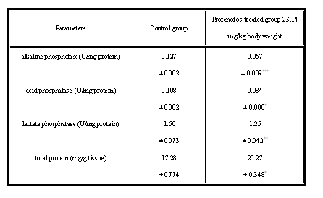
Data represent mean ± SE, n = 4, * P<0.05,** P<0.01, *** P<0.001 (student’s test)

In addition to the findings listed above, we have observed the presence of microscopic changes in the testes of male albino rats. Histological findings of testes from control and treated groups are presented in figs. 1, 2, respectively. Normal control animals, revealed normal mature seminiferous tubules with complete series of spermatogenesis and high spermatozoal concentration in the lumen (fig.1) Profenofos-intoxicated animals indicated that there were few numbers of sperm cells in the lumen of the seminiferous tubules (fig. 2), in correlation with the control one.

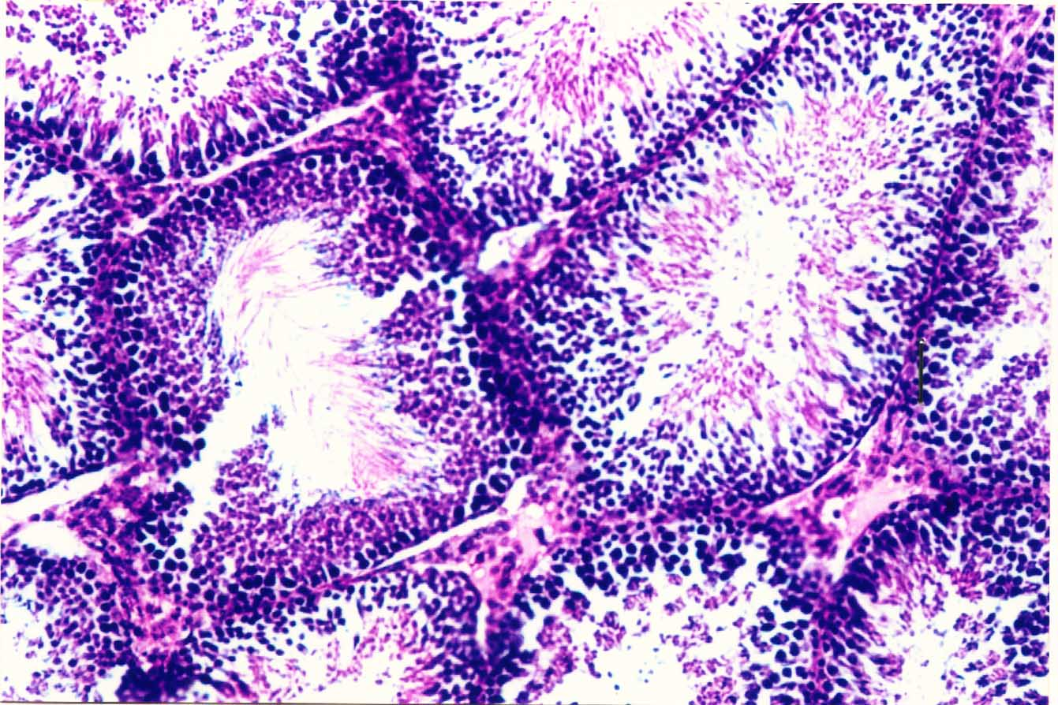

Fig 1: Testes of rat in control has shown the normal
histological structure of the seminiferous tubules in nature active condition.

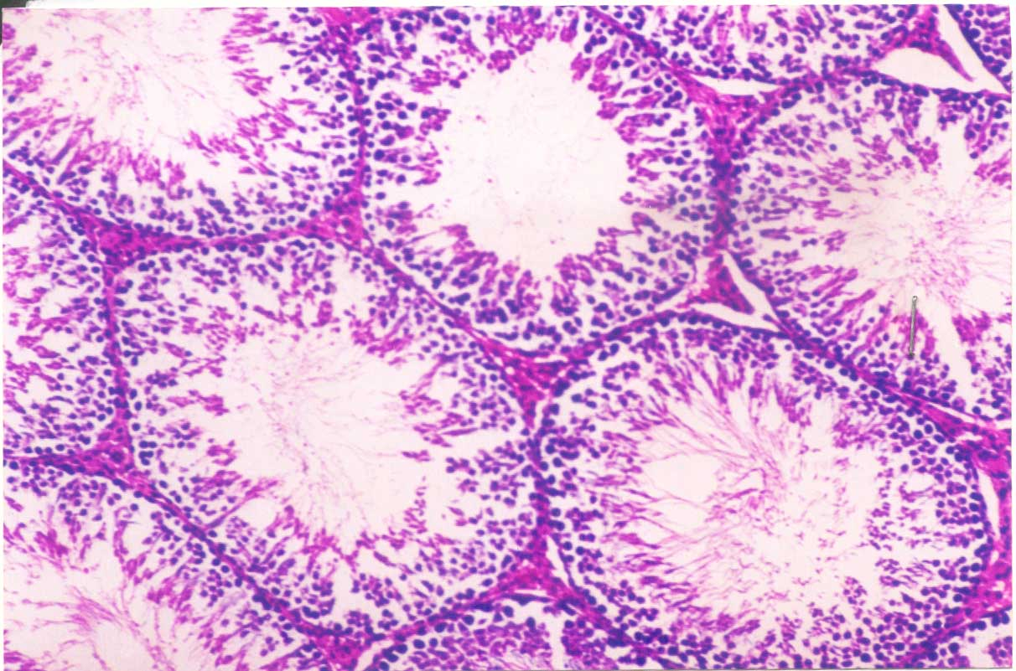

Fig 2: Testes of rat treated by profenofos showing low amount
of sperms in the lumen of the semineferous tubules.

Table 4
The Testicular tissue contents of microelements in
profenofos-treated rats after sub-chronic exposure (60 days)

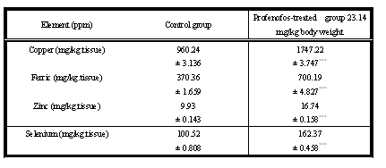
Data presented mean ± SE of five individual values.

The effect of oral administration of profenofos for the 60 days on testicular tissue contents of microelements is depicted in table (4).profenofos treatment produced significant increase (p<0.001) in iron (Fe), copper (Cu), zinc (Zn) as well as in selenium (Se) levels.

4. DISCUSSION
Organophosphates (OPIs) are among the most widely used synthetic insect pesticides. The wide spread use of OPIs has stimulated research into the possible extence of effects related with their reproductive toxic activity (Joshi et al., 2007). The present study results demonstrated that 60 day’s exposure of male rats to profenofos at the dose 23.14 mg/kg body weight (4 doses/week) resulted in decreased the testes and epididymus weights, male fertility indices (sperm count and motility), and activities of ALP, ACP and LDH but increased levels of total protein and microelements (Cu, Fe, Zn and Se) in testicular tissues. Our results showed that the weights of testes and epididymus were significantly lower in the profenofos-treated rats than in the controls. The decrease in testicular weight in treated rats may be due to reduced tubule size, spermatogenic arrest and inhibition of steroid biosynthesis of leydig cells, a site of steroid biosynthesis (Sujatha et al. ,2001 and Kaur and mangat, 1980). The decrease in testicular weight in profenofos-treated rats may indicate impairment at testicular, pituitary, or hypothalamic level (Chitra et al. ,1991). Similar results were recorded by Ref Joshi et al. (2007), who mentioned that chlorpyrifos (OPIs) at dose levels of 7.5, 12.5 and 17.5 mg/kg b.wt./day, for 30 days, decreased significantly the weight of testes. The epididymus is androgen-dependant organ, relying on testosterone for its growth and function (Klinefelter and Hess, 1998). On discussing the results with previous reports, it is proposed that profenofos probably imped the activity of testes and epididymus by inhibition of androgen production or its direct action on these organs (Kaur and mangat, 1980), thus, the reduction in the weights of testes and epididymus in our study may be due to lower bioavailability of androgen (Sujatha et al. ,2001). Moreover, the deleterious effects of profenofos on reproductive organ weights might be due to a decrease in the testosterone (T) and thyroid hormone levels after 60 days from the onset of the treatment (Takizawa and Horii, 2002).

The present results confirm the previous reports of (El-kashoury and El-far, 2004) who mentioned that administration of rats with profenofos at 23.14 and 46.30 mg/kg body weight for 28 days and 60 days, respectively, induced significant decrease in thyroid hormone levels, there is ample evidence that thyroid hormone is essential to the normal development of testes in the neonate (Cook et al. ,1994 and Hardy et al. ,1996), as well as an elevation in cholesterol level, a precursor of steroid hormone had occurred. Authors also, mentioned that inhibition of hepatic microsomal 7-hydroxylation of cholesterol by profenofos leads to reduction of cholesterol break down and its accumulation. Sperm count is one of the most sensitive tests for spermatogenesis and it is highly correlated with fertility. Our results revealed that, treatment of rats with profenofos significantly reduced the sperm count and motility. The decreased sperm motility and density (count) after oral administration of profenofos is may be due to androgen insufficiency (Chaudhary and Joshi, 2003) which caused impairment in testicular functions by altering the activities of the enzymes responsible for spermatogenesis (Sinha et al. ,1995 and Reuber, 1981).
Histological structure of the testes confirmed the aforementioned results, where it is revealed degeneration in some of seminiferous tubules associated with low luminal spermatozoal concentration. It is tempting to speculate that the decreased sperm motility in the present study may have been related to our earlier studies on profenofos (El-kashoury and El-far, 2004) which pointed that subclinical hypothyroid state in rats administered with profenofos for 60 days had occurred. Also, men with hypothyroid have been reported to have lower sperm motility than euthyroid controls (Corrales – Hernandez et al. ,1990) and thyroxine (T4) replacement in men with hypothyroidism is reported to improve sperm motility (Kumar et al. 1990). Moreover, it had been reported that chlorpyrifos brought about marked reduction in epididymal and testicular sperm counts in exposed males (Joshi et al., 2007). Also, testicular atrophy and degenerative changes in the seminiferous tubules had been reported in experimental animals administered with various O’Ch and OPIs pesticides (Dutta and Dikshith, 1973). Based on the data obtained in this study, administration of profenofos into male albino rats reduced the activities of acid and alkaline phosphatase and lactate dehydrogenase which reflect suppression in testicular function (Johnson et al. ,1970). Activities of markers enzymes viz ALP, ACP and LDH are considered to be functional indicators of spermatogenesis.

Our results confirm the findings of (Salem et al. ,1989) who investigated the influence of methamidophos (O’ps) on mammals. Results showed that treatment of male rats with methamidophos, at 100 ppm in drinking water for 9 and 45 days, reduced significantly acid and alkaline phosphatase and lactate dehyrogenase in testicular tissue. Also, (Mustafa et al. ,2007) reported that profenofos considered as one of the male reproductive toxicants. ALP is primary of testicular and epididymual origin and, therefore, suitable for differentiation of oligo-and azoospermia (Turner and Sertich, 2001; Turner and McDonell, 2003). Decline in ALP activity indicated that profenofos treatment produced a state of decreased steroidogenesis where the inter and intercellular transport was reduced as the metabolic reactions to channelize the necessary inputs for steroidogenesis slowed down (Latchoumycandane et al. ,1997). Acid phosphatases are enzymes capable of hydrolyzing orthophosphoric acid esters in an acid medium. The testicular acid phosphatase gene is up-regulated by androgens and is down-regulated by estrogens (Yousef et al. ,2001). Activities of phosphatases enzymes have been shown to rise when testicular steroidogenesis is increased (Mathur and Chattopandhyay, 1982).

Also, (Latchoumycandane et al. ,1997) mentioned that a decrease in ACP activity in free state would thus reflect decreased testicular steroidogenesis in rats and this may be correlated with the reduced secretion of gonadotrophins. LDH is associated with the maturation of germinal epithelial layer of seminiferous tubules and associated with post meiotic spermatogenic cells (Sinha et al., 1997). An inhibition in the activity of LDH in testes of profenofos-treated rats points toward the interference of profenofos with the energy metabolism in testicular tissues (Mollenhauer et al., 1990). The correlation between LDH and motility and living sperm could be a sign that extracellular LDH ensures metabolism of spermatozoa, perhaps even in anaerobic conditions (Pesch et al., 2006).

As regards the testicular protein, results of the present study exhibit an increase in its level in profefos-treated rats. The testicular fluid contains both stimulatory factors as well as inhibitory factors that selectivity alter the protein secretions (Brooks, 1983). Thus, the changes in protein suggested that there is a reduction in the synthetic activity in testes. An elevation in testicular protein in the present study confirms the previous results by (Joshi et al., 2007) who mentioned that the protein content was raised at significant levels in chlorphrifos-treated rats. Gupta et al. (1981) and Singh and Pandey (1989) illustrated that an elevation in the testicular protein may be due to the hepatic detoxification activities caused by endosulfan (O'ch) which results in the inhibitory effect on the activities of enzyme involved in the androgen biotransformation (Dikshith and Dutta, 1972).

Similar results showed the same trend in the protein content caused by several pesticides, at different periods and / or different concentrations, had been also reported (Shivanandappa and Krishnakumari (1981), Bhatnagar and Malviya, 1986; Chitra et al., 1999; Choudhary and Joshi, 2003). In accordance with the findings of the present study, Rao and Chinoy (1983), suggested that the accumulation of protein occurred in testes and epididymus due to androgen deprivation to target organs. This deprivation effect also led to a reduction in testicular and cauda epididymus sperm population, loss of motility in the latter and an increase in number of abnormal spermatozoa, thereby manifesting 100% failure in treated animals. Results of the present investigation showed that administration of profenofos into male rats increased the concentration of trace elements; Cu, Fe, Zn and Se in testicular tissue, which have a pivotal role in spermatogenesis (Homma-Takeda et al., 2007). These findings are not in accordance with those of Salem et al. (1989), who stated that treatment of rats with methamidophos (OPIs), for 45 days, decreased the concentrations of Zn and Se in the testicular tissues. On the other hand, similar results were recorded by Al-Bayati et al. (1988), who mentioned that 2, 3, 7, 8-tetrachlorodibenzo-p-dioxin (TCDD), O'ch, produced atrophy, morphological changes and impaired spermatogenesis in testes of experimental animals. In addition, testicular tissue contents of Fe, Cu, and Zn were significantly increased in the treated rats. Zinc (Zn) markedly increased the ALP and ACP activities and this occurred concomitantly with the appearance of spermatids and mature sperm cells (Guha and Vanha-Perttula, 1983). Selenium is an essential trace nutrient for humans and animals. It is an essential at lower concentrations and toxic at higher concentrations. Se is required for normal testicular development and spermatogenesis in rats (Behne et al., 1996). The selinodeiodinase enzymes (types I, II and III iodothyronine deiodinase) control the metabolism of thyroid hormone, which is essential for the normal development (Defrance et al., 1995) and function (Latchoumycandane et al., 1997) of testes in rats. The above explanation supports our findings where elevated testicular tissue content of Se associated with decrease in testicular weight, sperm count and motility in profenofos-treated rats. In support of these findings, earlier results (El-Kashoury and El-Far, 2004) revealed that treatment of rats with profenofos at the same dose and time interval decreased markedly (T₃) level in plasma in comparison with the control group.

Cupper is necessary for many enzymes like the Cu-Zn-Superoxide dismutase (SOD), which is involved in cell protection against free (Oxygen) radicals. Copper is also needed for the cytochrome C oxidase that is responsible for energy supply and for cellular and humoral immunity (Leonhard-Marek, 2001). As regards Cu concentrations, an administration of rats with profenofos increased testicular tissue contents of Cu by 2-fold, respectively. Elevated Cu concentrations reduced oxidative processes and glucolysis that may cause immotility and reduced viability (Leonhard-Marek, 2001). A proposed mechanism could explain elevated iron concentrations in testicular tissues in profenfos-treated rats, is that iron is known to be essential and mostly bound to transferrin (produced by sertoli cells), haptoglobin (sertoli, leydig and germ cells) and lactoferrin (spermatozoa and vascular gland). These proteins contain catalytic inactive iron which avoids extensive oxidation (Leonhard-Marek, 2001). Results of the present investigation suggested that profenofos may impede the utilization of micro-elements in the testes, consequently stagnation of Cu, Fe, Zn and Se in the testes occurred. It is concluded that profenofos induced adverse effects on testicular function by altering biomarker enzymes activities as well as disrupting micro-elements levels, thus care should be taken and more studies should be done to increase the validity of those information.

Abbreviation used:
OPIs, organophosphorous insecticides; O'Ch, organochlorine, TP, total protein, ALP, alkaline phosphatase; ACP, acid phosphatase; LDH, lactate dehydrogenase; Cu, Copper; Zn, Zinc; Fe, Iron; Se, Selenium; Ec, Emulsifiable concentrate; T₄, Thyroxine; T₃, Triiodothyronine; T, Testosterone; Ros, Reactive oxygen species.
REFERENCES
- A.O.A.C. (2004). Association of official analytical chemistry.
- Al-Bayati, Z.A.; Wahab, Z.Z. and Stohs, S.J. (1988). 2, 3, 7, 8 Tetrachlorodibenzo-p-dioxin (TCDD)-induced alterations in lipid peroxidation, enzymes and divalent cations in rat testis. Xenobiotica. 18: 1281-1289.
- Babson, A.L. and Ready, A.P. (1959). Colourimetric method for the determination of total and prostatic acid phosphatase. Am. J. Clin. Path., 32 : 89-91.
- Babson, L.A. (1965). Phenolphalein monophosphate methods for the determination of alkaline phosphatase. Clin. Chem., 11 : 789.
- Banchraft, J.D.; Stevens, A. and Turner, D.R. (1996). Theory and practice of histological techniques. 4th Ed., Churchill Livingstone, New York, London, San Francisco, Tokyo.
- Behne, D.; Weiler, H. and Kyriakopoulos A. (1996). Effects of selenium deficiency on testicular morphology and function in rats. J. Repord Fertile. 106: 291-297.
- Bhatnagar, V.K. and Malviya, A.N. (1986). Changes in some biochemical indices in rat upon pesticide toxicity. Indian J. Biochem. Biophys., 15 : 78-81.
- Bradford, M.M. (1976). A rapid and sensitive method for the quantitation of microgram quantities of protein utilizing the principle of protein-dye binding. Analyt. Biochem., 72 : 248-254.
- Brooks, D.E. (1983). Effect of androgen on protein synthesis and secretion in various regions of the rat epididymis, as analysed by two dimensional gel electrophoresis. Mol. Cell Endocrinol., 29 : 255-270.
- Chantcli-Forti, G.; Paolini, M. and Hrelia,P. (1993). Multiple end point procedure to evaluate risk from pesticides. Environ. Health perspect. 101, 15-20.
- Chaudhuri,K.; Selvaraj, S. and Pal, A. K. ( 1999). Studies on the genotoxicity of endosulfan in bacterial systems. Mutat. Res. 439, 63-67.
- Chia, S.E.; Ong, C.N.; Chua, L.H.; Ho, L.M. and Tay, S.K. (2000). Comparison of zinc concentrations in blood and seminal plasma and the various sperm parameters between fertile and infertile men, J Androl. 21: 53-57.
- Chitra, K.C.; Latchoumycandane, C. and Mathur, P.P. (1999). Chronic effect of endosulfan on the testicular functions of rat. Asian J. Andrology, 1 : 203-206.
- Choudhary, N. and Joshi, S.C. (2003). Reproductive toxicity of endosulfan in male albino rats. Bull. Environ. Contam. Toxicol., 70 : 285-289.
- Cooke, P.S.; Zhao, Y.D. and Bunick, D. (1994). Triiodothyronine inhibits proliferation and stimulates differentiation of cultured neonatal sertoli cell: Possible mechanism for increase adult testis weight and sperm production induced by neonatal goitrogen treatment. Biol. Reprod. 51: 1000-1005.
- Corrales-Hernandez, J.J.; Miralles-Gareia, J.M. and Garcia-Diez, L.C. (1990). Primary hypothyroidism and human spermatogenesis. Arch. Androl. 25: 21-27.
- Defrance, L.R.; Hess, R.A.; Cooke, P.S. and Russell, L.D. (1995). Neonatal hypothyroidism causes delayed sertoli cell maturation in rats treated with propylthiouracin: Evidence that sertoli cell controls testis growth. Anat. Rec. 242: 57-69.
- Dikshith, T.S.S. and Dutta, K.K. (1972). Pathological changes induced by pesticides in the testes and liver of rats. Exp. Pathol., 7 : 309-316.
- Dutta, K.K. and Dikshith, T.S.S. (1973). Histopathologic changes in the testes and liver of rats repeatedly exposed to pesticides. Exp. Pathol., 8 : 363-370.
- El-Kashoury, A.A. and El-Far, F.A. (2004). Effect of two products of profenofos on thyroid gland, lipid profile and plasma APO-1/FAS in adult male albino rats, Egypt. J. Basic and Appl. Physiol., 3: 213-226.
- Feustan, M.H.; Bodnai, K.R. and Kerstetter, S.L. (1989). Reproductive toxicity of 2-methoxy ethanol applied dermally to occluded and non-occluded sides in male rats. Toxicol. Appl. Pharmacol., 100 : 145-165.
- Gangadharan, B.; Murugan, M.A. and Mathur, P.P. (2001). Effect of methoxychlor on antioxidant system of goat epididymal sperm in vitro. Asian J. Androl., 3 : 285-288.
- Guha, K. and Vanha-Perttula, T. (1983). Acid phosphatases in the mouse testis: activity changes during development. Arch-Anorl. 10 (1): 7-16.
- Gupta, P.K.; Shrivastava, S.C. and Ansari, R.A. (1981). Toxic effects of endosulfan on male reproductive organs in rats. Indian J. Biochem. Biophys., 18 : 159-163.
- Hamameh, S. and Gatti, J.L. (1992). Role of the ionic environment and internal pH on sperm activity, Hum Repord Suppl. 4: 20-30.
- Hardy, M.P.; Sharma, R.S.; Arambepola, N.K.; Sottas, C.M.; Russell, L.D.; Bunick, D.; Hess, R.A. and Cooke, P.S. (1996). Increased proliferation of leydig cells induced by neonatal hypothyroidism in the rat. J. Androl. 17: 231-238.
- Homma-Takeda, S.; Nishimura, Y.; Watanabe, Y. and Yukawa, M. (2007). Site-specific changes in zinc levels in the epididymus of rats exposed to ionizing radiation. Nuclear instruments and methods in physics research section B. Beam interactions with materials and atoms. 260: 236-239.
- Huang, Y.L.; Tsen, W.C.; Cheng, S.Y. and Lin, T.H. (2000). Trace elements and lipid peroxydation in human seminal plasma, Biol. Trace element. 76: 207-215.
- Jadaramkunti, U.C. and Kaliwal, B.B. (2002). Dicofol formulation induced toxicity on tests and accessory reproductive organs in albino rats. Bull. Environ. Contam. Toxicol., 69 : 741-748.
- Johnson, A.D.; Gomes, M. and Vandemark, N.L. (1970). The testis. 1st Ed., Academic Press, New York and London.
- Joshi. S.C.; Mathur, R.; Gilati and Tags, N. (2007). Testicular toxcity of chlorpyrifos (an organophosphate pesticide) in albino rat. Toxicol Ind Health. 23: 439-444.
- Kaur, C. and Mangat, H.K. (1980). Effects of estradiol dipropionate on the biochemical composition of testes and accessory sex organs of adult rats. Andrologia, 12 (4) : 373-378.
- Klinefelter, G.R. and Hess, R.A. (1998). Toxicology of the male excurrent ducts and accessory sex glands. In : Reprod. and Dev. Toxicol., pp. 553-591, New York, Basel, Hong Kong; Marcel Dekker, Inc.
- Kumar, B.J.; Khurana, M.L.; Ammini, A.C.; Karmarkar, M.G. and Ahuja, M.M.S. (1990). Reproductive endocrine functions in men with primary hypothyioidism: Effect of thyroxine replacement. Horm. Res. 34: 215-218.
- Latchoumycandane, C.; Gupta, S.K. and Mathur, P.P. (1997). Inhibitory effects of hypothyrodism on the testicular functions of postnatal rats. Biomed. Lett., 56 : 171-177.
- Leonhard-Marek, S. (2001). Influence of drugs, pollution and trace elements on male fertility. In: Busch, W. and Holzmann, A. Editors, Andrology in veterinary medicine, Stuttgart, Schattauer, pp. 474-481.
- Mathur, P.P. and Chattopadhyay, S. (1982). Involvement of lysosomal enzymes in flutamide-induced stimulation of rat testis. Andrologia, 14 : 171-176.
- Mollenhauer, H.H.; Morre, D.J. and Rowe, L.D. (1990). Alteration of intracellular traffic by monensin : mechanism, specificity and relationship to toxicity. Biochem. Biophys. Acta, 1031 : 225-246.
- Moss, D. W. and Handerson, A.R. (1994). Lactate dehydrogenase 2nd Ed., Textbook of clinical chemistry, chapter 20, Enzymes, pp. 812-818
- Moustafa, G.G.; Ibrahim, Z.S.; Hashimoto Y; Alkelch A.M.; Sakamoto K.Q.; Ishizuka M. and Fujita S. (2007). Testicular toxicity of profenofos in matured male rats. Arch Toxicol.
- Pandy, V.K.; Parmeshwaran, M. and Soman, S.D. (1983). Concentrations of morphologically normal, motile spermatozoa: Mg, Ca and Zn in the semen of infertile men, Sci Total Environ 27: 49-52.
- Pesch, S.; Bergmann, M. and Bostedt, H. (2006). Determination of some enzymes and macro-and microelements in stallion seminal plasma and their correlations to semen quality. Theriogenology. 66: 307-313.
- Rao, M.V. and Chinoy, N.J. (1983). Effect of estradiol benzoate on reproductive organs and fertility in the male rat. Eur. J. Obstet. Gynecol. Reprod. Biol., 15 (3) : 189-198.
- Reuber, M.D. (1981). The role of toxicity in the carcinogenicity of endosulfan. Sci. Total. Environ., 20 : 23-47.
- Salem, H.A.; Younis, M.; El-Tohamy, M.; El-Herrawie, M.; Soliman, M. and Khalaf, A. (1989). Thyrotrophic and thyroid hormones concentration and some testicular biochemical parameters as affected by oral administration of methamidophs (Organophosphorus) into adult male rats. J. Egypt. Vet. Med. Ass. 49: 667-675.
- Sharma, Y.; Bashir, S.; Irshad, M.; Nag, T.C. and Dogra, T.D. (2005). Dimethoate-induced effects on antioxidant status of liver and brain of rats following subchronic exposure. Toxicology, 215 : 173-181.
- Shivanandappa, T. and Krishnakumari, M.K. (1981). Histochemical and biochemical changes in rats fed dietary Benzene hexachloride. Indian J. Exp., 19 : 1163-1168.
- Singh, S.K. and Pandey, R.S. (1989). Differential effects of chronic endosulfan exposure to male rats in relation to hepatic drug metabolism and androgen biotransformation. Indian J. Biochem. Biophys., 26 : 262-267.
- Sinha, N.; Narayan, R. and Saxena, D.K. (1997). Effect of endosulfan on the testes of growing rats. Bull. Environ. Contam. Toxicol., 58 : 79-86.
- Sinha, N.; Narayan, R.; Shanker, R. and Saxena, D.K. (1995). Endosulfan-induced biochemical changes in the testis of rats. Vet. Hum. Toxicol., 37 (6) : 547-549.
- Snedecor, G.W. and Cochran, W.G. (1980). Statistical methods (7th ed). Lowa State University Press. Ames.
- Stanwell-Smith, R.; Thompson, S.G.; Haines, A.P.; Ward, R.J. Cashmore, G. and Stedronska, J. (1983). A comparative study of zinc, copper, cadmium and lead levels in fertile and infertile men, Fertile Steril. 40: 670-677.
- Sujatha, R.; Chitra, K.C.; Latchoumycandane, C. and Mathur, P.P. (2001). Effect of lindane on testicular antioxidant system and steroidogenic enzymes in adult rats. Asian J. Androl., 3 : 135-138.
- Sultatos, L.G.(1994). Mammalian toxicity of organophosphorus pestiside. J. Toxicol. Environ. Health 43, 271-289.
- Takizawa, S. and Horii, I. (2002). Endocrinological assessment of toxic effects on the male reproductive system in rats treated with 5-fluorouracil for 2 or 4 weeks. J. Toxicol. Sci., 27 (1) : 49-56.
- Turner, R.M. and McDonnell, S.M. (2003). Alkaline phosphatase in stallion semen : characterization and clinical applications. Theriogenology, 60 : 1-10.
- Turner, R.M. and Sertich, P.L. (2001). Use of alkaline phosphatase activity as a diagnostic tool in stallions with a zoospermia and oligospermia. Anim. Reprod. Sci., 68 : 315-316.
- Weil, C.S. (1952). Tables for convenient calculation of medium effective (LD50 or EC50) and instruction in their use. Biometrics, 8 : 249-263.
- Yousef, G.M.; Diamandis, M.; Jung, K. and Eleftherios, P. (2001). Molecular cloning of a novel human acid phoshatase gene that is highly expressed in the testes. Genomics, 74 (3) : 385-395.

