Research Article
Conservation through in vitro method: A case of plant regeneration through somatic embryogenesis in Quercus semecarpifolia Sm.

¹Sushma Tamta , ² Lok Man S. Palni, ²P. Vyas and ²M.S.Bisht
¹Botany Department, D. S. B. Campus, Kumaun University, Nainital, UA, 263 002, India.
²G.B.Pant Institute of Himalayan Environment and Development, Kosi-Katarmal, Almora, UA, 263 643, India
____________________________________________________________________
An efficient and reproducible protocol for in vitro propagation via somatic embryogenesis (direct as well as indirect) induced on cotyledon halves (with embryo) taken from seeds of Quercus semecarpifolia (Sm.) has been developed. Direct as well as indirect somatic embryogenesis was induced from the cotyledons on Woody plant (WP) medium supplemented with 6-Benzyladenine (BA) + Indole-3-butyric acid (IBA), and, BA + 2,4-Dichlorophenoxyacetic acid (2,4-D), respectively. Somatic embryos thus obtained were multiplied profusely on Schenk and Hildebrandt (SH) + Murashige and Skoog (MS) basal as well as BA supplemented media. Germination and conversion of somatic embryos into plantlets was achieved on SH+MS medium supplemented with BA (0.44- 8.88 μM). Rooting of in vitro produced shoots was achieved on WP (1/2 macro + full concentration of rest of the constituents) medium supplemented with IBA (14.76 μM). The plants were hardened ex-vitro and transferred to earthen pots containing garden soil. [Journal of American Science 2009: 5(1), 70-76]
(ISSN: 1545-1003)

Key words: Quercus semecarpifolia, brown oak, somatic embryogenesis, micropropagation.

1. Introduction

The genus Quercus has a wide distribution range; mostly trees, either deciduous or evergreen and is of enormous ecological and economical value. One of the species of Quercus, i.e., Quercus semecarpifolia Sm. (family-Fagaceae); common name-brown or kharsu oak; is the main forest forming evergreen tree species around 2400 m amsl in parts of Indian Himalaya (Singh and Singh, 1987). In view of the general importance of this species and problems associated with its regeneration (Tamta et al. 2008), in the present study attempt has been made for the first time to develop an efficient in vitro micropropagation method through somatic embryogenesis.

Micropropagation through somatic embryogenesis offers considerable advantages over other methods of clonal propagation; this route has a high proliferation potential. It has been considered as a very promising method of oak micropropagation (Chalupa, 1995, Wilhelm 2000, Purohit et al.2002), and was found to be highly reproducible in this study on Q. semecarpifolia. Efficient protocols on SE induction and plant regeneration have recently become available for many plant species, including Arabidopsis thaliana, a model plant in genetics and embryogenesis (Gaj, 2004).

2. Materials and methods

Plant material and surface sterilization

Seeds of Quercus semecarpifolia Sm. were collected from well grown adult tree in the natural forests at Kilbury, Nainital (2100-2400 m amsl; 29° 24′ 30″ N- 29° 27′ N lat. and 79° 25′ E- 79° 29′ 40″ E long.), Uttarakhand, India. Following surface disinfection (Tamta et al. 2008), the seed coat was removed and seeds were divided into two halves; one half containing only one cotyledon while the other half contained the other cotyledon along with the embryo. These seed halves were used as explants for inoculation.

Media and culture establishment

Three basal media, namely MS (Murashige and Skoog, 1962), WP (Lloyd and McCown, 1980) and SH+MS, i.e., a combination of macronutrients of SH (Schenk and Hilderbrandt, 1972) and the remaining constituents of MS, were used. The basal media were supplemented with various concentrations of auxins, cytokinins and gibberellins. The sucrose concentration was 3.0% (w/v) and the media were solidified with 0.8% agar (w/v). The experiments were done using glass petridishes (10 cm dia, 25 ml medium per petirdish) or conical flasks (250 ml volume, 100 ml medium per flask). Incubation of cultures was carried out at 25 ±1 °C in a 16 h light and 8 h dark cycle, with 42.0 µmol m ⁻²s⁻¹ and 60.0 µmol m ⁻²s⁻¹ irradiance inside and outside the culture flasks, respectively by cool fluorescent tubes (Philips TI 40 W/54).

Production of somatic embryos

Seed halves turned green when inoculated on WP basal medium. After seven days, cotyledons with or without the zygotic embryo, were transferred on to WP or MS medium supplemented with either BA (0.44 μM) alone or in combination with 2,4-D (4.53 μM) or IBA (4.92 μM) or GA₃ (2.89 μM). Direct as well as indirect somatic embryogenesis with the intervening callus phase was induced within 13 weeks and 18 (10 weeks for callus establishment and proliferation + 8 weeks for induction of somatic embryos) weeks of culture, respectively. In both the cases, the presence of zygotic embryo seems to have some role in the production of somatic embryos. The callus raised from cotyledons without the zygotic embryos did not survive on further subculture and degenerated. For germination of somatic embryos, formed both from the direct as well as indirect pathways, SH+MS medium supplemented with BA (0.44-8.88 μM) was used. The somatic embryos germinated to form well developed shoots, leaves and tap root system.

Adventitious rooting of microshoots

The survival rate of plantlets thus obtained; after transfer to ex vitro conditions was very poor (data not shown). Therefore, the main tap root was excised and the shoots were transferred to the rooting medium, i.e., WP (1/2 macro + full concentration of rest of the constituents) or SH + MS (macro of SH + rest of the constituents of MS) media supplemented with different auxins (Table 4), containing sucrose (3.0%; w/v) and phytagel (0.25%; w/v). Well developed adventitious roots were found to form within 4 weeks.

Transfer of plantlets to soil

After 5 weeks, the shoots with well developed roots were taken out from the culture flasks, the roots gently washed with water to remove traces of phytagel and the plantlets were then transferred to small plastic cups (8.0 cm ht; 7.0 cm dia) containing garden soil and the cups were covered with a transparent polythene sheet. Plants were kept inside a polyhouse for acclimatization for 1 month. After that the plants were transferred to the earthen pots (18 cm high; 20 cm dia) containing the same soil.

Statistical analyses

Experiments were conducted using a randomized block design to determine the effect of treatments and were repeated as described in individual experiments. For all the experiments explants were used in triplicates.

3. Results and discussion

Direct somatic embryogenesis

Globular structures were found to develop directly on the periphery of cotyledons with attached zygotic embryo, after 13 weeks on WP medium supplemented with BA and IBA (Table 1). These structures were loosely attached to the surface of cotyledons (Fig. 1A). On subculture these globular structures were converted into bipolar somatic embryos (Fig. 1B). This has been reported in some other species of Quercus (Chalupa, 1995; Gingas and Lineberger, 1989). Bipolar somatic embryos were also observed in Q. robur (Cuenca et al., 1999) and in Q. suber (Puigderrajols et al., 1996), which were reported to be translucent or opaque-white in appearance. These somatic embryos were multiplied by secondary embryogenesis (Fig. 1C), and the frequency of secondary embryo formation was found to increase when subcultured on SH+MS medium, without any growth regulators. In Q. suber also secondary embryogenic lines were mainted on medium lacking PGRs (Fernandez-Guijarro et al., 1995). Proliferation of secondary embryos was most prolific from the root pole of the somatic embryos. Secondary embryos were produced mostly from the root pole end of the primary embryos as also observed by El Maataouti et al. (1990) and Gingas (1991). Cotyledons without the embryonic axes failed to give rise to direct embryos.

Indirect somatic embryogenesis

Callus was induced from the surface of cotyledons inoculated on both MS or WP media supplemented with BA and 2,4-D or IBA (Table 1). The creamy yellow callus developed on MS medium was slow to proliferate and degenerated on further subcultures. On the other hand friable callus was formed on WP medium after 10 weeks on cotyledonary halves with embryo (Fig. 1D); subsequently this callus was subcultured on MS basal medium (half or full strength) supplemented with CH (0.02%, w/v) and activated charcoal (1.0%, w/v) (Table 2). The friable callus developed on WP medium supplemented with BA (0.44 μM) and 2,4-D (4.53 μM) (Table 1) was found to turn embryogenic after 8 weeks (two months) of subculture (Table 2; Fig. 1E) when transferred to the above medium, i.e., MS basal (half or full strength) medium supplemented with CH (0.02%; w/v) + AC (0.1%; w/v). Somatic embryos could be multiplied through secondary embryogenesis on SH + MS medium supplemented with BA (0.44-8.88 μM) (Table 3). BA, a potent cytokinin, alone or in combination with auxins, particularly IBA or 2,4-D, has been known to induce somatic embryogenesis from the zygotic embryos (Chalupa, 1995; Gingas and Lineberger, 1989; Sasamoto and Hosoi, 1992; Kim et al. 2006). Somatic embryos of all stages (globular, heart and torpedo shaped) could be observed on the same medium.

The rate of multiplication of somatic embryos through secondary embryogenesis varied from 1.66 to 3.14 secondary embryos per somatic embryo, over a period of 5-6 weeks, depending upon the PGR supplements (Table 3). It is often reported in case of Quercus that calli turn embryogenic when transferred to the basal medium (Gingas and Lineberger, 1989; Guijarro et al., 1995; Kim et al., 1994).

Germination of somatic embryos

Somatic embryos (produced from the direct as well as indirect pathways) were transferred to BA (0.44-8.88 μM) supplemented SH+MS medium for germination. Some of the somatic embryos germinated and produced root and shoot in a well coordinated manner (Fig. 1F). In a number of somatic embryos only the root primordia elongated (Fig. 1G); its frequency varied from 4.0-27.0 per cent depending upon the concentration of BA in the medium. The overall conversion frequency of somatic embryos was only around 10 per cent. BA at 2.22 μM was found to be optimum for germination and conversion of somatic embryos into plantlets (Table 3). The frequency of conversion of somatic embryos into full plants in oaks is usually quite low (Chalupa, 1995); this is a matter of future investigations. Fig. 1H shows the germination of somatic embryo.

Adventitious rooting of microshoots excised from germinating somatic embryos

Out of various media tried (MS, WP, SH+MS) supplemented with various auxins (IAA, NAA, IBA) in different concentrations (4.92 μM - 28.55 μM), WP medium supplemented with IBA (14.76 μM) was found to be most effective (100.0%) in inducing rooting without any callus formation at the basal end (Table 4). The root initials were observed within 10 days and well developed roots were formed in four weeks (Fig. 1I). The average number of roots was 12.46 with maximum length of 6.97 cm (Fig. 1J). WP medium supplemented with NAA or IAA also induced rooting (16.6% and 50.0%, respectively). However, the average number of roots was 3.0 and 3.02 and the length of the longest roots were 0.2 and 2.2 cm, respectively. When IBA was added to SH+MS medium, this combination also induced rooting (100.0%) but the formation of callus was invariably seen at the base of the explant, and the average number of roots (4.3) and length of the longest root (0.21 cm) were also considerably less. The addition of NAA to SH+MS medium totally failed in inducing rooting, whereas IAA induced rooting in 40.0% shoots with the average number roots being 4.0. However, the roots did not elongate and the length of the longest root never exceeded beyond 0.2 cm. Secondary roots were found to develop only on WP medium supplemented with IBA with profuse adventitious rooting. Addition of IBA to the rooting medium gave better results in comparison to another auxin, NAA, in Q. suber (Manzanera and Pardos, 1990) also.

Hardening: Well rooted plants were taken out of the culture vessels and the adhering phytagel was carefully removed; the delicate roots were then gently and thoroughly washed before transferring to plastic cups containing garden soil (Fig. 1K). The survival of these plants was only 20.0 per cent. After one month, these plants were transferred to earthen pots containing same soil and maintained inside the polyhouse until new leaves were found to emerge (Fig. 1L). In conclusion, the present study describes, for the first time, the effective multiplication protocol for in vitro propagation of Q. semecarpifolia.

Table 1
Effect of treatments on seed halves of Q. semecarpifolia in different media

S. No. | Treatments | MS medium | WP medium
1 | Control | - | -
2 | BA (0.44 μM) | - | -
3 | BA+2,4-D (0.44 μM+4.53 μM) | Callus | Callus*
4 | BA+IBA (0.44 μM+4.92 μM) | Callus | Direct SE
5 | BA+ GA₃ ₍(0.44 μM+2.89 μM) | - | -

*embryogenic callus, - nil, SE: somatic embryogenesis, data recorded after 10 weeks of culture for callus formation and after 13 weeks for direct somatic embryo formation

Table 2
Callus proliferation and somatic embryogenesis in Q. semecarpifolia

Medium constituents | Callus  Proliferation | Embryogenesis | No. of embryos/ petri dish
MS | ++ | *** | 125
MS+CH (0.02%) | +++ | ** | 96
MS+CH (0.02%) +AC (0.1%) | + | - | NA
1/2 MS + CH (0.02%) | + | - | NA
1/2MS+CH (0.02%) + AC (0.1%) | ++ | *** | 110

The callus was initiated on WP medium supplemented with BA and 2,4-D;
MS: Murashige and Skoog medium; CH: Casein hydrolysate, AC: activated charcoal, all concentrations are w/v basis; + poor, ++ medium, +++ prolific; * poor, ** moderate, *** abundant, - nil, NA: not applicable; data recorded after 8 weeks (2 months) of culture; 6 petridishes were used per treatment with 4 callus pieces per petridish; the experiment was repeated twice with similar results
Table 3
Response of somatic embryos of Q. semecarpifolia on SH+MS medium supplemented with various concentrations of BA

BA (μM) | No. of somatic embryos transferred | Germination of somatic embryos (%) | Secondary embryogenesis* | Frequency of root formation (%)
0.44 | 30 | 0 | 1.66 | 26.60
0.88 | 97 | 4.50 | 2.28 | 18.40
1.78 | 44 | 5.20 | 3.14 | 18.18
2.22 | 49 | 6.90 | 3.00 | 14.00
4.44 | 68 | 2.90 | 1.85 | 4.40
8.87 | 90 | 0.89 | 1.76 | 4.10

* No. of total somatic embryos after six weeks/no. of somatic embryos initially inoculated per flask; each treatment consisted of 12 flasks, data was recorded 6 weeks after transfer of somatic embryos to the medium. The experiment was repeated twice with similar results.

Table 4
Effect of auxins and media on in vitro rooting of SE derived
microshoots of Q. semecarpifolia

Medium | PGRs (conc.in μM) | Shoot ht (cm) ±SD | % callusing | % rooting | No. of roots/ shoot ±SD | Length of longest root (cm)±SD | Sec. roots
WP | IBA (14.76) | 2.20 ±1.04 | 0.00 | 100.00 | 12.46 ±4.87 | 6.97 ±1.47 | +
 | NAA(16.11) | 1.33 ±0.68 | 100.00 | 16.60 | 3.00 ±1.22 | 0.20 ±0.03 | -
 | IAA (17.13) | 2.17 ±0.69 | 0.00 | 50.00 | 3.02 ±4.24 | 2.20± 0.57 | -
SH+MS | IBA (14.76) | 2.56 ±0.42 | 100.00 | 100.00 | 4.30 ±2.07 | 0.21 ±0.13 | -
 | NAA (16.11) | 1.93 ±0.89 | 48.00 | 0.00 | NA | NA | NA
 | IAA (17.13) | 2.00 ±1.31 | 0.00 | 40.00 | 4.00 ±2.3 | 0.20 ±0.11 | -

WP: 1/2 macro + full concentrations of rest of the constituents; SH+MS : macro (SH) + rest of the constituents of MS; SE: somatic embryo, +: occurred; -: did not occur; NA: not applicable; SD: standard deviation, data recorded 5 weeks after transfer to rooting medium, treatments were carried out in triplicate and each flask contain 9 microshoots

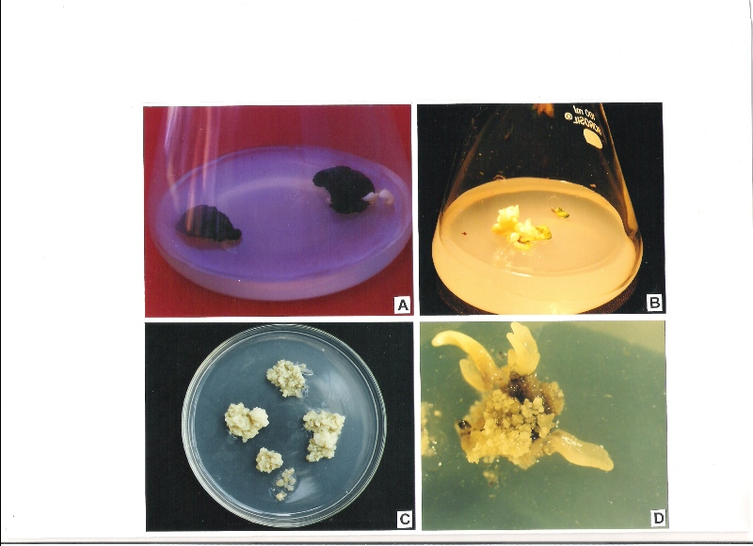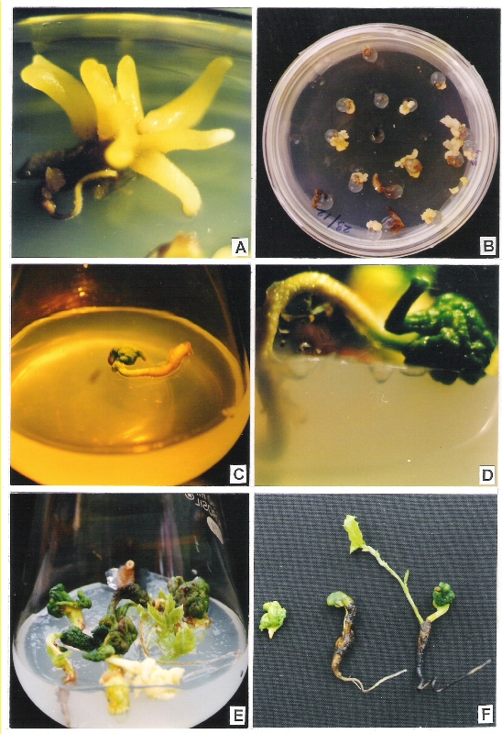
B
C
A
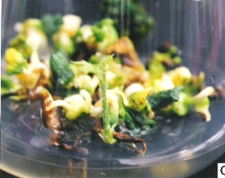
D
E
F
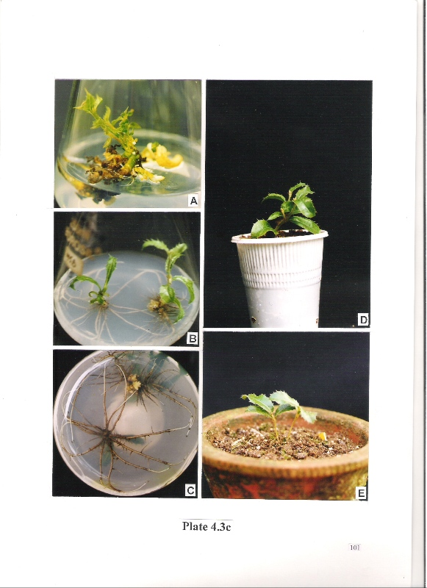
I
G
H
J
K
L

Fig. 1. In vitro propagation of Q. semecarpifolia
(A) Globular structures loosely attached to the surface of the cotyledon.
(B) Bipolar somatic embryos
(C) Secondary embryogenesis
(D) Friable embryogenic callus on WP medium
(E) Indirect somatic embryogenesis
(F) Germination of somatic embryo
(G) Elongation of root primordial from the somatic embryo
(H) Different stages of somatic embryo germination
(I) Well rooted plantlets after 4 weeks of culture on WP medium supplemented with IBA
(J) Rooting from basal view
(K) Well rooted plant 1 month after transfer to plastic cup containing garden soil
(L) Two –months-old in vitro propagated plant in earthen pot

Acknowledgement
The financial support received from the Department of Biotechnology, Govt. of India, is gratefully acknowledged.

Corresponding Author:
Dr (Mrs) Sushma Tamta,
Lecturer, Botany Department,
D. S. B. Campus, Kumaun University, Nainital, Uttarakhand, 263 002, India.
Email: sushma_tamta@yahoo.com
Telephone:9412924956

Referances
- Chalupa V (1995) Somatic embryogenesis in oak (Quercus spp.). In: Jain S, Gupta P, Newton R (eds) Somatic embryogenesis in Woody Plants. Angiosperms. Kluwer Academic Publishers, Dordrecht, The Netherlands, vol. 2, pp 67 – 87
- Cuenca B, San-Jose MC, Martinez MT (1999) Somatic embryogenesis from stem and leaf explants of Quercus robur L. Plant Cell Rep. 18: 538-543
- El Maataoui M, Espagnac H, Michaux-Ferriere N (1990) Histology of callogenesis and somatic embryogenesis induced in stem fragments of cork oak (Quercus suber) cultured in vitro. Ann. Bot. 66: 183-190
- Fernandez-Guijarro B, Celestino C, Toribio M (1995) Influence of external factors on secondary embryogenesis and germination in somatic embryos from leaves of Quercus suber. Plant Cell Tiss. Org. Cult. 41: 99-106
- Gaj DM (2004) Factors influencing somatic embryogenesis induction and plant regeneration with particular reference to Arabidopsis thaliana (L.) Heynh. Plant Growth Regulation. 43(1): 27-47
- Gingas VM (1991) Asexual embryogenesis and plant regeneration from male catkins of Quercus. Hort. Sci. 26: 1217-1218
- Gingas VM, Lineberger RD (1989) Asexual embryogenesis and plant regeneration in Quercus. Plant Cell Tiss. Org. Cult. 17: 191-203
- Guijarro FB, Clestino C, Toribio M (1995) Influence of external factors on secondary embryogenesis and germination in somatic embryos from leaves of Quercus suber. Plant Cell Tiss.Org. Cult. 41: 99-106
- Kim YW, Lee BC, Lee SK, Jang SS (1994) Somatic embryogenesis and plant regeneration in Quercus acutissima. Plant Cell Rep. 13: 315-318
- Kim Y, Moon H, Son S (2006) Repetitive somatic embryogenesis and plant regeneration in Zizyphus jujube Mill. InVitro Cell Dev Bio Plant. 42(3): 247-251
- Lloyd G. and McCown B. (1980) Commercially feasible micropropagation of mountain laurel, Kalmia latifolia, by shoot tip culture. Comb. Proc. Intl. Plant Prop. Soc. 30: 421-427.
- Manzanera J.A. and Pardos J.A. (1990) Micropropagation of juvenile and adult Quercus suber L. Plant Cell Tiss. Org. Cult. 21: 1 – 8.
- Murashige T. and Skoog F. (1962) A revised medium for rapid growth and bioassays with tobacco tissue culture. Physiol. Plant. 15: 473 – 497.
- Puigderrajols P, Fernandez-Guijarro B, Toribio M, Molinas M (1996) Origin and early development of secondary embryos in Q. suber L. Int. J. Plant Sci. 157: 674-684
- Purohit V.K., Palni L.M.S., Nandi S.K. Vyas P. and Tamta S. (2002) Somatic embryogenesis in Quercus floribunda, an important Central Himalayan oak. In: Role of plant tissue culture in biodiversity conservation and economic development. Eds. Nandi S.K., Palni L.M.S. and Kumar A. Gyanodaya Prakashan, Nainital, pp. 41-52.
- Sasamoto H, Hosoi Y (1992) Callus proliferation from the protoplasts of embryogenic cells of Quercus serrata. Plant Cell Tiss. Org. Cult. 29: 241-245
- Schenk R.U. and Hildebrandt A.C. (1972) Medium and techniques for induction and growth of monocotyledonous and dicotyledonous plant cell cultures. Can. J. Bot. 50: 199-204
- Singh JS, Singh SP (1987) Forest vegetation of the Himalaya. Bot. Rev. 53 (1): 80-192
- Tamta S., Palni L.M.S., Purohit V.K, and Nandi S.K. (2008) In vitro propagation of brown oak (Quercus semecarpifolia Sm.) from seedling explants (accepted: 21 March 2008 for publication in In Vitro Cell.Dev.Biol.-Plant; 44(2):136-141.
- Wilhelm E (2000) Somatic embryogenesis in oak (Quercus spp.). InVitro Cell Dev Bio Plant. 36: 349-357

