The Journal of American
Science

ISSN 1545-1003

Volume 5 - Number 1 (Cumulated No. 16), January 1, 2009

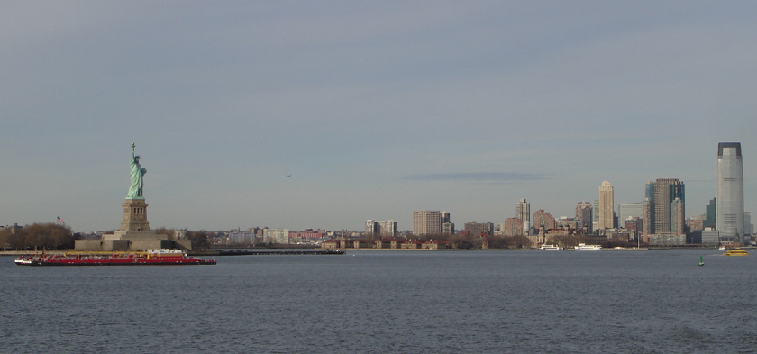

Marsland Press, Michigan, The United States

The Journal of American Science

ISSN 1545-1003

Marsland Press
2158 Butternut Drive
Okemos, Michigan 48864
The United States
Telephone: (517) 349-2362

Emails: editor@americanscience.org;
americansciencej@gmail.com;
sciencepub@gmail.com

Websites: http://www.americanscience.org;
http://www.sciencepub.net;
http://www.sciencepub.org

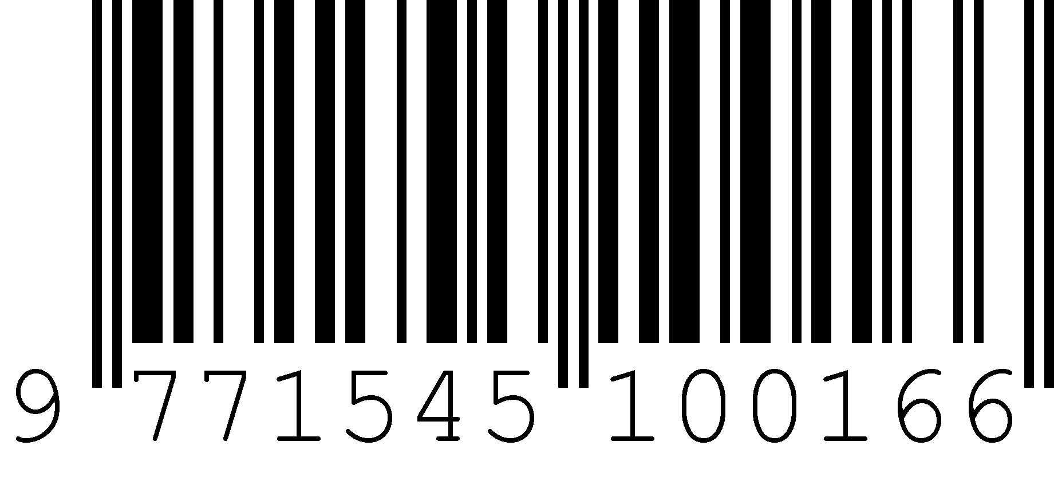
ISSN 1545-1003

