Himalayan Mouse-Hare Ochotona roylei : A Neglected Himalayan
Wild Species?

Ritesh Joshi

Doon Institute of Engineering and Technology, 9th Mile Stone, Shyampur,
Rishikesh, Dehradun, 249 204, Uttarakhand, India
ritesh_joshi2325@yahoo.com

Abstract: In order to generate primary information about Himalayan mouse-hare Ochotona roylei, an in-depth survey was carried out in Tungnath area, Garhwal Himalaya. Mouse hares are tail less Himalayan rodents and generally ranging usually from 2200 to 3500 meter above sea level. A short migration has been observed during winter season from higher to lower elevations of the mountain region basically in search of food and for mating needs. The home range was measured to 1.5 Km² during favourable conditions and average movement was observed to be 70 meters in a single day. Feeding behaviour of this Himalayan mammal is very exemplary and food generally comprises of medicinal plant species (Picrorhiza kurrooa, Saussurea costus, Aconitum heterophyllum, Angelica glouca and Allium spp.) and dry grasses. In sub alpine areas where less snowfall was occurred, animal’s movement activities were observed through out the year whereas in high altitude areas where ground surface was completely covered with snow, its movement activities were restricted to some extent. It was recommended that more studies are required on its behaviour, which can conclude about its movements during the winter especially in snow fed areas. [Journal of American Science 2009;5(4):1-6]. (ISSN: 1545-1003).

Key words: Himalayan Mouse-hare, Ochotona roylei, Garhwal Himalaya, behaviour, conservation

1. Introduction
Central Himalaya is recognized as a rich bio-diversity center due to its different climatic conditions, which provides variety of ecosystems with floral as well as faunal diversity. Himalayan mountain system includes 18,500 plant species, 241 mammals, 528 birds, 149 reptiles and 74 amphibian species (Ghosh, 1996). The diversity index of both plant and animal appears to be very significant including many of the primitive, new evolving wild species. Few of them are also categorized under threatened category mainly due to escalated rate of developmental and anthropogenic activities.
Presently several species of Himalayan wild animals have become extinct and many more are on the verge of extinction. Due to poor accessibility and rigid climatic conditions very less studies have been carried out on Himalayan mammals in high altitude (sub alpine and alpine) areas. Also in the absence of detailed studies and monitoring it appears too conjectural, to assume that the Himalayan wild animals are either migratory or resident. The order Lagomorpha comprises of two families, the Leporidae (hares and rabbits) and the Ochotonidae (mouse-hares). Mouse-hares (Ochotona roylei) are small tail less animal with short, broad, rounded ears and short legs (Figure 1). They are only restricted to the Himalayas, the mountains and steppes of central Asia and the mountains of western North America (Prater, 1998). Still no single document is available, which will focus on the conservation issues of this mammal and hence an attempt has been made to document the primary information regarding to its behaviour from sub alpine region (Tungnath) of Garhwal Himalaya. Besides, an effort has also been made to trace out their distribution in some other parts of Garhwal Himalaya. Mouse-hares are commonly called as ‘Runda’ and ranging usually from 2200 to 3500 meter above sea level. The body size varies from 15 to 20 centimeters in length and 5 to 7 centimeters in height. This animal shows both the characters of mouse and hare, therefore, may be an inter-connective link between the mouse and hare.

2. Study Area
The present investigation was carried out at Tungnath area [30°14' N latitude and 79°13' E longitude] of Garhwal Himalaya, altitude lies between 2200 to 3500 meter above sea level (Figure 2 & 3). The adverse climatic condition of study area reveals about maximum 26°C to minimum -4°C air temperature, intensive solar intensity (2500 lux in September to 79200 lux in May), high wind velocity, heavy frost, blizzards and low air pressure throughout the year except few months of the summer season. Precipitation is found to be in the form of snow, hail and sometime heavy rain. Soil type is loam / sandy loam, light gray to brown in colour at lower altitude and sandy with large debris above the 3500 meter of height. Surface soil pH ranges between 4-8 and 5-7 (Acidic). The study area is also enriched with myriad types of floral as well as of faunal diversity. Tungnath alpine region consist about 171 species of different grasses, sedges, monocots, short forbs, medium forbs, tall forbs and shrubs and most of them are medicinal (Nautiyal et al., 2001). Some important flora comprises of Rhododendron spp. (Buransh), Querques spp. (Baanj), Cedrus deodara (Devdar), Pinus spp. (Kail) and Abies pindraw (Raga). The major wild animals found in this area are Panthera uncial (Snow Leopard), Selenarctos thibentanus (Himalayan Black Bear), Moschus moschiferus (Musk deer), Martes flavigula (Himalayan Yellow throated Martin), Capra ibex (Himalayan Ibex), Hermitragus jemlahicus (Himalayan Thar), Lophophorus impejanus (Himalayan Monal Pheasant) and Pucrasia macrolopha (Koklass Pheasant).

3. Observations
Himalayan Mouse- hares are not the highly wide-ranging animal but traversing more distances to fulfill their basic requirements as per different seasons and environmental conditions. As local inhabitation in Garhwal Himalayan region is mainly concentrated around the alpine and timberline regions, therefore, this mouse-hare is frequently seen around these areas. A short migration has been observed during winter season from higher to lower elevations of the mountain region basically in search of food and for mating needs. The home range was measured to 1.5 Km² during favourable conditions and average movement was observed to be 70 meters in a single day.
During winter (mid-December to mid-March) when entire study area is covered by snow, mouse-hare lives under the blanket of snow and fulfills their feeding requirements by the food materials collected and stored during the pre-winter period. This reflects towards the hibernation behaviour of animal and helps them adaptable to the adverse and unfavorable climatic condition during the winter in snowfed areas. In sub alpine areas where less snowfall was occurred, animal’s movement activities were observed through out the year whereas in high altitude areas where ground level was completely covered with snow its movement activities were restricted to some extent. More research studies are required on its behaviour, which can conclude about its movements during the winter especially in snow fed areas. At Thangu (Sikkim, 3700 m asl) mouse hares are common in summer, but disappear completely during winter and it was suggested that there may be some movement to lower levels (Prater, 1998).
Feeding is one of the prime characteristics of animals, which directly link with their local movements and long-term migration. As the high altitude area are important source of many economically important medicinal plants this tail less mouse–hare generally feed on valuable parts of the medicinal plants, sometimes these are also observed to feed on ferns and small grasses of pasture lands. Among the medicinal and aromatic plants Picrorhiza kurrooa, Saussurea costus, Aconitum heterophyllum, Angelica glouca and Allium spp. are important ones. It was observed during the course of investigation that this rodent shows a typical feeding behaviour. During the pre winter period animal collects several types of medicinal plants and their different parts (leaves, roots, fruits and flowers) and stores them in their small burrows and den situated in between big pieces of stones (Figure 4). Dry grasses are a preffered item during this period as this can be utilized for a long period of time. This may helps them to utilize the stored food during unfavorable conditions, when whole of the area is covered by snow. As per the observations of the present study it was revealed that these mouse-hares are entirely dependent upon the natural food available in forest areas and near to human habitation areas, as the area does not comprises of any agricultural land.
The Himalayan mouse-hare population in the country has been adversely affected by the fragmentation of natural habitats, which leads to considerably limiting its frequent movement. It was observed that mouse-hare is slowly losing its habitat due to rapid increase in anthropogenic activities near to Tungnath area [Figure 5]. According to local people perceptions mouse hares are more commonly seen before last 4-5 years than today. Although no any evidences of human-animal conflict has been observed currently but unfortunately the number seems to decrease than the scenario of few previous years. This might be co-related with the studies on endangered medicinal and aromatic plant diversity. Till today no single research work has been carried out on its ecological aspects and this Himalayan rodent becomes neglected wild species in Garhwal Himalaya. According to a preliminary report their breeding habits are also unrecorded (Prater, 1998).
The future of the Himalayan mouse-hare in this region thus depends on the long-term research studies on its behaviour and on the management practices inside the region, where this animal generally live as well as in formulating a clear cut action plan for their long term survival. Presently, mainly due to the loss of natural habitat and human encroachment into the deeper forest regimes of high altitude areas many plants are categorized under threatened category or are on the verge of extinction. This has caused a serious problem for maintaining the biological diversity status of alpine region.

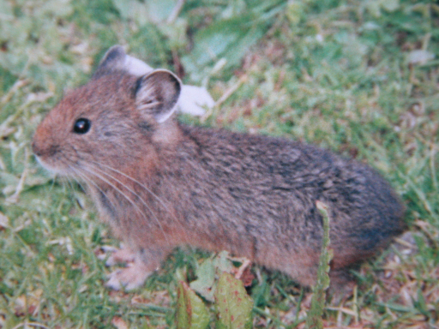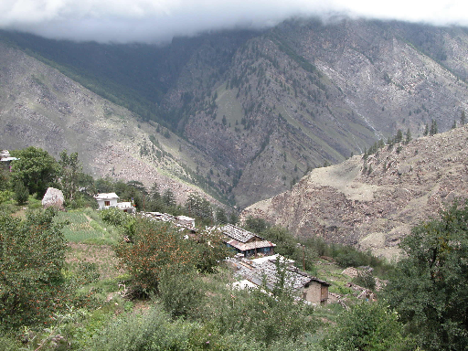
(1) (3)
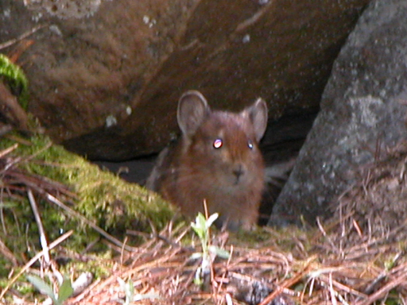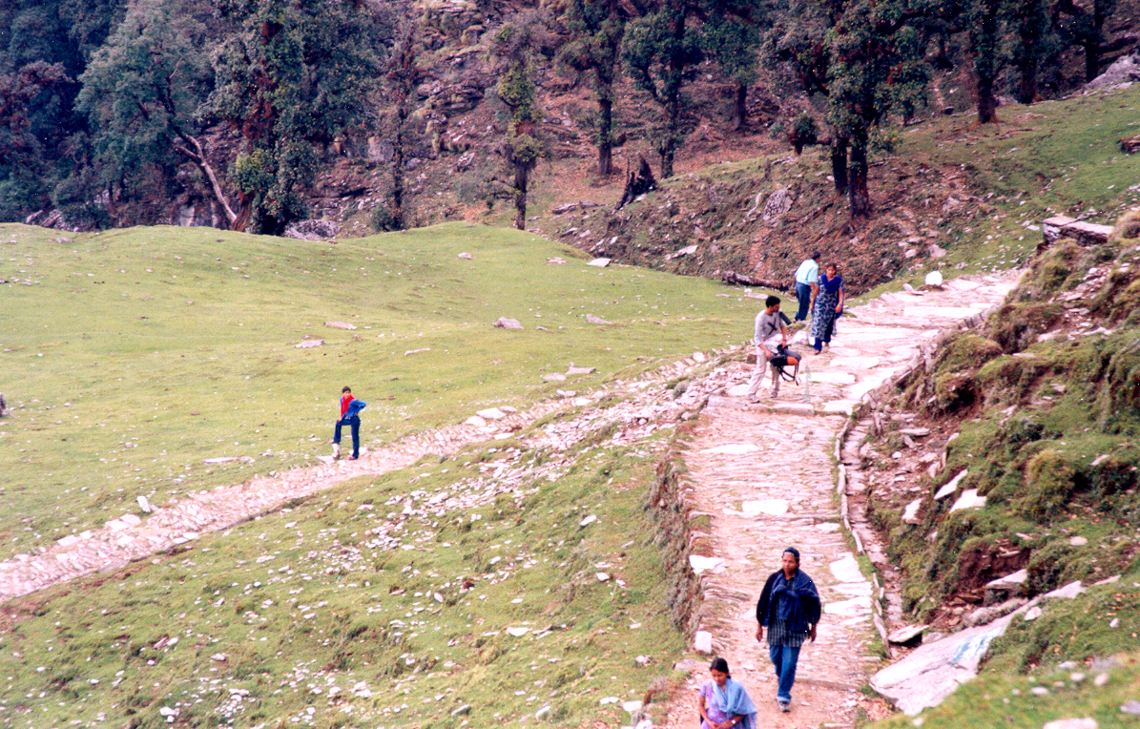
(4) (5)
Figure 1) Ochotona roylei: A flagship species of Garhwal Himalaya, 3) Overview of study area, 4) Himalayan mouse hare in its den under rocky clusters & 5) Anthropogenic activities around Tungnath area.

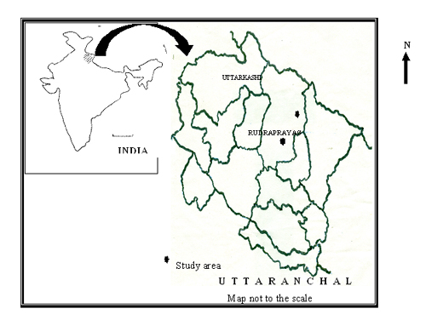

4. Recommendations
- It has been observed at different locations that tourists are not careful and aware about the dumping of remains of food items. These dumps not only attract the mouse-hare but it also attracts few other herbivore wild animals, which generally lead to drastic change in their behaviour. Several times animal may also died due to indigestion and subsequent blockage of intestine. Tourist must be motivated regarding to environmental pollution and conservation.
- Studies are required to be conducted regarding to altitude-wise distribution of mouse hare, which will be helpful in concluding its exact status whether animal is endangered, vulnerable or rare.
- Eco-development and conservation education activities through organizing training programmes and workshops can provide better management strategies.
- Grazing by horses, mules and other domestic animals is another major problem and it should be controlled in some of the habitats where population of mouse hares still exists.
- It is recommended that during the summer when large number of tourist visit to Tungnath area, hoardings must be placed regarding to environmental conservation, which will be helpful in creating awareness among local people and tourist about the conservation issues of Himalayan biological diversity.

Acknowledgements:

The author is highly thankful to the Director and Dr. R. K. Maikhuri, Scientist Incharge (Garhwal Unit) of the G. B. Pant Institute of Himalayan Environment and Development for their valuable support and cooperation during the investigation period. Thanks are also due to Dr. S. N. Bahuguna, Department of Zoology, HNB Garhwal University for providing valuable inputs during the investigation period. Chairman and Director, Doon Institute of Engineering and Technology are highly acknowledged for providing necessary facilities during the study period.

Correspondence to:
Ritesh Joshi
Doon Institute of Engineering and Technology, 9th Mile Stone, Shyampur, Rishikesh, Dehradun, 249 204, Uttarakhand, India
Telephone: + 91 135 2454353 (O)
Email: ritesh_joshi2325@yahoo.com

References
[1] Ghosh, A.K. 1996. Himalayan fauna with special reference to endangered and endemic species. In: Himalayan biodiversity: action plan (Dhar, U. ed.), Himavikas publication, Nainital. pp. 53-59.
[2] Prakash, I. 1978. Handbook of vertebrate pest control. ICAR Publication. pp. 1-95.
[3] Prater, S.H. 1998. The book of Indian animals. Bombay Natural History Society, Oxford University Press.

ISSN: 1545-1003
The journal of American Science
Normal paper structure for the Journal of American Science:
Each manuscript is suggested to include the following components but authors can do their own ways:
- The complete article title.
- Each author’s full name; institution(s) with which each author is affiliated, with city, state/province, zip code, and country; and the name, complete mailing address, telephone number, facsimile number (if available), and email address for all correspondence.
- You must put at least one email address under the authors’ address.
- Abstract: including Background, Materials and Methods, Results, and Discussions, 100-300 words preferred.
- Key Words.
- Introduction.
- Materials and Methods.
- Results.
- Discussions.
- Acknowledgments.
- Correspondence to.
- References.

Description of Manuscript Preparation and Format:
- Software: Microsoft Word file.
- Font: Normal, Times New Roman, 10 pt, single space.
- Indent: 8 spaces in the beginning of each new paragraph.
- Manuscript: Don’t use “Footnote” or “Header and Footer”.
- Spelling check: Do spelling check when you finish.
- Color: Email and website addresses are blue, and all other contents are black.
- Abstract: 100-300 words are preferred, and remember to add “[The Journal of American Science. 2009;x(x):xx-xx]. (ISSN 1545-1003)” in the end of abstract.
- Page setup: Margins: top 72 pt, bottom 72 pt. left 72 pt, right 72 pt.
- Paper size: Letter, width 612 pt, height 792 pt.
- Layout: Header 36 pt, Foot 36 pt.
- Title: Use Title Case in the title and subtitles, e.g. “Debt and Agency Costs”.
- Figures and Tables: Use full word of figure and table, e.g. “Figure 1. Annul Income of Different Groups”, Table 1. Annual Increase of Investment”.
- References: Cite 10-20 references preferred, by “last name, year”, e.g. “(Smith, 2003)”. References should include all the authors’ last names and initials, title, journal, year, volume, issue, and pages etc.
- Reference Examples: Journal Article: Hacker J, Hentschel U, Dobrindt U. Prokaryotic chromosomes and disease. Science 2003;301(34):790-3.
- Book: Berkowitz BA, Katzung BG. Basic and clinical evaluation of new drugs. In: Katzung BG, ed. Basic and clinical pharmacology. Appleton & Lance Publisher. Norwalk, Connecticut, USA. 1995:60-9.
- Insert page number by bottom / center.
- Header for odd: Marsland Press Journal of American Science 2009;x(x):xx-xx.
- Header for even: short title Family name of the first author, et al.
- Footer: http://www.americanscience.org americansciencej@gmail.com.
- Submission Address: sciencepub@gmail.com, editor@sciencepub.net, Marsland Press, P.O. Box 21126, Lansing, Michigan 48909, The United States, 347-321-7172.

